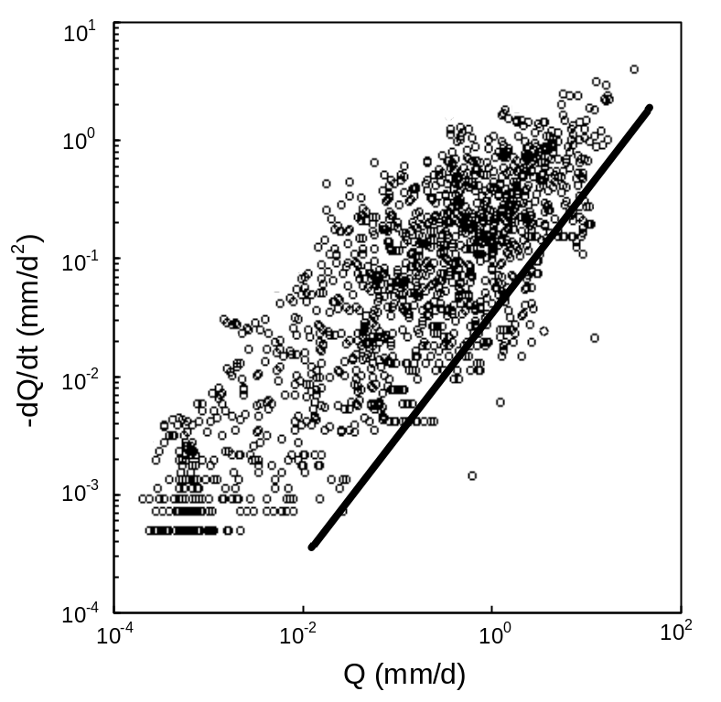
Fig. S1 Estimation of the recession constant (log ($-dQ/dt$) against log ($Q$) in the study site with ID 01013500) using ABIT. The black line is an envelope line lower than 5%, which has a slope of 0.982 and the estimate of the characteristic drainage time scale $K=55$ days

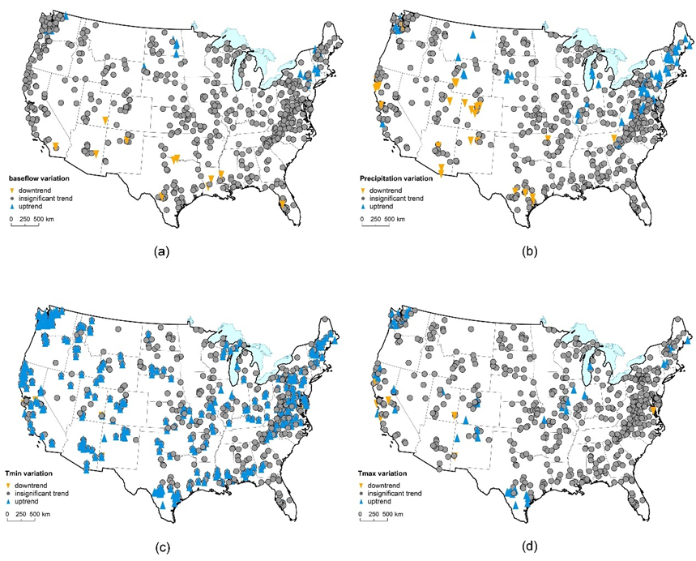
Fig. S2 The MK trend test during study period for (a) baseflow, (b) precipitation, (c) minimum temperature and (e) maximum temperature

Table S1 Correlation test between selected attributes p<0.001 (***)
 | FF | CF | SD | EL | GSP | SF
BFI | 0.42 *** | 0.37 *** | 0.32 *** | 0.33 *** | 0.33 *** | 0.37 ***

Table S2 The variance inflation factor values among selected factors (VIF>10 means strong collinearity)
 | FF | CF | SD | EL | GSP | SF
FF
CF | 5.6
SD | 7.2 | 1.5
EL | 2.4 | 3.1 | 8.1
GSP | 3.5 | 1.8 | 5.4 | 4.9
SF | 2.1 | 7.9 | 4.7 | 9.6 | 4.8

