Supplementary material: Extreme indices of temperature and precipitation in South America: trends and intercomparison of regional climate models.
Miguel Lagos-Zúñiga^{1,2,3}, Rocío Balmaceda-Huarte^{4,5}, Pedro Regoto⁶, Limbert Torrez⁷, Matías Olmo⁴, André Lyra⁶, David Pareja-Quispe^{6,8} and María Laura Bettolli^{4,5}

1: Center for Climate and Resilience Research (CR2), University of Chile, Santiago, Chile.
2: Advanced Mining Technology Center (AMTC), Faculty of Physical and Mathematical Sciences, University of Chile, Santiago, Chile.
3: Civil Engineering Department, Faculty of Physical and Mathematical Sciences, University of Chile.
4: Department of Atmospheric and Ocean Sciences, Faculty of Exact and Natural Sciences, University of Buenos Aires (DCAO-FCEN-UBA), Buenos Aires, Argentina.
5: National Council of Scientific and Technical Research (CONICET), Buenos Aires, Argentina
6: National Institute for Space Research (INPE), , Sao Jose dos Campos, Sao Paulo, Brazil
7: Department of Mechanical Engineering, University of La Serena, La Serena, Chile.
8: Universidad Nacional Mayor de San Marcos (UNMSM), Lima, Perú.

The station data was downloaded from the following URLs:
- National Weather Services of Argentina (www.smn.gob.ar)
- National Weather Services of Uruguay (www.inumet.gub.uy), and Paraguay (www.meteorologia.gov.py);
- National Institute of Meteorology for Brazil (INMET, https://bdmep.inmet.gov.br/#).
- Peruvian Meteorological Agency (SENAMHI, https://www.senamhi.gob.pe/?&p=descarga-datos-hidrometeorologicos);
- Meteorological stations from the Dirección General de Aguas and Dirección Meteorológica de Chile (https://explorador.cr2.cl/)

The supplementary Tables show the model agreement for each extreme index considering the agreement between the reference products: AgERA5 and CPC; within each RCM and within the GCMs HadGEM2-ES and NorESM1. The percent and fraction of agreement reflect the number of simulations that agree with the historical trend. In the case of 2 simulations for each row, number 1 stands for agreement and 0 for discrepancies.

The supplementary Figures show the historical trend for each extreme index for gridded products and regional simulations. Statistically significant trends are noted with a dot over the maps.

Table S1: Multimodel agreement for historical trends on Rx5day index. Blue tones indicate intensification, and yellow ones are the opposite.
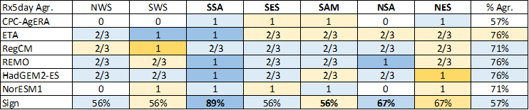
Table S2: Same as Table S1 but for CDD index.
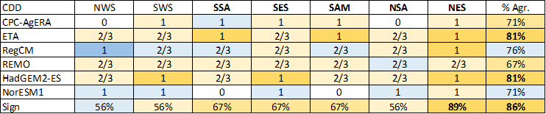

Table S3: Multimodel agreement for historical trends on TXx index. Blue tones indicate warmer conditions and blue ones cooler. In bold is highlighted sign agreement with CPC and AgERA5.
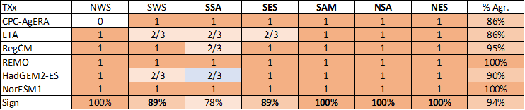
Table S4: Same as TS3 but for TNn index.
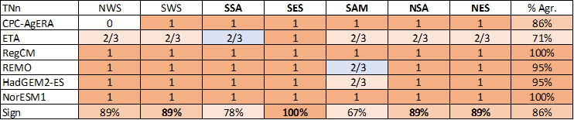

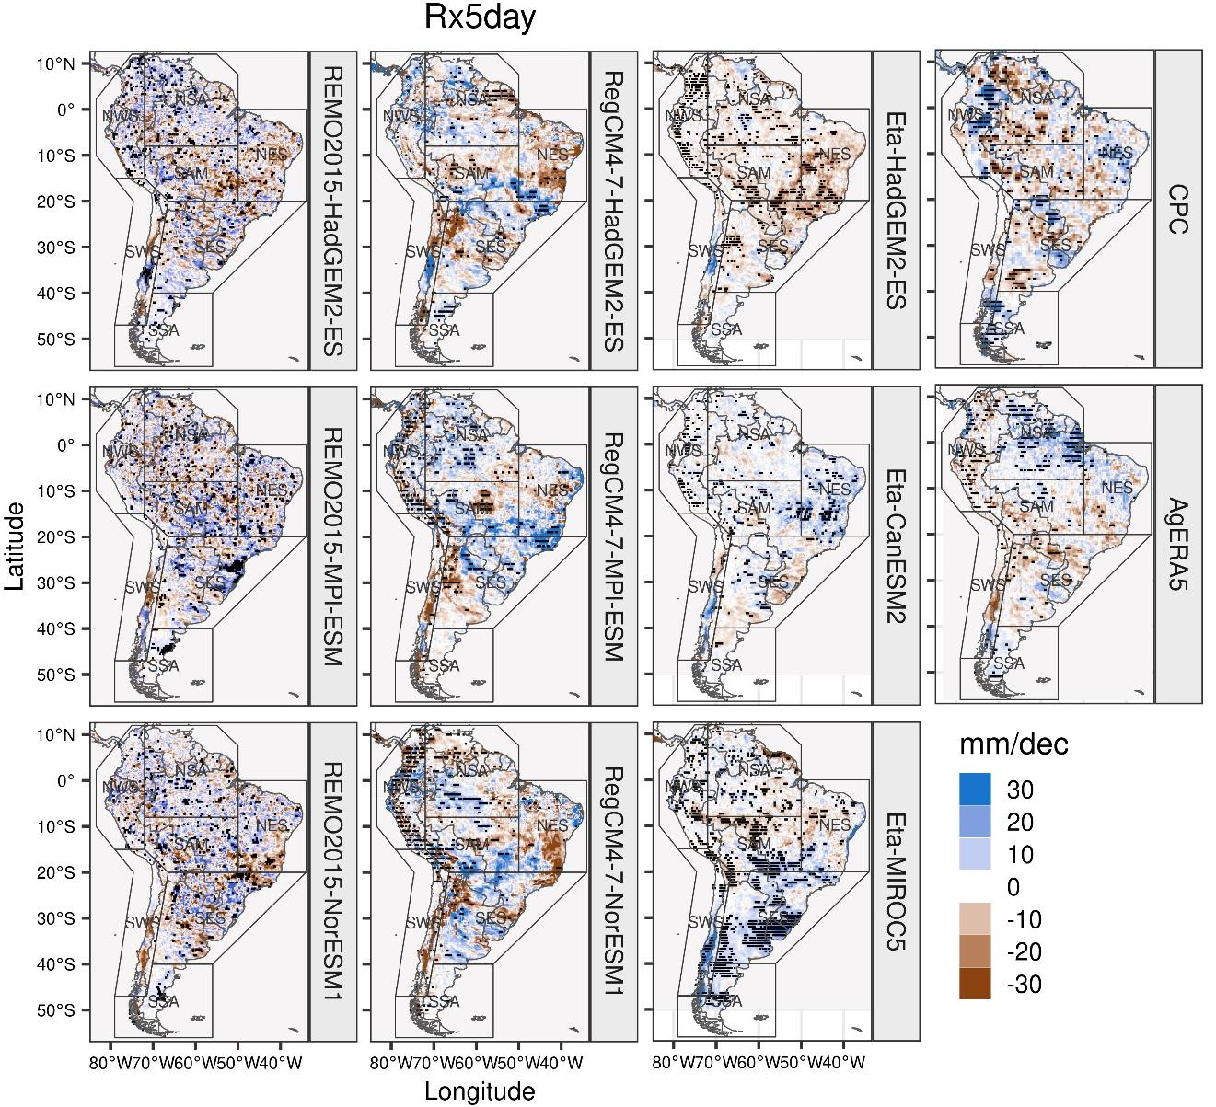
Figure S1: Trends on Rx5day index over South America for the different RCMs and reference products in the 1981-2005 period. Brown colors denote dryer conditions, and blue ones are wetter.

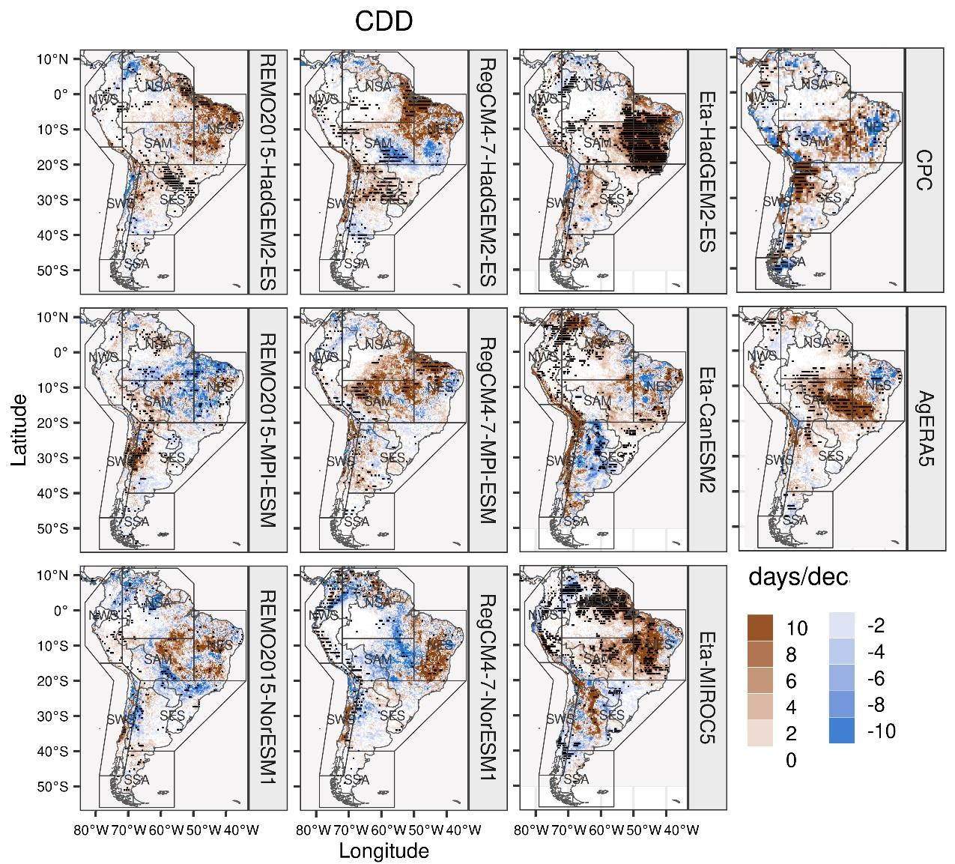
Figure S2: Same as Figure S1 but for CDD index.
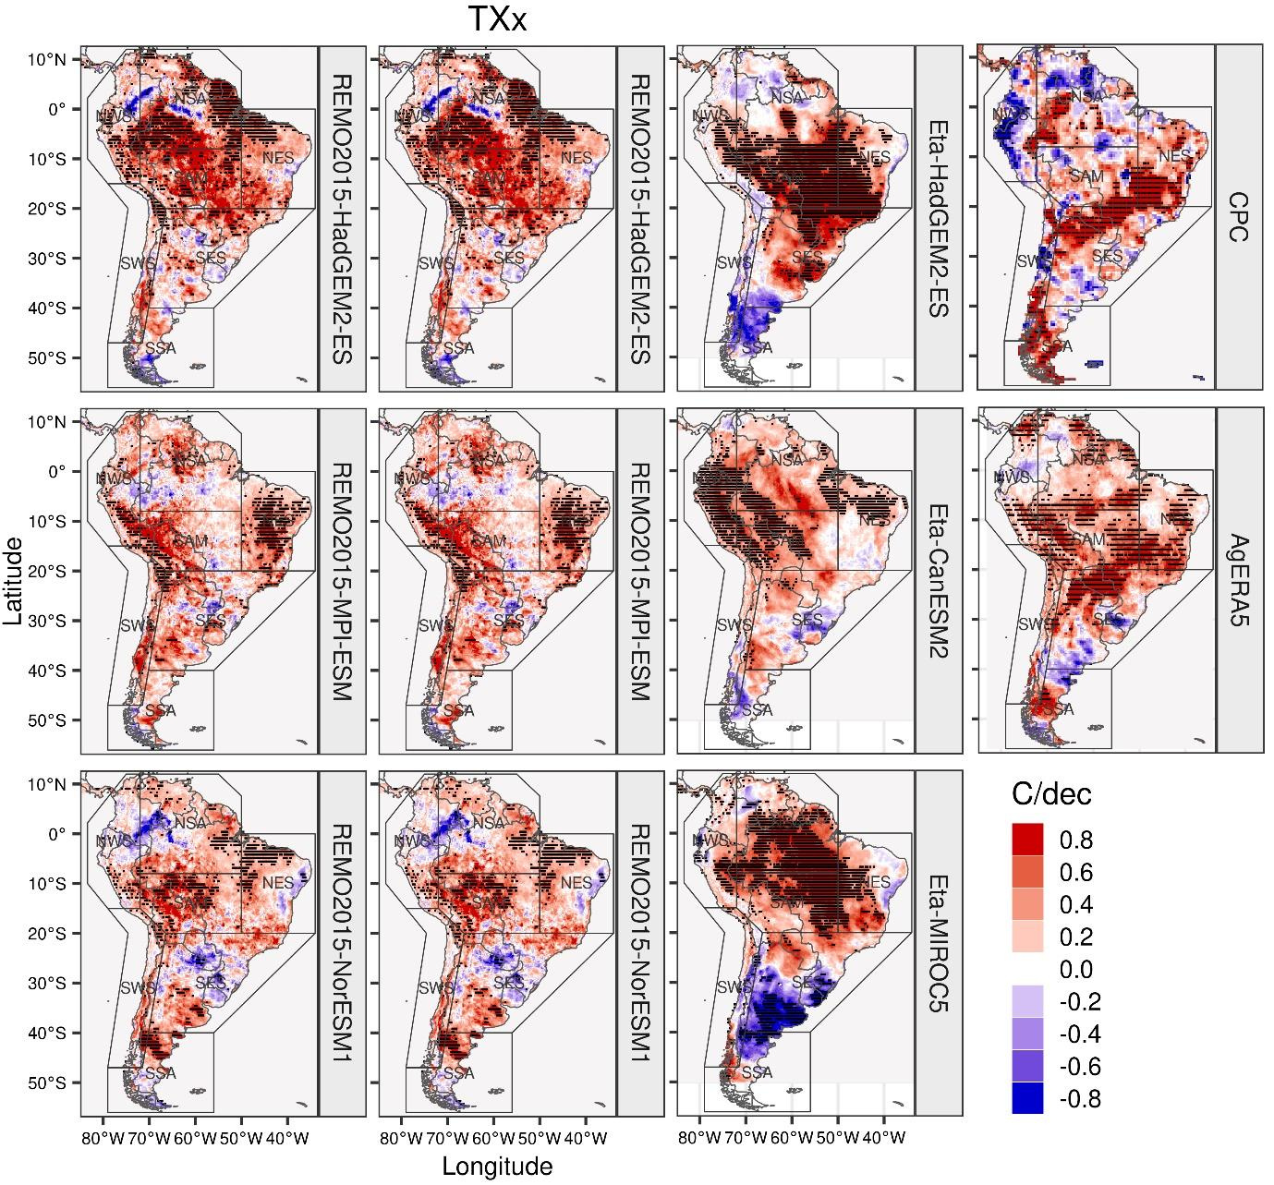
Figure S3: Trends on TXx index over South America for the different RCMs and reference products in the 1981-2005 period. Red colors denote warmer conditions, and blue ones are cooling tendencies.
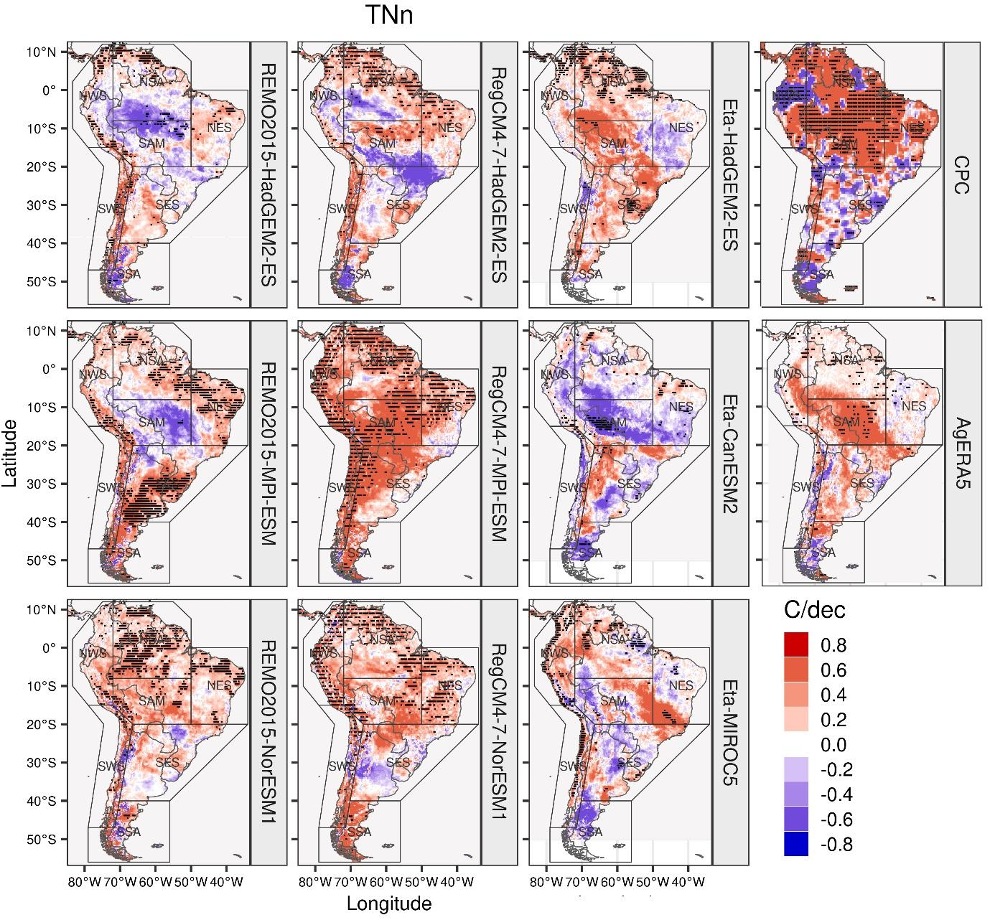
Figure S4: Same as Figure S3 but for the TNn index.

