Supplementary Information

Light-driven C-H bond activation mediated by 2D transition metal dichalcogenides

Jingang Li¹, Hao Li^{2*}, Haoyue Zhu³, Tianyi Zhang³, Yuqian Gu⁴, Zilong Wu¹, Suichu Huang¹, Deji Akinwande⁴, Mauricio Terrones^{3,5,6}, Joan M. Redwing^{3,7}, and Yuebing Zheng^{1,4*}

¹ Materials Science & Engineering Program, Texas Materials Institute, and Walker Department of Mechanical Engineering, The University of Texas at Austin, Austin, TX 78712, USA
² Advanced Institute for Materials Research (WPI-AIMR), Tohoku University, Sendai 980-8577, Japan
³ Department of Materials Science and Engineering, The Pennsylvania State University, University Park, PA 16802, USA
⁴ Department of Electrical and Computer Engineering, The University of Texas at Austin, Austin, TX 78712, USA
⁵ Center for Two-Dimensional and Layered Materials, The Pennsylvania State University, University Park, PA 16802, USA
⁶ Department of Physics and Department of Chemistry, The Pennsylvania State University, University Park, PA 16802, USA
⁷ 2D Crystal Consortium, Materials Research Institute, The Pennsylvania State University, University Park, PA 16802, USA

*Email: zheng@austin.utexas.edu (Y.Z.), li.hao.b8@tohoku.ac.jp (H.L.)

Supplementary Movies
Supplementary Movie 1: PL emission from CTAC on WSe₂ sample under different laser power

Supplementary Figures
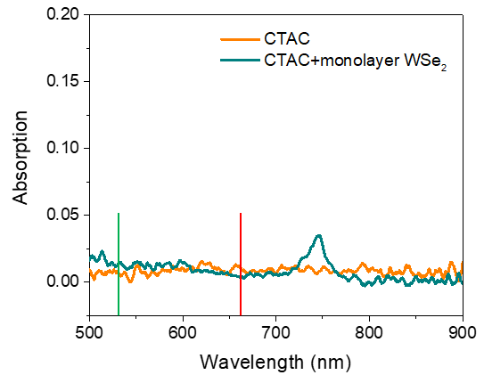
Supplementary Fig. 1. Measured optical absorption of CTAC and monolayer WSe₂. The green and red vertical lines indicate the laser wavelengths used in this work, 532 nm and 660 nm, respectively.

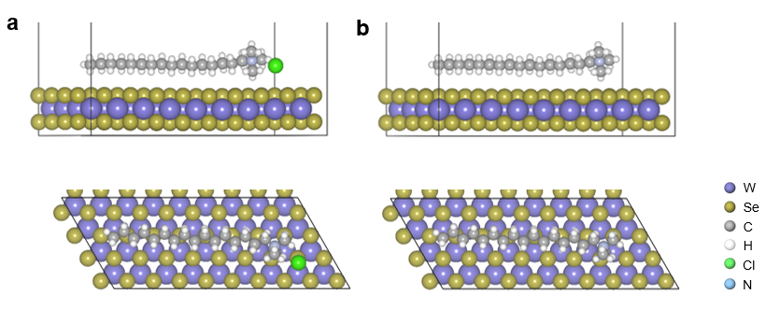
Supplementary Fig. 2. Optimized structures of WSe₂ surfaces with adsorbates. a, WSe₂ with adsorbed CTAC. b, WSe₂ with adsorbed CTAC derivative after dechlorination.

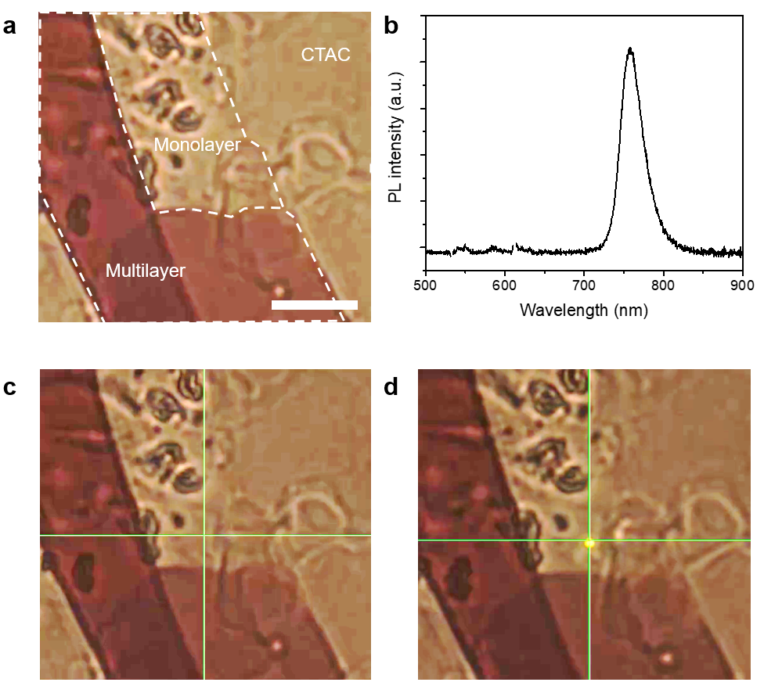
Supplementary Fig. 3. Light-driven C-H activation and carbon dots formation on mechanically exfoliated WSe₂. a, Optical image showing the exfoliated WSe₂ flake coated with a thin layer of CTAC. Scale bar: 10 μm. b, Measured photoluminescence (PL) spectrum at the monolayer region. c, No obvious PL emission from carbon dots after laser irradiation at 5 mW for 5 min. d, The evolution of carbon dots and PL after laser irradiation at 15 mW for 1 min.

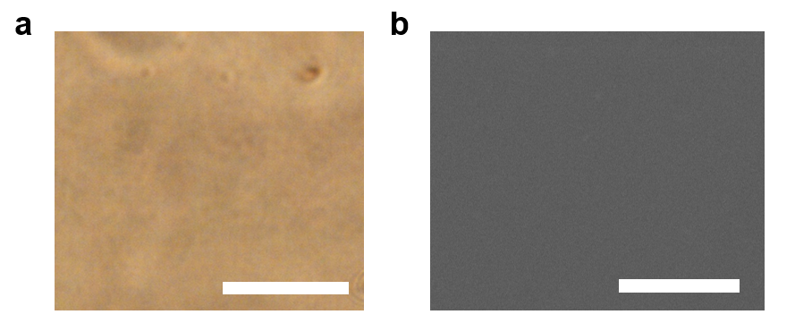
Supplementary Fig. 4. Characterization of the CTAC layer after the laser writing of carbon dots. (a) Optical image and (b) scanning electron microscopic image of the CTAC layer after the laser writing of carbon dots. Scale bars: 10 μm.

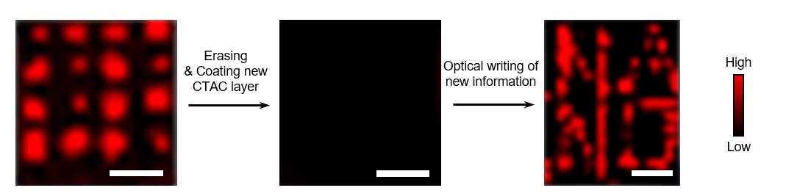
Supplementary Fig. 5. Erasing and rewriting of CDs on monolayer WSe₂. Raman mapping images showing the erasing and rewriting process. A 4x4 dot array was encoded first (left) and erased by washing with water (middle). A new layer of CTAC was coated and a “$\begin{matrix}NA \\ NO\end{matrix}$” pattern was written (right). The Scale bars are 10 μm.

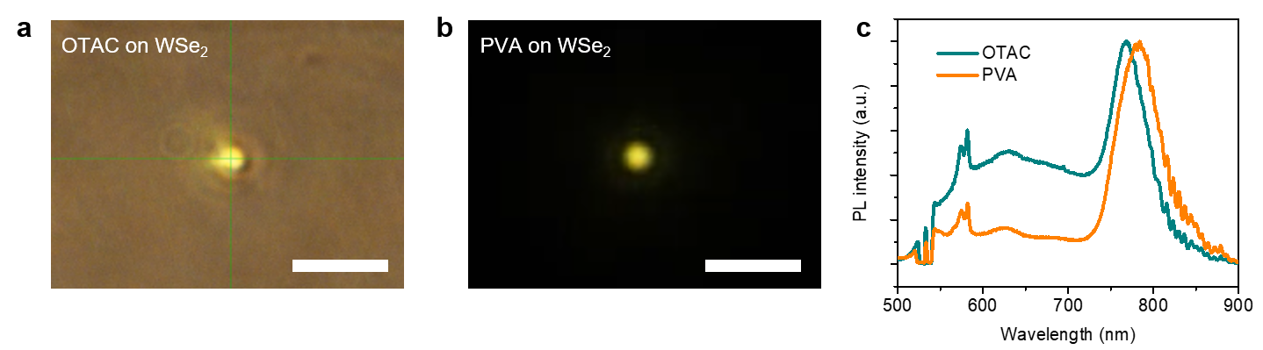
Supplementary Fig. 6. Light-driven C-H activation and carbon dots formation from other organic molecules on a monolayer WSe₂. a,b, Optical images showing the PL emission of carbon dots from (a) octyltrimethylammonium chloride (OTAC) and (b) polyvinyl alcohol (PVA) on monolayer WSe_{2.} The laser wavelength is 532 nm. Scale bars: 10 μm. c, Measured (PL) spectra from OTAC and PVA on WSe₂ sample, showing the emission band from carbon dots.

