Supplementary Materials for

Hippocampal neurons code individual episodic memories in humans

L. D. Kolibius^{1,4*}, F. Roux^{1,4}, G. Parish^{1,4}, M. Ter Wal⁴, M. Van Der Plas^{1,4}, R. Chelvarajah², V. Sawlani², D. T. Rollings², J. Lang³, S. Gollwitzer³, K. Walther³, R. Hopfengärtner³, G. Kreiselmeyer³, H. Hamer³, B. P. Staresina^{5,6}, M. Wimber^{1,4}, H. Bowman^{4,7}, S. Hanslmayr^{1,4*}

Correspondence to:
Email: l.kolibius.1@research.gla.ac.uk (Luca D. Kolibius)
Email: simon.hanslmayr@glasgow.ac.uk (Simon Hanslmayr)

This PDF file includes:

Materials and Methods
Figures S1 to S5
Tables S1 and S2

Materials and Methods
Procedure of memory experiment 1
During the encoding phase of the experiment the participant associated a cue with two other stimuli. For each episode, the cue was a new picture of an animal. The stimuli could be pictures of either places, faces or both. Every picture was only shown once. Two seconds after the animal cue was presented, the associate stimuli were shown, while the animal cue remained on the screen. The participant was asked to create a vivid imaginary story involving the cue and the two stimuli. This part of the experiment was self-paced. The task continued once the participant rated the plausibility of the imaginary story (plausible/implausible).
After the encoding phase, the participant performed a distractor task to rule out working memory effects. During the distractor task, participants had to indicate whether a random number (up to two digits) that appeared serially on the screen was odd or even. After each response, the participant received feedback indicating a correct or incorrect response. This task consisted of 15 trials.
During the retrieval phase, all cues from the previous encoding phase were presented sequentially in pseudorandom order. Each animal cue was presented for two seconds and subjects were tasked to retrieve the corresponding images. The participant was then asked how many associated images they remembered (none, one, or two). Participants had as much time to respond as they required. If the participant indicated that they remembered one or two images, they then were asked to select two pictures from an array of four pictures (two targets and two distractors that consisted of pictures from the previous encoding block which were associated with a different cue).
The experiment ended after the retrieval phase if the total runtime exceeded 40 minutes, or if the patient asked to abort the experiment. Otherwise, the experiment continued with the next encoding block. The encoding block initially consisted of 20 episodes but could be adjusted depending on the cognitive abilities of the patient. If the hit rate fell below 66.25%, fewer episodes were shown for the next block and vice versa if the hit rate surpassed 73.75%.
The patients performed the memory task on a laptop computer (experiment 1: Toshiba Tecra W50, 60 Hz refresh rate; experiment 2: Lenovo L390 Yoga, 60.01 Hz refresh rate), while either seated in a chair next to their bed or their hospital bed.

Procedure of memory experiment 2
The second experiment is based on the first experiment with the following adaptations: participants are presented with one cue image (depicting an animal/place/face) and only one associate image (depicting an animal/place/face). During retrieval, participants were asked whether they remembered the associate image and the participants had to choose the correct associate from an array of four pictures (one target and three distractors that consisted of pictures from the previous encoding block which were associated with a different cue). The experiment was terminated upon request or when the runtime at the end of a retrieval block exceeded 30 minutes.

Visual tuning task procedure
For experiment 2, the memory task was followed by a visual tuning task. During this tuning task, every image that was shown during the preceding memory task was displayed. Each image was shown six times in pseudorandom order on the screen for a duration of one second. The inter-image interval was jittered between 500ms and 550ms. To ensure attention, patients had to categorize the image as an animal, a place, or a face using the arrow keys on the keyboard.

Participants
For experiment 1, eight patients were recorded in the Queen Elizabeth Hospital Birmingham (Birmingham, UK) (4 female; mean age: 36.25 years, from 26-49 years) and eight patients in the Universitätsklinikum Erlangen (Erlangen, Germany) (3 female; mean age: 36.125 years, from 26-53 years). For experiment 2, eight patients were recorded in the Universitätsklinikum Erlangen (Erlangen, Germany) (4 female; mean age: 34.375, from 19-58 years).

Ethical approval
Ethical approval was granted by the National Health Service Health Research Authority (15/WM/0219) and the Ethik-Kommission of the Friedrich-Alexander Universität Erlangen-Nürnberg (142_12 B). Informed consent was obtained in accordance with the Declaration of Helsinki.

Behavioural analysis
For the analysis of the first experiment, we considered an episode a hit if the participant correctly identified both stimuli. We considered an episode a miss if the participant either indicated not to remember any stimuli or did not remember either stimulus correctly. Participants correctly recalled on average 68.38% (SE = 4.64%) episodes in the first experiment (see Table S1) and on average 60.46% (SE = 3.97%) episodes in the second experiment (see Table S2). This is substantially more than would be expected by chance (16.7% and 25% respectively).

Statistical analysis
All statistical analyses were conducted using MATLAB R2020a on a computer running Windows 10 Enterprise. The significance threshold for all statistical tests was set at 0.05. All permutation tests were implemented with N = 10,000 random draws.

Co-Registering
For all but one patient, a pre-operational T1-weighted MRI scan was co-registered with a post-operational scan and normalized in MNI space using SPM12. For one patient, a post-operational CT scan was used instead of a post-operational MRI scan. Each microelectrode was localized either within the hippocampus or outside it through visual inspection (see Figure S1). Only activity from microwires in Behnke-Fried electrodes that were assigned to the hippocampus was analyzed in the current study.

Recording System and Electrodes
Patients were implanted with one to eight (see Table S1 and S2 for an overview) depth electrodes of the Behnke Fried type with microwire bundles (Ad-Tech Medical Instrument Corporation, USA) to localize epileptic foci. The electrode location was determined by clinical need. These single-use electrodes are made from platinum, have a diameter of 1.3mm and allow for simultaneous macro- and microcontact recordings. Platinum has a high impedance for lower frequency and a low impedance for higher frequency bands. As such it is suitable to pick up local extra-cellular action potentials. The micro contacts extended radially past the endpoint of the macro depth electrode, and each contained eight high-impedance microwires (40-micron diameter) and one low-impedance microwire that is typically used for referencing.
The electrodes were connected to an ATLAS system (Neuralynx Inc, USA) consisting of CHET-10-A pre-amplifiers and a Digital Lynx NX amplifier and recorded with a sampling rate of either 32,000 Hz (Location: Birmingham) or 32,768 Hz (Location: Erlangen). Upon acquisition, an analogue bandpass filter from 0.1 Hz to 9,000 Hz was applied.

Spike detection and spike sorting
In the following paragraph, we will outline the process used to filter the raw data, detect spike timestamps, extract features of the waveshape and cluster spike waveshapes into putative single neurons using the wave_clus toolbox. For a more in-depth description of the wave_clus algorithm, the reader is referred to (Chaure et al., 2018).
The unfiltered signal included both the local field potential and the action potentials of individual neurons. Action potentials are characterized by a very steep and transient amplitude in the signal. To extract these spikes, we first applied zero-phase filtering using a second-order bandpass elliptic filter in the range of 300-3,000 Hz. The resulting signal contained the information of the so-called spike-band.
Next, we segmented the continuous filtered data into epochs of five minutes. Segmenting the continuous data into smaller epochs had the advantage that noise in the signal did not increase the detection threshold for the whole recording and instead was limited to the segment in which it occurred (Chaure et al., 2018).
Spike detection was performed separately for positive and negative deflections. Once a spike was identified, 64 data points around the spike maximum were extracted. This corresponds to a 2 ms window at a sampling rate of 32,000 Hz. The spike peak was aligned to the 20th sampling point. To avoid misalignment of the spike, the waveshape was first up-sampled to 320 data points using cubic spline-interpolated waveforms and then down-sampled again (Chaure et al., 2018).
Based on the extracted spike waveform, features were computed using a four-scale multiresolution decomposition with a Haar wavelet. This results in 64-wavelet coefficients for each spike. The 10 most significant coefficients were identified using a Lilliefors test and used for the clustering procedure (Chaure et al., 2018).
Nonparametric clustering in the feature space was performed using superparamagnetic clustering (SPC). SPC grouped spike waves into clusters based on nearest-neighbour interactions (Blatt et al., 1996). Template-matching in Euclidian space was performed to assign unclassified waveforms to one of the identified clusters. The resulting clustering solution was then manually inspected and further optimized by rejecting artefact clusters, splitting clusters that represent multi-unit activity and merging clusters that likely stem from the same neural source. See Figures S3 to S5 for an overview of the spike width, spike height, the Fano factor and the firing rate separately for ESNs and all other single units.

Identification of Episode Specific Neurons (ESNs)
For every single unit, we determined the number of spikes within each episode. During encoding, spikes from the onset of the associate images (two seconds after the cue onset i.e., when the whole information of the episode was present) until the end of the episode were considered. During the retrieval phase, spikes from cue onset until the time point at which participants indicated how many images they remembered were considered. We chose this time window because an episode could be reinstated following cue presentation, while after the response patients were presented with an array of images that could have potentially induced single-unit firing. Because the experiment was self-paced and longer episodes trivially contained more spikes, the firing rate (in hertz) was computed for each episode and single unit. In the next step, we z-scored this firing rate per single unit within all encoding episodes and retrieval episodes separately. Afterwards, we excluded all episodes that were later forgotten (for hit-ESNs) or that were later remembered (for miss-ESNs). We then multiplied this standardized firing rate for encoding and retrieval episodes elementwise to gain an indicator for the reinstatement of firing for each episode (Figure 2A).
To estimate a threshold at which episode-specific firing reinstatement occurs on a single-unit level, we permuted the order of the encoding episodes and recomputed the elementwise product of the shuffled episode series. We repeated this permutation step 10,000 times and stored all output values. The 99th percentile of these pooled values was then used as a threshold for firing reinstatement. As an additional constraint, z-scored firing during encoding and retrieval each had to exceed 1.645 (≙ p_{right-tailed} < 0.05) to make sure the elementwise product was not predominantly driven by a high firing rate in one of the two phases alone (i.e., either encoding or retrieval). This procedure is allowing us to threshold, but we do not have family-wise error corrected statistical significance at the single-unit level. Furthermore, we assume that single units fire independently. To ensure Concept Neurons tuned to the animal cue were not falsely interpreted as ESN activity, we excluded ESNs that showed a significant firing increase in response to the animal cue at encoding using the method described below under Identification of putative Concept Cells.
In a second step, we calculated whether the number of ESNs (as identified in the above procedure) was above chance level. We did this by randomly choosing one of the permutations calculated in the first step for every single unit and checking whether it would be classified as an ESN under the same criteria outlined above. This approach is similar to a set-level effect in SPM (Penny et al., 2011). This process was repeated 10,000 times and the total number of single units which would be classified as an ESN in every single iteration of this process was used to build a distribution against which we compared our empirically discovered number of ESNs.

Identification of ESNs that are not tuned to the stimulus category
We repeated the analysis under Identification of Episode Specific Neurons (ESNs) using a more conservative definition of ESN to exclude units coding for a specific face/place or faces and places in general. Here, firing had to exceed the threshold for at least one episode in which two places were used as associate stimuli and at least one episode in which two faces were used as associate stimuli. This definition seeks to ensure that ESN firing did not merely reflect firing to a specific concept (e.g., a certain category of faces) or specific stimulus, as these concepts and stimuli were orthogonal between episodes in which two places were used as associate stimuli and the episodes in which two faces were used as associate stimuli.

Identification of putative Concept Cells
We have followed the method outlined in Mormann et al. (2011; 2008) to detect significant single-unit responses towards images. To this end, the 1000ms period after the stimulus onset was divided into 19 overlapping 100ms bins. The spike counts of each bin over all presentations of an image were compared to the 500ms baseline periods before stimulus onset for all images in the session using a two-tailed Mann-Whitney U test (p < 0.0005). We used the Simes’ procedure to correct for multiple comparisons (Rødland, 2006).

Firing rate spike convolution
To produce the visualisations in Figure 4, we extracted spikes from one second before the cue onset until five seconds after cue onset for each episode. Binary spike times were convolved with a 251 ms Gaussian kernel (width factor: 2.5) to create a time-resolved signal of spike activity. We computed the average firing rate over time for all episodes (ep) during the baseline (BL) period 1,000 ms preceding the animal cue $\left({\overline{x}}_{BL}\right)$. We then z-scored the spike activity during the episode ($x_{ep,t}$) using the standard deviation ($std\left({\overline{x}}_{BL}\right)$) and mean (${\overline{\overline{x}}}_{BL}$) across all pre-cue baseline periods (see equation (1)). To account for instances where no spiking activity occurred during the baseline period, 0.1 (see (Ison et al., 2015)) was added to the standard deviation ($std\left({\overline{x}}_{BL}\right)$). Episodes were then split into reinstated and non-reinstated episodes. Firing rates for each episode type (reinstated/non-reinstated) were then averaged over ESNs.

$z_{ep,t}=\frac{x_{ep,t}-{\overline{\overline{x}}}_{BL}}{std\left({\overline{x}}_{BL}\right)+0.1}$ (1)

Identification of Time Cells
We defined the beginning of an encoding block as the most salient event. Based on Umbach and colleagues (Umbach et al., 2020), we then extracted all spikes within each block and convolved them with a 251 ms Gaussian kernel (width factor: 2.5). This created a block number x time points matrix. For our first analysis, we cut each encoding block into 40 equally sized bins, thereby normalizing block duration. We then used a Kruskal-Wallis test to determine whether any of the 40 bins significantly differed from each other.
We then performed a circular shifting permutation test to calculate whether we found a significant number of Time Cells. This is done by shifting a random number of values from the beginning of the vector to the end. This shifting was imposed on each block separately and repeated N = 10,000 times for every single unit.
In a second test, the block length was determined by the longest block and shorter blocks were filled up with NaN values. This resulted in no normalization of time between blocks. The rest of the procedure is the same as described in the above paragraph.

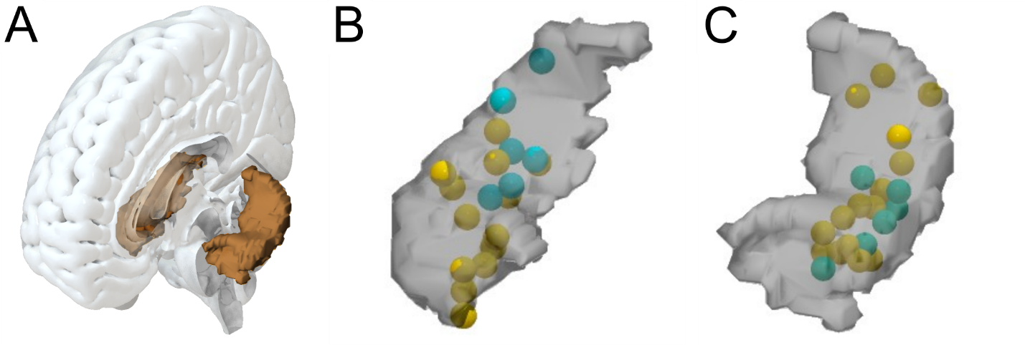Figure S1. Visualisation of the hippocampus and electrode positions for experiment 1 and experiment 2.
(A) Outline of the hippocampus within a whole brain mesh.
(B). Normalized right hippocampus. The yellow spheres represent the estimated position of microwire bundles that contain ESNs. The green spheres represent the estimated position of microwire bundles that do not contain ESNs. Only bundles where single-unit activity was recorded are shown.
(C) Same as (B), but for the left hippocampus.

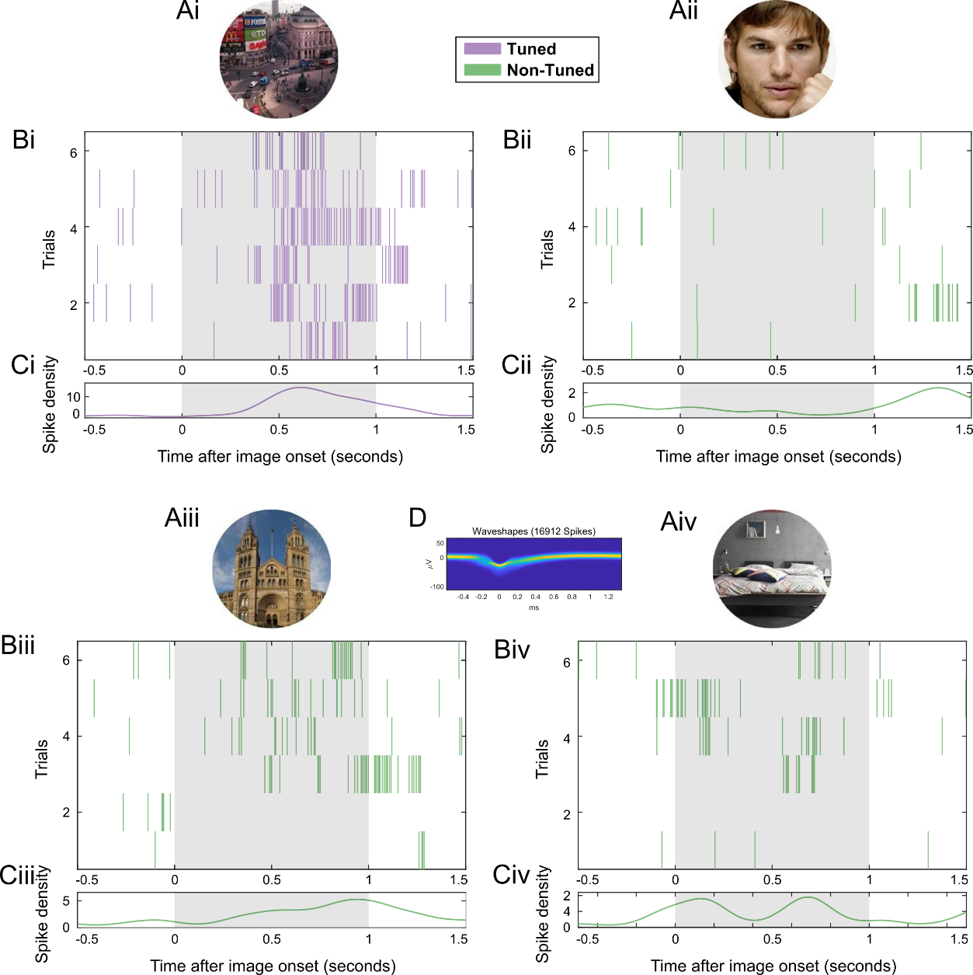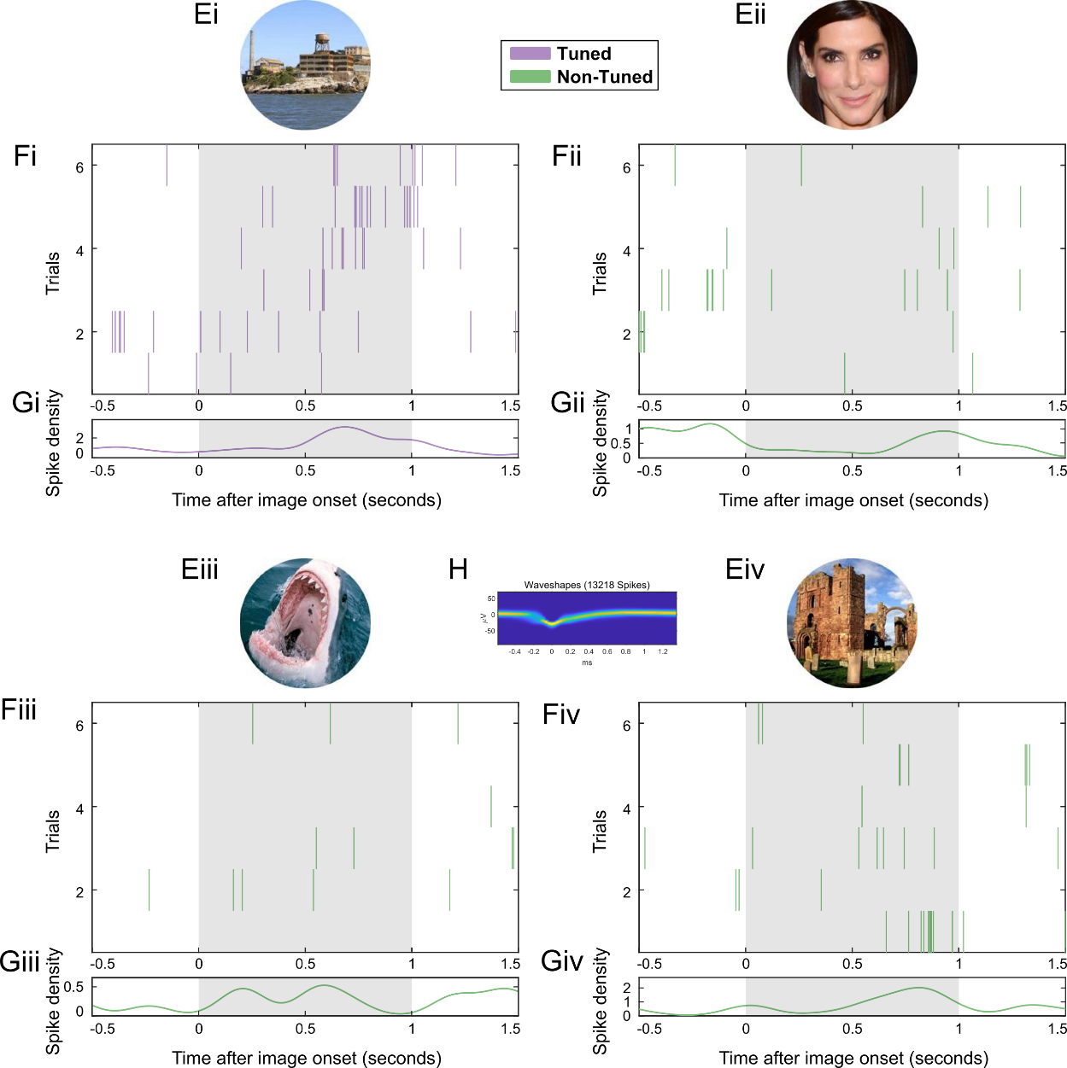

Figure S2. Firing patterns for two example putative Concept Neurons that were identified using a visual tuning task in experiment 2.

(A) Each during the memory task previously shown image (either an animal, a face or a place) is shown six times during the visual tuning task.

(B) Spike raster plot. Each line indicates a spike. On the x-axis is time (locked to image presentation) and on the y-axis are the six trials during which the above image is shown on the screen. Color-coded in purple for tuned images and green for non-tuned images. The grey area indicates the activation period that is considered for identifying Concept Neurons.

(C) Spike density plot (mean instantaneous firing rate over all six trials).

(D) 2D histogram of the waveshape of that particular unit (Niediek et al., 2016).

(E-H) same as (A-D) but for a different example ESN.

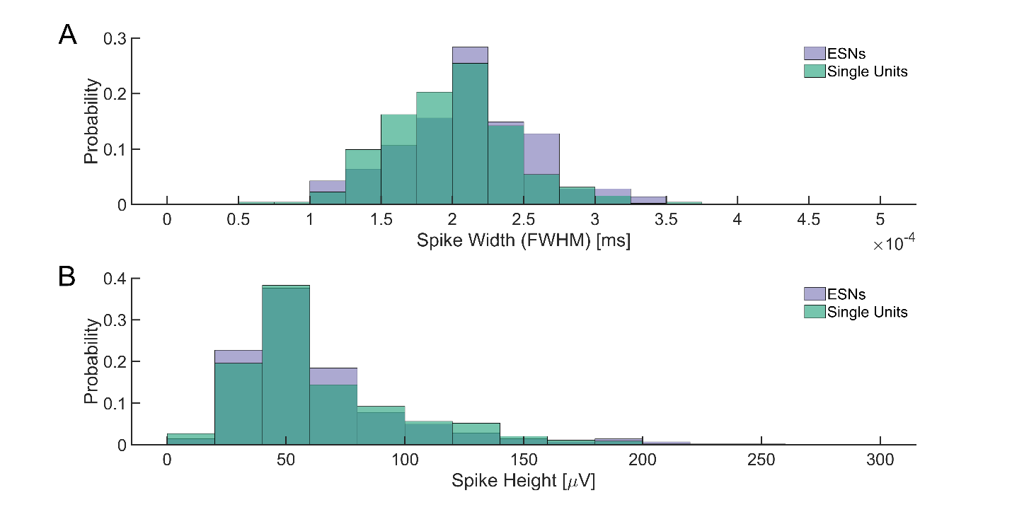

Figure S3.
(A) Distribution of spike widths and
(B) distribution of spike height of ESNs (purple) and single units (green).

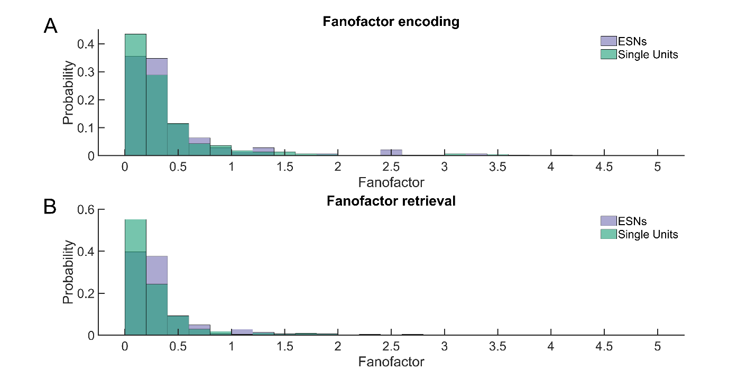

Figure S4.
(A) Distribution of Fano factors of ESNs (purple) and single units (green) during
encoding and during
(B) retrieval.

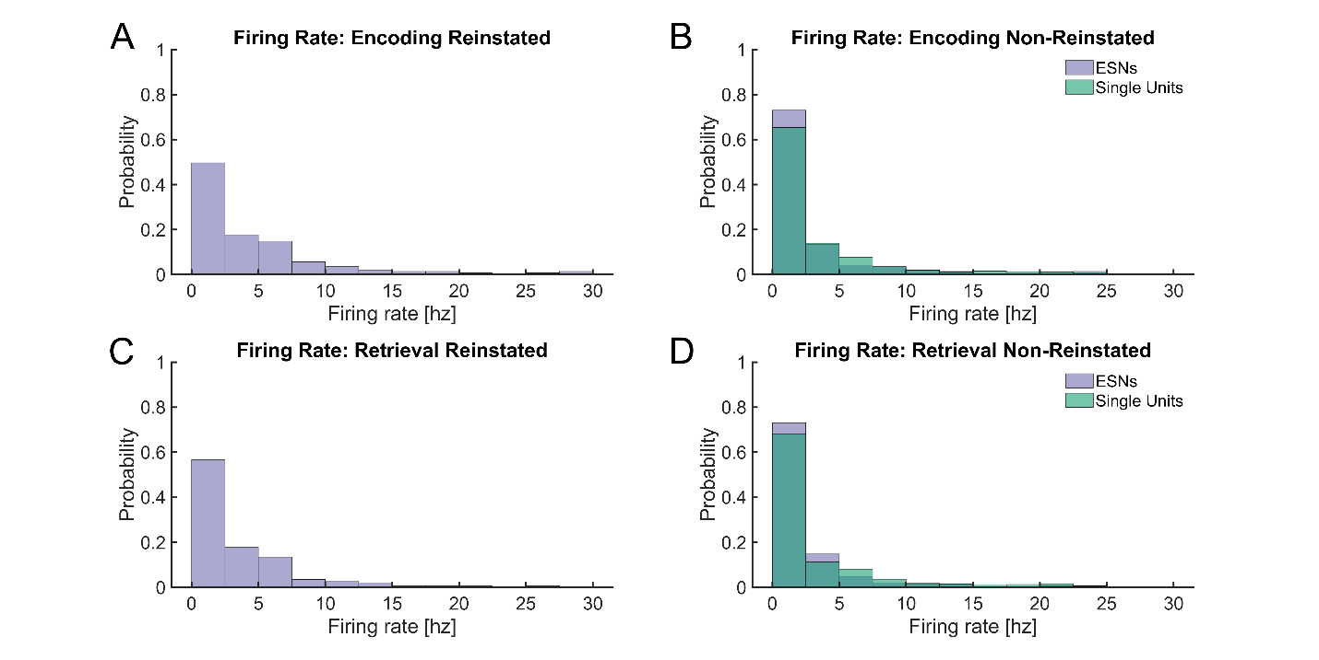
Figure S5.
Firing rate in hertz of ESNs (purple) during
(A) encoding and
(B) retrieval of reinstated episodes. Firing rate of ESNs and other single units (green) during
(C) encoding and
(D) retrieval of non-reinstated episodes.

Table S1.
Patient ID | Number of sessions | Number of bundles | Number of bundles in hippocampus | Trial numberª |  | Hitsª | Hipp.  bundles with SUs^{a,b} |  | Number of hipp. SUs^{a,b} | Number of ESNs^{a,c}
0002 | 7 | 6 | 6 | 49.4 (0.4) | 43.6 (1.3) |  |  | 2.6 (0.3) | 12.3 (2.9) | 3 (0.7)
0004 | 3 | 4 | 3 | 49 (0) | 33.7 (0.7) |  |  | 2 (0) | 7.3 (2) | 2 (1.2)
0005 | 4 | 6 | 6 | 49 (0) | 41.5 (2.7) |  |  | 3.3 (0.3) | 10.3 (1.5) | 4 (0.4)
0007 | 3 | 4 | 4 | 94.3 (1.7) | 86.7 (4.9) |  |  | 4 (0) | 16.7 (4.9) | 8.3 (2.3)
0008 | 4 | 6 | 4 | 68.8 (2.3) | 39.3 (3.9) |  |  | 1.8 (0.3) | 8.3 (1.6) | 1.5 (0.3)
0009 | 3 | 8 | 5 | 84.3 (7.3) | 56.3 (7.3) |  |  | 4 (0) | 17 (1.2) | 3.3 (0.9)
0012 | 4 | 8 | 6 | 53.8 (8.1) | 32.5 (6.9) |  |  | 4 (0.4) | 21.5 (4.1) | 4.5 (1.2)
0013 | 6 | 5 | 5 | 76.2 (6.3) | 45.3 (8.6) |  |  | 2.8 (0.3) | 17.2 (1.6) | 3.3 (1.2)
1003 | 4 | 2 | 1 | 52.5 (2.4) | 46.3 (4.9) |  |  | 1 (0) | 6.3 (0.5) | 1.8 (1)
1004 | 2 | 2 | 2 | 84.5 (11.5) | 75 (11) |  |  | 1 (0) | 1 (0) | 0.5 (0.5)
1005 | 4 | 2 | 2 | 73 (13.9) | 33.3 (7) |  |  | 1.5 (0.3) | 3.5 (1) | 0.8 (0.5)
1007 | 5 | 2 | 1 | 49.6 (8.5) | 31 (6.3) |  |  | 1 (0) | 4.4 (0.5) | 0.8 (0.2)
1008 | 3 | 1 | 1 | 85 (9.5) | 22.3 (6.8) |  |  | 1 (0) | 1.7 (0.7) | 0 (0)
1009 | 2 | 2 | 1 | 82.5 (13.5) | 67.5 (12.5) |  |  | 1 (0) | 2.5 (0.5) | 0 (0)
1011 | 2 | 2 | 2 | 51 (10) | 38 (5) |  |  | 1.5 (0.5) | 8.5 (0.5) | 1.5 (1.5)
1012 | 3 | 2 | 2 | 39.7 (11.6) | 21 (4.9) |  |  | 1 (0) | 7.7 (0.7) | 0.3 (0.3)
Overview of electrode implantation and memory performance.
ª Each number stands for the mean over all experimental sessions with the standard error across sessions in brackets.
^{b} SUs: Single Units (including ESNs)
^{c} ESNs: Episode Specific Neurons

Table S2.
Overview of electrode implantation and memory performance.
Patient ID | Number of sessions | Number of bundles in hippocampus with neurons | Trial numberª |  | Hitsª | Number of hipp. neurons^{a,b} |  | Number of ESNs^{a,c}
1015 | 2 | 1 | 61.5 (0.5) | 28 (3) |  |  | 2.5 (0.5) |  | 0.5 (0.5)
1016 | 3 | 1 | 46.7 (4.1) | 31.3 (3.8) |  |  | 1 (0) |  | 0.7 (0.3)
1017 | 2 | 1.5 | 62 (2) | 38.5 (0.5) |  |  | 2 (1) |  | 0 (0)
1018 | 2 | 3 | 56 (9) | 31 (5) |  |  | 16 (1) |  | 2 (1)
1019 | 1 | 2 | 64 (0) | 49 (0) |  |  | 12 (0) |  | 5 (0)
1021 | 1 | 2 | 54 (0) | 38 (0) |  |  | 15 (0) |  | 1 (0)
1022 | 1 | 2 | 62 (0) | 28 (0) |  |  | 10 (0) |  | 2 (0)
1023 | 1 | 1 | 47 (0) | 29 (0) |  |  | 5 (0) |  | 2 (0)

ª Each number stands for the mean over all experimental sessions with the standard error across sessions in brackets.
^{b} SUs: Single Units (including ESNs)
^{c} ESNs: Episode Specific Neurons

