Supplementary Information:

Predicting functional trait variation across climatic gradients in ectotherms

Juan G. Rubalcaba*, Sidney F. Gouveia, Fabricio Villalobos, Miguel Á. Olalla-Tárraga, Jennifer Sunday
* jg.rubalcaba@gmail.com

SI. Content
- Transient-heat model
- Model validation
- Assemblage-level analyses of mean trait values
- Assemblage-level analyses using phylogenetically imputed trait values
- References in SI
1. Transient heat model
We used a transient heat model to compute body temperature (T_{b}) variations of a lizard as a function of microclimatic conditions (i.e., solar radiation, air and soil temperature, and wind velocity), body size and skin colour (Porter and Gates 1969; Porter et al. 1973; Fei et al. 2012; Rubalcaba et al. 2019). The heat balance equation includes heat exchange rates via absorption of short-wave solar radiation (Q_{rad}, W), thermal radiation (Q_{IR}), convection (Q_{conv}), and conduction with the ground (Q_{cond}):
 | $$C\frac{dT_{b}}{dt}={\dot{Q}}_{rad}+{\dot{Q}}_{IR}+{\dot{Q}}_{conv}+{\dot{Q}}_{cond}$$ | (1)
where C is the thermal capacitance, i.e., the product of the lizard’s specific heat capacity (c_{p} = 3.7 Jg⁻¹ºC⁻¹; Porter et al. 1973) and body mass (M, g). The one-lump analytical solution of the heat balance equation (1) takes the form:
 | $$T_{b}(t)=T_{e}+\left(T_{0}-T_{e}\right)e^{-θt}$$ | (2)
with:
$$θ=\frac{A_{d}}{C}\left(R_{a}+h_{c}\right)+\frac{A_{g}}{C}\left(R_{g}+h_{g}\right)$$
and T_{e} (i.e., body temperature at the equilibrium):
$$T_{e}=\frac{A_{d}\left(aS+R_{a}T_{a}+h_{c}T_{a}\right)+A_{g}T_{g}\left(R_{g}+h_{g}\right)}{A_{d}\left(R_{a}+h_{c}\right)+A_{g}\left(R_{g}+h_{g}\right)}$$
This equation takes into consideration the absorption of solar radiation, modelled here as:
 | $${\dot{Q}}_{rad}=A_{d}aS$$ | (3)
where (A_{d}, m²) is the surface area of skin exposed to incoming radiation, a (-) is skin absorbance to short-wave radiation, and S (W m⁻²) is the total incoming radiation from the sun. We computed total skin surface area as A = 0.0314 × 3.14 × (M / 1000)^{2/3} (O’Connor 1999) and assumed that the exposed surface area A_{d} is two-thirds of the total animal’s surface (Barlett and Gates 1967).
To model heat exchanged via emission and absorption of thermal radiation (Q_{IR}, W), we used the linearized expression of the Stephan-Boltzmann law (Bakken 1976).
 | $${\dot{Q}}_{IR}=A_{d}εσ\left[{\left(T_{b}+273\right)}^{4}-{\left(T_{a}+273\right)}^{4}\right]+A_{g}εσ\left[{\left(T_{b}+273\right)}^{4}-{\left(T_{g}+273\right)}^{4}\right]≈A_{d}R_{a}\left(T_{b}-T_{a}\right)+A_{g}R_{g}\left(T_{b}-T_{g}\right)$$ | (4)
where T_{b} is body temperature, T_{a} is air temperature, and T_{g} is soil temperature (ºC). The radiative heat transfer coefficients R_{a} and R_{g}, which determine heat exchange rates via thermal radiation with the air and the ground, respectively, are $R_{a}=4εσ{\left(T_{a}+273\right)}^{3}$ and $R_{g}=4εσ{\left(T_{g}+273\right)}^{3}$ (Bakken 1976). Finally, A_{g} is the skin surface area facing towards the ground (estimated here as 1/3 × A; Barlett and Gates 1967).
The rate of heat transfer via convection is defined by the Newton law of cooling as a function of body and air temperature (T_{a}), skin surface area, and the convection heat transfer coefficient (h_{c}, Wm⁻² ºC⁻¹):
 | $${\dot{Q}}_{conv}=A_{d}h_{c}\left(T_{b}-T_{a}\right)$$ | (5)
We calculated the convection coefficient using the Reynolds (Re) and Nusselt (Nu) numbers. The Re number (Re = L × v/υ) predicts the behaviour of the air flow surrounding the body as a function of wind velocity (v, ms⁻¹), kinematic viscosity of the air (υ, m⁻²s), and the characteristic length (L, m) over which the fluid flows in contact with the animal’s surface, estimated here as L = A^{1/2}. The Nu number (Nu = L × h_{c}/k_{f}), which computes the ratio between the convective heat transfer coefficient (h_{c}) and the thermal conductivity of the air (k_{f}, Wm⁻¹ ºC⁻¹), was computed using an empirical Nu-Re relationship Nu = 2 + 0.37 × Re^{0.7}. Thus, the expression for the convective heat transfer coefficient was $h_{c}=2+ 0.37{\left(L\frac{v}{υ}\right)}^{0.7}\frac{k_{f}}{L}$ (Mitchell 1976).
Finally, we modelled heat exchange between the body and the ground using the conduction heat transfer coefficient h_{g} (Wm⁻² ºC⁻¹) in the equation:
 | $${\dot{Q}}_{cond}=A_{g}h_{g}\left(T_{b}-T_{g}\right)$$ | (6)
where h_{g} was estimated as the ratio between the thermal conductivity (set here to 0.027 Wm⁻¹ºC⁻¹) and skin thickness $t_{skin}=0.025{\left(\frac{0.001M}{π1000}\right)}^{0.2}$(Stevenson 1985).
2. Model validation
We tested the goodness of fit of the model by comparing predicted and observed body temperature data across lizard species in Rubalcaba et al. (2019). Here we show a subset of six species including Zootoca vivipara (Rozen‐Rechels et al. 2021), Aspidoscelis tigris, Uta stansburiana, Callisaurus draconoides, Ctenophorus isolepis, Ctenotus quatt, and Pedioplanis linneoocellata (Huey and Pianka 2017). We pooled field body temperature data across locations for each species and month. Then, we ran the model at the centroid of all locations and adjusted the values of T_{pref} and λ using maximum likelihood (Rubalcaba et al. 2019; Table SX). Finally, we compared predicted and observed daytime body temperature distributions and the daytime variations in body and operative temperatures (Fig. SX).
Table S1. Model parameters used for each species shown in Figure SX.
Species | Body mass (g) | Skin absorbance | Preferred temperature (ºC) | Thermoregulatory ability (λ) | Latitude | Longitude | Month
Zootoca vivipara | 5 | 0.7 | 31 | 0.45 | 44.6488647 | 3.68120178 | June
Aspidoscelis tigris | 15 | 0.80* | 40 | 1.10 | 34.8126277 | -114.28498 | June
Uta stansburiana | 3 | 0.86* | 35 | 0.44 | 34.8413515 | -114.9881 | July
Callisaurus draconoides | 10 | 0.83* | 40 | 1.34 | 34.3308931 | -114.54865 | June
Ctenophorus isolepis | 7 | 0.8 | 40 | 0.87 | -22.684984 | 125.402528 | February
Ctenotus quatt | 7 | 0.8 | 35 | 0.71 | -22.684984 | 125.402528 | February
Pedioplanis linneoocellata | 7 | 0.8 | 40 | 0.58 | -27.077956 | 17.9551698 | February
* Estimated from Clusella-Trullas et al. 2008

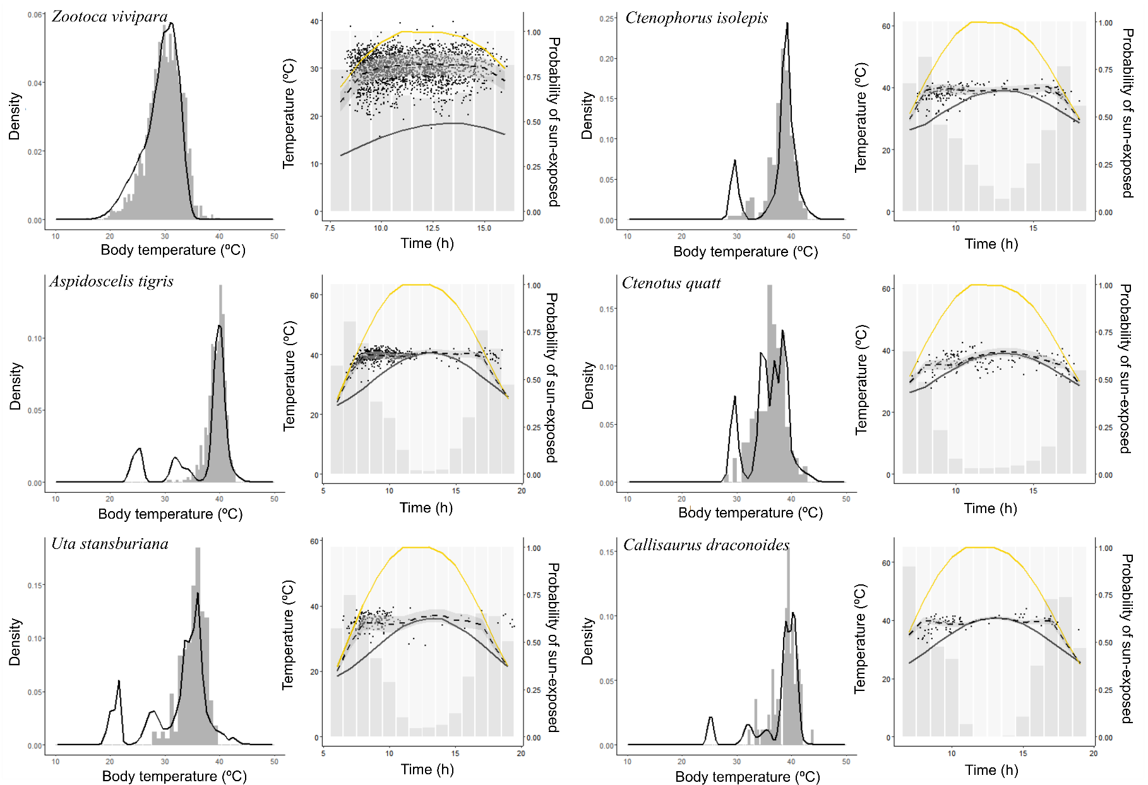
Fig S1. Observed body temperatures (histograms and data points) vs predicted temperatures (lines) of lizards. For each species, the left panel shows daytime body temperature distributions, and the right panel shows time variation in operative temperature in sun-exposed (yellow), shaded conditions (grey), and predicted body temperature (dashed lines). Grey bars in right panels show predicted probability of selection of sun-exposed conditions.
3. Assemblage-level analyses of mean trait values
Table S2. Relationship between mean trait values and sensitivity at the assemblage level.
 | Estimate ± SE | t | P
Body mass | -6.49 ± 12.07 | -0.54 | 0.591
Preferred temperature | 19.71 ± 11.67 | 1.688 | 0.092
Field body temperature | 52.13 ± 12.96 | 4.02 | <0.001
Critical thermal maximum | -1.46 ± 10.33 | -0.14 | 0.888
Critical thermal minimum | -23.08 ± 39.42 | -0.59 | 0.559

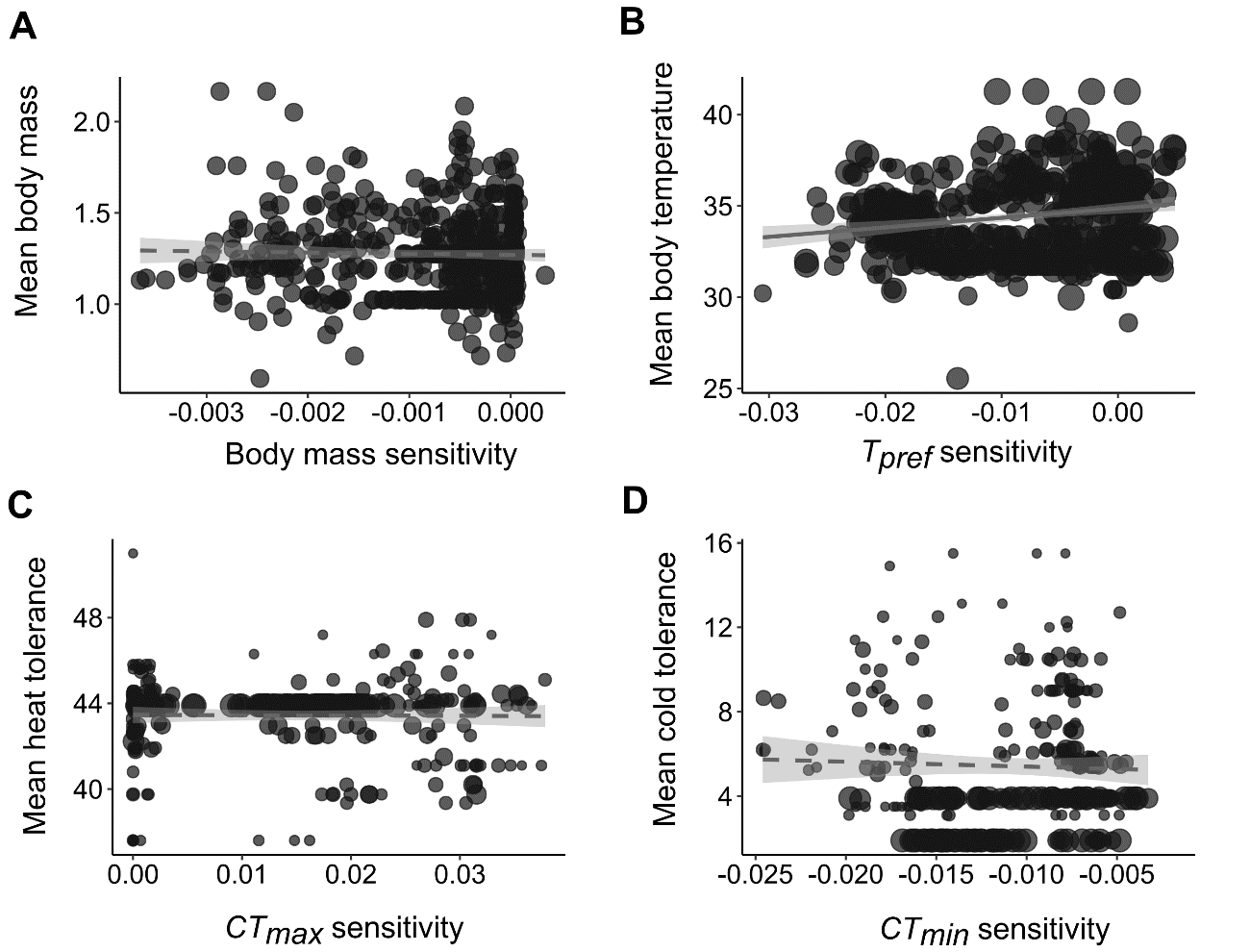
Fig S2. Mean assemblage body mass, preferred temperature, and critical thermal limits in relation to sensitivity estimated at the assemblage’s location. Dashed lines denote nonsignificant relationships. Each grey circle represents mean trait value across species coexisting in one cell, and the circle size is proportional to the percentage of species with known trait value data at each cell.
4. Assemblage-level analyses using phylogenetically imputed trait values
Estimated assemblage variances are especially sensitive to sample size, i.e., number of species coexisting in the grid cell. To test the extent to which missing species’ trait data affected the observed patterns, we performed additional analyses using phylogenetic imputation to estimate the relationship between trait variances and sensitivity. Phylogenetic imputation uses the evolutionary covariance between species using the existing data, the phylogenetic relatedness among species, and an evolutionary model to infer the value of missing trait data (Johnson et al. 2020).
We used the R package “Rphylopars” (Goolsby et al. 2017) in R v4.1.2 to impute ancestral states and missing trait data via maximizing log-likelihood of the covariance patterns among traits (Goolsby et al. 2017). To improve the accuracy of covariance estimations, we used a larger database including both diurnal and nocturnal lizards (6662 species; Meiri 2018), with body mass data available for 6633 species (99.5%), field body temperature for 1057 species (16%), preferred temperature for 234 species (3.5%), heat tolerance for 238 species (3.5%), and cold tolerance for 170 species (2.6%). Hence, we inferred missing trait values for all traits except for body mass. We used the Ornstein–Uhlenbeck evolutionary model for the imputation based on its higher log-Likelihood (-7570.161) when compared with the Brownian Motion model (-7995.505).
The results using phylogenetically imputed trait values are qualitatively similar to those with observed trait data (Fig SX), with triangular relationships delineated by quantile regressions (tau = 0.9) for both field body temperature, preferred temperature, and cold tolerance, and a positive relationship between variance in heat tolerance and sensitivity (Tabel SX).
Table S3. Analyses relating sensitivity and assemblage-level variances using phylogenetically imputed data. Note that missing trait data were phylogenetically imputed for all traits except body mass.
 | Ordinary regression |  |  | Quantile regression (tau = 0.9)
 | Estimate ± SE | t | P | Estimate ± SE | t | P
Body mass | -157.07 ± 35.53 | -4.421 | <0.001 | -324.14 ± 50.53 | -6.42 | <0.001
Preferred temperature | -85.84 ± 33.35 | -2.57 | 0.01 | -410.88 ± 63.39 | -6.48 | <0.001
Field body temperature | -374.78 ± 67.00 | -5.59 | <0.001 | -972.43 ± 136.77 | -7.11 | <0.001
Critical thermal maximum | 16.99 ± 5.00 | 3.39 | <0.001 | 66.84 ± 25.48 | 2.62 | 0.01
Critical thermal minimum | -213.09 ± 32.98 | -6.46 | <0.001 | -403.34 ± 104.10 | -3.87 | <0.001

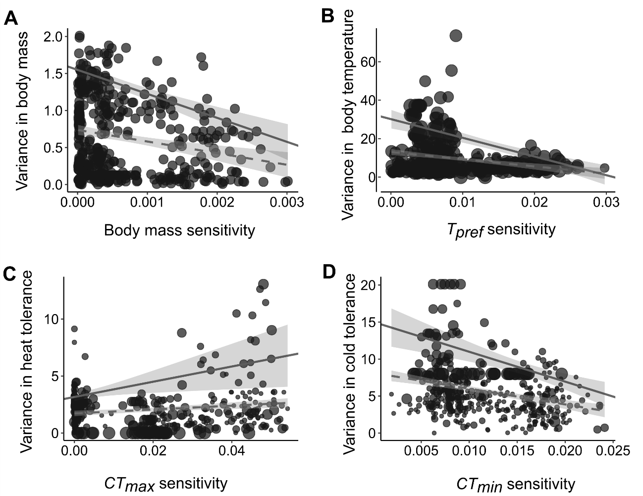
Fig S3. Variance in body mass, preferred temperature, and critical thermal limits of lizard assemblages estimated using phylogenetically imputed data. Dashed and solid lines represent, respectively, ordinary and quantile linear regressions (quantile 0.9). Each grey circle represents trait variance in one cell, and circle size is proportional to the percentage of species with known trait value data at each cell.

5. References in SI
Bakken, G. S., Santee, W. R., & Erskine, D. J. (1985). Operative and standard operative temperature: tools for thermal energetics studies. American Zoologist, 25(4), 933-943.
Barlett, P. N., & Gates, D. M. (1967). The energy budget of a lizard on a tree trunk. Ecology, 48(2), 315-322.
Clusella-Trullas, S., Terblanche, J. S., Blackburn, T. M., & Chown, S. L. (2008). Testing the thermal melanism hypothesis: a macrophysiological approach. Functional ecology, 232-238.
Fei, T., Skidmore, A. K., Venus, V., Wang, T., Schlerf, M., Toxopeus, B., ... & Liu, Y. (2012). A body temperature model for lizards as estimated from the thermal environment. Journal of Thermal Biology, 37(1), 56-64.
Goolsby, E. W., Bruggeman, J., & Ané, C. (2017). Rphylopars: fast multivariate phylogenetic comparative methods for missing data and within‐species variation. Methods in Ecology and Evolution, 8(1), 22-27.
Huey, R. B., & Pianka, E. R. (2018). Body temperature distributions of active diurnal lizards in three deserts: Skewed up or skewed down?. Functional Ecology, 32(2), 334-344.
Mitchell, J. W. (1976). Heat transfer from spheres and other animal forms. Biophysical Journal, 16(6), 561-569.
O’Connor, M. P. (1999). Physiological and ecological implications of a simple model of heating and cooling in reptiles. Journal of Thermal Biology, 24(2), 113-136.
Porter, W. P., & Gates, D. M. (1969). Thermodynamic equilibria of animals with environment. Ecological monographs, 39(3), 227-244.
Porter, W. P., Mitchell, J. W., Beckman, W. A., & DeWitt, C. B. (1973). Behavioral implications of mechanistic ecology. Oecologia, 13(1), 1-54.
Rozen‐Rechels, D., Rutschmann, A., Dupoué, A., Blaimont, P., Chauveau, V., Miles, D. B., ... & Le Galliard, J. F. (2021). Interaction of hydric and thermal conditions drive geographic variation in thermoregulation in a widespread lizard. Ecological monographs, 91(2), e01440.
Rubalcaba, J. G., Gouveia, S. F., & Olalla-Tárraga, M. A. (2019). Upscaling microclimatic conditions into body temperature distributions of ectotherms. The American Naturalist, 193(5), 677-687.
Stevenson, R. D. (1985). Body size and limits to the daily range of body temperature in terrestrial ectotherms. The American Naturalist, 125(1), 102-117.
Johnson, T. F., Isaac, N. J. B., Paviolo, A., & González-Suárez, M. (2020). Handling missing values in trait data. Global Ecology and Biogeography, 30(1), 51–62.

