Supplementary Figures
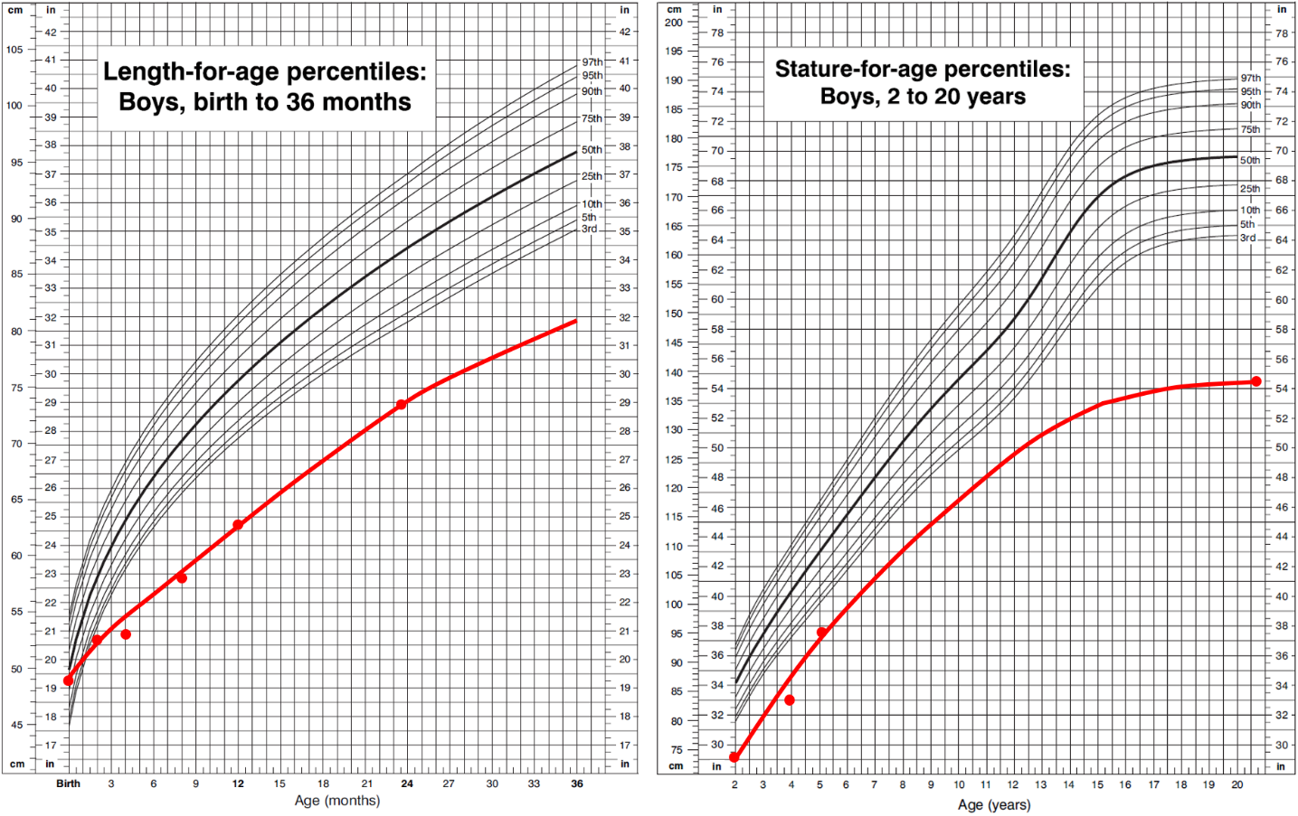 Supplementary Figure S1: Growth development of patient M2 from birth to the age of 20 years and 8 months. Growth between measured values has been estimated. Reference percentile curves were taken from the US Centers for Disease Control and Prevention reference growth charts.

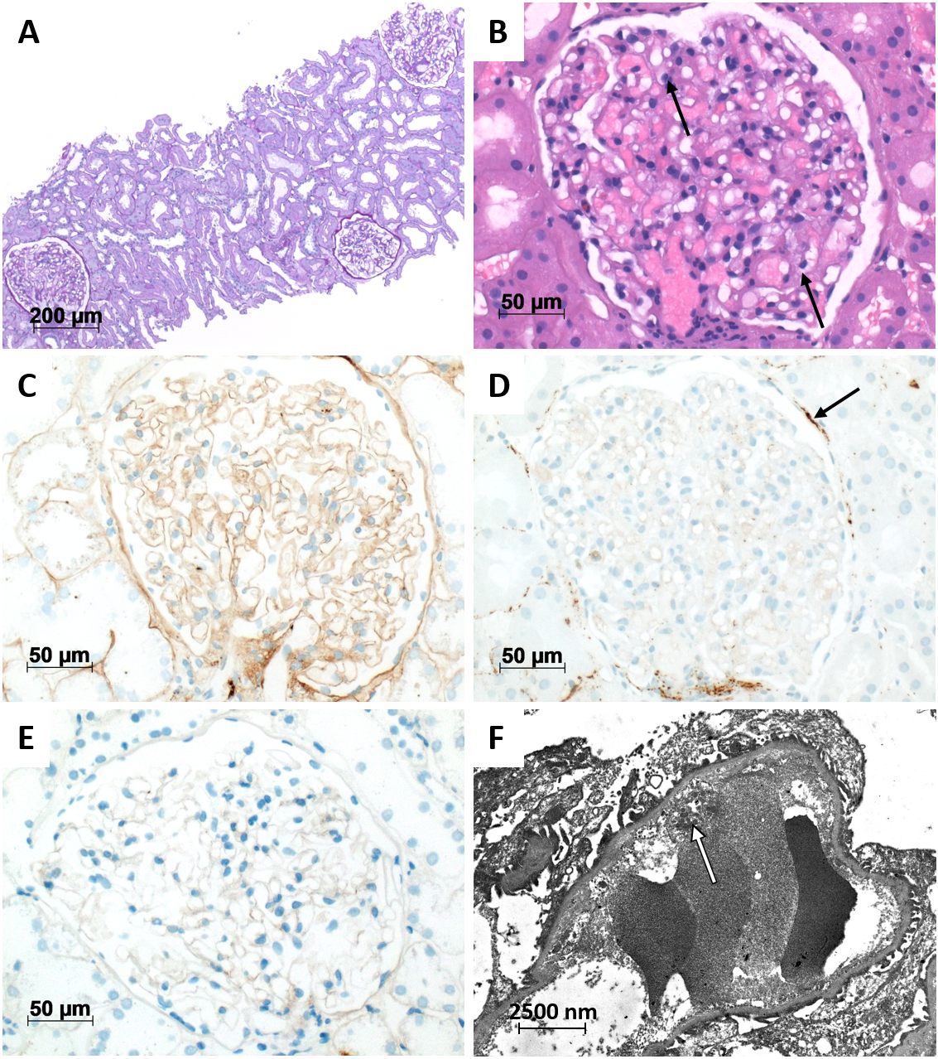
Supplementary Figure S2: Renal histology from patient M2 six months after clinical diagnosis of thrombotic microangiopathy and four months after discontinuation of Eculizumab treatment. A, Renal biopsy with unremarkable glomerular and tubulointerstitial compartment (PAS, 100x). B, At higher magnification, glomerulus with only mild signs of endothelial activation (arrows) with enlarged endothelial cell nuclei (H&E, 400x). C-E, Lack of glomerular deposits of C3c (C), C5b-9 (D) and IgA (E) with only traces of C5b-9 deposited at the Bowman´s capsule in the C5b-9 staining (arrow), all 400x original magnification. F, Electron microscopy showing only mild irregularities in small segments of the inner layer of the glomerular basement membrane and associated mild loss of fenestration of the endothelial cell (ultrathin section, 5000x).
Supplementary Results
Additional Case Details
Patient M1
This patient was born small for gestational age after 38 weeks of gestation (birth weight: 2390g (1st percentile (P1)); length 43cm (<P1); head circumference 33.5cm (P24)). The postpartum period was complicated by congenital pneumonia and persistent pulmonary hypertension necessitating high-frequency oscillatory ventilation with NO treatment, neonatal seizures and transient thrombocytopenia. Moreover, hypertrophic cardiomyopathy without signs of cardiac failure and disproportional stature with short limbs were diagnosed.
After birth, the boy showed severe thrombocytopenia which required platelet transfusions. Even thereafter platelet counts remained low, ranging between 100,000/µL and 200,000/µL (normal 200,000–400,000/µL). During his more frequent follow-ups in the last 2.5 years, the patient has shown chronic severe lymphopenia with leading T-lymphopenia. Repeated lymphocyte subtyping analyses showed 30-35% T lymphocytes (CD4⁺ 17-20%, CD8⁺ 10-12%), 42-45% B-lymphocytes and 19-21% NK cells. Additionally, the patient has chronic moderate to severe hypogammaglobulinemia (as low as 150mg/dL). He receives 500,000 units Penicillin V orally thrice daily.
Whereas hypertrophic cardiomyopathy disappeared spontaneously, the child developed mild aortic valve stenosis and insufficiency related to a dysplastic aortic valve, mild mitral valve stenosis and insufficiency related to a dysplastic mitral valve as well as progressive membraneous subaortic stenosis. The latter was resected at age 4 years but became progressive again later-on. There were no signs of cardiac failure.
Persistent and severe growth retardation could not be explained by endocrine abnormalities (IgF-1, IGFBP3 and thyroid hormone levels normal) and was treated with growth hormone therapy from the age of six years.
From early infancy, the boy showed severe psychomotor delay. At age 2 years his speech and motor capabilities were those of a one-year-old child. At the age of three years first steps were possible with the aid of a posterior walker. At the age of 5 years he started to walk without aid and was able to speak about 50 words. Despite normal social functioning, profound intellectual disability with an IQ value below 55 (SON-R 2-8) was found at the age of 6 years. Due to severe muscular hypotonia and moderate ataxia independent gait was only possible for short distances. A postnatal MRI was unremarkable.
During the neonatal period phenobarbital treatment had been initiated because of generalized seizures. At age 3 months, phenobarbital was switched to levetiracetam which, in turn, was replaced by carbamazepine 3 months later. Carbamazepine was continued until the age of 5 years despite the absence of epileptic seizures as hypersynchronic activity persisted on electroencephalographic recordings.
On examination, the patient showed shortening of extremities, clinodactyly of the fifth finger of both hands and mild syndactyly of the second and third toe with overlapping bended second and fourth toes. He had sparse bright and thin hair and eyebrows. Facial dysmorphisms included mild facial coarsening with a flattened nasal bridge and prominent nasal tip, and an open mouth with downturned corners, prominent lips and a tented upper lip.
At the age of five years the patient developed an atypical hemolytic uremic syndrome with mild complement hyperactivation and renal failure which necessitated peritoneal dialysis. Shigatoxin and pneumococci were excluded, ADAMTS13 activity was normal. Kidney function normalized after initiation of biweekly Eculizumab therapy which, in turn, was switched to four-weekly Ravulizumab infusions after one year.
Patient M2
At birth in the 41st gestational week, the patient’s weight was 2700g (P2), length 49cm (P15) and head circumference 34cm (P22).
At the age of 5 months, the patient was readmitted to the hospital with beginning central pneumonia and bilateral putrid Haemophilus influenzae conjunctivitis. During the acute infection, severe neutropenia (360/µL) developed. Throughout childhood, the patient was repeatedly hospitalized with pneumonia, middle ear infections and gastrointestinal infections, although the frequency and severity of these infections decreased in adolescence. During these hospitalizations until the age of 6 years, moderate to severe thrombocytopenia and mild anemia were repeatedly diagnosed. Further follow-up laboratory parameters starting from the age of 16 years until now show chronic mild thrombocytopenia (100,000-150,000/µL.
Patient M2 shows disproportionate short stature (138cm at 20 years, 8 months), with length and head circumference crossing the third percentile within the first months of life. Arms and legs are short (arm span 128cm, arm span to height ratio 0.93).
The patient started walking at 13 months, but speech developmental delay soon became apparent. He spoke his first words at 23 months. The ET 6-6 developmental test¹ at the age of 3 years and 7 months showed a delayed global development with test scores on average 2.6 standard deviations below the age-adjusted norm. The patient had a single febrile seizure when he was 3 years old. Early learning support started at age 1 year and 11 months. The patient currently works in a manual job.
Patient F1
Patient F1 is the mother of patients M1 and M2. She is 39 years old, has short stature (150cm, P1) and went to a school for children with learning disabilities.
Two other sons were born to a third father. One died two days after birth in the 30th gestational week due to multiorgan failure of unknown cause. The other is clinically unaffected and in foster care.
Patient F2
Patient F2 is the mother of patient F1, i.e. the maternal grandmother of patients M1 and M2. She is 58 years old, has low-normal stature (157cm, P9) and went to a school for children with learning disabilities. Her facial features are similar to those of patient F1. We found slight thrombocytopenia (144,000/µL), but otherwise normal blood results including differential blood counts.
Supplementary References
1. Macha T, Petermann F. The ET 6–6. A method for developmental assessment for German-speaking countries. Zeitschrift Für Psychologie / Journal of Psychology 216, 154-160 (2008).

