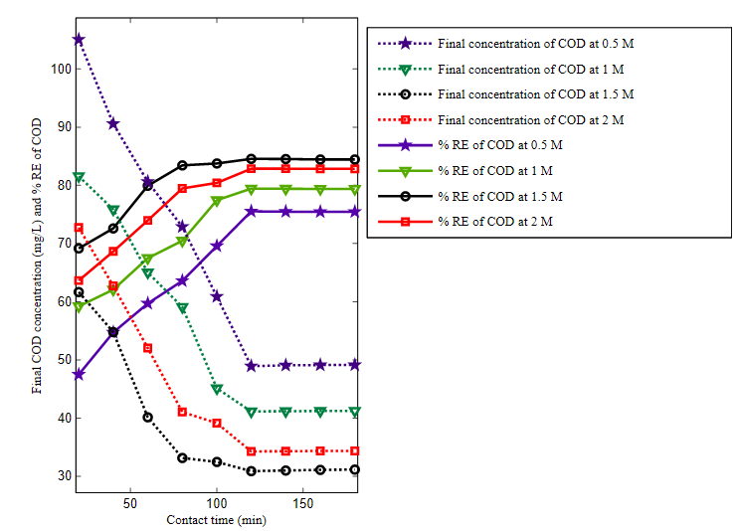
Fig. S1. Effect of CZnO coating dosage and contact time on %RE of COD (at pH 2 and initial COD concentration of 200 mg/L)
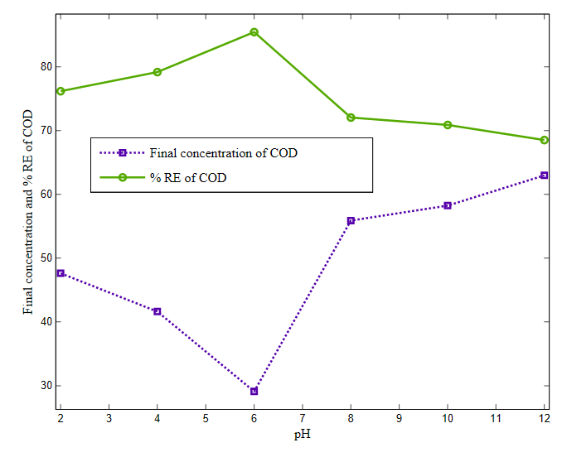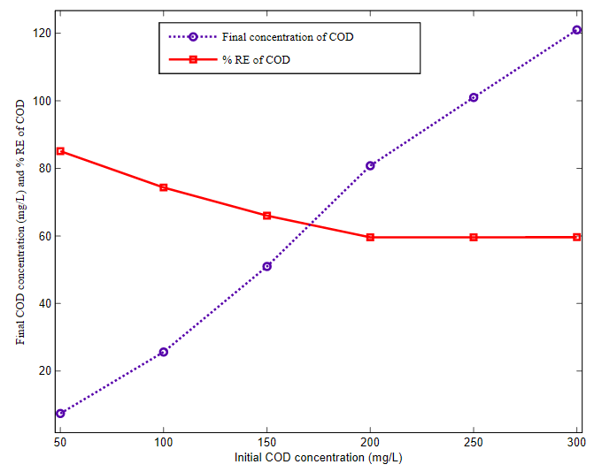
Fig. S2. Effect of pH on %RE of COD (at 1.5 M CZnO coating dosage, 120 min contact time and initial COD concentration of 200 mg/L)

Fig. S3. Effect of initial COD concentration on %RE of COD (at 1.5 M CZnO coating dosage, 120 min contact time and pH 2)

Table S1. Effect of CZnO nanoadsorbent coating dosage and contact time on %RE of BOD (at pH 7 and initial BOD concentration of 100 mg/L)
Contact time (min) | Coating dosage of CZnO (M)
Contact time (min) | 0.5 | 1 | 1.5 | 2
20 | 40.14±0.30  (59.86) | 54.22±0.40  (45.78) | 60.14±0.45  (39.86) | 57.53±0.43  (42.47)
40 | 48.46±0.36  (51.54) | 63.95±0.48  (36.05) | 75.46±0.56  (24.54) | 71.92±0.54  (28.08)
60 | 55.94±0.42  (44.06) | 70.39±0.53  (29.61) | 83.94±0.63  (16.06) | 78.29±0.59  (21.71)
80 | 61.54±0.46  (38.46) | 75.30±0.56  (24.70) | 91.54±0.69  (8.46) | 85.51±0.64  (14.49)
100 | 69.24±0.52  (30.76) | 82.15±0.62  (17.85) | 93.24±0.70  (6.76) | 88.26±0.66  (11.74)
120 | 75.22±0.56  (24.78) | 85.83±0.64  (14.17) | 95.22±0.71  (4.78) | 88.26±0.98  (11.74)
140 | 75.22±0.32  (24.78) | 85.83±0.64  (14.17) | 95.22±0.78  (4.78) | 88.26±0.22  (11.74)
160 | 75.22±0.28  (24.78) | 85.83±0.64  (14.17) | 95.22±0.18  (4.78) | 88.26±0.16  (11.74)
180 | 75.22±0.21  (24.78) | 85.83±0.64  (14.17) | 95.22±0.36  (4.78) | 88.26±0.61  (11.74)
 | CD @ (1%) | SE(d)± | SE(m)± | p-value
Contact time (A) | 0.48 | 0.24 | 0.17 | 0.001 (s)
Coating dosage (B) | 0.32 | 0.16 | 0.11
Interaction (A×B) | 0.97 | 0.48 | 0.34

Parenthesis value shows final concentration of BOD (mg/L)

Table S2. Effect of pH on %RE of BOD (at CZnO nanoadsorbent coating dosage of 1.5 M, contact time of 120 min and initial BOD concentration of 100 mg/L)
pH | % RE of BOD
2 | 57.24±0.26 (42.97)
4 | 60.03±0.25 (39.76)
6 | 90.03±0.39 (9.97)
8 | 89.18±0.38 (10.82)
10 | 87.21±0.38 (12.79)
12 | 84.27±0.36 (15.73)
CD @ 1(%) | 1.07
SE(m)± | 0.34
SE(d)± | 0.48
CV (%) | 0.76

Parenthesis value shows final concentration of BOD (mg/L)

Table S3. Effect of initial BOD concentration on %RE of BOD (at CZnO nanoadsorbent coating dosage of 1.5 M, contact time of 120 min and pH 6)

Initial concentration (mg/L) | % RE of BOD
50 | 94.44± 0.41 (2.78)
100 | 94.39±0.41 (5.61)
150 | 85.36±0.37 (21.95)
200 | 76.19±0.33 (47.61)
250 | 64.97±0.28 (87.56)
300 | 64.89±0.28 (105.33)
CD @ 1(%) | 1.09
SE(m)± | 0.35
SE(d) ± | 0.49
CV (%) | 0.76

Parenthesis value shows final concentration of BOD (mg/L)

