Supplementary materials for

Immobilization of cold-adapted lipase with rational design on hydrid nanoflowers for low temperature sugar esters synthesis
Yue Zhang^{1*}, Jiahui Chen¹, Zhaoxia Jin¹, Fang Yu¹, Yongming Bao²*

1School of Biological Engineering, Dalian Polytechnic University, Dalian, 116034, China.
2 School of Bioengineering, Dalian University of Technology, Dalian 116024, China.

*Corresponding author.
E-mail addresses: zhangyue124@126.com (Y. Zhang), biosci@dlut.edu.cn (Y. Bao).

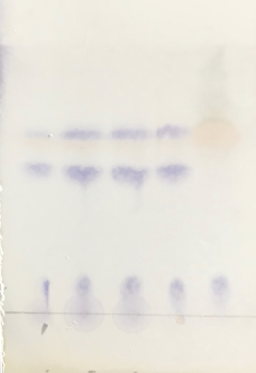
1 2 3 4 5
Fig.S1 TLC spectra of fructose laurate catalyzed by recombinant lipases
1. Control; 2. LHNs (Ca); 3. LHNs (Ca)-lip-∆lid; 4. LHNs (Ca)-lip-F144A; 5. LHNs (Ca)-lip-F144V

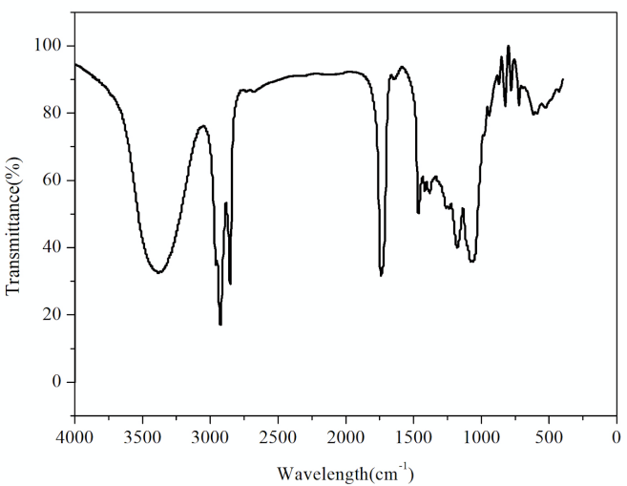
1078.1

1739.5

2850.3

2920.7

3380.8

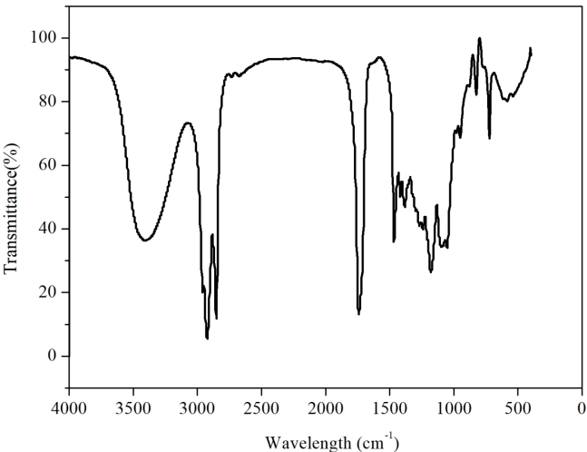
2921.7

3413.4

1097.3

1739.5

2852.2

Fig. S2 FTIR of fructose lauric acid monoester.
fructose lauric acid diester.

