Supplemental Figure 1

40-year-old man: 3rd degree burn on heel (full skin loss) Burned by hot frying pan during loss of consciousness

On August, 2021, while cooking, he suffered cerebral venous thrombosis, lost consciousness, and apparently got burned on his left heel by a hot frying pan. He was transferred to a hospital and admitted to the neurosurgery department. The heel burn was treated by a Wound Ostomy Continece (WOC) nurse with povidone iodine sugar gel, followed by silver sulfadiazine cream. He was told that the burn was a deep burn that would not heal without surgery.

On the first visit (21 days post injury) the left heel was in a state of full-layer defect and necrosis with a diameter of 5 cm. He was treated with composite absorbent pads. Walking was not restricted and heel loading was allowed. After epithelialization was completed, he continued to use only petroleum jelly and composite absorbent pads for protection.

(A) at the first visit, (B) 35days after the first visit, (C) 70 days after the first visit, and (D) 217 days after the first visit. The regenerated heel showed no hypertrophic scars. These figures were acquired from http://www.wound-treatment.jp/next/case/tokyo/case/3916/index.htm and are used with permission.

A B
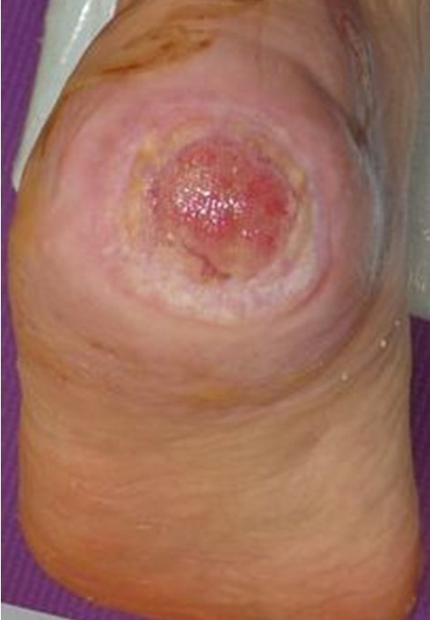
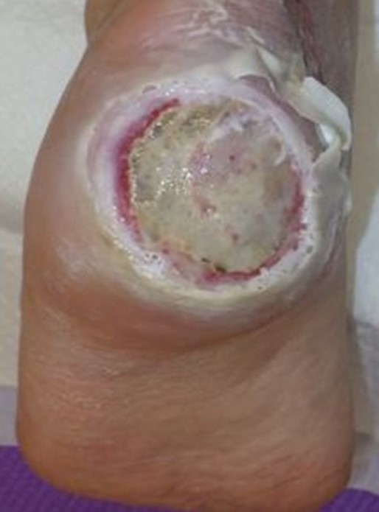

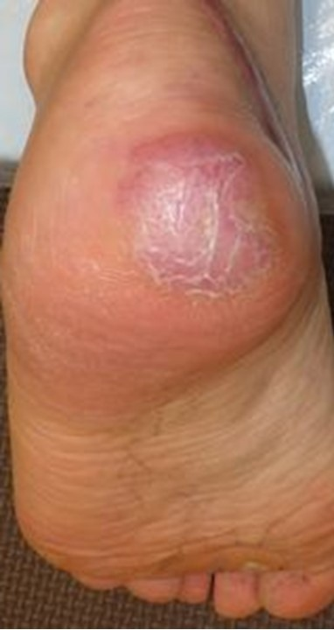
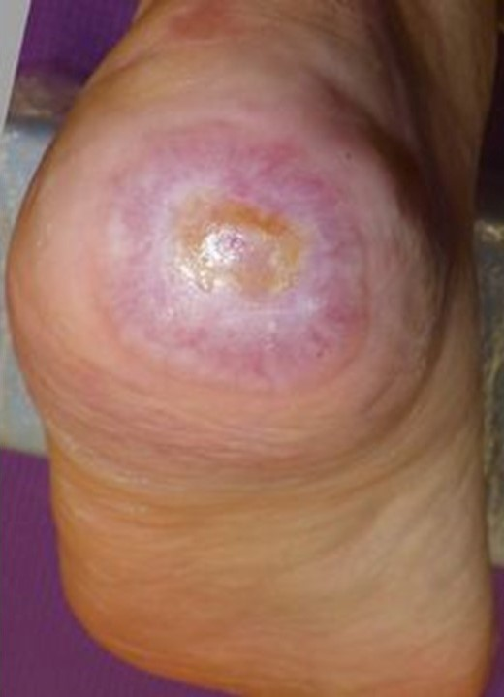
C D

