Supplemental Figure 2 A venous ulcer that healed in 1 year in an 80-year-old female.
Appearance (A) preoperatively, (B) 7 months postoperatively, and (C) 1 year postoperatively. Toward the end of the treatment, the erosion had healed after 1 week of topical steroid ointment application.
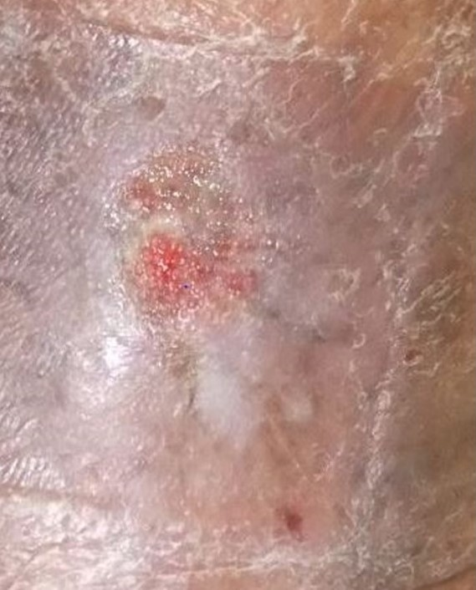
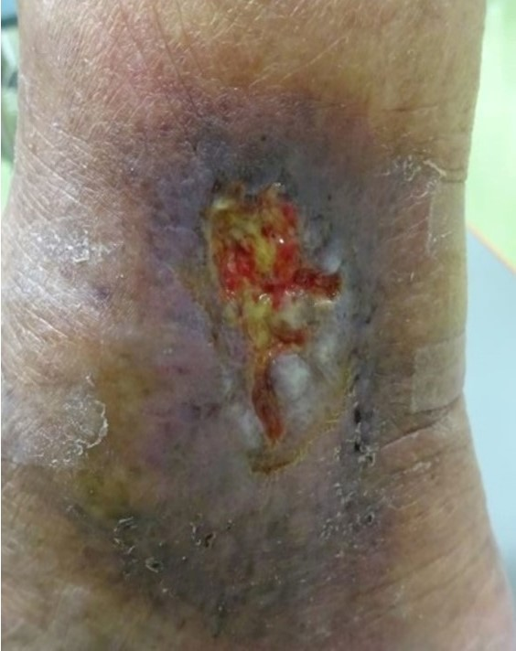
A B

C
