Supplementary Material

Supplementary Data

Correlation between initial RNA concentrations and the raw number of sequenced reads
A strong correlation was observed between the RNA concentration levels and the number of sequenced fragments in the samples, reaching $r\sim 0.81$ (Figure S5). The correlation decreases to ~59% if the outlier individual (CL_y3, with 67 ng/ul RNA concentration and ~106 million fragments sequenced) is removed.
This correlation further decreased slightly after raw data quality control and alignment to the reference genome ($r\sim 0.72$), but decreased greatly and turned from a positive to a negative correlation when the hemoglobin reads were removed from the analysis, after alignment ($r\sim -0.51$). This latter value was much more similar to the same correlation we observed when we analyzed brain samples in a different study ($r\sim -0.29$; data not shown) and we conclude that the presence of the hemoglobin reads in the data also affects the correlation between observed RNA concentration values and the sequencing depth.

Supplementary data 2: classification of the statistically significant differentially expressed genes into false and true positives. Note that this differentiation was made solely based on IGV images and no laboratory experiments were implemented.

Supplementary Tables

Table S1 Sequencing and alignment statistics of the 5 samples published by Yang et al. (2018) [12].
Sample ID | Number of sequenced reads | Number of reads after adapter trimming | Number of aligned reads |  | Number and proportion of hemoglobin reads |  | Secondary alignments with hemoglobin genes |  | Secondary alignments without hemoglobin genes
Sample ID | Number of sequenced reads | Number of reads after adapter trimming | N | % | N | % | N | % | N | %
CL_y1 | 42671378 | 42671378 | 39524617 | 92.63 | 7994228 | 20.23 | 22241554 | 52.12 | 1838873 | 4.31
CL_y2 | 49896210 | 49896210 | 46412277 | 93.02 | 3319432 | 7.15 | 12558839 | 25.17 | 2716801 | 5.44
CL_y3 | 50597914 | 50597914 | 47349445 | 93.58 | 30856658 | 65.17 | 89235386 | 176.36 | 1167602 | 2.31
CL_y4 | 50190664 | 50190664 | 47370709 | 94.38 | 35600080 | 75.15 | 103766041 | 206.74 | 694183 | 1.38
CL_y5 | 47960542 | 47960542 | 45713300 | 95.31 | 36739037 | 80.37 | 136808450 | 285.25 | 967553 | 2.02
dog average | 142447851 | 106061603 | 92099885 | 86.74 | 47171894 | 50.16 | 17400197 | 38.65 | 2277837 | 4.88
wolf average | 128189300 | 98386494 | 84957950 | 86.35 | 38825969 | 45.48 | 109936626 | 222.79 | 943113 | 1.90

Supplementary Figures
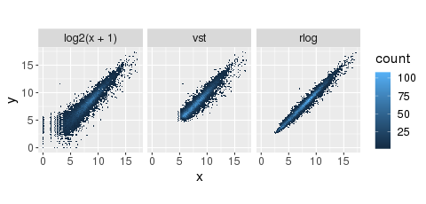
Figure S1: Raw read count transformations with three transformation methods: 1) the logarithm (base: 2) transformation; 2) the variance stabilizing transformation (vst) and 3) the regularized logarithm transformation. Read counts are shown for the first 2 individuals of our dataset.

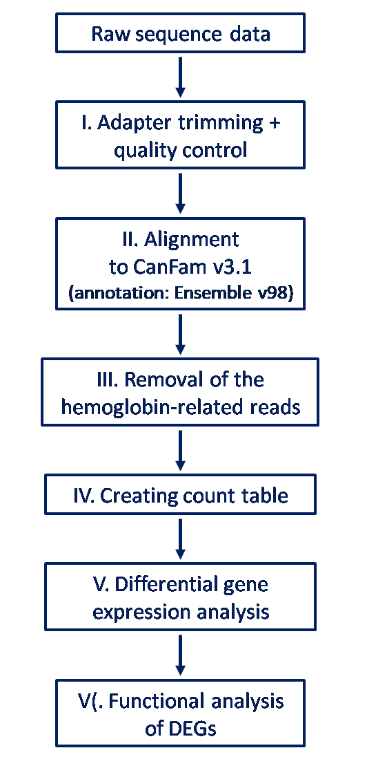
Figure S2: Schematic presentation of the applied analysis pipeline.

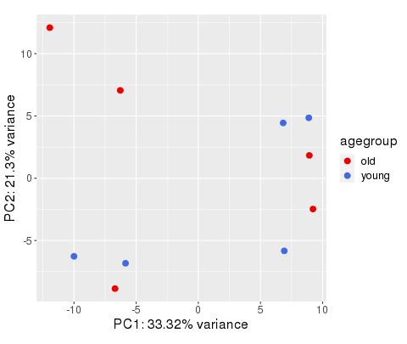
Figure S3: Results of a standard principal component analysis of the read counts of the 10 samples. The raw read counts were regularized-logarithm transformed.

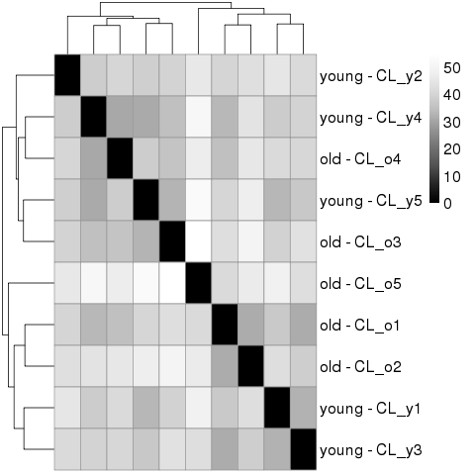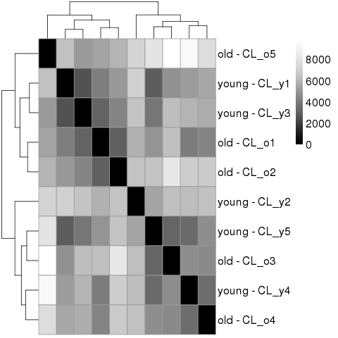
Figure S4: Sample distances calculated from the rlog-transformed raw read counts of all expressed genes. Left: Euclidean distances; right: Poisson distances.

Figure S5: Correlation between the RNA concentration levels and the sequencing depth.

