Supporting Information
Fabrication of a 3D supramolecular Cd(II)-coordination polymer as a luminescent sensor for detection of sulfamethazine
Scheme S1 view of the structural skeleton of SMZ.
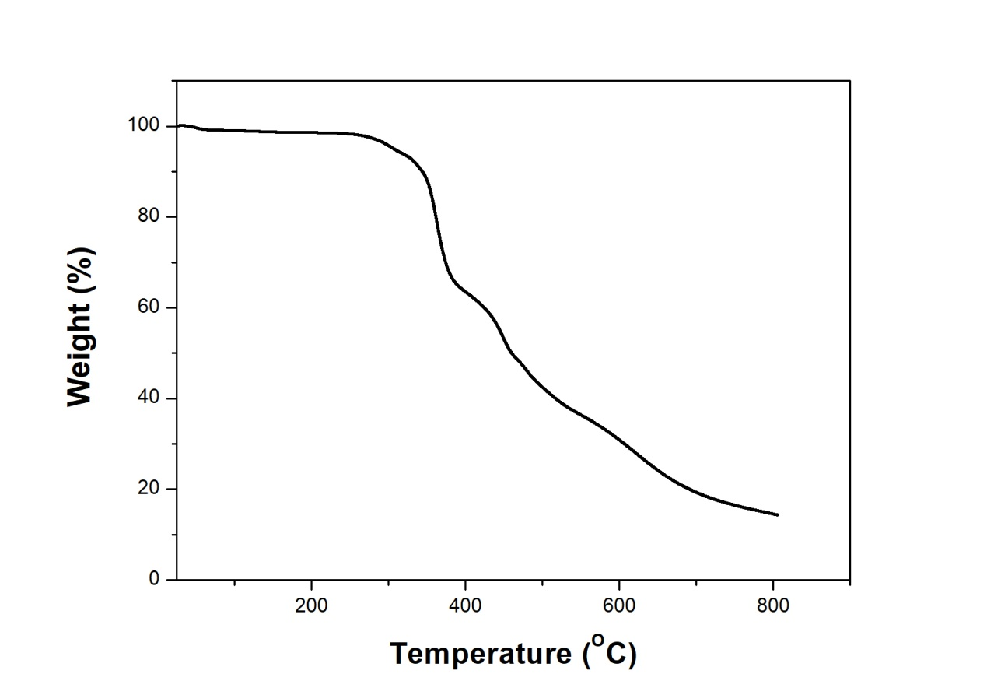
Fig. S1 view of the TGA in 1.
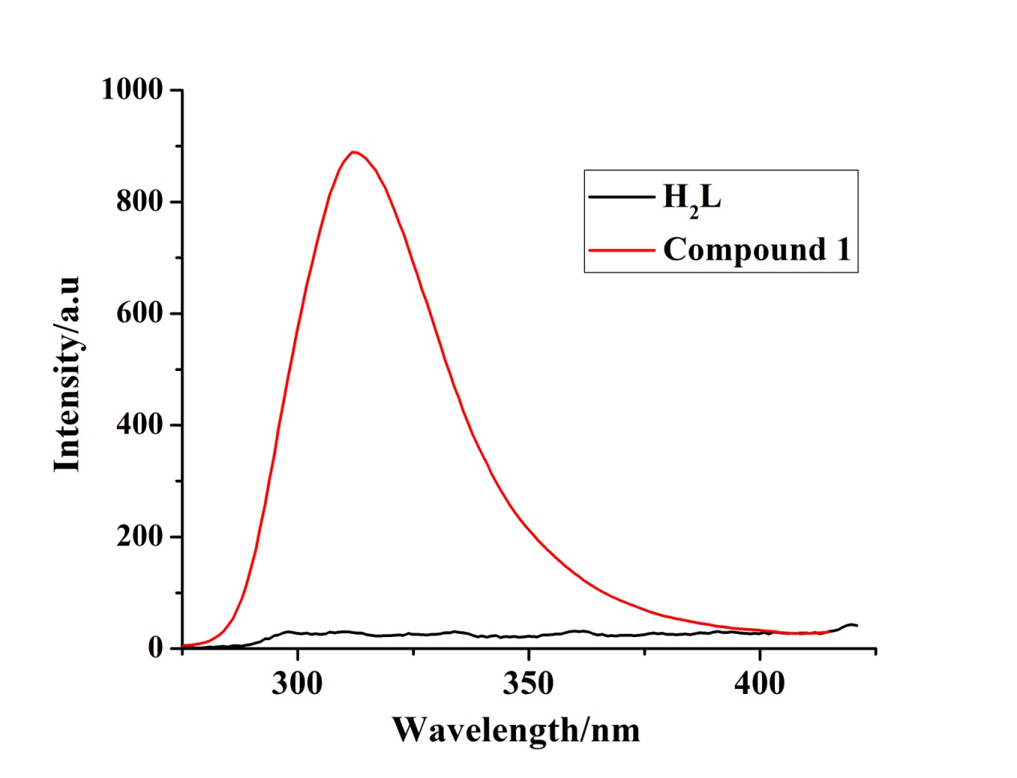
Fig. S2 The photoluminescence (PL) spectra of 1 and H₂L ligand.
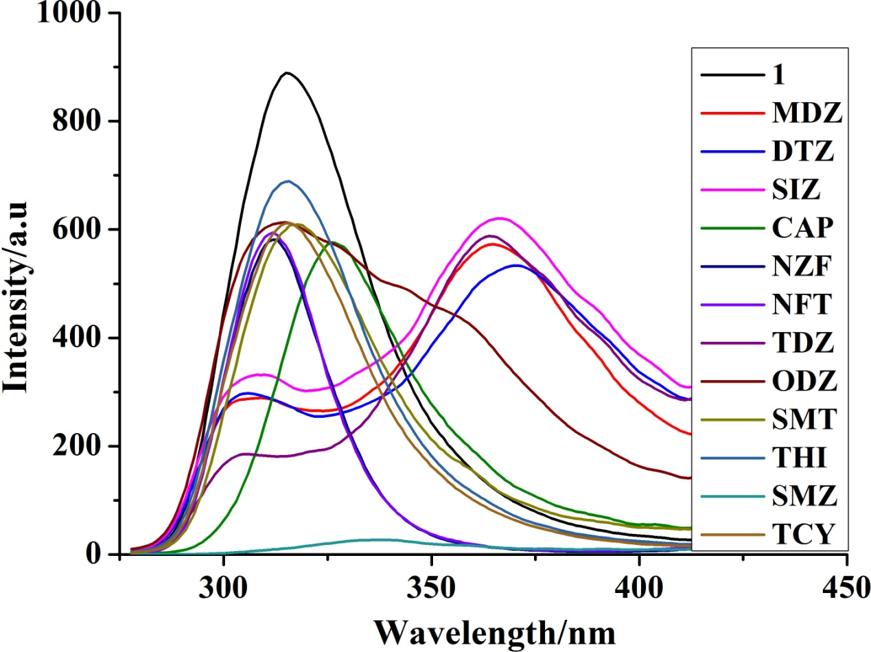
Fig. S3 view of the selective probing abilities of 12 types of antibiotics.

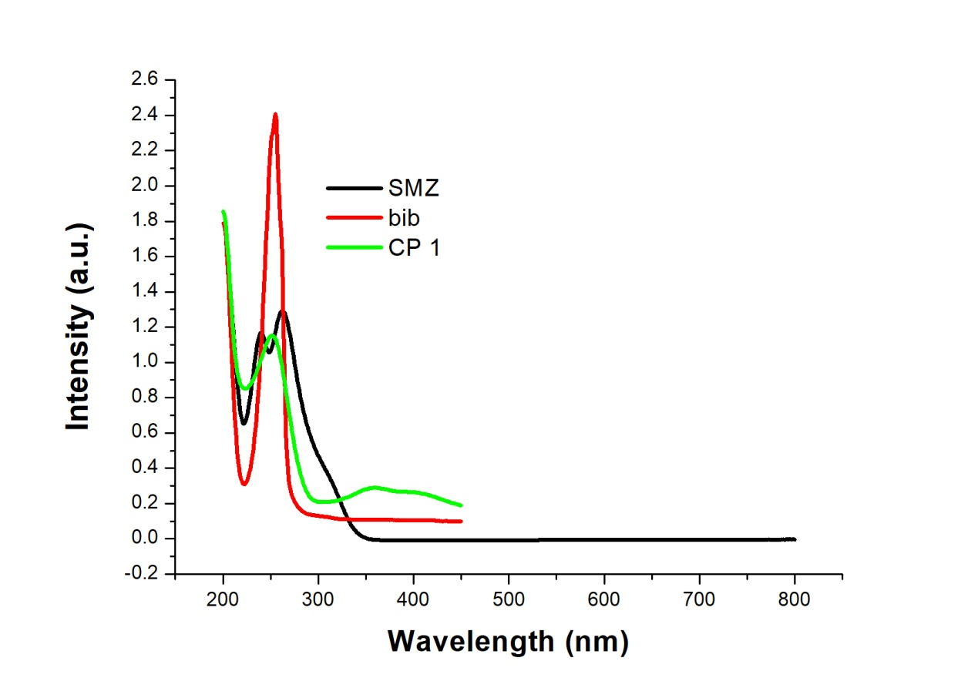
Fig. S4 the absorption band of SMZ exhibited maximum overlap with the emission spectrum of 1 and linker bib.

