Supplementary material
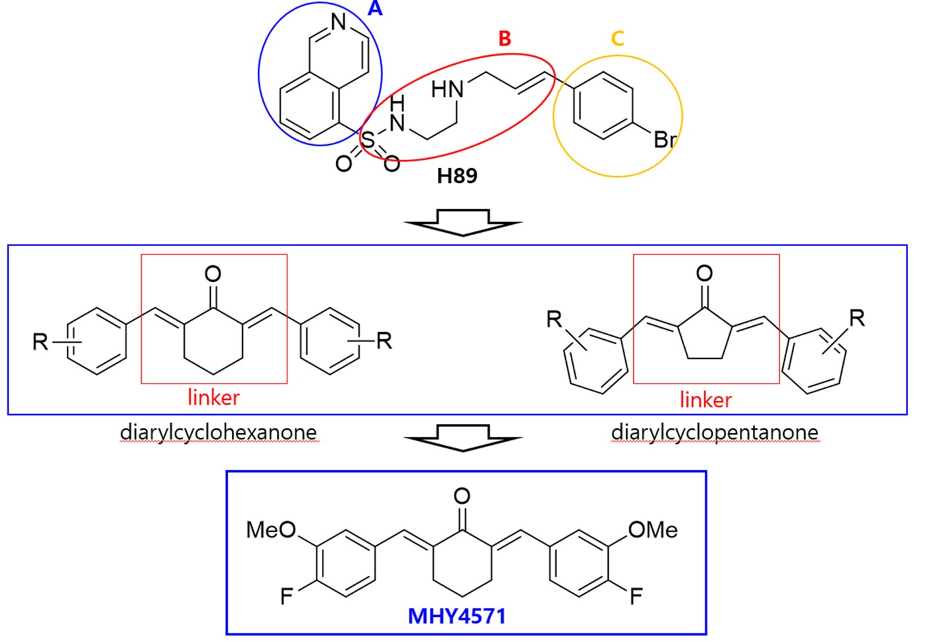
Supplementary Fig. 1. Design of a novel PKA inhibitor, MHY4571, from the structure of the well-known PKA inhibitor H89. In compound H89, the A and C moieties represent the aryl moiety, and the B moiety represents the linker.

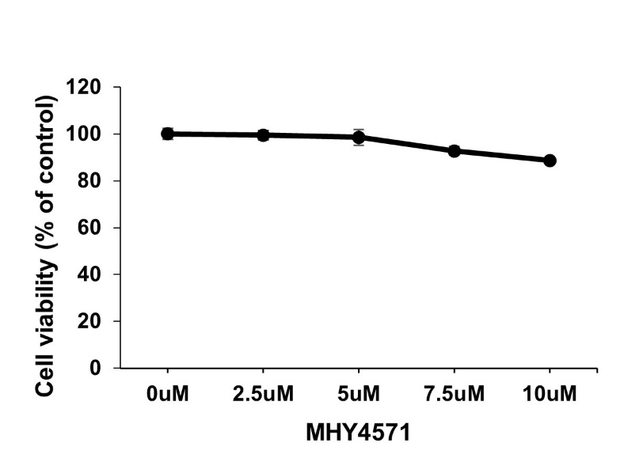
Supplementary Fig. 2. Effect of MHY4571 on cell viability of LC-2/ad cells. Graph showing the viability of cells treated for 24 hours with increasing concentrations of MHY4571. Results are mean ± SD, n=3, expressed as a percentage of vehicle-treated control.

Supplementary Table S1. Key resources table
Resources or Reagent | Sources | Identifier
Antibodies
P-PKACα (Thr197) | Cell signaling | 4781
PKACα | Cell signaling | 4782
PARP | Cell signaling | 9542
Procaspase-3 | Cell signaling | 9662
P-AKT (Ser473) | Cell signaling | 9275
AKT | Cell signaling | 9272
p-p44/42 MAPK (Erk1/2) | Cell signaling | 9101
p44/22 MAPK (Erk1/2) | Cell signaling | 9102
P-CREB (Ser133) | Abcam | ab32096
CREB | Abcam | ab32515
E2F1 | Santa cruz | sc-251
E2F2 | Abcam | ab138515
E2F8 | Genetex | GTX55599
β-actin | Bethyl | A300-491A
(HRP)-conjugated secondary antibodies | Enzo Life Sciences | ADI-SAB-300/ADI-SAB-100
siRNA
PKA siRNA | Bioneer
CREB siRNA | IDT&Mbiotech
Chemicals, Peptides, and Recombinant Proteins
Cisplatin | Selleckchem | S1166
Crystal violet | Sigma-Aldrich | V5265
Bronchial Epithelial Cell Growth Medium Bullet Kit | Lonza | CC-3170
RPMI 1640 | Welgene | LM 011-01
HAMS F12 | Welgene | LM 010-02
FBS | Welgene | S001-01
Opti-MEM | Gibco | 31585-070
Lipofectamine RNAiMAX | Invitrogen | 13778-075
TRIzol | Sigma-Aldrich | T9424
DAB staining | Dako | K5007
Critical Commercial Assays
FITC Annexin V Apoptosis Detection kit | BD Biosciences | 556547
cDNA synthesis platinum master mix | GenDEPOT | R5600
2X Real-Time PCR Smart mix | SolGent | SRH71-M40h
PKA Kinase Activity Assay | Enzo Life Sciences | ADI-EKS-390A

Supplementary Table S2. Primer sequence
Primer ID | Sequences
PRKACA_F | ATAAATACCTCGGCTGGCGT
PRKACA_R | TTCCCGGTCTCCTTGTGTTT
CREB_F | GACCACTGATGGACAGCAGATC
CREB_R | CAGGATGCCATAACAACTCCAGG
E2F1_F | CCATCAGTACCTGGCCGAGAGC
E2F1_R | CGCTTCTGCACCTTCAGCACCT
E2F2_F | GGCCAAGAACAACATCCAGT
E2F2_R | TGTCCTCAGTCAGGTGCTTG
E2F8_F | CCACCACAGCAAATATCGTG
E2F8_R | CTTTGGCCTCAGGTAATCCA

Supplementary Table S3. In silico ADME for MHY4571. PreADMET (ver2.0; https://preadmet.webservice.bmdrc.org/) was used to determine ADME prediction for MHY4571.
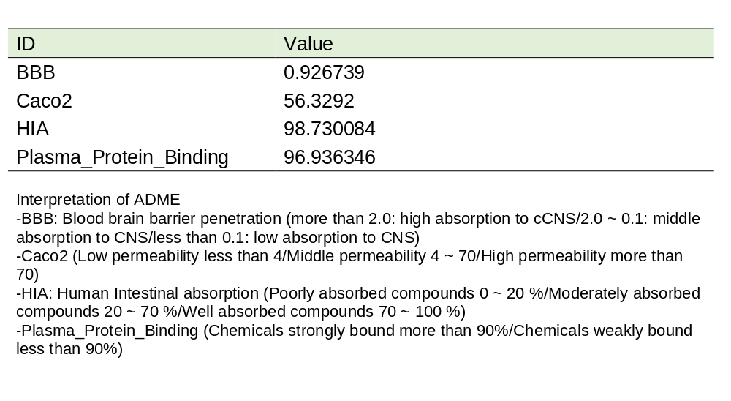

Supplementary Table S4. The kinase inhibition profile of MHY4571. The Selectivity was determined by measuring residual activity values at one concentration in duplicate (see in 410 kinase assays (397 protein kinase assays and 13 lipid kinase assays). (ref. Excel file)

