Table 2. Product images and cute utility values
Product number | 1 | 2 | 3 | 4 | 5 | 6 | 7 | 8 | 9 | 10 | 11
Product Image | 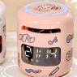 | 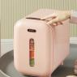 | 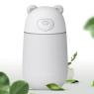 | 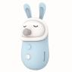 | 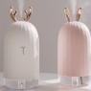 | 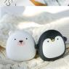 | 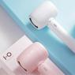 | 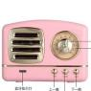 |  | 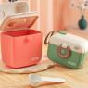 | 
Utility Mean | 1.95 | 1.43 | 1.69 | 1.04 | 1.86 | 1.78 | 1.69 | 1.60 | 1.30 | 1.43 | 1.39

Product number | 12 | 13 | 14 | 15 | 16 | 17 | 18 | 19 | 20 | 21 | 22
Product Image |  |  |  | 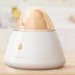 |  | 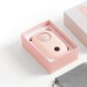 |  | 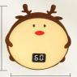 |  |  | 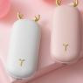
Utility Mean | 1.95 | 1.43 | 1.69 | 1.04 | 1.86 | 1.78 | 1.69 | 1.60 | 1.30 | 1.43 | 1.39

Product number | 23 | 24 | 25 | 26 | 27 | 28 | 29 | 30 | 31 | 32 | 33
Product Image | 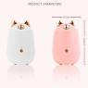 |  |  |  | 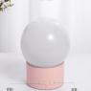 |  |  | 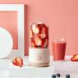 | 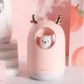 | 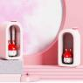 | 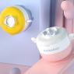
Utility Mean | 1.43 | 0.82 | 1.34 | 1.26 | 0.95 | 1.86 | 1.73 | 1.13 | 1.91 | 1.95 | 1.78

Product number | 34 | 35 | 36 | 37 | 38 | 39 | 40 | 41 | 42 | 43 | 44
Product Image |  |  | 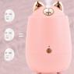 | 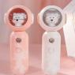 |  | 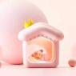 |  | 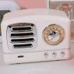 |  | 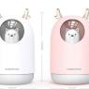 | 
Utility Mean | 1.34 | 1.78 | 1.52 | 2.17 | 2 | 2.21 | 0.73 | 0.91 | 0.91 | 1.69 | 1.78

Product number | 45 | 46 | 47 | 48 | 49 | 50 | 51 | 52 | 53
Product Image | 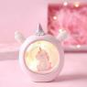 | 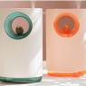 | 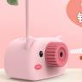 |  | 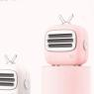 |  |  |  | 
Utility Mean | 2 | 1.56 | 1.56 | 1.95 | 1.04 | 1.47 | 1.30 | 1.86 | 1.04

