Table 6. Product serial number and product outline stroke
serial number | 2 | 3 | 4 | 6 | 7 | 8 | 9 | 10 | 11 | 14
contour map | 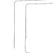 | 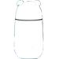 | 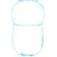 | 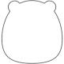 | 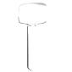 | 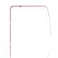 | 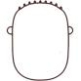 | 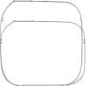 | 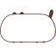 | 

serial number | 15 | 17 | 19 | 20 | 23 | 24 | 25 | 28 | 30 | 41
contour map | 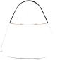 | 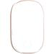 |  |  | 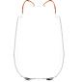 | 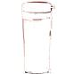 | 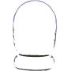 | 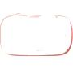 | 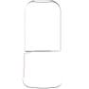 | 