Figure captions
Fig.S1 Effect of flocculation time on removal of As(Ⅲ) and As(Ⅴ) by Fe(VI) (a), The residual Fe in water samples at different pH (b). (Initial concentration of As(Ⅲ) and As(Ⅴ) 250 μg/L, As(V) removal at Fe(VI) dosage 6 mg/L and As(III) removal at Fe(VI) dosage 4 mg/L).
Fig. S2 The size distribution of flocs formed in Fe(VI) and hydrolytic ferric iron oxides for arsenic removal (ferrate resultant particles self-decomposition (Fe(VI)), ferrate oxidation with arsenic particles (in-situ), mixture of 30 min hydrolytic ferric iron oxides particles with arsenic (ex-situ)).
Fig. S3 Curve fitting the XPS spectrum of F2p in Fig. 5(b).

Table captions
Table S1 Characteristics of water samples for the designed experiments
Table S2 The EDS elements of the particles formed in Fe(VI) and hydrolytic ferric iron oxides for arsenic removal (ferrate oxidation with arsenic particles (in-situ), mixture of 30 min hydrolytic ferric iron oxides particles with arsenic (ex-situ))

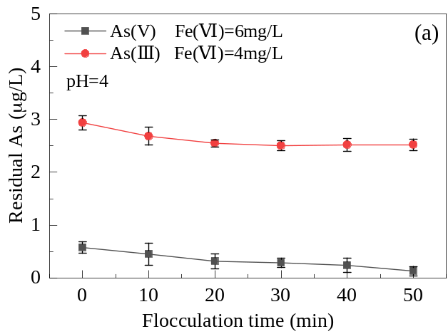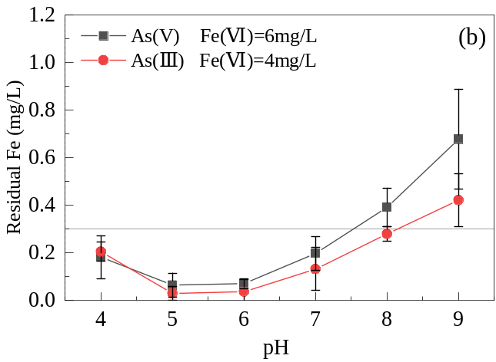
Fig.S1 Effect of flocculation time on removal of As(Ⅲ) and As(Ⅴ) by Fe(VI) (a), The residual Fe in water samples at different pH (b). (Initial concentration of As(Ⅲ) and As(Ⅴ) 250 μg/L, As(V) removal at Fe(VI) dosage 6 mg/L and As(III) removal at Fe(VI) dosage 4 mg/L).

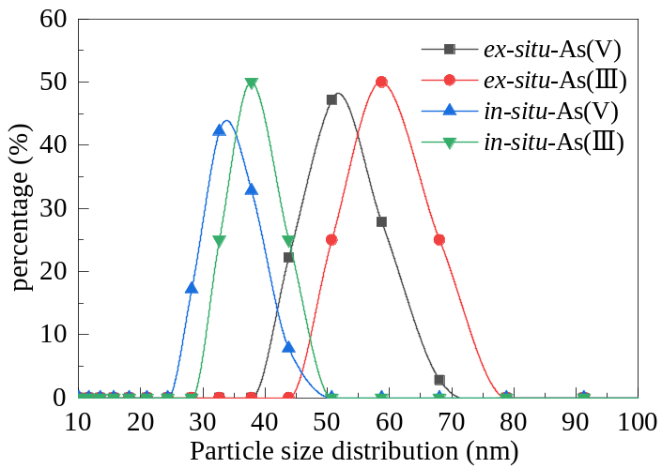
Figure S2. The size distribution of flocs formed in Fe(VI) and hydrolytic ferric iron oxides for arsenic removal (ferrate resultant particles self-decomposition (Fe(VI)), ferrate oxidation with arsenic particles (in-situ), mixture of 30 min hydrolytic ferric iron oxides particles with arsenic (ex-situ)).

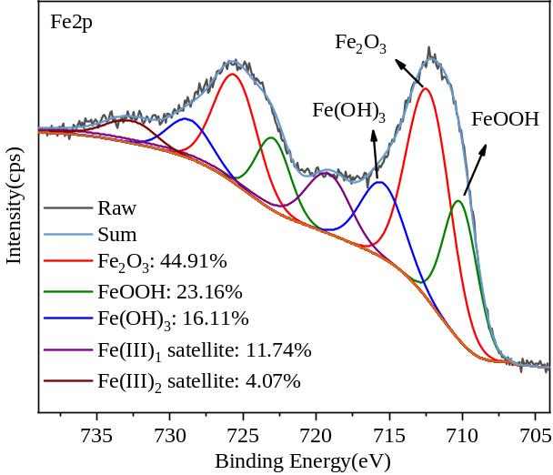
Figure S3. Curve fitting the XPS spectrum of F2p in Fig. 5(b).

Table S1 Characteristics of water samples for the designed experiments
Characteristics | Units of measurement | Numerical value
pH(25℃) | — | 7.70±0.05
Turbidity | NTU | 0.40±0.10
As(V)/As(Ⅲ) | μg/L | 250
DOC | mg/L | 3.194
Alkalinity | mg CaCO₃/L | 90
Hardness | mg CaCO₃/L | 157.5
P | mg/L | 0.012
Al | mg/L | 0.076
Fe | mg/L | 0.003
SO₄²⁻ | mg/L | 33.541
Cl⁻ | mg/L | 23.257

Table S2 The EDS elements of the particles formed in Fe(VI) and hydrolytic ferric iron oxides for arsenic removal (ferrate oxidation with arsenic particles (in-situ), mixture of 30 min hydrolytic ferric iron oxides particles with arsenic (ex-situ))
Elements(%) | in-situ-As(V) |  | in-situ-As(III) |  | ex-situ-As(V) |  | ex-situ-As(III)
Elements(%) | Weight | Atomic | Weight | Atomic | Weight | Atomic | Weight | Atomic
O | 93.76 | 98.15 | 96.42 | 98.99 | 90.69 | 97.21 | 93.21 | 97.95
K | 0.16 | 0.08 | 0.03 | 0.01 | 0.02 | 0.01 | 0.09 | 0.04
Fe | 5.52 | 1.65 | 2.91 | 0.86 | 8.42 | 2.58 | 6.59 | 1.98
As | 0.56 | 0.12 | 0.63 | 0.14 | 0.86 | 0.2 | 0.11 | 0.03

