Supplementary Materials

Experiments method and microstructures.
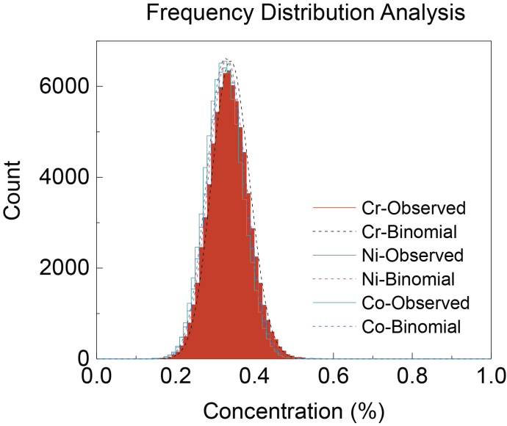
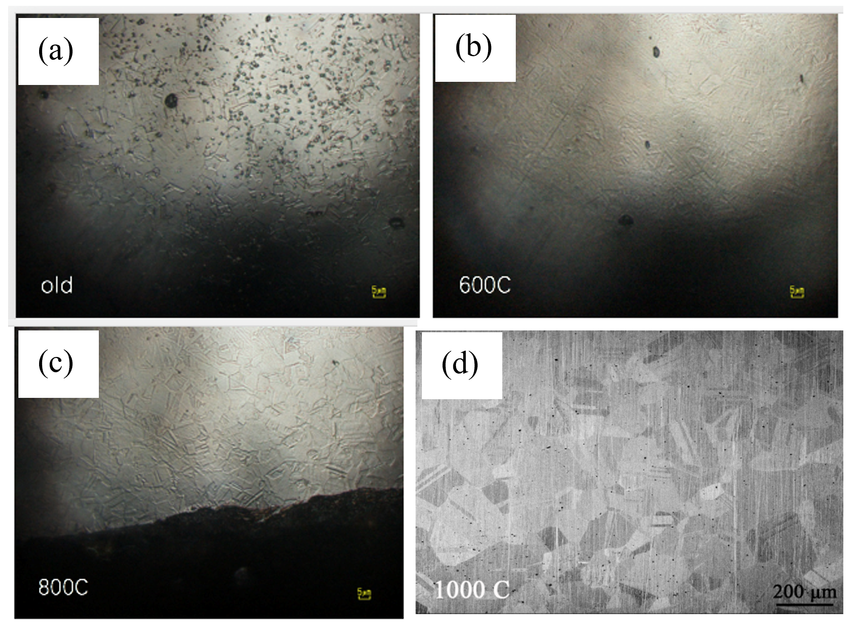
Figure S1. Grain sizes of the three samples. (a) as-received, (b) 600 ºC, and (c) 800 ºC illustrates the optical microscope (OM) observation of the etched samples under the same magnification. (d) is the SEM backscattered electron (BSE) image of 1100 ºC annealed state. The observation points out that the grain size (including annealing twin boundary) of the three samples were 4.28 μm (as-received), 4.55 μm (600 ºC), 4.66 μm (800 ºC), and ~182 μm 1100 ºC, respectively. The grain sizes of the as-received, 600 ºC, and 800 ºC samples are very close. Even though a larger grain size of ~182 μm is observed in 1100 ºC, considering the Hall-petch coefficient of CoCrNi (265 MPa·μm^{1/2}), the difference of strengthening contributed by grain boundary between 1100 ºC, and others is only about 105.3 MPa, which is much smaller than the yield strength difference (> 200 MPa). Thus, it seems that the influence of grain size on mechanical behavior may not be a major factor. Accordingly, the change of SRO should play more important role in affecting the mechanical properties.

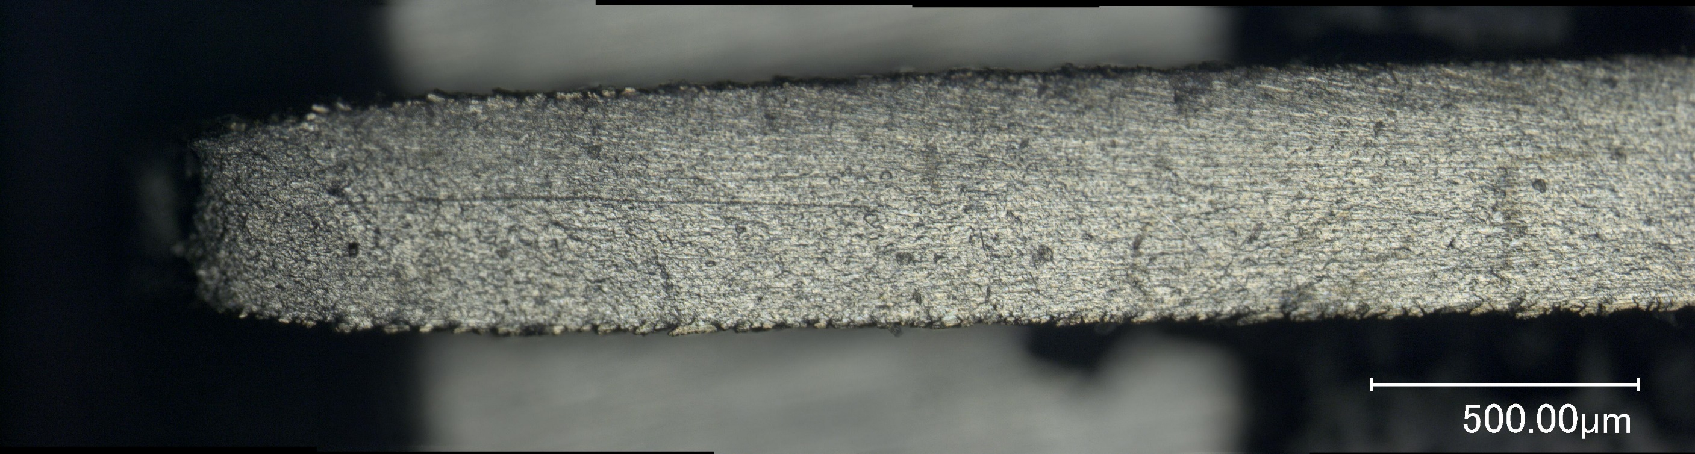

Figure S2. The illustration of the fractured sample. The explanation of the fracture shrinkage rate can be represented as below (the A1 and A2 are the area of the fracture and the uniform section, respectively):
(Ψ)=$\frac{A2-A1}{A2}$

* Percentage reduction of area:

The calculation result shows that the fracture shrinkage rates are 0.56, 0.59 and 0.51 for 600ºC, 800ºC and 1100ºC. The present calculation method of fracture shrinkage rate can avoid the influence of uniform elongation on fracture shrinkage rate. The results show that the fracture shrinkage rate of three kinds of materials on the surface is very close, indicating that the annealing temperature has little influence on the fracture mode of samples.

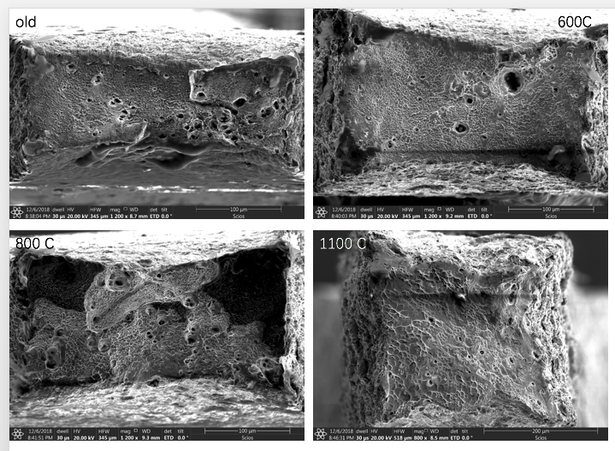

Figure S3. The fracture observation of the (a) as-received, (b) 600 ºC, (c) 800 ºC and (d) 1100 ºC annealed samples. The fracture observation of the four samples shows that the surface of the fracture is full of dimples, indicating that they are all ductile fractures. In addition, the large dimples on the fracture are inclusions that led to the observation through the fracture. The present fracture observation supports that the annealing temperature does not change the fracture behaviors of these four samples.

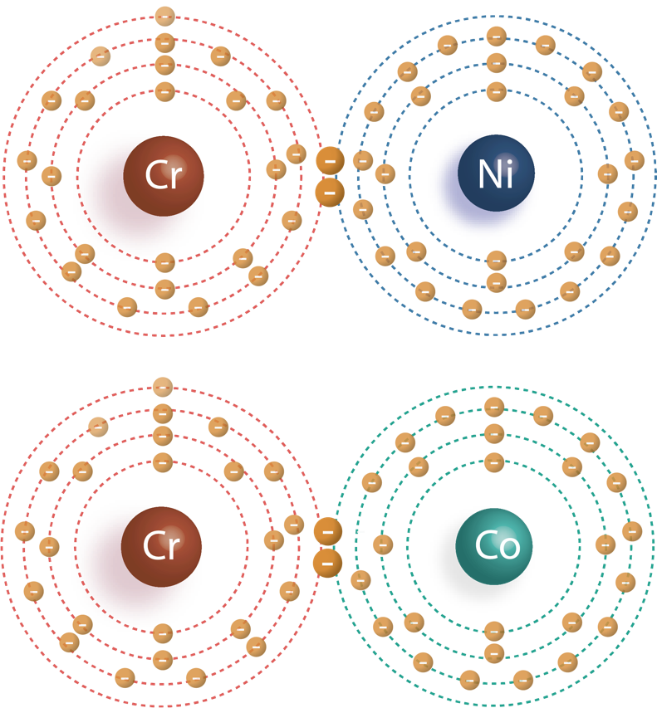

Figure. S4. Illustration of short chemical preference of Cr-Co and Cr-Ni.

Co and Ni are belonging to electron rich metal family. Compared to these two metals, i.e. Co, Ni, Cr seems much more electron deficient. Consequently, Cr prefers to form the intermetallic bonding with Ni or Co to achieve a more stable structure(14, 15).

