(a)  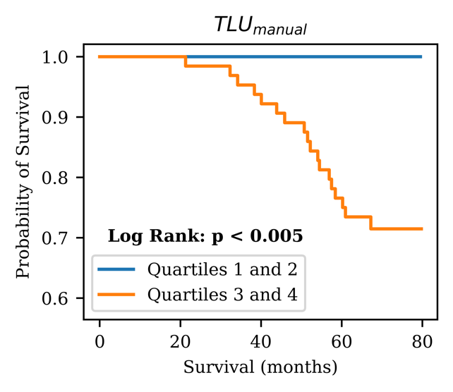 | (b)  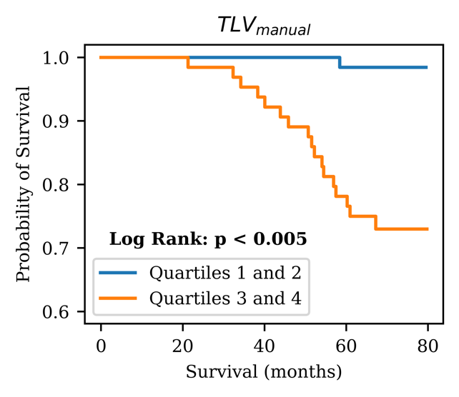
Supplementary Fig. 1 Kaplan-Meier analyses on the (a) total lesional uptake, and (b) total lesional volume calculated from the ground truth manual contours in the testing set PSMA scans.

