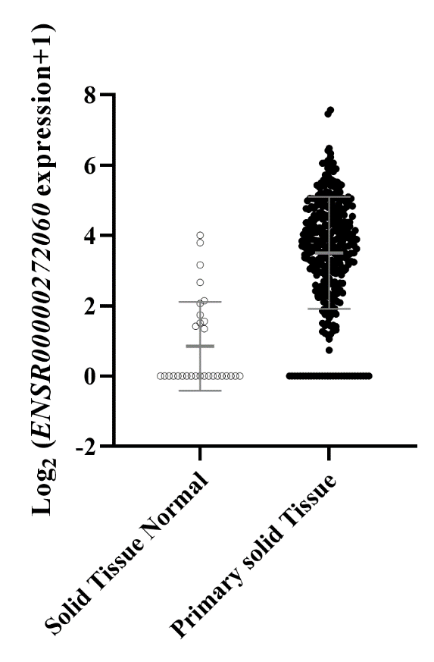
Supplementary Fig. S1. Expression profile of ENSR00000272060 in stomach tumor and non-tumor tissue samples of The Cancer Genome Atlas (TCGA) cohort
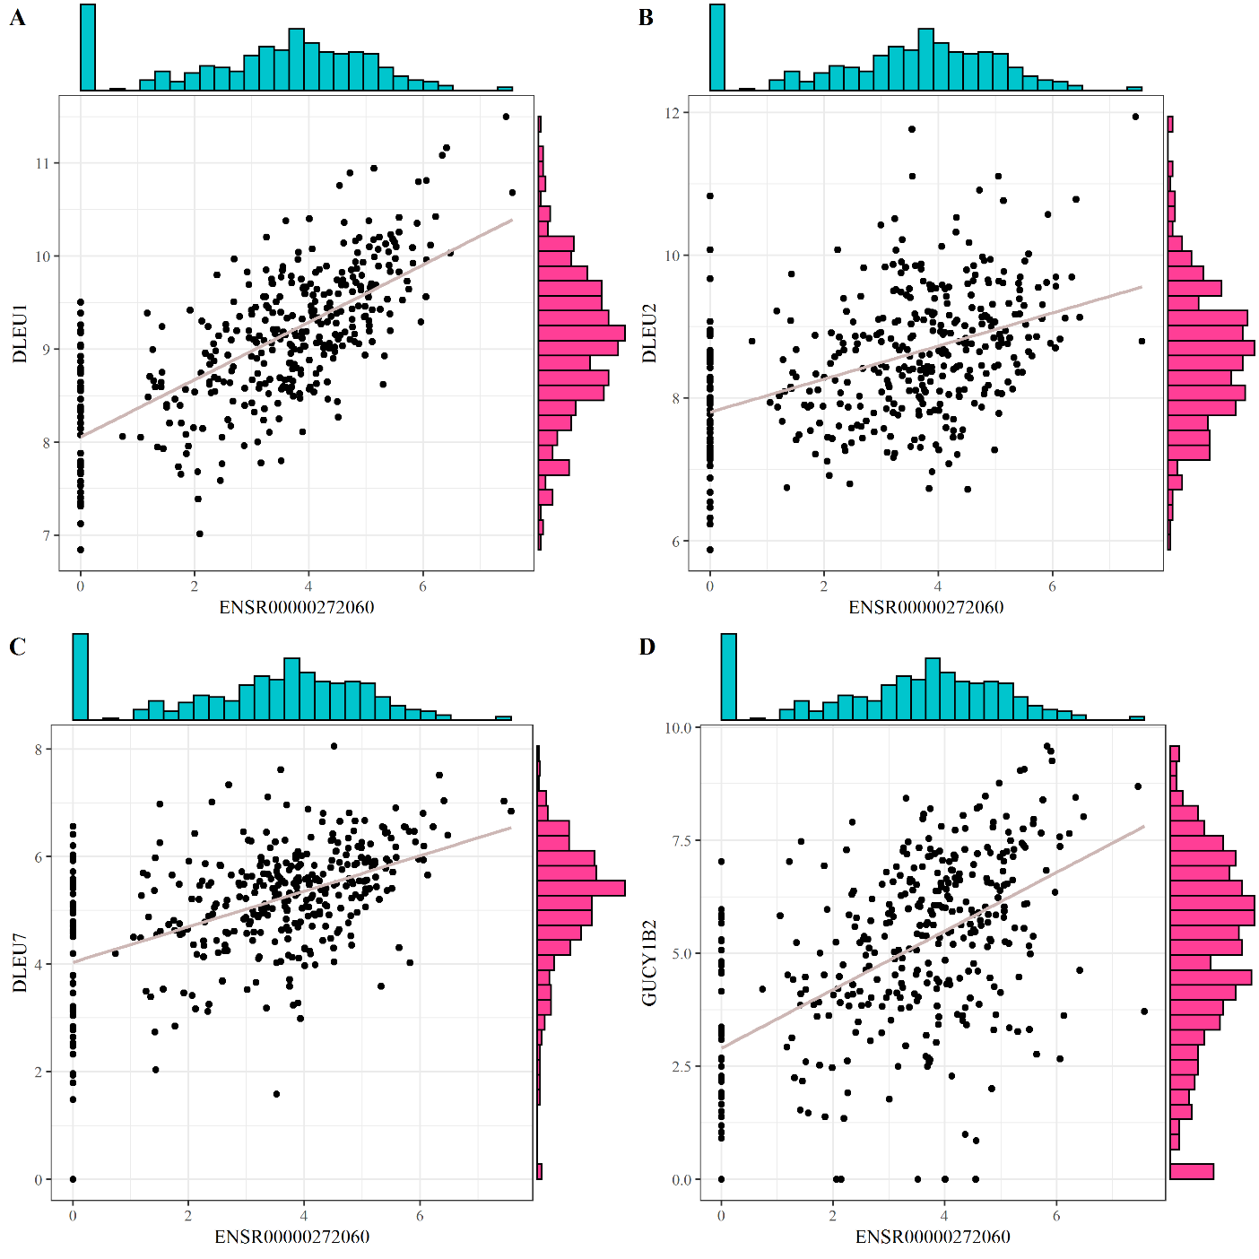

Supplementary Fig. S2. Expression correlation plots of ENSR00000272060 and its target genes. A) DLEU1 (correlation = 0.69, P-value = 5.71e-56), B) DLUE2 (correlation = 0.42, P-value = 1.05e-17), C) DLEU7 (correlation = 0.46, P-value = 6.58e-21) and D) GUCY1B2 (correlation = 0.50, P-value = 2.05e-25)

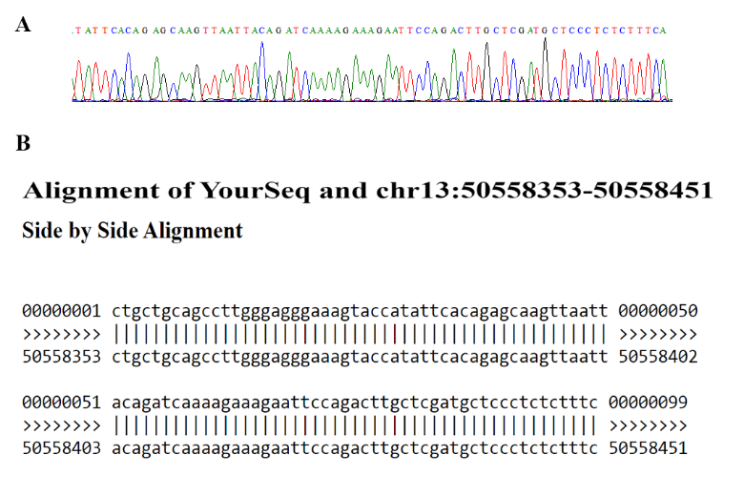
Supplementary Fig. S3. Sequencing analysis of ENSR00000272060 PCR product. A part of sequence electropherogram of ENSR00000272060 (A) and the result of BLAST-like alignment (BLAT)(B) are presented.

Supplementary Table S1. List of differentially-expressed genes in stomach samples of The Cancer Genome Atlas (TCGA)
Supplementary Table S2. List of differentially-expressed eRNAs in stomach samples of The Cancer Genome Atlas (TCGA)
Supplementary Table S3. List of altered methylated genes accompanied with altered expression
Supplementary Table S4. The information of 17 survival-related differentially-expressed eRNAs

Supplementary Table S5. List of top ten differentially-expressed eRNAs in the network, sorted by degree centrality FC: Fold change
Rank | Name | Degree Score | log₂FC
1 | ENSR00000232146 | 11 | 1.249511
2 | ENSR00000272060 | 4 | 3.009244
3 | ENSR00000062885 | 4 | 2.406591
4 | 9:124701845-124707845 | 4 | 1.439005
5 | 4:87483907-87489907 | 3 | -1.500357
6 | ENSR00000018210 | 3 | -2.056302
7 | ENSR00000018315 | 3 | -1.102035
8 | ENSR00000089171 | 3 | -1.937924
9 | ENSR00000095372 | 3 | 1.912583
10 | ENSR00000137463 | 3 | -2.677629

Supplementary Table S6. Sequences of specific primers
Transcript | Sequence (5' to 3') | Product size
ENSR00000272060 | F: GGCAGAGCAGGAAGAGTGAT | 149 bp
ENSR00000272060 | R: GAAAGAGAGGGAGCATCGAG | 149 bp
ACTB | F: TTCGAGCAAGAGATGGCC | 151 bp
ACTB | R: CACAGGACTCCATGCCCAG | 151 bp

