Supplement 1 Sepsis models displayed differential expression of plasma proteins when compared with the controls at 24 h.
CLP resulted in upregulation of 25 and downregulation of 5 proteins.
LPS treatment lead to upregulation of 44 and downregulation of 1 protein.
Midgut volvulus resulted in upregulation of 6 and downregulation of 5 proteins.
Expression was considered being significantly different, if FDR ≤ 0.05 and |log2FC| ≥ 1. The differentially regulated plasma proteins are listed in supplemental material II.

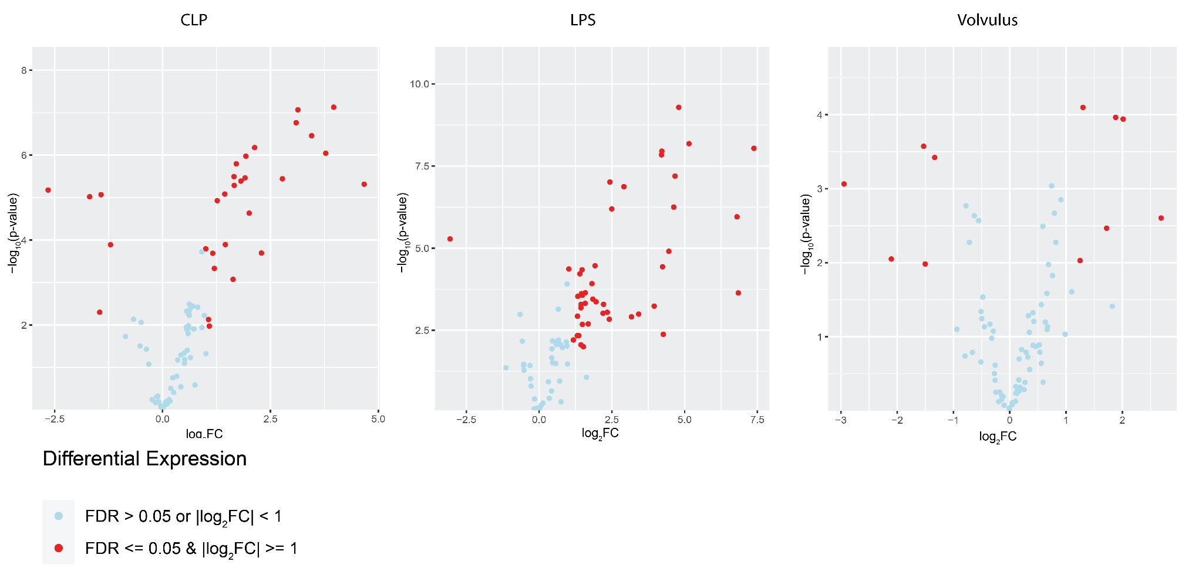

Supplement II: Sepsis models displayed differential expression of plasma proteins when compared with the controls at 24h.

CLP 24 h compared to control
Protein | Log2FC | P-Value | FDR | Mean in group CLP24h | Mean in group control
Ccl3 | 3.96 | 7.44E-08 | 0.00000351 | 6.99 | 3.02
Tnni3 | 3.13 | 8.55E-08 | 0.00000351 | 4.64 | 1.5
Ccl2 | 3.09 | 0.000000173 | 0.00000472 | 13.18 | 10.08
IL6 | 3.45 | 0.000000349 | 0.00000715 | 5.23 | 1.77
Prdx5 | 2.13 | 0.000000665 | 0.0000109 | 3.44 | 1.3
Ccl20 | 3.78 | 0.000000901 | 0.0000123 | 11.74 | 7.96
Tnfsf12 | 1.93 | 0.00000106 | 0.0000124 | 6.41 | 4.48
Matn2 | 1.71 | 0.0000016 | 0.0000164 | 6.76 | 5.05
Tpp1 | 1.65 | 0.0000032 | 0.0000269 | 8.12 | 6.46
Ntf3 | 1.91 | 0.00000344 | 0.0000269 | 3.77 | 1.86
IL17f | 2.78 | 0.00000361 | 0.0000269 | 4.09 | 1.31
IL10 | 1.81 | 0.00000409 | 0.0000279 | 3.76 | 1.94
Cxcl1 | 4.67 | 0.00000484 | 0.0000303 | 13.48 | 8.81
Tnfrsf11b | 1.66 | 0.00000517 | 0.0000303 | 7.53 | 5.87
Cyr61 | -2.65 | 0.00000665 | 0.0000363 | 3.9 | 6.55
Dctn2 | 1.44 | 0.00000826 | 0.0000412 | 2.6 | 1.16
Tgfa | -1.43 | 0.00000854 | 0.0000412 | 5.46 | 6.89
IL23r | -1.69 | 0.00000955 | 0.0000435 | 4.24 | 5.93
Eno2 | 1.27 | 0.0000118 | 0.0000511 | 4.87 | 3.6
IL1b | 2.01 | 0.0000233 | 0.0000955 | 4.15 | 2.14
Parp1 | 1.45 | 0.000128 | 0.000481 | 4.86 | 3.41
S100a4 | -1.21 | 0.000129 | 0.000481 | 3.44 | 4.65
Wfikkn2 | 1 | 0.000161 | 0.000573 | 6.27 | 5.27
Cxcl9 | 2.29 | 0.000203 | 0.000646 | 7.6 | 5.31
Sez6l2 | 1.16 | 0.000205 | 0.000646 | 5.47 | 4.31
Ccl5 | 1.2 | 0.000466 | 0.00142 | 2.24 | 1.04
Csf2 | 1.63 | 0.000843 | 0.00247 | 2.57 | 0.94
Pdgfb | -1.46 | 0.00502 | 0.0121 | 6.11 | 7.57
Nadk | 1.06 | 0.00744 | 0.0156 | 7.18 | 6.12
Fst | 1.08 | 0.0106 | 0.0208 | 8.85 | 7.77

LPS 24 h compared to control:
Protein | Log2FC | P-Value | FDR | Mean in group LPS 24h | Mean in group control
Ccl20 | 4.8 | 5.17E-10 | 4.24E-08 | 12.76 | 7.96
Ccl3 | 5.15 | 6.6E-09 | 2.29E-07 | 8.17 | 3.02
Ccl5 | 7.38 | 9.16E-09 | 2.29E-07 | 8.42 | 1.04
Ccl2 | 4.22 | 1.12E-08 | 2.29E-07 | 14.3 | 10.08
Csf2 | 4.21 | 1.44E-08 | 2.37E-07 | 5.15 | 0.94
IL10 | 4.67 | 6.43E-08 | 8.79E-07 | 6.61 | 1.94
Tnfsf12 | 2.43 | 9.74E-08 | 0.00000114 | 6.92 | 4.48
Matn2 | 2.91 | 0.000000135 | 0.00000138 | 7.96 | 5.05
IL6 | 4.63 | 0.000000563 | 0.00000513 | 6.4 | 1.77
Nadk | 2.5 | 0.000000641 | 0.00000526 | 8.62 | 6.12
Cxcl9 | 6.8 | 0.00000111 | 0.00000829 | 12.1 | 5.31
Cyr61 | -3.06 | 0.00000524 | 0.0000358 | 3.5 | 6.55
Cxcl1 | 4.46 | 0.0000125 | 0.0000788 | 13.27 | 8.81
Pla2g4a | 1.92 | 0.0000343 | 0.000201 | 6.68 | 4.76
Parp1 | 4.24 | 0.0000369 | 0.000202 | 7.65 | 3.41
Tpp1 | 1.02 | 0.0000432 | 0.000221 | 7.48 | 6.46
Clstn2 | 1.47 | 0.0000457 | 0.000221 | 3.8 | 2.33
Riox2 | 1.4 | 0.0000605 | 0.000275 | 3.47 | 2.07
Dctn2 | 1.82 | 0.00012 | 0.000506 | 2.98 | 1.16
Fst | 1.59 | 0.000229 | 0.000862 | 9.35 | 7.77
IL17f | 6.84 | 0.000231 | 0.000862 | 8.15 | 1.31
Casp3 | 1.46 | 0.000244 | 0.000869 | 7.2 | 5.74
Yes1 | 1.49 | 0.000272 | 0.000929 | 2.35 | 0.86
Wfikkn2 | 1.33 | 0.000293 | 0.000962 | 6.6 | 5.27
Ca13 | 1.85 | 0.000356 | 0.00112 | 3.34 | 1.49
IL1b | 1.96 | 0.00043 | 0.00131 | 4.1 | 2.14
Dll1 | 1.58 | 0.00048 | 0.00141 | 5.78 | 4.2
Qdpr | 2.21 | 0.000514 | 0.00141 | 5.24 | 3.03
Ntf3 | 1.44 | 0.000515 | 0.00141 | 3.3 | 1.86
Prdx5 | 3.95 | 0.000583 | 0.00154 | 5.26 | 1.3
Fstl3 | 1.44 | 0.000653 | 0.00167 | 7.38 | 5.94
Fas | 2.34 | 0.000898 | 0.00216 | 6.47 | 4.13
IL1a | 2.2 | 0.000962 | 0.00225 | 7.7 | 5.5
Tnni3 | 3.42 | 0.00102 | 0.00229 | 4.92 | 1.5
Gfra1 | 1.32 | 0.00118 | 0.00255 | 4.3 | 2.98
Tnfrsf12a | 3.17 | 0.00123 | 0.00259 | 6.18 | 3.01
Eda2r | 2.41 | 0.00146 | 0.003 | 8.85 | 6.44
Tnfrsf11b | 1.69 | 0.00203 | 0.00407 | 7.55 | 5.87
Clmp | 1.49 | 0.00209 | 0.00409 | 8.11 | 6.62
IL17a | 4.27 | 0.00421 | 0.00802 | 6.82 | 2.55
Mia | 1.37 | 0.00461 | 0.00841 | 6.35 | 4.99
Itgb6 | 1.31 | 0.00461 | 0.00841 | 3.34 | 2.02
Map2k6 | 1.18 | 0.00624 | 0.011 | 5.87 | 4.69
Apbb1ip | 1.44 | 0.00876 | 0.0133 | 4.07 | 2.63
Acvrl1 | 1.52 | 0.0101 | 0.0147 | 6.11 | 4.58

Volvulus 24 h compared to control:
Protein | Log2FC | P-Value | FDR | Mean in group Volvulus 24h | Mean in group control
Dctn2 | 1.3 | 0.0000797 | 0.00313 | 2.46 | 1.16
Parp1 | 1.88 | 0.000109 | 0.00313 | 5.29 | 3.41
Prdx5 | 2.01 | 0.000114 | 0.00313 | 3.32 | 1.3
IL23r | -1.53 | 0.000267 | 0.00547 | 4.39 | 5.93
Tgfa | -1.33 | 0.000379 | 0.00621 | 5.55 | 6.89
Cyr61 | -2.95 | 0.000864 | 0.0107 | 3.61 | 6.55
Tnni3 | 2.69 | 0.00249 | 0.017 | 4.19 | 1.5
IL1b | 1.72 | 0.00342 | 0.0187 | 3.86 | 2.14
Pdgfb | -2.1 | 0.00892 | 0.0404 | 5.47 | 7.57
Ccl2 | 1.25 | 0.00937 | 0.0404 | 11.33 | 10.08
IL1a | -1.5 | 0.0104 | 0.0414 | 4 | 5.5

Sepsis models displayed differential expression of plasma proteins when compared with the controls at 48 h:

CLP 48 h compared to control:
Protein | Log2FC | P-Value | FDR | Mean in group CLP48h | Mean in group control
Tnni3 | 5.44 | 0.00000537 | 0.00044 | 6.94 | 1.5
Tpp1 | 1.91 | 0.0000159 | 0.000653 | 8.37 | 6.46
IL17f | 2.95 | 0.0000393 | 0.00108 | 4.26 | 1.31
Matn2 | 1.96 | 0.0000991 | 0.00196 | 7.01 | 5.05
Itgb6 | 1.24 | 0.000133 | 0.00196 | 3.27 | 2.02
Tnfrsf11b | 1.77 | 0.000144 | 0.00196 | 7.63 | 5.87
Dctn2 | 1.32 | 0.00022 | 0.00258 | 2.49 | 1.16
Tnfsf12 | 2.03 | 0.000299 | 0.00286 | 6.52 | 4.48
Eno2 | 1.25 | 0.000314 | 0.00286 | 4.85 | 3.6
Sez6l2 | 1.72 | 0.000382 | 0.00287 | 6.03 | 4.31
Cxcl1 | 4.14 | 0.000403 | 0.00287 | 12.95 | 8.81
Wfikkn2 | 1.39 | 0.000449 | 0.00287 | 6.66 | 5.27
Ntf3 | 2.66 | 0.000479 | 0.00287 | 4.53 | 1.86
Ccl20 | 3.42 | 0.000491 | 0.00287 | 11.38 | 7.96
Adam23 | 1.27 | 0.000586 | 0.00313 | 2.62 | 1.35
IL23r | -1.43 | 0.000611 | 0.00313 | 4.49 | 5.93
Epo | 3.38 | 0.000742 | 0.00353 | 6.89 | 3.52
IL1b | 2.05 | 0.000774 | 0.00353 | 4.19 | 2.14
Tgfbr3 | 1.15 | 0.000901 | 0.00389 | 5.27 | 4.12
IL6 | 4.98 | 0.00177 | 0.00655 | 6.75 | 1.77
Ccl2 | 2.83 | 0.00179 | 0.00655 | 12.91 | 10.08
Prdx5 | 2.63 | 0.00184 | 0.00655 | 3.93 | 1.3
Vegfd | 1.02 | 0.00237 | 0.00779 | 4.93 | 3.91
Ccl3 | 4.01 | 0.00247 | 0.00779 | 7.03 | 3.02
IL17a | 1.78 | 0.00263 | 0.00799 | 4.34 | 2.55
Fst | 1.61 | 0.00384 | 0.0112 | 9.38 | 7.77
Cyr61 | -1.72 | 0.00463 | 0.0122 | 4.84 | 6.55
Csf2 | 2.51 | 0.0055 | 0.0141 | 3.45 | 0.94
Tgfa | -1.23 | 0.00587 | 0.0146 | 5.66 | 6.89
Parp1 | 1.53 | 0.00674 | 0.0163 | 4.93 | 3.41
Fas | 1.03 | 0.00961 | 0.0219 | 5.15 | 4.13
IL10 | 2.99 | 0.025 | 0.0489 | 4.93 | 1.94

LPS 48 h compared to control:
Protein | Log2FC | P-Value | FDR | Mean in group LPS 48h | Mean in group control
Ccl3 | 6.45 | 1.01E-11 | 8.31E-10 | 9.48 | 3.02
IL10 | 4.85 | 2.58E-10 | 1.06E-08 | 6.8 | 1.94
Ccl2 | 4.37 | 9.46E-10 | 2.59E-08 | 14.45 | 10.08
Nadk | 2.77 | 0.00000012 | 0.00000247 | 8.89 | 6.12
Tnfrsf11b | 2.52 | 0.000000216 | 0.00000355 | 8.38 | 5.87
Pla2g4a | 1.71 | 0.000000516 | 0.00000705 | 6.47 | 4.76
Ccl5 | 4.21 | 0.000000975 | 0.0000101 | 5.26 | 1.04
Parp1 | 3.36 | 0.00000103 | 0.0000101 | 6.77 | 3.41
Riox2 | 1.84 | 0.00000111 | 0.0000101 | 3.91 | 2.07
Ccl20 | 3.73 | 0.00000306 | 0.0000251 | 11.69 | 7.96
Ntf3 | 2.21 | 0.00000362 | 0.000027 | 4.07 | 1.86
Matn2 | 1.73 | 0.00000581 | 0.0000397 | 6.78 | 5.05
IL6 | 2.14 | 0.00000861 | 0.0000491 | 3.91 | 1.77
Wfikkn2 | 1.51 | 0.0000089 | 0.0000491 | 6.78 | 5.27
Csf2 | 2.69 | 0.00000897 | 0.0000491 | 3.63 | 0.94
IL1b | 2.15 | 0.0000103 | 0.0000529 | 4.29 | 2.14
Tnni3 | 3.38 | 0.0000121 | 0.0000585 | 4.88 | 1.5
Tnfsf12 | 1.8 | 0.0000172 | 0.0000743 | 6.28 | 4.48
Prdx5 | 2.61 | 0.0000178 | 0.0000743 | 3.91 | 1.3
Cyr61 | -2.22 | 0.0000181 | 0.0000743 | 4.33 | 6.55
Adam23 | 1.21 | 0.0000346 | 0.00013 | 2.56 | 1.35
Fas | 1.24 | 0.000035 | 0.00013 | 5.37 | 4.13
Cxcl1 | 3.49 | 0.0000492 | 0.000175 | 12.3 | 8.81
Dctn2 | 1.39 | 0.0000963 | 0.000321 | 2.56 | 1.16
Eda2r | 1.43 | 0.0000978 | 0.000321 | 7.86 | 6.44
Itgb6 | 1.37 | 0.000115 | 0.000364 | 3.39 | 2.02
Axin1 | 1.02 | 0.000125 | 0.000379 | 4.04 | 3.02
Tnfrsf12a | 1.68 | 0.000279 | 0.000788 | 4.69 | 3.01
Clmp | 1.11 | 0.000292 | 0.000798 | 7.74 | 6.62
Cxcl9 | 2.93 | 0.000468 | 0.00116 | 8.24 | 5.31
IL17f | 3.24 | 0.000512 | 0.00124 | 4.55 | 1.31
Pdgfb | -2.23 | 0.000691 | 0.00157 | 5.34 | 7.57
Fst | 1.46 | 0.000967 | 0.00203 | 9.23 | 7.77
Ca13 | 1.31 | 0.00184 | 0.00343 | 2.8 | 1.49
Crim1 | 1.06 | 0.00236 | 0.00421 | 2.69 | 1.64
Epo | 2.37 | 0.00292 | 0.00489 | 5.89 | 3.52
Ahr | 1.08 | 0.00313 | 0.00513 | 2.81 | 1.73
Apbb1ip | 1.24 | 0.00336 | 0.0054 | 3.87 | 2.63
IL1a | 1.72 | 0.00595 | 0.00912 | 7.22 | 5.5

Volvulus 48 h compared to control:
Protein | Log2FC | P-Value | FDR | Mean in group Volvulus 48h | Mean in group control
23r | -1.74 | 0.000139 | 0.00524 | 4.18 | 5.93
IL1b | 2.3 | 0.000196 | 0.00524 | 4.44 | 2.14
Epo | 3.27 | 0.000289 | 0.00524 | 6.79 | 3.52
Tgfa | -1.47 | 0.000931 | 0.0109 | 5.41 | 6.89
Prdx5 | 1.79 | 0.00213 | 0.0205 | 3.09 | 1.3
Cyr61 | -1.47 | 0.00271 | 0.0223 | 5.08 | 6.55
IL6 | 1.01 | 0.00506 | 0.0323 | 2.78 | 1.77
Pdgfb | -2.23 | 0.00511 | 0.0323 | 5.34 | 7.57
Gcg | -1.81 | 0.00596 | 0.0326 | 1.74 | 3.55
Ccl2 | 1.04 | 0.00927 | 0.0447 | 11.13 | 10.08
Parp1 | 1.21 | 0.0108 | 0.0492 | 4.62 | 3.41

Supplement III. In CLP and volvulus the differential plasma protein expression is stable in the interval between 24 and 48 h after intervention.
(A) In CLP only 1 protein was upregulated, (B) in volvulus the protein expression was stable and (C) in the LPS model 3 proteins were upregulated and 10 were downregulated. Expression was considered to differ significantly when FDR ≤ 0.05 and |log2FC| ≥ 1. The differentially expressed plasma proteins are listed in supplement III.

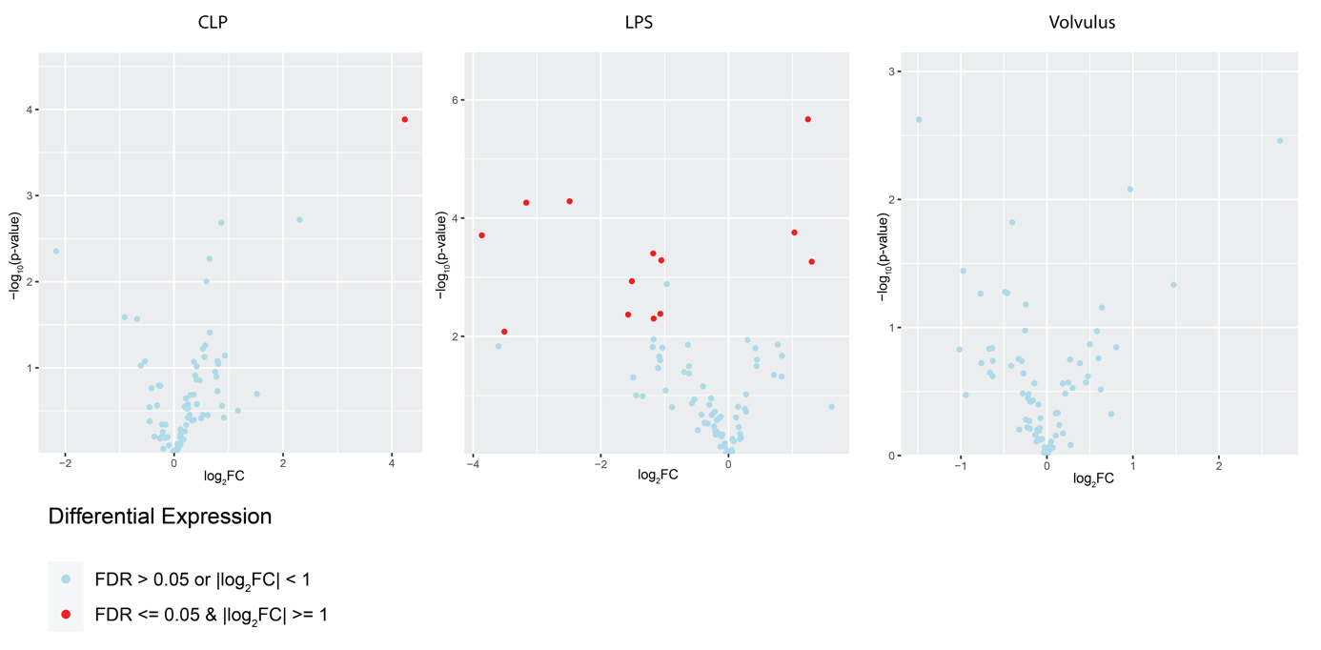

Supplement IV:

In CLP and volvulus, the differential plasma protein expression is stable in the interval between 24 h and 48 h after intervention. Differential expression of only very view proteins between the two timepoints is observed:

CLP 24 h compared to CLP 48 h:
Protein | Log2FC | P-Value | FDR | Mean in group CLP48h | Mean in group CLP24h
Epo | 4.24 | 0.000131 | 0.0107 | 6.89 | 2.66

LPS 24 h compared to LPS 48 h:
Protein | Log2FC | P-Value | FDR | Mean in group LPS48h | Mean in group LPS24h
Adam23 | 1.25 | 0.00000213 | 0.000175 | 2.56 | 1.31
IL6 | -2.49 | 0.0000519 | 0.0015 | 3.91 | 6.4
Ccl5 | -3.17 | 0.0000549 | 0.0015 | 5.26 | 8.42
S100a4 | 1.03 | 0.000175 | 0.00321 | 5.16 | 4.13
Cxcl9 | -3.86 | 0.000195 | 0.00321 | 8.24 | 12.1
Matn2 | -1.18 | 0.000396 | 0.00542 | 6.78 | 7.96
Clstn2 | -1.05 | 0.000518 | 0.0056 | 2.75 | 3.8
Ccl3 | 1.3 | 0.000546 | 0.0056 | 9.48 | 8.17
Csf2 | -1.51 | 0.00117 | 0.0106 | 3.63 | 5.15
Fstl3 | -1.07 | 0.00416 | 0.0293 | 6.31 | 7.38
Qdpr | -1.57 | 0.00429 | 0.0293 | 3.67 | 5.24
Mia | -1.17 | 0.00501 | 0.0316 | 5.18 | 6.35
IL17a | -3.51 | 0.00835 | 0.0489 | 3.31 | 6.82

Volvulus 24 h compared to 48 h volvulus:
Protein | Log2FC | P-Value | FDR | Mean in group Volvulus 48h | Mean in group Volvulus 48h
none | none | none | none | none | none

Supplement V:
 | Ccl3 | Il1b | Lpl | Wisp1 | Pla2g4a
CLP24 | 3.96 | 2.01 | n.s. | n.s. | n.s.
CLP48 | 4.91 | 2.05 | n.s. | n.s. | n.s.
LPS24 | 5.15 | 1.96 | n.s. | n.s. | 1.92
LPS48 | 6.45 | 2.15 | n.s. | n.s. | 1.71
Volvulus 24 | n.s. | 1.72 | n.s. | n.s. | n.s.
Volvulus 48 | n.s. | n.s. | n.s. | n.s. | n.s.

Differential expression of proinflammatory proteins in each of the three models at the timepoints 24h and 48h, expressed as Log2FC. Positive value indicated upregulation of protein expression, negative values indicate downregulation of proteins.

Supplement VI:
 | IL10 | Ghrl | Hgf
CLP24 | 1.81 | n.s. | n.s.
CLP48 | 2.99 | n.s. | 1.07
LPS24 | 4.67 | n.s. | n.s.
LPS48 | 4.85 | n.s. | n.s.
Volvulus 24 | n.s. | n.s. | n.s.
Volvulus 48 | n.s. | n.s. | n.s.

Differential expression of anti-inflammatory proteins in each of the three models at the timepoints 24h and 48h, expressed as Log2FC. Positive value indicated upregulation of protein expression, negative values indicate downregulation of proteins. Significance was defined when FDR ≤ 0.05 and |log2FC| ≥ 1 was met.

