Supplementary

One step to stabilize calcium sodium phosphate crystals acting as photocatalysts embedded in a glass matrix
Pongpen Kaewdeeª, Sujitra Tandornª, Apichart Limpichaipanit^{b}, Komsanti Chokethawai^{b}, Sumetha Suwanboon^{c}, Nopakarn Chandet^{d}, Apinun Kanpiengjai^{d}, Gobwute Rujijanagul^{b}, Chamnan Randorn^{a,e}

ª Department of Chemistry, Faculty of Science, Chiang Mai University, 50200, Thailand
^{b} Department of Physics and Materials Science, Faculty of Science, Chiang Mai University, 50200, Thailand
^{c} Department of Materials Science and Technology, Faculty of Science, Prince of Songkla University, Hat Yai, Songkhla 90112, Thailand
^{d} Division of Biochemistry and Biochemical Innovation, Department of Chemistry, Faculty of Science, Chiang Mai Unviersity, Chiang Mai 50200, Thailand
^{e} Center of Excellence in Materials Science and Technology, Chiang Mai University, Chiang Mai, 50200, Thailand

Table S1 The glass plate before and after heat treatment
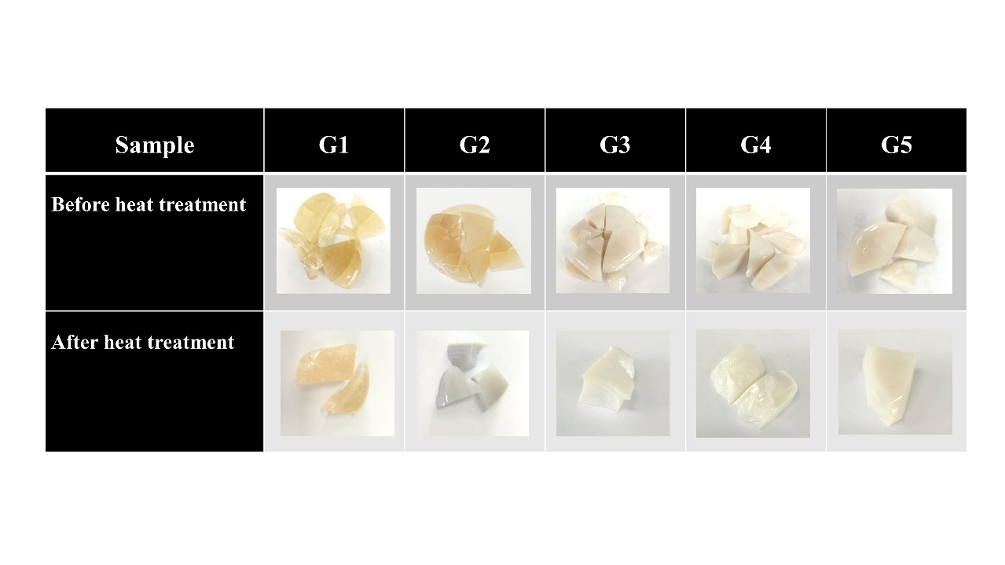

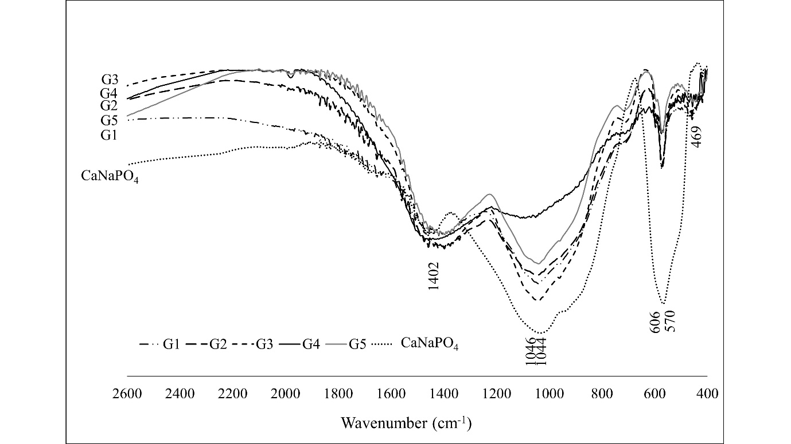
Figure S2 FT-IR spectra for the composition of G1-G5 glass-ceramics, and CaNaPO₄ powder

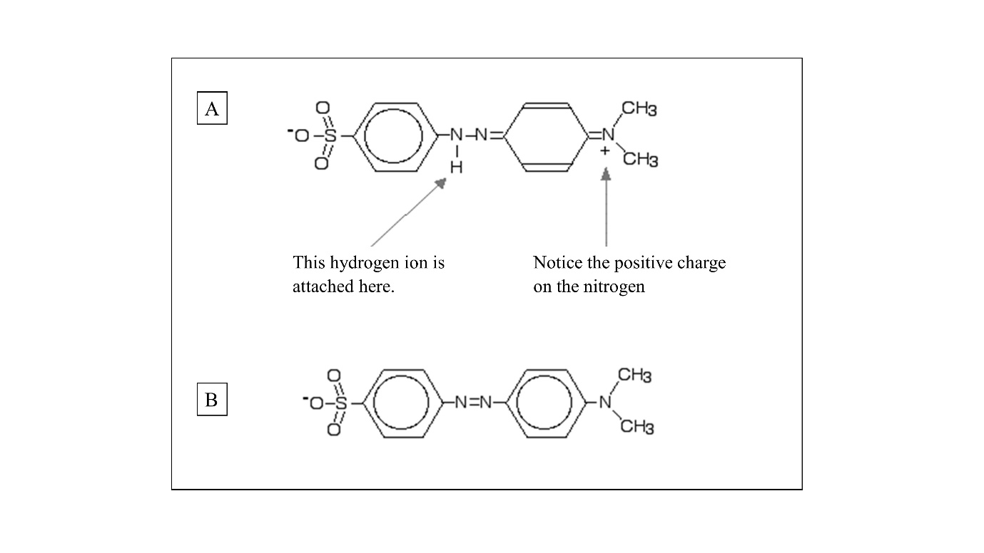
Figure S3 Methyl orange structure of A) red form B) yellow form
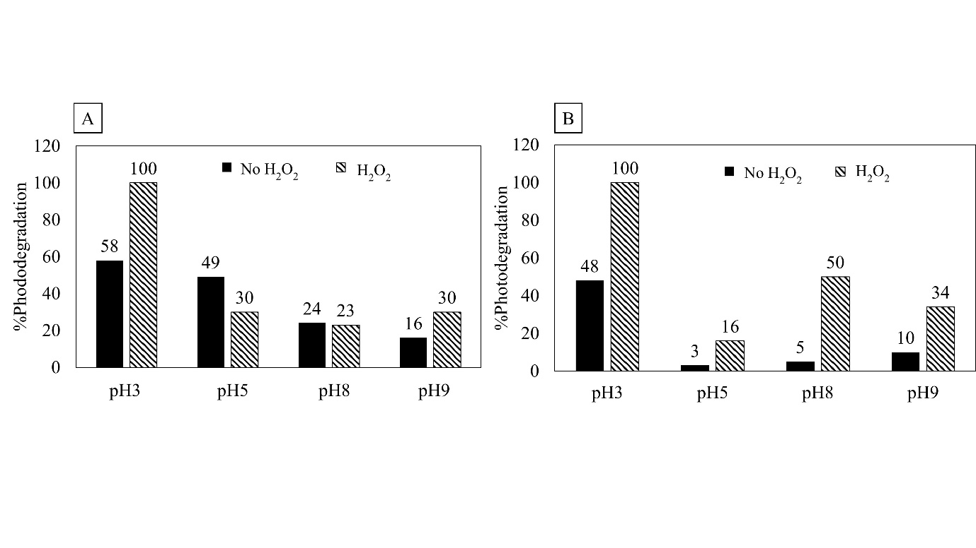
Figure S4 %Photodegradation with different pH value A) CaNaPO₄ powders
pH3 pH5 pH8 pH9
B) CaNaPO₄ glass ceramic powders

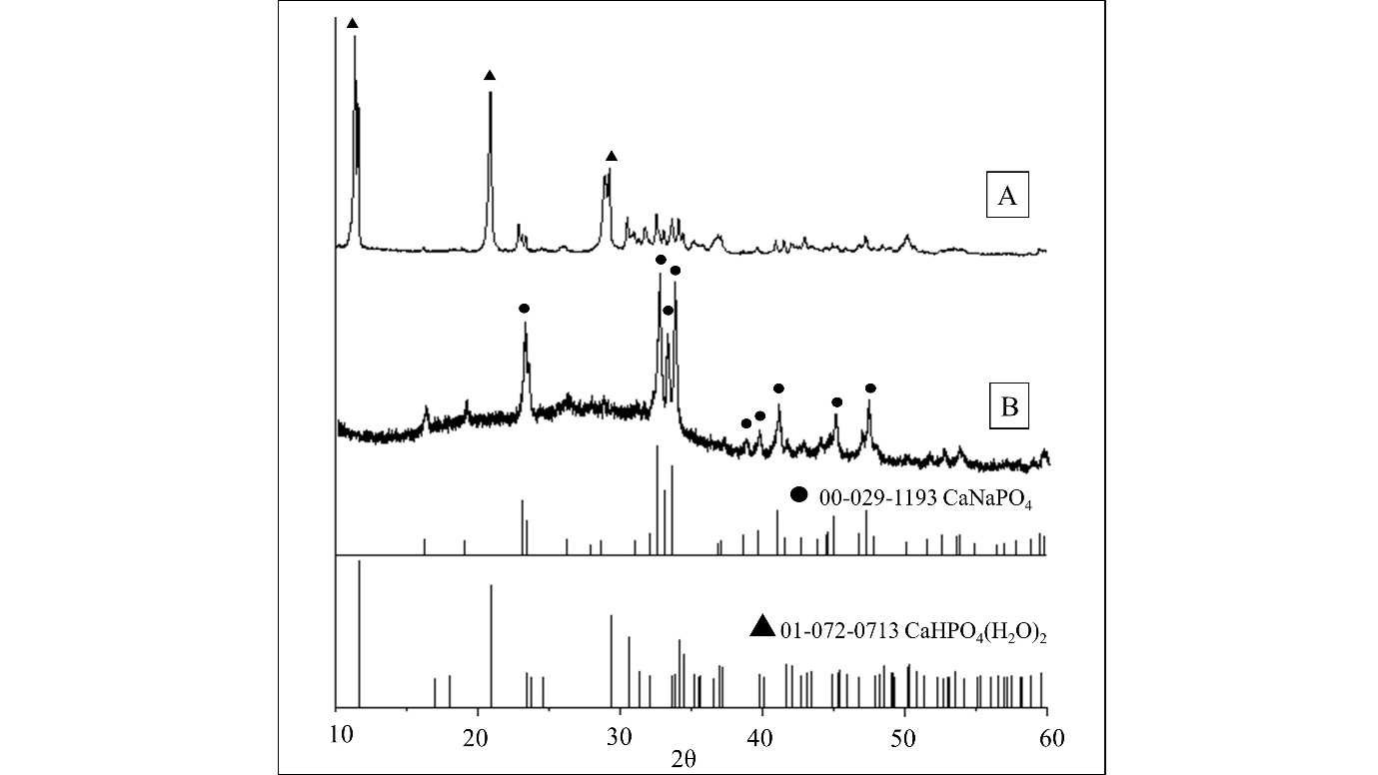
Figure S5 XRD pattern of A) CaNaPO₄ powders B) CaNaPO₄ glass-ceramic powders after photocatalytic reaction

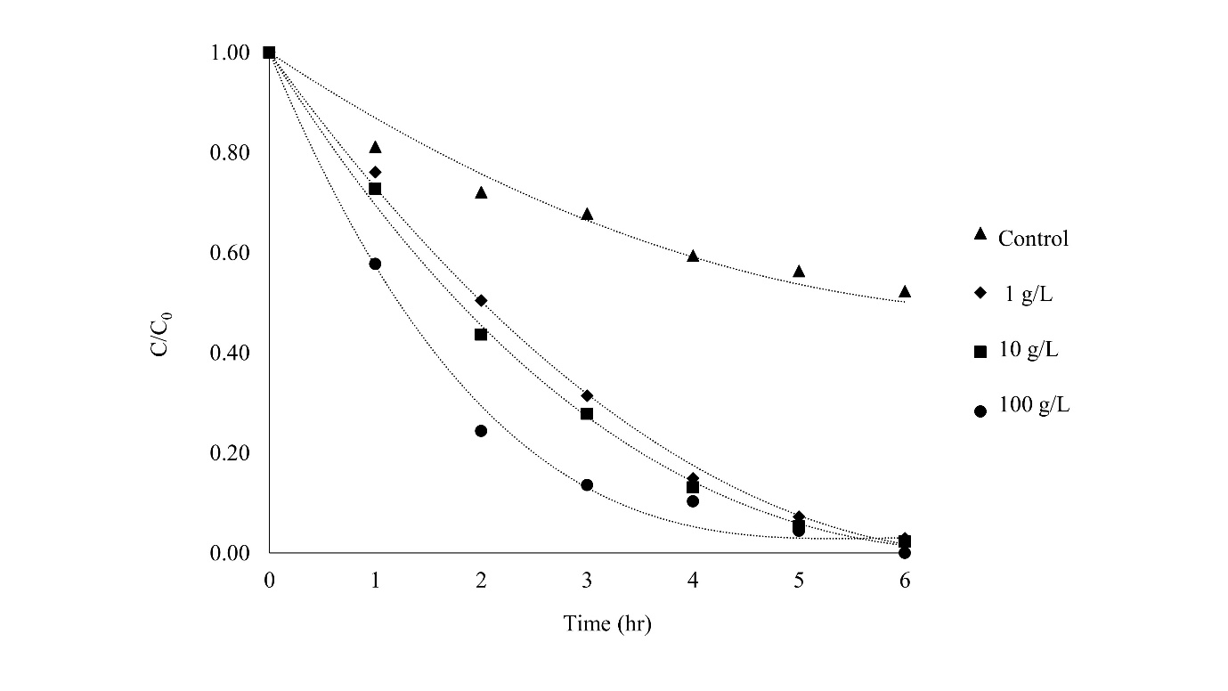
Figure S6 The effect of CaNaPO₄ glass-ceramic amount on the degradation of methyl orange solution at pH8 with H₂O₂ condition

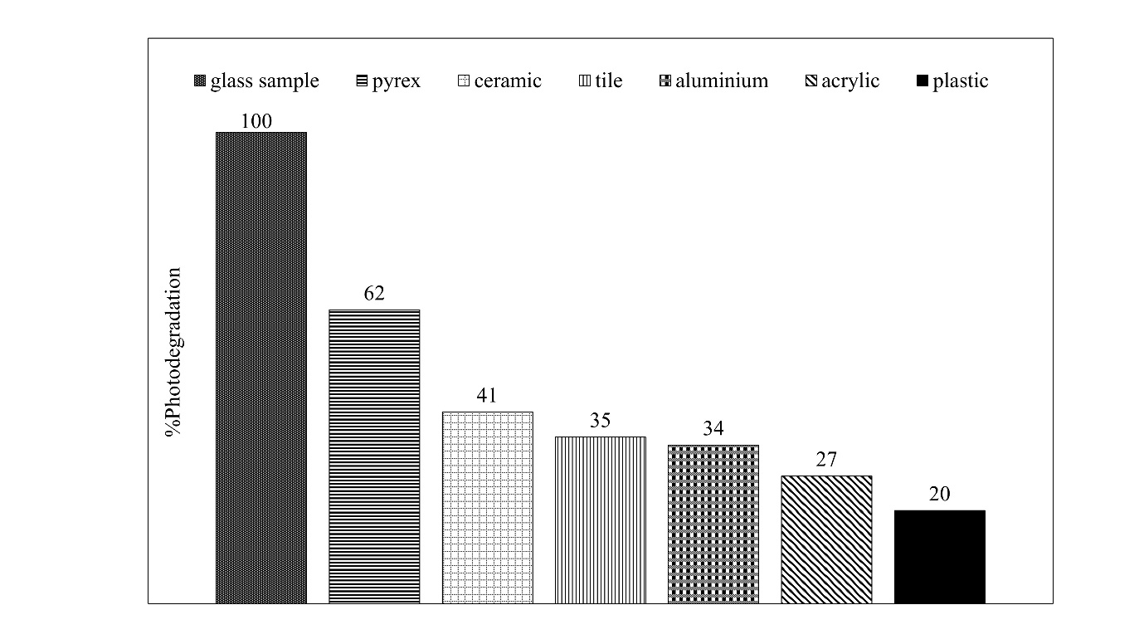
Figure S7 XRD pattern of CaNaPO₄ glass-ceramic after cycling run 8 cycles
2θ

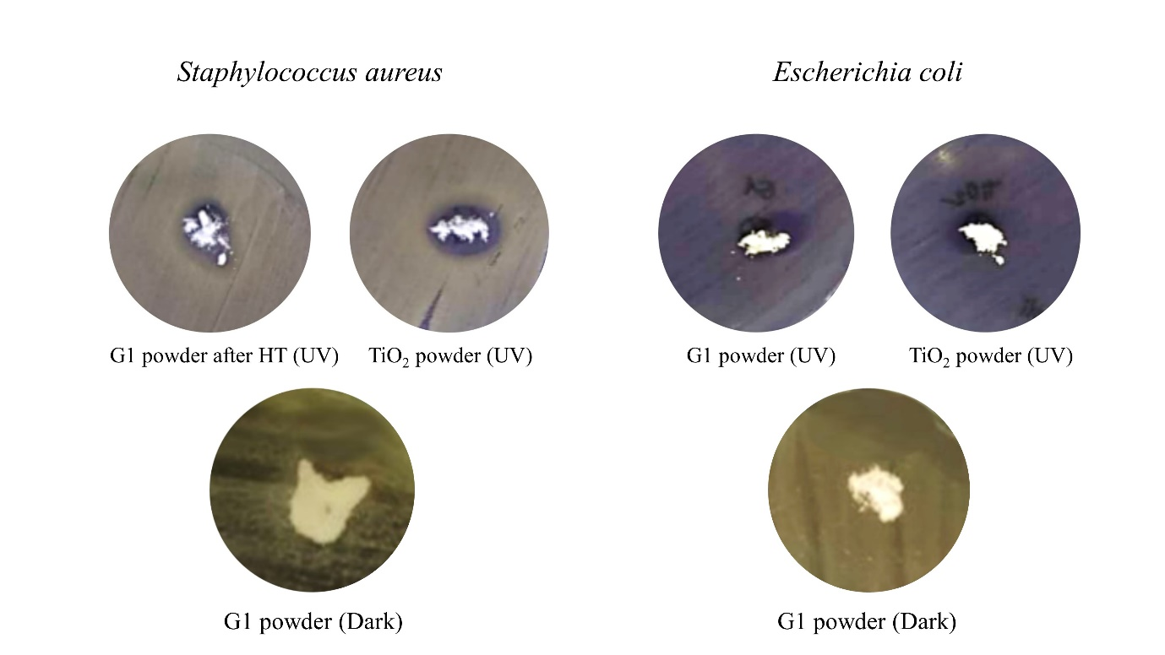
Figure S8 Antibacterial test results for E. coli and S. aureus

