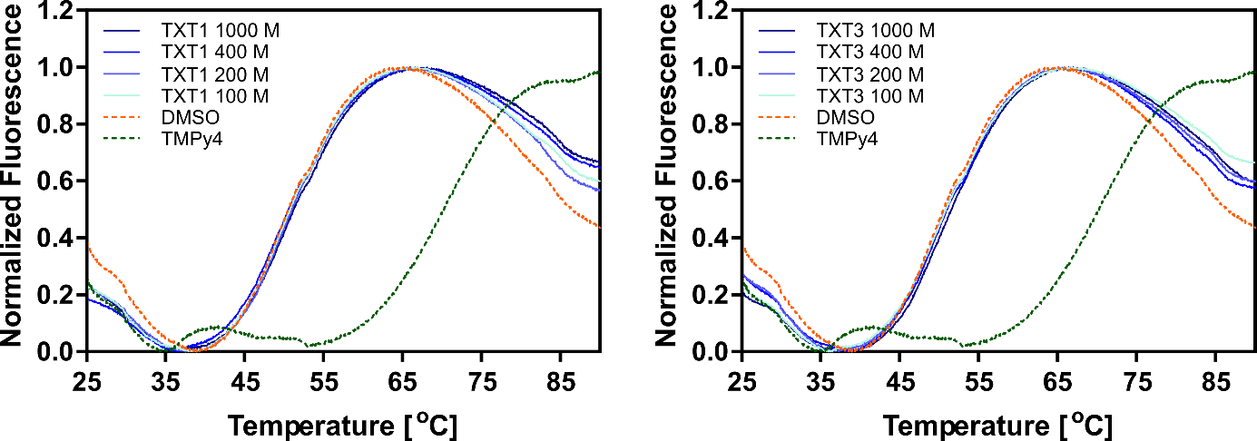Figure S1 FRET melting profile of human telomere G-4 DNA in the presence and absence of ligand.
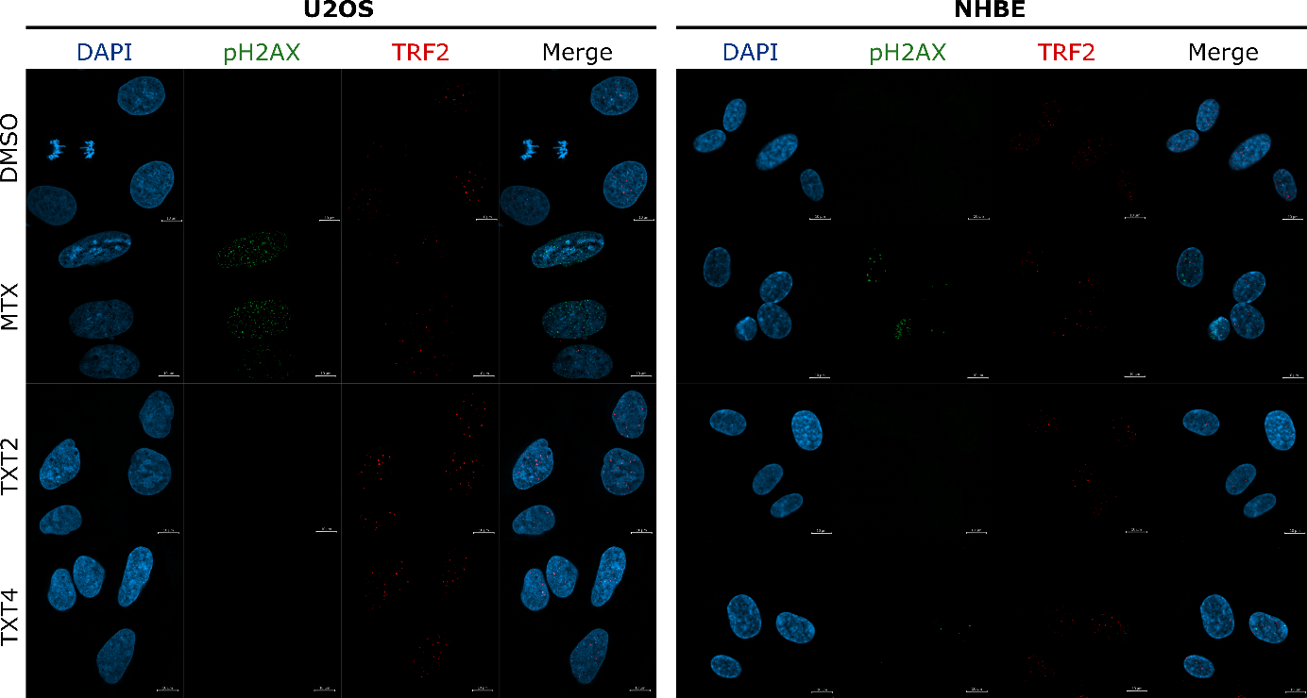
Figure S2 Representative high-resolution laser scanning confocal images showing the DNA DSBs (p-γ-H2AX) with TRF2 after treatment NHBE and U2OS cell lines. Scale bars =10 μm.

