Supplementary information file

The role of polarized macrophages in the activation of resolution pathways within human granulosa cells
Thaise S. Martinsª, Bruno M. Fonsecaª, Irene Rebelo^{a*}
ªUCIBIO, REQUIMTE, Department of Biological Sciences, Laboratory of Biochemistry, Faculty of Pharmacy, University of Porto, Porto, Portugal

*Corresponding author: UCIBIO, REQUIMTE, Department of Biological Sciences, Laboratory of Biochemistry, Faculty of Pharmacy, University of Porto. Rua Jorge de Viterbo nº 228, 4050-313, Porto, Portugal. Tel/Fax: +351 220428557; Email: irebelo@ff.up.pt
Original blots imagens
Figure 4a
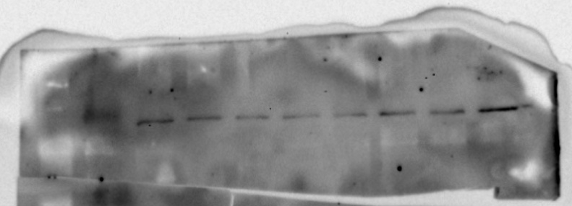
COX-2 (75 kDa)

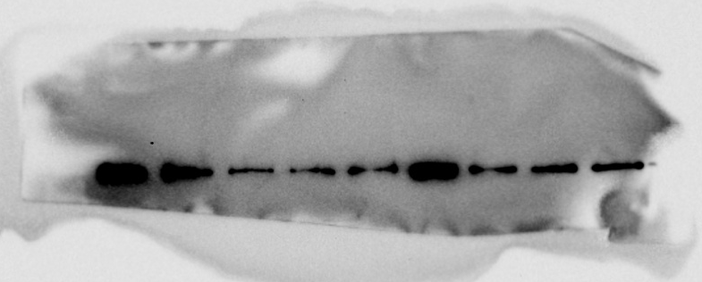
β-actin (43 kDa)

Figure 4b
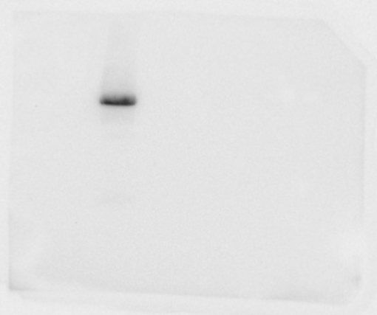
5-LOX (70 kDa)

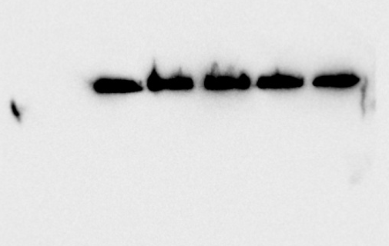
β-actin (43 kDa)

Figure 4c
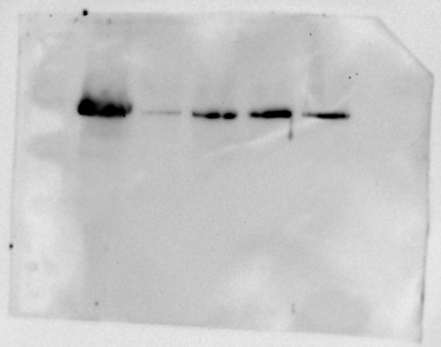
12-LOX (70 kDa)

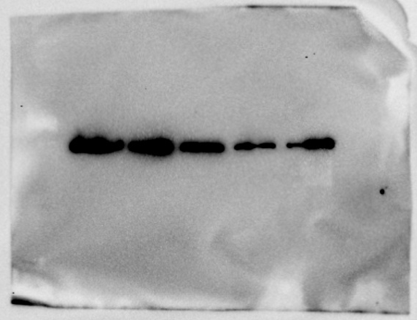

β-actin (43 kDa)

Figure 4d
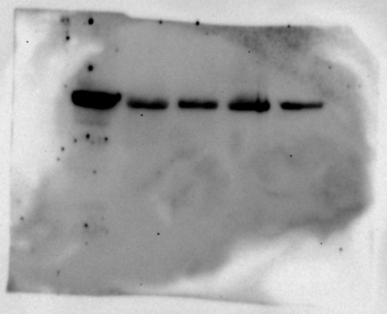
15-LOX (75 kDa)

β-actin (43 kDa)

Original blots imagens
Figure 5a
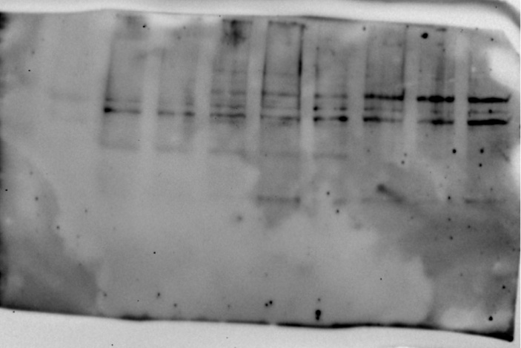
COX-2 (75 kDa)

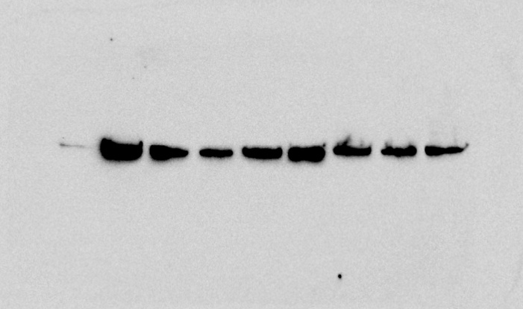

β-actin (43 kDa)

Figure 5b
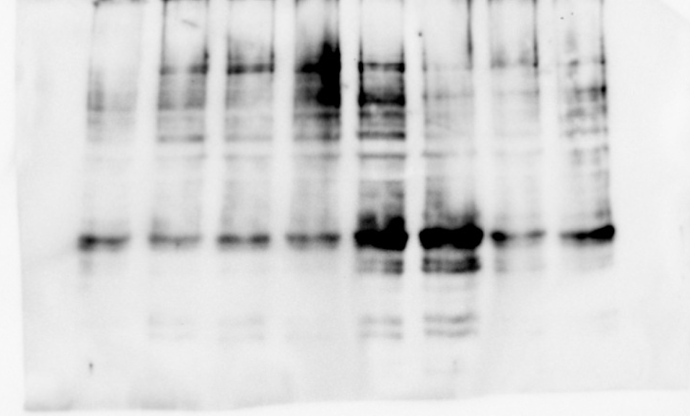
5-LOX (70 kDa)

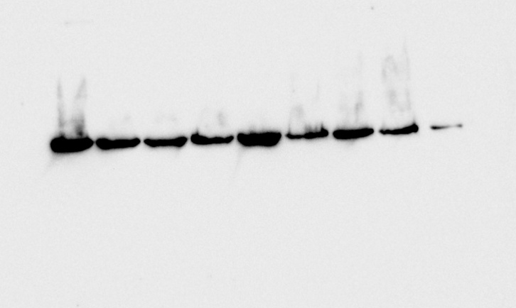

β-actin (43 kDa)

Figure 5c
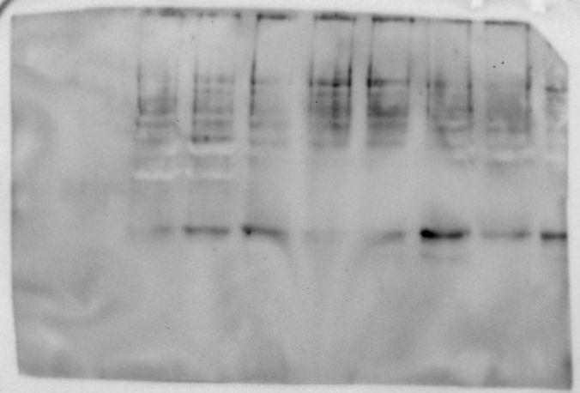
12-LOX (70 kDa)

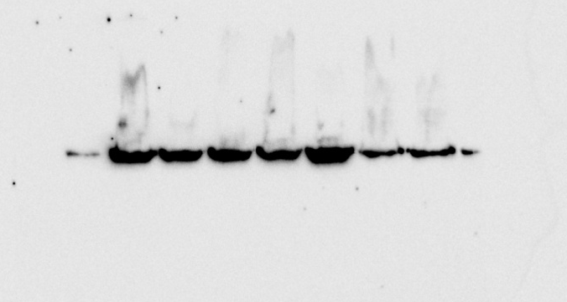

β-actin (43 kDa)

Figure 5d
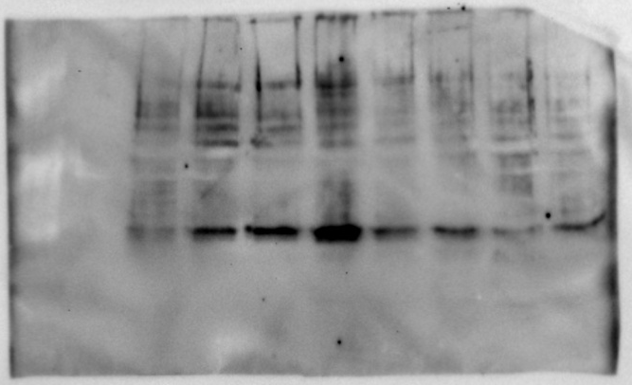
15-LOX (75 kDa)

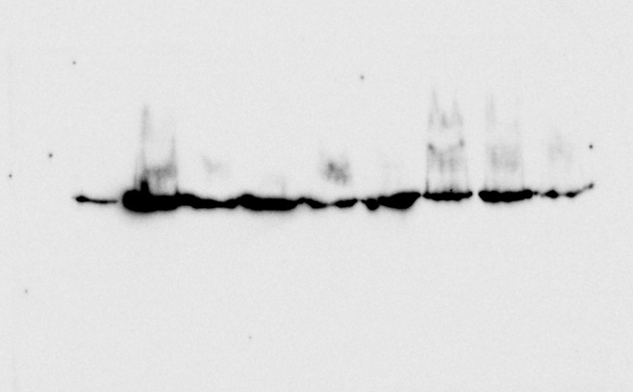
β-actin (43 kDa)
Supplementary figures 4 and 5: Uncropped gel from western blots shown in the main figures of the manuscript. Dotted line represents indirect co-culture of conditioned media of M0, M1 and M2 with hGCs (figure 4) and COV434 (figure 5).

