Assessing the performance of the satellite-based precipitation products (SPPs) in the data-sparse Himalayan terrain
Sonu Kumar¹*, Giriraj Amarnath², Surajit Ghosh², Edward Park¹*, Triambak Baghel³, Wang Jingyu¹, and Devesh Belbase³
¹ National Institute of Education (NIE), and Earth Observatory of Singapore (EOS), Nanyang Technological University (NTU), Singapore
² International Water Management Institute (IWMI), Sri Lanka
³ Water Engineering and Management, Asian Institute of Technology, Pathum Thani, Thailand

* Corresponding authors: Sonu Kumar (sonu92585@gmail.com); Edward Park (edward.park@nie.edu.sg).

Supplementary File

Supplementary Text 1: Observed hydro-meteorological data and Reanalysis-based Potential Evapotranspiration (RPET)
Gauge-based observed rainfall (2003–2018) for 18 rain gauge stations and discharge (2003–2014) for Khokana stream gauge station (station number 550) as an outlet of the basin were obtained from the Department of Hydrology and Meteorology (DHM), Nepal. All gauge-based observed rainfall with fewer missing values (less than 5%) within and nearby the study-selected basin were selected for evaluation (refer to Fig. 1a). The observed precipitation for Simat Khola River Basin at the daily, monthly, and yearly time scales was used to analyze the consistency and temporal variation in precipitation (Supplementary Fig. S1). The Thiessen Polygon (TP) method, widely accepted, was employed to estimate the daily areal precipitation across the basin from point gauge-based observed rainfall. The period of missing value was excluded for comparing the gauge-based rainfall with SPPs to prevent interpolation-related uncertainty. There was a missing value in the daily discharge from 2008 to 2009. Therefore, available discharge from 2003 to 2007 and 2010 to 2014 was used for calibration and validation of the hydrological model respectively.
The latest version of ECMWF reanalysis (ERA5), offers a wide range of climate parameters globally at 0.25° x 0.25° spatial resolution with sufficiently long temporal coverage (from 1950 to the present). At present, ERA5 has completely replaced the ERA-Interim reanalysis. ERA5 is prepared by combining all model results with observed gauge data from the entire world to deliver complete and consistent climate and weather data globally¹. In this study, Potential Evapotranspiration was downloaded at an hourly time scale for a selected study period (2003–2018). The total evapotranspiration was calculated from hourly datasets by taking the sum of evapotranspiration at every hour for one day. After converting the hourly data to daily, the areal average total daily evapotranspiration was extracted for the entire basin using Python programming.

Supplementary Text 2: Satellite-based Precipitation Products (SPPs)
A total of eight most widely-used publicly available SPPs — CHIRPS, CMORPH (V02), IMERG_Early (V06), IMERG_Late (V06), IMERG_Final (V06), PERSIANN, PERSIANN_CCS, and PERSIANN_CDR — were selected, with characteristics such as temporal resolutions, spatial resolutions, spatial and temporal coverage, and latency of datasets.
CHIRPS (Climate Hazards Group InfraRed Precipitation with Station data) is a freely available advanced precipitation dataset from 1981 to the near present. It was developed by the United States Geological Survey Earth Resources Observation and Science Center (USGS-EROSC) and Santa Barbara Climate Hazards Group at the University of California to offer inclusive, consistent, reliable, up-to-date datasets for real-time application (including trend analysis and seasonal drought analysis). It is generated at 0.05° × 0.05° spatial and daily temporal resolution. This is achieved by combining monthly precipitation datasets from Climate Hazards Group Precipitation Climatology (CH-GCP), quasi-global geostationary thermal infrared satellite observations, Tropical Rainfall Monitoring Mission (TRMM) product, atmospheric model precipitation fields from the National Oceanic and Atmospheric Administration (NOAA), Climate Forecast System (CFS), and observed precipitation ²⁻⁴.
NOAA CPC Morphing Technique (CMORPH)⁵ is a very high spatial (8 km at the equator) and temporal (30 minutes) resolution precipitation estimate. It is derived from low orbiter satellite microwave observations, geostationary satellite IR data, passive microwaves aboard the Defense Meteorological Satellite Program (DMSP 13, 14 & 15), the NOAA-15, 16, 17 & 18, Advanced Microwave Sounding Unit B and E and TRMM Microwave Imager aboard (TMI) NASA's Aqua and TRMM spacecraft, respectively. Furthermore, CMORPH datasets are available after 18 hours of real-time. In this study, CMORPH V1.0 data were downloaded at 0.25° and daily spatial and temporal resolution, respectively.
Integrated Multi-Satellite Retrievals for GPM (IMERG) precipitation datasets are created by combining all available data from the GPM satellite constellation. To provide extensive temporal coverage of precipitation data, both precipitations — estimated during the TRMM Era (2000–2015) — and current precipitation — estimated using GPM satellite (2014 to present) — have been merged in the latest version of IMERG data (IMERG V06) ⁶. IMERG provides a total of three types of products, namely IMERG-Early, IMERG-Late, and IMERG-Final for different users after observations of 4 hours, 14 hours, and 3.5 months at 0.1° x 0.1° spatial resolution with 90°S to 90°N global coverage. For this study, daily accumulated IMERG-Early V06 (henceforth referred to as IMERG_Early), IMERG-Late V06 (hereafter IMERG_Late), and IMERG-Final V06 (henceforth IMERG_Final) were downloaded for the selected period of study from the links listed in Table 2. There are two types of precipitation estimates available in the IMERG: HQprecipitation (High-Quality precipitation from all available passive microwave sources) and precipitationCal (Precipitation — combined microwave-IR — estimate with climatological calibration). This study has considered the calibrated products (precipitationCal) to improve the datasets^{6,7}.
PERSIANN (Precipitation Estimation from Remotely Sensed Information using Artificial Neural Networks) are available from 2003 with a spatial resolution at 0.25° x 0.25° and at 1hour temporal resolution with 50°S to 50°N global coverage. The neural network approximation method is used in estimating the precipitation rate from infrared brightness temperature images provided by geostationary satellites (i.e., GOES-8, GOES-10, GMS-5, Metsat-6, and Metsat-7)⁸.
PERSIANN-CCS (PERSIANN-Cloud Classification System) provides real-time precipitation datasets at 0.04° x 0.04° spatial and 1hour temporal resolution with 60°S to 60°N global coverage. The system uses the classification of cloud-patch features based on cloud height, areal extent, and variability of texture estimated from satellite imagery. Next, precipitation values are assigned to each pixel cloud based on a specific curve describing the relationship between rain rate and brightness temperature⁹.
The PERSIANN-CDR (Precipitation Estimation from Remotely Sensed Information using Artificial Neural Networks - Climate Data Record) dataset has been developed to provide long term precipitation data from January 1, 1983, to the present, at 0.25° x 0.25° spatial and daily temporal resolution with the 60°N to 60°S global coverage. It offers consistent, long-term, high-resolution, and global precipitation data for studying the changes and trends in daily precipitation, especially extreme precipitation events, due to climate change and natural variability¹¹.

PERSIANN⁸, PERSIANN-CCS⁹ and PERSIANN-CDR¹⁰ have been developed by the Center for Hydrometeorology and Remote Sensing (CHRS) at the University of California, Irvine (UCI). For this study, all three PERSIANN, CCS, and CDR products were downloaded for a duration of 16 years (2003–2018), in Network Common Data Form (NetCDF) file formats. Besides, most of these datasets have separate data for each day, which poses a significant challenge in process the data for a long period. Therefore, the XARRY Python library was used to merge whole files into a single file to extract the daily accumulated precipitation correspondence to 18-gauge stations for the selected period of this study. Furthermore, daily areal precipitation across the SKRB was calculated by taking the arithmetic mean of all pixels within the basin.

Supplementary Text 3: Performance Indicators
This study employed two statistical approaches to compare the performance of SPPs. The first is categorical variable verification approach, which uses dichotomous verification, i.e., yes/no; here, ‘yes’ and ‘no’, to indicate whether the event happened or not happened, respectively. A threshold value to differentiate between events and not events was taken as 1 mm/day in this study to avoid human error while taking a reading at gauge stations¹¹. The categorical variable verification of SPPs was done using four widely used categorical variable performance indicators, namely the Potential of Detection (POD), False Alarm Ratio (FAR), Accuracy (ACC), and Critical Successive Index (CSI). The second approach for performance comparison is continuous variable verification that measures how the magnitude of SPPs estimates differs from gauge observations. Continuous variable performance indicators —Pearson Correlation Coefficient (CC), Root Mean Square Error (RMSE) and Mean Absolute Error (MAE) — were used to check the accuracy of a continuous variable. The performance indicators along with their formula are mentioned below.
$Probability of detection (POD)=\frac{H}{H+M}$ (Eq. 1)
$False alarm ratio (FAR)=\frac{F}{H+F}$ (Eq. 2)
$Accuracy (ACC)=\frac{H+F}{H+F+M+N}$ (Eq. 3)
$Critical success index (CSI)=\frac{H}{H+M+F}$ (Eq. 4)
$Relative standard error \left(RSE\right)= \sqrt{\frac{\sum_{i=1}^{n}{{\left(P_{i}^{g}-P_{i}^{o}\right)}^{2}}}{n-2}}$ (Eq. 5)
$Pearson correlation coefficient \left(CC\right)=\frac{\sum_{i=1}^{n}{\left(P_{i}^{o}-{\underline{P}}^{o}\right)×\left(P_{i}^{g}-{\underline{P}}^{g}\right)}}{\sqrt{\sum_{i=1}^{n}{{\left(P_{i}^{o}-{\underline{P}}^{o}\right)}^{2}}}×\sqrt{\sum_{i=1}^{n}{{\left(P_{i}^{g}-{\underline{P}}^{g}\right)}^{2}}}}$ (Eq. 6)
$Root mean square error \left(RMSE\right)= \sqrt{\frac{\sum_{i=1}^{n}{{\left(P_{i}^{g}-P_{i}^{o}\right)}^{2}}}{n}}$ (Eq. 7)
$Mean absolute error (MAE)=\frac{1}{n}\sum_{i=1}^{n}{\left|P_{i}^{o}-P_{i}^{g}\right|}$ (Eq. 8)
Where H, M, F, and N represent the number of (i) Correctly detected real precipitation events by the SPPs; (ii) Real precipitation events that failed to be detected by the SPPs; (iii) Incorrectly detected precipitation events by the SPPs, and (iv) No rainfall events in ground-based observed and SPPs, respectively. $P_{i}^{g}$ and $P_{i}^{o}$ denote the SPPs estimates and gauge- precipitation at i^{th} time step, ${\underline{P}}^{g} and$ ${\underline{P}}^{o}$ is the mean value of the SPPs and gauge- precipitation for the selected period, and n represents the size of the sample of SPPs time series.

Supplementary Text 4: Development of a Hydrological Model
GR4J is a lumped model precipitation-runoff, widely recommended for peak simulation, which was used in this study to simulate the hydrological flow at the basin outlet. It requires daily areal precipitation in mm (P) and daily areal potential evapotranspiration in mm (E) as the input, while streamflow in mm per day (Q) is required to calibrate and validate the model.
The working principle of the GR4J model is straightforward. First, it subtracts the potential evapotranspiration (E) from the precipitation to obtain net precipitation. When P_{n} is different from zero, a portion Ps is used to fill the production storage in the upper soil profile as a function of the water content in that storage (S). In the other case, when E_{n} is different from zero, the actual evaporation rate (E_{s}) is calculated as a function of the water content in the production storage. After it is updated, a percolation (or infiltration) leakage (Perc) is computed as a power function of the water content in the storage. Then, the percolated water Perc — along with the portion of net precipitation that is not used to fill the production storage (P_{n}-P_{s}) — is split into two flow components: 90% is routed using a unit hydrograph (UH1) followed by non-linear routing storage, and the remaining 10% is routed using single unit hydrograph UH2. The two-unit hydrographs UH1 and UH2 allow for the simulation of the time lag between the precipitation event and the resulting streamflow peak. Finally, the total runoff is obtained by adding the two routed flow components together¹².

Supplementary Figures
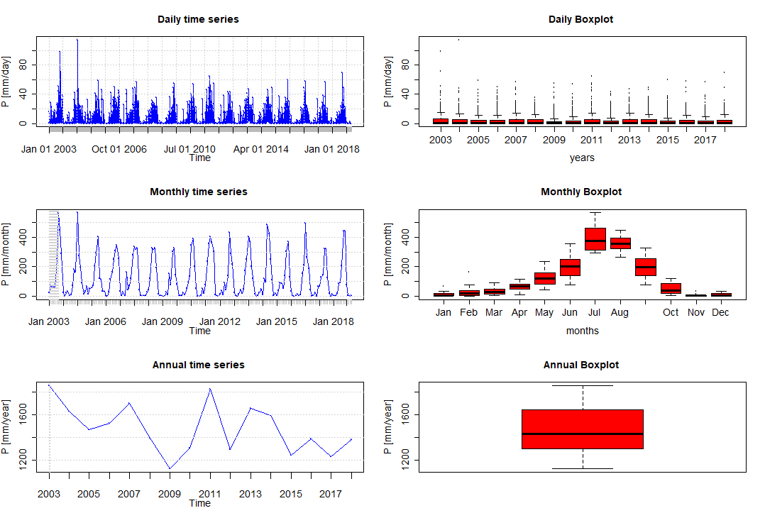
Supplementary Figure S1. Time series and box plots of precipitation (2003–2018) daily monthly, and annually time scale of Simat Khola River Basin, Nepal.
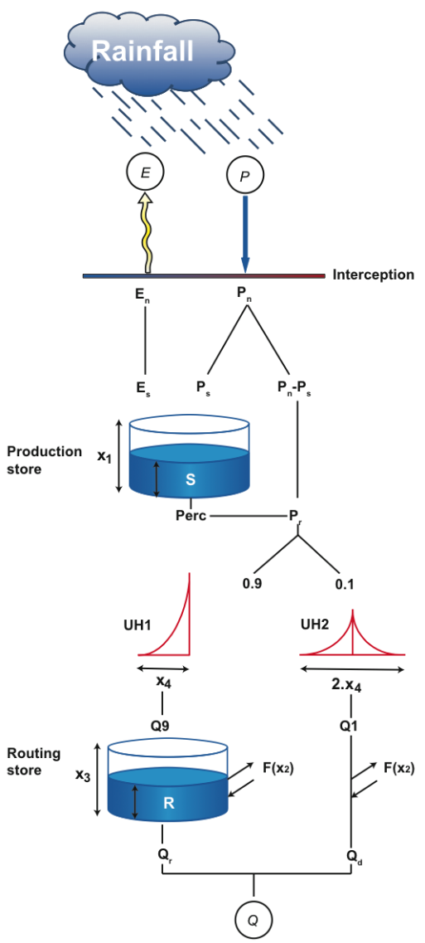
Supplementary Figure S2. Schematic model structure of GR4J with GR4JSG (Source: Perrin et al.)⁸.

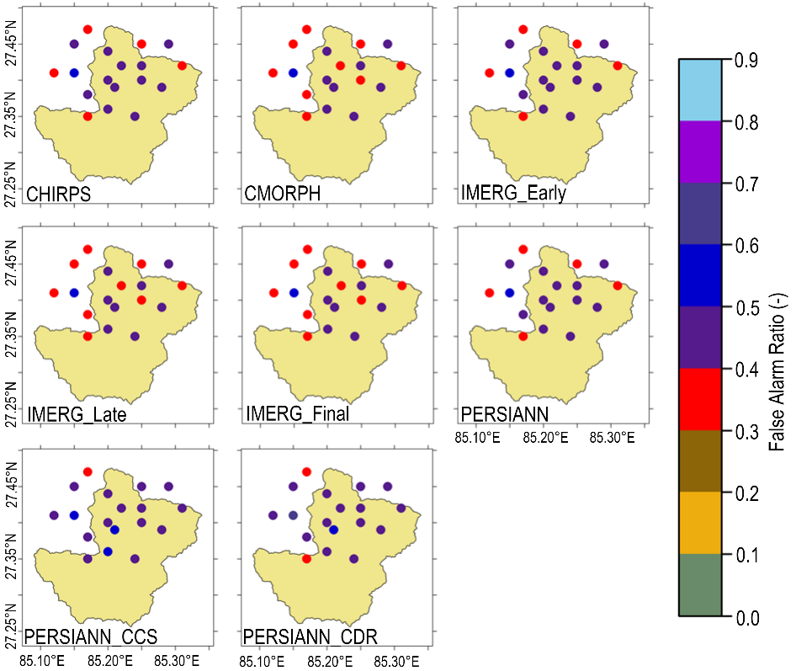

Supplementary Figure S3. Spatial variation in the performance of all datasets in terms of FAR correspondence to each rain gauge station of Simat Khola River Basin from 2003 to 2018.

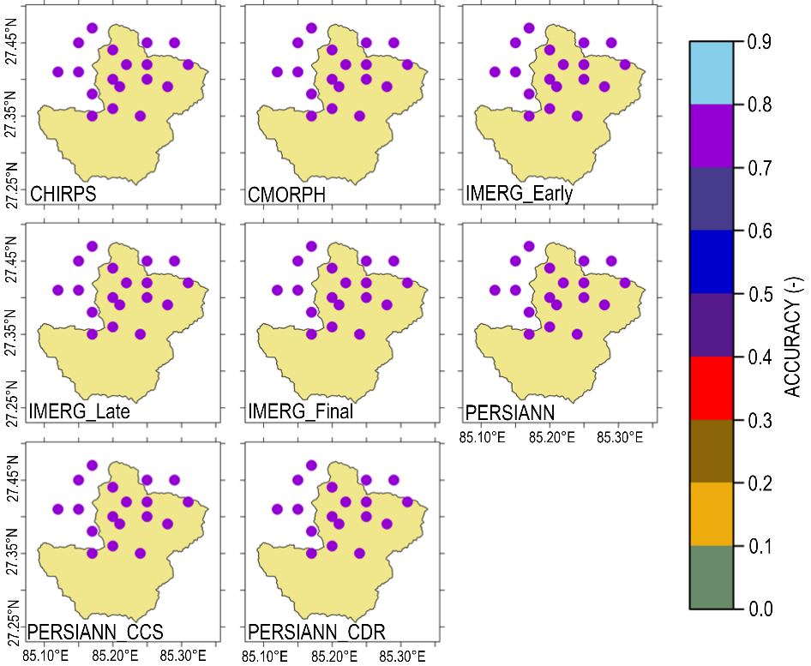

Supplementary Figure S4. Spatial variation in the performance of all datasets in terms of ACC correspondence to each rain gauge station of Simat Khola River Basin from 2003 to 2018.

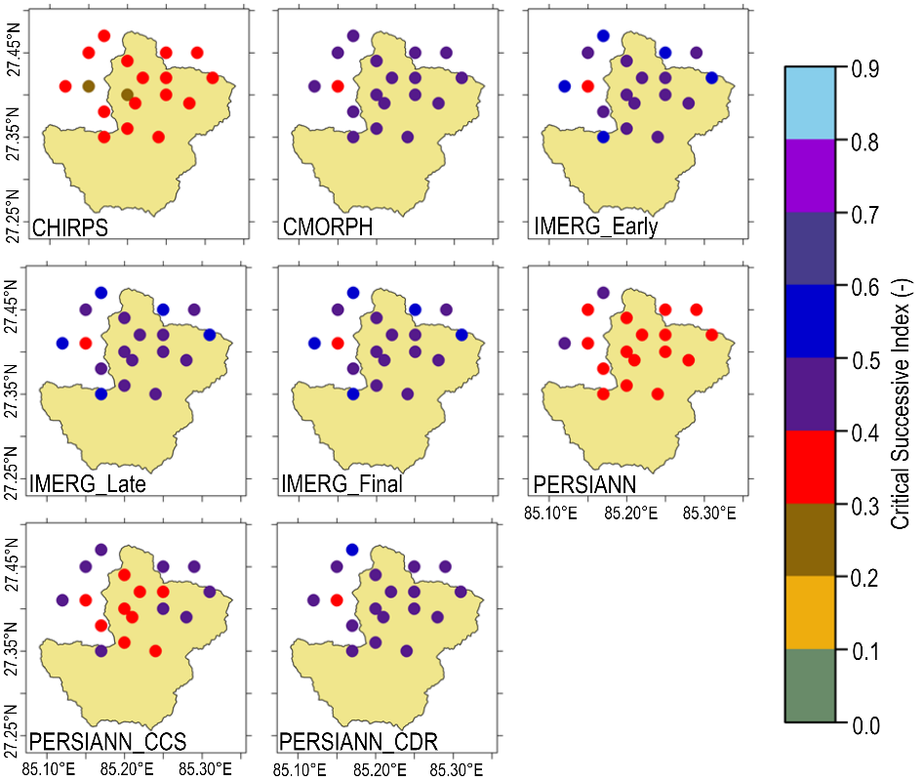

Supplementary Figure S5. Spatial variation in the performance of all datasets in terms of CSI correspondence to each rain gauge station of Simat Khola River Basin from 2003 to 2018.

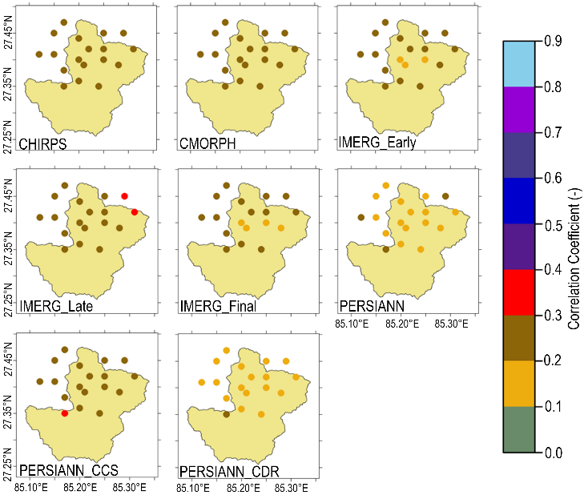

Supplementary Figure S6. Spatial variation in the performance of all datasets in terms of CC correspondence to each rain gauge station of Simat Khola River Basin from 2003 to 2018.

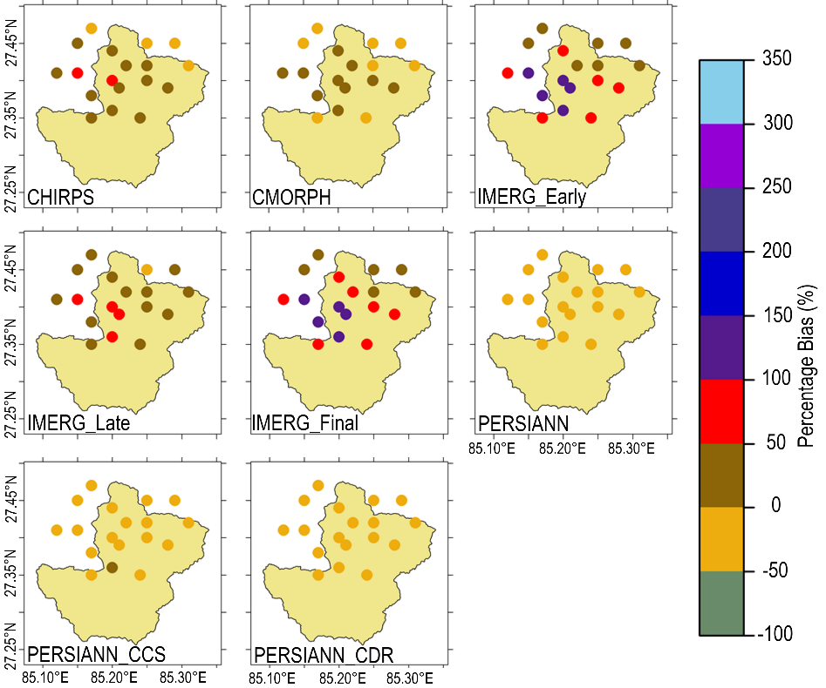

Supplementary Figure S7. Spatial variation in the performance of all datasets in terms of PBIAS correspondence to each rain gauge station of Simat Khola River Basin from 2003 to 2018.

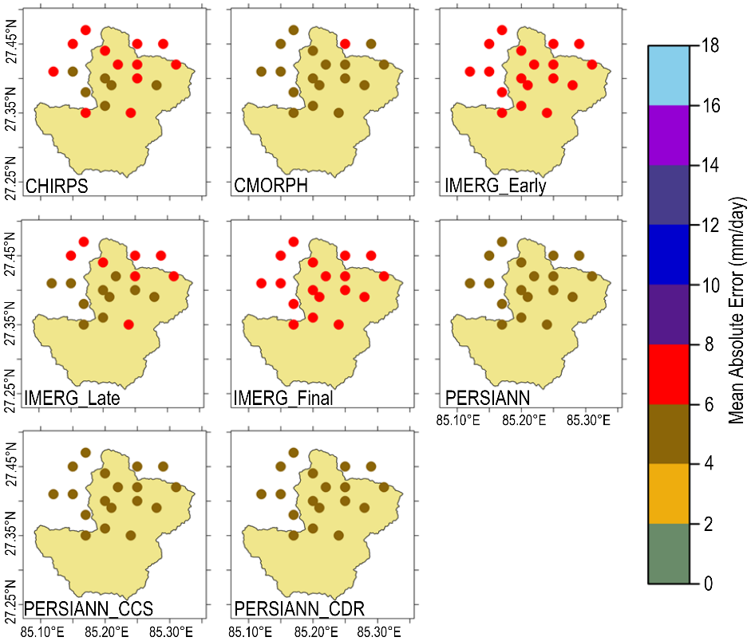

Supplementary Figure S8. Spatial variation in the performance of all datasets in terms of MAE correspondence to each rain gauge station of Simat Khola River Basin from 2003 to 2018.
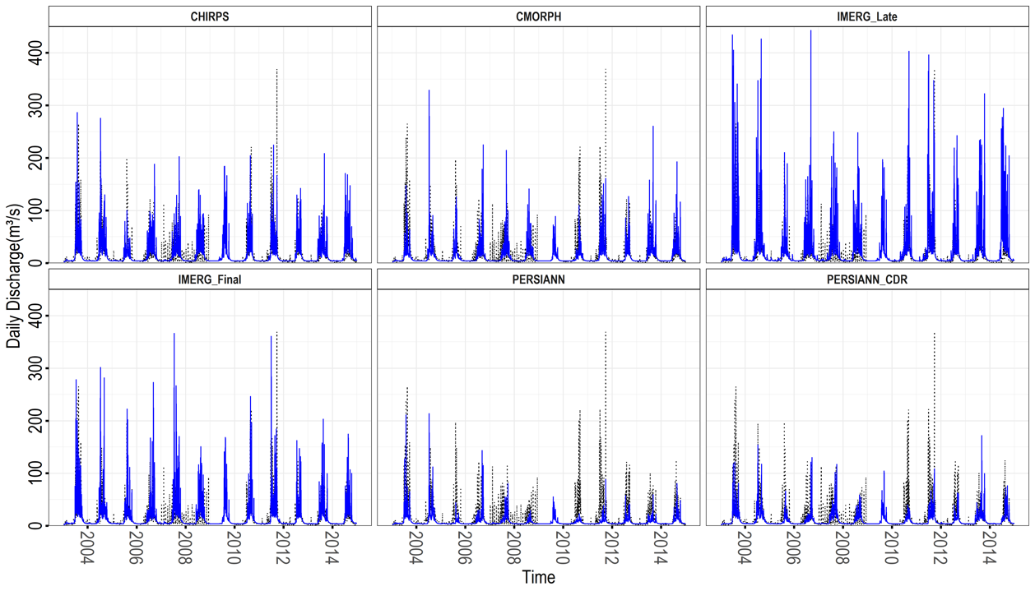
Supplementary Figure S9. Time series plot of daily observed and simulated discharge using GR4J model forced with selected SPPs - Observed (a), CHIRPS (b), CMORPH (c), IMERG_Final (d), PERSIANN (e), and PERSIANN_CDR (f) at the outlet of Simat Khola River Basin (2003–2014).
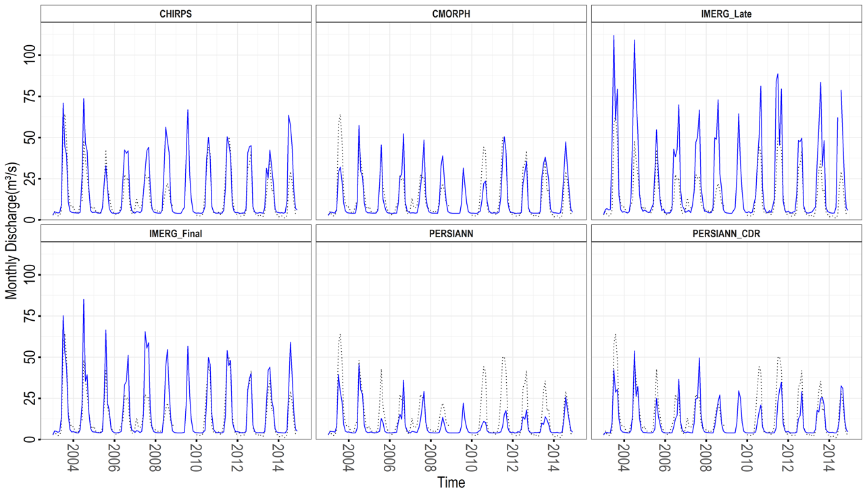
Supplementary Figure S10. Time series plot of monthly observed and simulated discharge using GR4J model forced with selected SPPs - Observed (a), CHIRPS (b), CMORPH (c), IMERG_Final (d), PERSIANN (e), and PERSIANN_CDR (f) at the outlet of Simat Khola River Basin (2003–2014).

Supplementary Tables
Supplementary Table S1. Sources and descriptions of the datasets used in the present study.
Products | Datasets | Period | Spatial Resolution | Frequency | Sources
Gauge | Precipitation | 2003–2018 | Point | Daily | DHM, Nepal
Gauge | Discharge | 2003–2015 | Point | Daily | DHM, Nepal
RPET | ERA5 | 2003–2018 | 0.25° | Hourly | https://cds.climate.copernicus.eu/cdsapp#!/dataset/reanalysis-era5-single-levels?tab=form
SPPs | CHIRPS | 2003–2018 | 0.05° | Daily | https://climateserv.servirglobal.net/
SPPs | CMORPH | 2003–2018 | 0.25° | Daily | https://www.ncei.noaa.gov/data/cmorph-high-resolution-global-precipitation-estimates/access/
SPPs | IMERG_Early | 2003–2018 | 0.1° | Daily | https://earthdata.nasa.gov/
SPPs | IMERG_Final  IMERG_Late | 2003–2018  2003–2018 | 0.1°  0.1° | Daily  Daily | https://earthdata.nasa.gov/  https://earthdata.nasa.gov/
SPPs | PERSIANN | 2003–2018 | 0.25° | Daily | http://chrsdata.eng.uci.edu/
SPPs | PERSIANN_CCS | 2003–2018 | 0.04° | Daily | http://chrsdata.eng.uci.edu/
 | PERSIANN_CDR | 2003–2018 | 0.04° | Daily | http://chrsdata.eng.uci.edu/
Supplementary Table S2. Summary of different parameters of GR4J model and its acceptable range (Source: Perrin et al.⁸).
ID | Description | Units | Process | Range
X1 | Maximum capacity of production storage | mm | ET, percolation | [100.0, 1200.0]
X2 | Groundwater exchange coefficient | mm | Groundwater routing | [ -5.0, 3.0]
X3 | One day ahead maximum capacity of routing store | mm | Soil storage, routing | [ 20.0, 300.0]
X4 | Time base of unit hydrograph UH1 | day | Peak flows | [ 1.1, 2.9]

Supplementary Table S3. Calculated Lp parameter using Compromise Programming and an overall rank of SPPs for the selected river basin.
Station | Lp values (calculated using Compromise Programming)
 | CHIRPS | CMORPH | IMERG_  Early | IMERG_  Final | IMERG_  Late | PERSIANN | PERSIANN_  CCS | PERSIANN_  CDR
1015 | 0.254 | 0.084 | 0.240 | 0.122 | 0.250 | 0.168 | 0.223 | 0.187
1022 | 0.197 | 0.079 | 0.227 | 0.109 | 0.253 | 0.150 | 0.221 | 0.138
1029 | 0.220 | 0.073 | 0.214 | 0.102 | 0.230 | 0.196 | 0.258 | 0.232
1030 | 0.238 | 0.109 | 0.241 | 0.144 | 0.254 | 0.185 | 0.237 | 0.158
1035 | 0.186 | 0.126 | 0.233 | 0.137 | 0.247 | 0.181 | 0.252 | 0.205
1039 | 0.210 | 0.111 | 0.230 | 0.122 | 0.237 | 0.203 | 0.238 | 0.200
1043 | 0.272 | 0.130 | 0.256 | 0.163 | 0.268 | 0.173 | 0.226 | 0.156
1052 | 0.266 | 0.085 | 0.214 | 0.116 | 0.240 | 0.249 | 0.268 | 0.247
1059 | 0.224 | 0.103 | 0.240 | 0.141 | 0.254 | 0.193 | 0.239 | 0.164
1060 | 0.202 | 0.076 | 0.231 | 0.110 | 0.256 | 0.151 | 0.211 | 0.115
1073 | 0.240 | 0.088 | 0.207 | 0.099 | 0.222 | 0.209 | 0.267 | 0.242
1075 | 0.259 | 0.068 | 0.207 | 0.101 | 0.232 | 0.196 | 0.250 | 0.136
1076 | 0.204 | 0.087 | 0.256 | 0.133 | 0.262 | 0.187 | 0.200 | 0.181
1077 | 0.272 | 0.113 | 0.229 | 0.130 | 0.240 | 0.223 | 0.252 | 0.179
1079 | 0.259 | 0.088 | 0.219 | 0.115 | 0.228 | 0.231 | 0.244 | 0.204
1080 | 0.181 | 0.073 | 0.225 | 0.127 | 0.249 | 0.199 | 0.255 | 0.210
1081 | 0.232 | 0.100 | 0.238 | 0.128 | 0.254 | 0.187 | 0.218 | 0.129
Avg. Lp | 0.230 | 0.094 | 0.230 | 0.123 | 0.246 | 0.193 | 0.239 | 0.181
Rank | 5 | 1 | 6 | 2 | 7 | 4 | 8 | 3

Supplementary Table S4. The calculated rank of SPPs for the selected river basin.
Station | Rank
Station | CHIRPS | CMORPH | IMERG_Early | IMERG_  Final | IMERG_  Late | PERSIANN | PERSIANN_  CCS | PERSIANN_  CDR
1015 | 8 | 1 | 6 | 2 | 7 | 3 | 5 | 4
1022 | 5 | 1 | 7 | 2 | 8 | 4 | 6 | 3
1029 | 5 | 1 | 4 | 2 | 6 | 3 | 8 | 7
1030 | 6 | 1 | 7 | 2 | 8 | 4 | 5 | 3
1035 | 4 | 1 | 6 | 2 | 7 | 3 | 8 | 5
1039 | 5 | 1 | 6 | 2 | 7 | 4 | 8 | 3
1043 | 8 | 1 | 6 | 3 | 7 | 4 | 5 | 2
1052 | 7 | 1 | 3 | 2 | 4 | 6 | 8 | 5
1059 | 5 | 1 | 7 | 2 | 8 | 4 | 6 | 3
1060 | 5 | 1 | 7 | 2 | 8 | 4 | 6 | 3
1073 | 6 | 1 | 3 | 2 | 5 | 4 | 8 | 7
1075 | 8 | 1 | 5 | 2 | 6 | 4 | 7 | 3
1076 | 6 | 1 | 7 | 2 | 8 | 4 | 5 | 3
1077 | 8 | 1 | 5 | 2 | 6 | 4 | 7 | 3
1079 | 8 | 1 | 4 | 2 | 5 | 6 | 7 | 3
1080 | 3 | 1 | 6 | 2 | 7 | 4 | 8 | 5
1081 | 6 | 1 | 7 | 2 | 8 | 4 | 5 | 3

References
1 Hersbach, H. et al. The ERA5 global reanalysis. Q. J. R. Meteorolog. Soc. 146, 1999–2049 https://doi.org/10.1002/qj.3803 (2020).
2 Katsanos, D., Retalis, A. & Michaelides, S. Validation of a high-resolution precipitation database (CHIRPS) over Cyprus for a 30-year period. Atmos. Res. 169, 459–464, https://doi.org/10.1016/j.atmosres.2015.05.015 (2016).
3 Tuo, Y., Duan, Z., Disse, M. & Chiogna, G. Evaluation of precipitation input for SWAT modeling in Alpine catchment: A case study in the Adige river basin (Italy). Sci. Total Environ. 573, 66–82, https://doi.org/10.1016/j.scitotenv.2016.08.034 (2016).
4 Luo, X., Wu, W., He, D., Li, Y. & Ji, X. Hydrological simulation using TRMM and CHIRPS precipitation estimates in the lower Lancang-Mekong River Basin. Chin. Geog. Sci. 29, 13–25, https://doi.org/10.1007/s11769-019-1014-6 (2019).
5 Joyce, R. J., Janowiak, J. E., Arkin, P. A. & Xie, P. CMORPH: A Method that produces global precipitation estimates from Ppassive microwave and infrared data at high spatial and temporal resolution. J. Hydrometeorol. 5, 487–503, https:/doi.org/10.1175/1525-7541(2004)005<0487:camtpg>2.0.co;2 (2004).
6 Huffman, G. J., Bolvin, D. T., Nelkin, E. J. & Tan, J. Integrated multi-satellite retrievals for GPM (IMERG) technical documentation. NASA/GSFC Code 612, 2019 (2015).
7 Beck, H. E. et al. MSWEP: 3-hourly 0.25 global gridded precipitation (1979–2015) by merging gauge, satellite, and reanalysis data. Hydrol. Earth Syst. Sci. 21, 589-615 https://doi.org/10.5194/hess-21-589-2017 (2017).
8 Sorooshian, S. et al. Evaluation of PERSIANN system satellite-based estimates of tropical rainfall. Bull. Am. Meteorol. Soc. 81, 2035–2046, https://doi.org/10.1175/1520-0477(2000)081<2035:eopsse>2.3.co;2 (2000).
9 Hong, Y., Hsu, K.-L., Sorooshian, S. & Gao, X. Precipitation estimation from remotely sensed imagery using an artificial neural network cloud classification system. J. Appl. Meteorol. 43, 1834-1853, https://doi.org/10.1175/jam2173.1 (2004).
10 Ashouri, H. et al. PERSIANN-CDR: Daily precipitation climate data record from multisatellite observations for hydrological and climate studies. Bull. Am. Meteorol. Soc. 96, 69–83 https://doi.org/10.1175/BAMS-D-13-00068.1 (2015).
11 Baghel, T., et al. A generalized methodology for ranking climate models based on climate indices for sector-specific studies: An application to the Mekong sub-basin. Sci. Total Environ. 829, https://doi.org/10.1016/j.scitotenv.2022.154551 154551 (2022).
12 Perrin, C., Michel, C. & Andréassian, V. Improvement of a parsimonious model for streamflow simulation. J. Hydrol 279, 275–289, https://doi.org/10.1016/s0022-1694(03)00225-7 (2003).

