Effects of diversity on thermal niche variation in bird communities under climate change
Marjakangas et al.

Supplementary material: Appendix S1

1 Supplementary methods
Table S1. Definitions of species’ functional traits. The traits were considered either continuous, ordinal, or binary. There were no missing values for any traits.
Trait | Definition | Reference
Body size | Body mass (g). Continuous. | (Wilman et al. 2014)
Clutch size | Number of eggs laid in a single brood. Continuous. | (De Magalhães and Costa 2009, Billerman et al. 2020)
Diet allocation | Proportional use of different food categories (%). Categories: invertebrate, vertebrate, scavenge, fruit, nectar or pollen, seed, other plant material. Ordinal. | (Wilman et al. 2014)
Diet diversity | Shannon diversity of proportional (%) use of different food categories. Categories: invertebrate, vertebrate (endotherm), vertebrate (ectotherm), fish, vertebrate (unknown), scavenge, fruit, nectar or pollen, seed, other plant material. Continuous. | (Wilman et al. 2014)
Foraging allocation | Allocation of foraging time to different vertical strata (%). Categories: aerial, aquatic, ground, forest. Ordinal. | (Wilman et al. 2014)
Habitat niche breadth | Number of IUCN habitat categories listed as ‘Suitable’. Continuous. | (IUCN 2019)
Migratory behavior | State of being migratory. Binary. | (Billerman et al. 2020, BirdLife International 2020)
Temperature niche breadth | Standard deviation of the species temperature index (STI) across species’ range. Continuous. | (BirdLife International and NatureServe 2015)

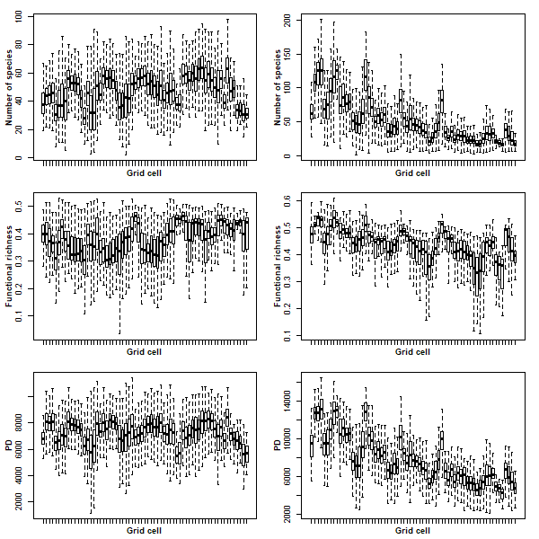

Figure S1. Variation in community diversity among survey routes/sites within grid cells (N = 65). Panels on the left represent taxonomic, functional, and evolutionary diversity measures in the breeding season. Panels on the right represent taxonomic, functional, and evolutionary diversity measures in the non-breeding season. Here, taxonomic diversity is represented as the number of species, functional diversity as functional richness, and evolutionary diversity as phylogenetic diversity (PD). For visualization, outlier values are omitted.
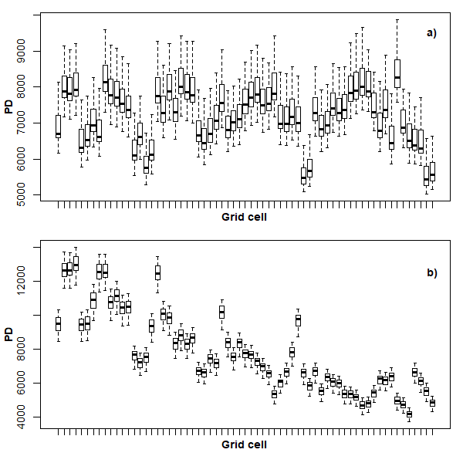
Figure S2. Variation in the mean phylogenetic diversity (PD) values in each grid cell calculated based on 25 replicated phylogenetic trees in breeding (panel a) and non-breeding (panel b) seasons. Phylogenetic diversity is measured as the sum of phylogenetic tree branch lengths in the phylogenetic tree of the community and then averaged over the survey routes/sites within the grid cell. Each box plot represents one grid cell (N = 65).

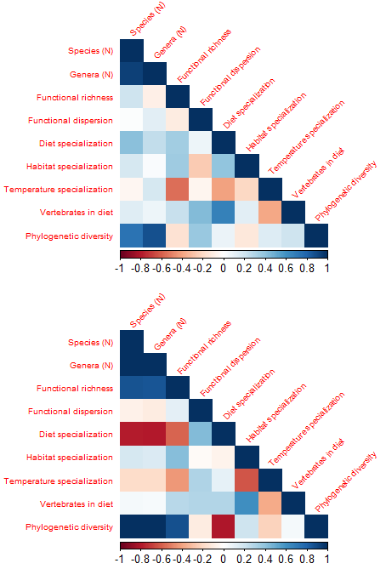
Figure S3. Pairwise correlations of taxonomic, functional, and evolutionary diversity measures quantified with Pearson’s correlation coefficients. The upper and lower panels describe the diversity measure correlations within grid cells for breeding and non-breeding season data, respectively. Diet specialization = Community weighted mean of diet diversity, Habitat specialization = Community weighted mean of habitat niche breadth, Temperature specialization = Community weighted mean of temperature niche breadth, Vertebrates in diet = Community weighted mean of vertebrates in diet. For description of diversity measures, see ‘Methods’ in the main text.
Table S2. Correlations between community diversity measures in the first decade of the dataset (1966-1976) and in the full dataset (1966-2016) in breeding and non-breeding seasons.
 | Correlation coefficient
Diversity measure | Breeding season | Non-breeding season
Number of species | 0.94 | 0.99
Functional richness | 0.87 | 0.92
Functional dispersion | 0.94 | 0.66
Community weighted mean of diet diversity | 0.95 | 0.87
Community weighted mean of temperature niche breadth | 0.79 | 0.94
Community weighted mean of habitat niche breadth | 0.94 | 0.88
Community weighted mean of percentage of vertebrates in diet | 0.87 | 0.89
Phylogenetic diversity | 0.92 | 0.99

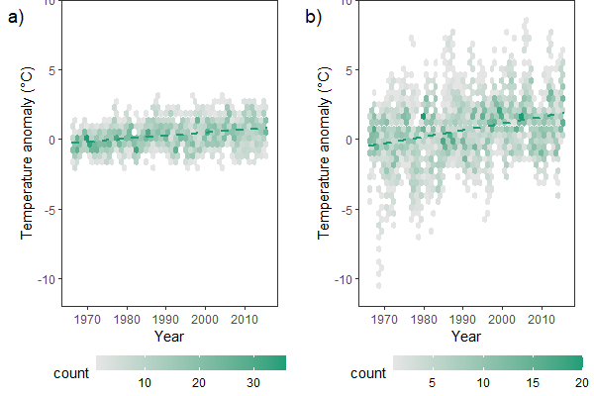
Figure S4. Temporal trends in climate across the study area between 1966 and 2016. As a proxy for measuring regional climate change, we used the observed monthly temperature anomalies in 5° × 5° grid cell data from Earth System Research Laboratory (Jones et al., 2012). Panels a) and b) show the linear temperature trend in the breeding and non-breeding season data, respectively. In both panels, hexagon color gradient indicates the number of observations (here, sampling routes/sites in a year) and the dashed line indicates the linear fit of the regression model: temperature anomaly ~ year.

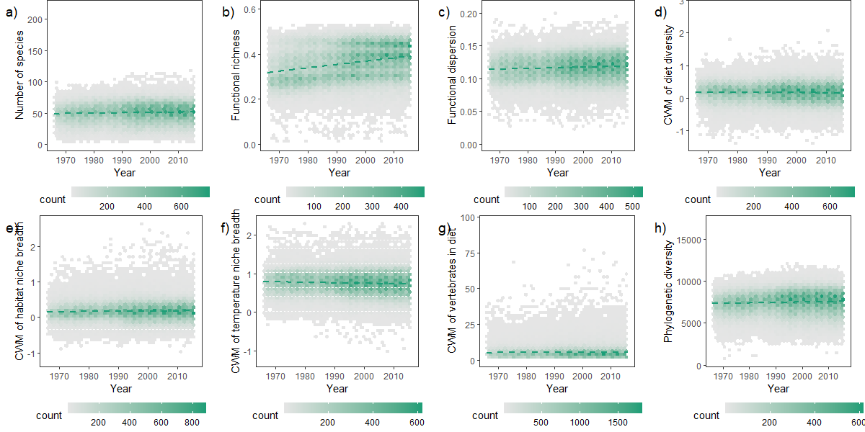

Figure S5. Temporal variation in diversity measures in the breeding season bird communities. Each panel shows the temporal variation in one diversity measure (indicated on the y-axis). In all panels, hexagon color gradient indicates the number of observations (here, sampling routes in a year) and the dashed line indicates the linear fit of the regression model: diversity measure ~ year.
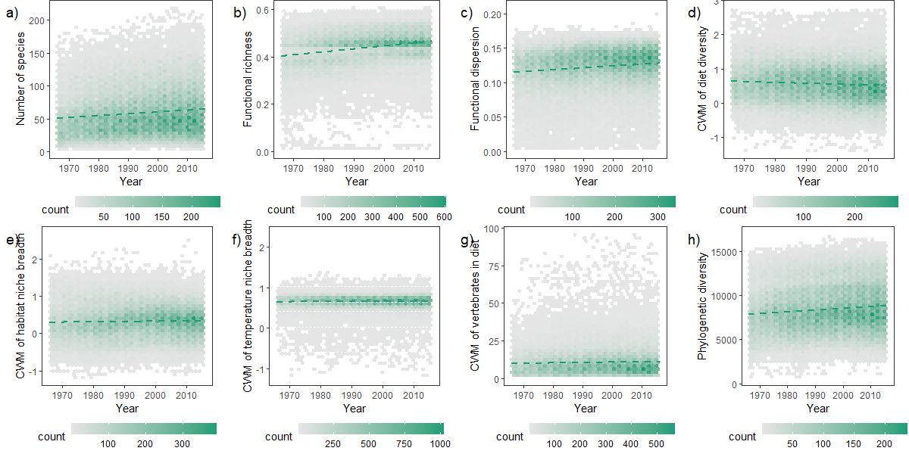
Figure S6. Temporal variation in diversity measures in the non-breeding season bird communities. Each panel shows the temporal variation in one diversity measure (indicated on the y-axis). In all panels, hexagon color gradient indicates the number of observations (here, sampling sites in a year) and the dashed line indicates the linear fit of the regression model: diversity measure ~ year.

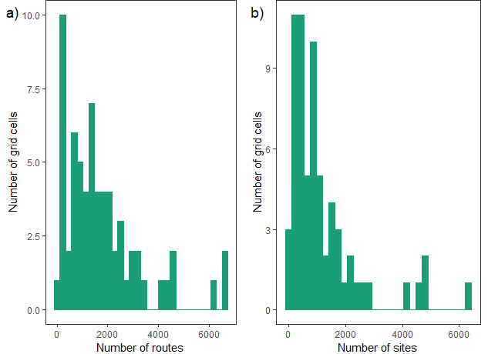
Figure S7. Variation in the number of sampling routes/sites within grid cells across years in the breeding (panel a) and non-breeding (panel b) season data.

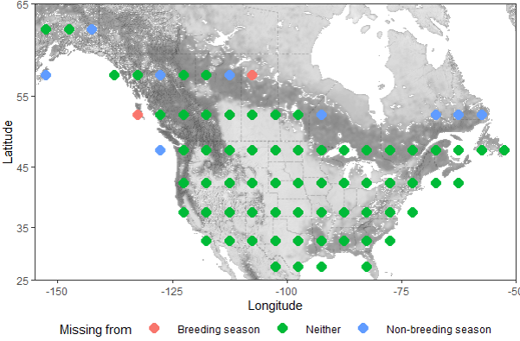
Figure S8. Spatial locations of 5 x 5 degree grid cells across North America. The red and blue circles show the distribution of excluded grid cells that included data only from one of the seasons. Red circles illustrate the grid cells that had data of the non-breeding season bird communities, but not of the breeding season bird communities. On the contrary, blue circles illustrate the grid cells that had data of the breeding season bird communities, but not of the non-breeding season bird communities.

2 Supplementary results
Among all the diversity-thermal variability models (response variable: |∆CTI|), models including community diversity measures performed better than the null model in the non-breeding but not in the breeding season (Table S3). In the breeding season, the null model performed best, while the second best model included the functional dispersion. In the non-breeding season, the diversity-thermal variability models that performed the best included the community weighted mean of vertebrates in diet, while the second best model included the community weighted mean of habitat niche breadth. In the non-breeding season, |∆CTI| was smaller when diversity was higher (Table S4).
We mainly did not find differences in the diversity-thermal variability relationships between breeding and non-breeding seasons (Table S5). More specifically, the interaction term was not significant in any of the models, except in the case of functional richness. The relationship between thermal variability and functional richness was stronger in the non-breeding season.
We inspected visually the best models for each season and found the model residuals normal and variances homogenetic in case of the best model fitted to non-breeding season data (Figures S4-S5).

Table S3. Output of linear models on the diversity-thermal variability relationships (response variable: |∆CTI|) between 1966 and 2016. Each row represents one hypothesis and one linear model with the same response variable and different explanatory variables. All models include a Gaussian spatial correlation structure and are weighted by the grid cell-specific standard errors obtained from the models CTI ~ Year. The best model(s) were identified using Akaike Information Criteria for small samples (AICc). The rows for each season are ordered from best to worst model according to ∆AICc, starting with the best supported model (∆AICc=0). We identified as the best model(s) those models for which ∆AICc ≤ 2. Pseudo R² for gls-models are represented to indicate models’ explanatory power. The coefficient and standard error of diversity measure variables in each model are shown in separate columns. Similarly, the coefficient and p-value of temperature change variable in each model are shown in separate columns.
Hypothesis | Model | ∆AICc | Pseudo R² | Diversity coef | Diversity SE | ∆Temp coef | ∆Temp p-value
Breeding season
Null | |∆CTI| ~ 1 | 0.000 | * | * | * | * | *
Temperature | |∆CTI| ~ ∆Temperature | 2.145 | 0.004 | * | * | 0.0512 | 0.7238
Functional | |∆CTI| ~ ∆Temperature + Functional dispersion | 2.972 | 0.014 | -0.130 | 0.107 | 0.0666 | 0.6455
Taxonomic | |∆CTI| ~ ∆Temperature + Number of species | 3.556 | 0.009 | < 0.001 | < 0.001 | 0.1077 | 0.4934
Functional | |∆CTI| ~ ∆Temperature + Community weighted mean of habitat niche breadth | 3.777 | 0.001 | -0.008 | 0.009 | 0.0157 | 0.9176
Functional | |∆CTI| ~ ∆Temperature + Community weighted mean of temperature niche breadth | 4.088 | 0.027 | -0.004 | 0.007 | 0.0376 | 0.7978
Evolutionary | |∆CTI| ~ ∆Temperature + Phylogenetic diversity | 4.360 | 0.008 | < 0.001 | < 0.001 | 0.027 | 0.8666
Functional | |∆CTI| ~ ∆Temperature + Community weighted mean of diet diversity | 4.477 | 0.001 | -0.001 | 0.007 | 0.0503 | 0.7311
Functional | |∆CTI| ~ ∆Temperature + Community weighted mean of vertebrates in diet | 4.487 | 0.002 | < 0.001 | 0.001 | 0.0505 | 0.7292
Functional | |∆CTI| ~ ∆Temperature + Functional richness | 15.937 | 0.004 | -0.034 | 0.028 | 0.048 | 0.7462
Non-breeding season
Functional | |∆CTI| ~ ∆Temperature + Community weighted mean of vertebrates in diet | 0.000 | 0.110 | -0.002 | 0.001 | -0.0775 | 0.4757
Functional | |∆CTI| ~ ∆Temperature + Community weighted mean of habitat niche breadth | 3.494 | 0.048 | -0.034 | 0.010 | -0.2059 | 0.1014
Null | |∆CTI| ~ 1 | 9.055 | * | * | * | * | *
Functional | |∆CTI| ~ ∆Temperature + Community weighted mean of diet diversity | 9.668 | 0.001 | -0.023 | 0.011 | 0.1035 | 0.458
Temperature | |∆CTI| ~ ∆Temperature | 11.207 | < 0.001 | * | * | -0.0401 | -0.0401
Functional | |∆CTI| ~ ∆Temperature + Community weighted mean of temperature niche breadth | 12.317 | 0.002 | 0.024 | 0.021 | -0.1233 | 0.3804
Evolutionary | |∆CTI| ~ ∆Temperature + Phylogenetic diversity | 13.210 | 0.051 | < 0.001 | < 0.001 | -0.1041 | 0.5175
Taxonomic | |∆CTI| ~ ∆Temperature + Number of species | 13.211 | 0.050 | < 0.001 | < 0.001 | -0.0951 | 0.5279
Functional | |∆CTI| ~ ∆Temperature + Functional dispersion | 13.302 | 0.011 | -0.176 | 0.354 | -0.0346 | 0.77
Functional | |∆CTI| ~ ∆Temperature + Functional richness | 35.366 | 0.086 | -0.145 | 0.110 | -0.3093 | 0.1285
* Not relevant for the model
Table S4. Linear model outputs for the best diversity-thermal variability relationships (response variable: |∆CTI|) in the breeding (B) and non-breeding (NB) seasons (for all models, see Table S3). All models include a Gaussian spatial correlation structure and are weighted by the grid cell-specific standard errors obtained from the models CTI ~ Year.
 | Model
Season | Breeding | Non-breeding
Model structure | |∆CTI| ~ 1 | |∆CTI| ~ ∆Temperature + Community weighted mean of vertebrates in diet
∆AICc | 0 | 0
Model pseudo R² | * | 0.110
df | 64 | 62
Temperature coefficient | * | -0.078
Temperature p | * | 0.476
Diversity measure coefficient | * | -0.002
Diversity measure p | * | <0.001
* Not relevant for the model
Table S5. Magnitude and significance of the seasonal effect on the diversity-thermal variability relationships (response variable: |∆CTI|) between 1966 and 2016. The coefficient and p-value of the interaction term for season and diversity measure are given in the right-most columns. All models include a Gaussian spatial correlation structure and are weighted by the grid cell-specific standard errors obtained from the models CTI ~ Year. Breeding season was set as the baseline.
Hypothesis | Model | Season interaction coefficient |  | Season interaction p
Taxonomic | ∆CTI ~ ∆Temperature + Number of species * Season + (1|Grid cell) | <0.001 | 0.616
Functional | ∆CTI ~ ∆Temperature + Community weighted mean of vertebrates in diet * Season + (1|Grid cell) | <0.001 | 0.760
Functional | ∆CTI ~ ∆Temperature + Community weighted mean of habitat niche breadth * Season + (1|Grid cell) | -0.008 | 0.693
Functional | ∆CTI ~ ∆Temperature + Functional dispersion * Season + (1|Grid cell) | -0.300 | 0.405
Functional | ∆CTI ~ ∆Temperature + Community weighted mean of diet diversity * Season + (1|Grid cell) | 0.009 | 0.564
Functional | ∆CTI ~ ∆Temperature + Community weighted mean of temperature niche breadth * Season + (1|Grid cell) | 0.001 | 0.967
Functional | ∆CTI ~ ∆Temperature + Functional richness * Season + (1|Grid cell) | -0.170 | 0.046
Evolutionary | ∆CTI ~ ∆Temperature + Phylogenetic diversity * Season + (1|Grid cell) | <0.001 | 0.963

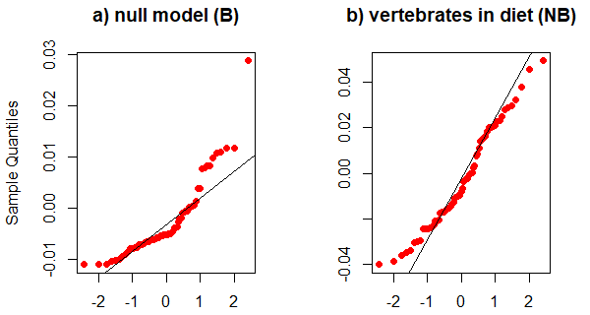
Figure S9. Normality of residuals in the best models (response variable: |∆CTI|) in the breeding (B) and non-breeding seasons (NB) (for the ranking of all models, see Table S3). Each panel represents one of the models listed in Table S4.
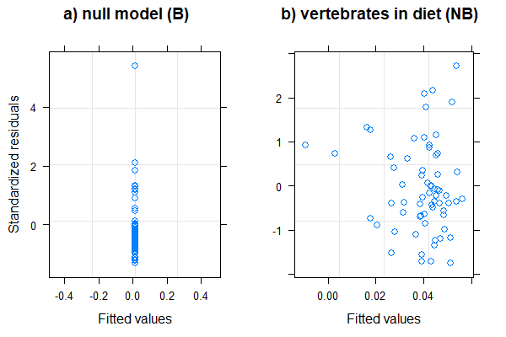
Figure S10. Variance homogeneity of residuals of the best models (response variable: |∆CTI|) in the breeding (B) and non-breeding (NB) seasons (for the ranking of all models, see Table S3). Each panel represents one of the models listed in Table S4.

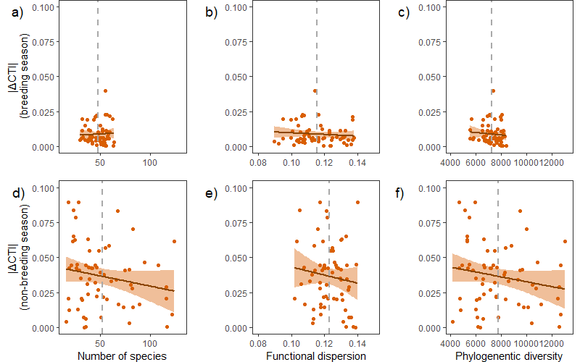
Figure S11. Examples of diversity-thermal variability relationships in breeding and non-breeding seasons. The raw linear relationships with measures of thermal variability and of taxonomic, functional, and evolutionary diversity for each season are illustrated. Thereby, panels a) and d) illustrate the temporal change in community temperature index (|∆CTI|) as a function of the number of species, panels b) and e) illustrate |∆CTI| as a function of the functional dispersion, and panels c) and f) illustrate |∆CTI| as a function of the phylogenetic diversity within the community. The mean of each diversity measure across grid cells is indicated with a grey dashed vertical line. Note that the effect of temperature trend or the spatial correlation structure are not accounted for in the model structures of the illustrated relationships (for full model statistics, see Table S3).

2.1 Sensitivity analyses

To account for the potential variation in temporal trend strengths of CTI and in the development of data collection methods, we conducted a sensitivity analysis of thermal variability models using subsets of the full datasets. By 1980, use of optical tools for bird observations became a standard, potentially increasing the detection probabilities.
We refitted the diversity-thermal variability models using thermal variability measure and community data between years 1980 and 2016. We found that |∆CTI| did not differ between the full and subset data analyses, such that the means across the grid cells in the breeding season were 0.009 and 0.009 and in the non-breeding season were 0.036 and 0.036, in the full and subset data analyses respectively. Qualitatively the general diversity-thermal variability results remained parallel in the sensitivity analysis as in the full data analysis (compare Figures S9 and Figure 3 in the main text). However, the ranking of the models differed, such that in the breeding season, the temperature model was ranked the best and in the non-breeding season, the evolutionary and taxonomic diversity models were ranked above other models (Table S9). However, the functional richness model in the non-breeding season had the steepest diversity-thermal variability slope but was not top-ranked due to high variation (Table S9).
We also tested for the relationship between temperature change and thermal variability in each season and found no significant relationships (Figure S13).

Table S9. Output of linear models on the diversity-thermal variability relationships (response variable: |∆CTI|) for data between years 1980 and 2016. Each row represents one hypothesis and one linear model with the same response variable and different explanatory variables. All models include a Gaussian spatial correlation structure and are weighted by the grid cell-specific standard errors obtained from the models CTI ~ Year. The best model(s) were identified using Akaike Information Criteria for small samples. The rows for each season are ordered from best to worst model according to ∆AICc, starting with the best supported model (∆AICc=0). We identified as the best model(s) those models for which ∆AICc ≤ 2. Pseudo R² for gls-models are represented to indicate models’ explanatory power. The coefficient and standard error of diversity measure variables in each model are shown in separate columns.
Hypothesis | Model | ∆AICc | Pseudo R² | Diversity coefficient | Diversity SE
Breeding season
Temperature | |∆CTI| ~ ∆Temperature | 0.000 | 0.045 | * | *
Functional | |∆CTI| ~ ∆Temperature + Community weighted mean of diet diversity | 0.873 | 0.061 | 0.008 | 0.006
Functional | |∆CTI| ~ ∆Temperature + Community weighted mean of vertebrates in diet | 1.670 | 0.061 | <0.001 | 0.001
Functional | |∆CTI| ~ ∆Temperature + Community weighted mean of temperature niche breadth | 1.829 | 0.055 | -0.005 | 0.007
Evolutionary | |∆CTI| ~ ∆Temperature + Phylogenetic diversity | 2.019 | 0.046 | <0.001 | <0.001
Taxonomic | |∆CTI| ~ ∆Temperature + Number of species | 2.242 | 0.045 | <0.001 | <0.001
Functional | |∆CTI| ~ ∆Temperature + Community weighted mean of habitat niche breadth | 2.338 | 0.045 | 0.001 | 0.009
Functional | |∆CTI| ~ ∆Temperature + Functional dispersion | 2.346 | 0.044 | -0.012 | 0.113
Functional | |∆CTI| ~ ∆Temperature + Functional richness | 7.931 | 0.025 | 0.030 | 0.031
Null | |∆CTI| ~ 1 | 11.562 | * | * | *
Non-breeding season
Evolutionary | |∆CTI| ~ ∆Temperature + Phylogenetic diversity | 0.000 | 0.081 | <0.001 | <0.001
Taxonomic | |∆CTI| ~ ∆Temperature + Number of species | 0.985 | 0.066 | <0.001 | <0.001
Null | |∆CTI| ~ 1 | 2.678 | * | * | *
Temperature | |∆CTI| ~ ∆Temperature | 4.278 | 0.002 | * | *
Functional | |∆CTI| ~ ∆Temperature + Community weighted mean of vertebrates in diet | 4.460 | 0.054 | -0.001 | 0.001
Functional | |∆CTI| ~ ∆Temperature + Community weighted mean of habitat niche breadth | 6.237 | 0.011 | -0.007 | 0.011
Functional | |∆CTI| ~ ∆Temperature + Community weighted mean of diet diversity | 6.542 | 0.002 | 0.003 | 0.010
Functional | |∆CTI| ~ ∆Temperature + Functional dispersion | 6.604 | 0.003 | -0.066 | 0.350
Functional | |∆CTI| ~ ∆Temperature + Community weighted mean of temperature niche breadth | 6.618 | 0.002 | 0.003 | 0.023
Functional | |∆CTI| ~ ∆Temperature + Functional richness | 16.548 | 0.301 | -0.131 | 0.064
* Not relevant for the model

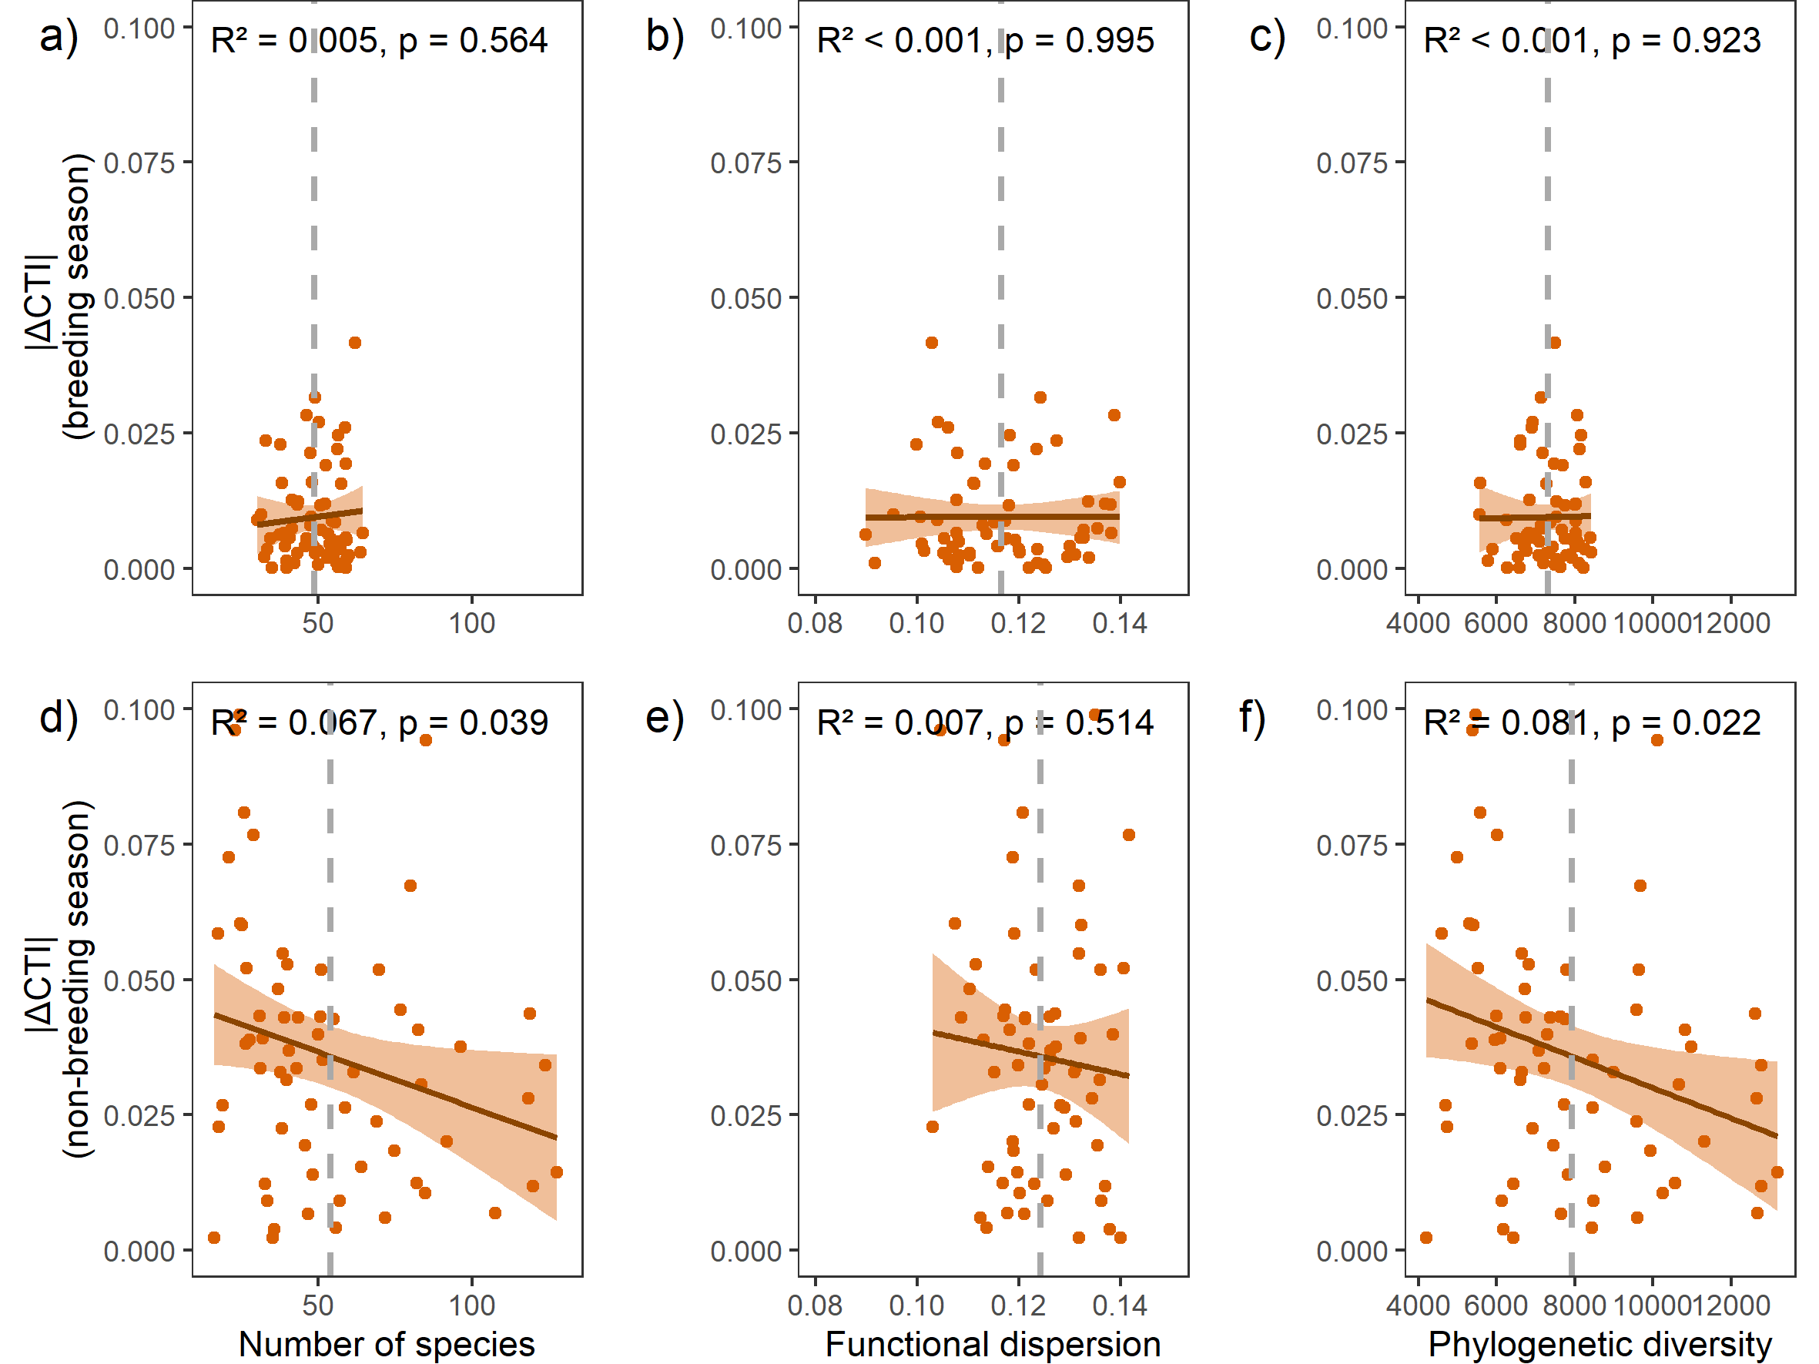
Figure S12. Examples of diversity-thermal variability relationships (response variable: |∆CTI|) in a)-c) breeding and d)-f) non-breeding seasons for data between years 1980 and 2016. The linear relationships with metrics of taxonomic, functional and evolutionary diversity for each season are illustrated. Thereby, panels a) and d) illustrate the temporal change in community temperature index (|∆CTI|) as a function of the number of species, panels b) and e) illustrate |∆CTI| as a function of the functional dispersion, and panels c) and f) illustrate |∆CTI| as a function of the phylogenetic diversity within the community. The model explanatory power and statistical significance are labelled at the top of each panel. Note that the effect of temperature trend is not accounted for in the model structure of the illustrated relationships (see Table S7).

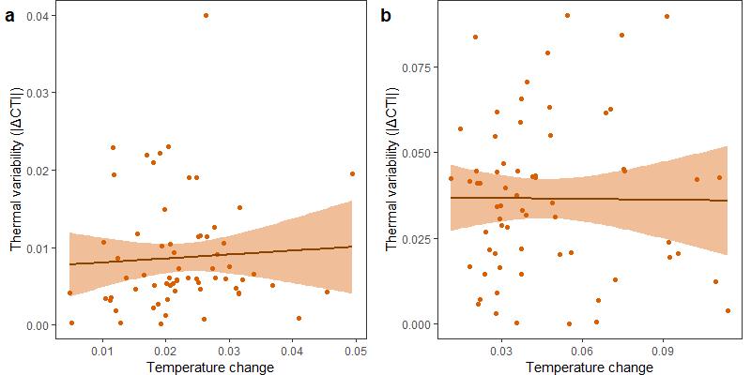
Figure S13. Thermal variability ~ temperature change relationships for the breeding (panel a) and the non-breeding (panel b) season bird communities. Each orange circle represents one grid cell. The solid lines represent the linear relationships. Neither of the relationships was statistically significant (breeding season: temperature coefficient = 0.051, SE = 0.106, p = 0.633; non-breeding season: temperature coefficient -0.008, SE = 0.110, p = 0.941). This means that the thermal variability was neither higher nor lower in areas where climate (temperature) change has been more intense.

3 Supplementary references
Billerman, S. M. et al. 2020. Birds of the World. in press.
BirdLife International 2020. IUCN Red List for birds.
BirdLife International and NatureServe 2015. Bird species distribution maps of the world. Version 4.0. in press.
De Magalhães, J. P. and Costa, J. 2009. A database of vertebrate longevity records and their relation to other life‐history traits. - J. Evol. Biol. 22: 1770–1774.
IUCN 2019. The IUCN Red List of Threatened Species. Version 2019-2.
Wilman, H. et al. 2014. EltonTraits 1.0: Species-level foraging attributes of the world’s birds and mammals. - Ecology 95: 2027–2027.

Supplementary material: Appendix S2

1 List of species included in the datasets
Species in breeding season data | Species in non-breeding season data
Acanthis flammea | Acanthis flammea
Accipiter cooperii | Accipiter cooperii
Accipiter gentilis | Accipiter gentilis
Accipiter striatus | Accipiter striatus
Actitis macularius | Actitis macularius
Aechmophorus clarkii | Aechmophorus clarkii
Aechmophorus occidentalis | Aechmophorus occidentalis
Aegolius acadicus | Aegolius acadicus
Aegolius funereus | Aegolius funereus
Aeronautes saxatalis | Aeronautes saxatalis
Agelaius phoeniceus | Aethia cristatella
Agelaius tricolor | Agelaius phoeniceus
Aimophila ruficeps | Agelaius tricolor
Aix sponsa | Aimophila ruficeps
Alca torda | Aix sponsa
Amazilia violiceps | Alca torda
Amazilia yucatanensis | Alle alle
Amazona viridigenalis | Amazilia beryllina
Ammodramus savannarum | Amazilia violiceps
Ammospiza caudacuta | Amazilia yucatanensis
Ammospiza leconteii | Amazona aestiva
Ammospiza maritima | Amazona albifrons
Ammospiza nelsoni | Amazona amazonica
Amphispiza bilineata | Amazona auropalliata
Anas acuta | Amazona autumnalis
Anas crecca | Amazona farinosa
Anas fulvigula | Amazona finschi
Anas platyrhynchos | Amazona ochrocephala
Anas rubripes | Amazona oratrix
Anhinga anhinga | Amazona viridigenalis
Anser albifrons | Ammodramus savannarum
Anser caerulescens | Amphispiza bilineata
Anthus rubescens | Amphispiza quinquestriata
Anthus spragueii | Anas acuta
Antigone canadensis | Anas americana
Antrostomus arizonae | Anas bahamensis
Antrostomus carolinensis | Anas clypeata
Antrostomus vociferus | Anas crecca
Aphelocoma californica | Anas cyanoptera
Aphelocoma coerulescens | Anas discors
Aphelocoma wollweberi | Anas fulvigula
Aquila chrysaetos | Anas penelope
Aramus guarauna | Anas platyrhynchos
Archilochus alexandri | Anas rubripes
Archilochus colubris | Anas strepera
Ardea alba | Anhinga anhinga
Ardea herodias | Anser albifrons
Arenaria interpres | Anthracothorax prevostii
Arremonops rufivirgatus | Anthus rubescens
Artemisiospiza belli | Anthus spragueii
Artemisiospiza nevadensis | Antrostomus carolinensis
Asio flammeus | Antrostomus vociferus
Asio otus | Aphelocoma californica
Athene cunicularia | Aphelocoma coerulescens
Auriparus flaviceps | Aphelocoma wollweberi
Aythya affinis | Aquila chrysaetos
Aythya americana | Ara ararauna
Aythya collaris | Ara severus
Aythya marila | Aramus guarauna
Aythya valisineria | Aratinga nenday
Baeolophus atricristatus | Aratinga weddellii
Baeolophus bicolor | Archilochus alexandri
Baeolophus inornatus | Archilochus colubris
Baeolophus ridgwayi | Ardea alba
Baeolophus wollweberi | Ardea herodias
Bartramia longicauda | Ardenna bulleri
Bombycilla cedrorum | Ardenna carneipes
Bombycilla garrulus | Ardenna creatopus
Bonasa umbellus | Ardenna gravis
Botaurus lentiginosus | Ardenna grisea
Brachyramphus marmoratus | Ardenna tenuirostris
Branta bernicla | Arenaria interpres
Branta canadensis | Arenaria melanocephala
Branta hutchinsii | Arremonops rufivirgatus
Bubo virginianus | Artemisiospiza belli
Bubulcus ibis | Artemisiospiza nevadensis
Bucephala albeola | Asio flammeus
Bucephala clangula | Asio otus
Bucephala islandica | Athene cunicularia
Buteo albonotatus | Auriparus flaviceps
Buteo brachyurus | Aythya affinis
Buteo jamaicensis | Aythya americana
Buteo lagopus | Aythya collaris
Buteo lineatus | Aythya marila
Buteo plagiatus | Aythya valisineria
Buteo platypterus | Baeolophus atricristatus
Buteo regalis | Baeolophus bicolor
Buteo swainsoni | Baeolophus inornatus
Buteogallus anthracinus | Baeolophus ridgwayi
Butorides striata | Baeolophus wollweberi
Cairina moschata | Bartramia longicauda
Calamospiza melanocorys | Basileuterus culicivorus
Calcarius lapponicus | Basileuterus rufifrons
Calcarius ornatus | Bombycilla cedrorum
Calcarius pictus | Bombycilla garrulus
Calidris alba | Bonasa umbellus
Calidris bairdii | Botaurus lentiginosus
Calidris minutilla | Brachyramphus brevirostris
Calidris pusilla | Brachyramphus marmoratus
Calidris virgata | Branta bernicla
Callipepla californica | Branta canadensis
Callipepla gambelii | Branta hutchinsii
Callipepla squamata | Brotogeris chiriri
Calothorax lucifer | Brotogeris jugularis
Calypte anna | Brotogeris versicolurus
Calypte costae | Bubo scandiacus
Camptostoma imberbe | Bubo virginianus
Campylorhynchus brunneicapillus | Bubulcus ibis
Caracara cheriway | Bucephala albeola
Cardellina canadensis | Bucephala clangula
Cardellina pusilla | Bucephala islandica
Cardellina rubrifrons | Buteo albonotatus
Cardinalis cardinalis | Buteo brachyurus
Cardinalis sinuatus | Buteo jamaicensis
Cathartes aura | Buteo lagopus
Catharus bicknelli | Buteo lineatus
Catharus fuscescens | Buteo plagiatus
Catharus guttatus | Buteo platypterus
Catharus minimus | Buteo regalis
Catharus ustulatus | Buteo swainsoni
Catherpes mexicanus | Buteogallus anthracinus
Centrocercus minimus | Buteogallus urubitinga
Centrocercus urophasianus | Butorides virescens
Cepphus columba | Cairina moschata
Cepphus grylle | Calamospiza melanocorys
Cerorhinca monocerata | Calcarius lapponicus
Certhia americana | Calcarius ornatus
Chaetura pelagica | Calcarius pictus
Chaetura vauxi | Calidris acuminata
Chamaea fasciata | Calidris alba
Charadrius melodus | Calidris alpina
Charadrius montanus | Calidris bairdii
Charadrius nivosus | Calidris canutus
Charadrius semipalmatus | Calidris fuscicollis
Charadrius wilsonia | Calidris himantopus
Charadrius vociferus | Calidris maritima
Chlidonias niger | Calidris mauri
Chloroceryle americana | Calidris melanotos
Chondestes grammacus | Calidris minutilla
Chondrohierax uncinatus | Calidris ptilocnemis
Chordeiles acutipennis | Calidris pugnax
Chordeiles minor | Calidris pusilla
Cinclus mexicanus | Calidris subruficollis
Circus hudsonius | Calidris virgata
Cistothorus palustris | Callipepla californica
Cistothorus platensis | Callipepla douglasii
Clangula hyemalis | Callipepla gambelii
Coccyzus americanus | Callipepla squamata
Coccyzus erythropthalmus | Calonectris diomedea
Coccyzus minor | Calypte anna
Colaptes auratus | Calypte costae
Colaptes chrysoides | Camptostoma imberbe
Colinus virginianus | Campylorhynchus brunneicapillus
Columbina inca | Caracara cheriway
Columbina passerina | Cardellina canadensis
Columbina talpacoti | Cardellina pusilla
Contopus cooperi | Cardinalis cardinalis
Contopus pertinax | Cardinalis sinuatus
Contopus sordidulus | Cathartes aura
Contopus virens | Catharus fuscescens
Coragyps atratus | Catharus guttatus
Corvus brachyrhynchos | Catharus minimus
Corvus caurinus | Catharus ustulatus
Corvus corax | Catherpes mexicanus
Corvus cryptoleucus | Centrocercus minimus
Corvus ossifragus | Centrocercus urophasianus
Coturnicops noveboracensis | Cepphus columba
Crotophaga ani | Cepphus grylle
Crotophaga sulcirostris | Cerorhinca monocerata
Cyanocitta cristata | Certhia americana
Cyanocitta stelleri | Chaetura pelagica
Cyanocorax yncas | Chaetura vauxi
Cygnus buccinator | Chamaea fasciata
Cygnus columbianus | Charadrius melodus
Cynanthus latirostris | Charadrius montanus
Cypseloides niger | Charadrius nivosus
Cyrtonyx montezumae | Charadrius semipalmatus
Dendragapus fuliginosus | Charadrius wilsonia
Dendragapus obscurus | Charadrius vociferus
Dendrocygna autumnalis | Chen caerulescens
Dendrocygna bicolor | Chen canagica
Dolichonyx oryzivorus | Chen rossii
Dryobates nuttallii | Chlidonias niger
Dryobates pubescens | Chloroceryle americana
Dryobates scalaris | Chondestes grammacus
Dumetella carolinensis | Chondrohierax uncinatus
Egretta caerulea | Chordeiles acutipennis
Egretta rufescens | Chordeiles minor
Egretta thula | Chroicocephalus philadelphia
Egretta tricolor | Chroicocephalus ridibundus
Elanoides forficatus | Cinclus mexicanus
Elanus leucurus | Cistothorus palustris
Empidonax alnorum | Cistothorus platensis
Empidonax difficilis | Clangula hyemalis
Empidonax flaviventris | Coccyzus americanus
Empidonax fulvifrons | Coccyzus erythropthalmus
Empidonax hammondii | Coccyzus minor
Empidonax minimus | Coereba flaveola
Empidonax oberholseri | Colaptes auratus
Empidonax occidentalis | Colaptes chrysoides
Empidonax traillii | Colinus virginianus
Empidonax virescens | Columbina inca
Empidonax wrightii | Columbina passerina
Eremophila alpestris | Columbina talpacoti
Eudocimus albus | Contopus cooperi
Eugenes fulgens | Contopus pertinax
Euphagus carolinus | Contopus sordidulus
Euphagus cyanocephalus | Contopus virens
Falcipennis canadensis | Coragyps atratus
Falco columbarius | Corvus brachyrhynchos
Falco femoralis | Corvus caurinus
Falco mexicanus | Corvus corax
Falco peregrinus | Corvus cryptoleucus
Falco rusticolus | Corvus imparatus
Falco sparverius | Corvus ossifragus
Fregata magnificens | Coturnicops noveboracensis
Fulica americana | Crotophaga ani
Gallinago delicata | Crotophaga sulcirostris
Gallinula galeata | Cyanocitta cristata
Gavia immer | Cyanocitta stelleri
Gavia pacifica | Cyanocompsa parellina
Gavia stellata | Cyanocorax sanblasianus
Gelochelidon nilotica | Cyanocorax yncas
Geococcyx californianus | Cygnus buccinator
Geothlypis formosa | Cygnus columbianus
Geothlypis philadelphia | Cygnus cygnus
Geothlypis tolmiei | Cygnus melancoryphus
Geothlypis trichas | Cynanthus latirostris
Geranoaetus albicaudatus | Cypseloides niger
Glaucidium brasilianum | Cyrtonyx montezumae
Glaucidium gnoma | Dendragapus fuliginosus
Grus americana | Dendragapus obscurus
Gymnogyps californianus | Dendrocygna autumnalis
Gymnorhinus cyanocephalus | Dendrocygna bicolor
Haematopus ater | Dolichonyx oryzivorus
Haematopus palliatus | Dryocopus pileatus
Haemorhous cassinii | Dumetella carolinensis
Haemorhous mexicanus | Egretta caerulea
Haemorhous purpureus | Egretta rufescens
Haliaeetus leucocephalus | Egretta thula
Helmitheros vermivorum | Egretta tricolor
Hesperiphona vespertina | Elanoides forficatus
Himantopus himantopus | Elanus leucurus
Hirundo rustica | Empidonax difficilis
Histrionicus histrionicus | Empidonax flaviventris
Hydrobates leucorhous | Empidonax hammondii
Hydroprogne caspia | Empidonax minimus
Hylatomus pileatus | Empidonax oberholseri
Hylocichla mustelina | Empidonax occidentalis
Icteria virens | Empidonax traillii
Icterus bullockii | Empidonax virescens
Icterus cucullatus | Empidonax wrightii
Icterus galbula | Eremophila alpestris
Icterus graduacauda | Eudocimus albus
Icterus gularis | Eudocimus ruber
Icterus parisorum | Eugenes fulgens
Icterus pectoralis | Euphagus carolinus
Icterus spurius | Euphagus cyanocephalus
Ictinia mississippiensis | Eupsittula canicularis
Ixobrychus exilis | Euptilotis neoxenus
Ixoreus naevius | Falcipennis canadensis
Junco hyemalis | Falco columbarius
Junco phaeonotus | Falco femoralis
Lagopus lagopus | Falco mexicanus
Lagopus leucura | Falco peregrinus
Lagopus muta | Falco rusticolus
Lampornis clemenciae | Falco sparverius
Lanius borealis | Fratercula arctica
Lanius ludovicianus | Fratercula cirrhata
Larus atricilla | Fratercula corniculata
Larus californicus | Fulica americana
Larus canus | Fulmarus glacialis
Larus delawarensis | Gallinago delicata
Larus glaucescens | Gallinula galeata
Larus heermanni | Gallus gallus
Larus hyperboreus | Gavia adamsii
Larus marinus | Gavia immer
Larus occidentalis | Gavia pacifica
Larus philadelphia | Gavia stellata
Larus pipixcan | Gelochelidon nilotica
Larus ridibundus | Geococcyx californianus
Larus smithsonianus | Geothlypis formosa
Laterallus jamaicensis | Geothlypis philadelphia
Leiothlypis celata | Geothlypis poliocephala
Leiothlypis luciae | Geothlypis tolmiei
Leiothlypis peregrina | Geothlypis trichas
Leiothlypis ruficapilla | Geranoaetus albicaudatus
Leiothlypis virginiae | Geranospiza caerulescens
Leptotila verreauxi | Glaucidium brasilianum
Leuconotopicus albolarvatus | Glaucidium gnoma
Leuconotopicus arizonae | Grus americana
Leuconotopicus borealis | Grus canadensis
Leuconotopicus villosus | Gymnogyps californianus
Leucosticte atrata | Gymnorhinus cyanocephalus
Leucosticte australis | Haematopus bachmani
Leucosticte tephrocotis | Haematopus palliatus
Limnodromus griseus | Haemorhous cassinii
Limnodromus scolopaceus | Haemorhous mexicanus
Limnothlypis swainsonii | Haemorhous purpureus
Limosa fedoa | Haliaeetus leucocephalus
Limosa haemastica | Helmitheros vermivorum
Lophodytes cucullatus | Himantopus mexicanus
Loxia curvirostra | Hirundo rustica
Loxia leucoptera | Histrionicus histrionicus
Mareca americana | Hydrocoloeus minutus
Mareca strepera | Hydroprogne caspia
Megaceryle alcyon | Hylocharis leucotis
Megaceryle torquata | Hylocichla mustelina
Megascops asio | Icteria virens
Megascops kennicottii | Icterus bullockii
Megascops trichopsis | Icterus cucullatus
Melanerpes aurifrons | Icterus galbula
Melanerpes carolinus | Icterus graduacauda
Melanerpes erythrocephalus | Icterus gularis
Melanerpes formicivorus | Icterus parisorum
Melanerpes lewis | Icterus pectoralis
Melanerpes uropygialis | Icterus pustulatus
Melanitta americana | Icterus spurius
Melanitta fusca | Icterus wagleri
Melanitta perspicillata | Ictinia mississippiensis
Meleagris gallopavo | Ixobrychus exilis
Melospiza georgiana | Ixoreus naevius
Melospiza lincolnii | Jacana spinosa
Melospiza melodia | Junco hyemalis
Melozone aberti | Junco phaeonotus
Melozone crissalis | Lagopus lagopus
Melozone fusca | Lagopus leucura
Mergus merganser | Lagopus muta
Mergus serrator | Lampornis clemenciae
Micrathene whitneyi | Lanius ludovicianus
Mimus gundlachii | Larus belcheri
Mimus polyglottos | Larus californicus
Mniotilta varia | Larus canus
Molothrus aeneus | Larus delawarensis
Molothrus ater | Larus dominicanus
Molothrus bonariensis | Larus fuscus
Morus bassanus | Larus glaucescens
Myadestes townsendi | Larus glaucoides
Mycteria americana | Larus heermanni
Myiarchus cinerascens | Larus hyperboreus
Myiarchus crinitus | Larus livens
Myiarchus tuberculifer | Larus marinus
Myiarchus tyrannulus | Larus occidentalis
Myioborus pictus | Larus schistisagus
Myiodynastes luteiventris | Larus thayeri
Nucifraga columbiana | Laterallus jamaicensis
Numenius americanus | Leptotila verreauxi
Numenius phaeopus | Leucophaeus atricilla
Nyctanassa violacea | Leucophaeus modestus
Nycticorax nycticorax | Leucophaeus pipixcan
Nyctidromus albicollis | Leucosticte atrata
Oenanthe oenanthe | Leucosticte australis
Onychoprion aleuticus | Leucosticte tephrocotis
Oporornis agilis | Limnodromus griseus
Oreortyx pictus | Limnodromus scolopaceus
Oreoscoptes montanus | Limnothlypis swainsonii
Ortalis vetula | Limosa fedoa
Oxyura jamaicensis | Limosa haemastica
Pandion haliaetus | Limosa lapponica
Parabuteo unicinctus | Lophodytes cucullatus
Parkesia motacilla | Loxia leucoptera
Parkesia noveboracensis | Megaceryle alcyon
Passerculus bairdii | Megaceryle torquata
Passerculus henslowii | Megascops asio
Passerculus sandwichensis | Megascops kennicottii
Passerella arborea | Megascops trichopsis
Passerella iliaca | Melanerpes aurifrons
Passerina amoena | Melanerpes carolinus
Passerina caerulea | Melanerpes erythrocephalus
Passerina ciris | Melanerpes formicivorus
Passerina cyanea | Melanerpes lewis
Passerina versicolor | Melanerpes uropygialis
Patagioenas fasciata | Melanotis caerulescens
Patagioenas flavirostris | Meleagris gallopavo
Patagioenas leucocephala | Melozone aberti
Pelecanus erythrorhynchos | Melozone crissalis
Pelecanus occidentalis | Melozone fusca
Perisoreus canadensis | Mergus serrator
Petrochelidon fulva | Micrathene whitneyi
Petrochelidon pyrrhonota | Milvago chimachima
Peucaea aestivalis | Mimus gundlachii
Peucaea botterii | Mitrephanes phaeocercus
Peucaea carpalis | Molothrus aeneus
Peucaea cassinii | Molothrus bonariensis
Peucedramus taeniatus | Morus bassanus
Phainopepla nitens | Myadestes townsendi
Phalacrocorax auritus | Mycteria americana
Phalacrocorax brasilianus | Myiarchus cinerascens
Phalacrocorax carbo | Myiarchus crinitus
Phalacrocorax pelagicus | Myiarchus nuttingi
Phalacrocorax penicillatus | Myiarchus sagrae
Phalaenoptilus nuttallii | Myiarchus tuberculifer
Phalaropus lobatus | Myiarchus tyrannulus
Pheucticus ludovicianus | Myioborus pictus
Pheucticus melanocephalus | Myiodynastes luteiventris
Phylloscopus borealis | Myiopsitta monachus
Pica hudsonia | Nomonyx dominicus
Pica nutalli | Nucifraga columbiana
Picoides arcticus | Numenius americanus
Picoides tridactylus | Numenius phaeopus
Pinicola enucleator | Nyctanassa violacea
Pipilo chlorurus | Nycticorax nycticorax
Pipilo erythrophthalmus | Nyctidromus albicollis
Pipilo maculatus | Oceanites oceanicus
Piranga ludoviciana | Oceanodroma furcata
Piranga olivacea | Oceanodroma homochroa
Piranga rubra | Oceanodroma leucorhoa
Pitangus sulphuratus | Oceanodroma melania
Platalea ajaja | Onychoprion anaethetus
Plegadis chihi | Onychoprion fuscatus
Plegadis falcinellus | Oporornis agilis
Pluvialis dominica | Oreortyx pictus
Podiceps grisegena | Oreoscoptes montanus
Podiceps nigricollis | Oreothlypis celata
Podilymbus podiceps | Oreothlypis luciae
Poecile atricapillus | Oreothlypis peregrina
Poecile carolinensis | Oreothlypis ruficapilla
Poecile gambeli | Oreothlypis superciliosa
Poecile hudsonicus | Oreothlypis virginiae
Poecile rufescens | Ortalis vetula
Poecile sclateri | Oxyura jamaicensis
Polioptila caerulea | Pachyramphus aglaiae
Polioptila californica | Pagophila eburnea
Polioptila melanura | Pandion haliaetus
Pooecetes gramineus | Parabuteo unicinctus
Porphyrio martinicus | Parkesia motacilla
Porzana carolina | Parkesia noveboracensis
Progne subis | Paroaria coronata
Protonotaria citrea | Passerculus sandwichensis
Psaltriparus minimus | Passerella iliaca
Psiloscops flammeolus | Passerina amoena
Ptychoramphus aleuticus | Passerina caerulea
Pyrocephalus rubinus | Passerina ciris
Quiscalus major | Passerina cyanea
Quiscalus mexicanus | Passerina versicolor
Quiscalus quiscula | Patagioenas fasciata
Rallus crepitans | Patagioenas flavirostris
Rallus elegans | Patagioenas leucocephala
Rallus limicola | Pelecanus erythrorhynchos
Rallus obsoletus | Pelecanus occidentalis
Recurvirostra americana | Perisoreus canadensis
Regulus calendula | Petrochelidon fulva
Regulus satrapa | Petrochelidon pyrrhonota
Rhynchophanes mccownii | Peucaea aestivalis
Riparia riparia | Peucaea botterii
Rissa tridactyla | Peucaea carpalis
Rostrhamus sociabilis | Peucaea cassinii
Rynchops niger | Peucedramus taeniatus
Salpinctes obsoletus | Phainopepla nitens
Sayornis nigricans | Phalacrocorax auritus
Sayornis phoebe | Phalacrocorax brasilianus
Sayornis saya | Phalacrocorax carbo
Scolopax minor | Phalacrocorax pelagicus
Seiurus aurocapilla | Phalacrocorax penicillatus
Selasphorus calliope | Phalacrocorax urile
Selasphorus platycercus | Phalaenoptilus nuttallii
Selasphorus rufus | Phalaropus fulicarius
Selasphorus sasin | Phalaropus lobatus
Setophaga americana | Phalaropus tricolor
Setophaga caerulescens | Pheucticus ludovicianus
Setophaga castanea | Pheucticus melanocephalus
Setophaga cerulea | Phoebastria albatrus
Setophaga chrysoparia | Phoebastria immutabilis
Setophaga citrina | Phoebastria nigripes
Setophaga coronata | Phoenicopterus ruber
Setophaga discolor | Pica hudsonia
Setophaga dominica | Picoides albolarvatus
Setophaga fusca | Picoides arcticus
Setophaga graciae | Picoides arizonae
Setophaga kirtlandii | Picoides borealis
Setophaga magnolia | Picoides dorsalis
Setophaga nigrescens | Picoides nuttallii
Setophaga occidentalis | Picoides pubescens
Setophaga palmarum | Picoides scalaris
Setophaga pensylvanica | Picoides stricklandi
Setophaga petechia | Picoides villosus
Setophaga pinus | Pinicola enucleator
Setophaga pitiayumi | Pionus maximiliani
Setophaga ruticilla | Pionus senilis
Setophaga striata | Pipilo chlorurus
Setophaga tigrina | Pipilo erythrophthalmus
Setophaga townsendi | Pipilo maculatus
Setophaga virens | Piranga flava
Sialia currucoides | Piranga ludoviciana
Sialia mexicana | Piranga olivacea
Sialia sialis | Piranga rubra
Sitta canadensis | Pitangus sulphuratus
Sitta carolinensis | Platalea ajaja
Sitta pusilla | Plectrophenax hyperboreus
Sitta pygmaea | Plectrophenax nivalis
Somateria mollissima | Plegadis chihi
Spatula clypeata | Plegadis falcinellus
Spatula cyanoptera | Pluvialis dominica
Spatula discors | Pluvialis fulva
Sphyrapicus nuchalis | Pluvialis squatarola
Sphyrapicus ruber | Podiceps grisegena
Sphyrapicus thyroideus | Podiceps nigricollis
Sphyrapicus varius | Podilymbus podiceps
Spinus lawrencei | Poecile atricapillus
Spinus pinus | Poecile carolinensis
Spinus psaltria | Poecile cinctus
Spinus tristis | Poecile gambeli
Spiza americana | Poecile hudsonicus
Spizella atrogularis | Poecile rufescens
Spizella breweri | Poecile sclateri
Spizella pallida | Polioptila caerulea
Spizella passerina | Polioptila californica
Spizella pusilla | Polioptila melanura
Steganopus tricolor | Polioptila nigriceps
Stelgidopteryx serripennis | Polysticta stelleri
Stercorarius longicaudus | Pooecetes gramineus
Stercorarius parasiticus | Porphyrio martinicus
Sterna forsteri | Porzana carolina
Sterna hirundo | Progne subis
Sterna paradisaea | Protonotaria citrea
Sternula antillarum | Psaltriparus minimus
Strix nebulosa | Psiloscops flammeolus
Strix occidentalis | Psittacara chloropterus
Strix varia | Psittacara erythrogenys
Sturnella magna | Psittacara finschi
Sturnella neglecta | Psittacara holochlorus
Sula dactylatra | Psittacara leucophthalmus
Sula leucogaster | Psittacara mitratus
Sula nebouxii | Psittacara wagleri
Surnia ulula | Ptychoramphus aleuticus
Tachybaptus dominicus | Pyrocephalus rubinus
Tachycineta bicolor | Pyrrhura frontalis
Tachycineta thalassina | Pyrrhura molinae
Thalasseus elegans | Quiscalus major
Thalasseus maximus | Quiscalus mexicanus
Thalasseus sandvicensis | Quiscalus quiscula
Thryomanes bewickii | Rallus crepitans
Thryophilus sinaloa | Rallus elegans
Thryothorus ludovicianus | Rallus limicola
Toxostoma bendirei | Rallus obsoletus
Toxostoma crissale | Recurvirostra americana
Toxostoma curvirostre | Regulus satrapa
Toxostoma lecontei | Rhodostethia rosea
Toxostoma longirostre | Rhynchophanes mccownii
Toxostoma redivivum | Rhynchopsitta pachyrhyncha
Toxostoma rufum | Riparia riparia
Tringa flavipes | Rissa tridactyla
Tringa incana | Rostrhamus sociabilis
Tringa melanoleuca | Rupornis magnirostris
Tringa semipalmata | Rynchops niger
Tringa solitaria | Salpinctes obsoletus
Troglodytes aedon | Sayornis nigricans
Troglodytes hiemalis | Sayornis phoebe
Troglodytes pacificus | Sayornis saya
Trogon elegans | Scolopax minor
Turdus migratorius | Seiurus aurocapilla
Tympanuchus cupido | Selasphorus calliope
Tympanuchus pallidicinctus | Selasphorus platycercus
Tympanuchus phasianellus | Selasphorus rufus
Tyrannus couchii | Selasphorus sasin
Tyrannus crassirostris | Setophaga americana
Tyrannus dominicensis | Setophaga caerulescens
Tyrannus forficatus | Setophaga castanea
Tyrannus melancholicus | Setophaga cerulea
Tyrannus tyrannus | Setophaga chrysoparia
Tyrannus verticalis | Setophaga citrina
Tyrannus vociferans | Setophaga coronata
Tyto alba | Setophaga discolor
Uria aalge | Setophaga dominica
Vermivora chrysoptera | Setophaga fusca
Vermivora cyanoptera | Setophaga graciae
Vireo altiloquus | Setophaga magnolia
Vireo atricapilla | Setophaga nigrescens
Vireo bellii | Setophaga occidentalis
Vireo cassinii | Setophaga palmarum
Vireo flavifrons | Setophaga pensylvanica
Vireo gilvus | Setophaga petechia
Vireo griseus | Setophaga pinus
Vireo huttoni | Setophaga pitiayumi
Vireo olivaceus | Setophaga ruticilla
Vireo philadelphicus | Setophaga striata
Vireo plumbeus | Setophaga tigrina
Vireo solitarius | Setophaga townsendi
Vireo vicinior | Setophaga virens
Xanthocephalus xanthocephalus | Sialia currucoides
Zenaida asiatica | Sialia mexicana
Zenaida macroura | Sialia sialis
Zonotrichia albicollis | Sitta canadensis
Zonotrichia atricapilla | Sitta carolinensis
Zonotrichia leucophrys | Sitta pusilla
Zonotrichia querula | Sitta pygmaea
 | Somateria mollissima
 | Somateria spectabilis
 | Sphyrapicus nuchalis
 | Sphyrapicus ruber
 | Sphyrapicus thyroideus
 | Sphyrapicus varius
 | Spindalis zena
 | Spinus lawrencei
 | Spinus pinus
 | Spinus psaltria
 | Spinus tristis
 | Spiza americana
 | Spizella atrogularis
 | Spizella breweri
 | Spizella pallida
 | Spizella passerina
 | Spizella pusilla
 | Spizelloides arborea
 | Sporophila torqueola
 | Stelgidopteryx serripennis
 | Stercorarius maccormicki
 | Stercorarius parasiticus
 | Stercorarius pomarinus
 | Stercorarius skua
 | Sternula antillarum
 | Streptoprocne zonaris
 | Strix nebulosa
 | Strix occidentalis
 | Strix varia
 | Sturnella magna
 | Sturnella neglecta
 | Sula dactylatra
 | Sula leucogaster
 | Sula nebouxii
 | Sula sula
 | Surnia ulula
 | Synthliboramphus antiquus
 | Synthliboramphus craveri
 | Synthliboramphus scrippsi
 | Tachybaptus dominicus
 | Tachycineta bicolor
 | Tachycineta thalassina
 | Thalasseus elegans
 | Thalasseus maximus
 | Thalasseus sandvicensis
 | Thectocercus acuticaudatus
 | Thryomanes bewickii
 | Thryophilus sinaloa
 | Thryothorus ludovicianus
 | Tigrisoma mexicanum
 | Toxostoma bendirei
 | Toxostoma crissale
 | Toxostoma curvirostre
 | Toxostoma lecontei
 | Toxostoma longirostre
 | Toxostoma redivivum
 | Toxostoma rufum
 | Tringa flavipes
 | Tringa incana
 | Tringa melanoleuca
 | Tringa semipalmata
 | Tringa solitaria
 | Troglodytes aedon
 | Troglodytes hiemalis
 | Troglodytes pacificus
 | Trogon elegans
 | Turdus assimilis
 | Turdus grayi
 | Turdus migratorius
 | Turdus rufopalliatus
 | Tympanuchus cupido
 | Tympanuchus pallidicinctus
 | Tympanuchus phasianellus
 | Tyrannus caudifasciatus
 | Tyrannus couchii
 | Tyrannus crassirostris
 | Tyrannus dominicensis
 | Tyrannus forficatus
 | Tyrannus melancholicus
 | Tyrannus savana
 | Tyrannus tyrannus
 | Tyrannus verticalis
 | Tyrannus vociferans
 | Tyto alba
 | Uria aalge
 | Uria lomvia
 | Vermivora chrysoptera
 | Vermivora cyanoptera
 | Vireo altiloquus
 | Vireo atricapilla
 | Vireo bellii
 | Vireo cassinii
 | Vireo crassirostris
 | Vireo flavifrons
 | Vireo flavoviridis
 | Vireo gilvus
 | Vireo griseus
 | Vireo huttoni
 | Vireo olivaceus
 | Vireo philadelphicus
 | Vireo plumbeus
 | Vireo solitarius
 | Vireo vicinior
 | Xanthocephalus xanthocephalus
 | Xema sabini
 | Zenaida asiatica
 | Zenaida aurita
 | Zenaida macroura
 | Zonotrichia albicollis
 | Zonotrichia atricapilla
 | Zonotrichia leucophrys
 | Zonotrichia querula

