SNP | Genotypic frequency |  |  | Allelic frequency |  | P value | Odds ratio (OR) with 95% CI
BCL11A  (rs11886868) | CC | CT | TT | C | T | P=0.02 | 0.47  (0.22-0.98)
SCD  (n=30) | 4  (0.13) | 17 (0.56) | 9  (0.3) | 25  (0.41) | 35  (0.58) | P=0.02 | 0.47  (0.22-0.98)
Control (n=30) | 11  (0.36) | 14 (0.46) | 5 (0.16) | 36 (0.6) | 24 (0.4) | P=0.02 | 0.47  (0.22-0.98)
BCL11A  (rs1427407) | GG | GT | TT | G | T | P=0.62 | 1.1  (0.5-2.47)
SCD  (n=30) | 20  (0.66) | 6  (0.2) | 4 (0.13) | 46 (0.76) | 14 (0.23) | P=0.62 | 1.1  (0.5-2.47)
Control (n=30) | 28  (0.93) | 29 (0.96) | 1 (0.03) | 85 (0.73) | 31 (0.26) | P=0.62 | 1.1  (0.5-2.47)
HBS1L-MYB  (rs66650371) | TAC/TAC | -/TAC | -/- | TAC | -/- | P=0.02 | 0.25  (0.07-0.84)
SCD  (n=30) | 18  (0.6) | 11  (0.36) | 1  (0.03) | 47 (0.78) | 13 (0.21) | P=0.02 | 0.25  (0.07-0.84)
Control (n=30) | 26  (0.86) | 4  (0.13) | 0 | 56 (0.93) | 4 (0.06) | P=0.02 | 0.25  (0.07-0.84)
XMN1  (HBG2 c.-211 C—>T) | CC | CT | TT | C | T | P=0.001 | 0.001  (0.0001-0.01)
SCD  (n=30) | 0 | 1  (0.03) | 29 (0.96) | 1 (0.01) | 59  (0.98) | P=0.001 | 0.001  (0.0001-0.01)
Control (n=30) | 26  (0.86) | 4  (0.13) | 0 | 56  (0.93) | 4  (0.06) | P=0.001 | 0.001  (0.0001-0.01)
Supplementary Table1: Polymorphic variations in BCL11A, HBS1L-MYB, γ globin promoter region polymorphism

Supplementary Table 2: Effect of associated alpha thalassemia on the hematological parameters in SCD patients

Haematological parameters | SCD patients without alpha thalassemia trait  N=14 Median | SCD patients with alpha thalassemia deletion  N=16 Median | P value
WBC (x103/µL) | 11.3 | 9.15 | 0.04
RBC (x106/µL) | 3.13 | 3.65 | 0.05
Hb (g/dL) | 7.9 | 10.95 | 0.05
MCV (fL) | 78.4 | 86.04 | 0.00004
MCH (g/dL) | 24.85 | 29.64 | 0.00002
HbF (%) | 15.66 | 21.9 | 0.01
HbS (%) | 77.15 | 68.01 | 0.00001

Supplementary Table 3: miRNA and target gene interaction

miRNA | Target genes | pathways
miR-96 | RCC2, NIFK, RBM27, RGS5, EIF4E, NUCKS1, HNRNPUL1, TAF13, SYNCRIP, FOXO1, NOTCH2, GSK3B, KDELR1, PITPNM, IGFR1, ACTN4, TAOK1, SPPL2A, CCND2, BCL2, ATXN1 | Erythropoiesis, Cancer pathways, P53 signalling, Focal adhesion, Cell cycle regulation, mTOR signalling
miR-29a | RCC2, NIFK, NRIP1, MTPN, BMPR1A, ZNF460, GSK3B, FOXN3, HOXA10, PTEN, IGFN1, REL, EPHX2, CDK2, SYNCRIP, CCND2, BCL2, CDK6, CALM3 | Erythropoiesis, Cancer pathways, P53 signalling, Focal adhesion, Cell cycle regulation
miR-215 | NIFK, NRIP1, RFT1, FOXO1, PURA, RACGAP1, REL, HSPA4L, KDELR1, CMTM6, TEAD1, NLN, NUCKS, CFL2, KMT2A, ORC1, IGFR1, CDKN2A, WNK1, HOXA10, ALDH9A1, BCL2, CCNE1, MDM4 | Erythropoiesis, Cancer pathways, P53 signalling, Cell cycle regulation
miR-130b | RBM27, MTPN, RFT1, FOXO1, RANGAP1, IGF1, NOTCH2, EPHX2, HSPA8, CD44, POLR3D, KMT2A, PITPNM3, XPO4, TMLHE, WNK1, HNRNPUL1, HSP90B1, RACGAP1, CFL2, KDELR1, ATP6V1B2, ORC1, TAOK1, PTEN, CCND2, MAPK1 | Cancer pathways, P53 signalling, Focal adhesion, Cell cycle regulation, mTOR signalling
miR-223 | RGS5, BMPR1A, PURA, IGF1, CFL2, FBXW7, IGF1R, AR, CREBRF, TAOK1, CCND1, TSC22D2 | mTOR signalling, JAK-STAT signalling
miR-16-1 | ZNF460, RFT1, RANGAP1, PURA, NUCKS1, HSP90B1, RACGAP1, NOTCH2, REL, CFL2, HSPAB, HSPA4L, TAF13, GSK3B, CD44, KMT2A, FBXW7, ATP6V1B2, IGF1R, XPO4, CDKN2A, ACTN4,CREBRF, HOXO10, ACTB, TAOK1, CCND2, MCL1, TSC22D2, BCL2, BM1, CCNE1, FOXON3, SPPL2A, NLN, CCND1, ATXN1, NPM1, EIF2S3, C5orf51 | Erythropoiesis, Prostate cancer, P53 signalling, Focal adhesion Cell cycle regulation, mTOR signalling, NOD-like receptor signalling
miR-320 | HNRNPUL1, HSPA4L, KDELR1, POLR3D, KMT2A, ATV6V1B2, ORC1, IGFR1, CDKN2, WNK1, SYNCRIP, TEAD1, ACTN4, CREBRF, HOXA1, ACTB, PTEN, CCND2, MAPK1, MCL1, TSC22D2, CDK6, CALM3, BMI1, EZH2, ATXN1, NPM1, MET, C5orf51 | Erythropoiesis, P53 signalling, Focal adhesion, cell cycle regulation, mTOR signalling
miR-494 | PITPNM3, CREBRF, PTEN, ALDH9A1, EIP2S3, IGFR1, TMLHE, SYNCRIP, HOXA10, MAPK1, CCND1, BCL2, BMI1, ATXN1, MDM4 | Erythropoiesis, Focal adhesion, mTOR signalling, NOD-like receptor signalling
miR-144 | TAF13, FBXW7, CMTM6, WNK1, HOXA10, TAOK1, PTEN, NLN, MCL1, ATXN1, EZH2, EIF2S3, MET, CCNE1, MDM4, C5orf51 | Focal adhesion, Cell cycle regulation

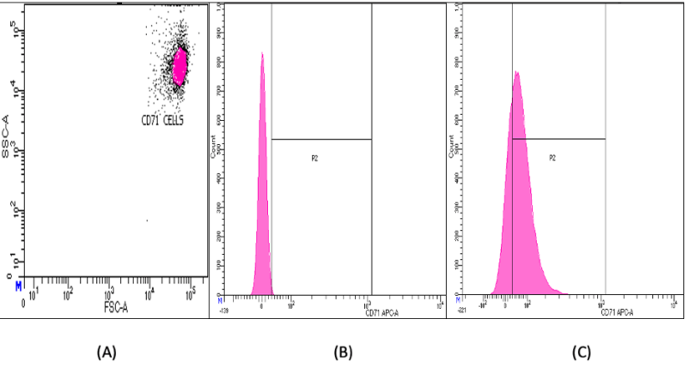

Supplementary figure 1: Flow cytometric analysis for CD71+ cells. (1A) Identification of CD71+ cells (logarithmic scale) (1B) Histogram depicting unstained CD71+ cells (1C) Histogram depicting stained CD71+ cells. The % stained CD71+ cells was found to be 69.9%

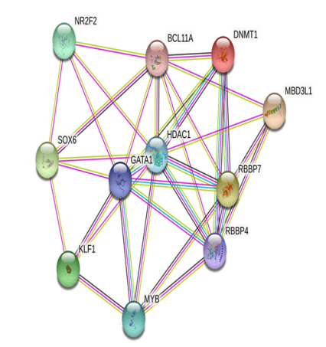

Supplementary figure 2: Protein-protein interaction network of genes regulating γ globin. PPI network was constructed using STRING software which consisted of 11 nodes and 34 edges with PPI enrichment p value (p<0.0001). In PPI network the identified hub genes were BCL11A, N2RF2, SOX6, KLF1, MYB, RBBP4, RBBP7, MBD3L1, DNMT1, HDAC1, GATA1 which are essential modulators of fetal hemoglobin.

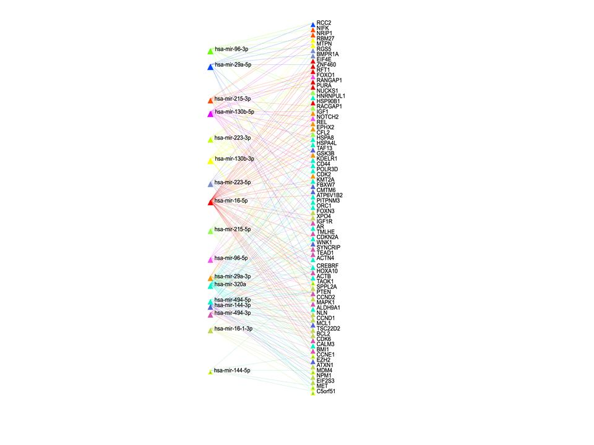
Supplementary figure 3: miRNA-mRNA network construction using miRNet software. The miRNA target genes were identified using miRNet web tool. The target miRNA genes identified were significantly (p<0.0001) enriched in pathways such as erythropoiesis, cell cycle regulation, mTOR signalling, JAK-STAT pathway and cancer pathways. miRNA-target interaction networks constructed for each miRNA is based on the node ‘degree’ and ‘betweenness’ of miRNA and target gene.
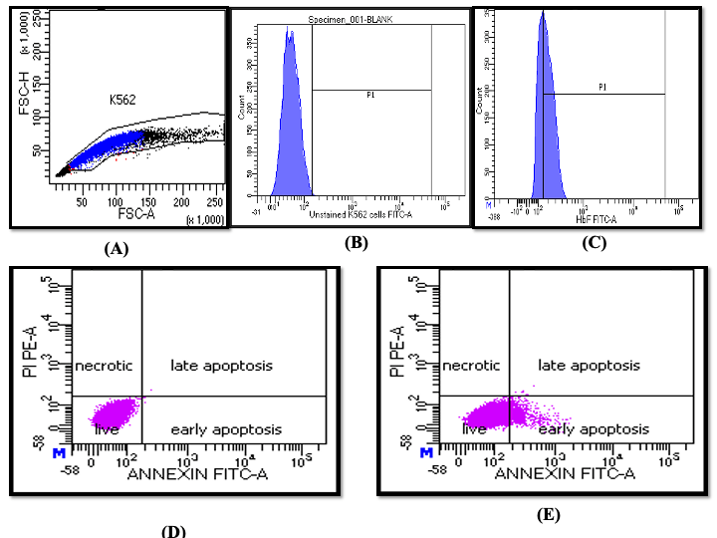

Supplementary figure 4: Evaluation of ‘F cells’ and identification of apoptosis rate in miRNA transfected K562 cells. (4A) Gating strategy of K562 cells (linear scale) (4B)Unstained K562 cells as negative control (4C)Histogram depicts stained ‘F cells’ using anti-HbF FITC labelled antibody in K562 cells. The percent F cells were found to be 57.1%. (4D) Evaluation of apoptosis rate in non-transfected K562 cells using FITC labelled-Annexin V antibody and Propidium Iodide which was found to be 0.1%. (4E) Evaluation of apoptosis rate in miRNA transfected K562 cells using FITC labelled-Annexin V antibody and Propidium Iodide which was found to be 7.9%.
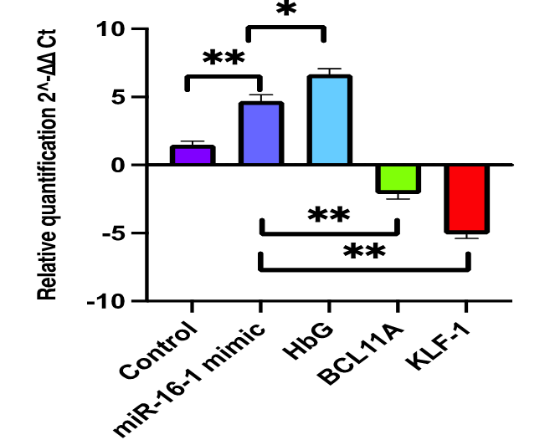

Supplementary figure 5: Transfection of miR-16-1 mimic in CD34+ cells in SCD patient. Transfection of miR-16-1 mimics resulted into significant upregulation of y globin gene (6.6 folds) and downregulation of BCL11A (2.1 folds) and KLF-1 (5.1 folds) gene.
*Significant at p<0.001, **Significant at p≤0.0001

