Supplementary Information
Comparative non-invasive T1w/T2w myelin mapping of the night monkey: implications for cortical adaptation to a nocturnal niche environment

Authors
Takuro Ikeda¹, Joonas A. Autio¹, Akihiro Kawasaki¹, Chiho Takeda¹, Takayuki Ose¹, Masahiko Takada², David C. Van Essen³, Matthew F. Glasser^{3,4}, Takuya Hayashi¹

Affiliations
¹Laboratory for Brain Connectomics Imaging, RIKEN Center for Biosystems Dynamics Research, Kobe, Japan
²Center for the Evolutionary Origins of Human Behavior, Kyoto University, Inuyama, Japan
³Department of Neuroscience, Washington University Medical School, St Louis, MO
⁴Department of Radiology, Washington University Medical School, St Louis, MO

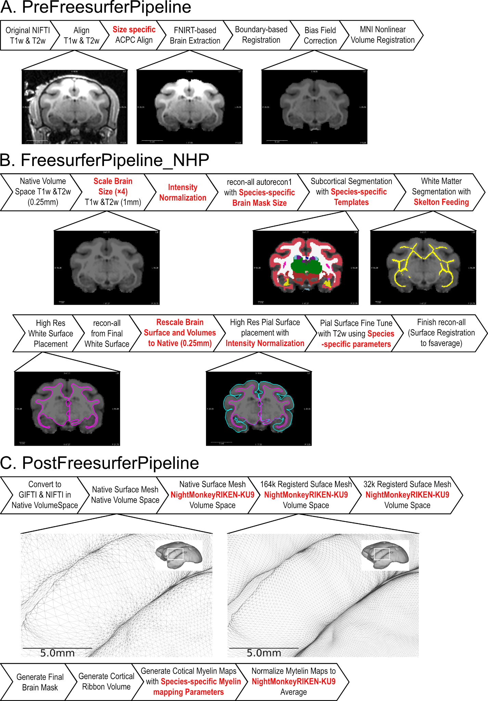
Supplementary Figure 1. HCP-NHP pipeline adapted for structural image processing in night monkeys.
An overview of the non-human primate (NHP) version of the HCP pipeline consists of (A) PreFreeSurfer Pipeline, (B) FreeSurfer Pipeline, and (C) PostFreeSurfer Pipeline. Texts in red describe adaptation of the pipeline to the night monkey brain. Preprocessed T1w images in a representative subject (NM52) are shown at each step.

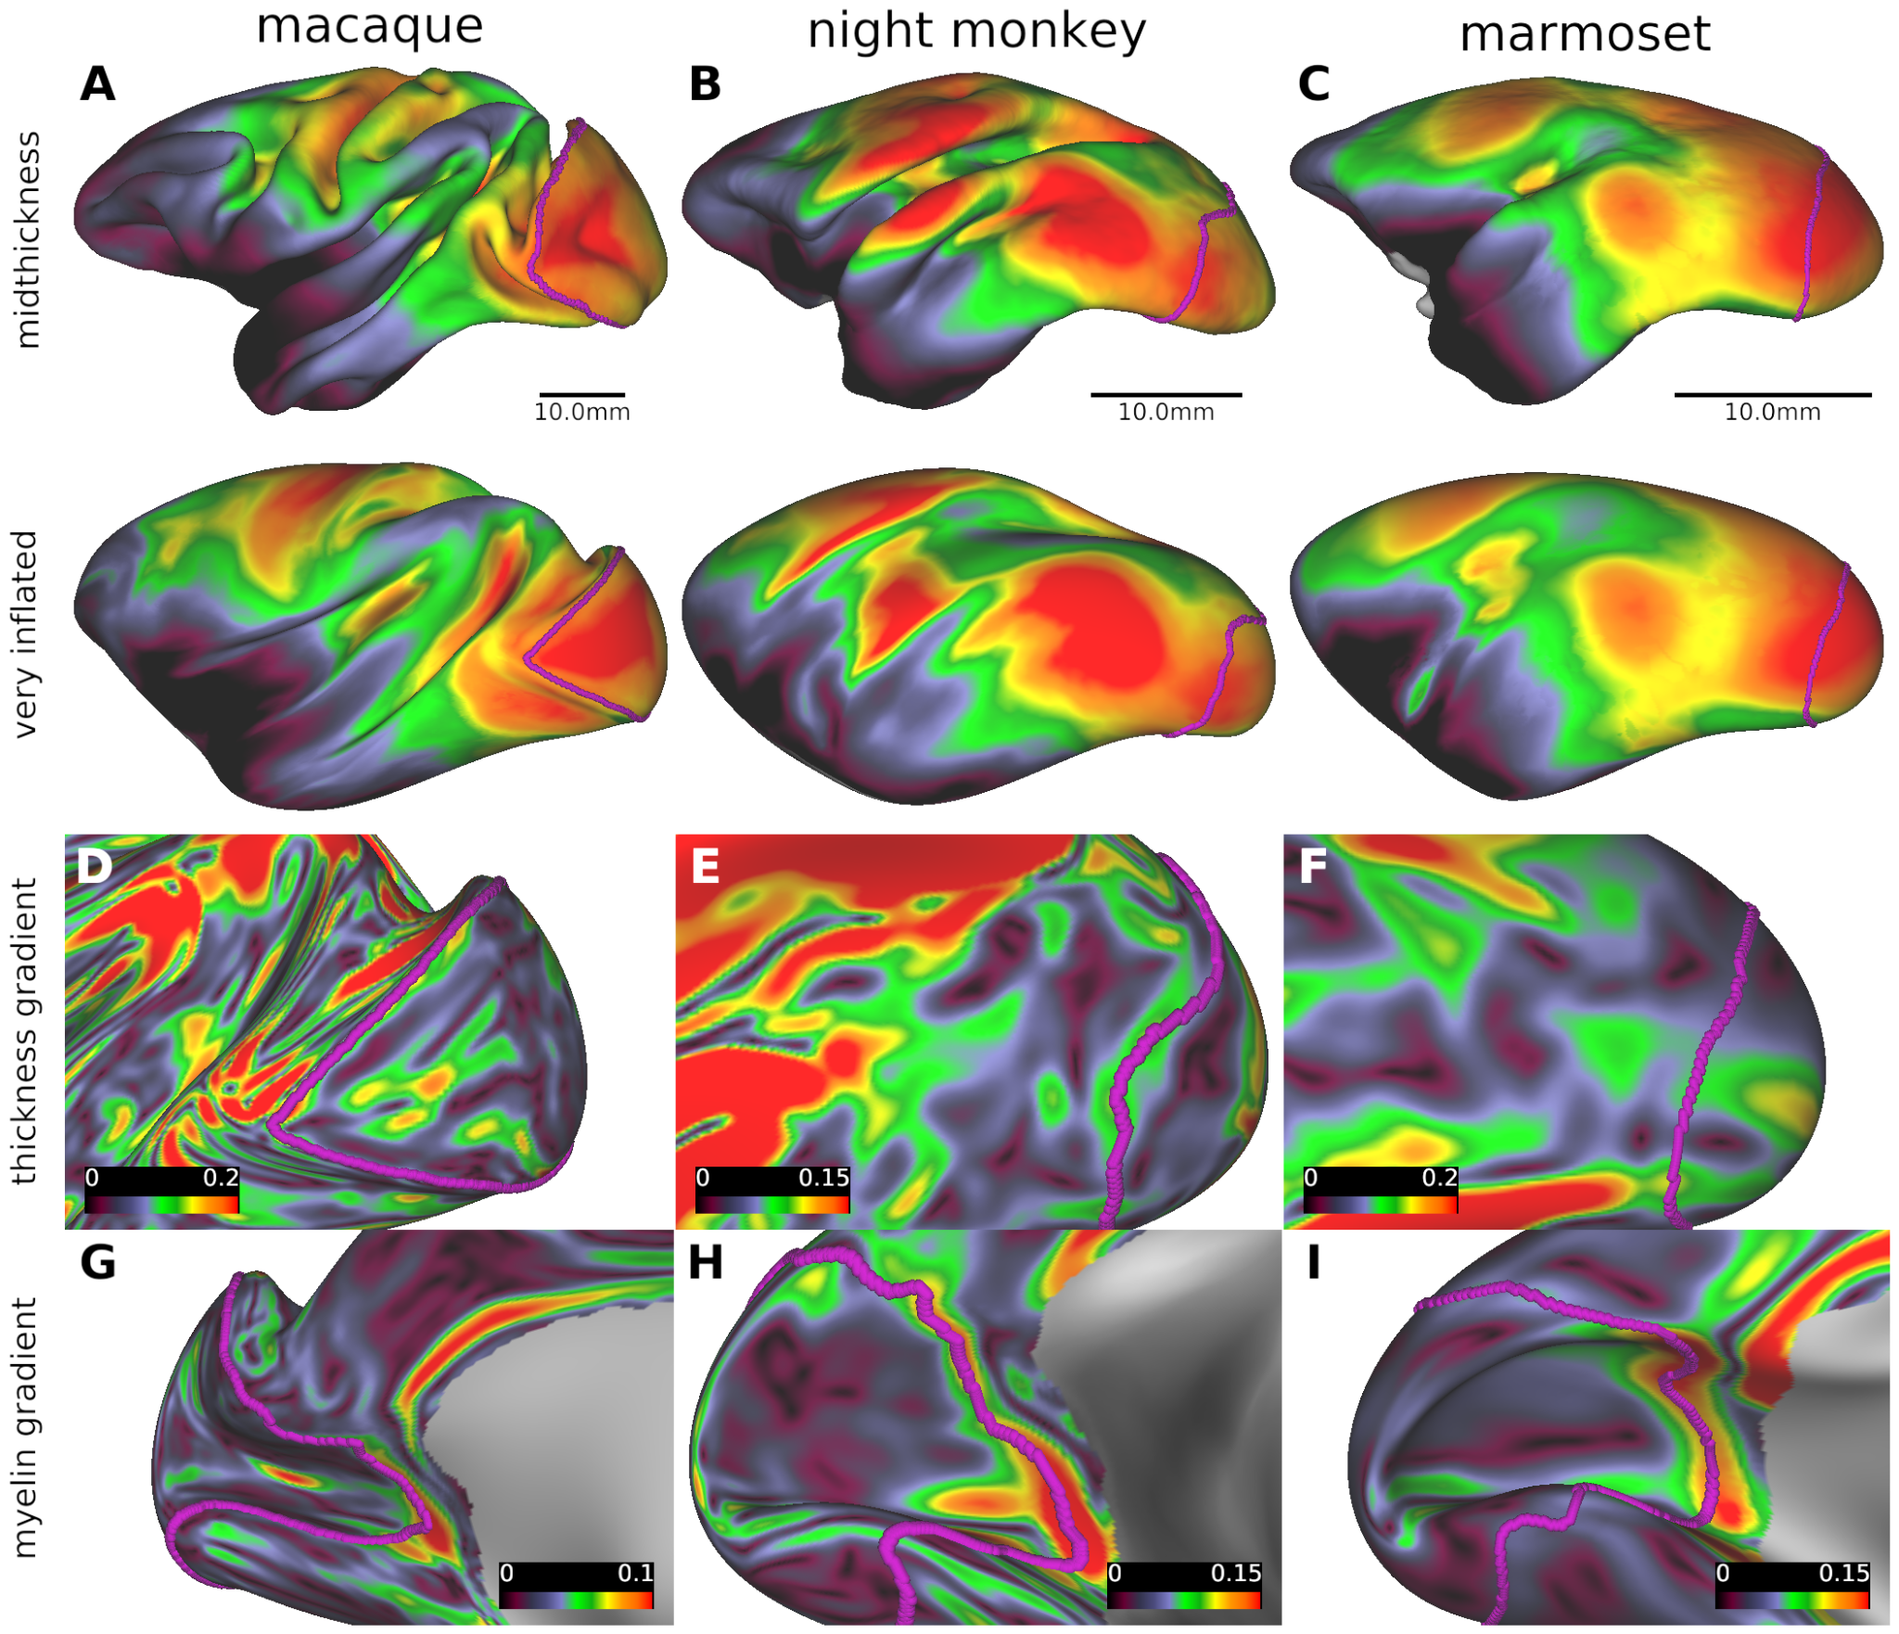
Supplementary Figure 2. Interspecies comparison of primary visual cortex (V1).
T1w/T2w myelin contrast in (A) macaque, (B) night, and (C) marmoset monkeys displayed on a midthickness surface (top row) and a very inflated surface (bottom row) with V1 border (purple line). V1 borders were defined based on thickness gradient (lateral side; D, E, F) and myelin gradient (medial side; G, H, I).

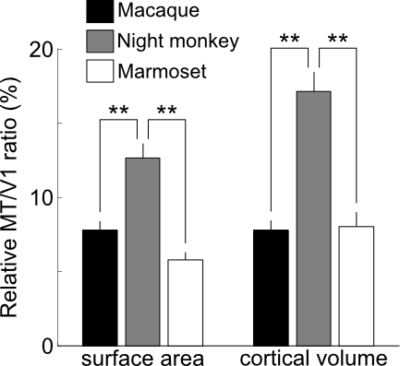
Supplementary Figure 3. Relative size of MT in comparison to V1.
The error-bars indicate the standard deviation across subjects (macaque N=32x2, night monkey N=9x2, marmoset N=20x2). Interspecies differences were tested by 1-way ANOVA, followed by t-test with Bonferroni correction. * and ** indicate corrected p < 0.05 and 0.001, respectively.
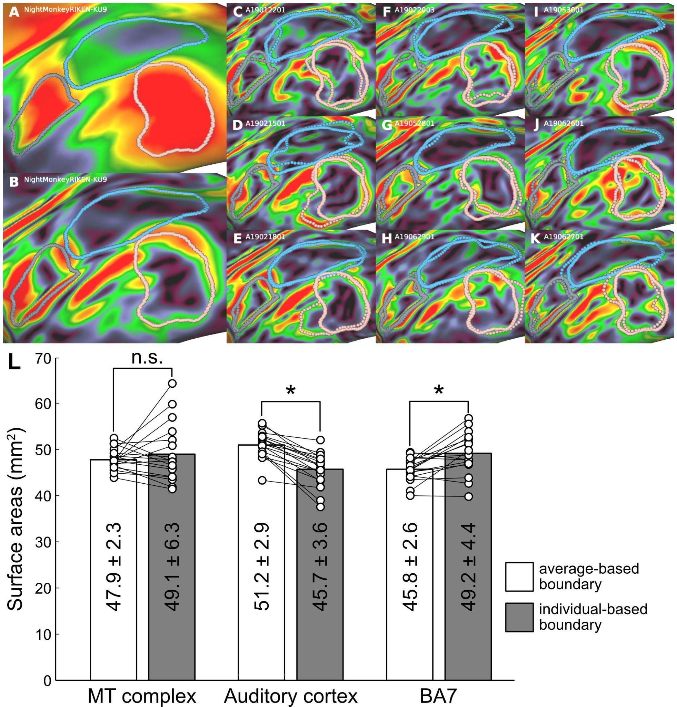
Supplementary Figure 4. Inter-subject comparison of myeloarchitecture in parieto-temporal cortex of night monkey.
(A) Average T1w/T2w myelin contrast (B) and its gradient in night monkey (NightMonkeyRIKEN-KU9). The areal borders of MT+ complex (pink), auditory cortex (gray), and area 7 (cyan) were defined based on average T1w/T2w myelin gradient. (C-K) Individual T1w/T2w myelin gradients (N=9). Solid lines indicate the areal borders based on the average gradient while dotted lines indicate the areal borders based on the individual gradients. (L) Comparisons of surface area determined using average-based boundary (white) and individual-based boundary (gray), with mean ± SD inside the bars. * indicates p < 0.05 by paired t-test (N=9x2).

