Supporting Information
Bond | Distance | Bond | Distance | Bond | Distance
Nd(1)-O(1) | 2.402(2) | Nd(1)-O(5)#3 | 2.503(2) | Nd(1)-O(4)#2 | 2.498(2)
Nd(1)-O(2)#1 | 2.363(2) | Nd(1)-O(6)#3 | 2.459(2) | Nd(1)-O(7)#5 | 2.852(2)
Nd(1)-O(3)#2 | 2.531(2) | Nd(1)-O(7)#4 | 2.340(2) | Nd(1)-O(8)#5 | 2.415(2)
Table s1. Selected Bond Lengths (Å) and Bond Angles (°) of Nd-MOF.
Angle | (°) | Angle | (°) | Angle | (°)
O(1)-Nd(1)-O(3)#2 | 144.88(8) | O(1)-Nd(1)-O(4)#2 | 146.81(8) | O(7)#4-Nd(1)-O(4)#2 | 96.16(9)
O(1)-Nd(1)-O(5)#3 | 72.91(8) | O(1)-Nd(1)-O(6)#3 | 75.22(8) | O(7)#4-Nd(1)-O(6)#3 | 135.80(8)
O(1)-Nd(1)-O(7)#5 | 68.77(7) | O(1)-Nd(1)-O(8)#5 | 83.15(8) | O(7)#4-Nd(1)-O(8)#5 | 124.50(8)
O(2)#1-Nd(1)O(3)#2 | 71.02(8) | O(2)#1-Nd(1)-O(1) | 131.68(8) | O(8)#5-Nd(1)-O(3)#2 | 73.89(8)
O(2)#1-Nd(1)O(5)#3 | 142.72(9) | O(2)#1-Nd(1)-O(4)#2 | 74.85(9) | O(8)#5-Nd(1)-O(5)#3 | 134.74(8)
O(2)#1-Nd(1)O(7)#5 | 66.48(8) | O(2)#1-Nd(1)-O(6)#3 | 146.74(8) | O(8)#5-Nd(1)-O(7)#5 | 48.89(7)
O(4)#2-Nd(1)O(5)#3 | 74.47(8) | O(2)#1-Nd(1)-O(8)#5 | 81.11(9) | O(8)#5-Nd(1)-O(6)#3 | 84.16(8)
O(5)#3-Nd(1)-O(7)#5 | 140.56(8) | O(3)#2-Nd(1)-O(7)#5 | 111.41(7) | O(7)#4-Nd(1)-O(1) | 75.99(9)
O(5)#3-Nd(1)-C(14)#3 | 26.45(9) | O(4)#2-Nd(1)-O(3)#2 | 52.22(8) | O(7)#4-Nd(1)-O(3)#2 | 139.07(8)
O(6)#3-Nd(1)-O(3)#2 | 76.29(8) | O(4)#2-Nd(1)-O(7)#5 | 141.33(8) | O(7)#4-Nd(1)-O(5)#3 | 86.57(8)
O(6)#3-Nd(1)-O(5)#3 | 53.14(8) | O(5)#3-Nd(1)-O(3)#2 | 105.14(8) | O(7)#4-Nd(1)-O(7)#5 | 75.61(8)
O(7)#4-Nd(1)-O(2)#1 | 76.20(9) | O(6)#3-Nd(1)-O(4)#2 | 90.10(9) | O(8)#5-Nd(1)-O(4)#2 | 125.48(8)
O(6)#3-Nd(1)-O(7)#5 | 122.38(8)

Figure S1. IR spectrum of Nd-MOF.
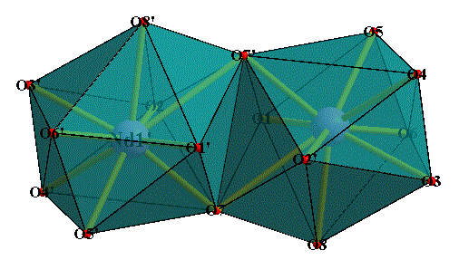

Figure S2. The coordination polyhedron formed by binuclear structure with two Nd(III) and sixteen coordination oxygen atoms.
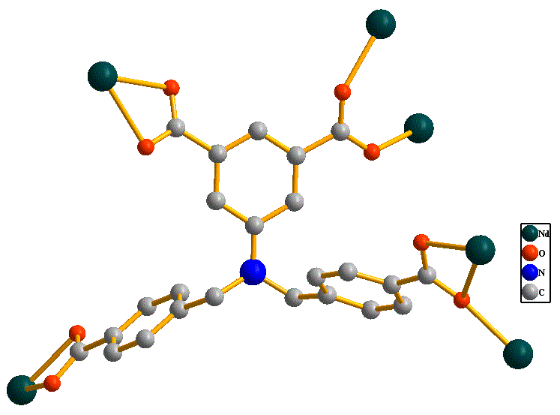
Figure S3. The coordination mode of the ligand in Nd-MOF.

