Supplementary
S1: Description of nodes within MNP spectra: Chebyshev polynomial
The behavior of the harmonic spectral signal A_{n} in dependency of increasing magnetic offset fields H_{DC} follows the Chebyshev polynomials closely. The dependency shows more and more nodes (zero-points) for higher harmonic numbers n [1] (see Fig. S1-1)
 | $$\left|A_{n}\right|(H_{DC})=-\frac{2i}{T}M'(H_{DC})*\left(U_{n-1}(\frac{H_{DC}}{H_{AC}})⋅\sqrt{1-{\left(\frac{H_{DC}}{H_{AC}}\right)}^{2}}\right)$$ | (EqS1-1)
where U_{n-1} represents the Chebyshev polynomials of the second kind and M’(H_{DC}) is the derivative of the magnetic response. These ‘dips’ within a Fourier spectrum of a MPS signal can be explained by two separate signals S_{pos} and S_{neg}, which can be generated from the time signal S(t)=dM(t)/dt, which can be seen as the induction signal captured by a receive coil following Faradays’ law.
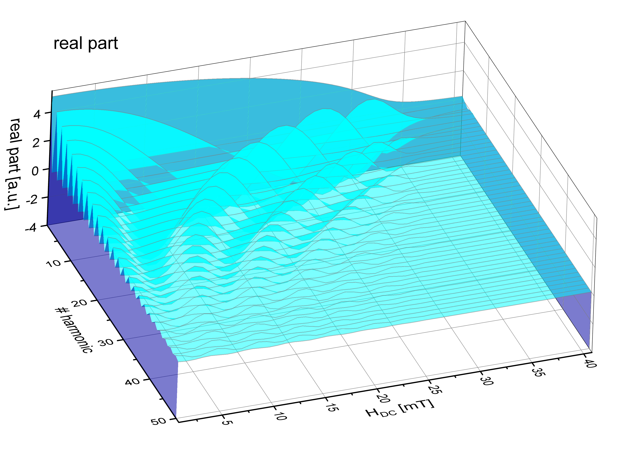
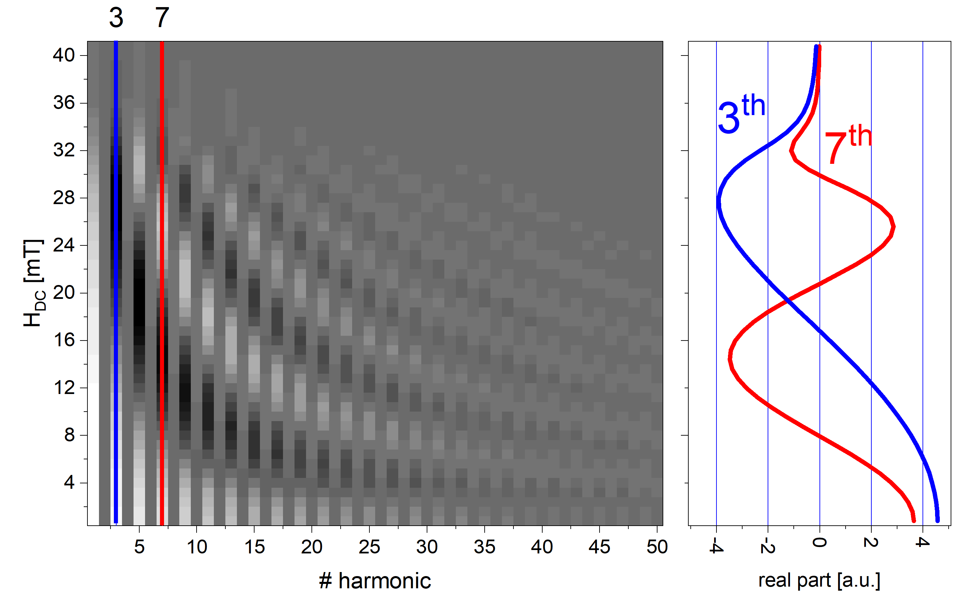

Fig. S1-1: Top: 3D plot of real spectra in dependency of increasing offset magnetic fields H_{DC} (H_{AC}≈40 mT). Bottom: 2D gray-scaled plots of real part of the spectra. It shows the wave-like shape along the H_{DC} axis for the 3rd and 7th harmonic, which follows the Chebyshev polynomials of the second kind convolved with the derivative of the magnetic response.

The signals S_{pos} and S_{neg} consists of the positive signal peaks and the negative signal peaks of the derivative signal S (Fig. S1-2). The Fourier transforms for both F(S_{pos}) and F(S_{neg}) do not show any ‘dips’ in the absolute spectrum, but the sum of both spectra F(S_{pos}+ S_{neg}). A closer look at a single harmonic A_{n} at this specific offset field H_{DC} shows destructive interference (both amplitudes almost equal |A₂/A₁|≈1 and a phase difference of almost dφ=φ₁-φ₂≈180°):
 | $$A_{n}\left(H_{DC}, t\right)=A_{1}⋅\sin\left(2π⋅t+φ_{1}\right)+A_{2}⋅\sin\left(2π⋅t+φ_{2}+Δφ\right).$$ | (EqS1-2)
The phase at such ‘dips’ (Fourier spectrum) or nodes (A_{n}(H_{DC}) plots) jumps almost 180° with a steep slope. This implies a high sensitivity to minimal changes, which explains the designation as critical point (CP).
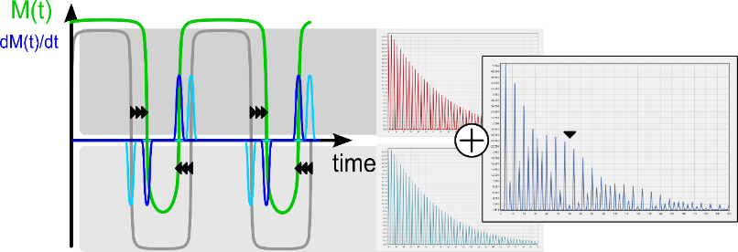
Fig. S1-2: Two magnetization curves over time M(t) are shown for different offset magnetic fields H_{DC}. The derivative of both (induction signal) shows positive and negative peaks on the x-axis, which moves to each other due to the asymmetry caused by the offset magnetic field. This asymmetry generates even higher harmonics in the Fourier spectrum. When performing a Fourier transform on either the positive data S_{pos} or the negative data S_{neg}, both spectra consist of even and odd higher harmonics, but without any ‘dips’. In the sum S=S_{pos}+S_{neg}, the harmonics interfere and produce destructive harmonic signals (dip).

S2: Realistic MNPs and simulation model
Idealized MNP ensembles follow the single particle model and do not show the mentioned phase differences dφ (Fig. 2) since they follow the assumption that the particles can instantaneously follow the external magnetic field. They also do not show particle-particle interaction effects [2]. In contrast, real particle behavior is described mainly by two types of relaxation effects, Brownian relaxation and Néel relaxation [3, 4]. Brownian relaxation is dominant for large particles (diameter larger than 30 nm) and describe the rotation of the particle within the surrounding medium, Néel relaxation describes the rotation of the particle magnetization m inside the particle, which becomes more dominant for particles much smaller than 30 nm. Both relaxation types affect the amplitude of the magnetization as well as the phase difference between excitation field and signal, especially in the non-linear case at higher harmonics. The theory for Néel and Brownian relaxation are idealized models, which cannot be directly applied to typical multicore particle systems [3].
The Langevin-function (Eqn. 1) assumes, that the magnetic moments of the particles follow the external field instantaneously. Given high enough frequencies, this is no longer a valid approximation. In addition, the preferred particles for the given method are nanoparticles with a magnetic moment fixed inside the particle, which maximizes the dependency of the magnetic response on viscosity of the suspending liquid and changes in the particle’s hydrodynamic diameter. It is modelled by the Langevin-equation [2, 5]
 | $$\frac{d\vec{m}}{dt}=\frac{μ}{ζ}\left(\vec{m}×\vec{H}\right)×\vec{m}+\sqrt{\frac{2k_{B}T}{ζ}}\vec{λ}×\vec{m},$$ |  | (EqS2-1)
with k_{B} as the Boltzmann constant, T as the Temperature, $\vec{λ}$ as normally distributed random vectors with expectation value <λ_{i}(t)>=0 and ζ=κηR³ as the Stokes-Einstein diffusion coefficient (viscosity-coefficient) which depends on the viscosity η of the surrounding liquid, the particle diameter R, a shape factor κ and the magnetic permeability μ. In general, the magnetic moment cannot be assumed completely fixed inside the magnetic particles. A first order approximation of a more generalized particle system can be replacing ζ with a reduced effective value reflecting the mobility of the magnetization inside the particle, which can only be determined empirically.
Changes in these parameters also change the dependence of the harmonic on H_{DC}, i.e., it changes the shape of the Chebyshev-like polynomial affecting amplitude, phase and the position of nodes and critical points).
It has to be emphasized, that following the theory of Debye [12], which holds true for weak excitation fields, e.g., used in ACS, the characteristic frequency of MNPs with hydrodynamic diameters of 330 nm can be calculated to about 12 Hz, which is much lower than the frequency used in MPS or COMPASS. But this model applies only for very weak fields. In MPS the rotation rate caused by magnetic moment of the particles and the magnetic fields strengths is much larger than the rotation rate caused by thermal random forces (see EqS2-1).
To get a better understanding of the COMPASS effect, a basic simulation using Langevin-equation [2, 5] (see Equ. EqS2-1) of two different particle systems with a minimal difference of about 5% in their ζ-parameter, which corresponds to, e.g., a small change in the effective hydrodynamic particle diameter of about 1.7 %, were performed.
At a specific excitation field strength H_{AC} and frequency f₁ of the excitation signal, multiple data sets are generated at different offset magnetic fields H_{DC}. A full set of Chebyshev-like polynomials (1st to 11th harmonic) is generated for both MNP sample variants.
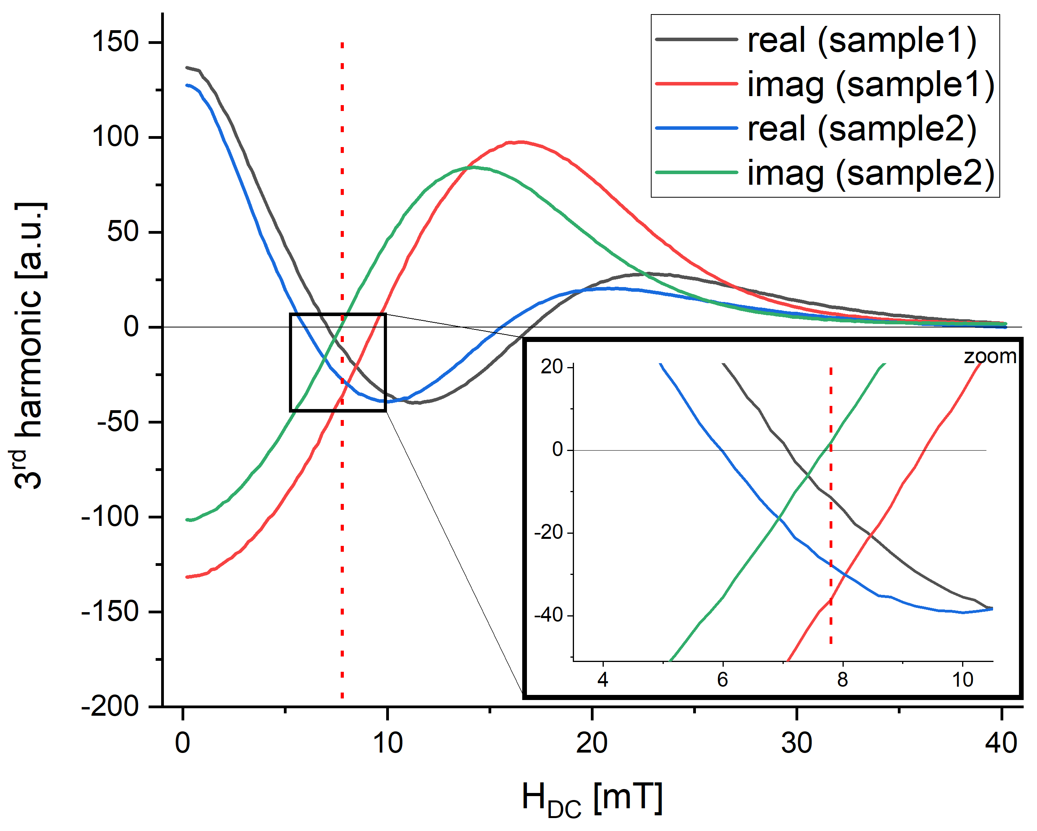
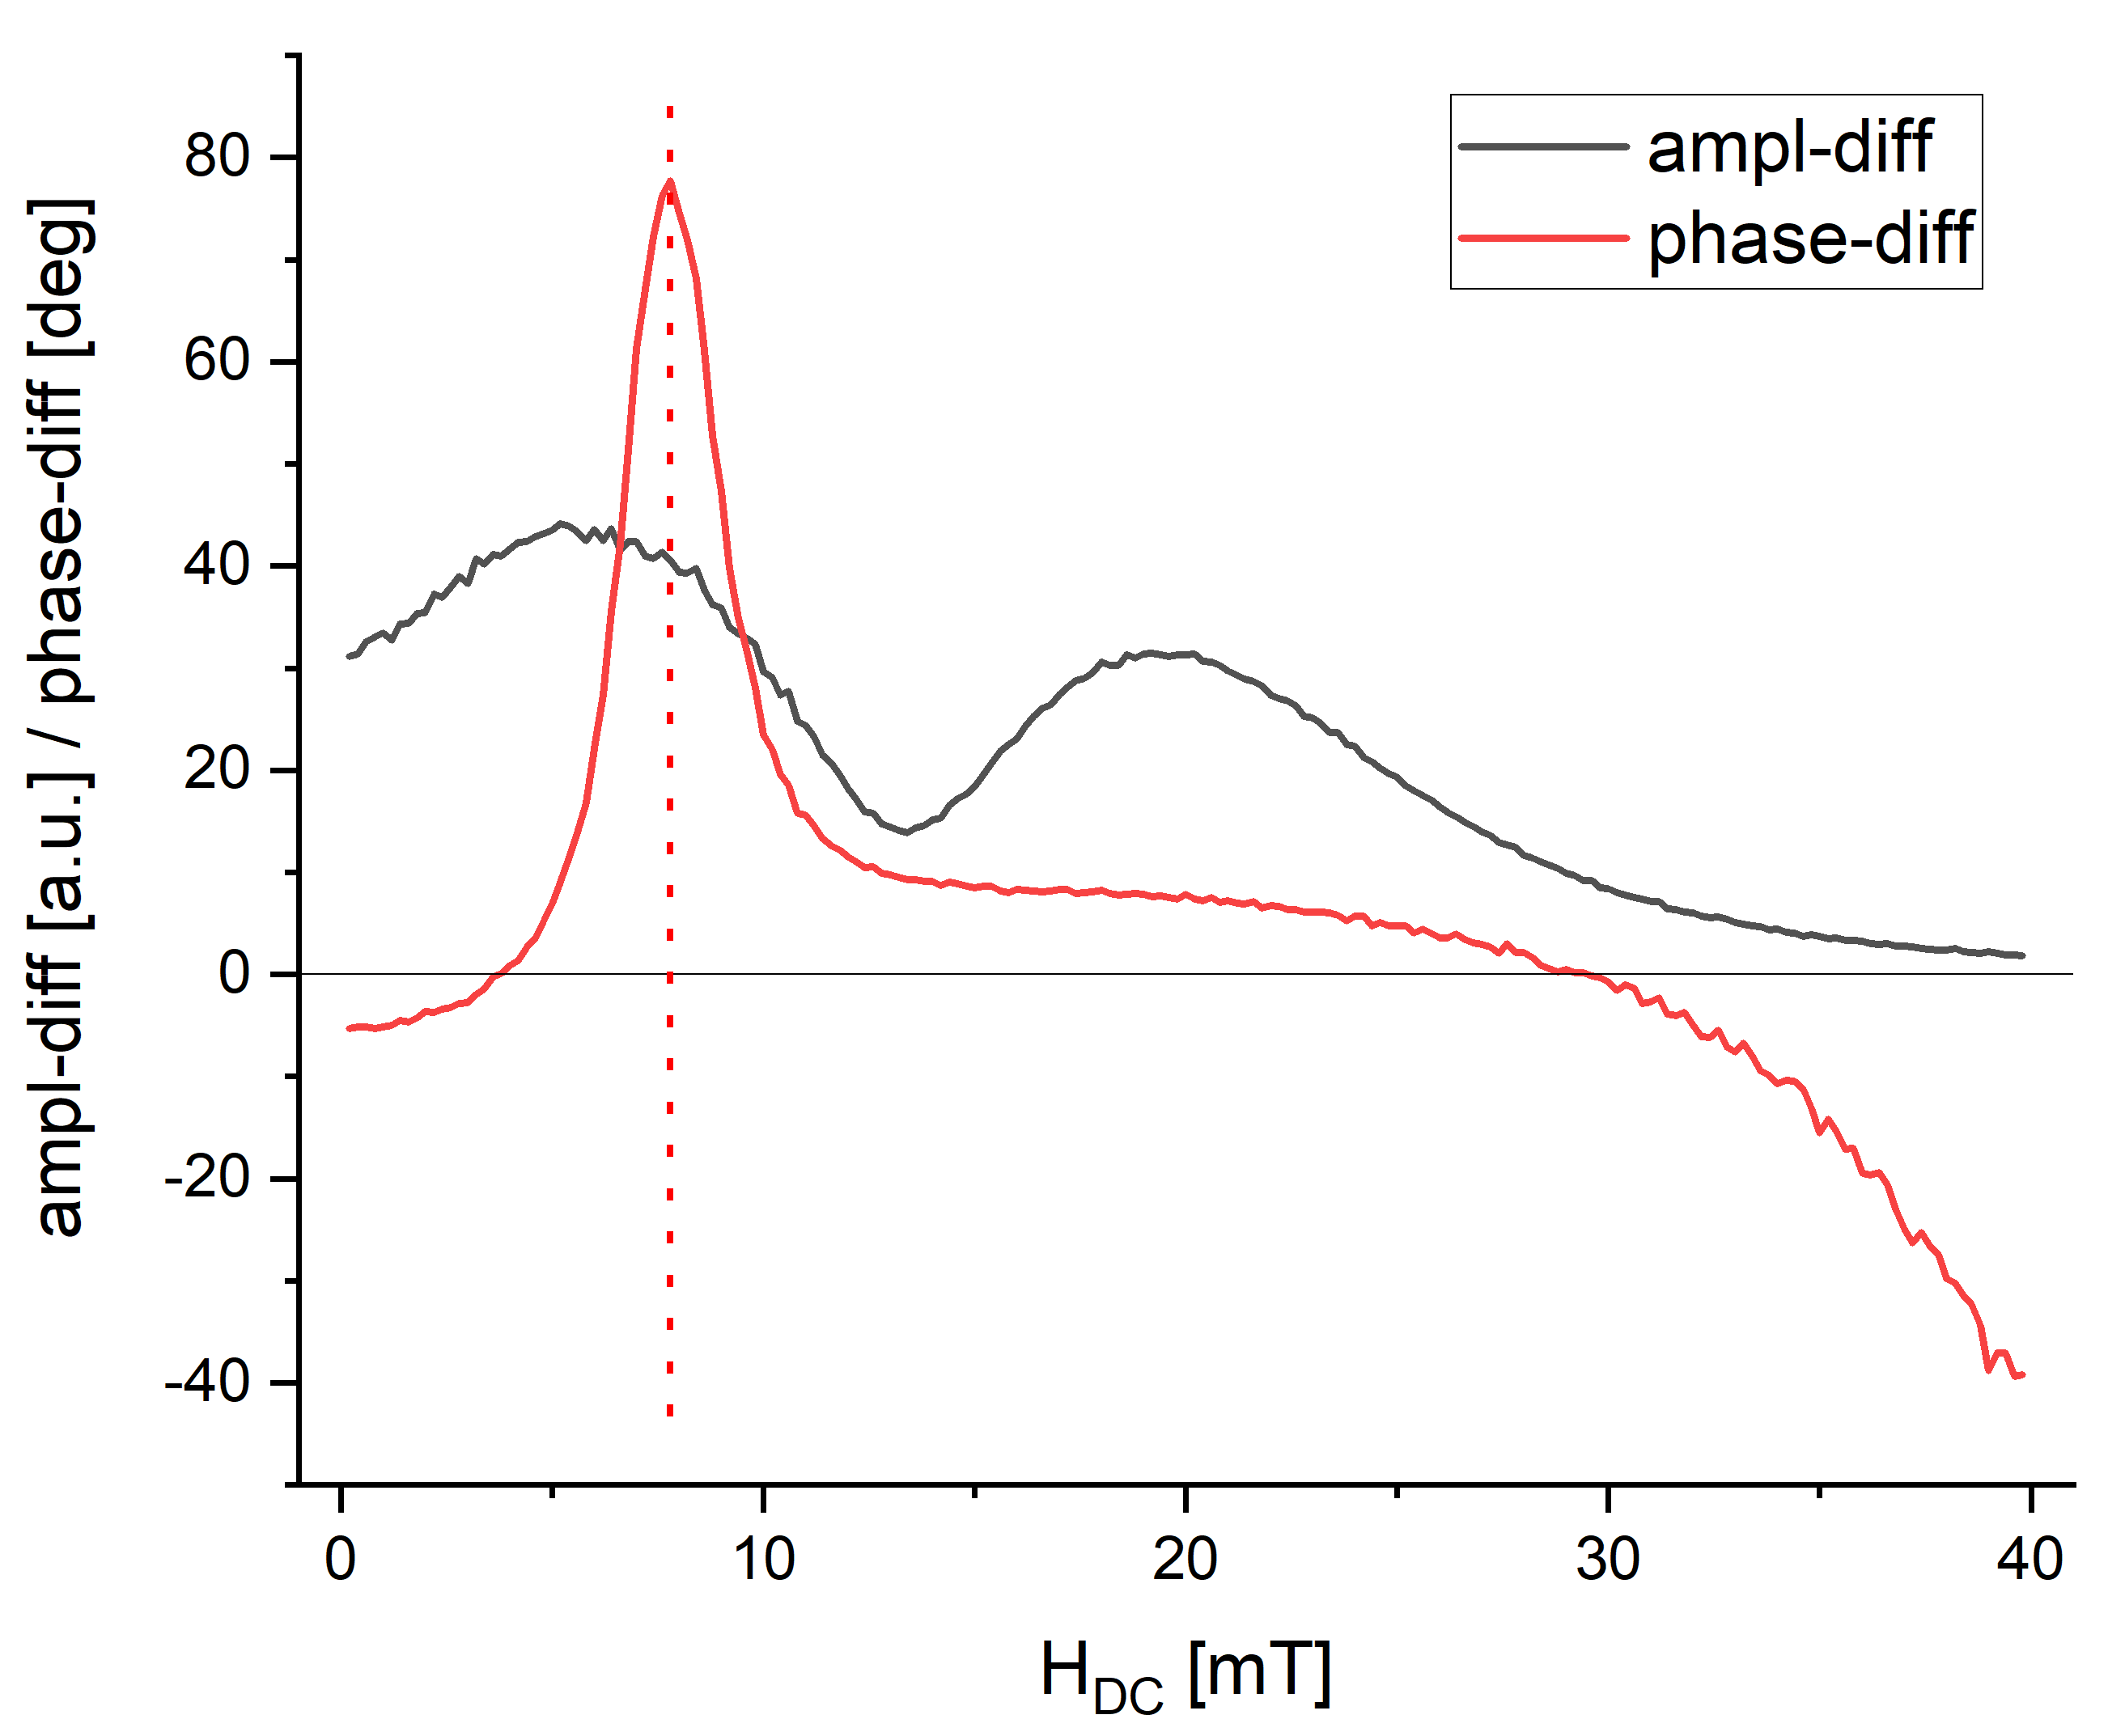
Fig. S2-1: Top: offset field amplitude dependency of the 3rd harmonic (real and imaginary parts) of a simulated data set. There is a difference between the signals due to the ζ -variation. Bottom: the graphs show the difference of the amplitudes of both samples as well as the phase difference. As expected, the highest sensitivity lies between the critical points of both samples (red dotted line).
In Fig. S2-1, an example is given for the 3rd harmonic: Fig. S2-1 top left: the real and imaginary part of both MNP sample simulations is given. Due to the ζ-parameter variation, the crossing points of real and imaginary signals slightly shift as indicated in the zoom graph (top right). The difference in the amplitude (Fig. S2-1) of both samples shows a strong variation of about 5%. The phase difference plot (Fig. S2-1) shows an extremum, which means, that at this specific offset magnetic field strength the maximum phase difference between both samples is observable to distinguish the given samples.
To emulate the measurement with a magnetic field gradient G in the above-mentioned setup (Fig. 1 & S5-1 & S5-3), the signal needs to be integrated over offset magnetic field strengths H_{DC} present in the sample volume (see Fig. S5-2))
 | $$\hat{S}(t)=\int_{a}^{b}{ϱ\left(H_{DC}\right)⋅S(t, H_{DC}) dH_{DC}},$$ | (EqnS2-2)
with a and b as minimum and maximum value of H_{DC} within the sample (see Fig. 5). The density distribution ρ depends on the sample shape and gradient shape as well as MNP distribution throughout the sample. The integration limits a and b strongly depend on the offset magnetic field configuration used for the measurement.
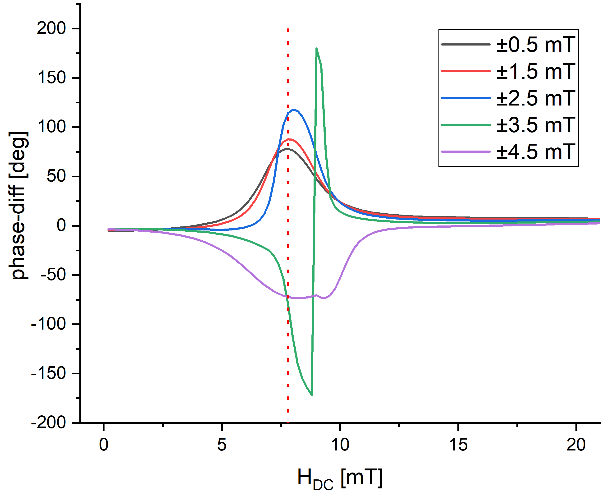
Fig. S2-2: The phase difference of the two cumulated signals for different integration limits a and b. The integration limits are ±0.5 mT, ±1.5 mT, ±2.5 mT, ±3.5 mT, ±4.5 mT.
For integration, several parameters can be set: integration limits a and b, which depend directly on the magnetic field gradient G over the sample (range of the integration), and the offset magnetic field H_{DC}, which defines the center of the integration window.
In Fig. S2-2, for several gradients strengths G (corresponding to different intervals [a, b]) the phase difference of the integrated signals is shown. For increasing G the phase difference between both samples increases significantly over a wider range of offset fields. This effect can be observed for every harmonic for different offset magnetic fields H_{DC}, magnetic field gradients G and multiple times depending on the number of critical points (CP).

S3: MNP-APTES preparation and functionalization with S1 protein
For initial testing, MNPs functionalized with APTES ((3-aminopropyl) triethoxysilane, Carl Roth, Germany) were used as an exemplary particle system. These MNPs are coated with APTES and produced by alkaline precipitation as already described in [6] (see Fig. S3). The MNPs produced in this way have a hydrodynamic diameter of about 200 nm with the single crystallites showing a diameter of about 12 nm. SARS-CoV-2-S1 protein (SARS-CoV-2 (2019-nCoV) spike S1-His, Sino Biological, China) is covalently bound to the surface of the particles by binding SBA (N-succinimidyl bromoacetate) over cysteines present in the protein. A 0.05 M borate buffer with pH 8.5 was used during binding. The particle concentration during the functionalization processing was adjusted to 1 mg Fe/ml and 20 mM SBA dissolved in DMF (Carl Roth, Germany) was added. The samples were shaken for 2 h at 1,400 rpm. After that, the particles were washed several times with buffer solution. The obtained MNP-APTES-SBA were redispersed in borate buffer for binding of SARS-CoV-2-S1 protein. The samples were shaken again for 2 h at 1,400 rpm and washed several times with doubly distilled H₂O. The final MNP-APTES-S1 poses a concentration of 10 µg S1 protein per 100 µg Fe (determined by UV-VIS measurements). After binding and the last washing step, the hydrodynamic size of the multicore particles (MNP-APTES-S1) lies around 330 nm with a PDI of 0.3. Particles were stored in doubly distilled water until further use.
Standard antibody detection assay
ELISA: sample preparation and measurement
For human CoV-19 ELISA for S1 antibodies (RayBio, Peachtree Corners, GA), the S1 antibodies were diluted from 1,500 ng/ml to 25 ng/ml in the same buffer as used for the other tests. For the ELISA an amount of 100 μl sample were added to each well. After 1 h of incubation at RT under gentle shaking, all liquid was depleted and the plate was washed four times with washing buffer. 100 μl of prepared Biotinylated Anti-Human IgG Antibody is added to each well followed by an incubation for 1 h as carried out before followed by another washing as described. Next 100 μl of prepared HRP-Streptavidin solution were pipetted into each well, followed by another incubation for 30 min. After washing 100 μl of TMB One-Step Substrate Reagent were applied to the wells. After further 30 min of incubation 50 μl of Stop Solution were added. The OD at 450 nm was detected using a plate reader (SpectraMax iD3, Molecular Devices).
Particle based antibody detection assays
Flow cytometry analysis: sample preparation and measurement
To test the binding selectivity to the correct antibody flow cytometry-analysis was performed with a Gallios flow cytometer (Beckman Coulter, Fullerton, CA, USA). First the antibodies (conc. 1 µg/ml SARS-CoV/SARS-CoV-2 Spike antibody (S1 antibodies, MW: 146.16 kDa), Chimeric Mab, Sino Biological, China) were diluted 1:2,000, 1:5,000, 1:10,000, 1:20,000 (last dilution corresponding to 50 ng/ml) antibodies in a buffer (PBS with 0.1% BSA). For the measurement 25 µL of MNP-APTES-S1 dispersions (iron conc. 100 µg Fe/ml) were added in an 0.5 ml Eppendorf cap. Subsequently 25 µL of antibody dilution or buffer (ref) were added. Samples were incubated for 1 h at 4°C. For washing, samples were centrifuged at 18,000 rcf for 10 min, the supernatant discarded and the MNPs redispersed in buffer. For detection, MNPs were further incubated with fluoresceinisothiocyanat (FITC) labeled protein A (1 µg/ml) for 1 h at room temperature (RT), which is known to bind specifically the Fc-region of IgG-antibodies [7]. Finally, the MNPs were washed as described before, redispersed and diluted 1:250 in buffer and analyzed for fluorescence by using flow cytometry. The fluorescence bleed through was eliminated by electronic compensation. The acquired data were analyzed with Kaluza software version 2.0 (Gallios, Brea, USA).
Sample preparation for COMPASS
For the detection of S1 antibodies using the COMPASS device, the stock solution was diluted in buffer 1:2,000, 1:5,000 1:10,000, 1:20,000 and 1:200,000 (corresponding to 5 ng/ml for the lowest antibody concentration) as described before. An amount of 25 µl of MNP-APTES-S1 dispersions (100 µg Fe/ml) was added in an 0.5 ml Eppendorf cap. Subsequently 25 µl of antibody dilution (S+) or buffer (ref) were added. Samples were directly measured in the COMPASS device after carful mixing by pipetting without any further incubation times.
The results can be found in the supplementary section S7.

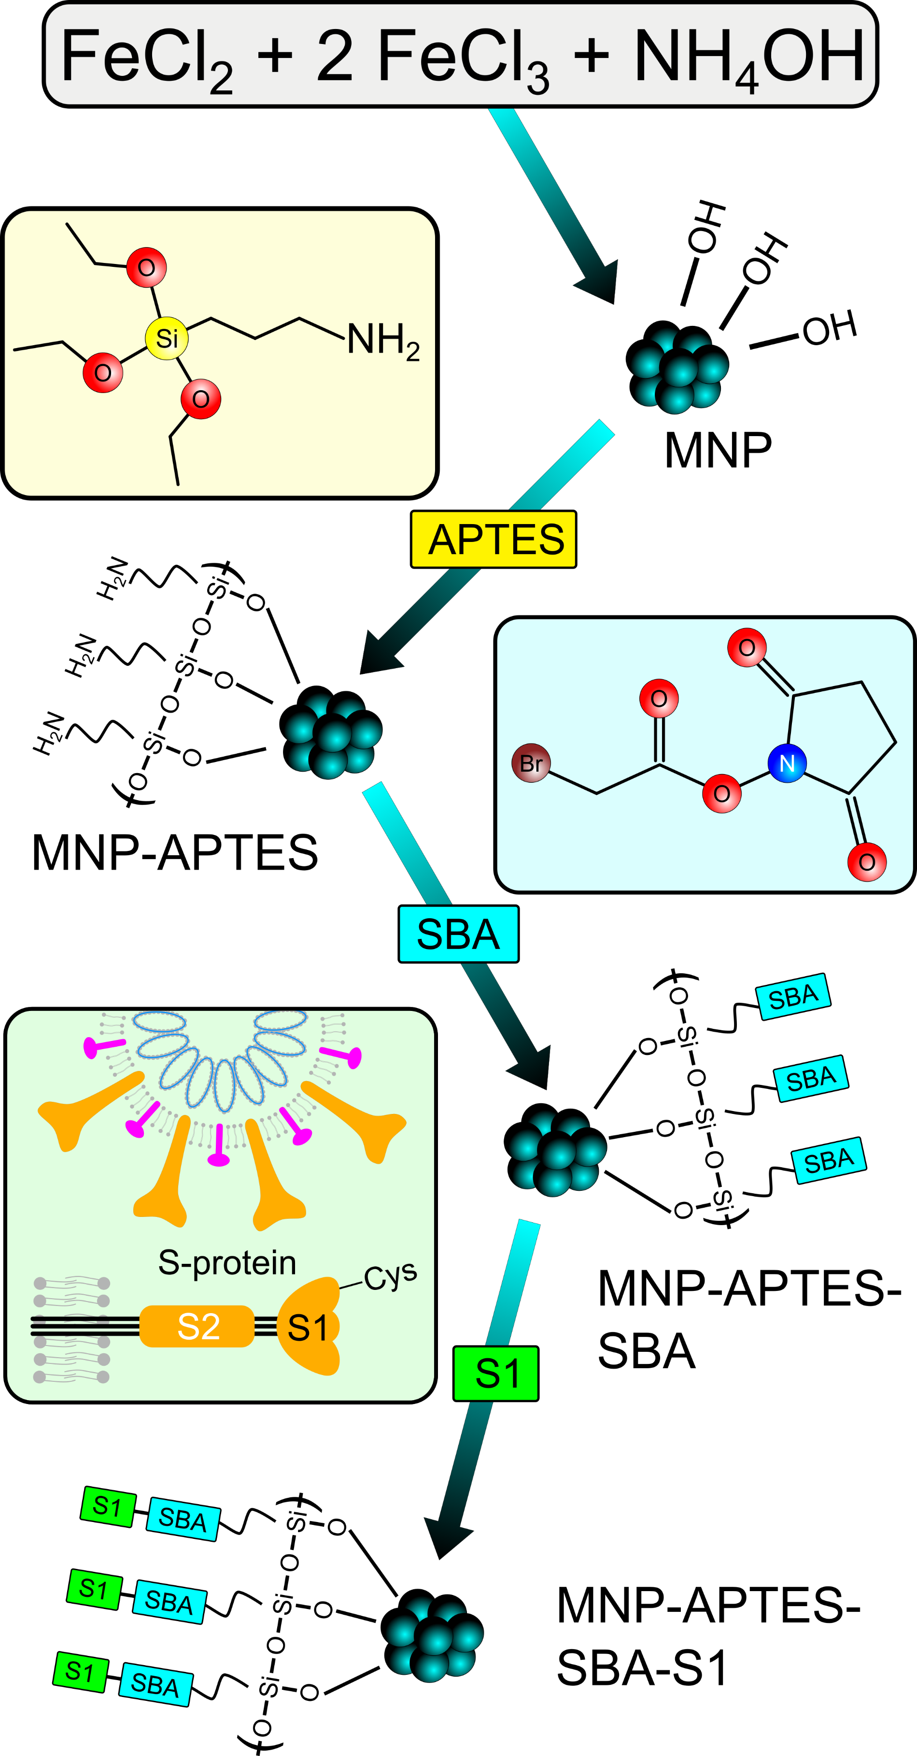
Fig. S3: Synthesis and functionalization route for MNP-APTES and MNP-APTES-S1 particles.

S4: full data sets
To get a better understanding of the signal behavior at the critical points and the behavior of the magnetic field configurations, a more sophisticated experiment was performed to obtain a full data set. For that, the samples were measured with multiple offset magnetic fields H_{DC} as well as multiple excitation magnetic field strengths H_{AC,j}(t) to obtain a data set over a defined range of both parameters.
The result is a 2D contour plot for real and imaginary parts of the MNP signal depending on the offset magnetic field H_{DC} and excitation magnetic field H_{AC,j}(t) for each harmonic n.
The range of the offset magnetic field spans 0 mT up to 20 mT in 0.1 mT steps. The range of the excitation magnetic field spans 0.6 mT up to 21.6 mT in 0.3 mT steps. In sum 200·36=7,200 individual measurements were performed for each full data set. The basic excitation frequency was f₁=20 kHz.
Fig. S4-1 shows a full data set of a reference sample as an example. With increasing excitation magnetic field H_{AC} (y-axis) the Chebyshev polynomial like shape as well as the nodes shows up more clearly. In the profile plot of the 3rd harmonic for an specific excitation magnetic field H_{AC}=17 mT, it can be seen, that around a node or critical point (real and imaginary part crosses near the x-axis) the phase shows a shift of about 180°.
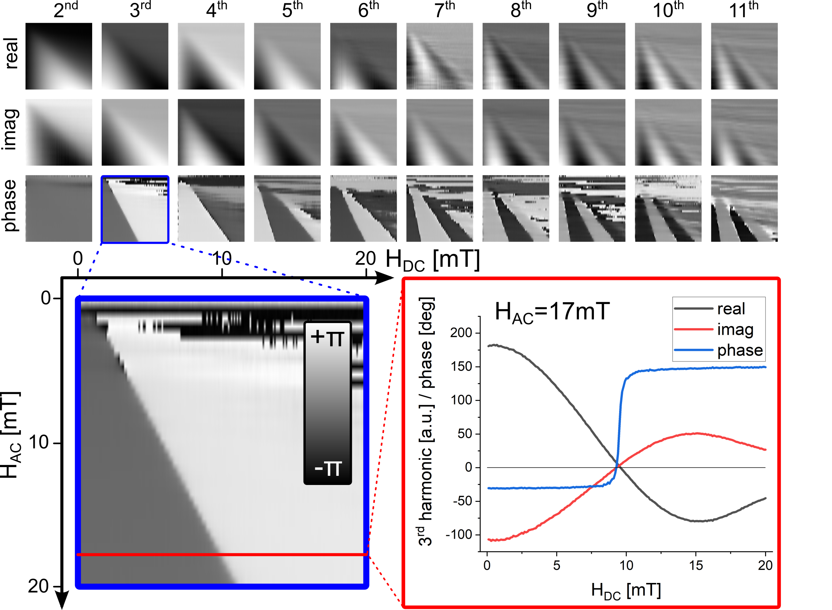
Fig. S4-1: Full data set (7,200 single measurements) for a reference sample. Top: Real, imaginary and phase 2D contour plot for the 2nd to the 11th higher harmonic of f₁=20 kHz. Bottom: Exemplary phase plot of the 3rd higher harmonic and the real, imaginary and phase profile for a specific excitation magnetic field H_{AC}=17 mT.
With this full data set, a more specific view on the COMPASS effect can be visualized when subtracting these data from different samples. In Fig. S4-2, the subtraction was performed for three data sets: subtraction between two reference samples (ref₁-ref₁’) and subtraction between a reference sample and a binding sample (ref₁-S+). In the top rows, the phase differences for each higher harmonic are shown. For a better visualization, the absolute values for the phase differences are provided in the second row. For example, the data of the 3rd harmonic of each difference (ref₁-ref₂’) and (ref₁-S+) are shown in more detail in the center: at a first glance, along the Chebyshev nodes high differences can be seen. Even in the difference between both reference samples this is visible. But a view on the profile plot along a specific excitation magnetic field strength (H_{AC}=18 mT) shows a 13 times higher phase difference peak for binding versus reference. It has to be mentioned, that the difference of the amplitude, which is also provided in the profile plot, also shows a 10 times higher signal at the position of the phase difference peak. Combining both parameters (amplitude and phase) provides a 13·10=130-fold increase in the difference between binding and non-binding samples.
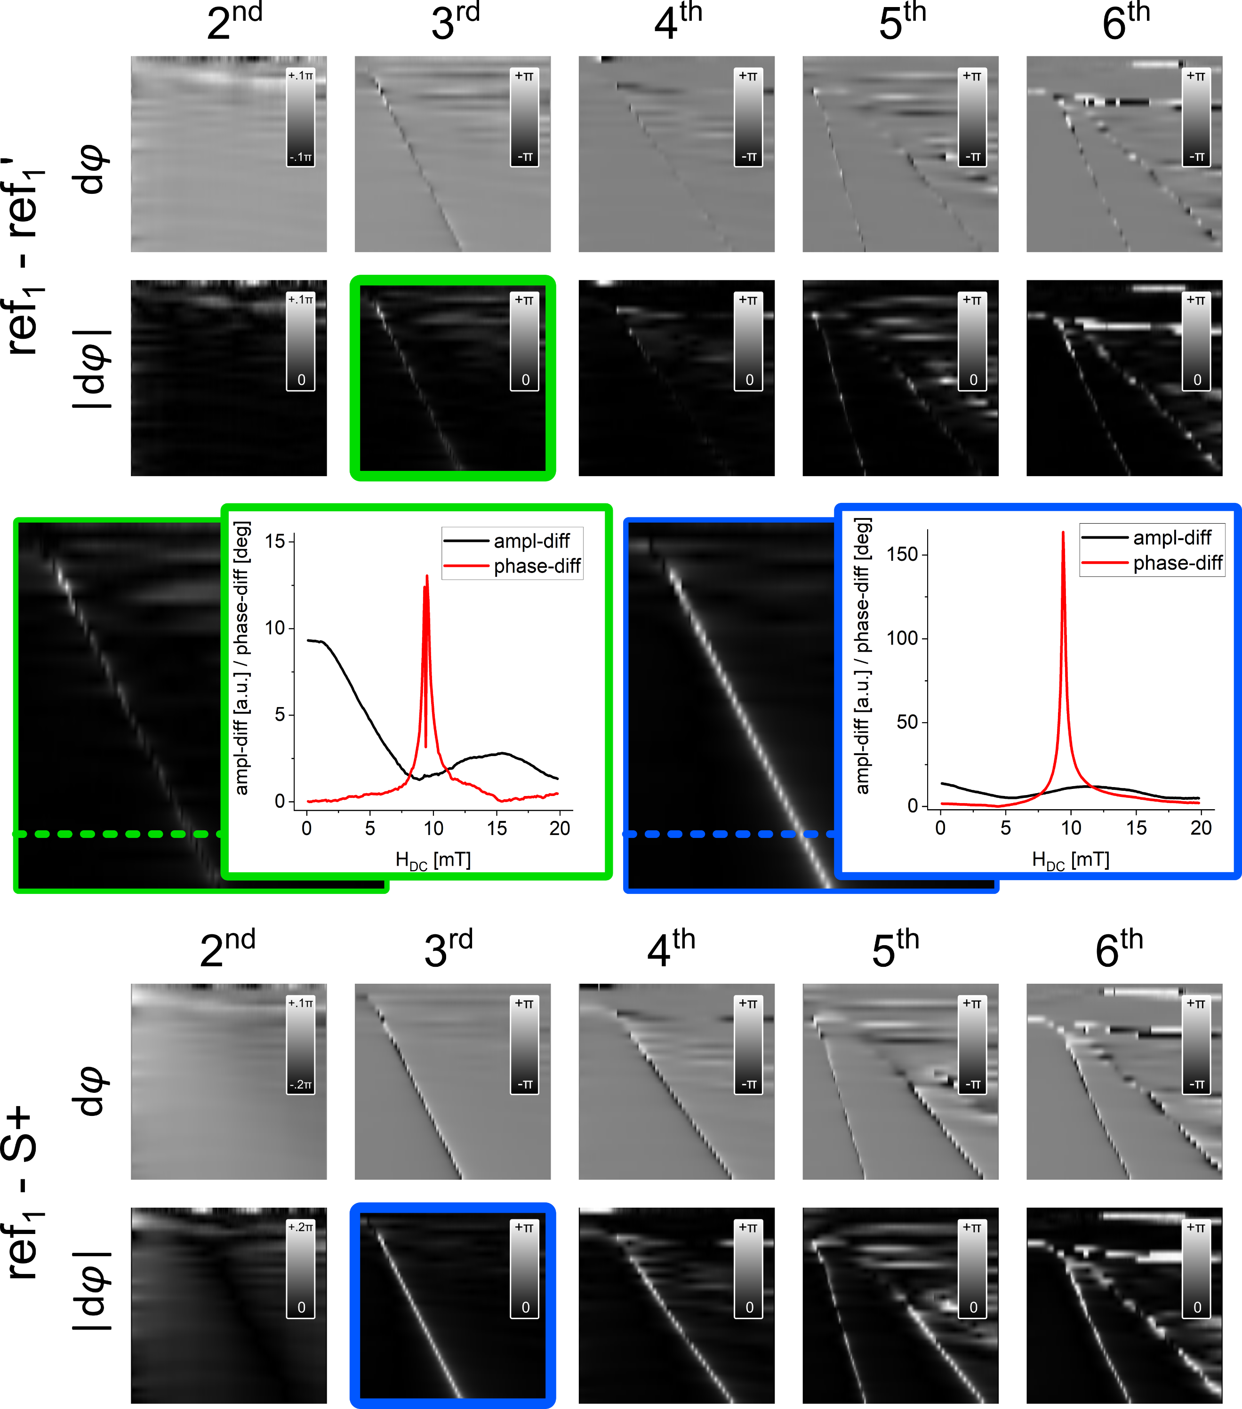
Fig. S4-2: Subtraction plots of three full data sets: Top: The phase difference for higher harmonics (2nd to 6th) of two reference samples (ref₁-ref₁’) are shown (first row). Bottom: the phase difference for higher harmonics (2nd to 6th) of a reference sample and a binding sample (ref₁-S+) are shown (first row). For better visualization, the absolute values are plotted (second row). Middle: Comparison of the 3rd higher harmonic for both subtractions: the increased phase difference can be clearly seen for the binding sample.
Furthermore, the graph in Fig. S4-3 offer even more information about the onset of exploited signal behavior. Above an excitation magnetic field amplitude H_{AC} of about 2.5 mT and an offset magnetic field H_{DC} of about 2 mT, the phase difference is clearly detectable. Below these values, the signal can be still measured but with less much less SNR. This is a possible explanation why this effect was not reported before in ACS experiments or common MPS experiments.
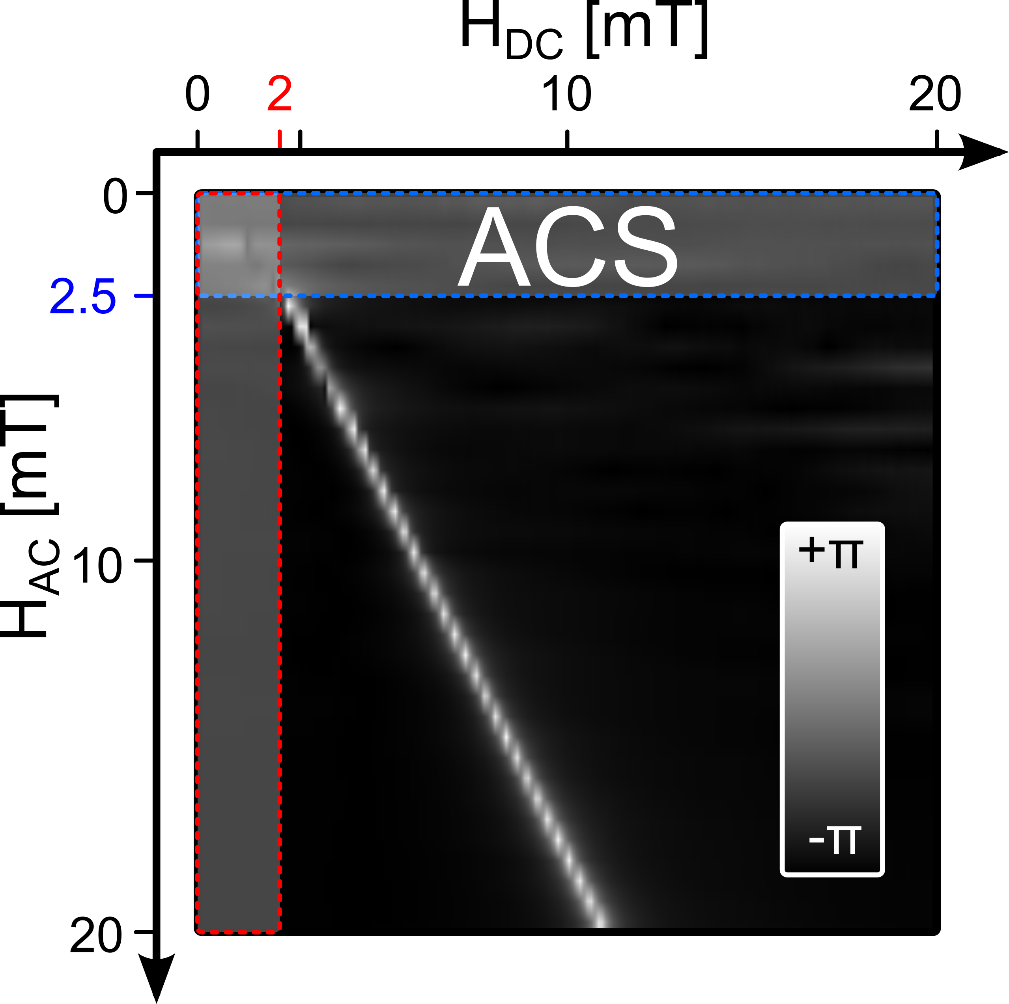
Fig. S4-3: A closer look at the absolute phase difference of the 3rd harmonic between a reference sample (ref) and a binding sample (S+) indicates the ‘starting points’ of the proposed COMPASS effect. Below H_{DC}=2 mT offset magnetic field and H_{AC}(t)=2.5 mT excitation magnetic field strength, the effect is much weaker and cannot be measured.

S5: Mobile COMPASS device
The measurement system is similar to common MPS devices as known from the literature [8, 9]. Only few modifications turn the MPS device into an highly sensitive MNP measuring COMPASS device. The first is adding a strong magnetic field gradient along the FOV of the MPS device. In case of the proposed mobile modified MPS device, a strong permanent magnet (10 mm³ Neodym N52) is placed near the transmit/receive (tx/rx) unit. In Fig. S5-1, a CAD drawing of the modular tx/rx unit is shown with the positioned magnet. The bore provides space for 0.5 ml samples (Eppicaps). The gradiometric receive coils are placed as closely as possible to the sample to guarantee high SNR. Only one receive coil receives signal from the sample, while the second one is wired antiparallelly to suppress the signal induced directly by the excitation coil as well as environmental noise [10]. The transmit coil (tx) is placed around the receive coils. To adjust the gradiometric receive coil, the entire rx-inset can be moved and adjusted in relation to the tx-coil to suppress the excitation signal as well as possible (at least 60 dB). The coil parameters for transmit coil are 4×9 windings (90×0.1 mm litz wire, Rupalit, Pack-Feindrähte, Germany) resulting in a magnetic field of 2.1 mT per ampere. The receive coil uses 20 windings for each coil (12×0.04 mm litz wire, Rupalit, Pack-Feindrähte, Germany) resulting in a resistance of about 2 Ω. The transmit chain is optimized for 20 kHz and can generate magnetic fields up to 50 mT with a current of approximately 25 A.
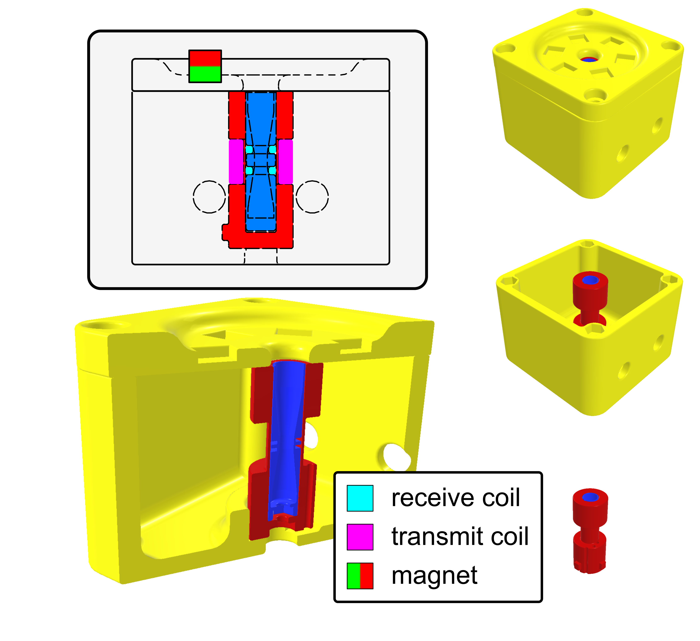
Fig. S5-1: CAD drawing/3D-renderings of the tx/rx module. The modular box consists of a transmit coil, an adjustable gradiometric coil and a permanent magnet for magnetic field generation within the FOV. The tx/rx module can be connected via two BNC adapters to the main system.
The tx/rx module is connected via two coaxial cables to the main device, which serves as stand-alone system consisting, among other parts, of a microcontroller (PSoC 5LP, Cypress Semiconductors, USA), a BLE module (HC-05, AZ-Delivery, Germany), an audio amplifier (TDA7294, STMicroelectronics, Switzerland), and rx-filter components. The power supply, here a battery pack and can be connected via a standard USB-B connector.
The positioning of the permanent magnet (Neodym N52) generates in the center of the tx/rx module (FOV) a strong gradient magnetic field. In Fig. S5-2, a simulation of the magnetic field vectors is presented for the entire volume of the gradiometric receive coil, where only in the upper area the sample is positioned [11].
marker | B-field [mT]
1 | 6.8
2 | 10.0
3 | 5.8
4 | 7.3
5 | 5.0
6 | 6.6
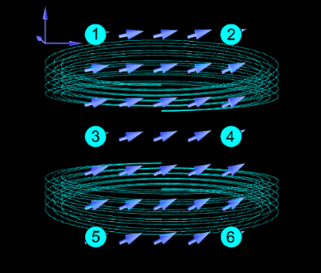
Fig. S5-2: Magnetic field gradient strength within the gradiometric receive coil or field of view (FOV). The magnetic field strengths are in the range between 5.8 mT to 10.0 mT for the upper area of the gradiometric rx coil.
Four buttons and a 2-line display are used for setting up the device, perform measurements and display all required results without using additional hardware components. For additional information about the experiments, such as signal graphs or debugging information, all data are broadcasted via Bluetooth and can be analyzed via mobile equipment and a dedicated host software. In Fig. S5-3 top, an image of the mobile MPS device is shown. At the bottom, some pictures show the real tx/rx module, the tx/rx coil system and the entire box with additional permanent magnets. Most parts are 3D-printed with FDM (N2, Raise, USA) or SLA (Form3, Formlabs, USA) method.
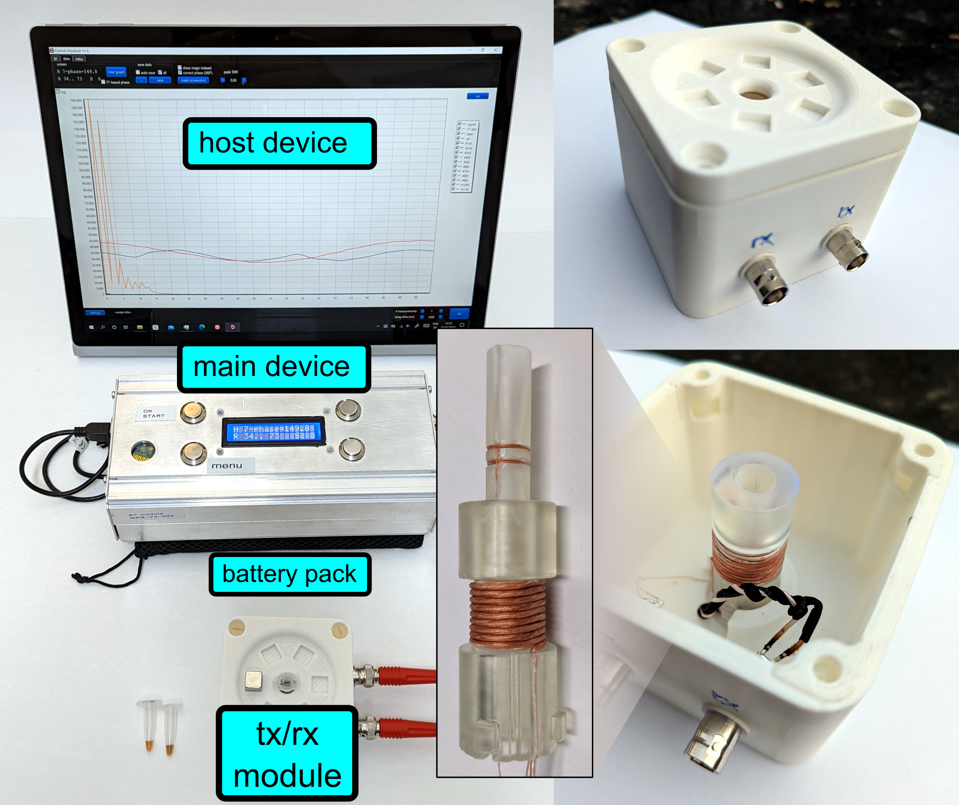
Fig. S5-3: Top: mobile modified MPS device with the main device consisting of all necessary hardware components such as microcontroller, amplifier and filters, the transmit/receive module for 0.5 ml Eppicaps and a battery pack as power supply. Bottom: pictures of the tx/rx module.
COMPASS operating points
To set up a COMPASS device for highly sensitive measurements, the optimal operating points must be adjusted. As mentioned before, critical points (CPs) are found at specific field ratios of H_{AC} and H_{DC} (H_{AC}>H_{DC}) for each higher harmonic n, where the number of nodes N_{n} per harmonic depends on the harmonic number n
 | $N_{n}=n mod 2 for n> 0$. | (EqnS4-1)
With that, critical points CP_{n,m} can be uniquely assigned.
The graph in Fig. S5-4 shows normalized absolute plots A_{n}(H_{DC}) of the 3rd, 6th, 9th, and 12th harmonic of simulated data. For a limited selection of harmonics, which is the case for realistic receive chains due to signal-to-noise limitation as well as the resonant behavior of the receive chain, the critical points accumulate in specific areas, e.g., CP_{3,1}, CP_{6,2}, CP_{9,2}, CP_{12,3}. The operation point of a COMPASS device should preferably be chosen to cover such an area to analyze critical points for as many harmonics as possible for higher robustness and redundancy.
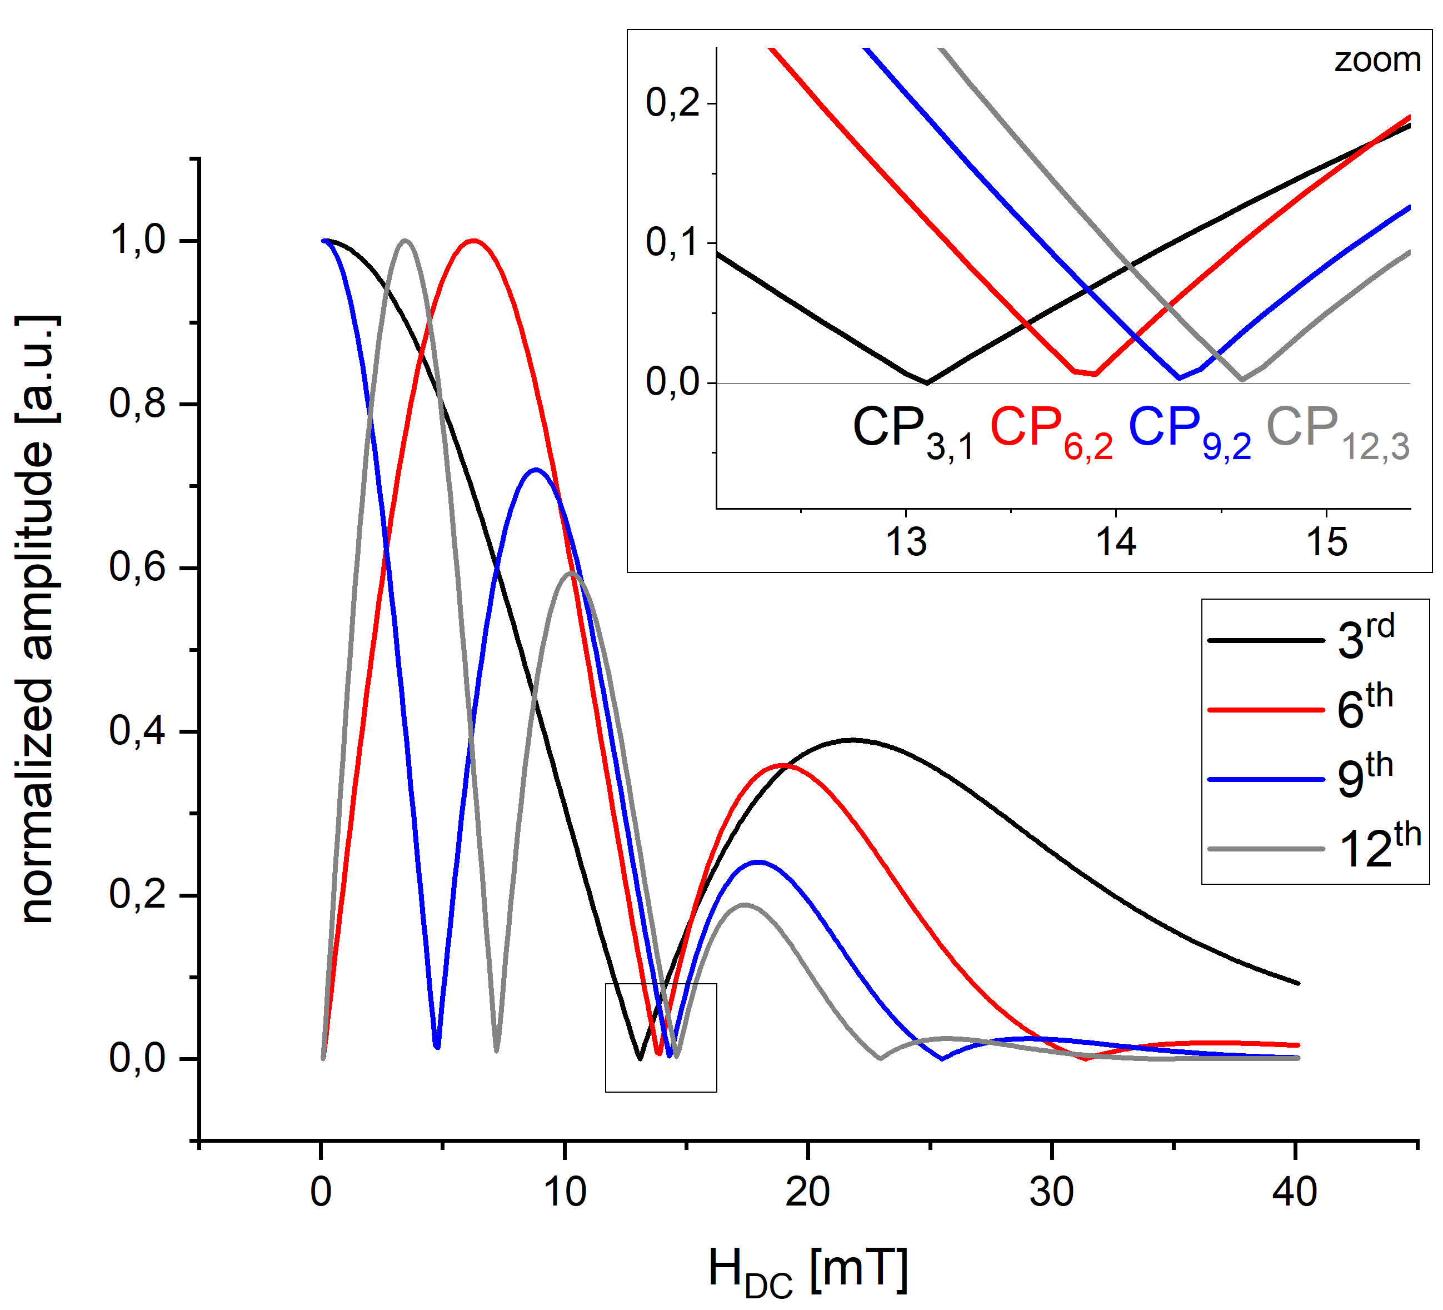
Fig. S5-4: Amplitude plots A_{n}(H_{DC}) of simulated data for the 3rd, 6th, 9th, and 12th harmonic show multiple critical points CP_{i,j} (H_{AC}≈40 mT). With a limited set of harmonics, areas with high density of CPs can be found.
For calibration, three steps are required:
- Placing a reference sample in the COMPASS device
- Set up the offset magnetic field H_{DC} by positioning and/or adjusting of a permanent magnet or electro magnet
- Perform an amplitude sweep for H_{AC} to find the desired operating point

S6: Data processing
Data processing is performed completely within the PSoC microcontroller (PSoC 5LP, Cypress Semiconductors, USA) using the onchip resources. The digital-to-analog (DAC) converter generates a customizable sinusoidal excitation signal (data length of 10,000 samples at a sampling rate of 1 MS/s, which corresponds to 10 ms length) feeding the audio amplifier (TDA7294, STMicroelectronics, Switzerland) for generation of the required time varying magnetic field. After passive filtering and pre-amplification two onboard 12 bit analog-to-digital (ADC) converter are used for interleaved data acquisition of the incoming signal from the gradiometric coil. Controlling both the transmit and receive channel with the same chip and a single reference clock results in a low phase jitter and allows for high resolution and accuracy even with the comparatively low sampling rates (2 MS/s) and bit-resolution values. The acquired data are directly processed on the chip. In a first step, the entire data set (20,000 sample points) is cut into sub data sets containing 100 samples each corresponding to one full period of the excitation frequency of 20 kHz. This reduces the on-chip calculation time for the following sine and cosine transformation to a few milliseconds without sacrificing SNR and enables repetition times below 1 s. A combined sine and cosine transformation for the first 11 higher harmonics is used to calculate the phase and amplitude for each harmonic.
For an independent data visualization, a 2-line display in the main device is used. The data can also be broadcasted automatically through an external host software to an external device like a desktop computer or laptop for evaluating additional information and for better visualization.

S7: Sensitivity compared to ELISA and flow cytometry-analysis
To evaluate the sensitivity of the proposed methods within the flexible MPS device, a comparison with ELISA as well as flow cytometry-analysis were performed. For flow cytometry, a sample series with antibody dilutions of 1:2,000, 1:5,000, 1:10,000, and 1:20,000 (corresponding to 50 ng/ml antibodies) as well as a reference sample (ref) and a non-binding sample (1:2,000) with a MERS antibody (neg. control) were prepared and measured within a flow cytometer and the modified MPS device.
The results in Fig. S7-1 show a sensitivity of antibodies detection of dilutions between 1:5,000 and 1:10,000.
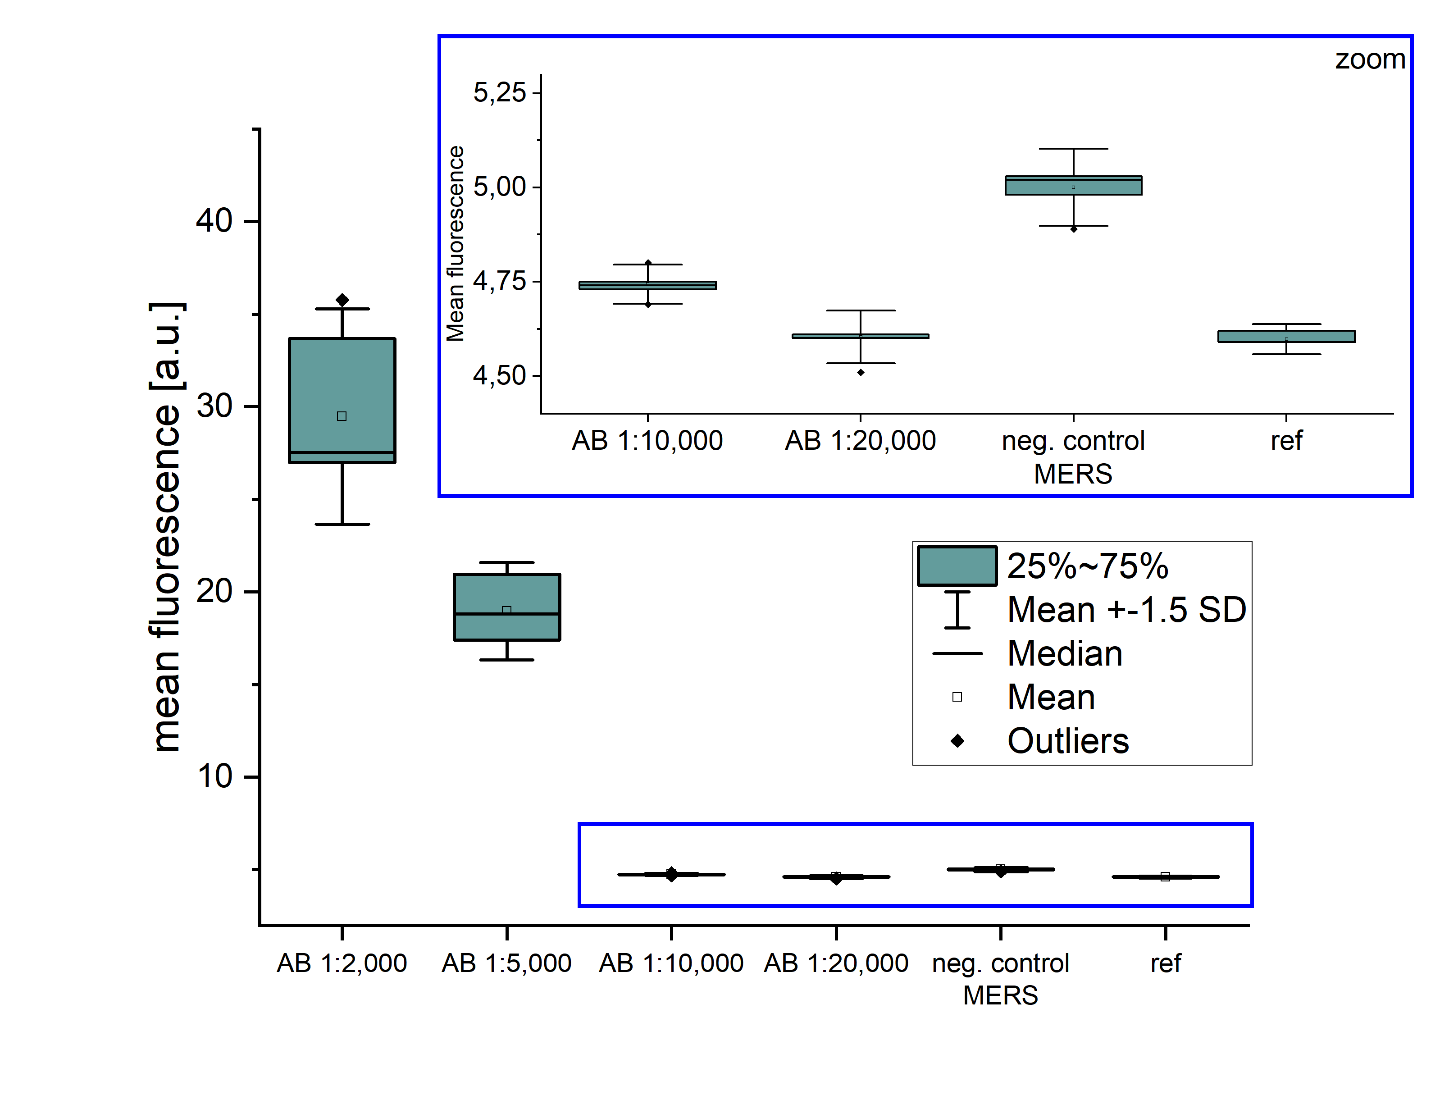
Fig. S7-1: Mean fluorescence of MNP-APTES-S1 after incubation with antibodies and Protein A-FITC. Detection of antibodies was possible up to a dilution of 1:10,000 with flow cytometry-analysis.
In Fig. S7-2, the results of the COMPASS experiments are shown. Top: The single experiments of the measuring sequence (ref, 1:2,000, 1:5,000, 1:10,000, 1:20,000, neg. control) show a clear trend in phase difference of the 7th and 9th higher harmonics. Each sample was measured 5 times without any averaging (acquisition time 10 ms each). A closer look at the values reveals a sensitivity, which lies beyond the flow cytometry measurements.
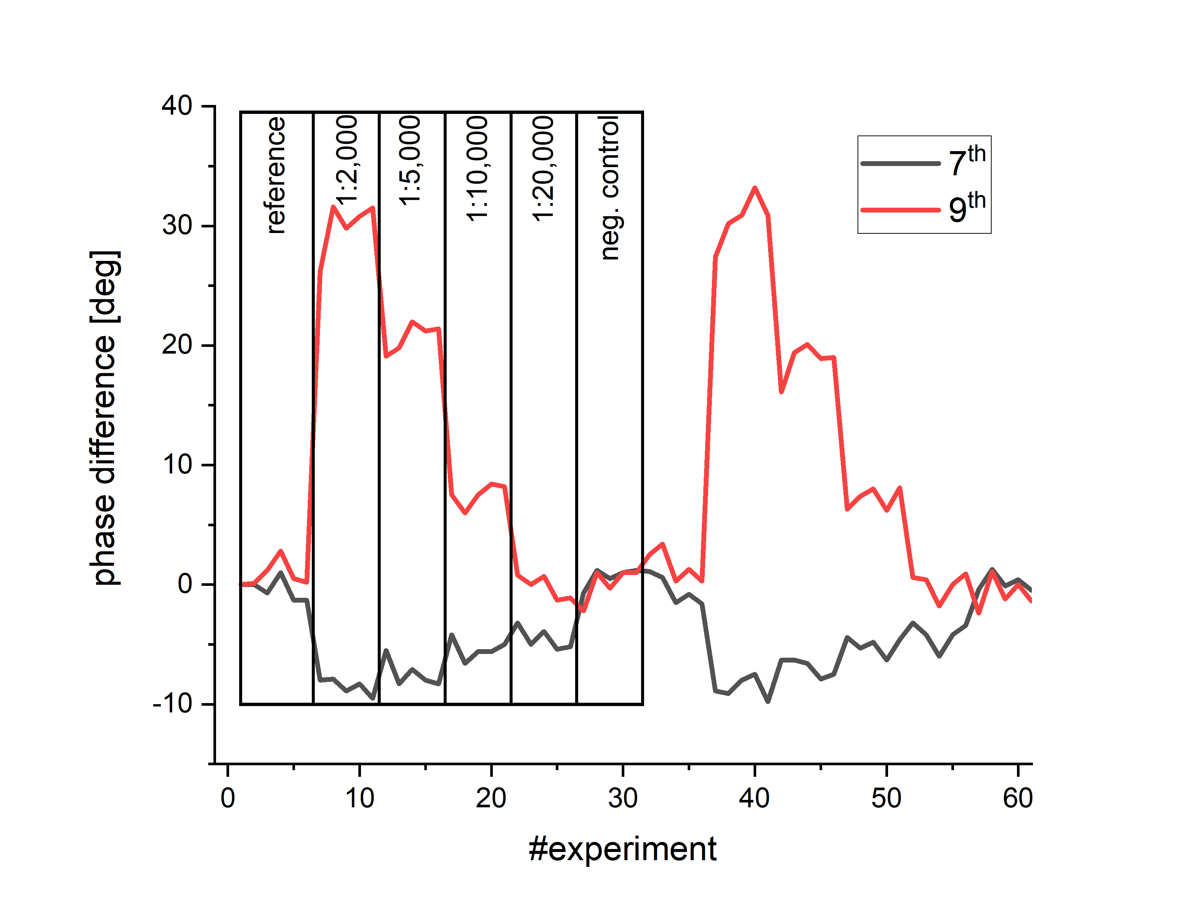
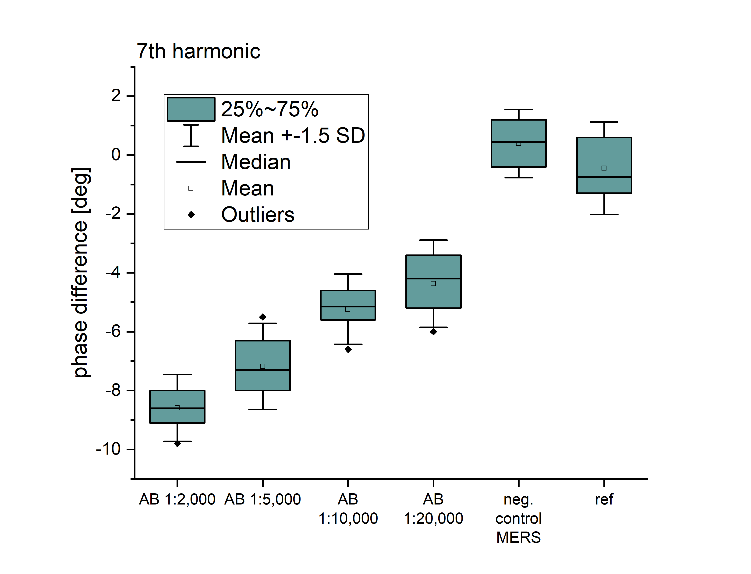
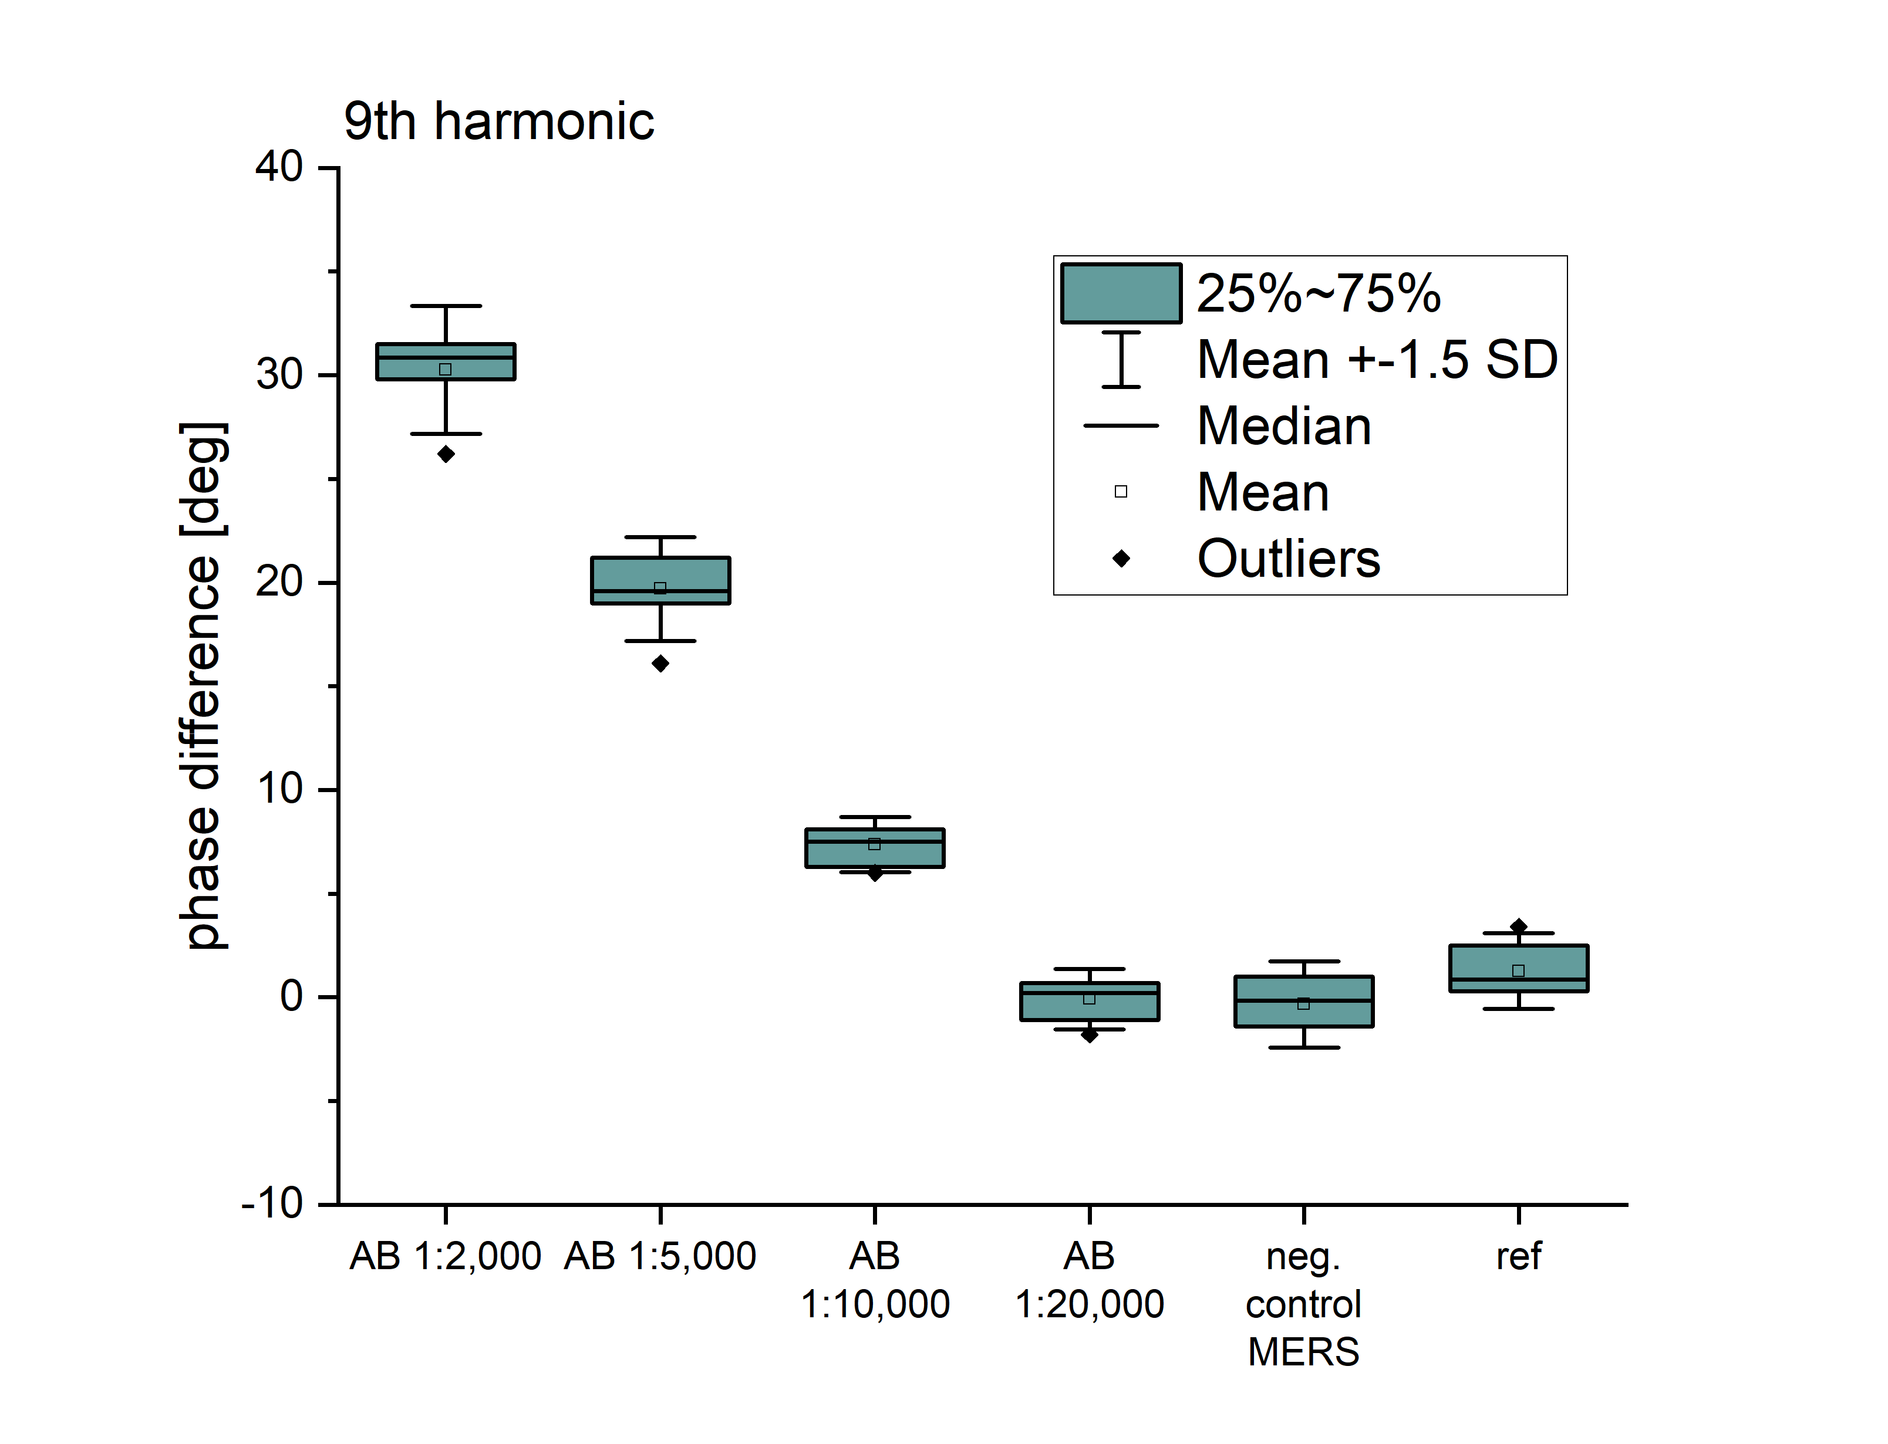
Fig. S7-2: Results of measuring the dilution series within the COMPASS device using MNP-APTES-S1: Top: The phase differences of the 7th and 9th harmonic are shown for the measuring sequence: reference (ref), dilutions 1:2,000, 1:5,000, 1:10,000, 1:20,000, and neg. control, 5 times each, repeated 2 times. Center and bottom: A closer look at the data reveals the sensitivity of this method.
For comparison, a standard SARS-CoV ELISA test (RayBio® COVID19 S1 RBD protein Human IgG ELISA Kit Protocol, RayBiotech, Inc.) was performed according to the manufacturer’s instructions. Due to low signal, the incubation time was extended to 18 hours instead of 30 minutes.
In Fig. S7-3, the result of the ELISA test is shown. The averaged optical density (OD) at 450 nm of the wells (triplets) were determined and show a sensitivity limit at 25 ng to 50 ng antibodies per ml corresponding to 1-2 BAU (binding antibody unit).
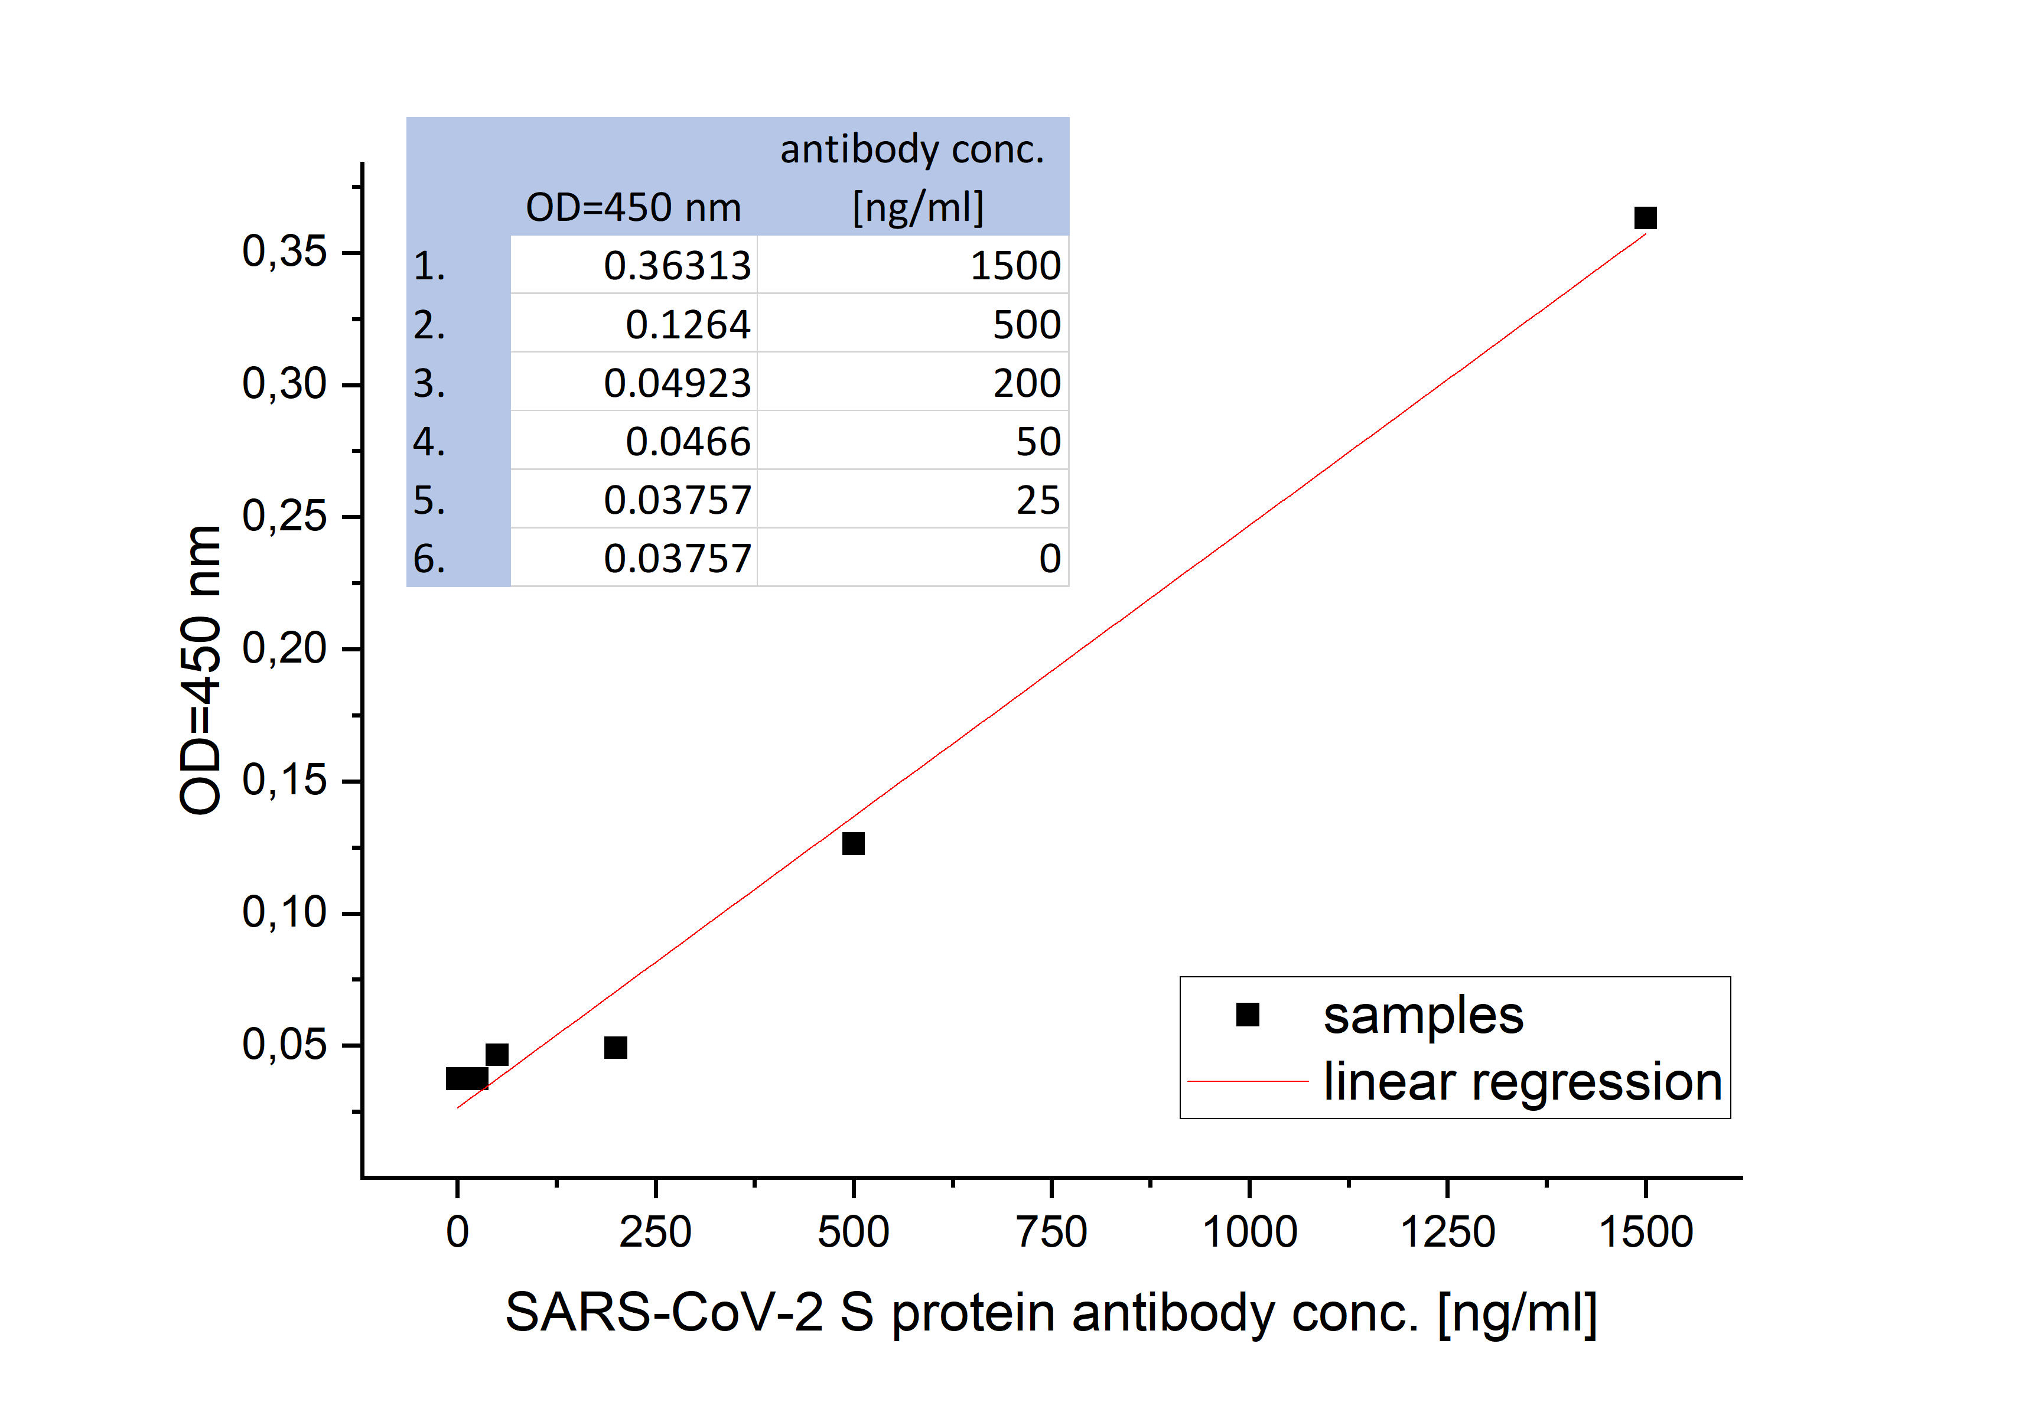
Fig. S7-3: Result of a standard SARS-CoV-2 S1 protein IgG test.
In conclusion, the sensitivity of the provided dilution series measured with the COMPASS device can be determined to about 50 ng/ml antibodies, which corresponds to a BAU of about 2. With a weight of 150 kDa per antibody and a sample size of 50 µl, a sensitivity of about 8.5 fmole/50 µl (1.25 ng/ml or 330 pM) can be calculated, which is also comparable to the sensitivity of ELISAs.
As indicated in the main text, using an COMPASS device optimized to a specific critical point (S5: COMPASS operating points), the sensitivity is improved at least by a factor of 10 and reaches 0.85 fmole/50 µl ≙ 33 pM.

S8: Measurement protocol for COMPASS
The measurement protocol for testing with COMPASS is optimized for receiving clear and robust results rapidly (within seconds). For that, a differential measurement of two identical probes split from the original prepared MNP-APTES-S1 batch is used (Fig. S8 (1)). The to-be-measured substance is directly given in the sample probe (Fig. S8 (2)) and can be instantaneously measured with COMPASS without further washing processes or conjugation or incubation times (Fig. S8 (4)). The same amount of a buffer solution is added in the reference sample (Fig. S8 (3)) before measured with COMPASS (4). The results are available within seconds (Fig. S8 (5)).
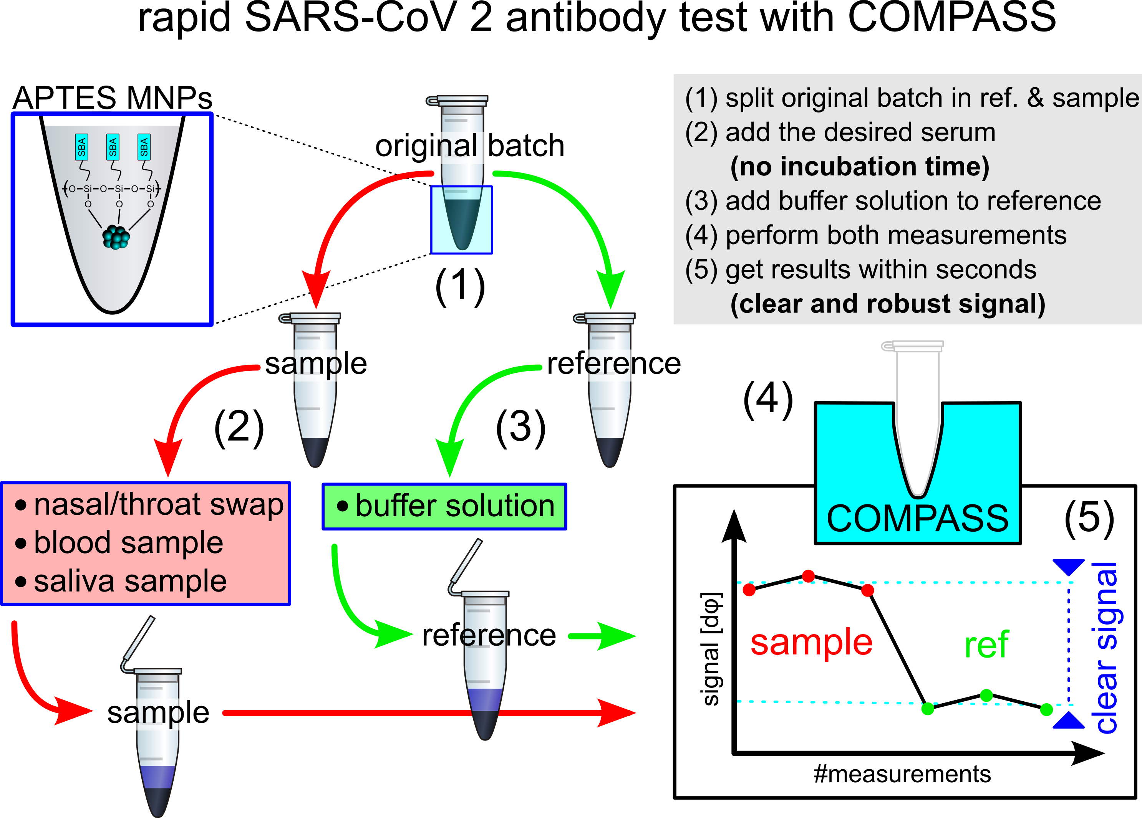
Fig. S8: Sketch of the measurement protocol: starting from a prepared MNP-APTES-S1 batch, two identical probes are prepared: sample and reference (1). The to-be-measured substance is directly added in the sample vial without any further washing step or incubation time (2) before measured in the COMPASS device (4). The reference sample is filled with buffer solution (3) and measured (4). Within seconds, a clear and robust result is available (5).

References
- J. Rahmer, J. Weizenecker, B. Gleich, J. Borgert, Signal encoding in magnetic particle imaging: properties of the system function, BMC Med Imaging, vol. 9(4): 19335923, 2009.
- W. T. Coffey, Y. P. Kalmykov, J. T. Waldron. The Langevin equation. 2nd ed. Singapore: World Scientific 2004
- S. Ota, Y. Takemura, Characterization of Néel and Brownian Relaxations Isolated from Complex Dynamics Influenced by Dipole Interactions in Magnetic Nanoparticles, J. Phys Chem, vol. 123(47), pp. 28859-66, 2019.
- P. Ilg, M. Kröger, Dynamics of interacting magnetic nanoparticles: effective behavior from competition between Brownian and Néel relaxation, Phys. Chem. Chem. Phys., vol. 22, pp. 22244-22259, 2020.
- M.A. Martens, R.J. Deissler, Y.W. Wu, L. Bauer, Z. Yao, R. Brown, Modeling the Brownian relaxation of nanoparticle ferrofluids: Comparison with experiment, Med Phys, vol. 40(2):022303, 2013.
- W. Karawacka, C. Janko, H. Unterweger, M. Mühlberger, S. Lyer, N. Taccardi, A. Mokhir, W. Jira, W. Peukert, A.R. Boccaccini, M. Kolot, R. Strauss, C. Bogdan, C. Alexiou, R. Tietze, SPIONs functionalized with small peptides for binding of lipopolysaccharide, a pathophysiologically relevant microbial product, Colloids and Surface B, vol. 174, pp. 95-102, 2019.
- J. Sjödahl, Structural Studies on the Four Repetitive Fc-Binding Regions in Protein A from Staphylococcus aureus, Eur. J. Biochem., vol. 78, pp. 471 -490, 1977.
- S. Biederer, T. Sattel, T. Knopp, K. Lüdtke-Buzug, B. Gleich, J. Weizenecker, J. Borgert, T. M. Buzug, Magnetization response spectroscopy of superparamagnetic nanoparticles for magnetic particle imaging, J Phys D, vol. 42(20), 2009.
- K. Wu, D. Su, R. Saha, J. Liu, V.K. Chugh, J.P. Wang, Magnetic Particle Spectroscopy: A short review of applications using magnetic nanoparticles, ACS Appl. Nano Mater, vol. 3(6), pp. 4972-89, 2020.
- M. Graeser et al, Towards picogram detection of superparamagnetic iron-oxide particles using a gradiometric receive coil, Sci. Rep., vol. 7 , pp. 1-13, 2017.
- M. Liebl, D. Eberbeck, A. Coene, J. Leliaert, P. Jauch, M. Kruteva, L. Fruhner, L. Barnsley, S.G. Mayr and F. Wiekhorst, Magnetic measurement methods to probe nanoparticle–matrix interactions, Physical Sciences Reviews, pp. 20190112, 2021.
- C.V. Topping and S. J. Blundell, A.C. susceptibility as a probe of low-frequency magnetic dynamics, Journal of Physics: Condensed Matter, vol. 31:013001, 2019.

