Supporting Information
MSCs-Engineered Biomimetic PMAA Nanomedicines for Multiple Bioimaging-Guided and Photothermal-Enhanced Radiotherapy of NSCLC

Yipengchen Yin,‡ Yongjing Li,‡ Sheng Wang,‡ Ziliang Dong, Chao Liang, Jiaxin Sun, Changchun Wang, Rong Chai, Weiwei Fei, Jianping Zhang, Ming Qi, Liangzhu Feng, Qin Zhang*
Department of Radiation Oncology, Shanghai Chest Hospital, Shanghai Jiao Tong University, Shanghai 200030, P. R. China;
‡These authors contributed equally to this work.
*Corresponding author.
*Qin Zhang: Email: zhangqin@shsmu.edu.cn (Q. Zhang)

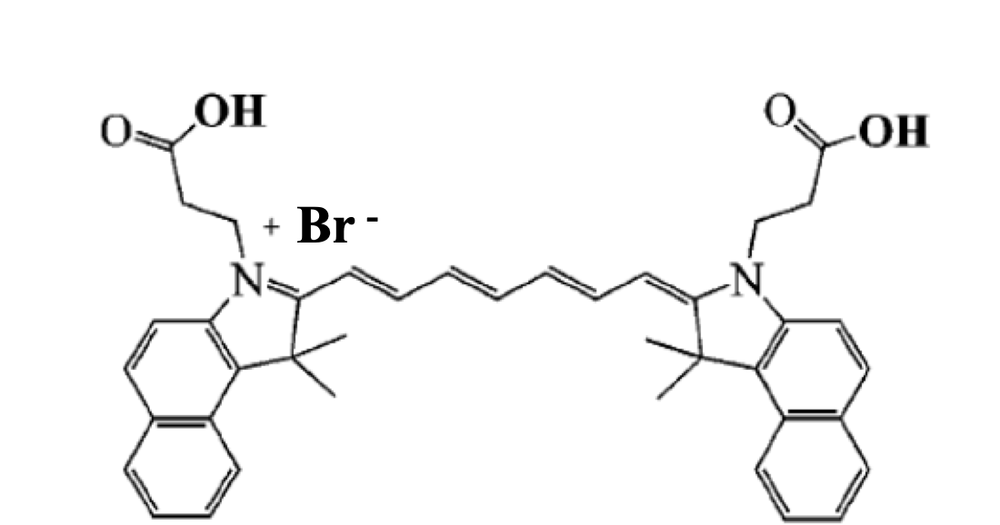

Fig S1. Structural formula of cypate.

Fig S2. Hydrodynamic diameters and zeta potenials of PMAA-Fe and Cyp-PMAA-Fe@MSCs.
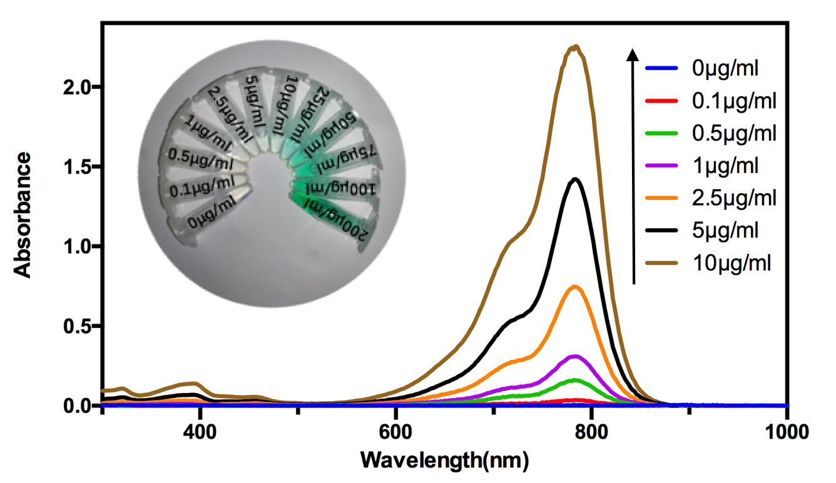

Fig S3. UV-vis-NIR spectra and typical photos of cypate with various concentrations.

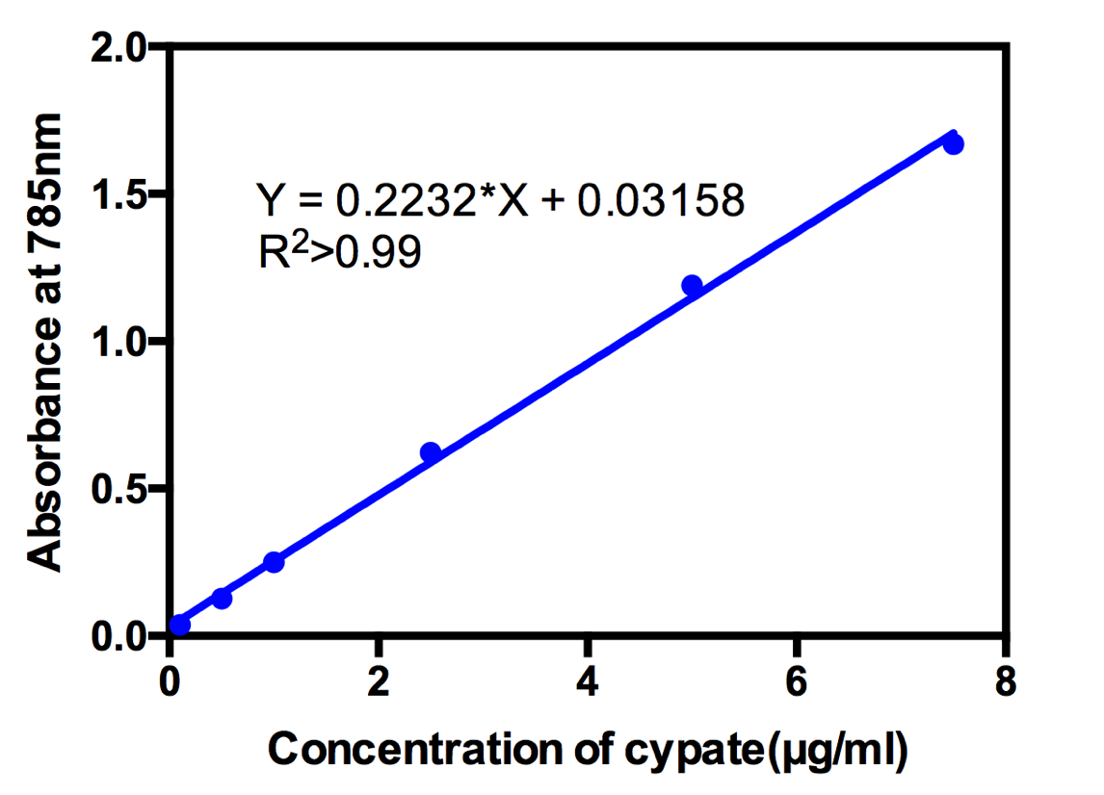
Fig S4. Absorbance of cypate with various concentrations at 785 nm.

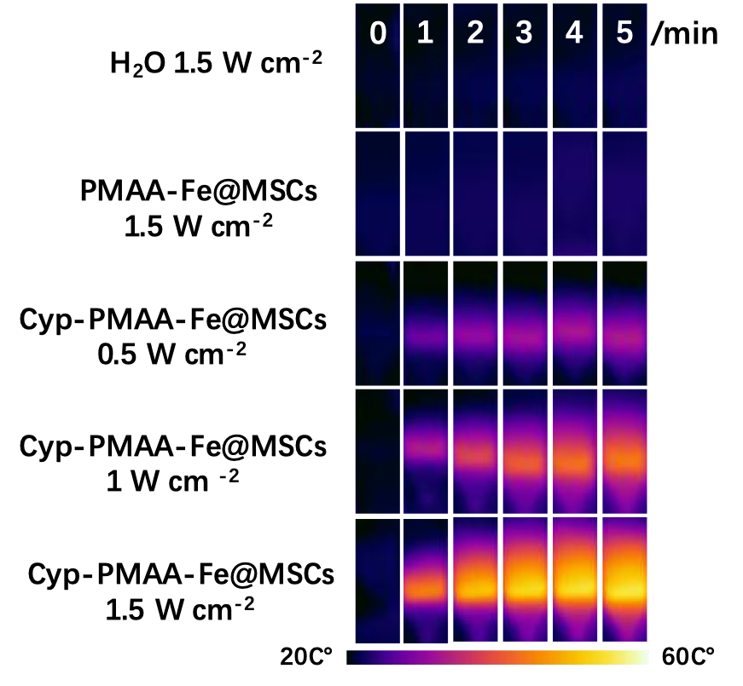

Fig S5. IR images of Cyp-PMAA-Fe@MSCs at 808 nm laser with various powers.

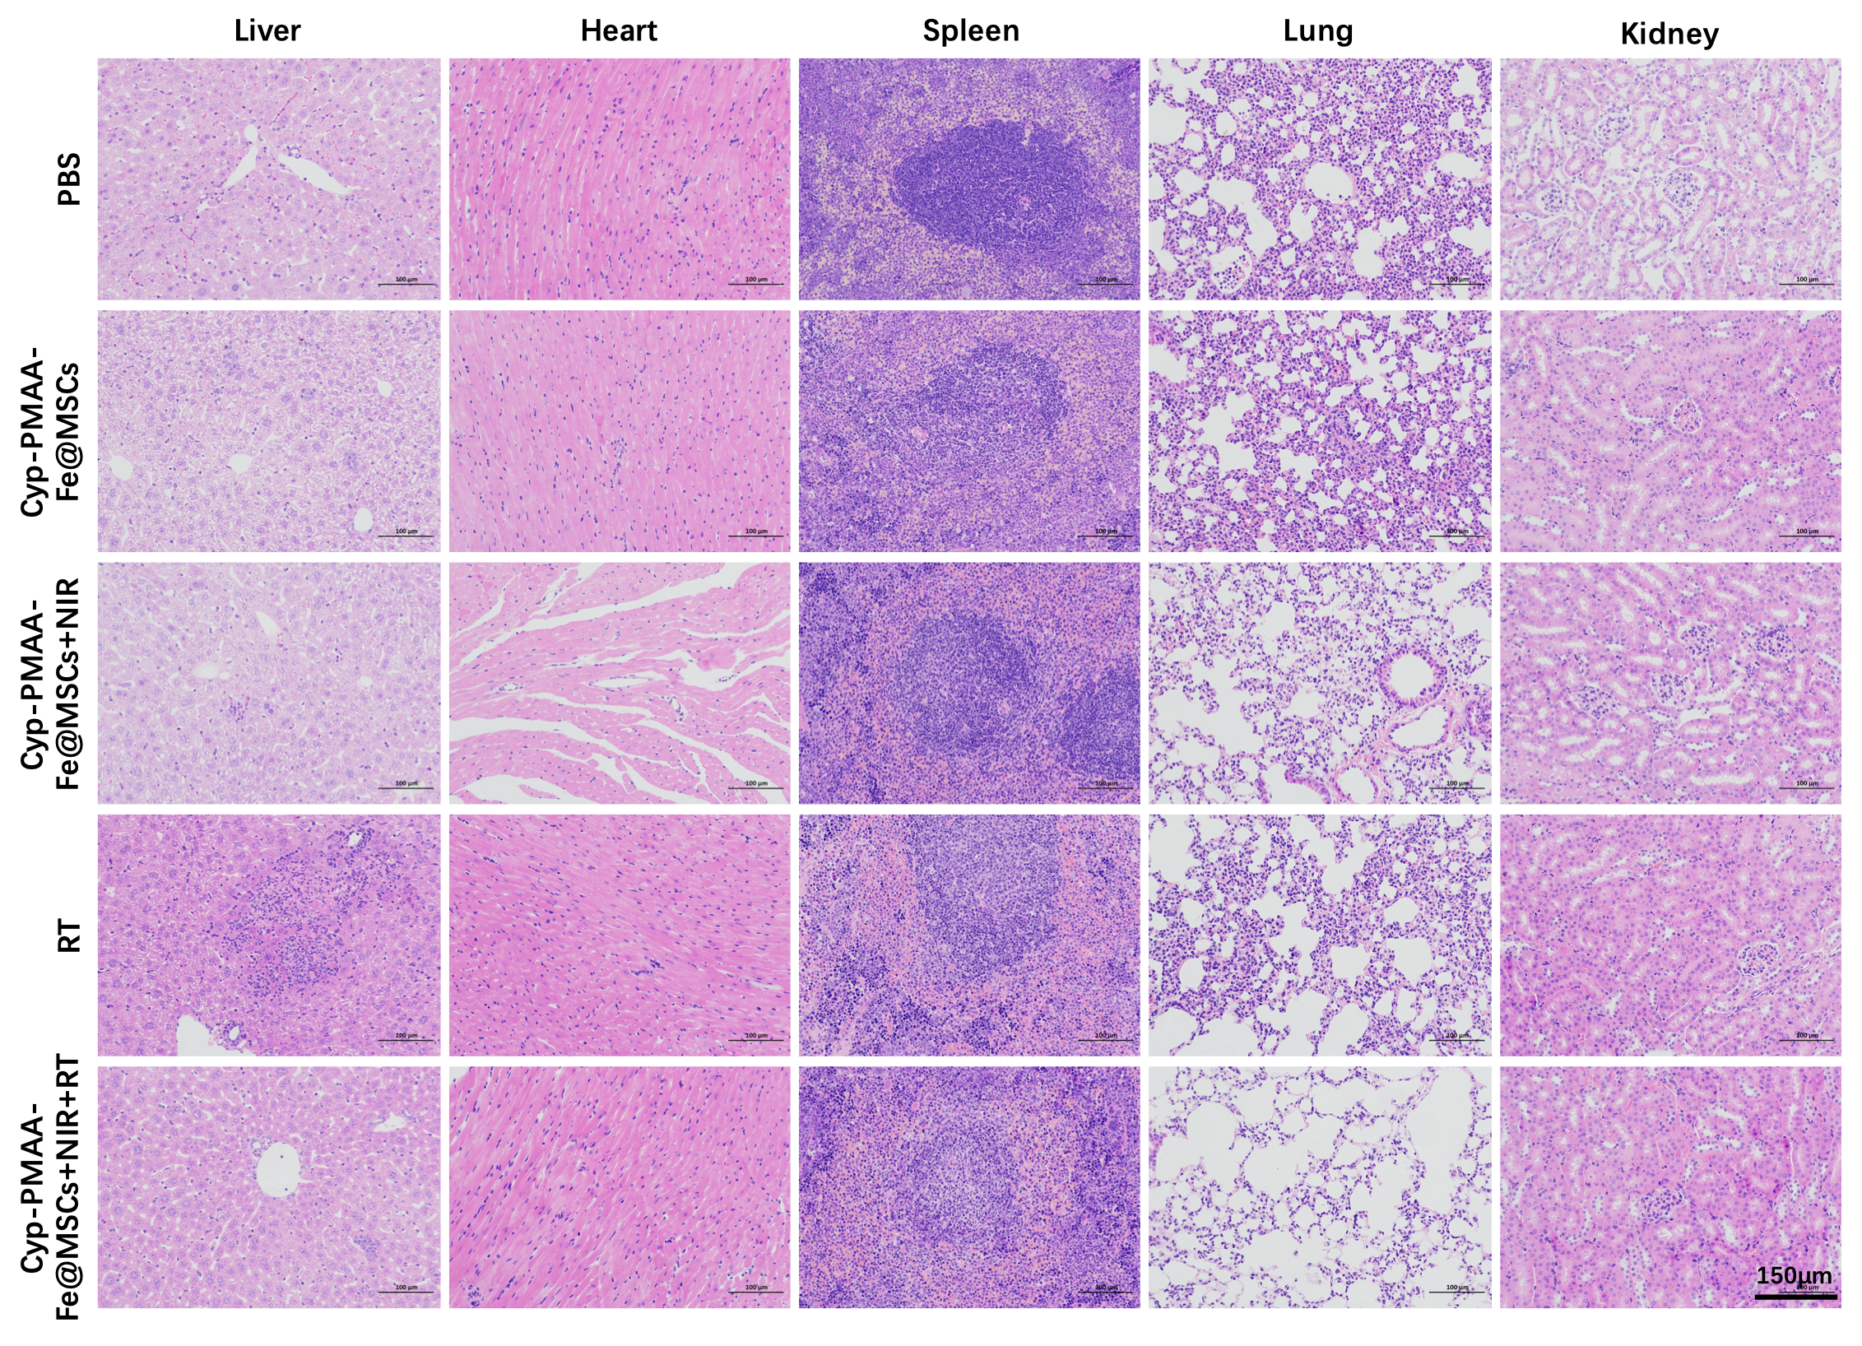
Fig S6. H&E staining of tissue slices from several organs in various groups.

