Supplementary Information
Azide-functionalized Ligand Enabling Organic–Inorganic Hybrid Dielectric for High-Performance Solution-Processed Oxide Transistors

Juhyeok Lee, Syed Zahid Hassan, Sangjun Lee, Hye Ryun Sim, Dae Sung Chung*
Department of Chemical Engineering, Pohang University of Science and Technology (POSTECH), Pohang 37673, Republic of Korea
*Correspondence: dchung@postech.ac.kr

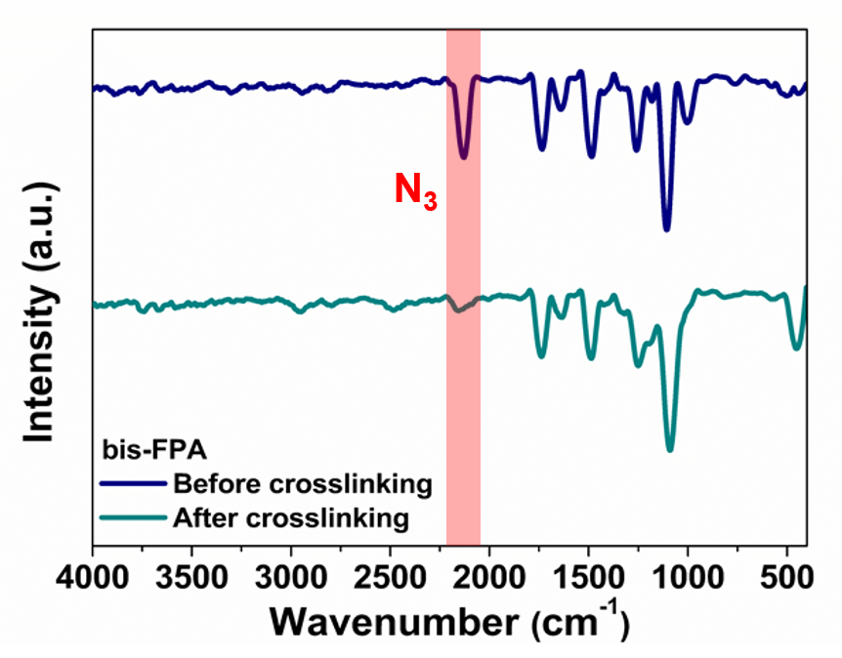

Supplementary Fig. 1. FT-IR spectra of bis-FPA films before and after being crosslinked.
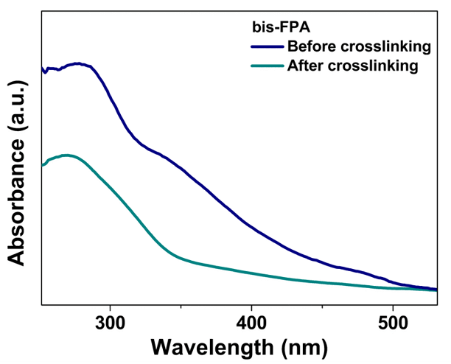

Supplementary Fig. 2. UV-visible absorption spectra of bis-FPA films before and after being crosslinked.
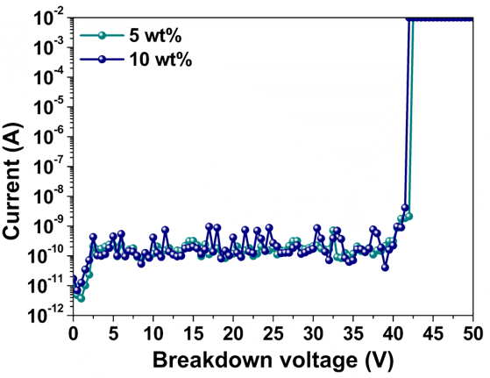

Supplementary Fig. 3. Breakdown voltage of hybrid dielectric with 5 wt% and 10 wt% of bis-FPA.
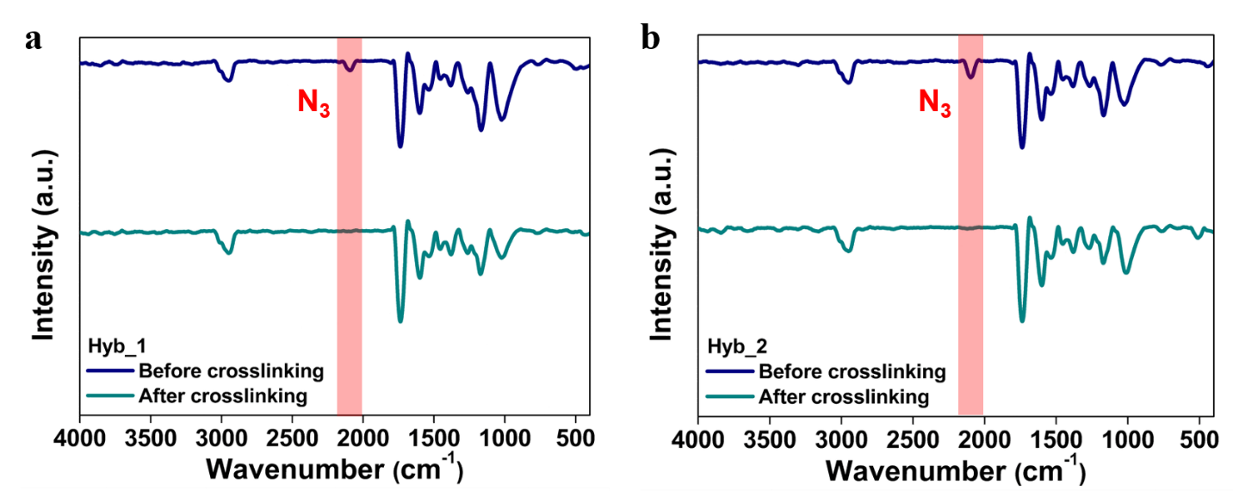

Supplementary Fig. 4. FT-IR spectra of a Hyb_1 and b Hyb_2 films before and after being crosslinked.
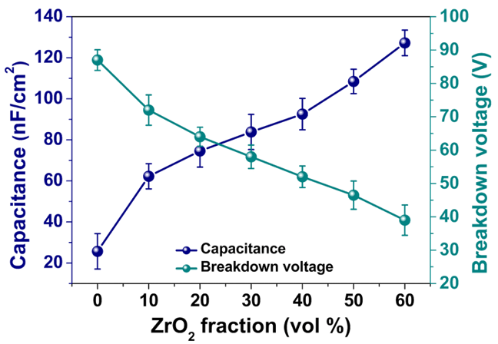

Supplementary Fig. 5. Capacitance and breakdown voltage as a function of ZrO₂ fractions.
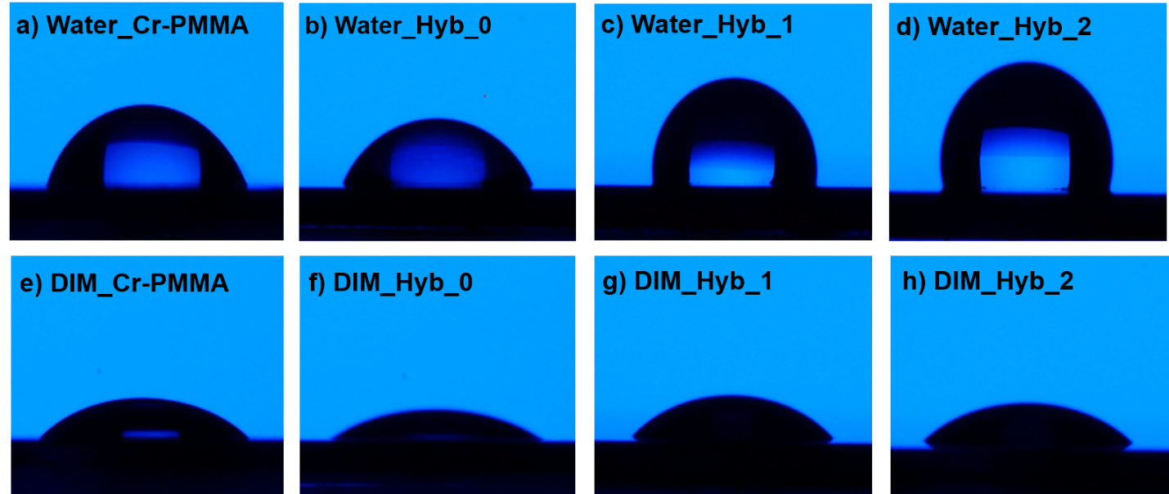

Supplementary Fig. 6. Contact angle images of a-d water and e-h DIM droplets on the surface of a,e crosslinked-PMMA, b,f Hyb_0, c,g Hyb_1, and d,h Hyb_2.
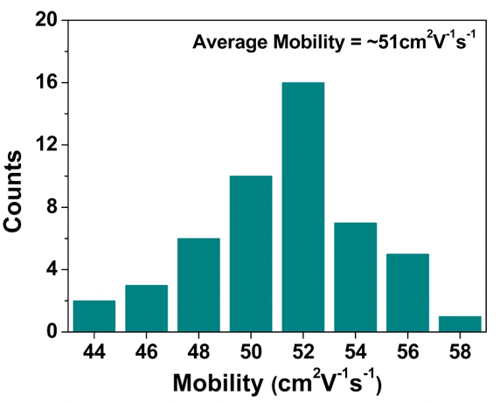

Supplementary Fig. 7. Mobility statistics of In₂O₃/ZnO heterojunction TFTs with Hyb_2 as a gate dielectric.
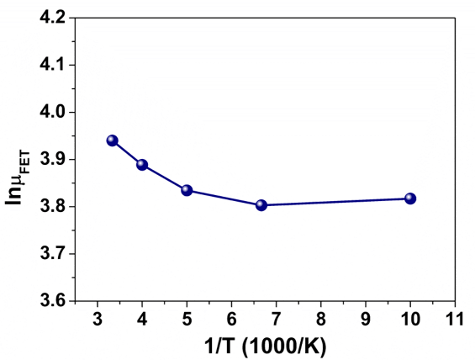

Supplementary Fig. 8. Temperature dependence of electron mobilities.
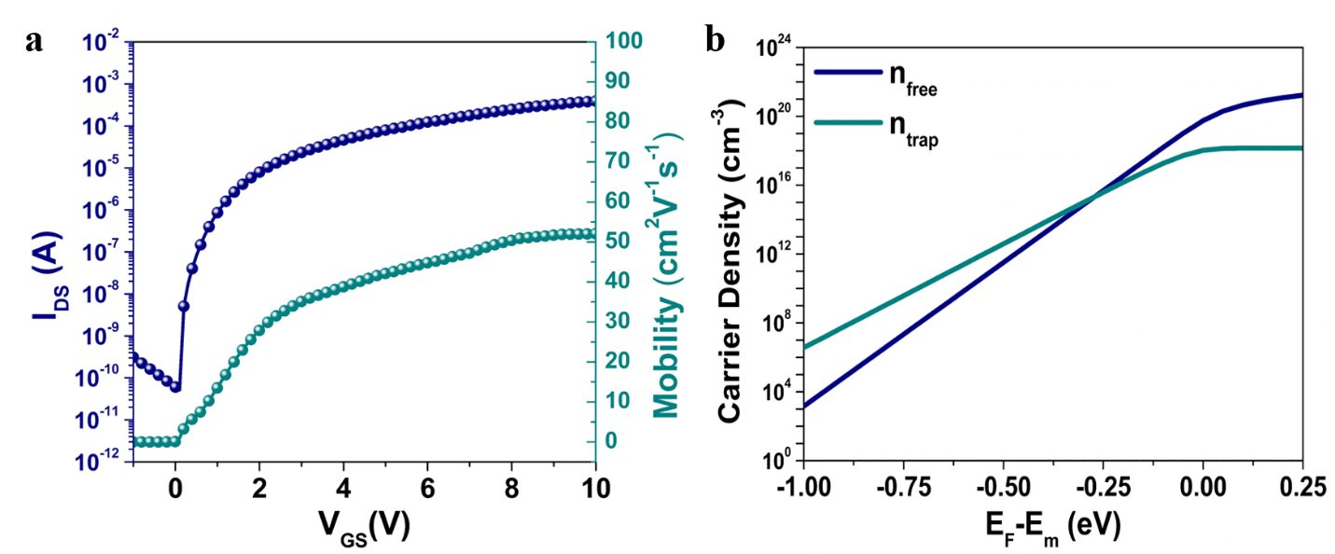

Supplementary Fig. 9. Carrier density characteristics of In₂O₃/ZnO heterojunction TFT with Hyb_2 as a gate dielectric. a Drain-source current (I_{DS}) and electron mobility as a function of gate-source voltage (V_{GS}). b Carrier densities (n_{free} and n_{trap}) as a function of Fermi energy level (E_{F}) from the conduction band edge (E_{m}).
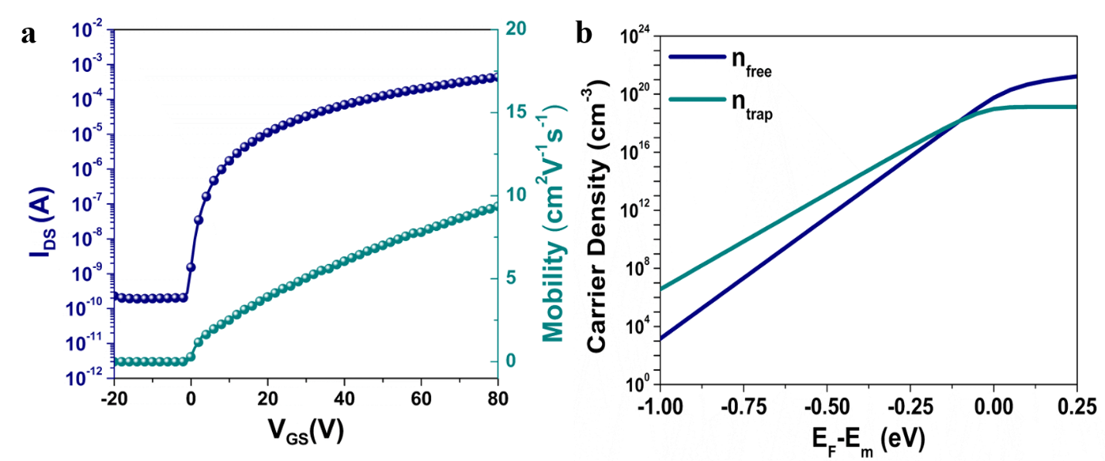

Supplementary Fig. 10. Carrier density characteristics of In₂O₃/ZnO heterojunction TFT with SiO₂ as a gate dielectric. a Drain-source current (I_{DS}) and electron mobility as a function of gate-source voltage (V_{GS}). b Carrier densities (n_{free} and n_{trap}) as a function of Fermi energy level (E_{F}) from the conduction band edge (E_{m}).
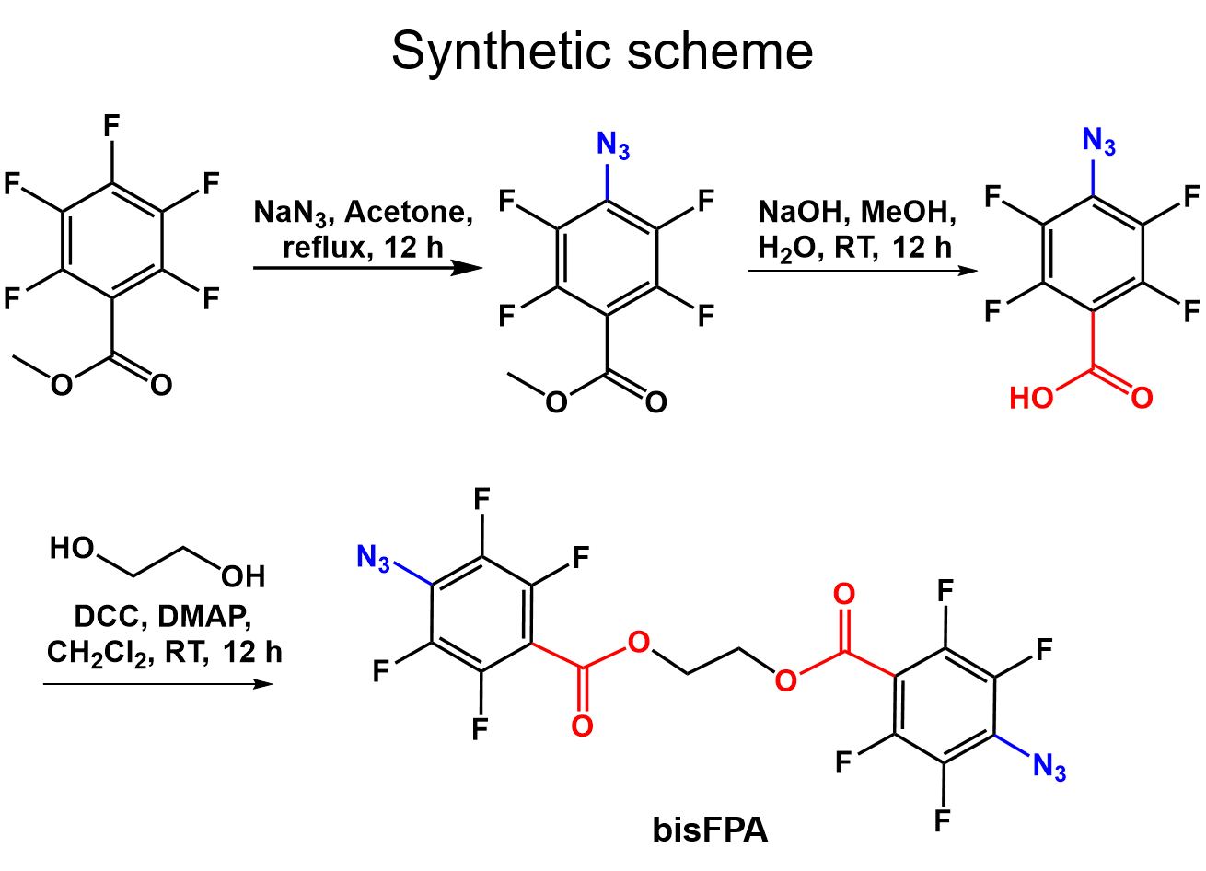

Supplementary Fig. 11. Synthetic procedure of ethane-1,2-diyl bis(4-azido-2,3,5,6-tetrafluorobenzoate).

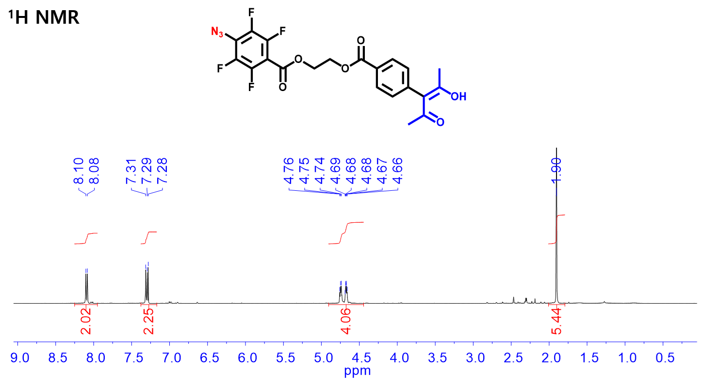

Supplementary Fig. 12. ¹H NMR data of 2-((4-(1-acetyl-2-hydroxy-1-propen-1-yl)benzoyl)oxy)ethyl 4-azido-2,3,5,6-tetrafluorobenzoate.
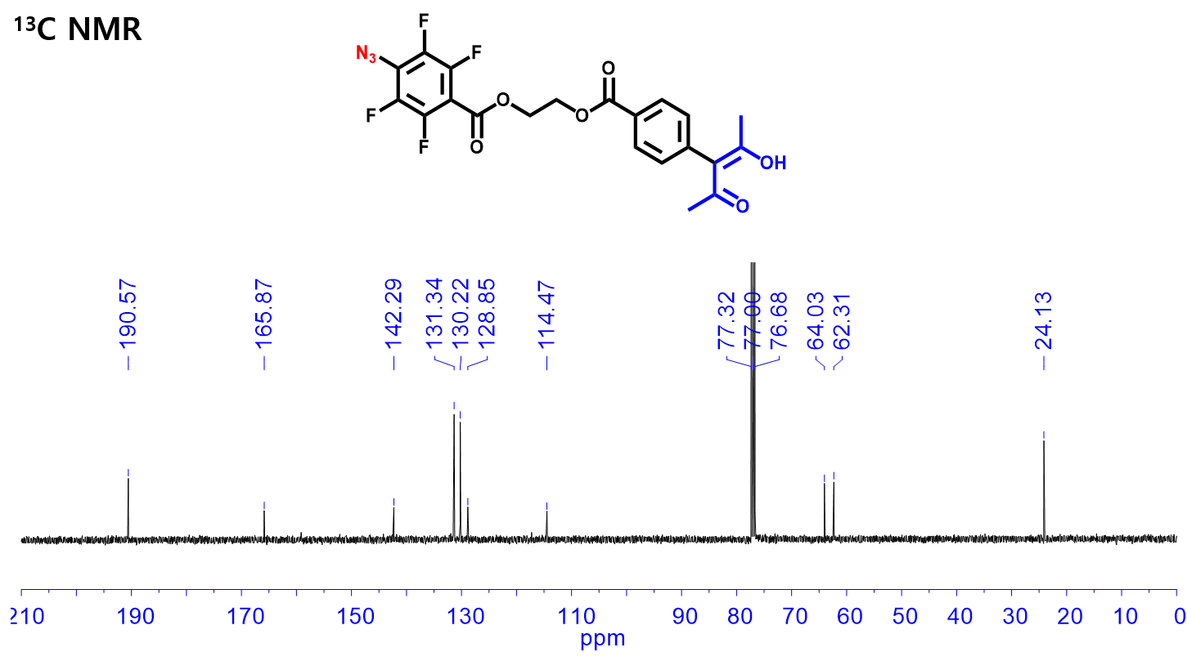

Supplementary Fig. 13. ¹³C NMR data of 2-((4-(1-acetyl-2-hydroxy-1-propen-1-yl)benzoyl)oxy)ethyl 4-azido-2,3,5,6-tetrafluorobenzoate.
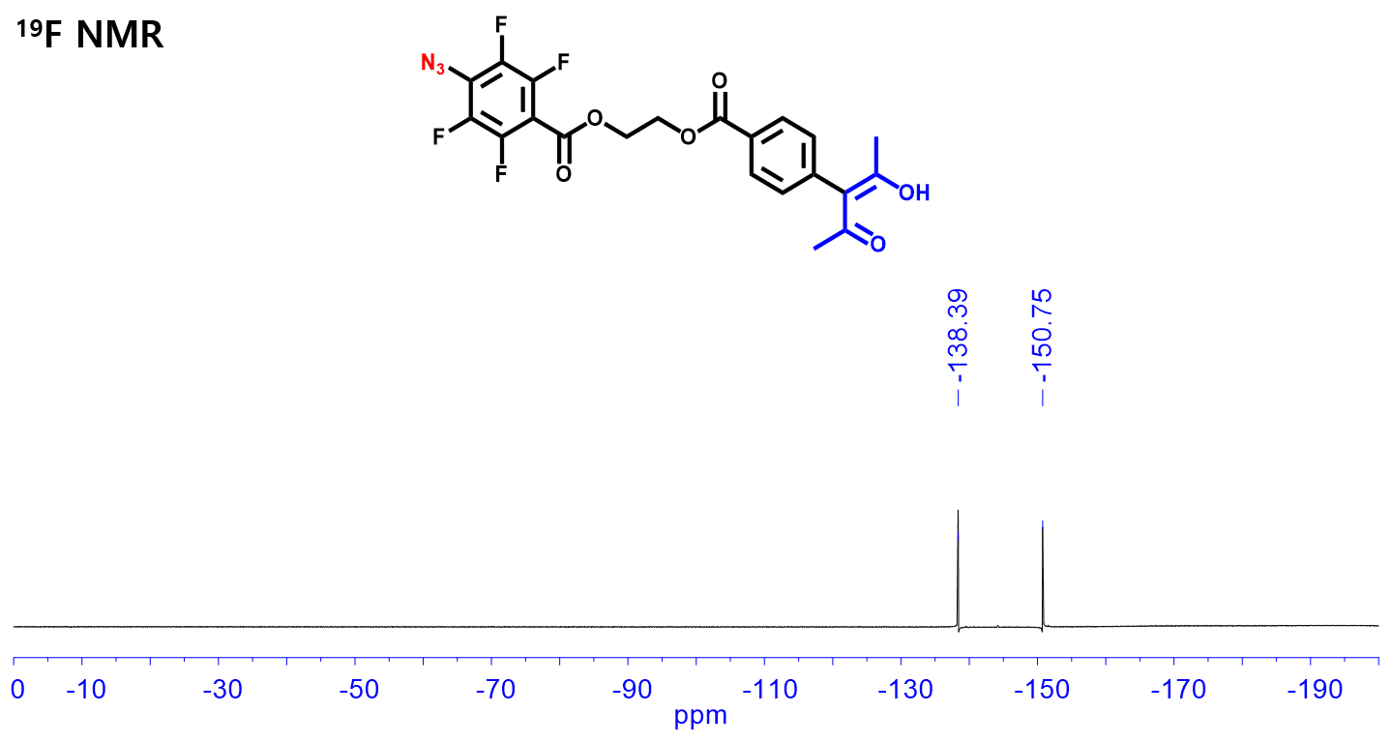

Supplementary Fig. S14. ¹⁹F NMR data of 2-((4-(1-acetyl-2-hydroxy-1-propen-1-yl)benzoyl)oxy)ethyl 4-azido-2,3,5,6-tetrafluorobenzoate.
Supplementary Table 1. Summary of contact angles measured on various surfaces (crosslinked-PMMA, Hyb_0, Hyb_1, and Hyb_2) and surface energy values calculated on basis of them.

 | $θ$_{water} (º) | $θ$_{DIM} (º) | γ (mN/m)
Crosslinked-PMMA | 70.92 | 37.54 | 47.51
Hyb_0 | 53.87 | 28.21 | 58.77
Hyb_1 | 92.69 | 41.29 | 39.55
Hyb_2 | 97.89 | 42.62 | 38.39

Supplementary Table 2. Comparison of dielectric properties and electrical characteristics for various n-MOS with different organic-inorganic hybrid gate dielectric materials.
Dielectric  material | Channel  material | k | Mobility  (cm²V⁻¹s⁻¹) | I_{on}/I_{off} | V_{TH}  (V) | SS  (V dec⁻¹) | Ref.
PVP-co-PMMA-PMF-HfO_{x} | IGTO | 8.84 | 25.9 | ~10⁷ | -0.2 | 0.4 | 1
PVP-co-PMMA-PMF-ZrO₂ | IZO | 5.6 | 28.4 | ~10⁷ | -2.0 | 0.7 | 2
PMMA-GPTMS-Al₂O₃ | ZnO | 6.2 | 4.5 | ~10⁷ | 0.7 | - | 3
PMMA-GPTMS-ZrHfO₂ | ZnO,  IGZO | 9.4 | 12.8,  2.45 | ~10³, ~10⁷ | 2.5, 1.2 | 3,  0.68 | 4
PMMA-TMSPM-ZrO₂ | ZnO | 6.8 | 0.48 | ~10⁵ | 3.3 | 0.47 | 5
PMMA-GPTMS-HfO₂ | ZnO | 11.3 | 15.5 | ~10⁶ | 0.5 | 0.37 | 6
PVP/Al₂O₃ | SIZO | - | 8.84 | ~10⁵ | -1.5 | 1.09 | 7
PVP/ZrO₂:B | In₂O₃ | 8.5 | 0.44 | ~10⁵ | 1.7 | - | 8
PVP/Al₂O₃ | IGZO | - | 8.39 | ~10⁵ | 7.03 | 0.68 | 9
PVP-PMF-Al₂O₃ | IGZO | 6.1 | 5.13 | ~10⁵ | 2.3 | 0.84 | 10
PVP-PMF-HfO₂ | In₂O₃ | 6.5 | 2.6 | ~10⁵ | 0.1 | 0.33 | 11
PVA-GO | IGZO | - | 42 | ~10⁷ | 0.79 | 0.106 | 12
GPTMS-HfO₂ | IGZO | 11.4 | 4.74 | ~10⁴ | 0.3 | - | 13
PMMA-ZrO₂ | In₂O₃/ZnO | 14.0 | 51.19 | ~10⁷ | 0.46 | 0.108 | This work

Supplementary Table 3. Comparison of bias-stress stability characteristics for various n-MOS with different gate dielectric materials.

Dielectric  material | Channel  material | Stress  time (s) | Gate  stress (V) | τ (s) | β | Ref.
SiO₂ | In₂O₃/ZnO | 86,400 | 30 | 2.55x10⁸ | 0.40 | 14
SiO₂ | In₂O₃/ZnO:Al | 86,400 | 30 | 6.03x10³ | 1 | 14
SiO₂ | In₂O₃ | 13,200 | 10 | 3.64x10⁴ | 0.53 | 15
SiO₂ | IGZO | 10,000 | 15 | 2.00x10⁴ | 0.42 | 16
SiO₂ | In₂O₃ | 32,400 | 40 | 2.34x10⁵ | 0.51 | 17
SiO₂ | ZnO | 32,400 | 40 | 2.32x10⁵ | 0.50 | 17
SiO₂ | IGZO | 7,000 | 30 | 1.30x10⁶ | 0.46 | 18
Al₂O₃ | IGZO | 10,000 | 5 | - | - | 19
ZrO₂ | IZO | 1,000 | 20 | - | - | 20
AlZrO_{x} | SWCNT | 1,800 | -3 | 2.63x10³ | - | 21
HfO_{y}/AlO_{x} | ZTO | 3,600 | 3 | 1.13x10⁷ | 0.20 | 22
AlO_{x}/HfO_{y} | ZTO | 3,600 | 3 | 0.65x10³ | 0.44 | 22
ZrO₂/HfO₂ | IGZO | 3,600 | 5 | 8.31x10⁶ | 0.79 | 23
PMMA-ZrO₂ | In₂O₃/ZnO | 43,200 | 10 | 4.06x10⁵ | 0.64 | This work

References
[1] Hur, J. S., Kim, J. O., Kim, H. A. & Jeong, J. K. Stretchable Polymer Gate Dielectric by Ultraviolet-Assisted Hafnium Oxide Doping at Low Temperature for High-Performance Indium Gallium Tin Oxide Transistors. ACS Appl. Mater. Interfaces 11, 21675-21685 (2019).
[2] Son, B.-G., Je, S. Y., Kim, H. J. & Jeong, J. K. Modification of a polymer gate insulator by zirconium oxide doping for low temperature, high performance indium zinc oxide transistors. RSC Adv. 4, 45742-45748 (2014).
[3] Meza-Arroyo, J., Syamala Rao, M. G., Mejia, I., Quevedo- López, M. A. & Ramírez-Bon, R. Low temperature processing of Al₂O₃-GPTMS-PMMA hybrid films with applications to high-performance ZnO thin-film transistors. Appl. Surf. Sci. 467-468, 456-461 (2019).
[4] Syamala Rao, M. G. et al. Low-temperature sol-gel ZrHfO₂-PMMA hybrid dielectric thin-films for metal oxide TFTs. J. Non-Cryst. Solids 502, 152-158 (2018).
[5] Alvarado-Beltran, C. G., Almaral-Sanchez, J. L., Mejia, I., Quevedo-Lopez, M. A. & Ramirez-Bon, R. Sol-Gel PMMA-ZrO₂ Hybrid Layers as Gate Dielectric for Low-Temperature ZnO-Based Thin-Film Transistors. ACS Omega 2, 6968-6974 (2017).
[6] Mullapudi, G. S. R., Velazquez-Nevarez, G. A., Avila-Avendano, C., Torres-Ochoa, J. A., Quevedo-López, M. A. & Ramírez-Bon, R. Low-Temperature Deposition of Inorganic–Organic HfO₂–PMMA Hybrid Gate Dielectric Layers for High-Mobility ZnO Thin-Film Transistors. ACS Appl. Electron. Mater. 1, 1003-1011 (2019).
[7] Choi, J. Y., Kim, S., Hwang, B. U., Lee, N. E. & Lee, S. Y. Flexible SiInZnO thin film transistor with organic/inorganic hybrid gate dielectric processed at 150 °C. Semicond. Sci. Technol. 31, 125007 (2016).
[8] Park, J. H, Oh, J. Y, Han, S. W, Lee, T. I. & Baik, H. K. Low-temperature, solution-processed ZrO₂:B thin film: a bifunctional inorganic/organic interfacial glue for flexible thin-film transistors. ACS Appl. Mater. Interfaces 7, 4494-4503 (2015).
[9] Hwang, B.-U. et al. Role of ultrathin Al₂O₃ layer in organic/inorganic hybrid gate dielectrics for flexibility improvement of InGaZnO thin film transistors. Org. Electron. 15, 1458-1464 (2014).
[10] Lai, H.-C., Pei, Z., Jian, J.-R. & Tzeng, B.-J. Alumina nanoparticle/polymer nanocomposite dielectric for flexible amorphous indium-gallium-zinc oxide thin film transistors on plastic substrate with superior stability. Appl. Phys. Lett. 105, 033510 (2014).
[11] Rao, M. G. S. et al. Tuning the electrical performance of solution-processed In₂O₃TFTs by low-temperature with HfO₂-PVP hybrid dielectric. Mater. Today Commun. 26, 102120 (2021).
[12] Wang, X., Gao, Y., Liu, Z., Luo, J. & Wan, Q. Flexible Low-Voltage IGZO Thin-Film Transistors With Polymer Electret Gate Dielectrics on Paper Substrates. IEEE Electron Device Lett. 40, 224-227 (2019).
[13] Rao, M. G. S., Sánchez-Martinez, A., Gutiérrez-Heredia, G., Quevedo- López, M.A. & Ramírez-Bon, R. Sol-gel derived low temperature HfO₂-GPTMS hybrid gate dielectric for a-IGZO thin-film transistors (TFTs). Ceram. Int. 44, 16428-16434 (2018).
[14] Lin, Y.-H. et al. Hybrid organic–metal oxide multilayer channel transistors with high operational stability. Nat. Electron. 2, 587-595 (2019).
[15] Abdullah, I. et al. Bias stability of solution-processed In₂O₃ thin film transistors. J. Phys. Mater. 4, 015003 (2020).
[16] Lee, J.-M., Cho, I.-T., Lee, J.-H. & Kwon, H.-I. Bias-stress-induced stretched-exponential time dependence of threshold voltage shift in InGaZnO thin film transistors. Appl. Phys. Lett. 93, 093504 (2008).
[17] Khim, D., Lin, Y. H. & Anthopoulos, T. D. Impact of Layer Configuration and Doping on Electron Transport and Bias Stability in Heterojunction and Superlattice Metal Oxide Transistors. Adv. Funct. Mater. 29, 1902591 (2019).
[18] Chowdhury, M. D. H., Ryu, S. H., Migliorato, P. & Jang, J. Effect of annealing time on bias stress and light-induced instabilities in amorphous indium–gallium–zinc-oxide thin-film transistors. J. Appl. Phys. 110, 114503 (2011).
[19] Kim, Y. H. et al. Flexible metal-oxide devices made by room-temperature photochemical activation of sol-gel films. Nature 489, 128-132 (2012).
[20] Park, J. H. et al. Low-temperature, high-performance solution-processed thin-film transistors with peroxo-zirconium oxide dielectric. ACS Appl. Mater. Interfaces 5, 410-417 (2013).
[21] Li, J., Huang, C.-X. & Zhang, J.-H. Tuning the electrical performance and bias stability of a semiconducting SWCNT thin film transistor with an atomic layer deposited AlZrO_{x} composite. RSC Adv. 7, 52517-52523 (2017).
[22] Kim, Y. G., Avis, C. & Jang, J. Low Voltage Driven, Stable Solution-Processed Zinc-Tin-Oxide TFT with HfO_{y} and AlO_{x} Stack Gate Dielectric. ECS Solid State Lett. 1, Q23-Q25 (2012).
[23] Yang, J., Yang, X., Zhang, Y., Che, B., Ding, X. & Zhang, J. Improved gate bias stressing stability of IGZO thin film transistors using high-k compounded ZrO₂/HfO₂ nanolaminate as gate dielectric. Mol. Cryst. Liq. Cryst. 676, 65-71 (2019).

