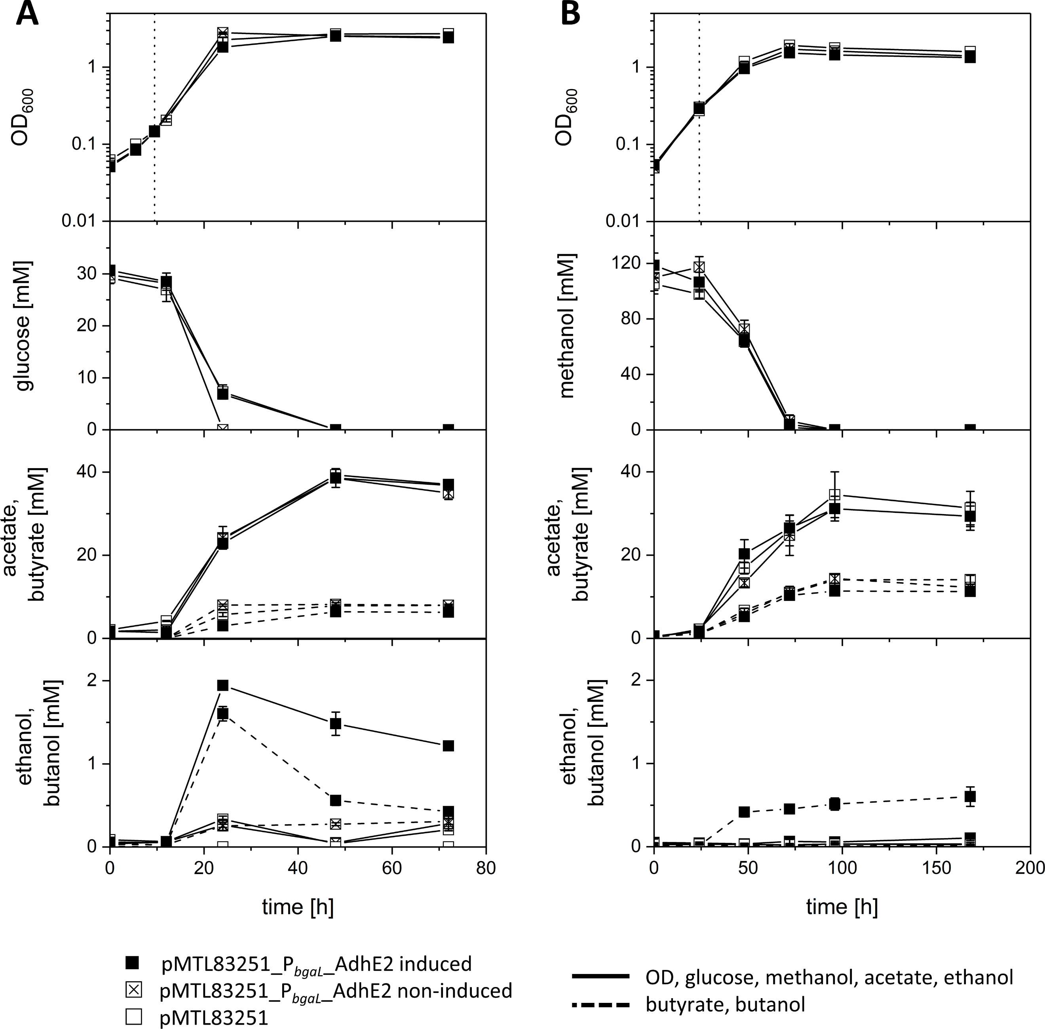
Fig. S1 Growth experiment with E. limosum [pMTL83251_P_{bgaL}_AdhE2] and E. limosum [pMTL83251]. Strains were cultivated using (A) 30 mM glucose or (B) 100 mM methanol as carbon source. Gene expression of cells was either induced by lactose or non-induced. Induction with lactose is indicated with the vertical dotted line. Monitored are OD₆₀₀, methanol consumption, as well as acetate, butyrate, ethanol, and butanol production. Error bars indicate standard deviations. n=3.

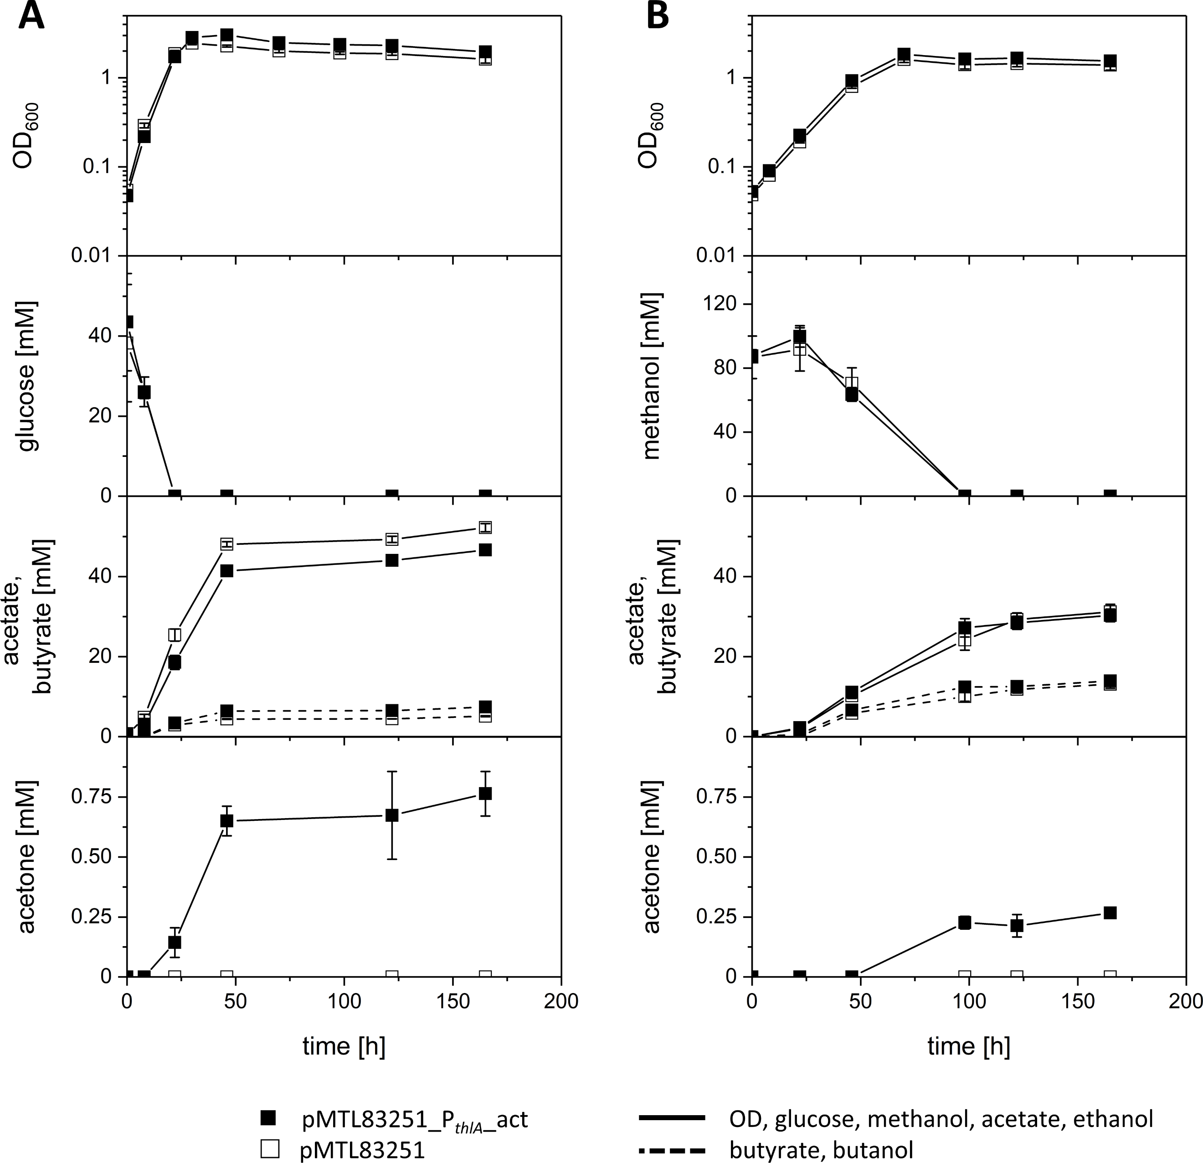
Fig. S2 Growth experiment with E. limosum [pMTL83251_P_{thlA}_act] and E. limosum [pMTL83251]. Strains were cultivated using (A) 30 mM glucose or (B) 100 mM methanol as carbon source. Monitored are OD₆₀₀, glucose and methanol consumption, as well as acetate, butyrate, and acetone production. Error bars indicate standard deviations. n=3.

Table S1 Growth characteristics and product formation of recombinant E. limosum strains characterized in growth experiments using glucose as carbon source.
strain | OD_{max} | growth rate µ  [h⁻¹] | products [mM] |  |  |  |  | products  [mol / 100 mol substrate] |  |  |  |  | product ratio [acetate:butyrate]
strain | OD_{max} | growth rate µ  [h⁻¹] | acetate | butyrate | ethanol | butanol | acetone | acetate | butyrate | ethanol | butanol | acetone | product ratio [acetate:butyrate]
pMTL83251¹ | 2.7 | 0.19 | 39.3 | 7.9 | 0.3 | 0 | n.d. | 134.5 | 26.8 | 0 | 0 | n.d. | 5:1
pMTL83251_P_{bgaL}_AdhE2 induced | 2.5 | 0.17 | 38.6 | 6.4 | 1.9 | 1.6 | n.d. | 125.7 | 20.8 | 6.2 | 5.2 | n.d. | 6:1
pMTL83251_P_{bgaL}_AdhE2 uninduced | 2.8 | 0.2 | 38.5 | 8.2 | 0.3 | 0.3 | n.d. | 129.3 | 27.5 | 1 | 1 | n.d. | 5:1
pMTL83251² | 2.5 | 0.13 | 52.2 | 5.1 | n.d. | n.d. | 0 | 136.6 | 13.3 | n.d. | n.d. | 0 | 10:1
pMTL83251_P_{thlA}_act | 3.0 | 0.15 | 46.7 | 7.4 | n.d. | n.d. | 0.8 | 107.2 | 17.0 | n.d. | n.d. | 1.8 | 6:1
pMTL83251_P_{bgaL}_C-FAST-AdhE2 induced | 2.5 | 0.16 | 46.3 | 4.8 | 1 | 0.6 | n.d. | 153.7 | 16.1 | 3.3 | 1.9 | n.d. | 10:1
pMTL83251_P_{bgaL}_C-FAST-AdhE2 uninduced | 3 | 0.17 | 46.7 | 5.8 | 0.3 | 0 | n.d. | 155.3 | 19.3 | 1 | 0 | n.d. | 8:1
pMTL83251_P_{bgaL}_N-FAST-AdhE2 induced | 2.7 | 0.18 | 34.7 | 7.2 | 2.4 | 1.8 | n.d. | 112.3 | 23.4 | 7.9 | 6 | n.d. | 5:1
pMTL83251_P_{bgaL}_N-FAST-AdhE2 uninduced | 3 | 0.22 | 36.3 | 9.9 | 0.4 | 0.2 | n.d. | 115.3 | 31.5 | 1.3 | 0.7 | n.d. | 4:1
pMTL83251³ | 2.5 | 0.17 | 35.7 | 10.9 | 0 | 0 | 0 | 101.1 | 30.9 | 0 | 0 | 0 | 3:1
pMTL83251_P_{thlA}_C-FAST-Adc | 3.3 | 0.15 | 35.9 | 9.5 | 0 | 0 | 0.8 | 109.9 | 29 | 0 | 0 | 2.3 | 4:1
pMTL83251_P_{thlA}_N-FAST-Adc | 3.1 | 0.15 | 39.7 | 9.3 | 0 | 0 | 0.1 | 125.8 | 29.4 | 0 | 0 | 0.4 | 4:1
¹ control strain during growth experiment with E. limosum [pMTL83251_P_{bgaL}_AdhE2]
² control strain during growth experiment with E. limosum [pMTL83251_P_{thlA}_act]
³ control strain during growth experiment with E. limosum [pMTL83251_P_{thlA}_C-FAST-Adc] and E. limosum [pMTL83251_P_{thlA}_N-FAST-Adc]
n.d.: not determined

Table S2 Growth characteristics and product formation of recombinant E. limosum strains characterized in growth experiments using methanol as carbon source.
strain | OD_{max} | growth rate µ  [h⁻¹] | products [mM] |  |  |  |  | products  [mol / 100 mol substrate] |  |  |  |  | product ratio [acetate:butyrate]
strain | OD_{max} | growth rate µ  [h⁻¹] | acetate | butyrate | ethanol | butanol | acetone | acetate | butyrate | ethanol | butanol | acetone | product ratio [acetate:butyrate]
pMTL83251¹ | 1.8 | 0.06 | 34.5 | 14.1 | 0 | 0 | n.d. | 32.8 | 13.3 | 0 | 0 | n.d. | 5:2
pMTL83251_P_{bgaL}_AdhE2 induced | 1.5 | 0.05 | 31.2 | 11.4 | 0.1 | 0.6 | n.d. | 26.3 | 9.6 | 0.1 | 0.5 | n.d. | 3:1
pMTL83251_P_{bgaL}_AdhE2 uninduced | 1.7 | 0.05 | 31.2 | 14.4 | 0 | 0 | n.d. | 28.4 | 13.1 | 0 | 0 | n.d. | 2:1
pMTL83251² | 1.6 | 0.06 | 31.2 | 13.1 | n.d. | n.d. | 0 | 34 | 14.3 | n.d. | n.d. | 0 | 2:1
pMTL83251_P_{thlA}_act | 1.7 | 0.06 | 30.3 | 14 | n.d. | n.d. | 0.3 | 30.4 | 14 | n.d. | n.d. | 0.3 | 2:1
pMTL83251_P_{bgaL}_C-FAST-AdhE2 induced | 1.6 | 0.05 | 37.0 | 13.3 | 0.1 | 0.4 | n.d. | 34 | 12.2 | 0.1 | 0.3 | n.d. | 3:1
pMTL83251_P_{bgaL}_C-FAST-AdhE2 uninduced | 1.8 | 0.05 | 35.3 | 14.9 | 0 | 0 | n.d. | 28.6 | 12.1 | 0 | 0 | n.d. | 2:1
pMTL83251_P_{bgaL}_N-FAST-AdhE2 induced | 1.7 | 0.06 | 43.1 | 14.3 | 0.2 | 0.6 | n.d. | 40.4 | 13.4 | 0.2 | 0.6 | n.d. | 3:1
pMTL83251_P_{bgaL}_N-FAST-AdhE2 uninduced | 2 | 0.06 | 35.3 | 14.9 | 0 | 0 | n.d. | 36.5 | 15.4 | 0 | 0 | n.d. | 2:1
pMTL83251³ | 1.9 | 0.07 | 25.3 | 16 | 0 | 0 | 0 | 22.3 | 14.1 | 0 | 0 | 0 | 3:2
pMTL83251_P_{thlA}_C-FAST-Adc | 1.6 | 0.08 | 19.5 | 14.9 | 0 | 0 | 1.6 | 19.5 | 14.9 | 0 | 0 | 1.6 | 3:2
pMTL83251_P_{thlA}_N-FAST-Adc | 1.6 | 0.07 | 20.2 | 13.9 | 0 | 0 | 0.1 | 23.5 | 16.2 | 0 | 0 | 0.1 | 3:2
¹ control strain during growth experiment with E. limosum [pMTL83251_P_{bgaL}_AdhE2]
² control strain during growth experiment with E. limosum [pMTL83251_P_{thlA}_act]
³ control strain during growth experiment with E. limosum [pMTL83251_P_{thlA}_C-FAST-Adc] and E. limosum [pMTL83251_P_{thlA}_N-FAST-Adc]

