Supplementary Information for
Biodegradable and Biorecyclable Organic Glass

Methods
Reagents
Amino acids were purchased or synthesized from Bachem, Macklin, Energy Chemical, J&K Scientific, GL Biochem (Shanghai) Ltd. and Aladdin Biochemical Technology Co., Ltd. Proteinase K from Tritirachium album, pepsin from porcine gastric mucosa and pancreatin from porcine pancreas were purchased from Sigma–Aldrich. Hydrochloric acid (HCl), sodium hydroxide (NaOH), sodium chloride (NaCl) and monobasic potassium phosphate (KH₂PO₄) were products of Beijing Chemical Co., Ltd. Composting soil was purchased from a local facility. Water was obtained from a double-stage Milli-Q Plus purification system (Millipore, America). All solutions were freshly prepared and filtered for immediate use. The CQDs were purchased from Suzhou Xingshuo Nanotech Co., Ltd. The dyes Nile red, thioflavin T, rubrene, rhodamine B and rhodamine 6G (R6G) were purchased from Sigma–Aldrich. Cyclosporin A was a product of Shanghai Yuanye Bio-Technology Co., Ltd.
Glass transition and melting temperature analysis
The thermogravimetric curves and heat flow curves of all the samples were measured using a TGA/DSC 3⁺ series instrument (Mettler Toledo, Switzerland) and a DSC 1 instrument (Mettler Toledo, Switzerland). Before the tests, two empty platinum crucibles with loose lids were used for baseline adjustment. The amino acid or peptide powders were placed in one platinum crucible that was placed on the “S” side, and an empty crucible was placed on the “R” side as a control (Fig.1B). By using the TGA/DSC 3⁺ series instrument, the samples were heated from room temperature to a relatively high temperature (e.g., ~500.15 K) to determine T_{m} and T_{d}. For the DSC 1 instrument, the samples were heated and cooled following a preset procedure (Fig.1C). For Upscan 1, the platinum crucible filled with powders was heated from room temperature (T₀) to a temperature (T₁) greater than T_{m} but less than T_{d}. Quenching from T₁ to a temperature (T₂) lower than T₀ was followed by an isothermal procedure at T₁ for 15 min. For Upscan 2, the product was reheated from T₂ to a temperature (T₃) close to T_{m}, and T_{g} was recorded. To ensure sample homogeneity, the platinum crucible was less than 50% full. The heating and cooling rates were 10 K min⁻¹. Samples were protected by inert gases (e.g., argon) throughout the measurements.
Glass formation
The glasses were formed by a heating and quenching procedure under an ultrapure inert gas atmosphere in a glove box (Mikrouna, China). The amino acid or peptide powder (50.0 mg) was placed in a clean glass container and heated. The samples were completely melted before being transferred to an experimental apparatus for quenching. For the heating process, the starting temperature was T₀, and the ending temperature was T₁. The quenching process followed an isothermal procedure for 15 min. For the quenching process, the final temperature was set at a temperature less than T_{g.} The heating and cooling rates were 10 K min⁻¹. The fully cured samples were used for subsequent characterization analysis.
Viscosity-temperature test
Cyclic viscosity-temperature curves of Ac-F were measured using an MCR 302 rheometer (Anton Paar, Austria). The Ac-F powder (50.0 mg) was placed on the panel of the rheometer under an inert atmosphere, and the initial temperature was set to 473.15 K. The sample was heat preservation for 15 min to melt the powder, and then the temperature was decreased to 273.15 to obtain a viscous liquid. The temperature was increased to 473.15 K and then lowered to 273.15 K, and this procedure was repeated for three cycles. The strain was 0.1%, and the heating and cooling rates were 10 K min⁻¹.
Calculations of ∆C_{p}, ∆H_{m} and m
The calculation of these thermodynamic and kinetic parameters was adapted from Richert et al.¹ with minor modifications. ∆C_{p} was calculated based on the heat flow curve (Upscan 2) obtained by DSC by using formula i.
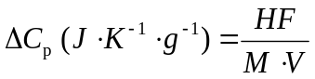 (i)
where HF is the heat flow, M is the amount of sample and V is the heating or cooling rate. ∆H_{m} was calculated based on the heat flow curve obtained by DSC-TGA by using formula ii.
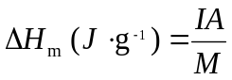 (ii)
where IA is the integrated area obtained by Origin 8.0 Software. m was calculated from formula iii.
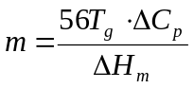 (iii)
XRD and variable-temperature in situ XRD analysis
Room-temperature XRD data were collected with a SmartLab (9 kW) diffractometer (Rigaku, Japan) equipped with a Cu filter and a Cu Kα1 radiation source (λ = 1.5406 Å). The collection conditions were as follows: a 2θ range of 10° to 45°, 10 deg min⁻¹, and a step size of 0.01. For variable-temperature XRD measurements, a PANalytical Empyrean in situ diffractometer (PANalytical, Netherlands) was employed. The collection conditions were as follows: a 2θ range of 3° to 40°, 20 deg min⁻¹, and a step size of 0.01. The samples were placed in a quartz cuvette with a 10.0-mm diameter and a 0.5-mm height.
POM analysis
Cross-polarized microscopy images were acquired on a BX53 polarized microscope system (Olympus, Japan). The powder sample (1.5 mg) was gently placed on a slide with a diameter of 30.0-mm and a thickness of 1.0-mm. The powder sample was heated and cooled to form glass following the above method. Subsequently the POM images were taken by microscopy.
Variable-temperature in situ Raman spectroscopy
In situ Raman experiments of Ac-F single crystal cultivated following the literature method² were conducted on an RM1000 micro-Raman spectroscopy system (Renishaw, England). The spectra were collected in a back-scattering geometry, and a 1200 lines/mm grating was used. The collection conditions were as follows: laser wavelength of 532 nm as the excitation source and a range of 50-3500 cm⁻¹. The samples were placed directly under the microscope without preprocessing, and data acquisitions were performed.
NMR spectroscopy
The solution ¹H NMR spectra of digested samples (dissolved in dimethyl sulfoxide-d6 (DMSO-d6)) were recorded on a 600-MHz Avance spectrometer equipped with a triple resonance cryogenic probe using a simple 1D pulse sequence (Bruker, Germany). ssNMR measurements were conducted on a 400-MHz Avance III system equipped with a 4 mm HXY triple resonance MAS probe (Bruker, Germany). The samples were ground by an agate mortar into a homogeneous powder, transferred to a zirconia NMR tube and analysed by the spectrometer.
Computational simulations
The Gromacs package (Version 5.1.4) was used to perform the all-atom molecular dynamics (AAMD) simulations³. The general AMBER force field (GAFF) was used to model the Ac-F molecule. To derive the force field parameters within the framework of the GAFF, the optimized geometry and molecular electrostatic potential of the Ac-F were obtained at the HF/6-31g (d) level of theory. The Antechamber package was then used to compute the partial charge according to the restrained electrostatic potential (RESP) formalism⁴. In this study, we performed AAMD simulations on 632 Ac-F lattices² with 144 Ac-F molecules. The system was first minimized using the conjugate-gradient algorithm with a tolerance on the maximum force of 200 kJ mol⁻¹, and the temperature and volume of each system were equilibrated by running 400 ps of a constant-volume, constant-temperature (NVT) simulation followed by 400 ps of NPT simulations. Finally, the whole system was heated, maintained and cooled to simulate the annealing process. The temperature change during the annealing process is shown in Fig.2B. The leapfrog algorithm with a time step of 2 fs was used to integrate the equations of motion. The velocity rescale thermostat and the isotropic Parrinello-Rahman barostat were used with 0.4 ps and 2.0 ps as the thermostat and barostat relaxation times, respectively. The electrostatic forces were calculated by means of the particle–mesh Ewald approach with a cut-off of 1.0 nm. A 1.0 nm cut-off was also used for the van der Waals forces. The LINCS algorithm was applied at each step to preserve the bond lengths.
Glass transmittance spectroscopy
The transmittance spectra of the Ac-F glass and the Cbz-FFG glass in the UV–visible region (200–800 nm) and NIR region (800–3000 nm) were obtained by means of a Cary 5000 UV–VIS-NIR spectrophotometer (Varian, America). The glass was processed to a thickness of 1.0 mm and polished before analysis.
3D printing and model pouring experiment
Powders of Ac-F and CQDs or dyes were mixed evenly before printing or casting in moulds. The mass ratio of CQDs or dyes to Ac-F is 1:10⁵. We printed 3D structures using a 3D Discovery bioprinter (RegenHU, Switzerland) in a laminar-flow hood. The mixture was used to fill the charging barrel. The barrel temperature was raised to 500.15 K, and the flow was regulated by pressure (3.5 bar). The print head (HM 300H) operated in the y, z-plane and the collector operated along the x-axis. The sample mixture was placed in a special glass dish, which was heated in a high temperature furnace with an operation temperature of 500.15 K to obtain a supercooled liquid. The liquid was slowly poured into the moulds. Next, the moulds were transferred to a low-temperature device with an operation temperature of 273.15 K and demoulded after complete solidification.
Characterization of glass degradation in vitro
Degradation was conducted in an enzyme solution (0.1 mg mL⁻¹ proteinase K solution at pH 7.50) at a specified temperature (37~38 ℃). Further degradation experiments were conducted utilizing solutions of SGF_{[sp]} and SIF_{[sp]}, which were prepared according to the United States Pharmacopeia (USP). For SGF_{[sp]} (pH≈1.2), 1.0 g of NaCl and 1.6 g pepsin were dissolved in 3.5 mL of HCl and sufficient water to make a 500 mL test solution. For SGF_{[sp]}, 6.8 g of KH₂PO₄ was dissolved in 250 mL water and mixed, and 77.0 mL of 0.2 N NaOH and 500 mL of water were added. Next, 10.0 g of pancreatin was added, the solution was mixed, and the pH was adjusted to 6.8. Then, the solution was diluted with water to 1000 mL. Glass beads with a diameter of 0.3 cm were dipped in the above solutions and incubated at 37 ℃. Photographs were taken to record the morphological changes. ESI-MS spectrometry (APEX II, Bruker, Germany) was used to identify the degradation products of the Cbz-FFG glasses. The Cbz-FFG glass beads were incubated with 2.5 mL proteinase K solution, SGF_{[sp]} and SIF_{[sp]} at 37 ℃ for 2 weeks. The solution was analysed by ESI-MS after being filtered through a 0.45 μm filter membrane.
Degradation in composts
Soil was purchased from a local composting company. The soil was baked overnight at 120 ℃, and then water was added to the dry soil to achieve a total moisture content of 50%, consistent with ASTM standards. Glass beads with a diameter of 0.5 cm were embedded in the soil with a depth of 2.5 cm. To facilitate observations, the compost soil was placed in transparent glass containers.
Characterization of glass degradation in vivo
All in vivo experiments were handled in accordance with the protocols approved by the Institutional Animal Care and Use Committee (IACUC) in compliance with Chinese law for treatment of experimental animals. The Ethics Committee for Animal Experimentation of Institute of Process Engineering, Chinese Academy of Sciences, approved the study. Female 4~6-week-old Kunming (KM) mice weighing approximately 30 g each were purchased from Vital River Laboratory Animal Technology Co., Ltd. (Beijing, China). The mice were kept in a specific pathogen-free (SPF) facility with plenty of food and water. Prior to the experiments, each mouse was injected with anaesthesia (pentobarbital, 50.0 mg kg⁻¹). Immediately afterward, the dorsal areas of the mice were shaved and disinfected with 75% ethanol, and incisions (approximately 0.5~0.6 cm) were made. Cbz-FFG glass beads with a diameter of 0.35 mm were gently placed into the connective tissues. The mass percentage of cyclosporin A in the Cbz-FFG-CA glass was 10%. Cyclosporin A powder was added to the viscous liquid of Cbz-FFG, and after stirring and dissolving evenly, the mixture was cooled to form Cbz-FFG-CA glass. The skin surface at the incision sites was sutured using suture string (5-0 type with a wire diameter of ~0.1 mm). At 2, 12 and 30 days after embedding the glass beads, the mice were anaesthetized with an isoflurane and gas-air mixture. Tissues surrounding the embedding sites, including the skin and muscle (Fig.4C), were excised and harvested. The tissues were washed with PBS and fixed in a 4% paraformaldehyde solution. Then, the tissues were embedded in paraffin blocks, sectioned into 5.0 µm slices, and mounted on glass slides. Standard H&E staining was performed, and the samples were analysed by professional technicians according to International Organization for Standardization (ISO) guidelines for evaluating the local effects of materials. The body weights of the mice were recorded every day, and photographs were taken.

References
1 Wang, L. M., Angell, C. A. & Richert, R. Fragility and thermodynamics in nonpolymeric glass-forming liquids. J. Chem. Phys. 125, 074505 (2006).
2 Stout, K. L., Hallock, K. J., Kampf, J. W. & Ramamoorthy, A. N-Acetyl-l-phenyl­alanine. Acta Crystallogr. C56, e100 (2000).
3 Wang, J., Wolf, R. M., Caldwell, J. W., Kollman, P. A. & Case, D. A. Development and testing of a general amber force field. J. Comput. Chem. 25, 1157–1174 (2004).
4 Wang, J., Wang, W., Kollman, P. A. & Case, D. A. Antechamber: an accessory software package for molecular mechanical calculations. J. Am. Chem. Soc 222, U403 (2001).

Tab.S1 Kinetic and thermodynamic parameters related to the glass transitions of amino acid- and peptide-based glasses, including the glass transition temperature (T_{g}), melting temperature (T_{m}), decomposition temperature (T_{d}), reduced glass transition temperature T_{rg} (T_{g}/T_{m}), glass transition heat capacity increase (∆C_{p}), enthalpy of fusion (∆H_{m}), and fragility m-index (m). These characteristic parameters were determined with heating and cooling rates of ±10 K min⁻¹.
Amino Acid or Peptide | T_{g} (K) | T_{m} (K) | T_{d} (K) | T_{rg} | ∆C_{p} (J∙K⁻¹∙g⁻¹) | ∆H_{m} (J∙g⁻¹) | m
Ac-Q | 307.90 | 477.80 | 591.73 | 0.64 | 1.10 | 443.07 | 43
Ac-G | 293.40 | 484.80 | 515.77 | 0.61 | 0.38 | 409.24 | 15
Ac-H | 365.00 | 412.90 | 532.85 | 0.88 | 0.91 | 428.20 | 43
Ac-F | 312.46 | 442.30 | 534.50 | 0.71 | 0.70 | 258.87 | 48
Ac-Y | 328.80 | 427.20 | 541.25 | 0.77 | 2.22 | 522.07 | 78
Fmoc-G | 313.50 | 450.80 | 541.35 | 0.70 | 0.69 | 242.98 | 50
Fmoc-F | 309.00 | 460.10 | 531.70 | 0.67 | 0.78 | 231.78 | 58
Fmoc-V | 304.70 | 423.00 | 529.65 | 0.72 | 0.71 | 200.25 | 61
Cbz-Y | 313.20 | 370.95 | 548.75 | 0.84 | 0.72 | 209.76 | 60
Cbz-F | 303.40 | 360.10 | 537.28 | 0.84 | 0.13 | 171.71 | 13
Cbz-FF | 316.65 | 427.65 | 544.50 | 0.74 | 0.61 | 533.20 | 20
Cbz-YY | 349.35 | 406.85 | 541.40 | 0.86 | 0.57 | 567.05 | 20
Cbz-YL | 330.65 | 424.75 | 543.73 | 0.78 | 0.63 | 280.82 | 42
Cbz-FFG | 333.05 | 453.28 | 519.80 | 0.73 | 0.67 | 199.84 | 63

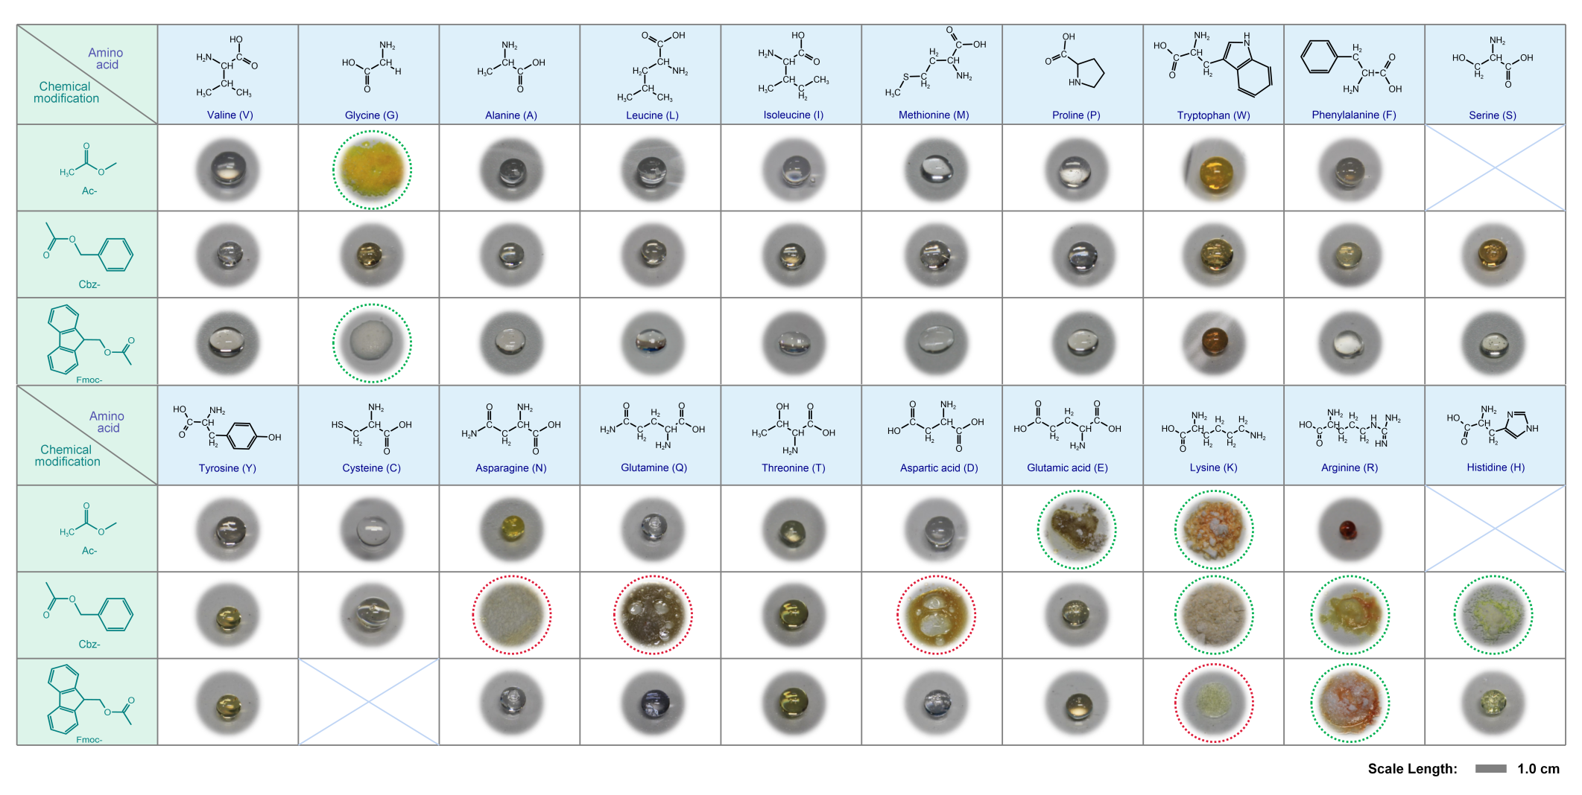
Tab.S2 Photographs of amino acid-based organic glasses.
*The green circles indicate amino acid derivatives that have not yet formed a glass through the melting and quenching processes. The red circles indicate amino acid derivatives that formed glass analogues, but their processability must be improved. Because of the limitations of synthetic technology, Ac-S, Ac-H and Fmoc-C were not used in this experiment.
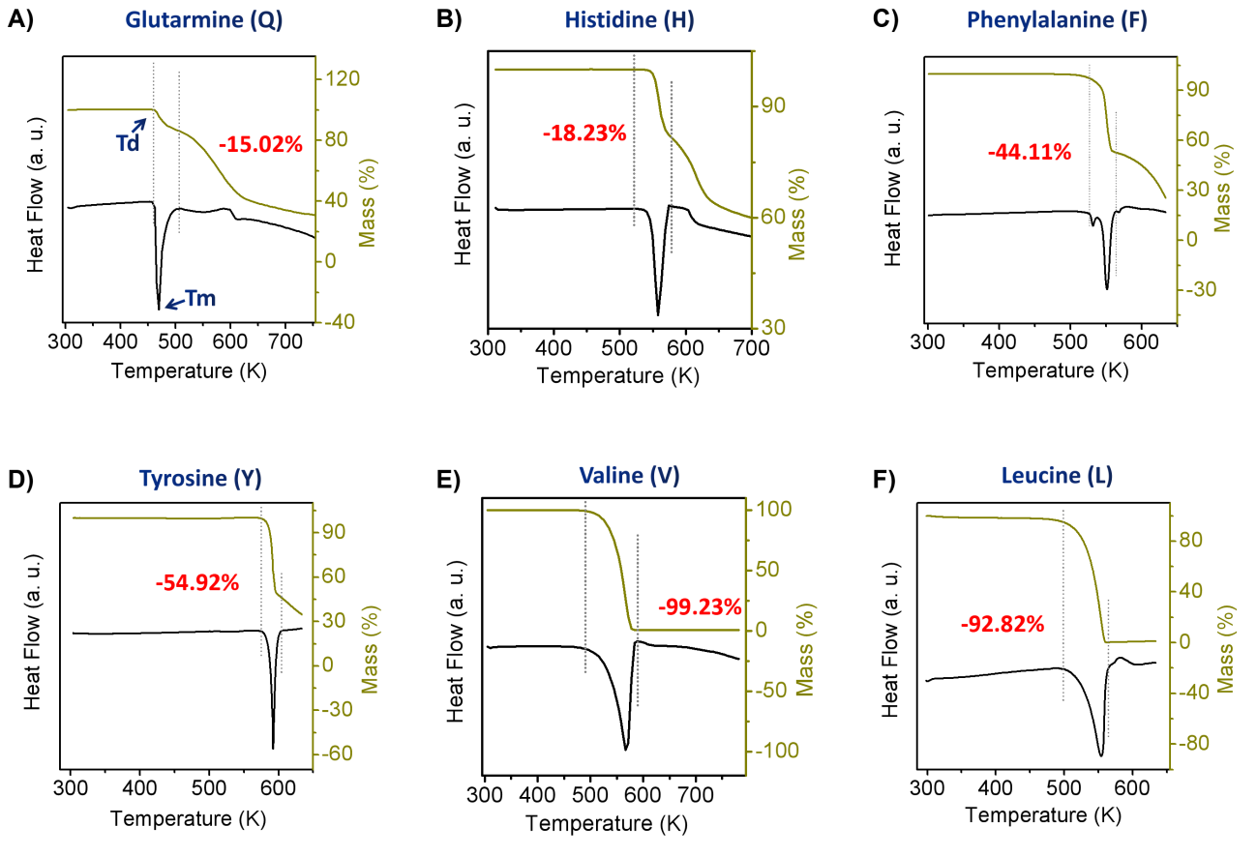Fig.S1 Thermogravimetric analysis and enthalpic responses of amino acids using a DSC-TGA instrument with cooling and heating rates of ±10 K min⁻¹.

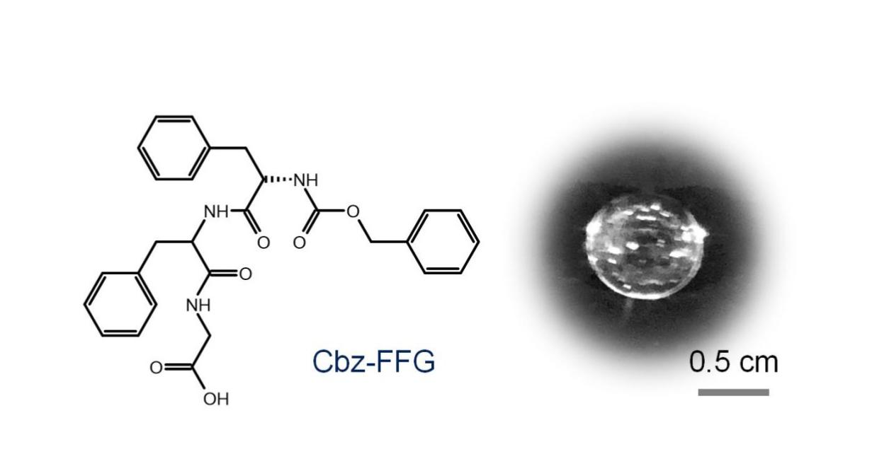
Fig.S2 Molecular structure and photograph of a Cbz-FFG peptide organic glass.
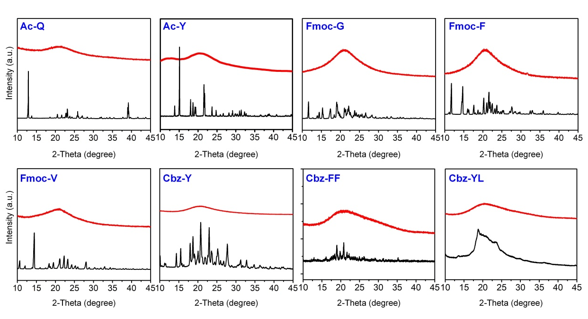
Fig.S3 XRD patterns of typical amino acid or peptide powders (blank line) and glasses (red line) showing the obvious crystalline state of the raw material powders and the amorphous state of the as-prepared glasses.
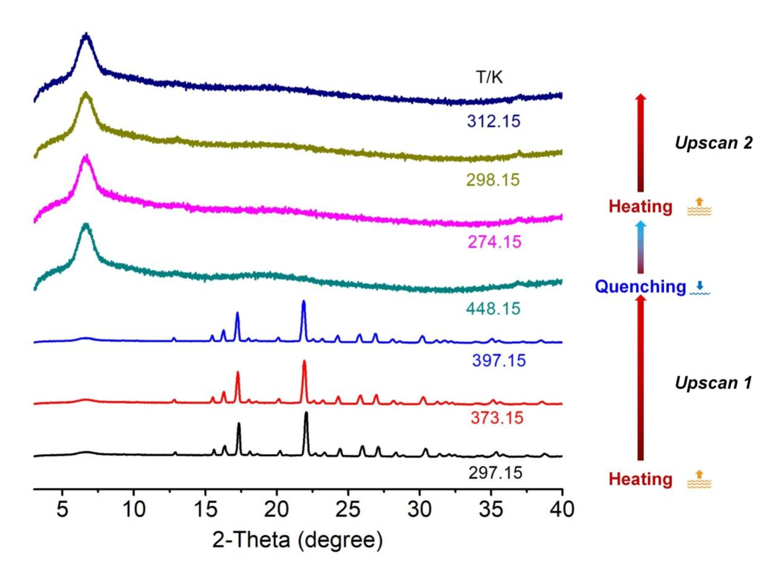
Fig.S4 In situ XRD patterns obtained during the transformation of Ac-F from the crystalline state to the glassy state during heating-quenching across the entire temperature range studied.
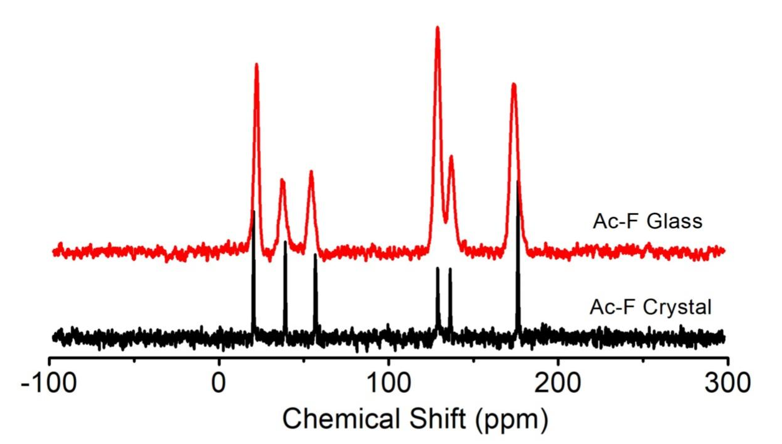
Fig.S5 Solid-state NMR (ssNMR) spectra of Ac-F samples, indicating no change in the Ac-F chemical structure during the formation of a glass.
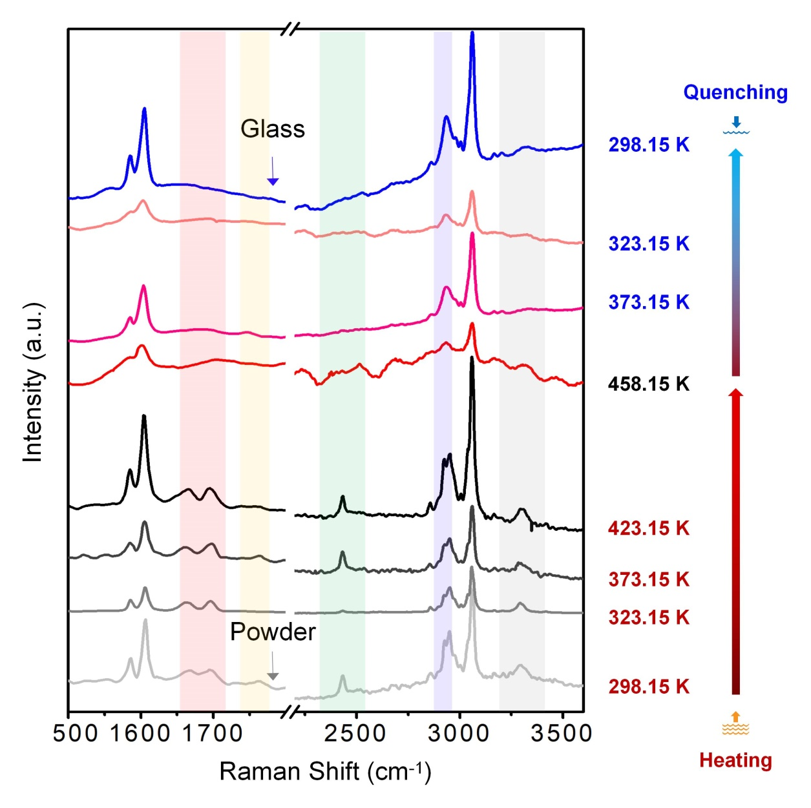
Fig.S6 In situ Raman spectra of Cbz-FFG as a function of temperature. Cbz-FFG powder was heated, melted and then quenched to form a glass.

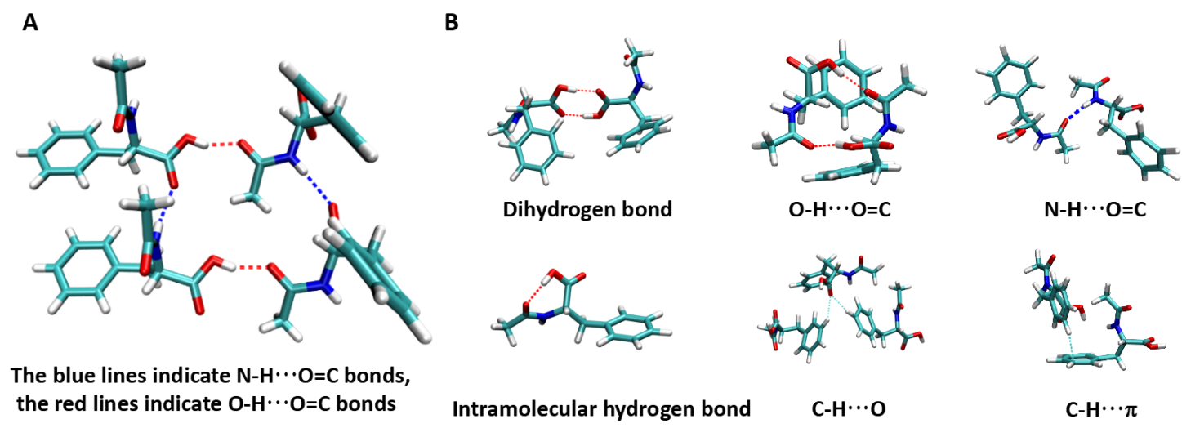Fig.S7 Hydrogen bond types in the (a) single crystal and (b) glass of Ac-F.
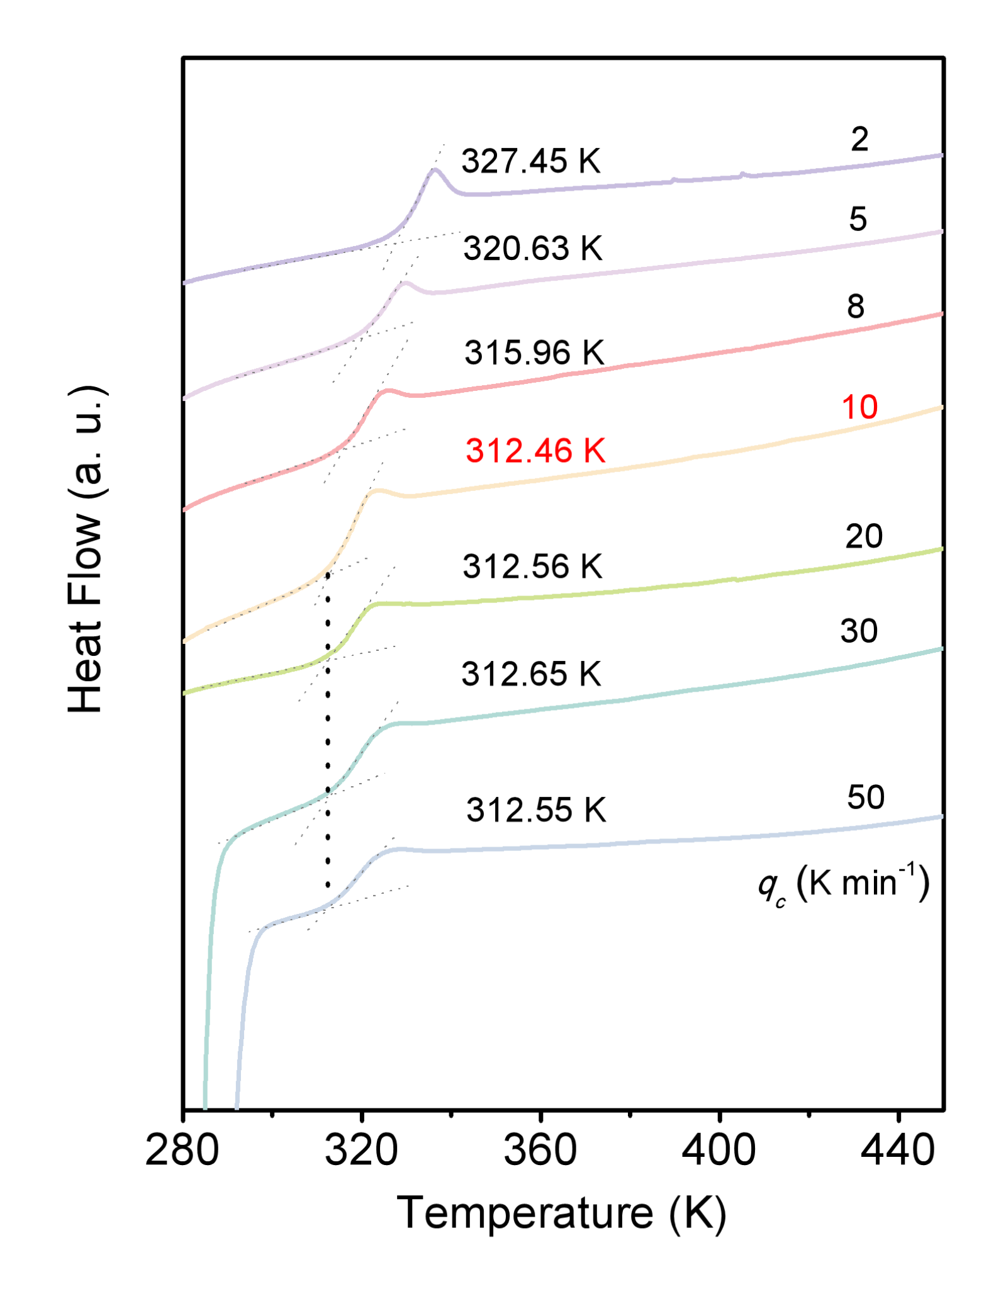
Fig.S8 DSC curves (Upscan 2) of Ac-F vs. temperature with different heating rates (q_{h}) equal to the cooling rate (q_{c}), showing no change in the glass transition temperature when the cooling rate was over 10 K min⁻¹. The intersection of two dashed lines represents T_{g}.
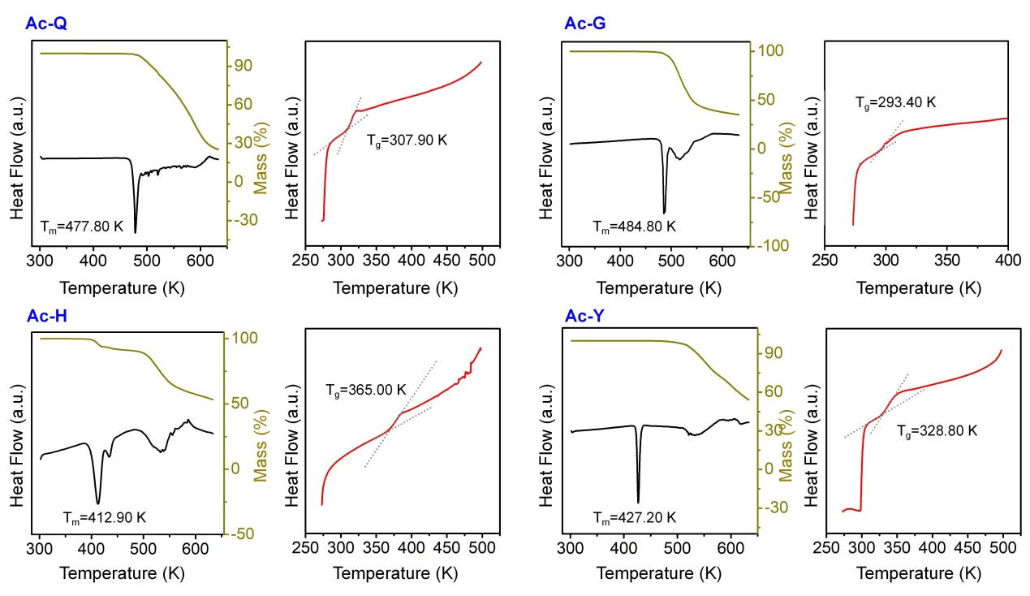
Fig.S9 Thermogravimetric analysis and enthalpic responses of the typical Ac-amino acid glasses listed in Tab.S1. The intersection of two dashed lines represents T_{g}.

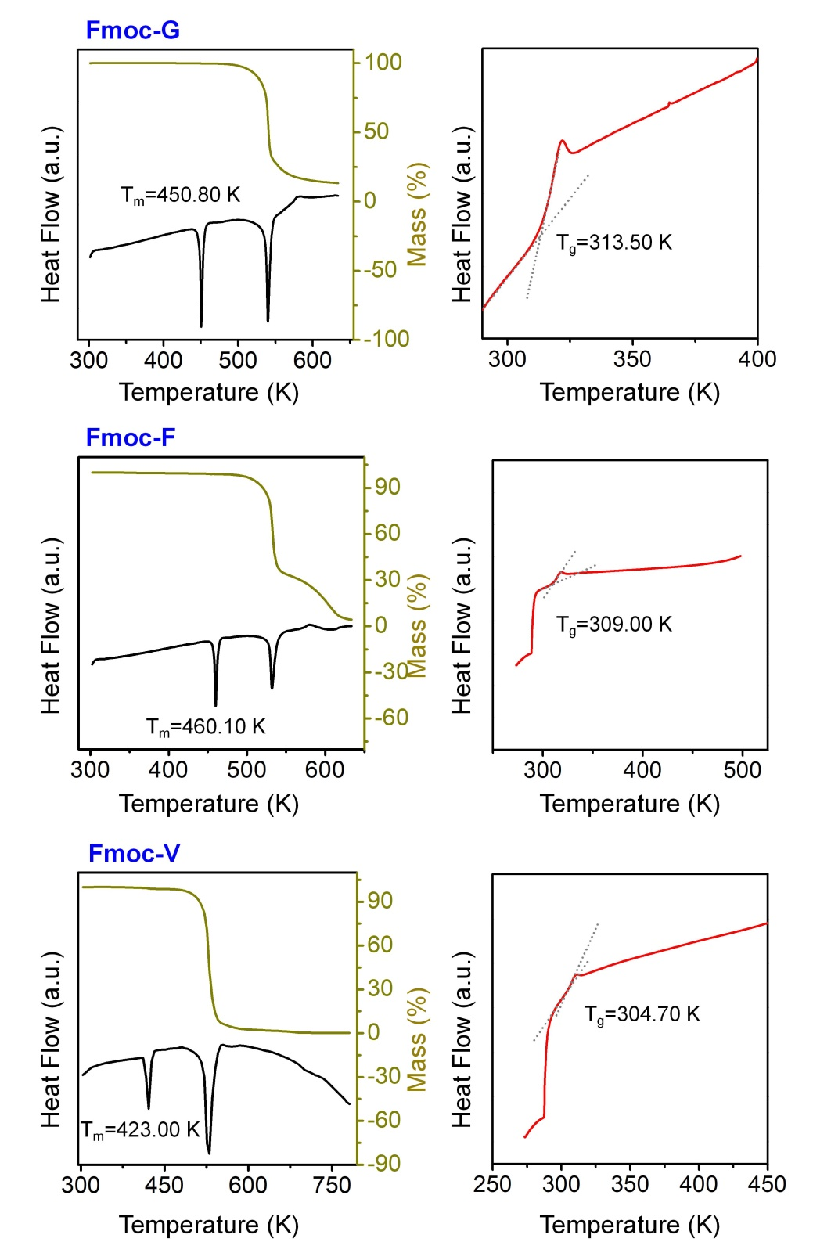
Fig.S9 (cont’d) Thermogravimetric analysis and enthalpic responses of the typical Fmoc-amino acid glasses listed in Tab.S1. The intersection of two dashed lines represents T_{g}.
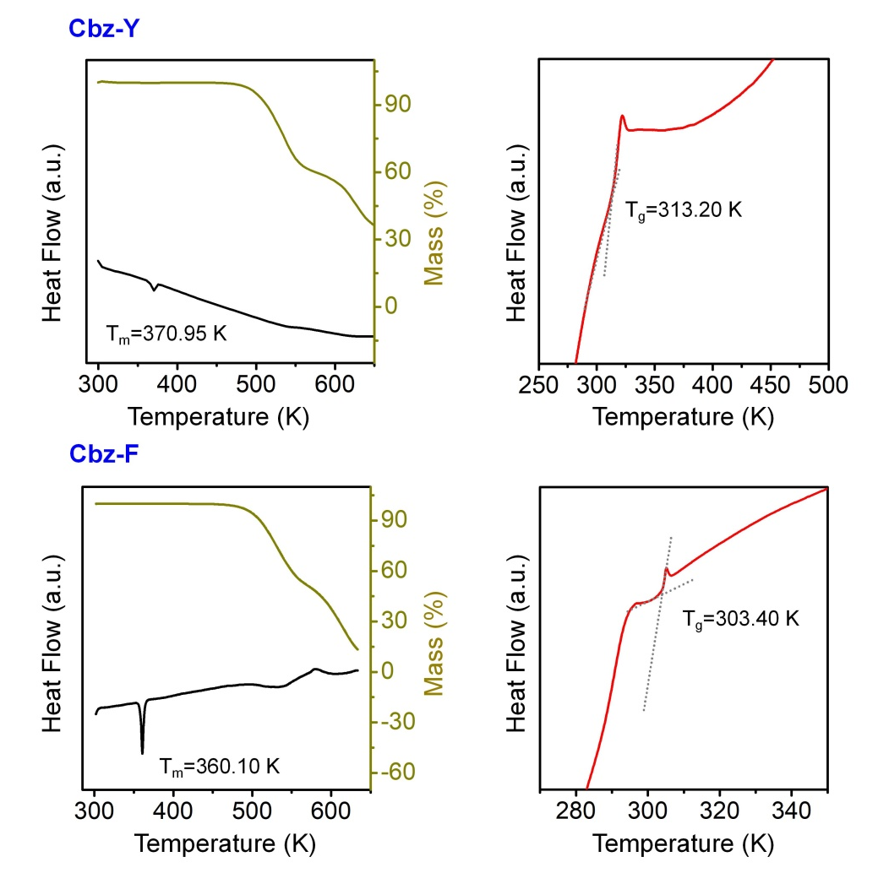
Fig.S9 (cont’d) Thermogravimetric analysis and enthalpic responses of the typical Cbz-amino acid glasses listed in Tab.S1. The intersection of two dashed lines represents T_{g}.
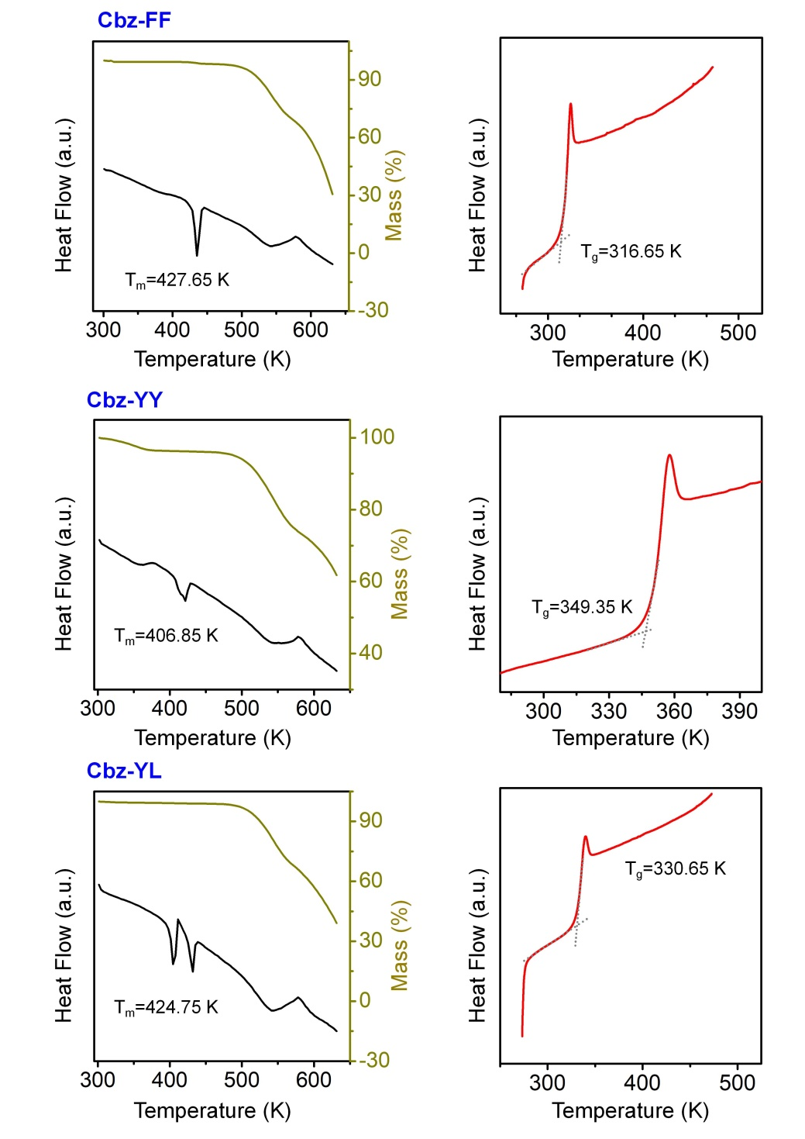
Fig.S9 (cont’d) Thermogravimetric analysis and enthalpic responses of the typical peptide glasses listed in Tab.S1.The intersection of two dashed lines represents T_{g}.
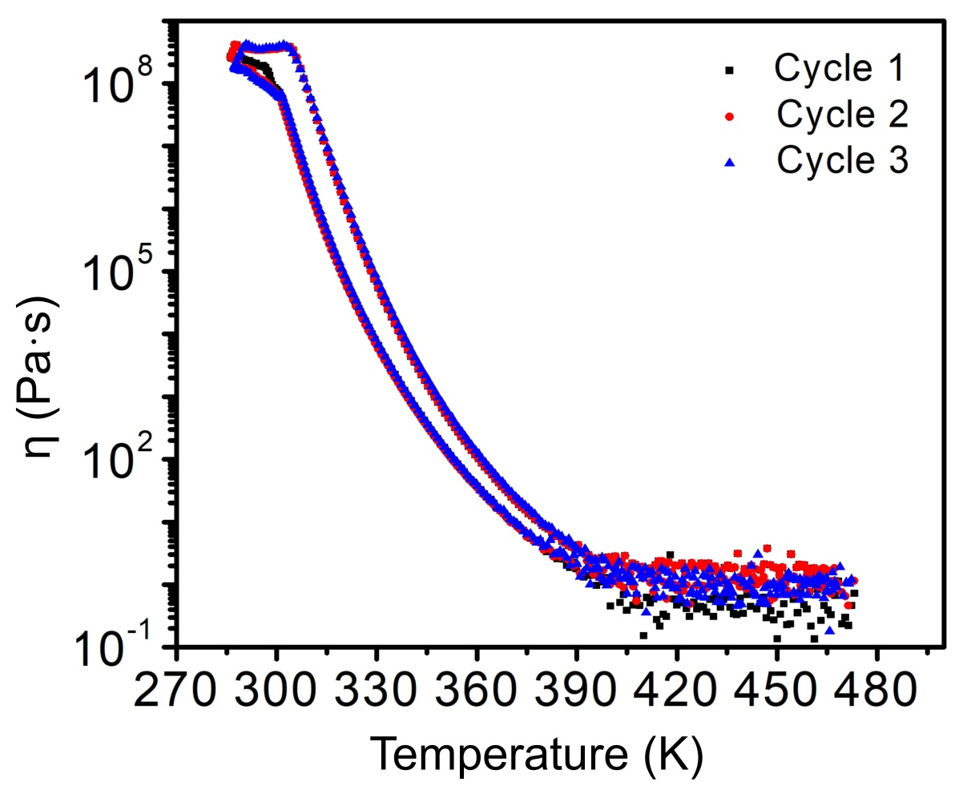
Fig.S10 Viscosity curves of the Ac-F system vs. temperature. The Ac-F powder was placed on the panel of a rheometer and heated and melted (15 min at 473.15 K). Subsequently, the temperature was decreased to 273.15 K to obtain a viscous liquid. The process of increasing and decreasing the temperature was repeated three times. The strain was 0.1%, and the heating and cooling rates were 10 K min⁻¹.

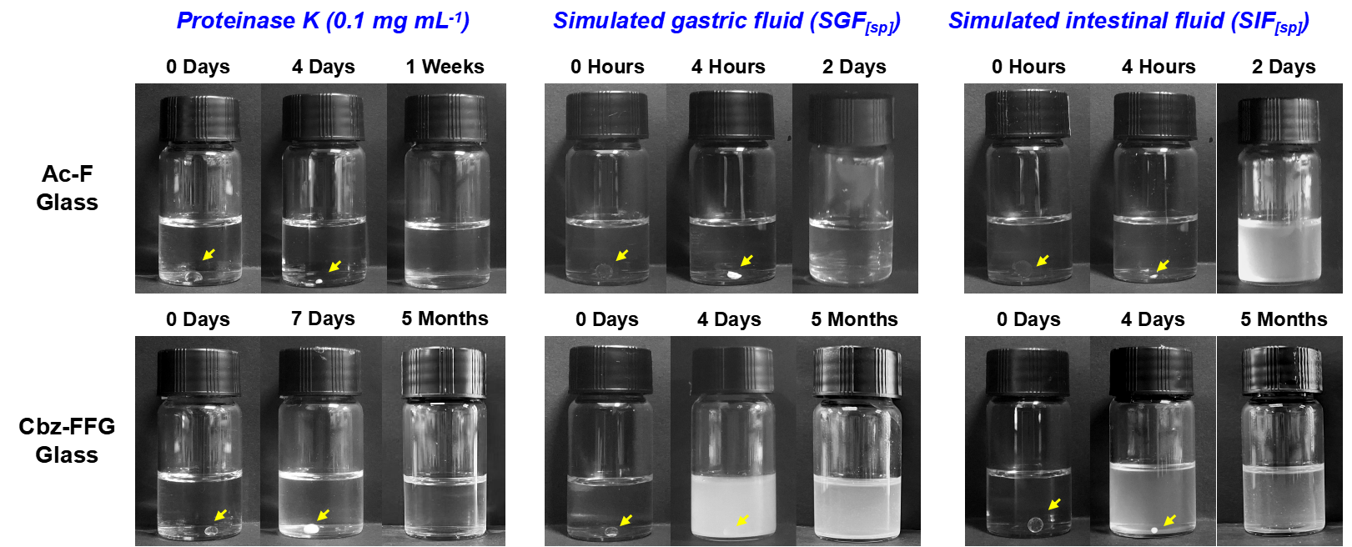Fig.S11 Degradation of glasses exposed to proteinase K solution (0.1 mg mL⁻¹), simulated gastric fluid (SGF_{[sp]}) containing pepsin and simulated intestinal fluid (SIF_{[sp]}) containing pancreatin.

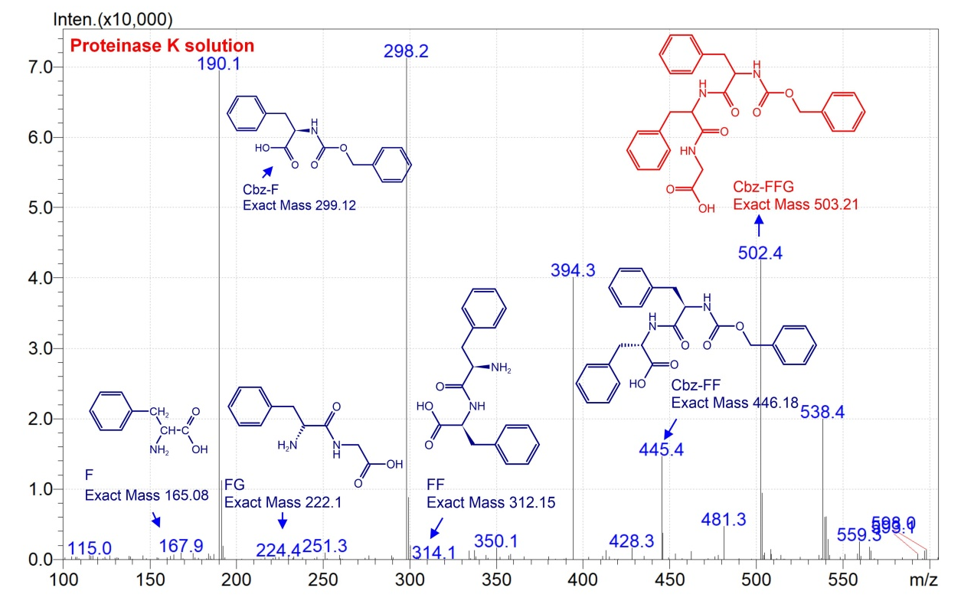
Fig.S12 Mass spectrometry data for the degradation products of Cbz-FFG glass incubated with proteinase K solution.

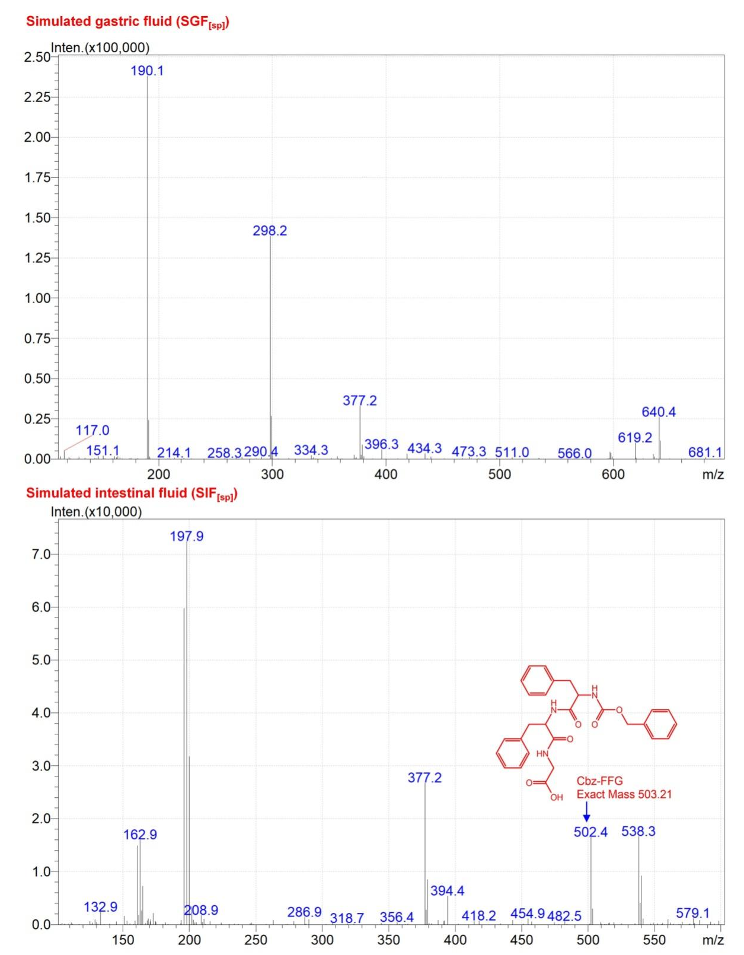
Fig.S12 (cont’d) Mass spectrometry data for the degradation products of Cbz-FFG glass incubated with simulated gastric fluid (SGF_{[sp]}) and simulated intestinal fluid (SIF_{[sp]}).

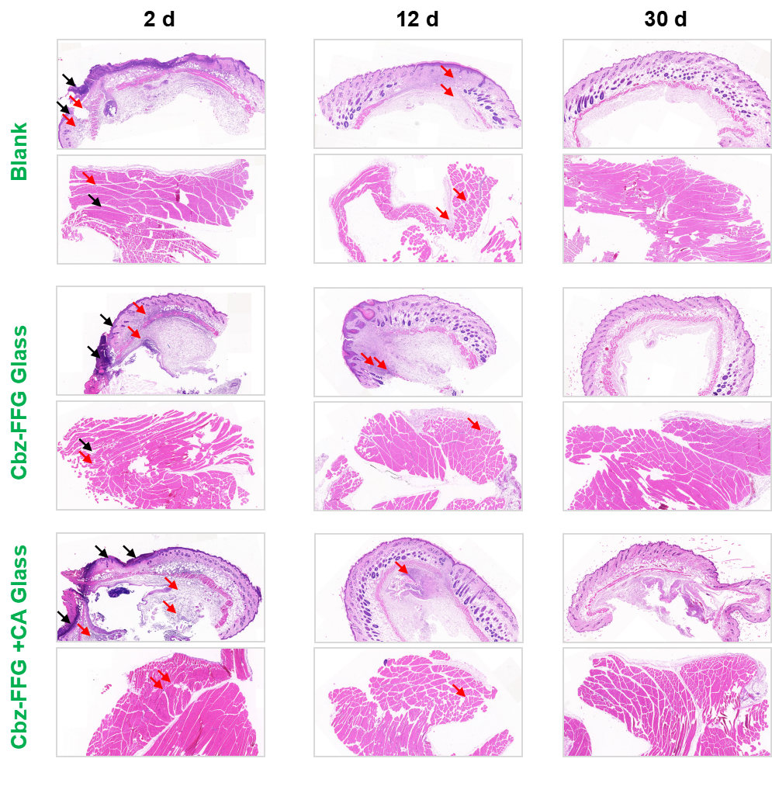
Fig.S13 Histopathological analysis of the tissues in contact with the glass implants. The upper layer is skin tissue, and the lower layer is muscle tissue. The red arrows show inflammatory cell infiltration, and the black arrows show cuticle thickening.

