The table of contents entry:

A facile strategy to generate high-transconductance (>10 mS) and highly elastic all-polymer organic electrochemical transistor was presented using gelatin-based electrolyte printed with PEDOT:PSS/LiTFSI microelectrodes and 3D micro-engineered channel/electrolyte interface. The imprinted 3D-microstructured polymer channel combined with wrinkled electrodes enabled biaxial stretchability of 100% strain and preserved performance for 1000 cycles under 80% strain. And the glycerol-soaked gelatin electrolyte permitted long-term environmental stability for months and readily recyclability, paving the way to wide applications including artificial synapses and wearable sensing.

Keywords: conducting polymer, organohydrogel electrolyte, organic electrochemical transistor, stretchable electronics, soft lithography

W. J. Wang, Z. X. Li, M. C. Li, L. Y. Fang, F. B. Chen, S. J. Han, L. Y. Lan, J. X. Chen, Q. Z. Chen, H. S. Wang, C. Liu, Y. B. Yang, W. Yue, Z. Xie*

High-Transconductance, Highly Elastic, Durable and Recyclable All-Polymer Electrochemical Transistors with 3D Micro-engineered Interfaces

ToC figure

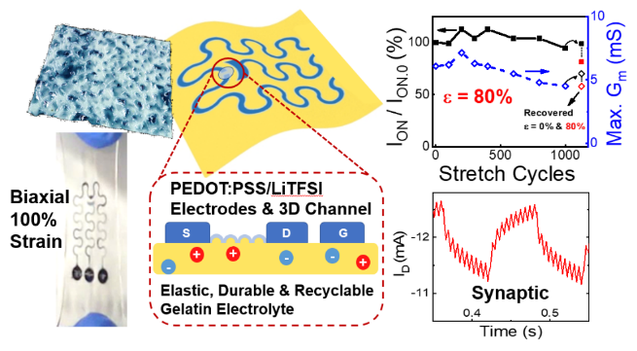

Supporting Information

High-Transconductance, Highly Elastic, Durable and Recyclable All-Polymer Electrochemical Transistors with 3D Micro-engineered Interfaces

Wenjin Wang,^{1,#} Zhaoxian Li, ^{1,#} Mancheng Li,¹ Lvye Fang,¹ Fubin Chen,¹ Songjia Han,² Liuyuan Lan,¹ Junxin Chen, ¹ Qize Chen, ¹ Hongshang Wang, ¹ Chuan Liu, ² Yabin Yang, ¹ Wan Yue, ¹ Zhuang Xie^{1,*}

¹ School of Materials Science and Engineering, Guangzhou Key Laboratory of Flexible Electronic Materials and Wearable Devices, and Key Laboratory for Polymeric Composite and Functional Materials of Ministry of Education, Sun Yat-sen University, Guangzhou, 510275, P. R. China
* E-mail: xiezhuang@mail.sysu.edu.cn

² State Key Laboratory of Optoelectronic Materials and Technologies and Guangdong Province Key Laboratory of Display Material and Technology, School of Electronics and Information Technology, Sun Yat-Sen University, Guangzhou 510275, P. R. China.

# Wenjin Wang and Zhaoxian Li contributed equally to this work

Keywords: conducting polymer, organohydrogel electrolyte, organic electrochemical transistor, stretchable electronics, soft lithography

Figure S1. Cyclic loading–unloading curves at 100% strain for 25% GEL-60% GLY/Na₃Cit, with diminished residual strain and recovery of dissipated energy observed after 1 h.

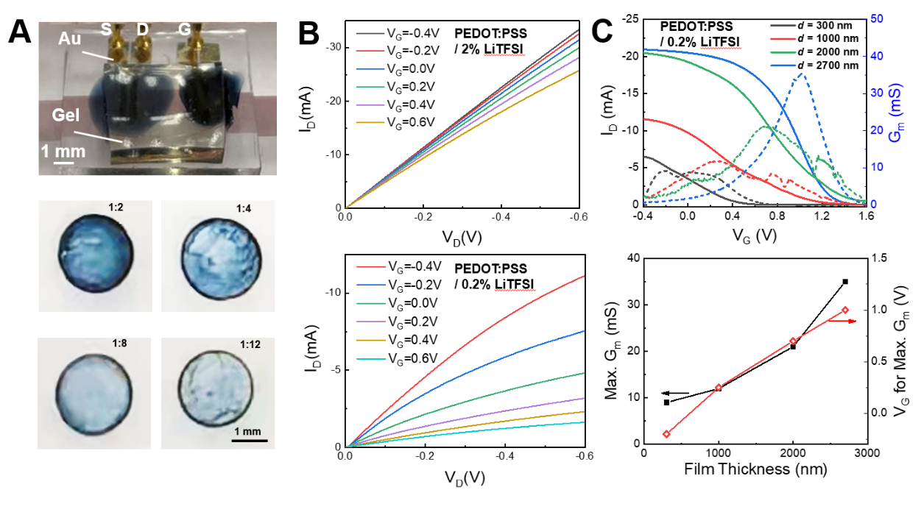
Figure S2. (A) Photos of the OECT measurement on Au electrodes and PEDOT:PSS/LiTFSI with varied thickness through controlling the dilution ratio. (B) Typical output curves of PEDOT:PSS doped with 2 wt% LiTFSI (top) and 0.2 wt% LiTFSI (bottom) with similar thickness. (C) Control of the transfer and G_{m} characteristics of PEDOT:PSS/0.2% LiTFSI channel by adjusting the film thickness.

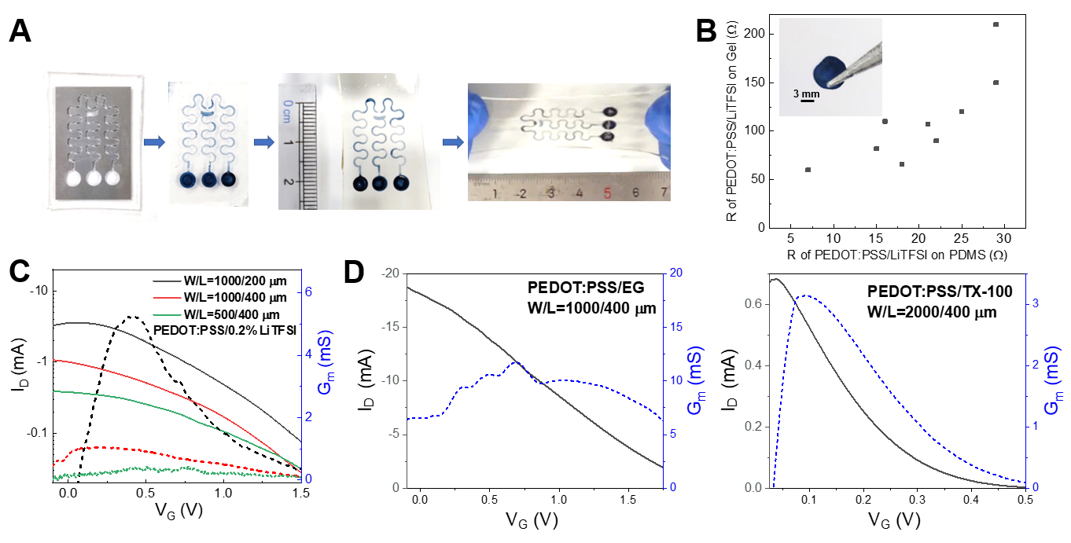
Figure S3. (A) Fabrication process of patterned hydrophilic and hydrophobic PDMS surface using oxygen plasma under a stainless steel mask to form the PEDOT:PSS/LiTFSI patterns on PDMS by dewetting, followed by transfer printing to obtain stretchable microelectrodes on gel. (B) Plot of resistance values of the PEDOT:PSS/LiTFSI films on 25% GEL-80% GLY/Na₃Cit corresponding to those on PDMS before transfer. (C) Transfer and G_{m} curves of all-polymer OECTs with controlled W/L ratios. The channels were PEDOT:PSS/0.2% LiTFSI drop cast with 1:4 dilution. (D) Transfer and G_{m} curves of the all-polymer OECT consisting of PEDOT:PSS/LiTFSI electrodes and PEDOT:PSS/5% TritonX-100 as the channel.
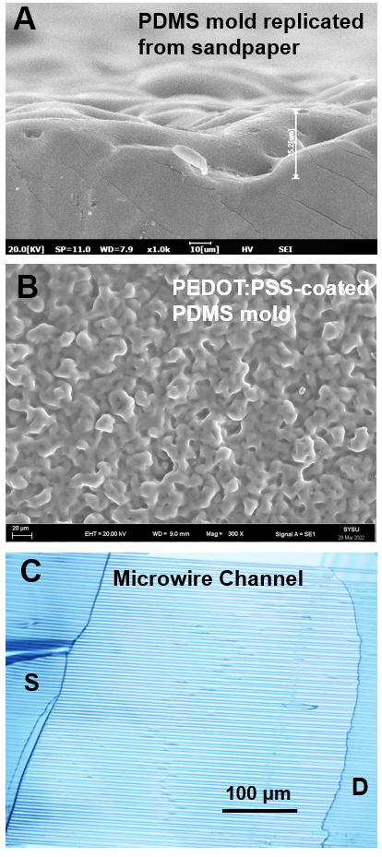
Figure S4. (A) Cross-sectional scanning electron microscopy (SEM) image of PDMS mold replicated from a sandpaper (400 mesh). (B) SEM top view of the PDMS mold after spin coating PEDOT:PSS/LiTFSI. (C) Optical microscope image of the microwire channel by printing two polymer electrodes to contact with the microwire arrays.

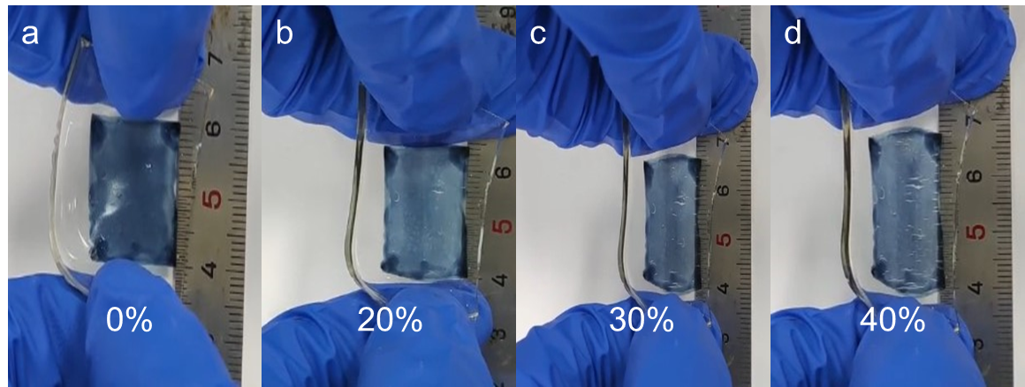
Figure S5. Photos of PEDOT:PSS/LiTFSI attached on the gel electrolyte under strains from 0-40%, showing the macroscopic cracks above 30% strain.

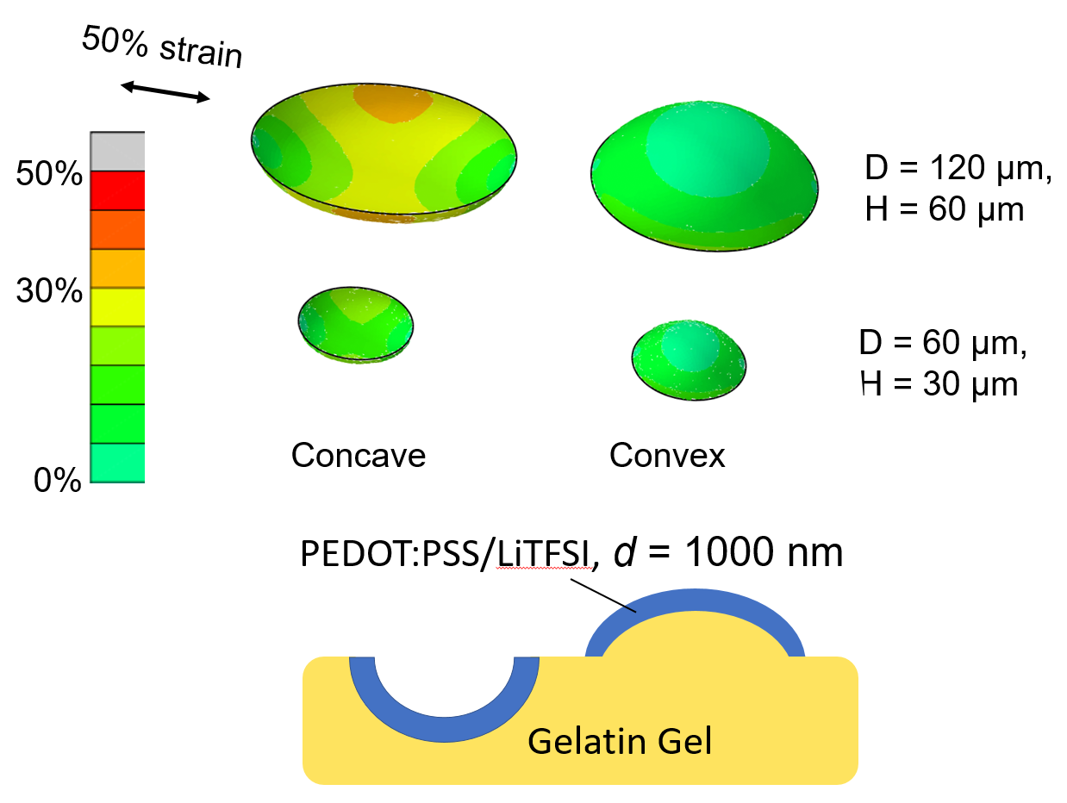
Figure S6. Finite element simulations of strain distribution on PEDOT:PSS/LiTFSI thin layer coated on concave and convex microstructures of gelatin-based gel electrolyte, with an overall strain of 50%. It indicates that the convex structure and the smaller diameter may decrease the strain on the PEDOT:PSS/LiTFSI.

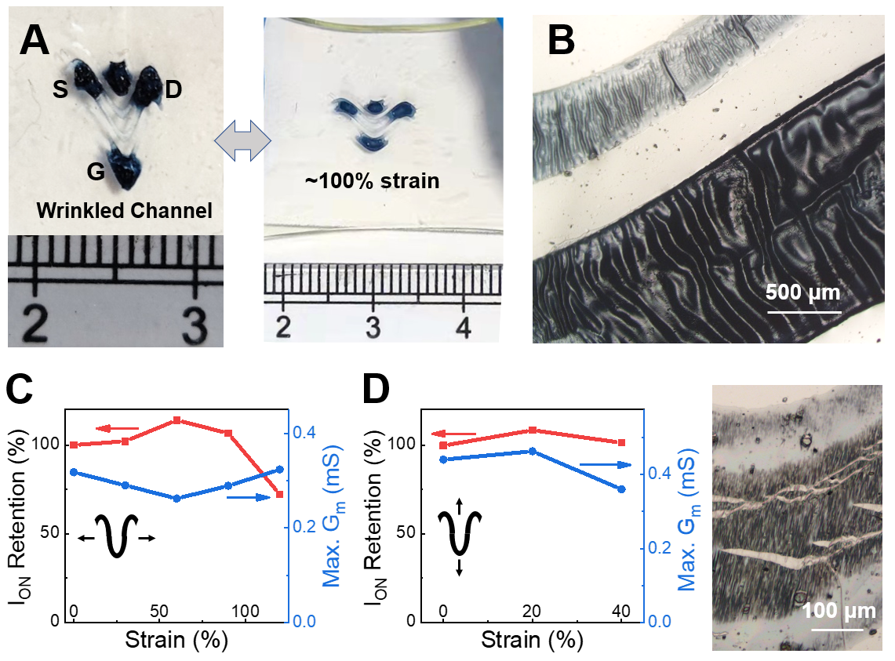
Figure S7. (A) Photographs of the all-polymer OECT with wrinkled channel and electrodes (100% prestrain) under relaxed and stretched states. (B) Optical microscope image of the wrinkled channel and electrode. (C) I_{ON} retention and maximum G_{m} of the stretchable all-polymer OECT during stretching from 0 to 100% strain parallel to the prestretched direction. (D) OECT performance under strains of 0-40% in the perpendicular direction. The corresponding optical microscope image shows the channel cracking after perpendicular stretching.

Figure S8. I_{D} retention of the wrinkled electrode under repeated stretching for 800 cycles at 100% strain.

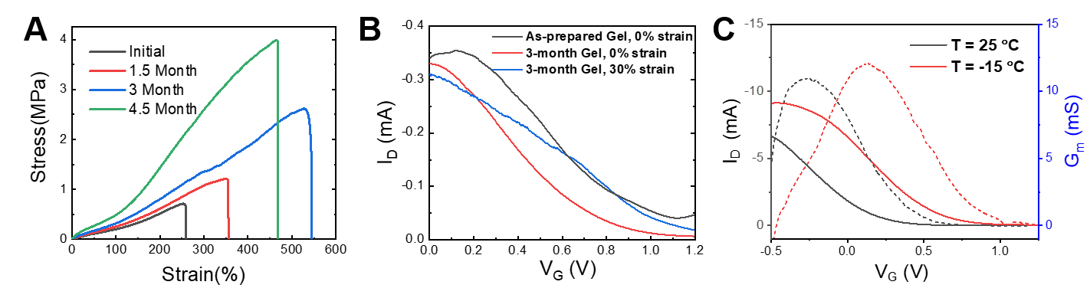
Figure S9. (A) Typical tensile stress–strain curves of 20% GEL-60% GLY/Na₃Cit under ambient storage for up to 4.5 month. (B) Transfer curves of OECT prepared with fresh and aged gel electrolytes. (C) Transfer curves of OECT under varied temperature conditions.

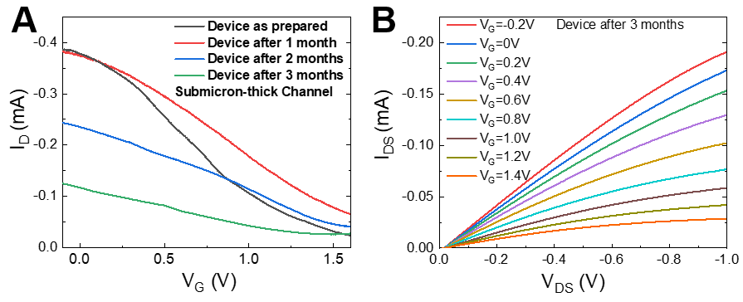
Figure S10. (A) Transfer curves of an all-polymer OECT with submicron-thick channel during the storage for 3 months. (D) Output curves of the OECT after 3 months.

