Rectifying disorder of extracellular matrix to suppress urethral stricture by protein nanofilm-controlled drug delivery from urinary catheter

Supplementary Information Content
Supplementary Methods
Supplementary Figures (1-42)
Supplementary Tables (1-5)
Supplementary References

Supplementary Methods.
Entrapment efficiency determination for drug in the delivery system.
The sustained-release catheters were soaked in acetonitrile solution and vigorously stirred (700 rpm) for 4 h at room temperature. The solution was centrifuged at 10000 rpm for 10 min. Then the supernatant solution was detected by a UV-spectrometer to determine the amount of rapamycin encapsulated in the drug delivery system. The entrapment efficiency was calculated by using the following formula:
Entrapment efficiency =$\frac{W}{W_{0}}×100\%$
where W₀ represents the initially added amount of drug and W represents the amount of drug entrapped in the drug delivery system.
Rapamycin measurement in whole blood.
The analysis of rapamycin concentration in whole blood was performed using a previously published method with a slight adaption¹. Briefly, after adding 50 μL of fresh whole blood to 200 μL of methanol, the vials were vortexed for 5 min and centrifuged at 13,000 rpm for 10 min. The supernatant was injected and analysed with LC-MS/MS using a Thermo Fisher Scientiﬁc (Waltham, USA) triple quadrupole Quantum Access LC-MS/MS system. Data acquisition and data processing were performed using Xcalibur software version.
Immunostaining.
All paraffin-embedded tissue was cut into 5 µm thick continuous sections. Tissue sections were deparaffinized, rehydrated, antigen retrieval, and quenched in 3% hydrogen peroxide. After blocking with 5% BSA, the slides were incubated with primary antibody at 4ºC overnight, and then incubated with secondary horseradish peroxidase (HRP)-labelled rabbit/mouse anti-goat IgG antibodies (Zhongshan Corp.). The sections were visualized with a 3,3’-diaminobenzidine kit (DAB, Zhongshan Corp.) and counterstained with haematoxylin. The data was analyzed by ImageJ v1.8.0.
Immunofluorescence.
Primary rat urethral fibroblasts were seeded on coverslips in 24-well plates. After the cells attached, the coverslips with attached cells were taken out and fixed with 4% paraformaldehyde for 15 min at room temperature, followed by permeabilization with 0.3% Triton for 15 min. After blocking with 5% BSA at room temperature for 1 h, the primary antibody was dropped onto the coverslips and incubated overnight at 4°C. Then, they were incubated with Alexa Fluor 488-labled Goat Anti-Rabbit IgG (1:500, A0423, Beyotime Institute of Biotechnology, China) at room temperature for 40 min, and the nuclei were stained with 4,6-diamino-2-phenylindole (DAPI, C1002, Beyotime Institute of Biotechnology, China).
For paraffin-embedded tissue sections, antigen retrieval was performed with citrate buffer before permeabilization. Antibodies against Vimentin (1:500, D21H3, CST, USA), collagen I (1:400,14695-1-AP, Proteintech, China) and collagen III (1:400, ab7778, abcam, UK) were diluted with 1% bovine serum albumin in PBS. The image was taken using a confocal laser scanning microscope.

Supplementary Figures.
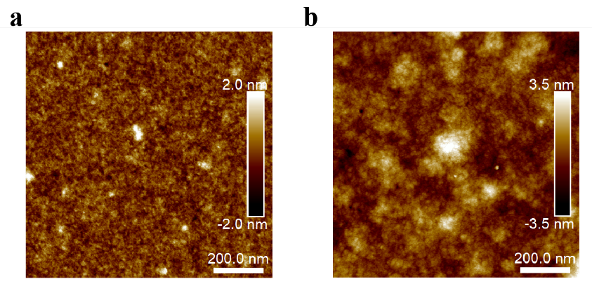
Figure S1. The AFM images showing the PTB@SA coating morphology at different reaction time. (a) 5 min; (b) 10 min.

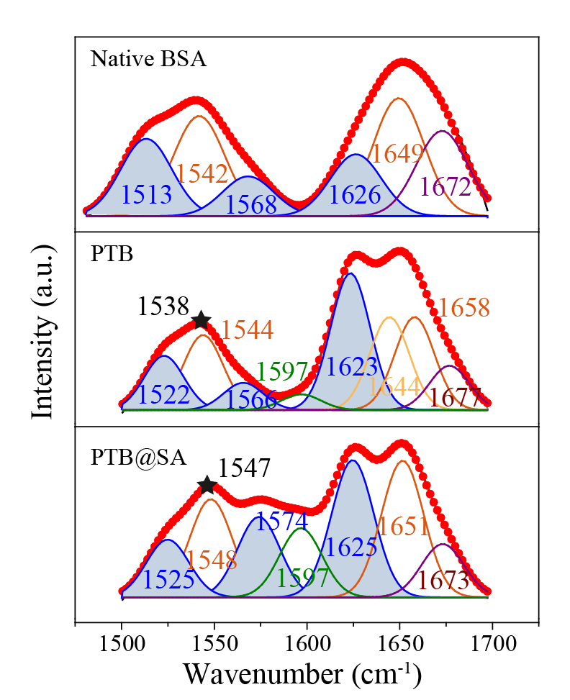
Figure S2. FTIR peaks of amide I and amide II of native BSA, the pure PTB or the hybrid PTB@SA nanofilm. The blue area and asterisk indicate the deconvoluted β-sheet band and the main peak of amide II, respectively.
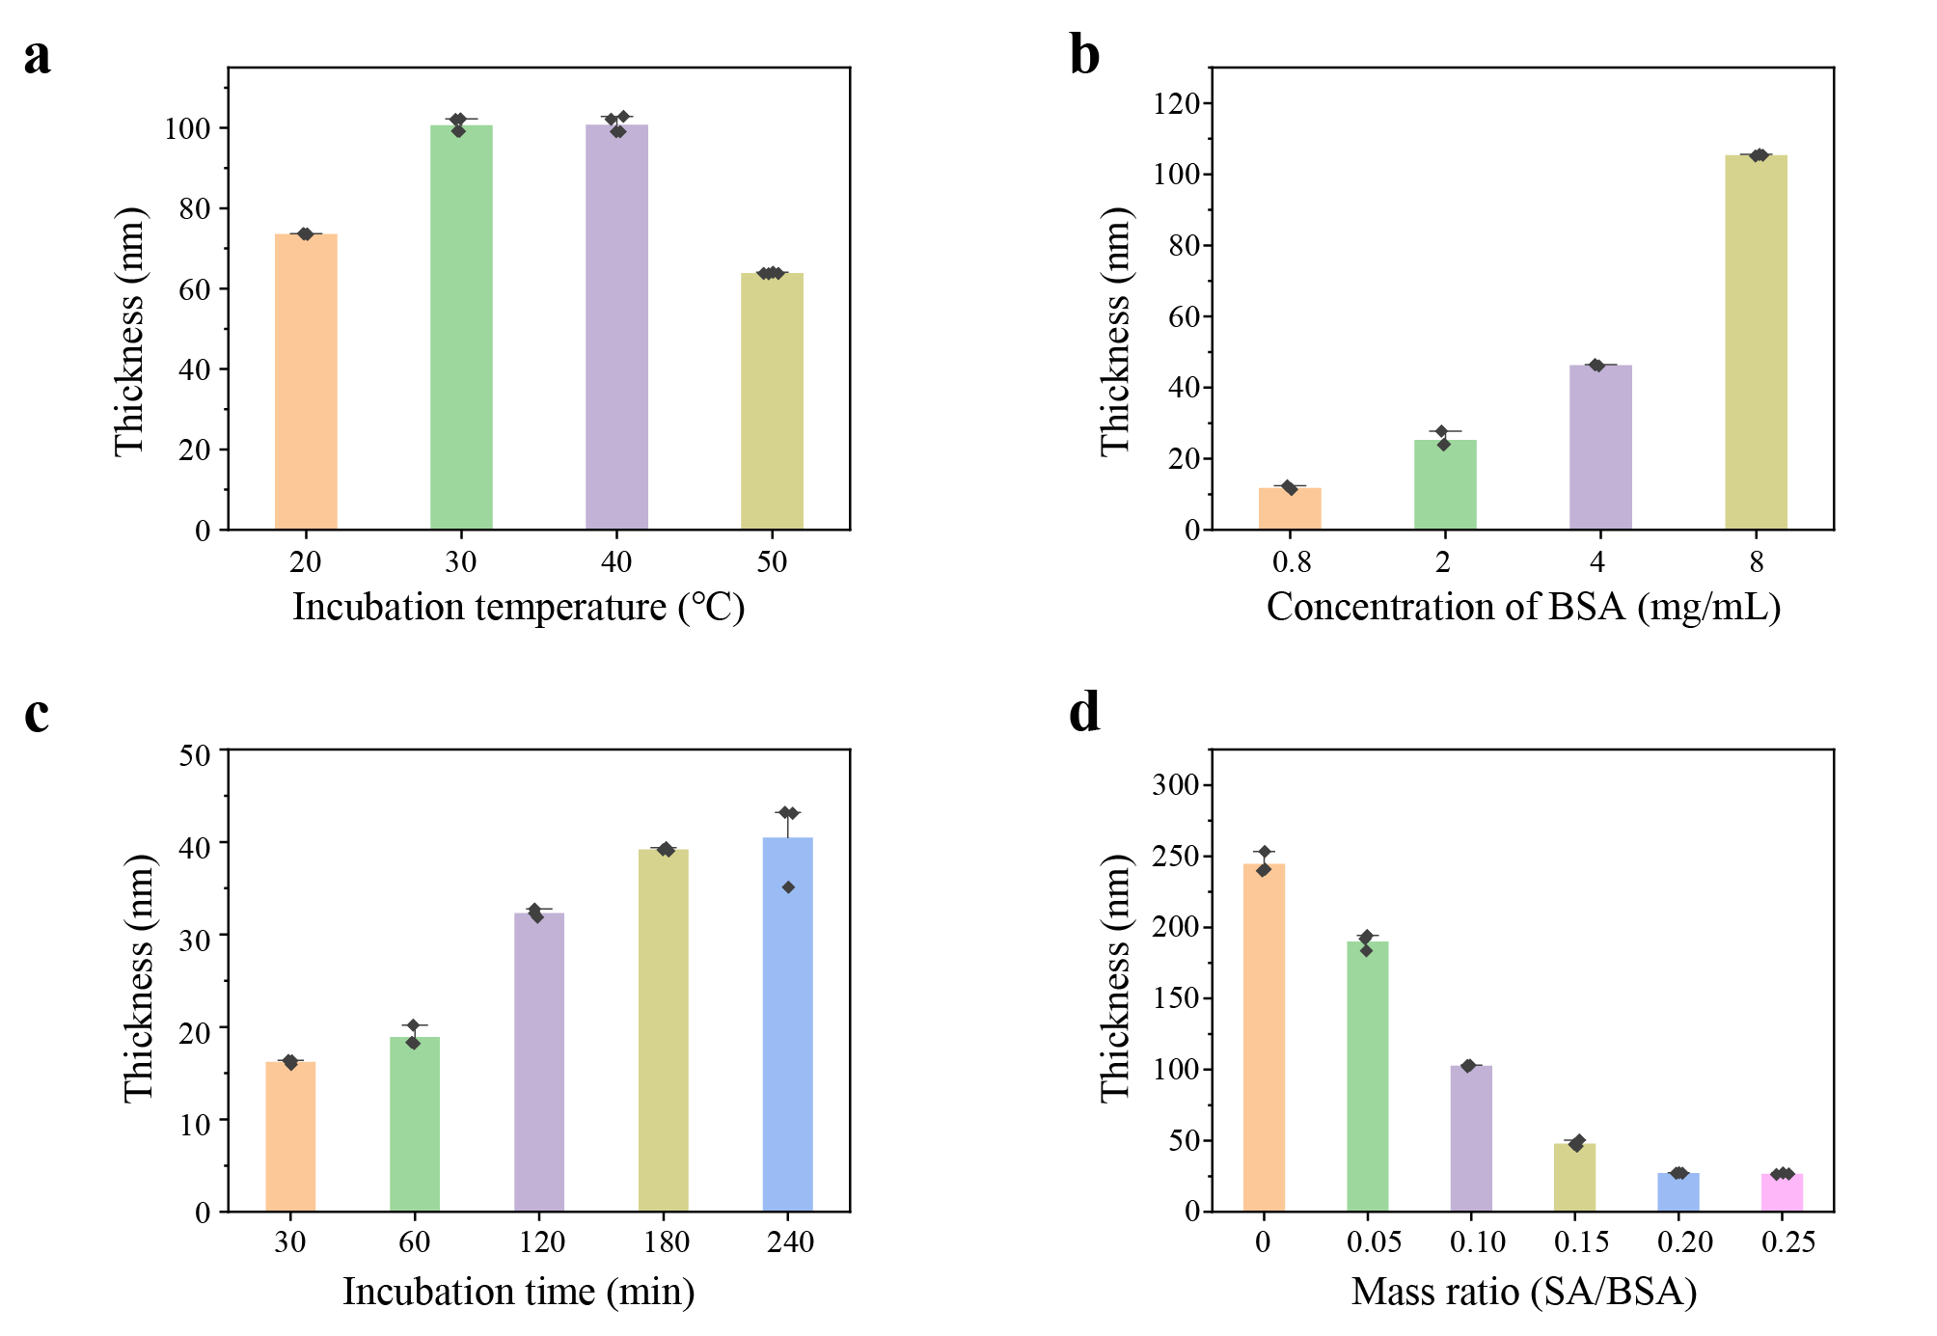
Figure S3. The thickness of the hybrid PTB@SA nanofilm controlled by the incubation temperature (a), BSA concentration (b), incubation time (c) and SA addition ratio (d). (a). The final concentrations of BSA, TCEP, and SA in the phase transition solution for manufacturing the coating were 8 mg/mL, 20 mM and 0.8 mg/mL, respectively. The incubation time was 3 h, and the reaction temperature varied from 20°C to 30°C. (b). For a given mass ratio of SA to BSA (0.10), the final concentration of BSA in the phase transition solution was ranged from 0.8 to 8 mg/mL, and the reaction temperature and time were 30°C and 3h, respectively. (c). The final concentrations of BSA, TCEP, and SA in the phase transition solution used to prepare the coating were 4 mg/mL, 20 mM, and 0.4 mg/mL, respectively, and the incubation time at 30°C varied from 30 to 240 min. (d). The final concentrations of BSA and TCEP are 8 mg/mL and 20 mM, and the mass ratio of SA to BSA in the phase transition solution varied from 0.05 to 0.25. The reaction temperature and time were 30°C and 3 h, respectively. Data are presented as the mean ± s.d.; n=3.

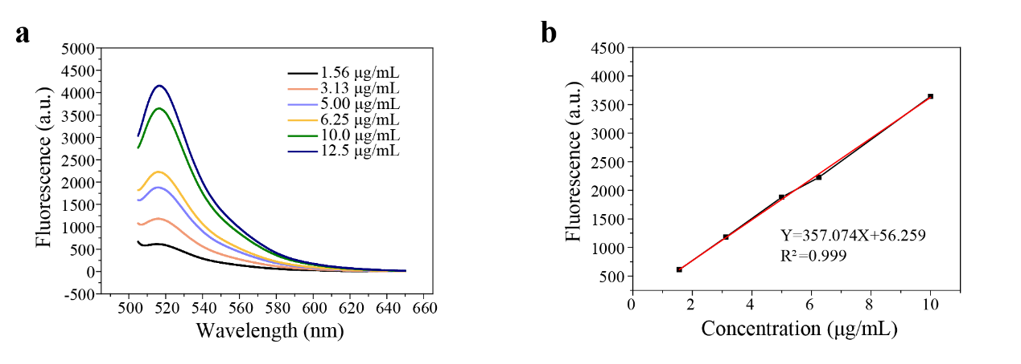
Figure S4. Encapsulation density of SA in hybrid nanofilms. (a) The fluorescent spectra of 5(6) -aminofluorescein-labeled SA in 2 M NaOH at different concentrations. (b) Standard curve and regression equation of 5(6) -aminofluorescein-labeled SA in 2 M NaOH.

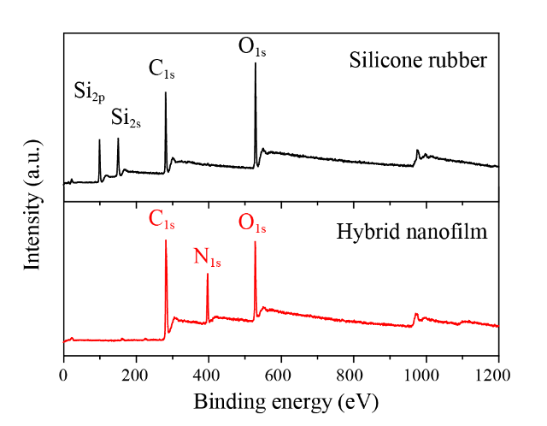
Figure S5. XPS spectra of pristine silicone rubber (SR) and the hybrid PTB@SA nanofilm coated SR.

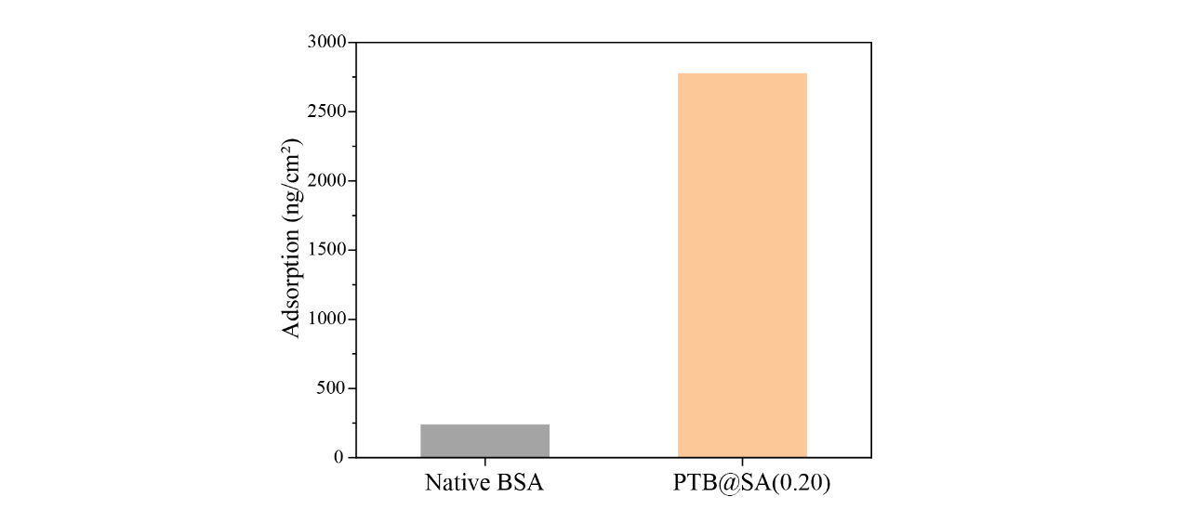
Figure S6. The adsorption amount of native BSA and PTB@SA(0.20) on Au chips.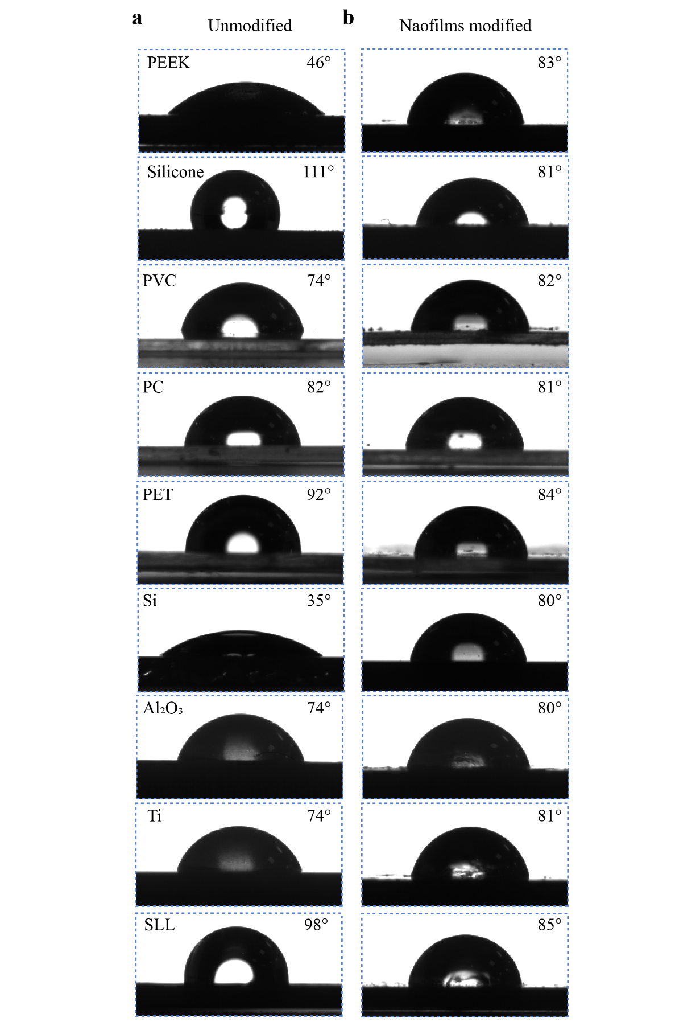
Figure S7. The water contact angle images on unmodified substrates (a) and substrates coated by the hybrid PTB@SA nanofilm (b). The final concentrations of BSA and TCEP in the phase transition solution to prepare the coating were 8 mg/mL and 20 mM, respectively, and the mass ratio of SA to BSA was 0.1:1. PEEK: polyether ether ketone; PVC: polyvinyl chloride; PC: polycarbonate; PET: polyethylene terephthalate; Si: silicon wafer; Al₂O₃: aluminum oxide; Ti: titanium; SLL: stainless steel.
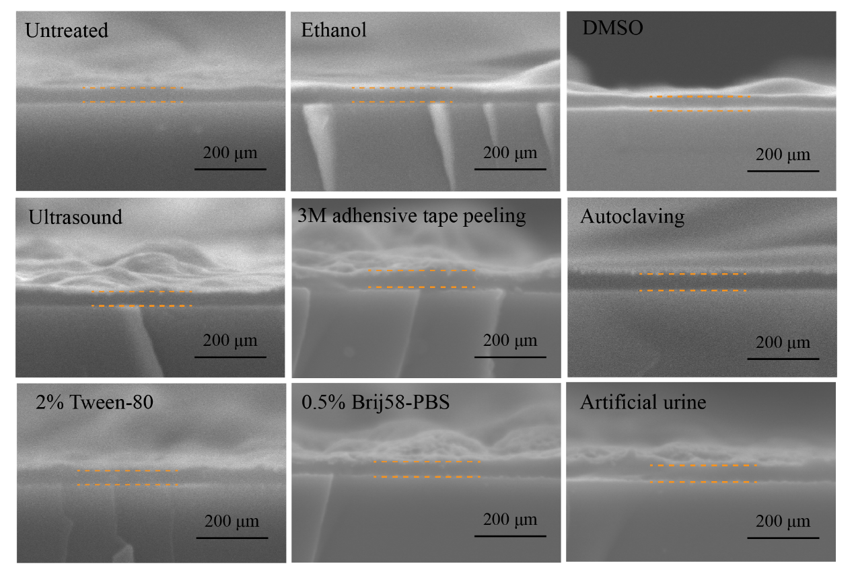
Figure S8. The SEM cross-sectional images showing the thickness of the hybrid PTB@SA coating with an original thickness of 50 nm after different treatments. The dotted line indicates the coating. DMSO: dimethyl sulfoxide; Brij58: polyethylene glycol hexadecyl ether.

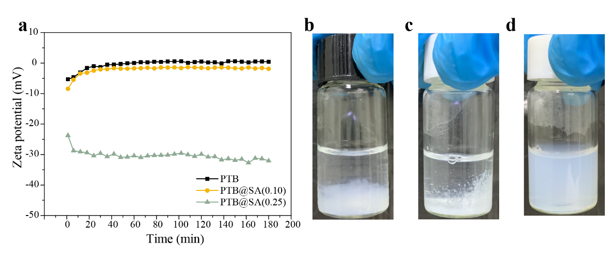
Figure S9. Real-time zeta potential analysis of PTB, PTB@SA(0.10) and PTB@SA(0.25). (a) The zeta potential of the protein colloids in the phase transition solution with different addition ratios of SA incubated at 30°C for 3 h. (b-d) Corresponding optical images of the aggregation in the phase transition solution with different components. (b) PTB, (c) PTB@SA(0.10), (d) PTB@SA(0.25).
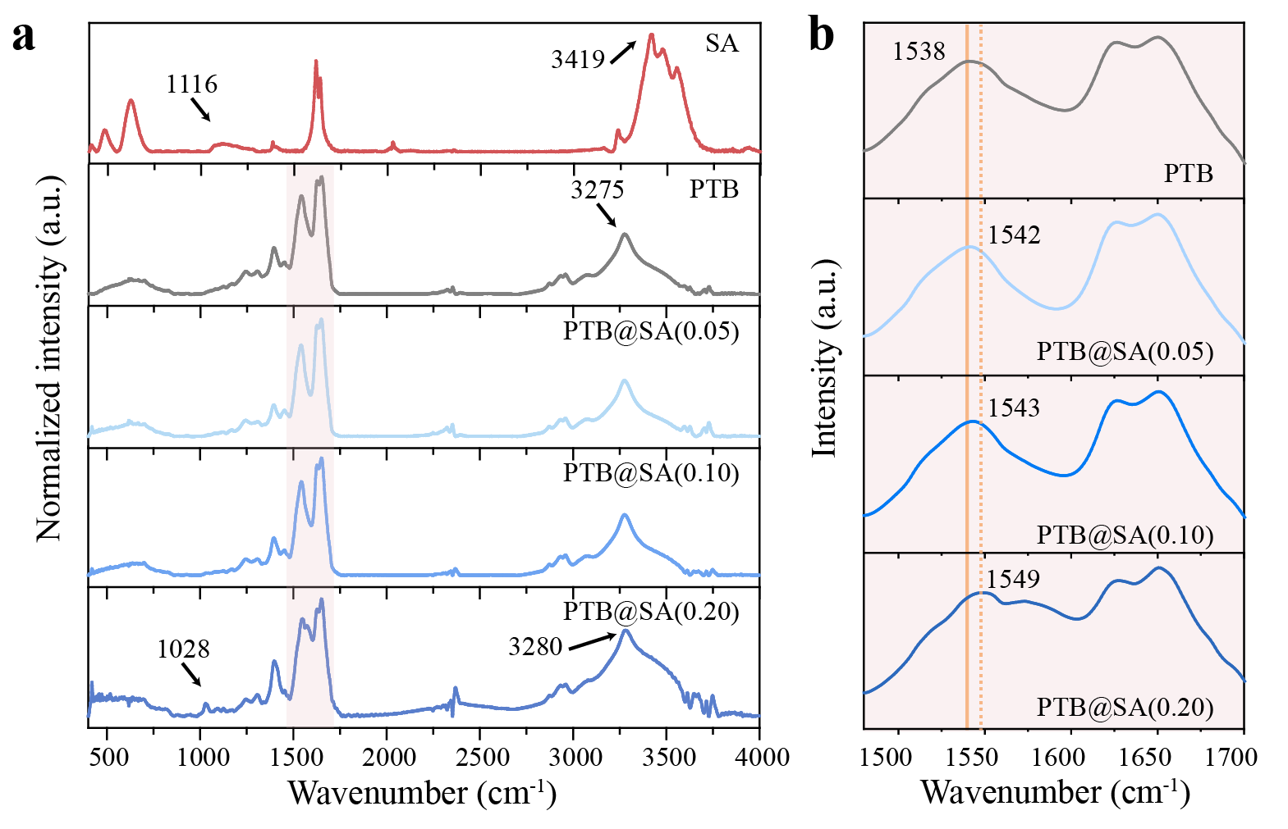
Figure S10. FTIR characterization of SA, pure PTB nanofilm and PTB@SA nanofilm with different SA addition ratios. (a) FTIR spectra of the SA, PTB and hybrid PTB@SA nanofilms with different SA additive proportions. (b) The shift of amide II peak position with increasing the amount of SA integrated in the hybrid PTB@SA nanofilm.

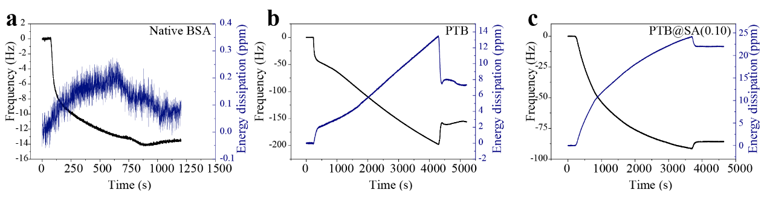
Figure S11. QCM frequency shift and dissipation shift as a function of time during the adsorption of (a) native BSA, (b) phase transition solution of BSA (PTB), (c) phase transition solution of BSA doped with SA (PTB@SA) on Au surface. The concentration of native BSA was 0.33 mg/mL. After mixing 2 mL of BSA (2 mg/mL) with 2 mL of water, 2 mL of TCEP solution (50 mM, pH at 4.5) was added to the system to obtain a phase transition solution of BSA. The phase transition solution of BSA doped with SA was prepared by mixing 2 mL of BSA (2 mg/mL) with 1.2 mL of water and 0.8 mL of SA (1 mg/mL) solution, followed by the addition of 2 mL of TCEP (50 mM, pH at 4.5). Five minutes after the phase transition triggered by TCEP, the phase transition solution was filtered by a 0.22 μm filter and then pumped into the flow chamber. The final concentration of BSA in the above three solutions was 0.33 mg/mL.
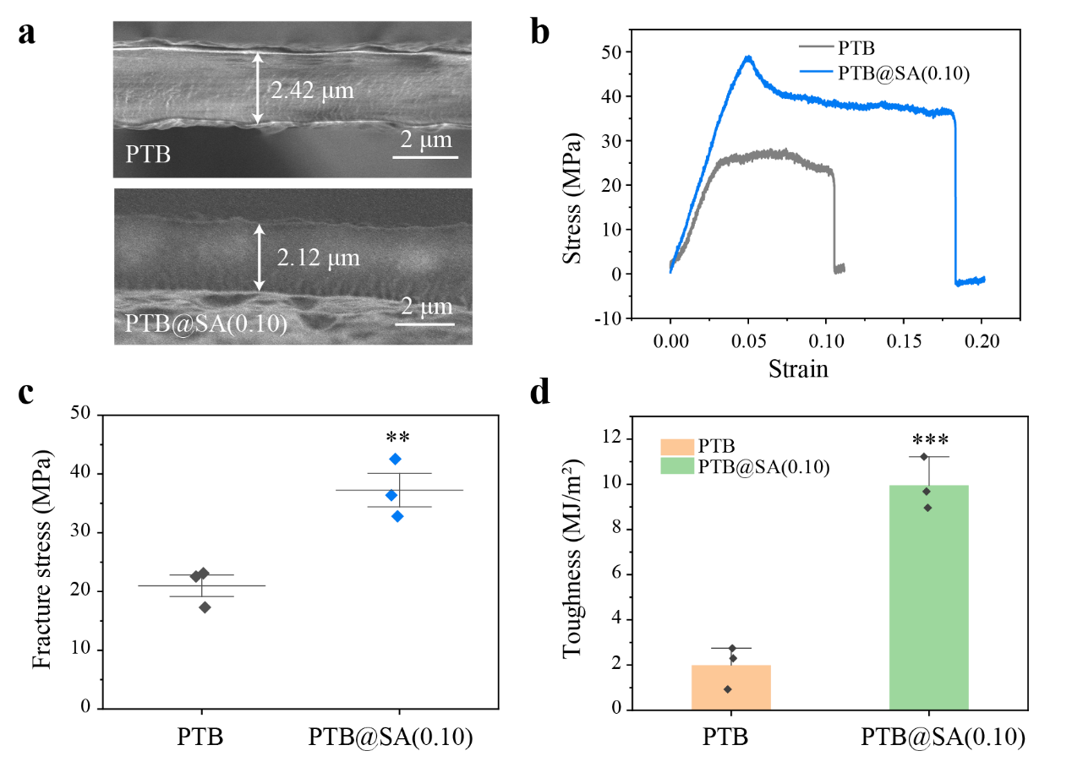
Figure S12. The mechanical properties of the PTB and PTB@SA hybrid membrane measured by uniaxial tensile tests. (a) Cross-section images of the PTB or PTB@SA(0.10) films that were prepared by repeatedly stacking the nanofilms formed at the air/liquid interface. (b-d) Stress-strain curve (b), fracture stress (c), and toughness (d) of the PTB and PTB@SA(0.10) samples recorded at 22℃ and 75% relative humidity. Data are presented as the mean ± s.d; n=3. ** P<0.01, *** P<0.001. This figure was recorded at a higher ambient humidity than that of Fig. 2d, e. Increased humidity hydrated the proteinaceous films and thus reduced fracture stress with an accompanying increase in elongation at break.

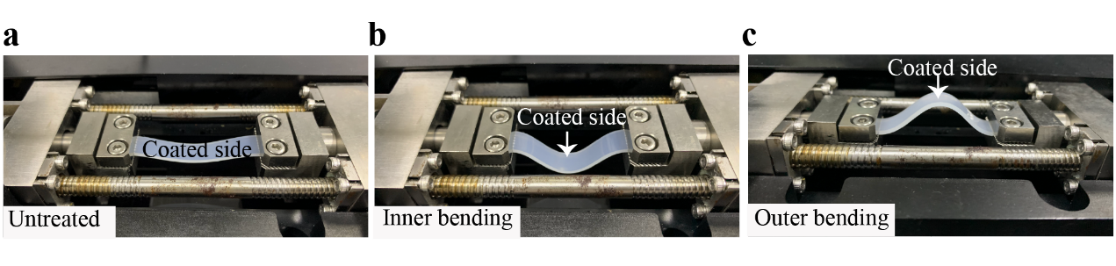Figure S13. The images showing each step of the bending test with a bending radius of 2 cm. (a) Untreated, (b) Inner bending, (c) Outer bending.

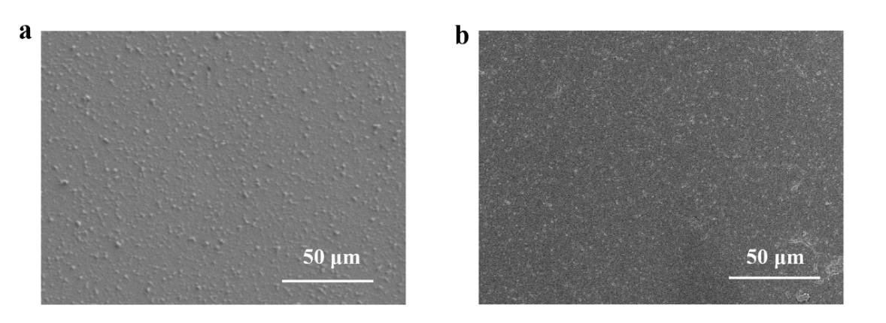
Figure S14. SEM images of the PTB (a) or PTB@SA(0.10) (b) nanofilm-modified SR before the fatigue bending test.

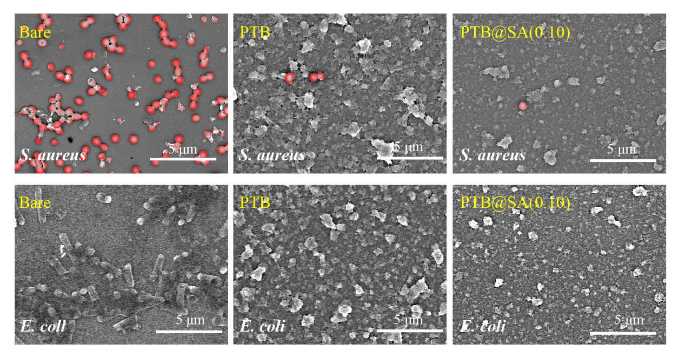
Figure S15. Representative SEM images of S. aureus and E. coli adhered to bare substrate, PTB and PTB@SA(0.10) coating.

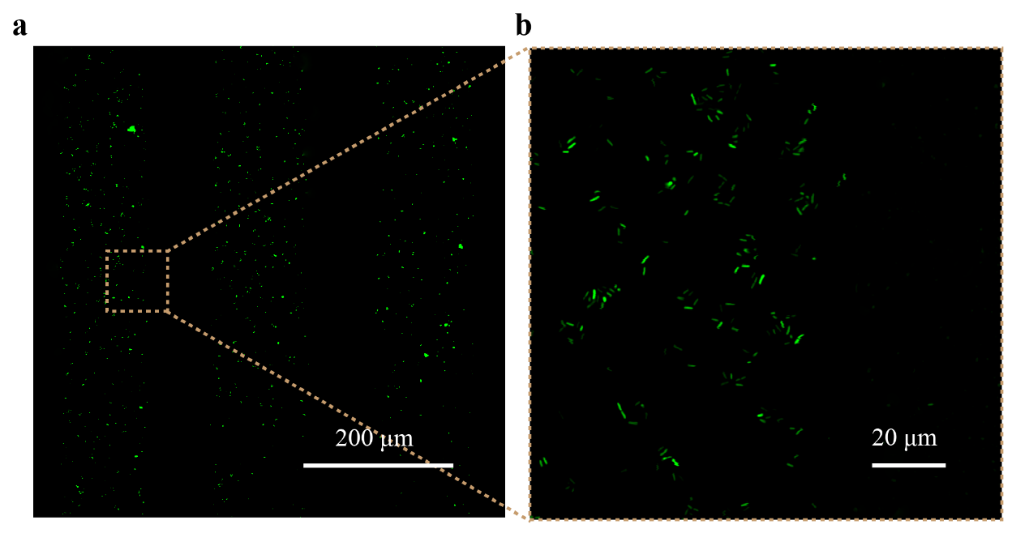
Figure S16. CLSM images showing the adherence of E. coli on the bare substrate with micropatterned PTB@SA coating as the resistant layer.
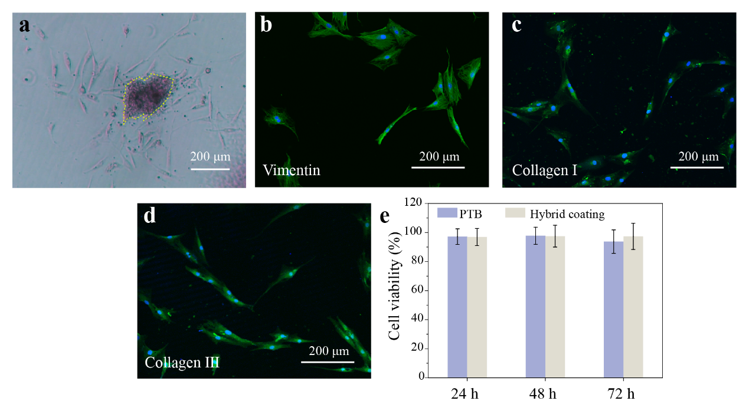
Figure S17. Characterization and cytotoxicity evaluation of primary urethral fibroblasts established from fresh rat urethral tissue. (a) The fibroblasts isolated from urethral tissues presented typical spindle shape under an optical microscope. The dotted line showing the fragments of urethral tissue after collagenase digestion. (b-d) The expression of typical fibroblast protein markers in the primary fibroblast as determined by immunofluorescences staining. The fibroblasts were stained positive for Vimentin (b), Collagen I (c), and Collagen III (d) under a fluorescent microscopy. The nuclei were counter-stained with DAPI. (e) The cytotoxicity of PTB and PTB@SA(0.10) coating on rat primary urethral fibroblasts analyzed by MTT assay. Data are presented as the mean ± s.d.; n=6.

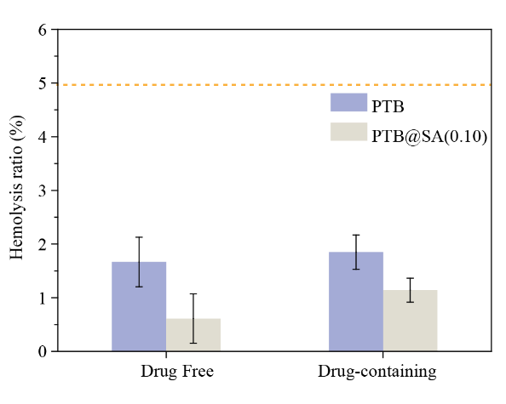
Figure S18. The hemolysis ratios of the PTB, PTB@SA(0.10) nanofilms and the corresponding rapamycin-loaded coatings. All values were below 5%. Data are presented as the mean ± s.d.; n=3.

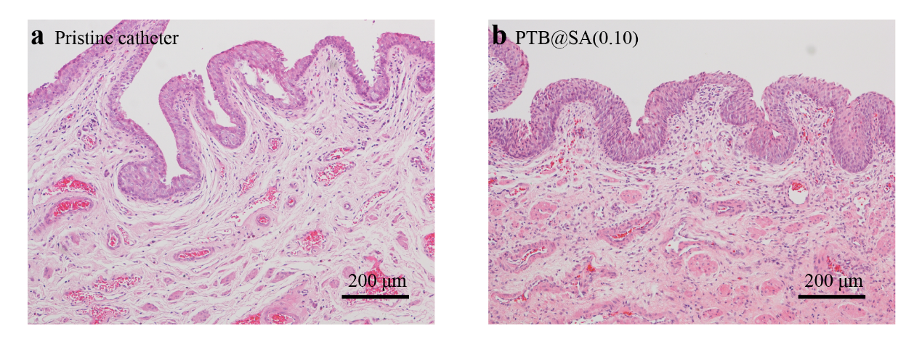
Figure S19. H&E staining of rabbit urethral tissue after indwelling the pristine SR catheter (a) or PTB@SA(0.10) coated urinary catheter (b) for 1 month to evaluate histocompatibility.

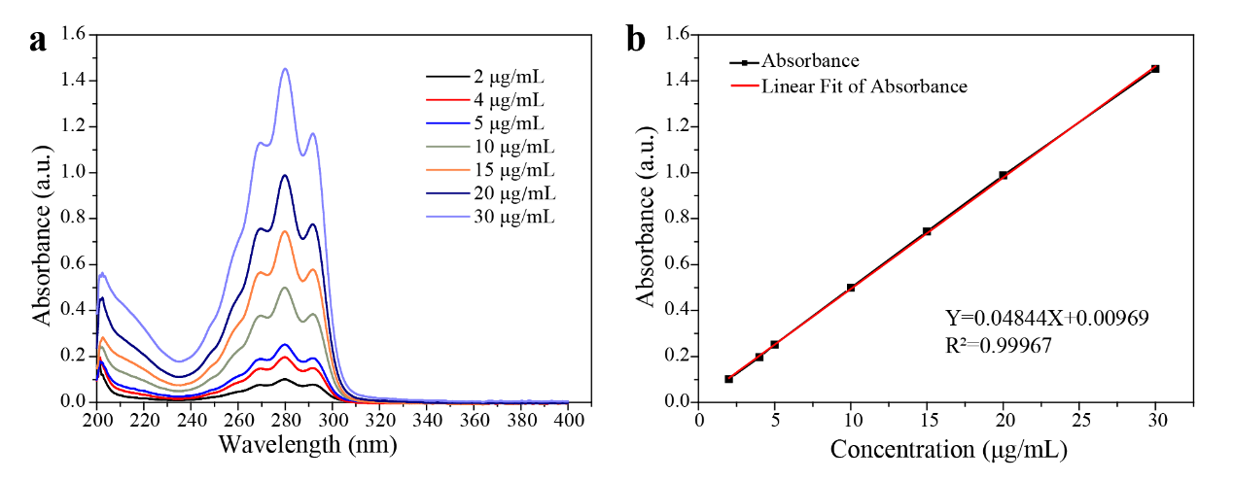
Figure S20. Establishment of regression equation for rapamycin dissolved in release medium. (a) UV-Vis spectra of rapamycin dissolved in 0.5% Brij58-PBS solution at different concentrations. (b) The standard curve and regression equation of rapamycin in the release medium.

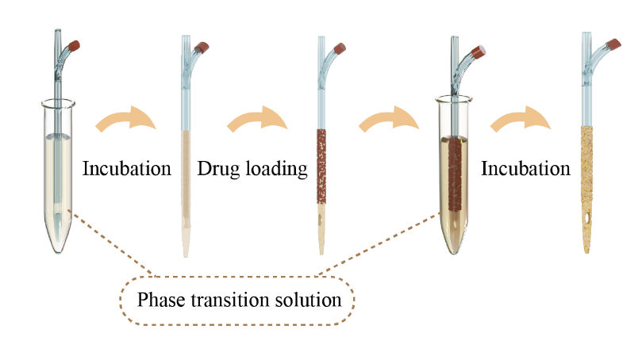
Figure S21. Schematic diagram for the preparation of the anti-fibrotic drug coating on the urethral catheter for continuous local drug delivery. This drug delivery system consists of a sandwich-like structure including the bottom priming layer of PTB@SA(0.10), the middle solid drug reservoir deposition layer and the top release rate-controlling membrane of PTB@SA nanofilm.
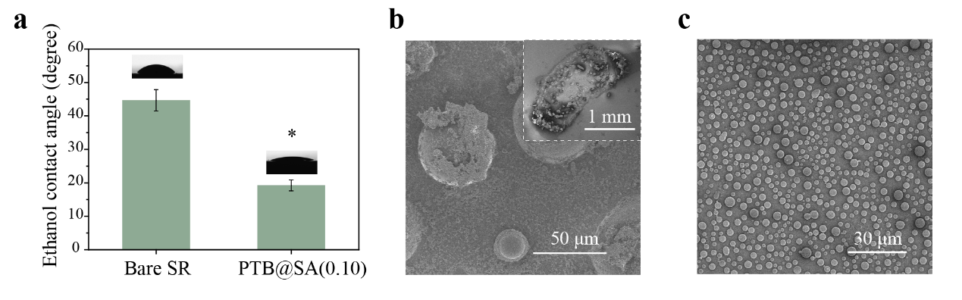
Figure S22. Improved effect of the PTB@SA(0.10) priming coating on poor wettability of SR and uniform distribution of drug particles. (a) The contact angle of ethanol on the surface of bare SR and the PTB@SA(0.10) coating. These values indicate that the hybrid coating could improve the wettability of ethanol on the surface of SR. (b) The SEM images of drug gathered on bare SR, with the inset showing an image of 500 times magnification. (c) The SEM image of solid drug particles uniformly dispersed on the SR modified with PTB@SA(0.10) nanofilm. Data are presented as the mean ± s.d.; n=10. * P<0.05. The presence of the hybrid PTB@SA nanofilm priming layer on SR surface allowed the drug-ethanol solution to spread evenly on hydrophobic SR surface. In contrast, due to the poor wettability of SR, the drug-containing ethanol cannot be uniformly dispersed on the SR without the PTB@SA priming layer, and the resultant drug particles easily aggregated together.

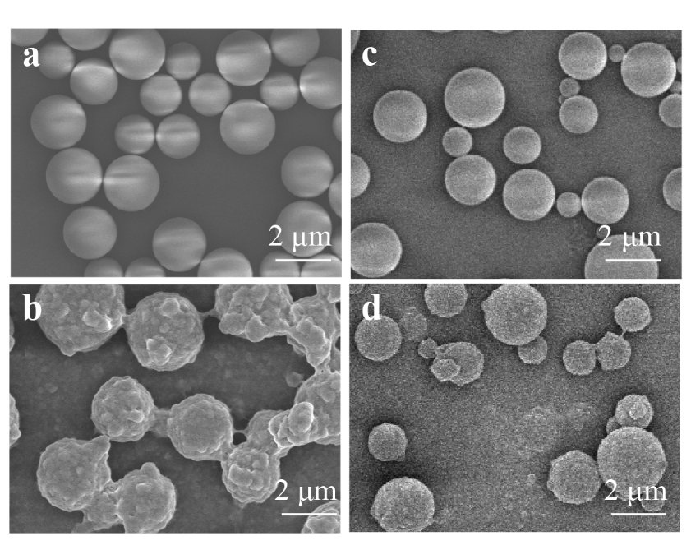
Figure S23. The SEM images showing the bare rapamycin particles on the PTB (a) or PTB@SA(0.10) (c) priming coating, and the morphology of the drug particles coated with the PTB (b) or PTB@SA(0.10) nanofilm (d). Before loading the drug, the surface of the wafer was modified with the corresponding PTB or hybrid PTB@SA priming coating. As the biopolymer nanoparticles assembled in situ on the reservoir to form a nanofilm coating, the originally smooth drug particles surface became rough.
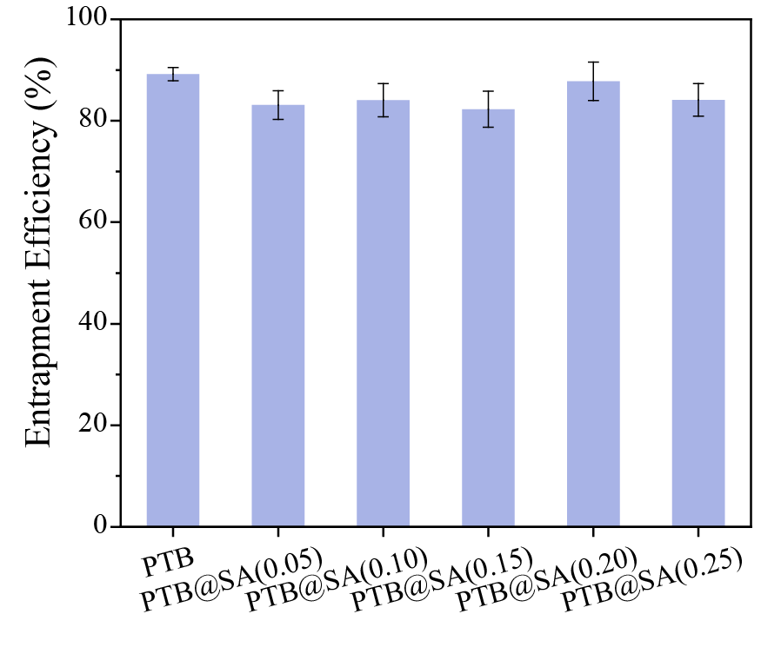
Figure S24. Drug entrapment efficiency of the delivery systems with the release-rate controlling PTB@SA nanofilms at different content of SA. Data are presented as the mean ± s.d.; n=6.

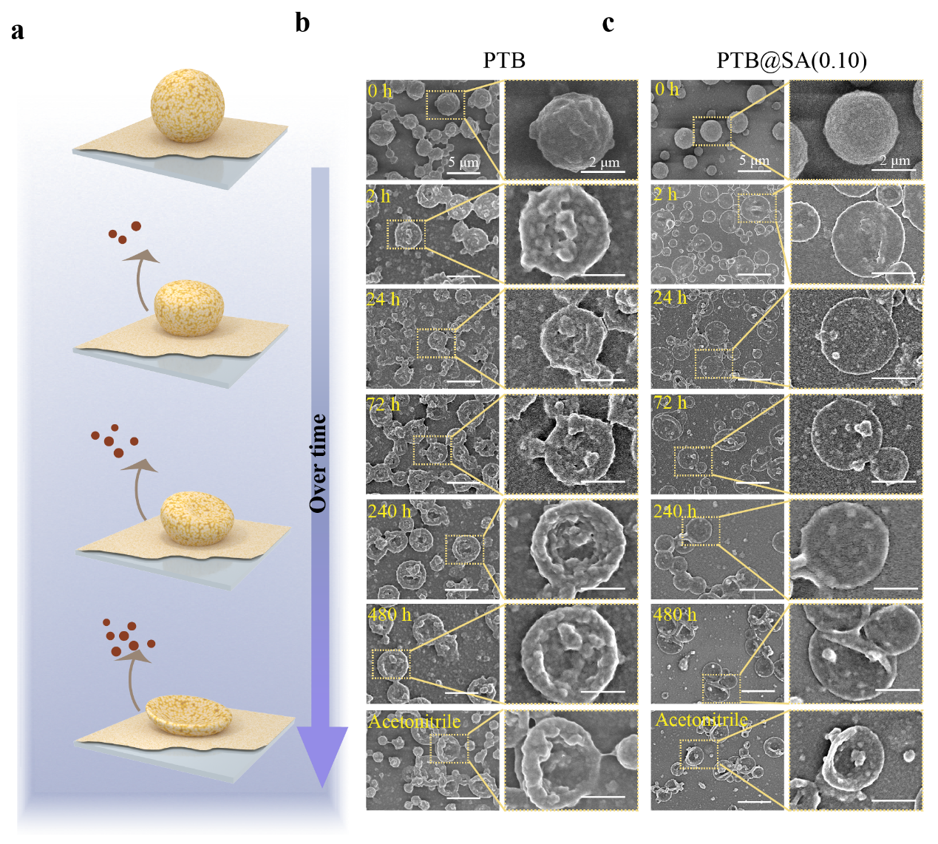
Figure S25. The morphology of the drug delivery system tracked by SEM as a function of the release process. (a) The schematic diagram showing that the morphology of the drug reservoir coated by the PTB or PTB@SA(0.10) nanofilms changed with the drug release process. (b, c) The SEM images showing the morphology of the rapamycin delivery system controlled by the PTB (b) or PTB@SA(0.10) nanofilm (c) over time, as well as the morphology after the drug in the reservoir was completely eluted by acetonitrile. Scale bar on the left is 5 μm, and scale bar on the right is 2 μm. The occurrence and progress of the collapse of solid drug reservoir could be reflected by the area and extent of the central depression of the reservoir. Therefore, as the drug release progressing, the rapamycin spheres coated with PTB or PTB@SA(0.10) nanofilm gradually collapsed and approached the state of elution with acetonitrile, indicating a long-term release.

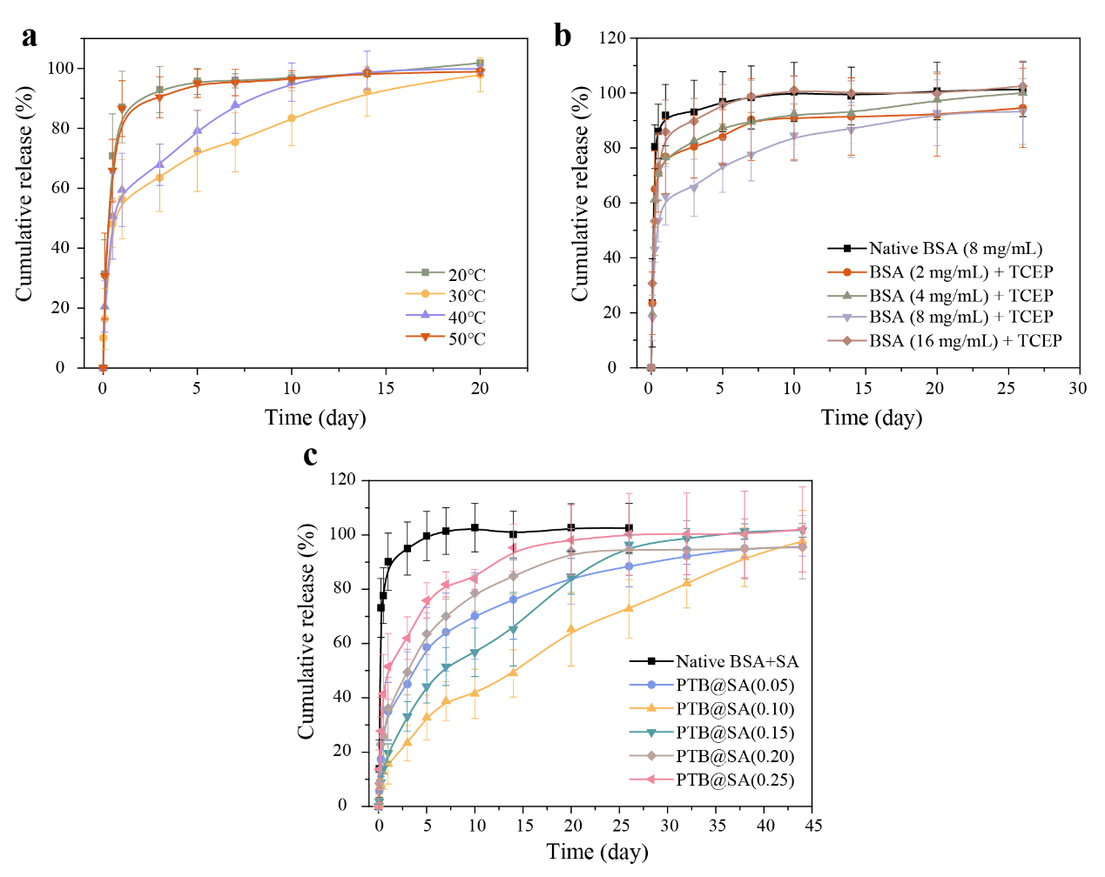
Figure S26. Rapamycin release behavior controlled by different release-rate controlling membranes. (a) The release behaviors of rapamycin controlled by the PTB nanofilm prepared at different temperatures. (b) The release profiles of rapamycin as a function of the final concentration of BSA used to prepare the release-rate controlling PTB membrane, with the use of the non-specific adsorption layer of native BSA as a control. (c) The release profile of rapamycin as a function of the mass ratio of SA to BSA (from 0.05:1 to 0.25:1), with the final concentration of BSA being kept at 8 mg/mL and the non-specific adsorption layer of the mixture of native BSA and SA was used as a control. Data are presented as the mean ± s.d.; n=6.

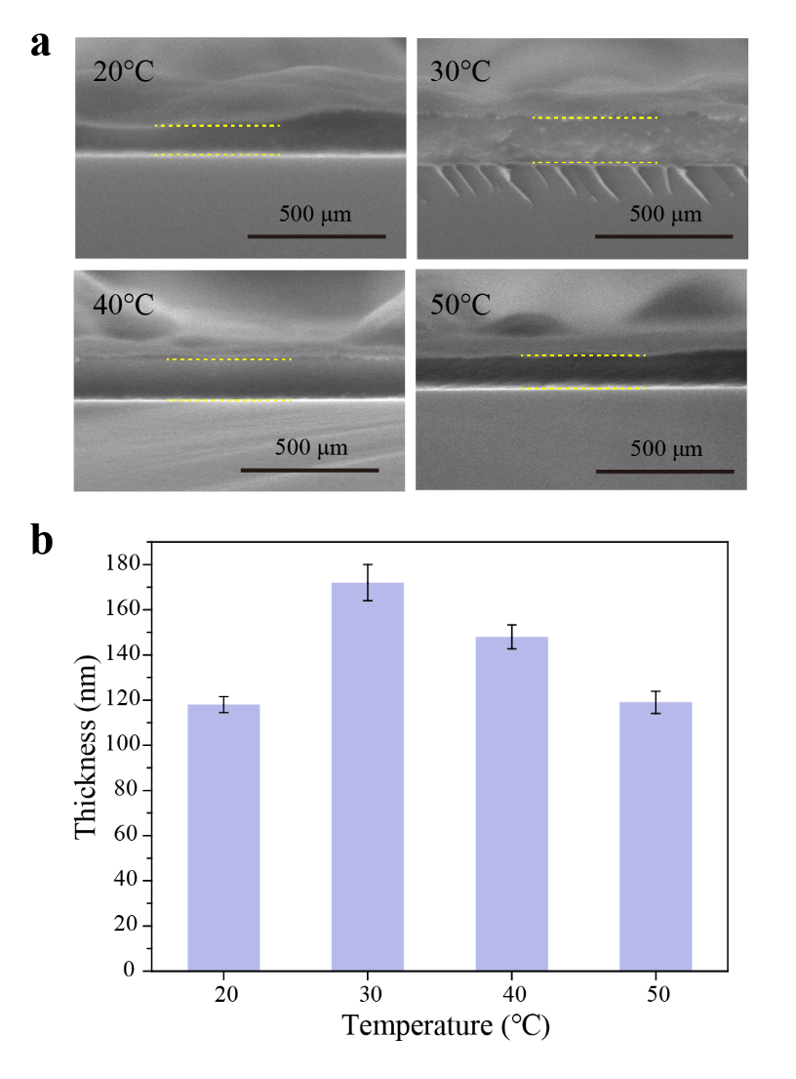
Figure S27. The effect of incubation temperature on the thickness of the PTB nanofilm. (a) The SEM cross-sectional images showing the thickness of the PTB coating prepared at different temperatures. The dotted line indicates the coating. (b) The thickness of the PTB coating controlled by the reaction temperature. The silicon wafer was immersed in the phase transition solution obtained by mixing BSA (20 mg/mL), water and TCEP (50 mM, pH=4.5) in a volume ratio of 1:1:0.5, and incubated at the indicated temperature for 180 min. Data are presented as the mean ± s.d.; n=3.

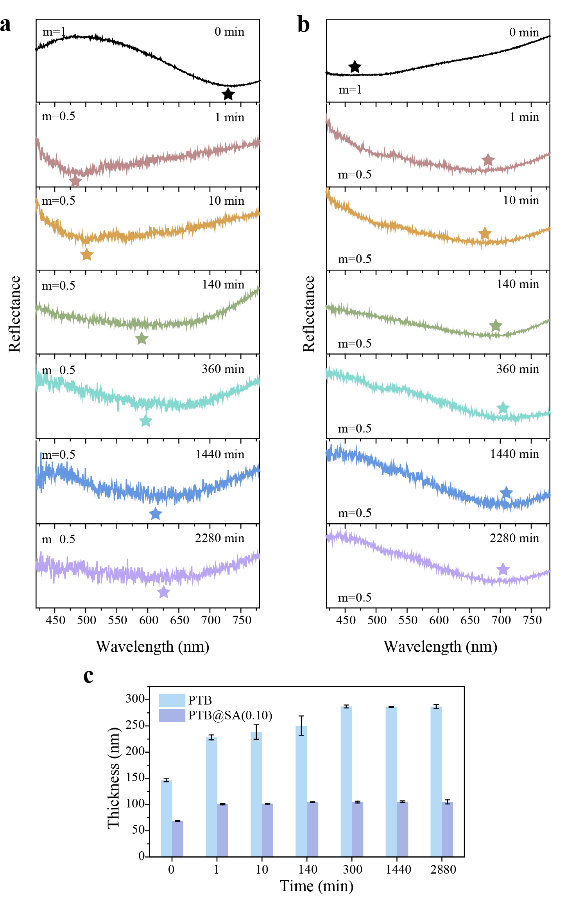
Figure S28. The thickness of the PTB and PTB@SA nanofilms as a function of immersion time in the release medium. The corresponding reflection spectra of the PTB (a) and PTB@SA(0.10) nanofilm (b) at an incident angle of 0° with different immersion time in the release medium. Asterisks indicate reflection valleys. (c) The thickness variation of the PTB and PTB@SA(0.10) nanofilm in the release medium as the function of time. Data are presented as the mean ± s.d.; n=4.
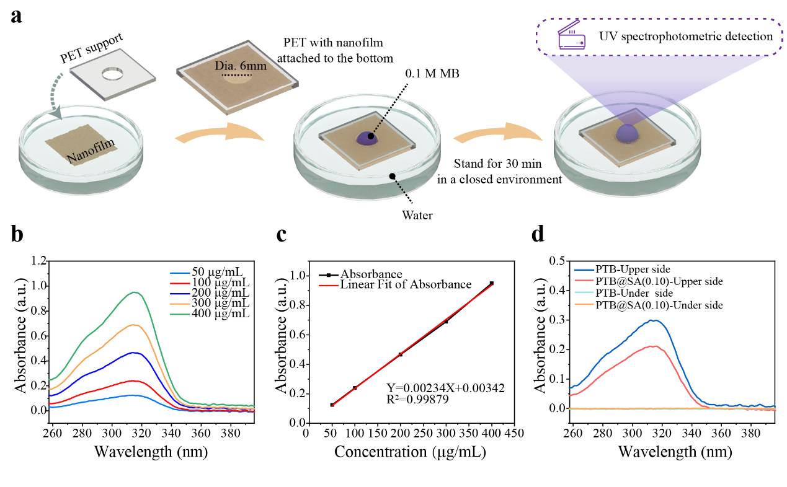
Figure S29. The water permeability of the PTB or PTB@SA nanofilm was determined by forward osmosis. (a) Schematic diagram of water permeability of the PTB or PTB@SA(0.10) nanofilm determined by forward osmosis. Methyl blue (MB, 0.1 M), which could be completely retained by the nanofilm, was applied to the upper side (air side) of the nanofilm to provide a constant driving force for permeation. (b) UV-Vis spectra of MB aqueous solutions at different concentrations. (c) Standard curve and regression equation of MB aqueous solution. (d) After 30 min, the MB solution located on the upper side of the PTB or PTB@SA(0.10) nanofilm in (a) (PTB-Upper side or PTB@SA Upper side) was diluted by the water permeating through the nanofilm, and the resulting decrease in MB concentration was used to estimate the water flux and permeability of the nanofilm. In addition, there is no absorption in the UV spectrum of the water under the nanofilm (PTB-Under side or PTB@SA Under side), indicating that the rejection ratio of MB for both PTB and PTB@SA(0.10) nanofilm was 100%.

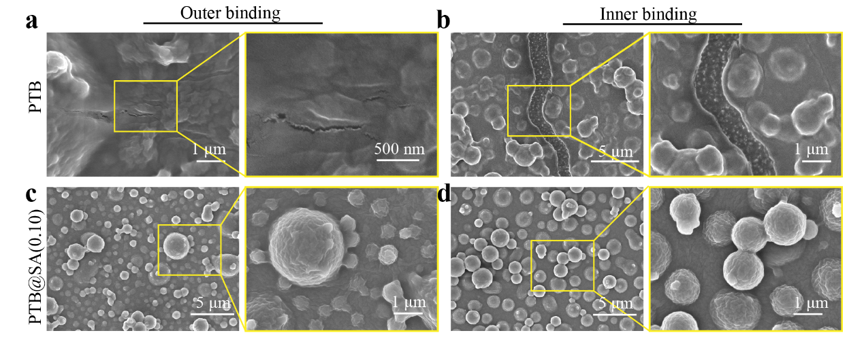
Figure S30. The SEM images showing the integrity of the rapamycin delivery system controlled by the PTB or PTB@SA(0.10) nanofilm on the SR after the bending test. (a) The delivery system using the PTB nanofilm as the release-rate controlling membrane after suffering outer bending with a bending radius of 1.5 cm. (b) The delivery system using the PTB nanofilm as the release-rate controlling membrane after suffering inner bending with a bending radius of 1.5 cm. (c) The delivery system using the PTB@SA(0.10) nanofilm as the release-rate controlling membrane after suffering outer bending with a bending radius of 1.5 cm. (d) The delivery system using the PTB@SA(0.10) nanofilm as the release-rate controlling membrane after suffering inner bending with a bending radius of 1.5 cm.

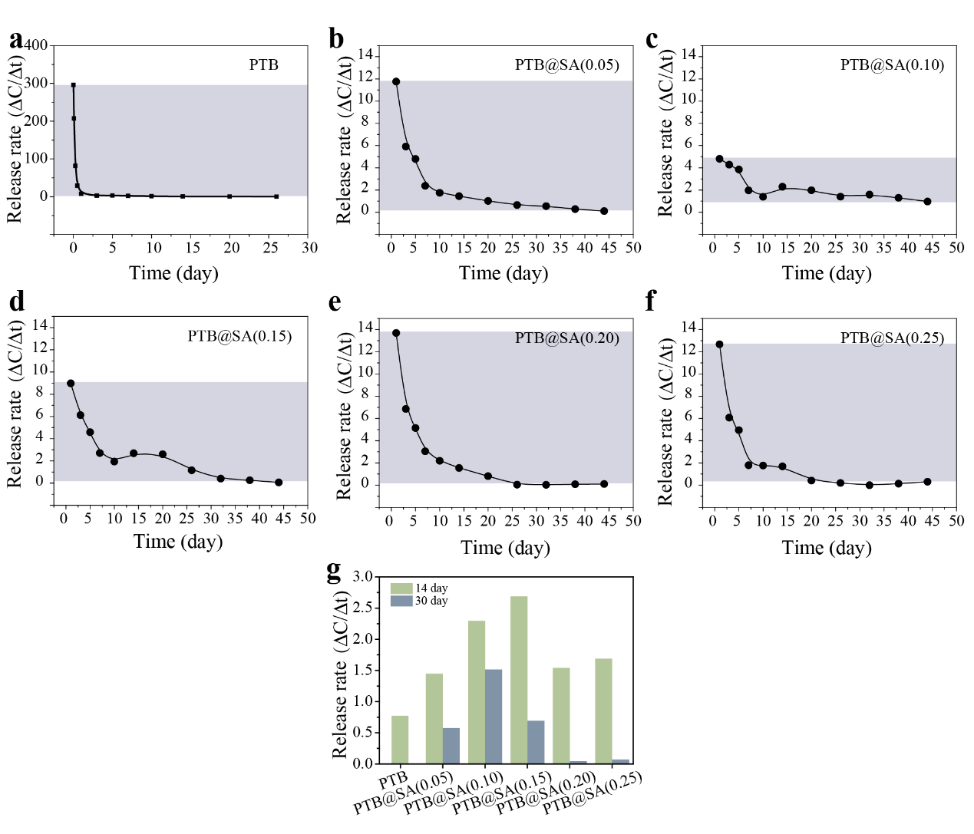
Figure S31. Effect of SA additive proportion in phase transition solution used to prepare release-rate controlling membrane on rapamycin release rate. (a-f) The effect of the addition ratio of SA in the phase transition solution on the release rate of rapamycin, with using the PTB or PTB@SA at different SA addition ratio as the release-rate controlling membrane. The release rate was derived from the derivative of the cumulative release, meaning the average percentage of the drug released per day at the indicated time. Among them, PTB@SA(0.10) exhibited the most stable release rate throughout the release period. (g) The release rate of rapamycin controlled by the nanofilms with different SA additive proportions on the 14th and 30th day. The initial moderate release rate contributed to the reservation of sufficient dose for the later period. Therefore, at the 30th day, rapamycin was still being released from the PTB@SA(0.10) nanofilm at a rate of 1.52% of the total drug amount per day, which was much higher than that of membranes prepared in other proportions.

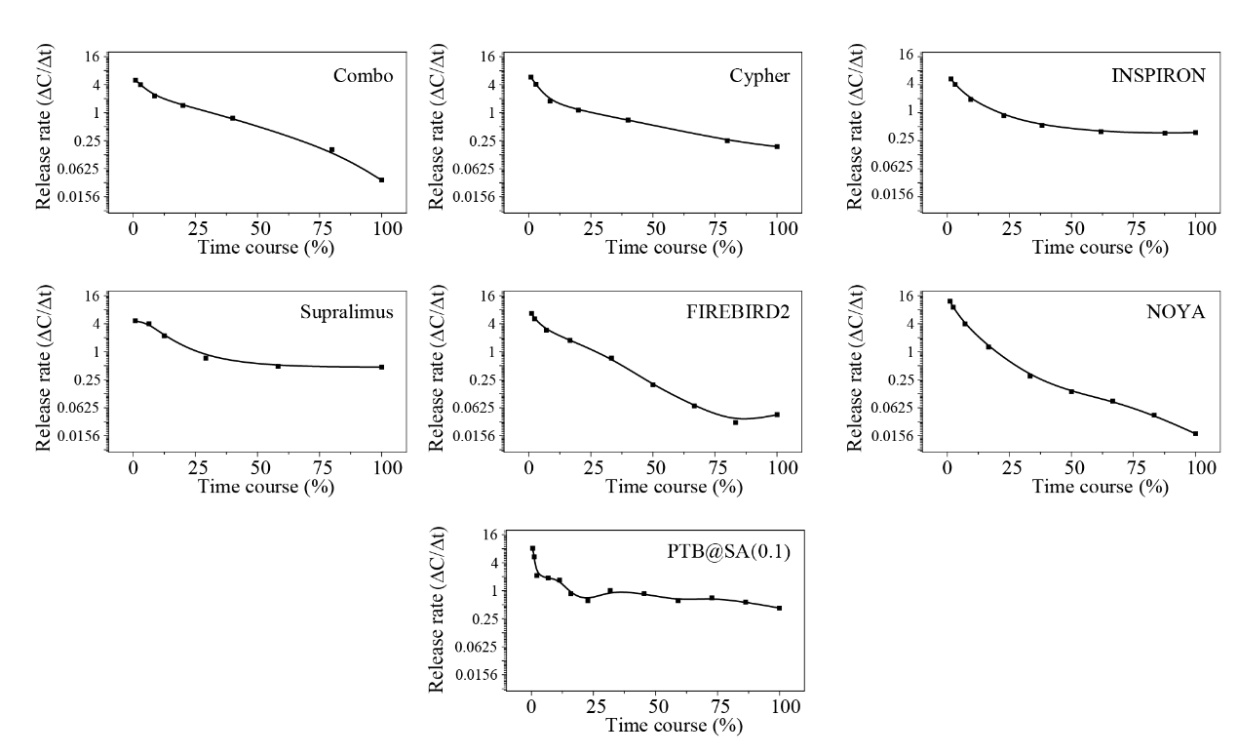
Figure S32. Rapamycin release rate controlled by the PTB@SA(0.10) nanofilm and commercially available rapamycin-eluting stents, including Combo, Cypher, INSPIRON, Supralimus, FIREBIRD2 and NOYA^{2–5}. The detailed information of commercially available products is listed in Table S3.

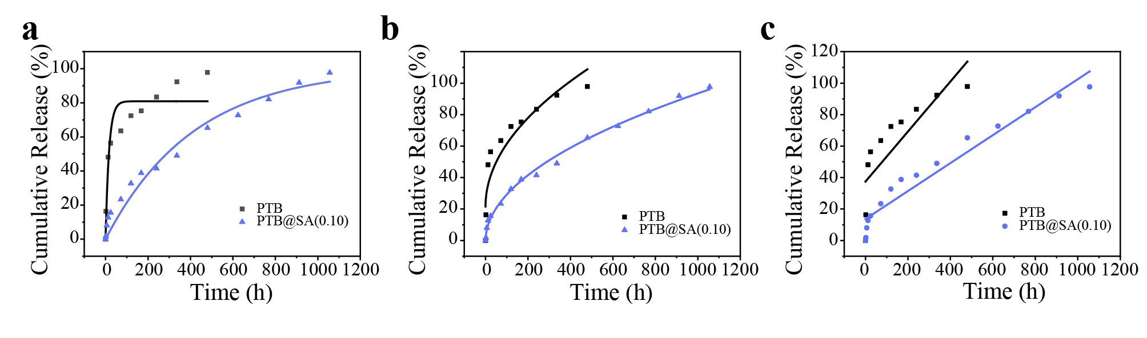
Figure S33. Mathematical models for drug release kinetics by using the PTB or PTB@SA(0.10) nanofilm as the release-rate controlling membrane. (a) First-order model, (b) Higuchi model, (c) Zero-order model. The correlation coefficient (R²) and regression equations for each model are presented in the Table S4.

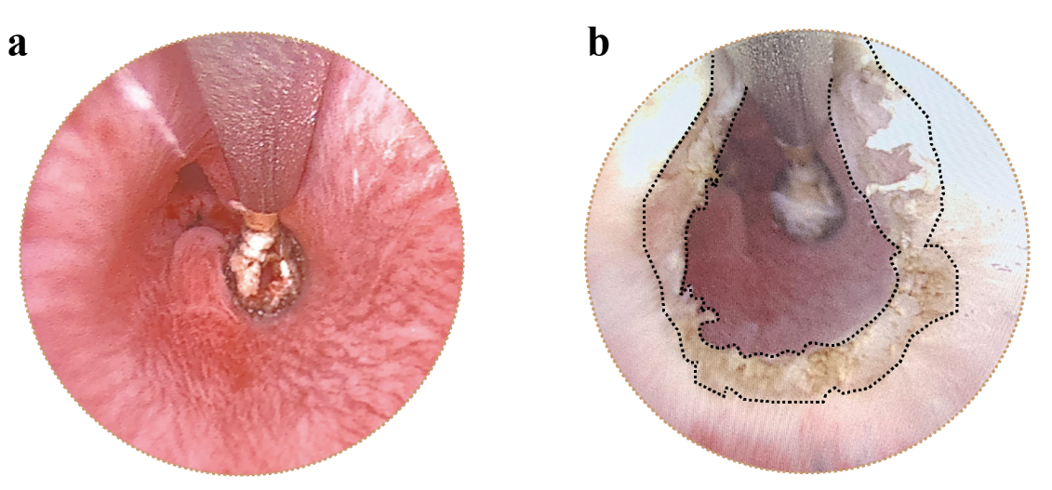
Figure S34. Representative urethroscopy before (a) and after (b) urethral electrocoagulation in rabbits. The dotted line indicates the boundary between the urethra damaged by electrocoagulation and the adjacent normal tissues.

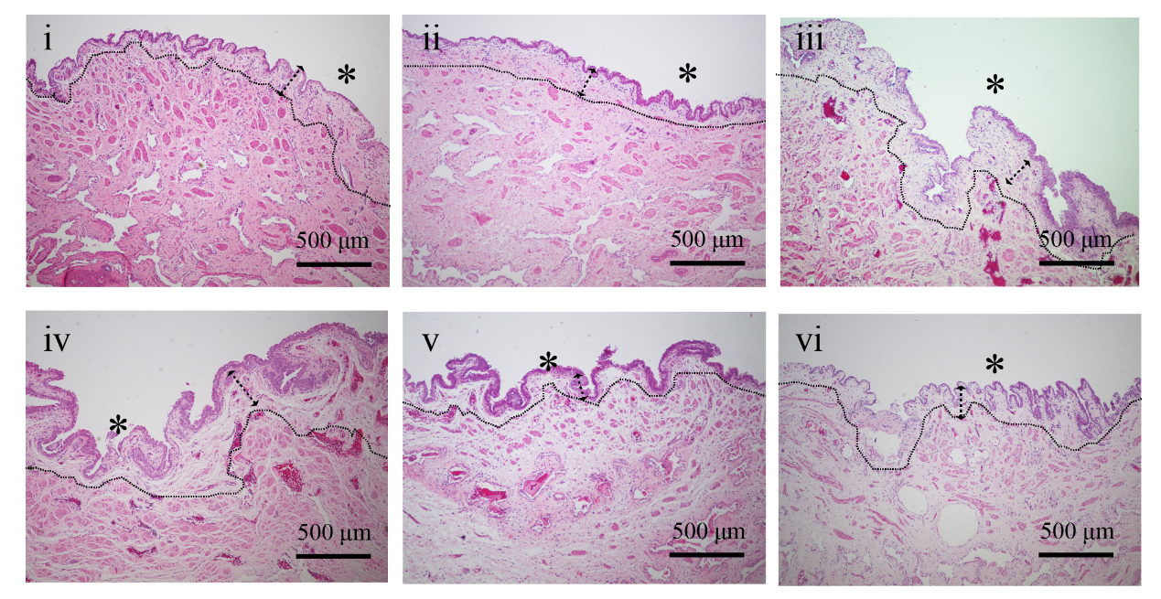
Figure S35. H&E staining images of undamaged urethra after 1 month in each group. i, Control, ii; Unmodified catheter; iii, Systemic administration; iv, PTB@SA; v, Burst-releasing; vi, PTB@SA-Rapamycin. Asterisk represents urethral luminal side, and the dotted line indicates the boundary between the submucosa and the muscularis.

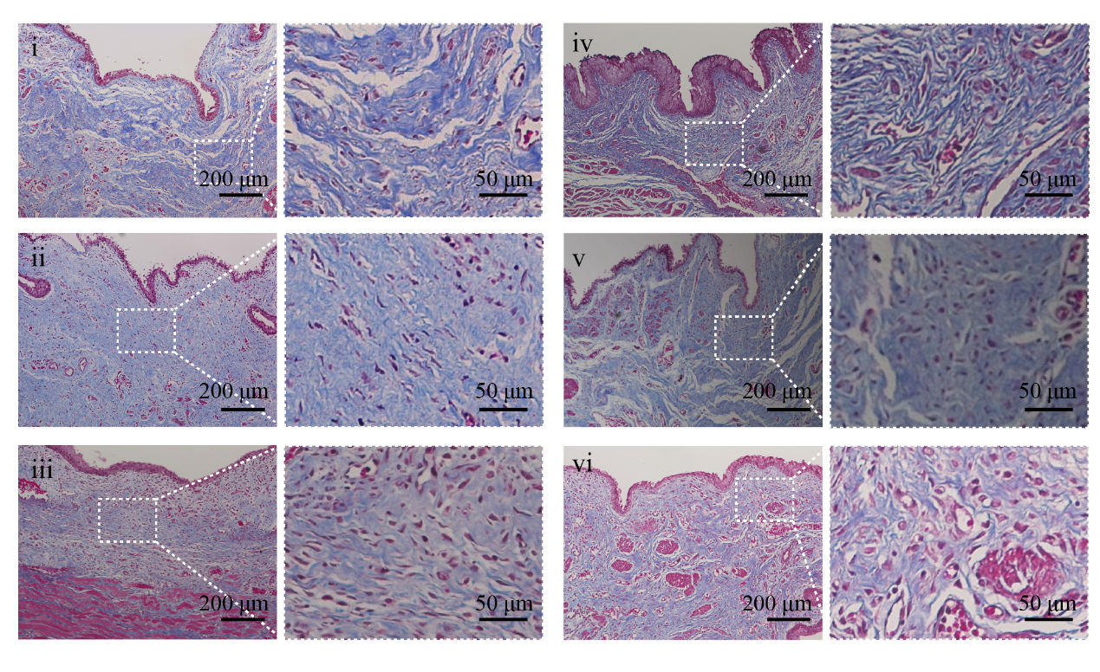
Figure S36. Masson's Trichrome staining images showing collagen fiber deposition under the damaged urethral mucosa after being treated differently for one month. i, Control, ii; Unmodified catheter; iii, Systemic administration; iv, PTB@SA; v, Burst-releasing; vi, PTB@SA-Rapamycin.

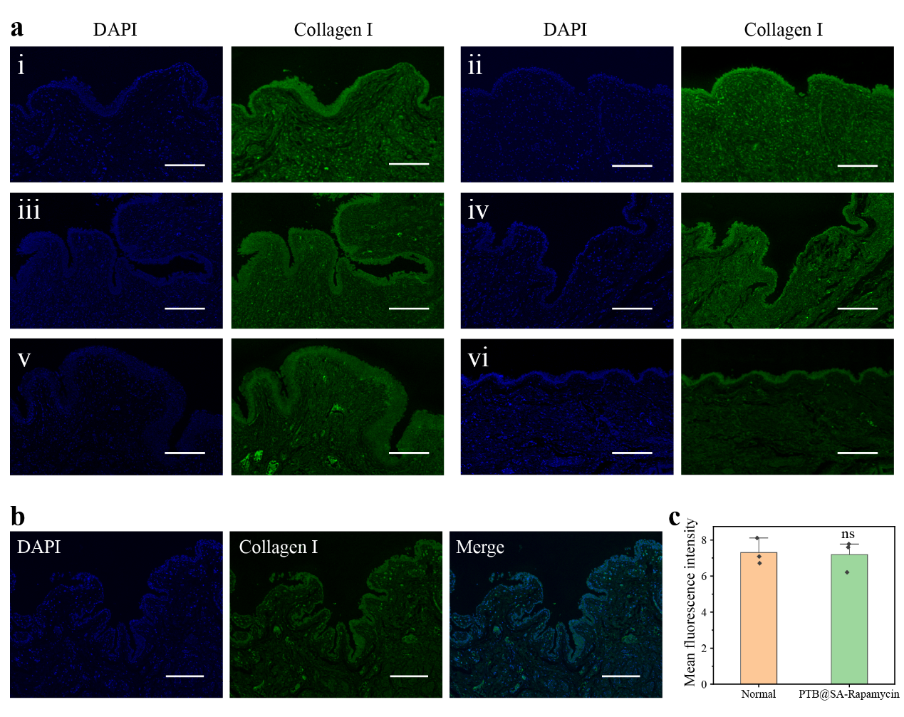
Figure S37. Immunofluorescence staining images showing collagen deposition in urethral tissue. (a) Immunofluorescence staining of Collagen Ⅰ at the urethral injury site after different treatments for 1 month. Nuclei (blue) was stained with DAPI. Scale bar, 200 μm. i, Control, ii; Unmodified catheter; iii, Systemic administration; iv, PTB@SA; v, Burst-releasing; vi, PTB@SA-Rapamycin. (b) The urethral tissue of normal rabbits was sectioned for immunostaining with Collagen Ⅰ. Nuclei (blue) was stained with DAPI. Scale bar, 200 μm. (c) Quantification of the Collagen Ⅰ fluorescence intensity in normal rabbit urethral tissue and PTB@SA-Rapamycin catheter-mediated urethral injury healing. Data are presented as the mean ± s.d.; n=3. ns means no statistical difference.

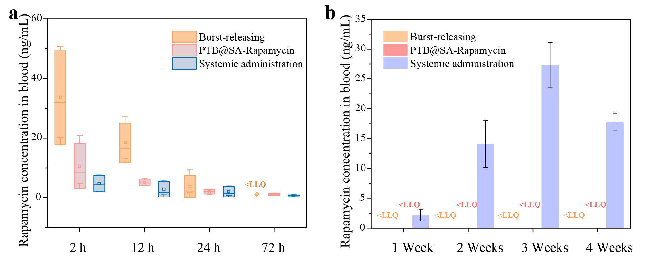
Figure S38. Circulatory distribution of rapamycin in systemic administration, burst-releasing catheter and sustained-release catheter groups. (a) The blood concentration of rapamycin measured at 2 h, 12 h, 24 h, 72 h after a single oral dose (1.5 mg/kg), indwelling a rapamycin burst-releasing or sustained release catheter. (b) The blood concentration of rapamycin in the systemic administration group was measured every seven days, while those in the burst and sustained release catheter groups were below the lower limit of quantitation. LLQ: Lower Limit of Quantification. Data are presented as the mean ± s.d.; n=3.

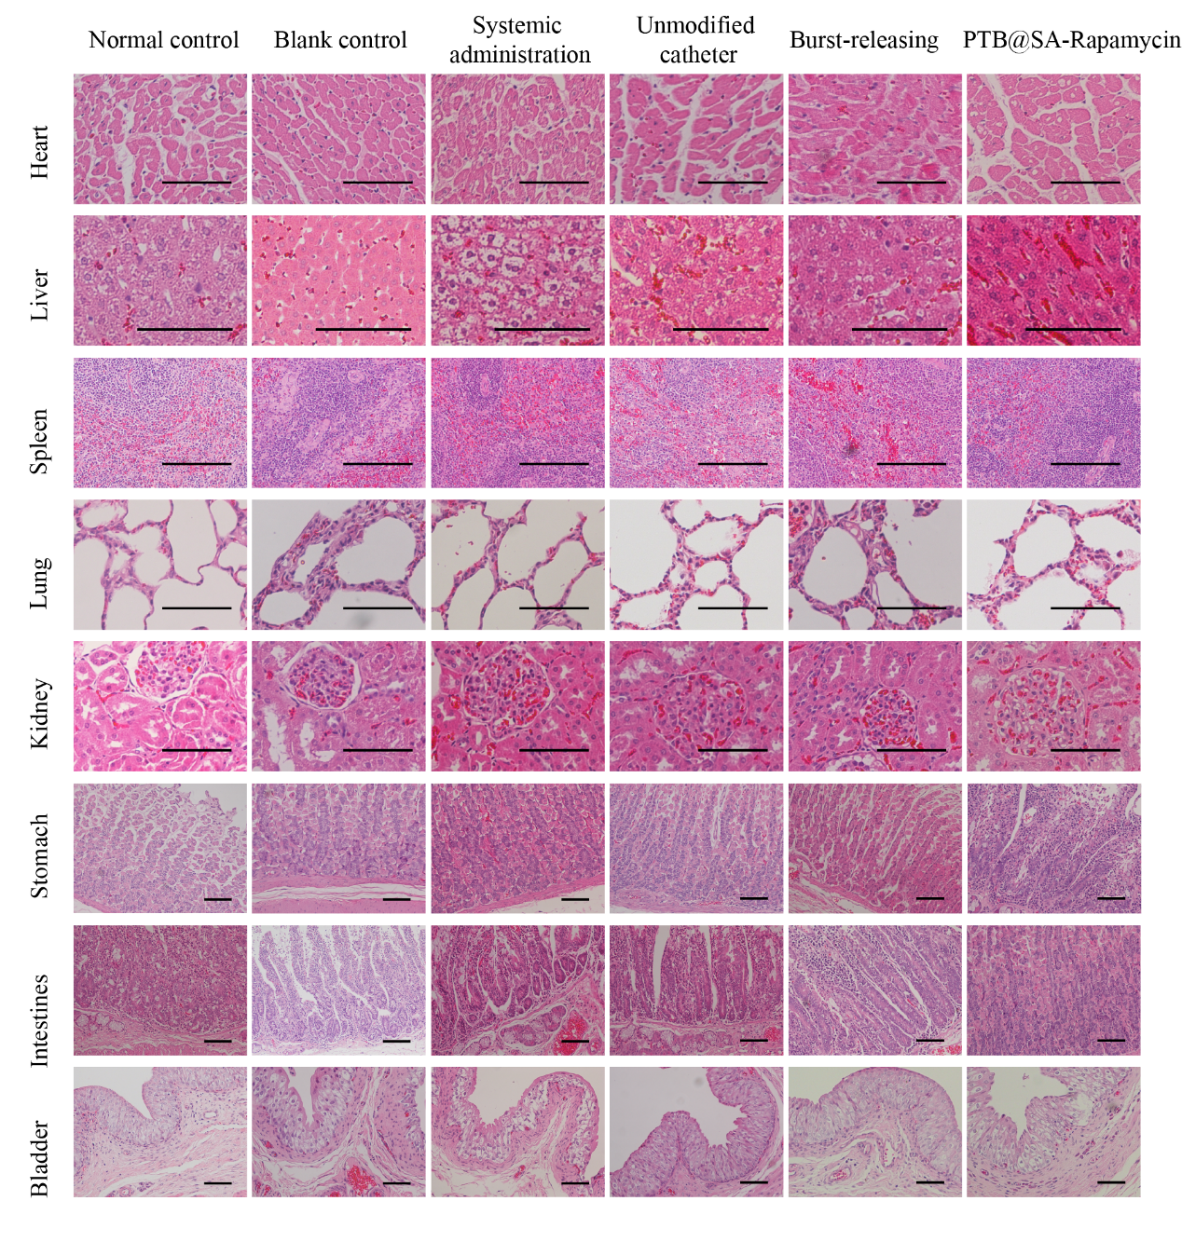
Figure S39. H&E staining images of major organs for normal healthy group and rabbits in each group. After 30 days of different treatments, the major organs were collected and the tissue sections were stained with H&E. Compared with the healthy rabbit, the liver sections of the rabbits in the systemic administration group showed diffuse hepatocyte ballooning, which is a manifestation of liver cell damage, suggesting that the systemic spillover of rapamycin caused hepatotoxicity in rabbits. However, due to the limited systemic exposure of local administration, no damage was observed in rabbits treated with the PTB@SA-Rapamycin catheter, and the total drug amount of the sustained-release catheter was only 3 mg, whereas the cumulative intake of rapamycin in rabbits administered orally was as high as 135 mg. Scale bars, 100 μm.

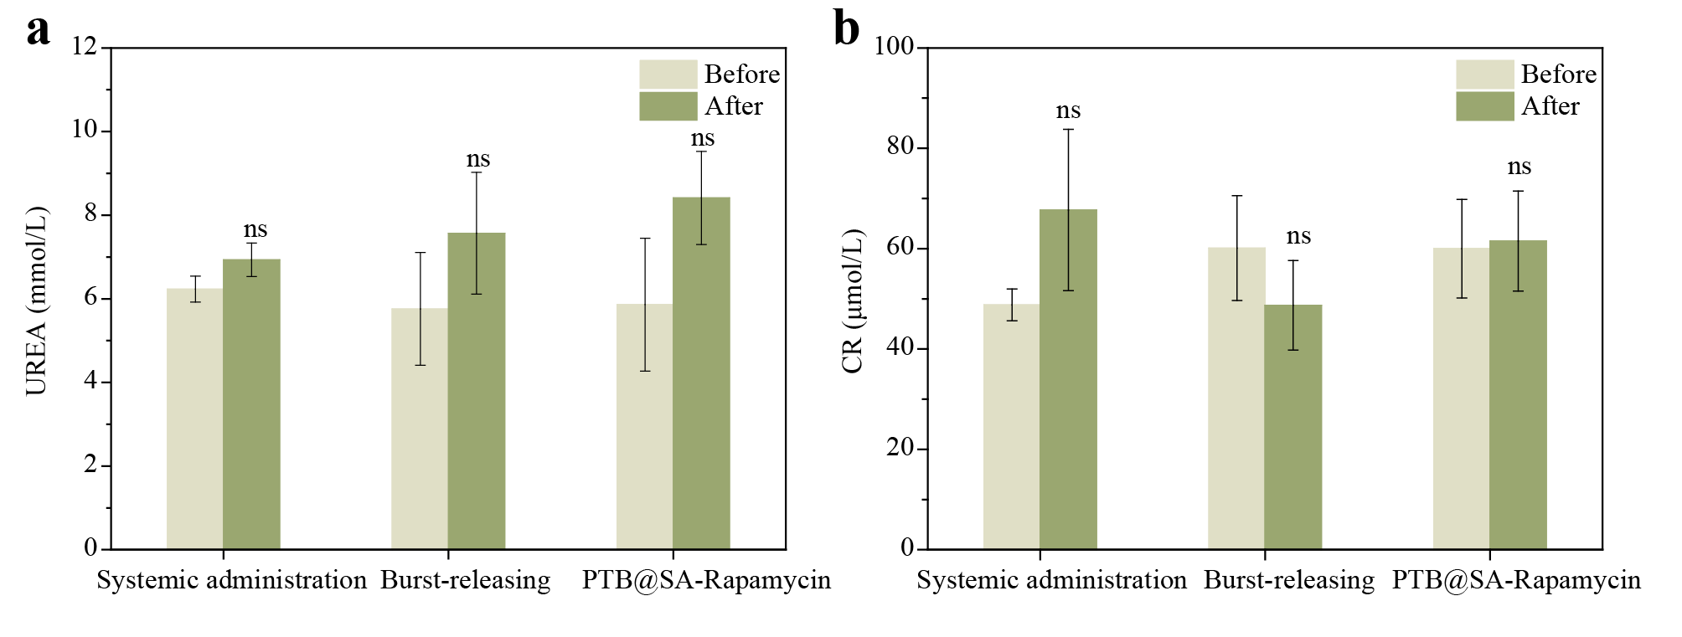
Figure S40. Kidney function changes caused by systemic administration, indwelling burst-releasing or PTB@SA-Rapamycin catheter. Before and after the intervention, whole blood was collected and centrifuged at 2500 rpm for 5 min to obtain serum for the determination of urea (a) and creatinine (CR, b). The data are presented as the mean ± s.d.; n=3. ns means no statistical difference.

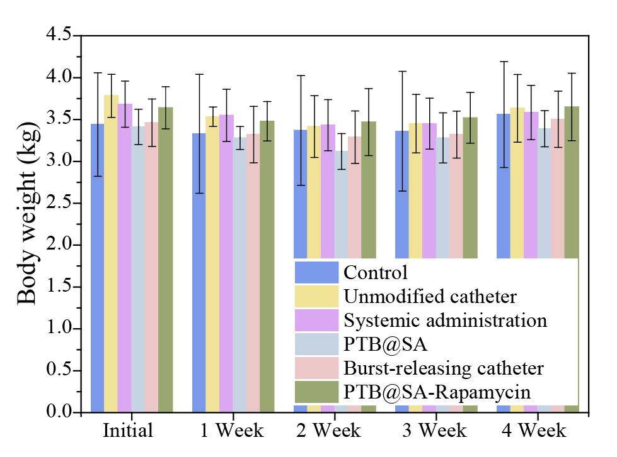
Figure S41. The initial body weight and the weight of the rabbits in each group at 1, 2, 3 and 4 weeks after the urethra was injured by electrocoagulation. The data are presented as the mean ± s.d.; n=3.

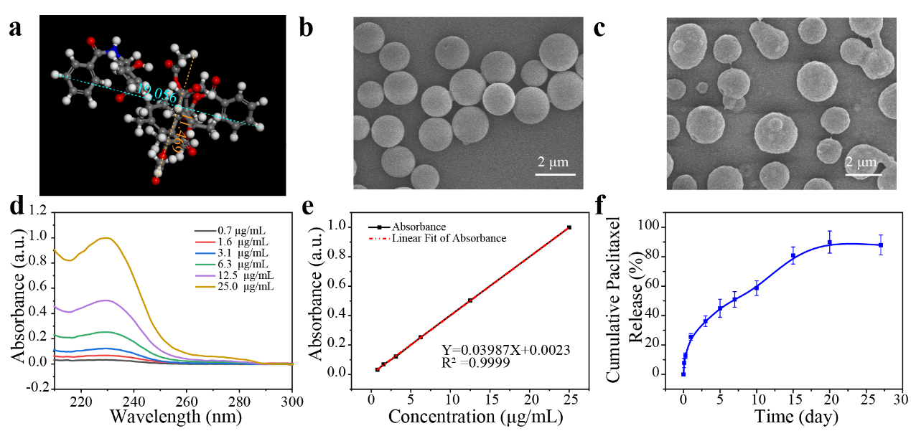
Figure S42. The sustained release of paclitaxel controlled by the PTB@SA(0.10) nanofilm. (a) The structure and molecular size of paclitaxel depicted using Materials Studio 7.0 software. The unit of the molecular size shown in the inset is angstrom (Å). (b) SEM image showing bare paclitaxel particles on the PTB@SA(0.10) priming coating. (c) SEM image showing paclitaxel particles coated with the PTB@SA(0.10) nanofilm. (d) UV-Vis spectra of paclitaxel dissolved in release medium. (e) The standard curve and regression equation of paclitaxel in the release medium. (f) In vitro release behavior of paclitaxel controlled by the PTB@SA(0.10) nanofilm. Data are presented as the mean ± s.d.; n=6.

Supplementary Tables.
Table S1. Drug release kinetics of rapamycin from a constant or nonconstant activity source.
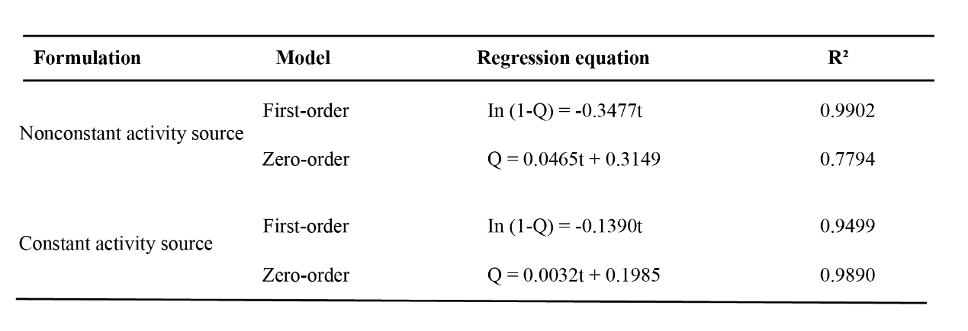

Table S2. The calculated similarity factor (f₂) between compared formulations.
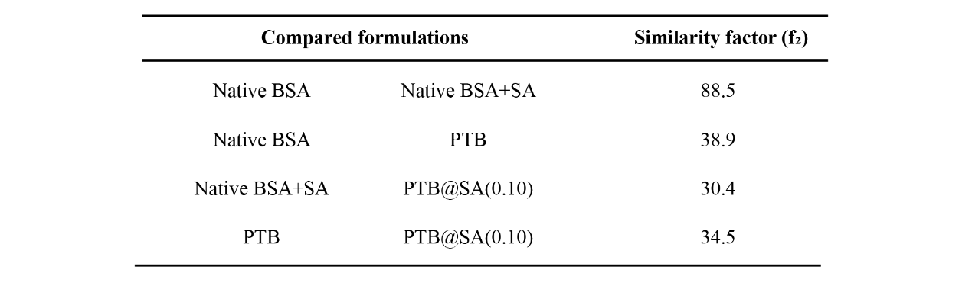

Table S3. Details of several typical commercially available rapamycin-eluting stents.
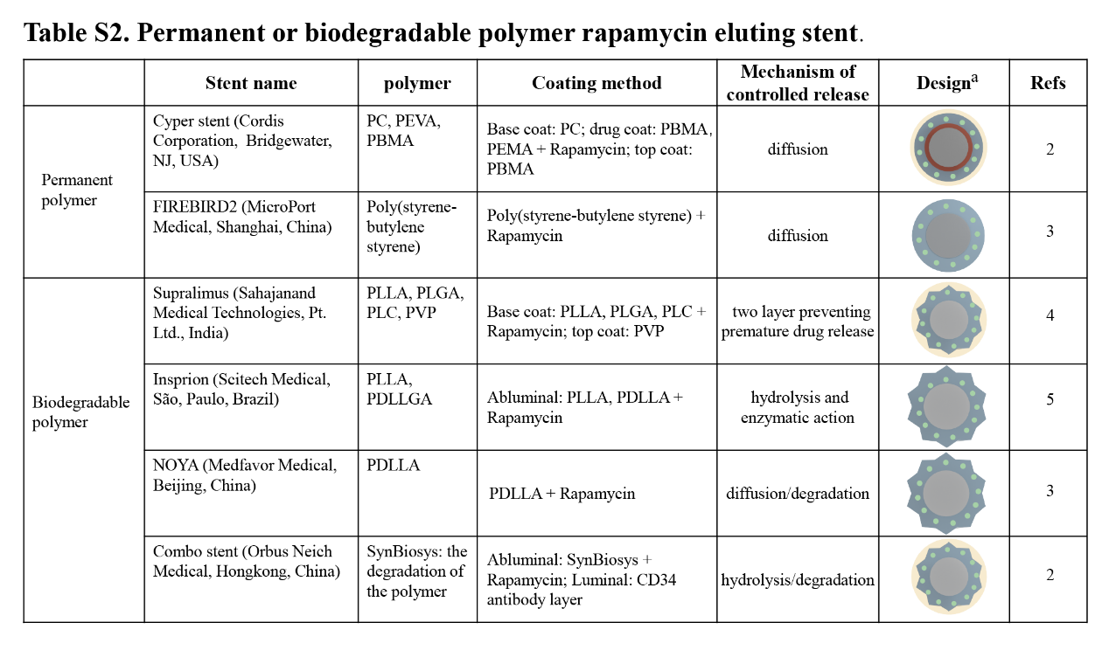
- The gray represents the cross-section of a stent strut, the red color represents the base coat, the blue color represents the drug-containing matrix, the green color represents the anti-fibrotic drug, and the yellow color represents the top coat for slowing down the rate of drug release.
PC: parylene C; PEVA: poly(ethylene-co-vinyl acetate); PBMA: poly(n-butyl methacrylate); PLLA: poly(L-lactic acid); PLGA: poly(lactide-co-glycolide); PLC: poly(lactide-co-caprolactone); PVP: polyvinylpyrrolidone; PLLA: poly(L-lactic acid); PDLLGA: poly(D, L-lactide-coglycolide); PDLLA: poly(D, L -lactide).

Table S4. Results of fitting the curves of in vitro release.
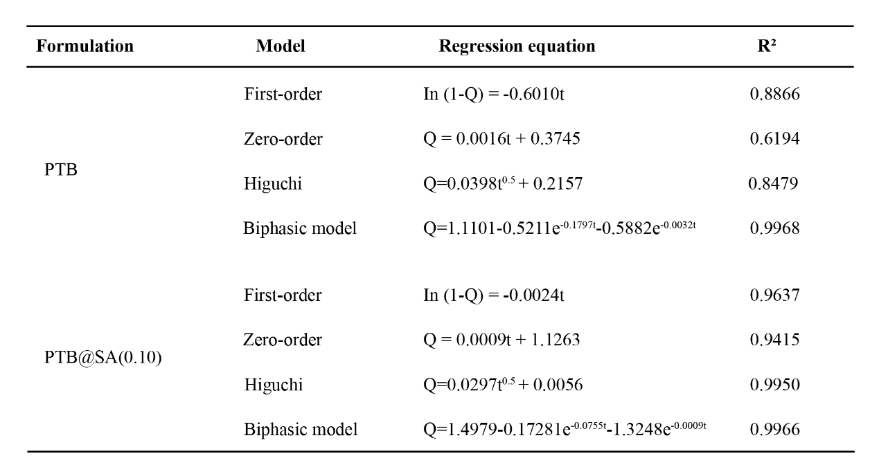

Table S5. Overview of preclinical outcomes of topical therapy to prevent urethral strictures^{6–9}.
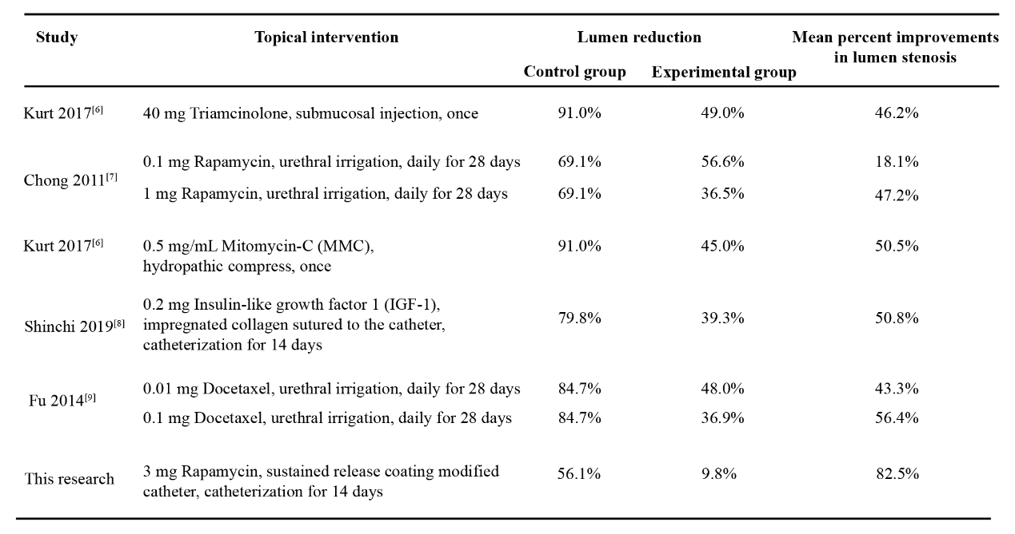

Supplementary References.
1. Koster, R. A., Dijkers, E. C. F. & Uges, D. R. A. Robust, high-throughput LC-MS/MS method for therapeutic drug monitoring of cyclosporine, tacrolimus, everolimus, and sirolimus in whole blood. Ther. Drug Monit. 31, 116–125 (2009).
2. Granada, J. F. et al. Development of a novel prohealing stent designed to deliver sirolimus from a biodegradable abluminal matrix. Circ. Cardiovasc. Interv. 3, 257–266 (2010).
3. Xu, B. et al. Nine-month angiographic and 2-year clinical follow-up of the NOYA biodegradable polymer sirolimus-eluting stent in the treatment of patients with de novo native coronary artery lesions: The NOYA I trial. EuroIntervention 8, 796–802 (2012).
4. Dani, S. et al. Biodegradable-polymer-based, sirolimus-eluting Supralimus® stent: 6-month angiographic and 30-month clinical follow-up results from the Series I prospective study. EuroIntervention 4, 59–63 (2008).
5. Ribeiro, E. E. et al. First-in-man randomised comparison of a novel sirolimus-eluting stent with abluminal biodegradable polymer and thin-strut cobalt-chromium alloy: INSPIRON-I trial. EuroIntervention 9, 1380–1384 (2014).
6. Kurt, O. et al. Effect of mitomycin - C and triamcinolone on preventing urethral strictures. Int. Braz J Urol 43, 939–945 (2017).
7. Chong, T. et al. Rapamycin inhibits formation of urethral stricture in rabbits. J. Pharmacol. Exp. Ther. 338, 47–52 (2011).
8. Shinchi, M. et al. Insulin-like growth factor 1 sustained-release collagen on urethral catheter prevents stricture after urethral injury in a rabbit model. Int. J. Urol. 26, 572–577 (2019).
9. Fu, D., Chong, T., Li, H., Zhang, H. & Wang, Z. Docetaxel inhibits urethral stricture formation, an initial study in rabbit model. PLoS One 9, 1–6 (2014).

