Figure S1. Phylogenetic tree of PvMES1–PvMES7 and NtSABP2 from Xue et al. (2018)

Ⅰ

Ⅱ

Ⅲ

Figure S2. The cDNA and gDNA cloning of PvMES1 gene by PCR

973 bp
3265 bp
cDNA
gDNA
Marker

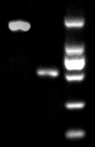

Figure S3. Disease symptoms in the susceptible BRB130 and resistant CAAS260205 genotypes after infection by F. oxysporum f. sp. phaseoli from Xue et al. (2015). A-E show the BRB130 phenotype at 0, 4, 8, 12 and 16 d post inoculation; F-J show the CAAS260205 phenotype at 0, 4, 8, 12 and 16 d post inoculation (dpi).

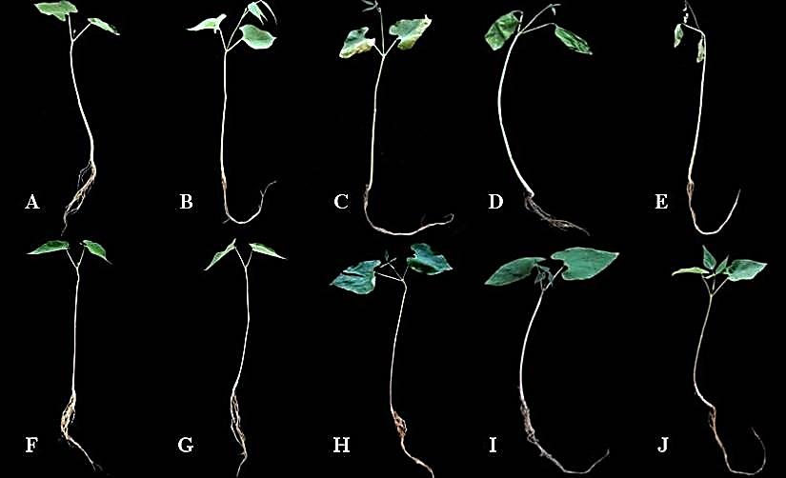

Figure S4. Overview of RNA-seq data from PvMES1-overexpressed, PvMES1- silenced, and pathogen-infected plants. Number of total reads, mapped reads and the percentage of mapped reads in each data set are shown. The value was marked with the exponential notation.

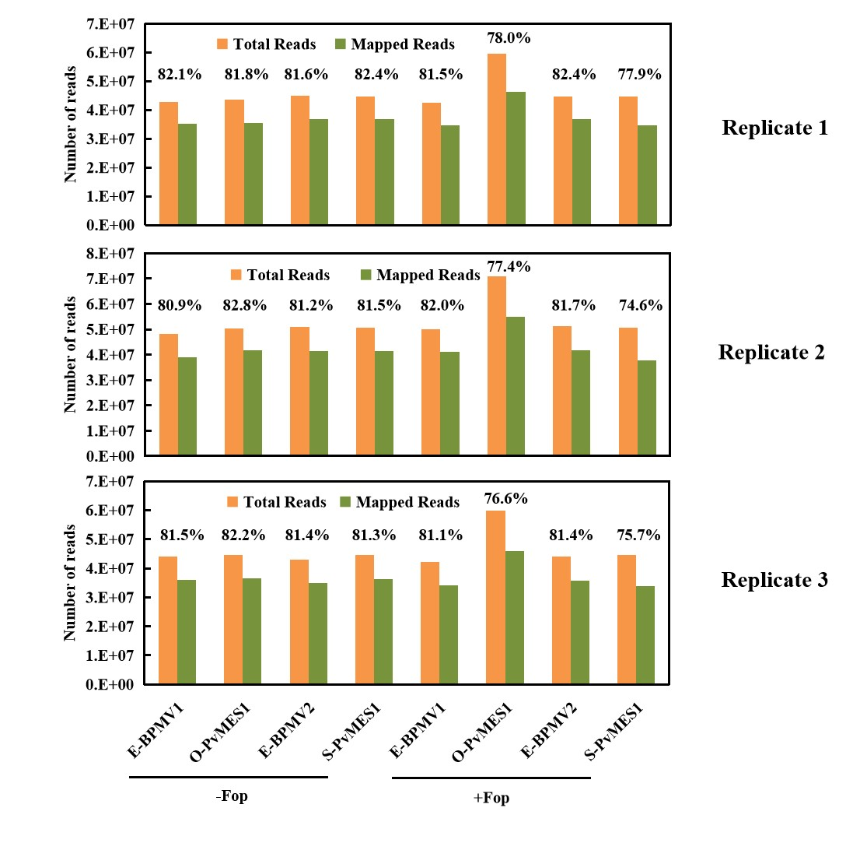

Figure S5. PCA for the transcriptome data of interaction between Fop and common bean. (a) PCA of PvMES1-overexpressed and E-BPMV1 (control) plants (+/-Fop); (b) PCA of PvMES1-silenced and E-BPMV2 (control) plants (+/-Fop). The values were determined from median-normalized transcript counts for the transcriptomics (n=3 biologically independent samples) data sets with the number of principal components (PC) set at 5. The amounts of variation explained by the first two components are indicated on the axes and the numbers represent the principal component score(Z-values×eigenvector). The dashed circles outline biological replicates for each genotype/treatment.

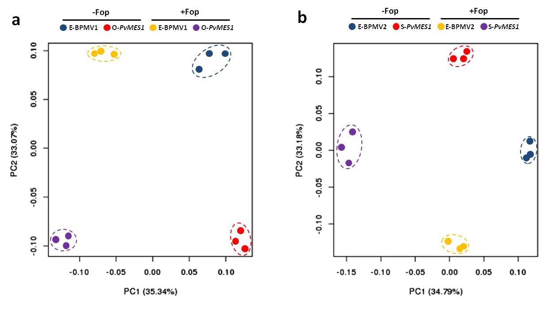

Figure S6. GO analysis of the genes in the interaction term of ANOVA analysis of the RNA-seq data. (a) PvMES1-overexpressed and E-BPMV1 (control) plants (+/-Fop); (b) PvMES1-silenced and E-BPMV2 (control) plants (+/-Fop).

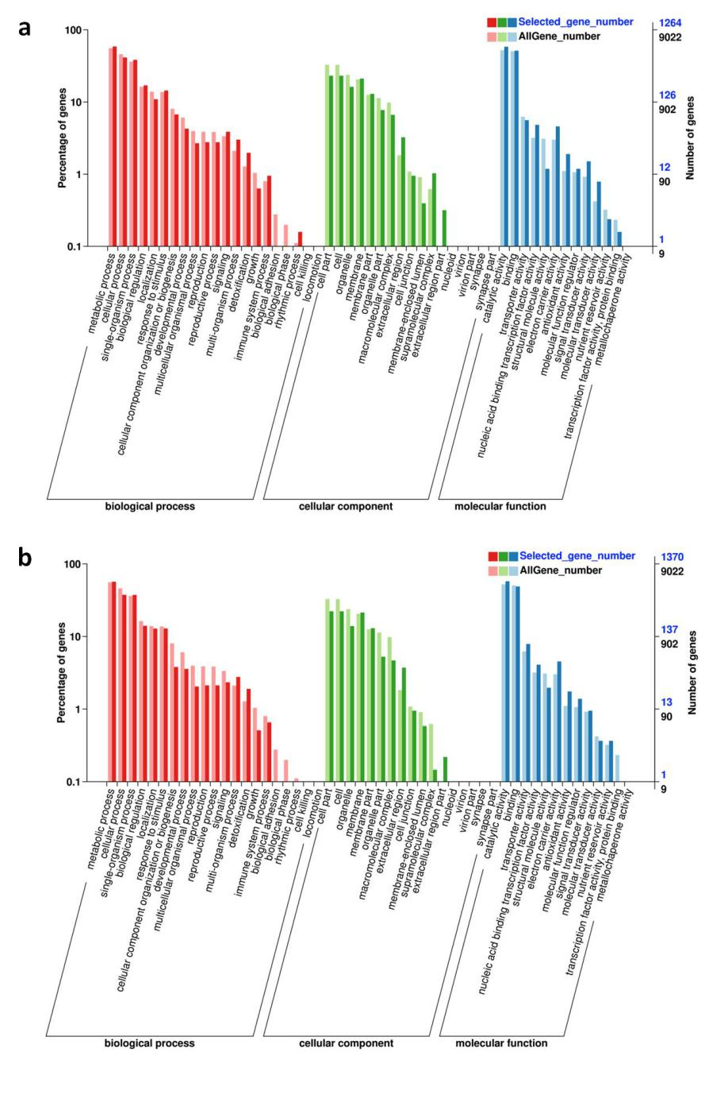

Figure S7. KEGG analysis of the genes in the interaction term of ANOVA analysis of the RNA-seq Data. (a) Histogram of KEGG pathway classification; (b) Statistics analysis of KEGG pathway enrichment. Left: PvMES1-overexpressed and E-BPMV1 (control) plants (+/-Fop); right: PvMES1-silenced and E-BPMV2 (control) plants (+/-Fop).

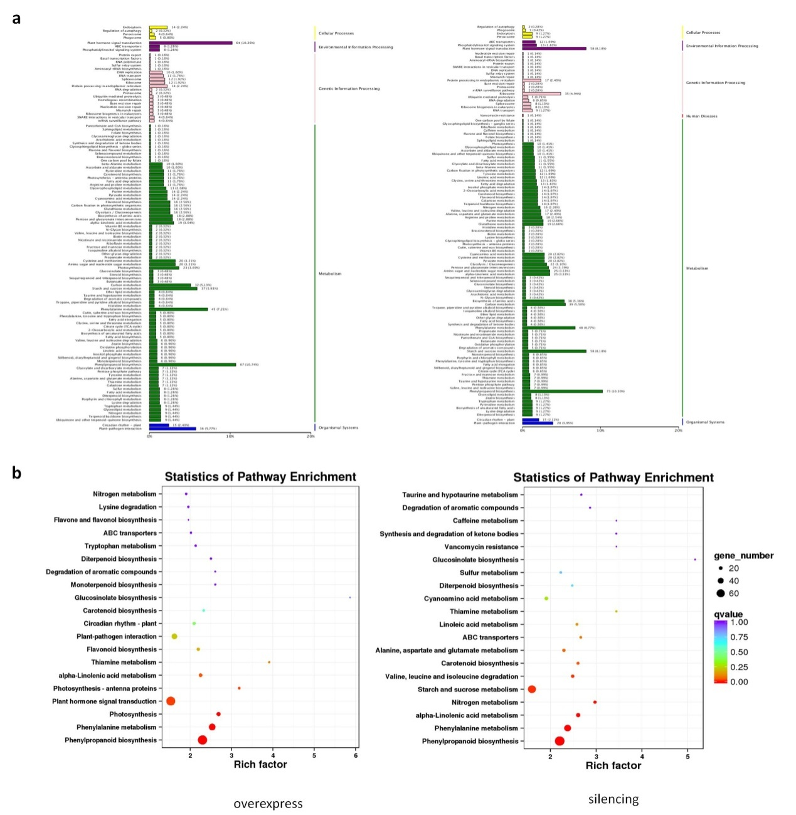

Figure S8. PAL activity, SOD activity, POD activity, H2O2 contents, MDA contents, total phenolic contents, and lignin contents of the controls, O- and S- PvMES1 plants at 0, 24, and 72 hpi infected by F. oxysporum f. sp. phaseoli.

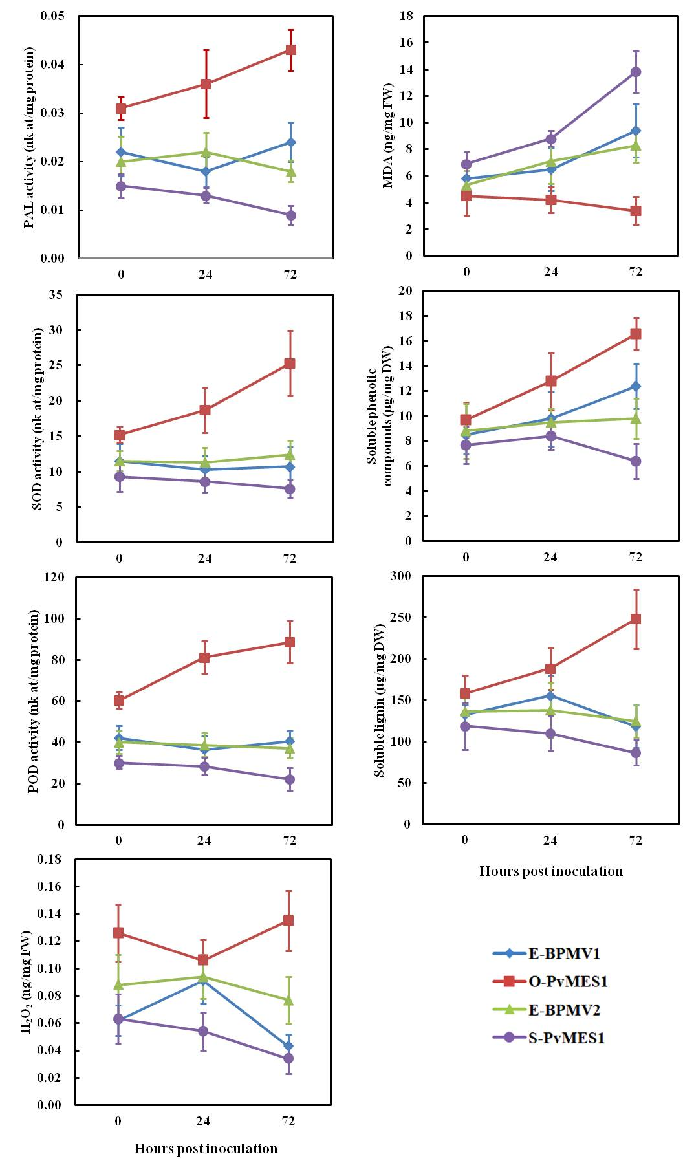

Figure S9. Glucose, fructose, sucrose and starch content analysis of the controls, O- and S-PvMES1 plants at 0, 24, and 72 hpi infected by F. oxysporum f. sp. phaseoli.

