Supporting Information

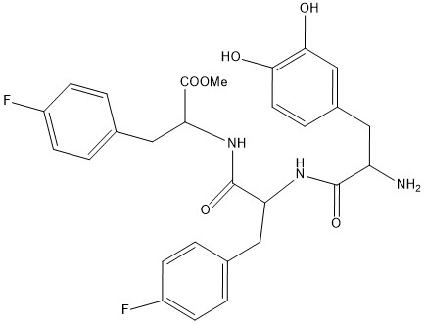
Fig. S1 The chemical structure of the peptide Dopa-Phe(4F)-Phe(4F)-OMe.

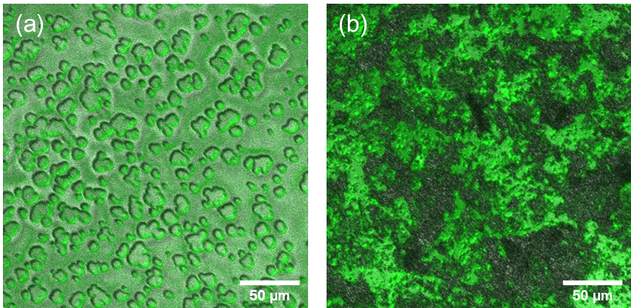
Fig. S2 CLSM images of the peptide assemblies. (a) before and (b) after lyophilization.

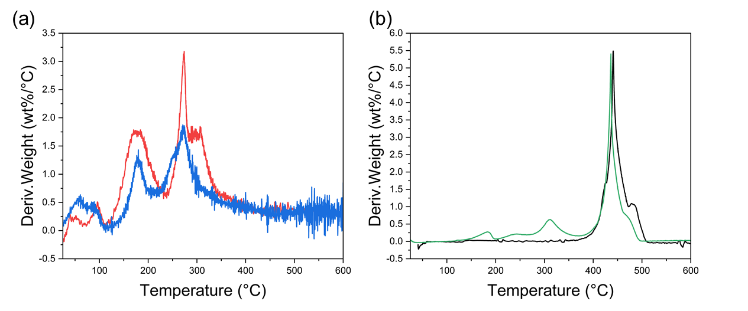Fig. S3 Differential thermogravimetric analysis of the (a) peptide assemblies (red) and non-assembled peptide (blue). (b) neat LDPE (black) and LDPE/peptide (green).
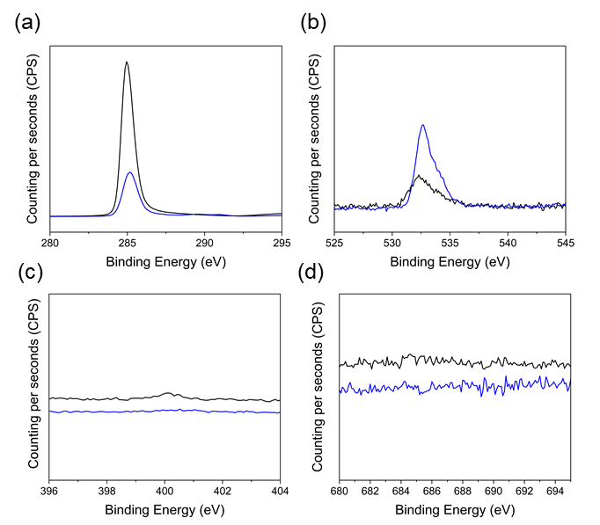
Fig. S4 XPS analysis of (a) carbon, (b) oxygen, (c) fluorine, and (d) nitrogen of neat LDPE (black) and LDPE/peptide (blue).

Table S1 Surface elemental composition and contact angle of LDPE and LDPE/peptide.
Surface | mass concentration [%] |  |  |  | contact angle [degree]
Surface | C_{1s} | O_{1s} | N_{1s} | F_{1s} | contact angle [degree]
LDPE | 98.9±0.3 | 0.9±0.3 | 0.2±0.1 | 0 | 100±3
LDPE/peptide | 94.7±0.3 | 5.2±0.4 | 0.13±0.08 | 0 | 101±2

Fig. S5 DSC thermograms of the neat LDPE (black) and LDPE/peptide (green).

Table S2 DSC data for the LDPE and LDPE/peptide films.
Surface | Tm (°C) | Tc (°C) | ΔHm (J/g.) | Xc (%)
LDPE | 108.3 | 92.6 | 90.6 | 31
LDPE/peptide | 108.3 | 94.7 | 94.3 | 33

Table S3 Optical properties of LDPE and LDPE/peptide films.
Surface | Transmission (%) | Clarity (%) | Haze (%)
LDPE | 91±0 | 95±0 | 15±3
LDPE/peptide | 91±0 | 90±1 | 37±4

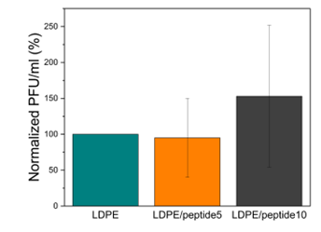
Fig. S6 Antiviral assay of the polymer films: neat LDPE, LDPE films compounded with the non-assembled peptide (5 wt%, LDPE/peptide5), and LDPE films compounded with the non-assembled peptide (10 wt%, LDPE/peptide10). Standard deviation (SD) is based on three independent experiments with triplicates (n = 9).

