Survey on the viral contamination of environmental surfaces around patients with COVID-19
Atsuko Hayase^{1,8}, Masayuki Ogata², Makoto Hiki³, Yasuhiro Okada^{4,8}, Shun Kubo^{1,8}, Mari Sato⁵, Toshio Naito⁶, Yoko Tabe⁷, Kenji Manabe⁴, Takuya Mori¹, Noriyasu Ota¹, Satoshi Hori⁸

Supplementary Figure S1. Relationship between cough symptoms and virus dispersion. The subjects were divided into two groups according to the existence of cough symptoms during the study period.
□Group without coughing (#2, #5, #9 [n = 3]), ■Group with coughing (#1, #3, #4, #6, #7, #8 [n = 6])

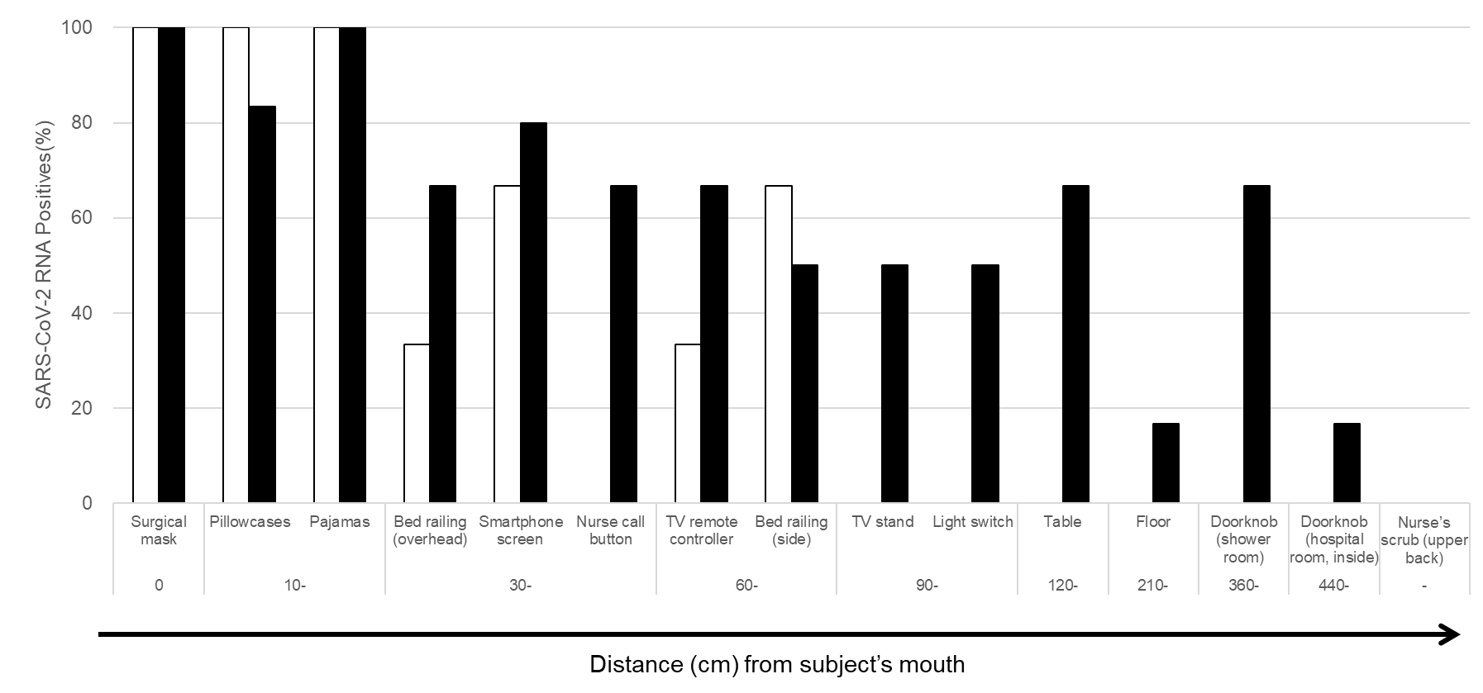

Supplementary Table S1. Severe acute respiratory syndrome coronavirus 2 RNA copy number (log₁₀/cps*) in samples
Map No. | Sample |  |  | #1 | #2 | #3 | #4 | #5 | #6 | #7 | #8 | #9
A | Surgical mask |  |  | 3.50 | 5.16 | 5.06 | 5.72 | 2.94 | 5.29 | 4.74 | 3.87 | 4.75
B | Pillowcase | Upper left |  |  | 3.25 | 5.22 | 4.76 | 1.91 | 4.97 | 3.07 | 3.55 | 4.52
B | Pillowcase | Lower left |  |  |  | 5.58 | 5.74 | 2.35 | 3.84 | 5.20 | 3.05 | 4.79
B | Pillowcase | Upper right |  |  |  | 5.92 | 5.07 | NS | 4.21 | 3.84 | 3.41 | 3.52
B | Pillowcase | Lower right |  |  |  | 5.29 | 4.91 | 2.97 | 4.24 | 4.50 | 4.42 | 3.85
C | Pajamas | Chest area_left |  |  | 3.62 | 6.41 | 6.01 | 2.80 | 7.00 | 3.68 | 5.07 | 4.83
C | Pajamas | Chest area_right |  |  | 3.02 | 5.48 | 5.79 | 3.12 | 5.23 | 4.02 | 5.74 | 5.64
C | Pajamas | Sleeve_left |  | 2.61 | 3.57 | 5.10 | 5.72 | 2.92 | 4.64 | 2.33 | 3.71 | 3.97
C | Pajamas | Sleeve_right |  | 3.64 | NS | 4.52 | 5.36 | 2.44 | 4.47 | 2.90 | 4.10 | 3.97
D | Bed railing (overhead) |  |  |  |  | 2.81 | 2.15 |  | 1.73 |  | 2.16 | 2.47
E | Smartphone screen |  |  |  | 2.51 | 4.63 | 4.41 |  | 3.59 | 1.84 | NS | 3.17
F | Nurse call button |  |  |  |  | 3.34 | 2.90 |  | 3.89 | 2.48
G | TV remote controller |  |  |  |  | 2.99 | 4.62 |  | 4.36 |  | 2.06 | 3.95
H | Bed railing (side) |  | Left |  |  | 4.15 | 2.95 | 2.34 | 2.77
H |  |  | Right |  |  | 8.48 | 3.76 |  | 3.01 |  |  | 2.51
I | TV stand |  |  |  |  | 2.62 | 2.88 |  | 4.15
J | Light switch |  |  |  |  | 3.46 | 3.73 |  |  | 2.38
K | Table |  | Left |  |  | 3.87 | 3.18 |  | 2.10
K |  |  | Right |  |  | 3.91 | 3.53 |  | 1.87 | 1.43
L | Floor |  |  |  |  | 3.21
M | Doorknob (toilet) |  |  |  |  | 4.49 | 2.59 |  | 3.31 | 2.20
N | Doorknob (hospital room, inside) |  |  |  |  | 4.53
O | Nurse’s scrub (upper back)
Blank, not detected; NS, no sample
Infections samples are denoted by bold and underlined numbers.
*cps, copies per sample (36 cm²)

