Legends
Table S1. AIC and BIC of trajectory groups selection 3
Table S2. Comparison of fuel usage among different ADL disability trajectory groups 4
Table S3. Comparison of fuel usage among different IADL disability trajectory groups 5
Table S4. Baseline characteristics of participants without ADL disability before 2011 in longitudinal analysis from 2011 to 2018 6
Table S5. Baseline characteristics of participants without IADL disability before 2011 in longitudinal analysis from 2011 to 2018 8
Table S6. Coefficients of fuel in 2011 with new-onset ADL disability: ZINB regression 10
Table S7. Coefficients of fuel in 2011 with new-onset IADL disability: ZINB regression 11
Table S8. Baseline characteristics of participants without ADL disability before 2013 in longitudinal analysis from 2013 to 2018 12
Table S9. Baseline characteristics of participants without IADL disability before 2013 in longitudinal analysis from 2013 to 2018 14
Table S10. HR (95% CI) of fuel usage transitions with new-onset ADL disability: Cox proportional-hazards model 16
Table S11. HR (95% CI) of fuel usage transitions with new-onset IADL disability: Cox proportional-hazards model 18
Figure S1. Flow chart 19
Figure S2. ADL trajectory groups during 2011 and 2018 20
Figure S3. IADL trajectory groups during 2011 and 2018 21
Figure S4. Sankey diagram of household fuel usage transition from 2011 to 2013 and subsequent new-onset ADL disability 22
Figure S5. Sankey diagram of household fuel usage transition from 2011 to 2013 and subsequent new-onset IADL disability 23

Table S1. AIC and BIC of trajectory groups selection
 | Trajectory Groups
 | 2 | 3 | 4 | 5
ADL
AIC | -34042.83 | -33882.59 | -33861.94 | -33791.01
BIC | -34071.06 | -33924.92 | -33918.39 | -33861.57
IADL
AIC | -49582.03 | -49221.82 | -49150.51 | -49073.59
BIC | -49612.65 | -49267.75 | -49211.75 | -49150.14
Note: AIC, Akaike Information Criterion. BIC, Bayesian Information Criterion. ADL, activity of daily living. IADL, instrumental activity of daily living.

Table S2. Comparison of fuel usage among different ADL disability trajectory groups
 | Maintained low ADL score | Increasing ADL score | P value
Cooking fuel |  |  | <0.001
Clean | 2317 (82.4) | 495 (17.6) | <0.001
Solid | 4296 (74.6) | 1462 (25.4) | <0.001
Heating fuel |  |  | <0.001
Clean | 1088 (82.2) | 236 (17.8) | <0.001
Solid | 5525 (76.3) | 1721 (23.8) | <0.001
Cooking and heating fuel |  |  | <0.001
Both clean | 859 (84.2) | 161 (15.8) | <0.001
Cooking clean and heating solid | 1458 (81.4) | 334 (18.6) | <0.001
Cooking solid and heating clean | 229 (75.3) | 75 (24.7) | <0.001
Both solid | 859 (84.2) | 161 (15.8) | <0.001
Note: ADL, activities of daily living. “Maintained low ADL score” group represents those maintaining low degree of ADL disability between 2011 and 2018. “Increasing ADL score” group represents those with exacerbating ADL disability between 2011 and 2018.

Table S3. Comparison of fuel usage among different IADL disability trajectory groups
 | Maintained low IADL score | Increasing IADL score | P value
Cooking fuel |  |  | <0.001
Clean | 5337 (86.8) | 811 (13.2) | <0.001
Solid | 7196 (76.2) | 2246 (23.8) | <0.001
Heating fuel |  |  | <0.001
Clean | 2751 (88.5) | 358 (11.5) | <0.001
Solid | 9782 (78.4) | 2699 (21.6) | <0.001
Cooking and heating fuel |  |  | <0.001
Both clean | 2208 (89.3) | 264 (10.7) | <0.001
Cooking clean and heating solid | 3129 (85.1) | 547 (14.9) | <0.001
Cooking solid and heating clean | 543 (85.2) | 94 (14.8) | <0.001
Both solid | 6653 (75.6) | 2152 (24.4) | <0.001
Note: IADL, instrumental activities of daily living. “Maintained low ADL score” group represents those maintaining low degree of ADL disability between 2011 and 2018. “Increasing ADL score” group represents those with exacerbating ADL disability between 2011 and 2018.

Table S4. Baseline characteristics of participants without ADL disability before 2011 in longitudinal analysis from 2011 to 2018
Baseline Characteristics |  | New-onset ADL disability (N=2368) | No new-onset ADL disability (N=3858) | P value
Age, year |  | 61.0 (55.0-68.0) | 58.0 (51.0-64.0) | <0.001
Sex |  |  |  | <0.001
 | Male | 956 (40.4) | 1761 (45.7) | <0.001
 | Female | 1412 (59.6) | 2097 (54.4) | <0.001
Residence |  |  |  | 0.05
 | Rural | 1679 (70.9) | 2644 (68.5) | 0.05
 | Urban | 689 (29.1) | 1214 (31.5) | 0.05
Education |  |  |  | <0.001
 | Less than primary school | 1363 (57.6) | 1828 (47.4) | <0.001
 | Primary school | 548 (23.1) | 967 (25.1) | <0.001
 | Middle school | 327 (13.8) | 783 (20.3) | <0.001
 | High school or above | 130 (5.5) | 280 (7.3) | <0.001
Economic status |  |  |  | <0.001
 | Bottom tertile | 855 (36.1) | 1330 (34.5) | 0.03
 | Middle tertile | 847 (35.8) | 1318 (34.2) | 0.03
 | Top tertile | 666 (28.1) | 1210 (31.4) | 0.03
Marital status |  |  |  | <0.001
 | Married or cohabiting | 2040 (86.2) | 3494 (90.6) | <0.001
 | Unmarried and not cohabiting | 328 (13.9) | 364 (9.4) | <0.001
Cooking fuel |  |  |  | <0.001
 | Clean | 745 (31.5) | 1418 (36.8) | <0.001
 | Solid | 1623 (68.5) | 2440 (63.3) | <0.001
Heating fuel |  |  |  | <0.001
 | Clean | 339 (14.3) | 752 (19.5) | <0.001
 | Solid | 2029 (85.7) | 3106 (80.5) | <0.001
Cooking and heating fuel |  |  |  | <0.001
 | Both clean | 257 (10.9) | 579 (15.0) | <0.001
 | Cooking clean and heating solid | 488 (20.6) | 839 (21.8) | <0.001
 | Cooking solid and heating clean | 82 (3.5) | 173 (4.5) | <0.001
 | Both solid | 1541 (65.1) | 2267 (58.8) | <0.001
Smoking history |  |  |  | 0.11
 | Never smoking | 1505 (63.6) | 2373 (61.5) | 0.11
 | Ever smoking | 863 (36.4) | 1485 (38.5) | 0.11
Drinking history |  |  |  | <0.001
 | Never drinking | 1893 (79.9) | 2930 (76.0) | <0.001
 | Ever drinking | 475 (20.1) | 928 (24.1) | <0.001
Diabetes |  |  |  | <0.001
 | No | 1985 (83.8) | 3395 (88.0) | <0.001
 | Yes | 383 (16.2) | 463 (12.0) | <0.001
Hypertension |  |  |  | <0.001
 | No | 1272 (53.7) | 2318 (60.1)
 | Yes | 1096 (46.3) | 1540 (39.9)
Dyslipidemia |  |  |  | 0.002
 | No | 1709 (72.2) | 2924 (75.8) | 0.002
 | Yes | 659 (27.8) | 934 (24.2) | 0.002
CVDs |  |  |  | <0.001
 | No | 1934 (81.7) | 3368 (87.3) | <0.001
 | Yes | 434 (18.3) | 490 (12.7) | <0.001
BMI status |  |  |  | 0.001
 | Normal weight | 1364 (57.6) | 2279 (59.1) | 0.001
 | Over weight | 666 (28.1) | 1150 (29.8) | 0.001
 | Obesity | 338 (14.3) | 429 (11.1) | 0.001
WC, cm |  | 85.4 (78.0-93.0) | 84.4 (77.2-91.6) | <0.001
Notes: Values are presented as number (N) with percent (%) or medians with interquartile ranges (IQRs). ADL, activities of daily living. CVDs, cardiovascular diseases. BMI, body mass index. WC, waist circumference.

Table S5. Baseline characteristics of participants without IADL disability before 2011 in longitudinal analysis from 2011 to 2018
Baseline Characteristics |  | New-onset IADL disability (N=3312) | No new-onset IADL disability (N=6418) | P value
Age, year |  | 60.0 (54.0-67.0) | 56.0 (49.0-62.0) | <0.001
Sex |  |  |  | <0.001
 | Male | 1456 (44.0) | 3593 (56.0) | <0.001
 | Female | 1856 (56.0) | 2825 (44.0) | <0.001
Residence |  |  |  | <0.001
 | Rural | 2393 (72.3) | 4056 (63.2) | <0.001
 | Urban | 919 (27.8) | 2362 (36.8) | <0.001
Education |  |  |  | <0.001
 | Less than primary school | 1858 (56.1) | 2299 (35.8) | <0.001
 | Primary school | 785 (23.7) | 1619 (25.2) | <0.001
 | Middle school | 489 (14.8) | 1642 (25.6) | <0.001
 | High school or above | 180 (5.4) | 858 (13.4) | <0.001
Economic status |  |  |  | <0.001
 | Bottom tertile | 1262 (38.1) | 1902 (29.6) | <0.001
 | Middle tertile | 1151 (34.8) | 2186 (34.1) | <0.001
 | Top tertile | 899 (27.1) | 2330 (36.3) | <0.001
Marital status |  |  |  | <0.001
 | Married or cohabiting | 2945 (88.9) | 5945 (92.6) | <0.001
 | Unmarried and not cohabiting | 367 (11.1) | 473 (7.4) | <0.001
Cooking fuel |  |  |  | <0.001
 | Clean | 1036 (31.3) | 2858 (44.5) | <0.001
 | Solid | 2276 (68.7) | 3560 (55.5) | <0.001
Heating fuel |  |  |  | <0.001
 | Clean | 522 (15.8) | 1495 (23.3) | <0.001
 | Solid | 2790 (84.2) | 4923 (76.7) | <0.001
Cooking and heating fuel |  |  |  | <0.001
 | Both clean | 375 (11.3) | 1186 (18.5) | <0.001
 | Cooking clean and heating solid | 661 (20.0) | 1672 (26.1) | <0.001
 | Cooking solid and heating clean | 147 (4.4) | 309 (4.8) | <0.001
 | Both solid | 2129 (64.3) | 3251 (50.7) | <0.001
Smoking history |  |  |  | <0.001
 | Never smoking | 2056 (62.1) | 3592 (56.0) | <0.001
 | Ever smoking | 1256 (37.9) | 2826 (44.0) | <0.001
Drinking history |  |  |  | <0.001
 | Never drinking | 2571 (77.6) | 4545 (70.8) | <0.001
 | Ever drinking | 741 (22.4) | 1873 (29.2) | <0.001
Diabetes |  |  |  | 0.002
 | No | 2871 (86.7) | 5736 (89.4)
 | Yes | 441 (13.3) | 682 (10.6)
Hypertension |  |  |  | <0.001
 | No | 1898 (57.3) | 4156 (64.8) | <0.001
 | Yes | 1414 (42.7) | 2262 (35.2) | <0.001
Dyslipidemia |  |  |  | <0.001
 | No | 2457 (74.2) | 4993 (77.8) | <0.001
 | Yes | 855 (25.8) | 1425 (22.2) | <0.001
CVDs |  |  |  | <0.001
 | No | 2819 (85.1) | 5892 (91.8) | <0.001
 | Yes | 493 (14.9) | 526 (8.2) | <0.001
BMI status |  |  |  | <0.001
 | Normal weight | 2007 (60.6) | 3777 (58.9) | <0.001
 | Over weight | 894 (27.0) | 1960 (30.5) | <0.001
 | Obesity | 411 (12.4) | 681 (10.6) | <0.001
WC, cm |  | 84.4 (77.3-91.6) | 84.3 (78.0-91.8) | 0.68
Notes: Values are presented as number (N) with percent (%) or medians with interquartile ranges (IQRs). IADL, instrumental activities of daily living. CVDs, cardiovascular diseases. BMI, body mass index.WC, waist circumference.

Table S6. Coefficients of fuel in 2011 with new-onset ADL disability: ZINB regression
 | Logit portion |  |  | Negative binomial portion
 | β (95% CI) | SE | P Value | β (95% CI) | SE | P Value
Cooking fuel
Clean | Reference | / | / | Reference | / | /
Solid | -0.293 (-0.515, -0.072) | 0.113 | 0.01 | 0.100 (0.016, 0.184) | 0.043 | 0.02
Heating fuel
Clean | Reference | / | / | Reference | / | /
Solid | -0.506 (-0.773, -0.240) | 0.136 | <0.001 | 0.070 (-0.041, 0.181) | 0.057 | 0.22
Cooking and heating fuel
Both clean | Reference | / | / | Reference | / | /
Cooking clean and heating solid | -0.440 (-0.797, -0.083) | 0.182 | 0.02 | 0.045 (-0.103, 0.195) | 0.076 | 0.55
Cooking solid and heating clean | -0.196 (-0.709, 0.318) | 0.262 | 0.46 | 0.128 (-0.095, 0.350) | 0.114 | 0.26
Both solid | -0.614 (-0.932, -0.296) | 0.162 | <0.001 | 0.132 (-0.002, 0.266) | 0.068 | 0.05
Note: ADL, activities of daily living. ZINB, zero-inflated negative binomial. β, regression coefficient. CI, confidence interval. SE, standard error. β was adjusted for age (continuous value), sex (male or female), residence (urban or rural), education (less than primary school, primary school, middle school, or high school or above), economic status (poor, middle, or rich), marital status (married or cohabiting, or unmarried and not cohabiting), smoking history (never smoking or ever smoking), drinking history (never drinking or ever drinking), body mass index status (normal weight, overweight, or obesity), waist circumference, diabetes (yes or no), hypertension (yes or no), dyslipidemia (yes or no), and cardiovascular diseases (yes or no).

Table S7. Coefficients of fuel in 2011 with new-onset IADL disability: ZINB regression
 | Logit portion |  |  | Negative binomial portion
 | β (95% CI) | SE | P Value | β (95% CI) | SE | P Value
Cooking fuel
Clean | Reference | / | / | Reference | / | /
Solid | -0.411 (-0.534, -0.288) | 0.063 | <0.001 | 0.069 (0.009, 0.129) | 0.031 | 0.02
Heating fuel
Clean | Reference | / | / | Reference | / | /
Solid | -0.278 (-0.430, -0.126) | 0.078 | <0.001 | 0.184 (0.103, 0.264) | 0.041 | <0.001
Cooking and heating fuel
Both clean | Reference | / | / | Reference | / | /
Cooking clean and heating solid | -0.076 (-0.267, 0.116) | 0.098 | 0.44 | 0.158 (0.051, 0.264) | 0.054 | 0.004
Cooking solid and heating clean | -0.221 (-0.538, 0.096) | 0.162 | 0.17 | -0.007 (-0.170, 0.156) | 0.083 | 0.93
Both solid | -0.482 (-0.662, -0.303) | 0.092 | <0.001 | 0.191 (0.094, 0.287) | 0.049 | <0.001
Note: IADL, instrumental activities of daily living. ZINB, zero-inflated negative binomial. β, regression coefficient. CI, confidence interval. SE, standard error. β was adjusted for age (continuous value), sex (male or female), residence (urban or rural), education (less than primary school, primary school, middle school, or high school or above), economic status (poor, middle, or rich), marital status (married or cohabiting, or unmarried and not cohabiting), smoking history (never smoking or ever smoking), drinking history (never drinking or ever drinking), body mass index status (normal weight, overweight, or obesity), waist circumference, diabetes (yes or no), hypertension (yes or no), dyslipidemia (yes or no), and cardiovascular diseases (yes or no).

Table S8. Baseline characteristics of participants without ADL disability before 2013 in longitudinal analysis from 2013 to 2018
Baseline Characteristics |  | New-onset ADL disability (N=845) | No new-onset ADL disability (N=1800) | P value
Age, year |  | 61.0 (55.0-68.0) | 59.0 (52.0-65.0) | <0.001
Sex
 | Male | 329 (38.9) | 807 (44.8) | 0.005
 | Female | 516 (61.1) | 993 (55.2)
Residence |  |  |  | 0.17
 | Rural | 616 (72.9) | 1265 (70.3)
 | Urban | 229 (27.1) | 535 (29.7)
Education |  |  |  | <0.001
 | Less than primary school | 480 (56.8) | 859 (47.7)
 | Primary school | 193 (22.8) | 481 (26.7)
 | Middle school | 122 (14.4) | 351 (19.5)
 | High school or above | 50 (5.9) | 109 (6.1)
Economic status |  |  |  | 0.24
 | Bottom tertile | 321 (38.0) | 670 (37.2)
 | Middle tertile | 308 (36.5) | 615 (34.2)
 | Top tertile | 216 (25.6) | 515 (28.6)
Marital status |  |  |  | 0.002
 | Married or cohabiting | 716 (84.7) | 1605 (89.2)
 | Unmarried and not cohabiting | 129 (15.3) | 195 (10.8)
Cooking fuel |  |  |  | 0.002
 | Clean | 241 (28.5) | 624 (34.7)
 | Solid | 604 (71.5) | 1176 (65.3)
Heating fuel |  |  |  | <0.001
 | Clean | 98 (11.6) | 324 (18.0)
 | Solid | 747 (88.4) | 1476 (82.0)
Cooking and heating fuel |  |  |  | <0.001
 | Both clean | 69 (8.2) | 251 (13.9)
 | Cooking clean and heating solid | 172 (20.4) | 373 (20.7)
 | Cooking solid and heating clean | 29 (3.4) | 73 (4.1)
 | Both solid | 575 (68.1) | 1103 (61.3)
Smoking history |  |  |  | 0.04
 | Never smoking | 552 (65.3) | 1102 (61.2)
 | Ever smoking | 293 (34.7) | 698 (38.8)
Drinking history |  |  |  | 0.01
 | Never drinking | 681 (80.6) | 1372 (76.2)
 | Ever drinking | 164 (19.4) | 428 (23.8)
Diabetes |  |  |  | 0.02
 | No | 715 (84.6) | 1586 (88.1)
 | Yes | 130 (15.4) | 214 (11.9)
Hypertension |  |  |  | 0.06
 | No | 468 (55.4) | 1067 (59.3)
 | Yes | 377 (44.6) | 733 (40.7)
Dyslipidemia |  |  |  | 0.14
 | No | 613 (72.5) | 1355 (75.3)
 | Yes | 232 (27.5) | 445 (24.7)
CVDs |  |  |  | <0.001
 | No | 679 (80.4) | 1555 (86.4)
 | Yes | 166 (19.6) | 245 (13.6)
BMI status |  |  |  | 0.01
 | Normal weight | 480 (56.8) | 1049 (58.3)
 | Over weight | 234 (27.7) | 546 (30.3)
 | Obesity | 131 (15.5) | 205 (11.4)
WC, cm |  | 86.0 (78.0-93.4) | 84.8 (77.2-91.7) | 0.003
Notes: Values are presented as number (N) with percent (%) or medians with interquartile ranges (IQRs). ADL, activities of daily living. CVDs, cardiovascular diseases. BMI, body mass index. WC, waist circumference.

Table S9. Baseline characteristics of participants without IADL disability before 2013 in longitudinal analysis from 2013 to 2018
Baseline Characteristics |  | New-onset IADL disability (N=1351) | No new-onset IADL disability (N=4208) | P value
Age, year |  | 59.0 (53.0-66.0) | 56.0 (49.0-62.0) | <0.001
Sex |  |  |  | <0.001
 | Male | 585 (43.3) | 2419 (57.5)
 | Female | 766 (56.7) | 1789 (42.5)
Residence |  |  |  | <0.001
 | Rural | 1000 (74.0) | 2786 (66.2)
 | Urban | 351 (26.0) | 1422 (33.8)
Education |  |  |  | <0.001
 | Less than primary school | 713 (52.8) | 1470 (34.9)
 | Primary school | 344 (25.5) | 1076 (25.6)
 | Middle school | 220 (16.3) | 1099 (26.1)
 | High school or above | 74 (5.5) | 563 (13.4)
Economic status |  |  |  | <0.001
 | Bottom tertile | 516 (38.2) | 1312 (31.2)
 | Middle tertile | 473 (35.0) | 1386 (32.9)
 | Top tertile | 362 (26.8) | 1510 (35.9)
Marital status |  |  |  | <0.001
 | Married or cohabiting | 1189 (88.0) | 3870 (92.0)
 | Unmarried and not cohabiting | 162 (12.0) | 338 (8.0)
Cooking fuel |  |  |  | <0.001
 | Clean | 423 (31.3) | 1812 (43.1)
 | Solid | 928 (68.7) | 2396 (56.9)
Heating fuel |  |  |  | <0.001
 | Clean | 223 (16.5) | 930 (22.1)
 | Solid | 1128 (83.5) | 3278 (77.9)
Cooking and heating fuel |  |  |  | <0.001
 | Both clean | 156 (11.6) | 736 (17.5)
 | Cooking clean and heating solid | 267 (19.8) | 1076 (25.6)
 | Cooking solid and heating clean | 67 (5.0) | 194 (4.6)
 | Both solid | 861 (63.7) | 2202 (52.3)
Smoking history |  |  |  | <0.001
 | No smoking | 836 (61.9) | 2354 (55.9)
 | Smoking | 515 (38.1) | 1854 (44.1)
Drinking history |  |  |  | <0.001
 | No drinking | 1047 (77.5) | 2957 (70.3)
 | Drinking | 304 (22.5) | 1251 (29.7)
Diabetes |  |  |  | 0.001
 | No | 1162 (86.0) | 3758 (89.3)
 | Yes | 189 (14.0) | 450 (10.7)
Hypertension |  |  |  | <0.001
 | No | 764 (56.6) | 2786 (66.2)
 | Yes | 587 (43.5) | 1422 (33.8)
Dyslipidemia |  |  |  | <0.001
 | No | 965 (71.4) | 3283 (78.0)
 | Yes | 386 (28.6) | 925 (22.0)
CVDs |  |  |  | <0.001
 | No | 1165 (86.2) | 3885 (92.3)
 | Yes | 186 (13.8) | 323 (7.7)
BMI status |  |  |  | 0.02
 | Normal weight | 789 (58.4) | 2493 (59.2)
 | Over weight | 387 (28.7) | 1284 (30.5)
 | Obesity | 175 (13.0) | 431 (10.2)
WC, cm |  | 84.6 (77.3-92.0) | 84.0 (77.8-91.0) | 0.34
Notes: Values are presented as number (N) with percent (%) or medians with interquartile ranges (IQRs). IADL, instrumental activities of daily living. CVDs, cardiovascular diseases. BMI, body mass index. WC, waist circumference.

Table S10. HR (95% CI) of fuel usage transitions with new-onset ADL disability: Cox proportional-hazards model
 | No. of participants | Total population (N=2645) | Age-stratified |  | Sex-stratified |  | Residence-stratified
 | No. of participants | Total population (N=2645) | Age < 65 (N=1868) | Age ≥ 65 (N=777) | Male (N=1136) | Female (N=1509) | Rural (N=1881) | Urban (N=764)
Cooking fuel
Keep clean | 687 | 1.00 (0.85~1.17) | 1.00 (0.83~1.20) | 1.00 (0.73~1.37) | 1.00 (0.77~1.30) | 1.00 (0.82~1.22) | 1.00 (0.80~1.25) | 1.00 (0.82~1.22)
Clean to solid | 178 | 1.06 (0.81~1.39) | 0.95 (0.67~1.35) | 1.32 (0.86~2.04) | 0.97 (0.61~1.52) | 1.00 (0.71~1.42) | 1.24 (0.90~1.70) | 0.77 (0.45~1.33)
Keep solid | 1316 | 1.00 (0.91~1.10) | 1.00 (0.88~1.13) | 1.00 (0.85~1.18) | 1.00 (0.85~1.17) | 1.00 (0.88~1.14) | 1.00 (0.90~1.11) | 1.00 (0.79~1.26)
Solid to clean | 464 | 0.88 (0.75~1.03) | 0.91 (0.74~1.11) | 0.85 (0.65~1.12) | 0.91 (0.70~1.19) | 0.89 (0.73~1.09) | 0.94 (0.78~1.12) | 0.67 (0.46~0.97)
Heating fuel
Keep clean | 220 | 1.00 (0.73~1.36) | 1.00 (0.65~1.53) | 1.00 (0.63~1.59) | 1.00 (0.56~1.79) | 1.00 (0.70~1.44) | 1.00 (0.57~1.77) | 1.00 (0.70~1.43)
Clean to solid | 202 | 1.48 (1.13~1.93) | 2.19 (1.60~2.99) | 0.81 (0.48~1.36) | 2.12 (1.36~3.31) | 1.23 (0.88~1.72) | 1.57 (1.12~2.20) | 1.34 (0.87~2.08)
Keep solid | 1901 | 1.00 (0.91~1.09) | 1.00 (0.90~1.11) | 1.00 (0.85~1.18) | 1.00 (0.87~1.15) | 1.00 (0.89~1.13) | 1.00 (0.91~1.09) | 1.00 (0.84~1.20)
Solid to clean | 322 | 0.80 (0.65~0.97) | 0.86 (0.67~1.10) | 0.71 (0.51~0.99) | 1.00 (0.75~1.35) | 0.68 (0.52~0.88) | 0.76 (0.60~0.98) | 0.87 (0.62~1.23)
Cooking and heating fuel
Keep both clean | 174 | 1.00 (0.71~1.42) | 1.00 (0.63~1.58) | 1.00 (0.57~1.74) | 1.00 (0.54~1.85) | 1.00 (0.65~1.53) | 1.00 (0.48~2.10) | 1.00 (0.68~1.48)
Both clean to 1 solid | 126 | 1.20 (0.82~1.76) | 1.62 (1.04~2.52) | 0.74 (0.35~1.58) | 1.85 (1.02~3.38) | 0.99 (0.60~1.63) | 1.15 (0.63~2.09) | 1.32 (0.80~2.17)
Both clean to both solid | 20 | 1.93 (0.96~3.90) | 3.56 (1.32~9.61) | 1.18 (0.43~3.19) | 3.14 (1.26~7.83) | 1.01 (0.32~3.17) | 2.42 (1.07~5.47) | 1.43 (0.35~5.83)
Keep 1 solid | 359 | 1.00 (0.83~1.21) | 1.00 (0.80~1.24) | 1.00 (0.67~1.49) | 1.00 (0.71~1.40) | 1.00 (0.79~1.26) | 1.00 (0.77~1.29) | 1.00 (0.76~1.31)
1 solid to both clean | 117 | 0.90 (0.64~1.25) | 0.83 (0.55~1.25) | 0.99 (0.54~1.81) | 1.38 (0.83~2.29) | 0.69 (0.44~1.09) | 0.80 (0.47~1.36) | 0.94 (0.61~1.46)
1 solid to both solid | 171 | 1.00 (0.77~1.31) | 0.88 (0.63~1.22) | 1.29 (0.82~2.03) | 0.84 (0.52~1.36) | 1.00 (0.73~1.38) | 1.13 (0.83~1.53) | 0.74 (0.42~1.28)
Keep both solid | 1176 | 1.00 (0.90~1.11) | 1.00 (0.88~1.14) | 1.00 (0.84~1.19) | 1.00 (0.85~1.18) | 1.00 (0.88~1.14) | 1.00 (0.90~1.11) | 1.00 (0.78~1.28)
Both solid to both clean | 124 | 0.81 (0.59~1.11) | 0.87 (0.58~1.31) | 0.75 (0.45~1.25) | 1.04 (0.67~1.62) | 0.66 (0.42~1.03) | 0.84 (0.59~1.21) | 0.74 (0.38~1.43)
Both solid to 1 solid | 378 | 0.86 (0.72~1.03) | 0.91 (0.73~1.13) | 0.78 (0.57~1.06) | 0.76 (0.56~1.04) | 0.95 (0.76~1.18) | 0.89 (0.73~1.08) | 0.68 (0.44~1.05)
Note: ADL, activities of daily living. HR, hazard ratio. CI, confidence interval. 1 solid, either solid cooking fuel or solid heating fuel. HR was adjusted for age (continuous value), sex (male or female), residence (urban or rural), education (less than primary school, primary school, middle school, or high school or above), economic status (poor, middle, or rich), marital status (married or cohabiting, or unmarried and not cohabiting), smoking history (never smoking or ever smoking), drinking history (never drinking or ever drinking), body mass index status (normal weight, overweight, or obesity), waist circumference, diabetes (yes or no), hypertension (yes or no), dyslipidemia (yes or no), and cardiovascular diseases (yes or no).

Table S11. HR (95% CI) of fuel usage transitions with new-onset IADL disability: Cox proportional-hazards model
 | No. of participants | Total population (N=5559) | Age-stratified |  | Sex-stratified |  | Residence-stratified
 | No. of participants | Total population (N=5559) | Age < 65 (N=4402) | Age≥ 65 (N=1157) | Male (N=3004) | Female (N=2555) | Rural (N=3786) | Urban (N=1773)
Cooking fuel
Keep clean | 1850 | 1.00 (0.89~1.13) | 1.00 (0.87~1.14) | 1.00 (0.78~1.28) | 1.00 (0.83~1.20) | 1.00 (0.86~1.17) | 1.00 (0.86~1.17) | 1.00 (0.84~1.18)
Clean to solid | 385 | 1.29 (1.06~1.57) | 1.14 (0.90~1.44) | 1.91 (1.32~2.77) | 1.57 (1.16~2.10) | 1.12 (0.85~1.46) | 1.28 (1.01~1.62) | 1.27 (0.86~1.89)
Keep solid | 2378 | 1.00 (0.92~1.08) | 1.00 (0.91~1.10) | 1.00 (0.86~1.16) | 1.00 (0.88~1.13) | 1.00 (0.90~1.11) | 1.00 (0.92~1.09) | 1.00 (0.83~1.20)
Solid to clean | 946 | 0.84 (0.74~0.95) | 0.87 (0.75~1.01) | 0.75 (0.57~0.97) | 0.87 (0.72~1.06) | 0.81 (0.68~0.95) | 0.89 (0.77~1.03) | 0.66 (0.50~0.87)
Heating fuel
Keep clean | 613 | 1.00 (0.81~1.23) | 1.00 (0.77~1.30) | 1.00 (0.69~1.45) | 1.00 (0.74~1.36) | 1.00 (0.75~1.34) | 1.00 (0.64~1.57) | 1.00 (0.79~1.27)
Clean to solid | 540 | 1.59 (1.34~1.89) | 1.80 (1.48~2.18) | 1.18 (0.81~1.73) | 1.15 (0.86~1.53) | 2.03 (1.64~2.52) | 3.48 (2.82~4.30) | 0.94 (0.69~1.27)
Keep solid | 3650 | 1.00 (0.93~1.08) | 1.00 (0.92~1.09) | 1.00 (0.86~1.16) | 1.00 (0.89~1.12) | 1.00 (0.91~1.10) | 1.00 (0.93~1.08) | 1.00 (0.86~1.16)
Solid to clean | 756 | 0.83 (0.71~0.96) | 0.89 (0.75~1.06) | 0.65 (0.48~0.88) | 0.77 (0.60~0.97) | 0.87 (0.71~1.06) | 0.84 (0.69~1.01) | 0.80 (0.61~1.04)
Cooking and heating fuel
Keep both clean | 475 | 1.00 (0.78~1.28) | 1.00 (0.75~1.33) | 1.00 (0.62~1.61) | 1.00 (0.69~1.44) | 1.00 (0.72~1.39) | 1.00 (0.59~1.69) | 1.00 (0.76~1.32)
Both clean to 1 solid | 352 | 1.38 (1.09~1.74) | 1.42 (1.09~1.85) | 1.31 (0.80~2.17) | 1.28 (0.90~1.83) | 1.46 (1.07~1.99) | 2.59 (1.88~3.57) | 1.02 (0.73~1.42)
Both clean to both solid | 65 | 1.27 (0.75~2.15) | 1.11 (0.57~2.13) | 2.26 (0.93~5.52) | 1.27 (0.53~3.07) | 1.32 (0.68~2.56) | 2.95 (1.67~5.21) | 0.40 (0.1~1.63)
Keep 1 solid | 825 | 1.00 (0.86~1.17) | 1.00 (0.83~1.20) | 1.00 (0.72~1.38) | 1.00 (0.78~1.28) | 1.00 (0.82~1.22) | 1.00 (0.82~1.22) | 1.00 (0.77~1.29)
1 solid to both clean | 412 | 0.91 (0.72~1.14) | 1.02 (0.78~1.33) | 0.65 (0.40~1.04) | 0.90 (0.63~1.28) | 0.91 (0.67~1.25) | 0.95 (0.71~1.29) | 0.87 (0.61~1.26)
1 solid to both solid | 367 | 1.44 (1.19~1.75) | 1.43 (1.14~1.79) | 1.40 (0.96~2.04) | 1.50 (1.12~2.01) | 1.39 (1.08~1.79) | 1.33 (1.07~1.66) | 1.72 (1.16~2.55)
Keep both solid | 2083 | 1.00 (0.92~1.09) | 1.00 (0.90~1.11) | 1.00 (0.85~1.17) | 1.00 (0.88~1.14) | 1.00 (0.89~1.12) | 1.00 (0.92~1.09) | 1.00 (0.81~1.24)
Both solid to both clean | 234 | 0.75 (0.57~0.98) | 0.79 (0.57~1.10) | 0.69 (0.42~1.13) | 0.78 (0.51~1.18) | 0.73 (0.51~1.04) | 0.73 (0.52~1.01) | 0.74 (0.46~1.19)
Both solid to 1 solid | 746 | 0.86 (0.74~0.98) | 0.90 (0.77~1.06) | 0.71 (0.53~0.96) | 0.92 (0.74~1.14) | 0.83 (0.68~0.99) | 0.90 (0.77~1.05) | 0.69 (0.50~0.96)

Note: IADL, instrumental activities of daily living. HR, hazard ratio. CI, confidence interval. 1 solid, either solid cooking fuel or solid heating fuel. HR was adjusted for age (continuous value), sex (male or female), residence (urban or rural), education (less than primary school, primary school, middle school, or high school or above), economic status (poor, middle, or rich), marital status (married or cohabiting, or unmarried and not cohabiting), smoking history (never smoking or ever smoking), drinking history (never drinking or ever drinking), body mass index status (normal weight, overweight, or obesity), waist circumference, diabetes (yes or no), hypertension (yes or no), dyslipidemia (yes or no), and cardiovascular diseases (yes or no).
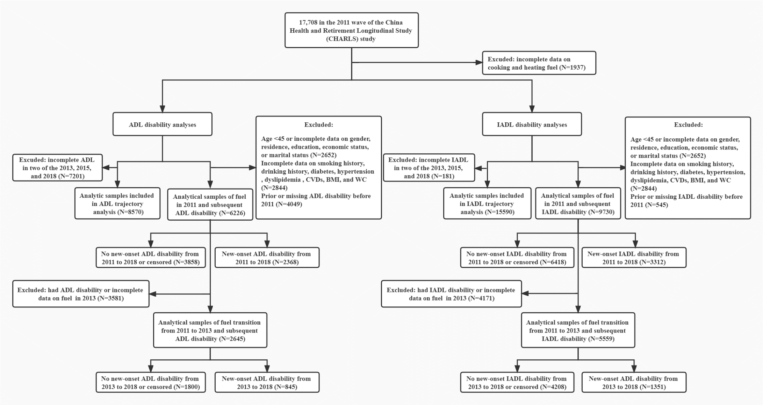

Figure S1. Flow chart
Note: ADL, activity of daily living. IADL, instrumental activity of daily living. CVDs, cardiovascular diseases. BMI, body mass index. WC, waist circumference.

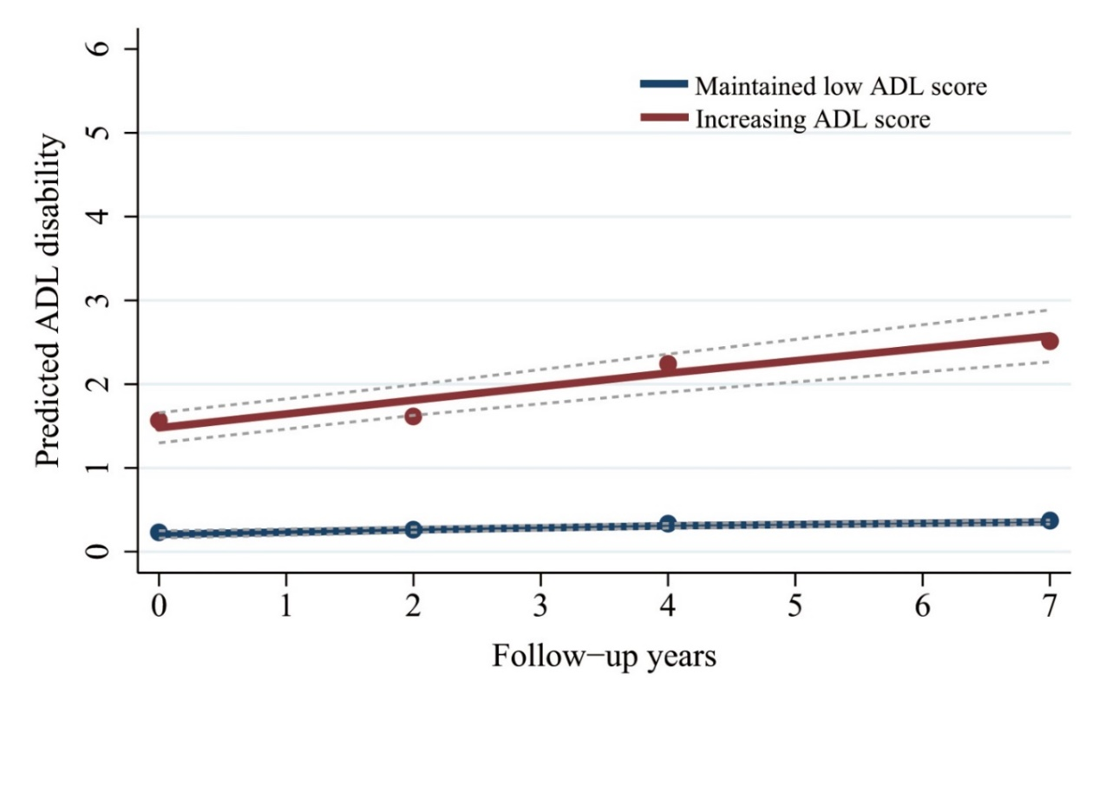

Figure S2. ADL trajectory groups during 2011 and 2018
Note: ADL, activity of daily living. “Maintained low ADL score” group represents those maintaining low degree of ADL disability between 2011 and 2018. “Increasing ADL score” group represents those with exacerbating ADL disability between 2011 and 2018.

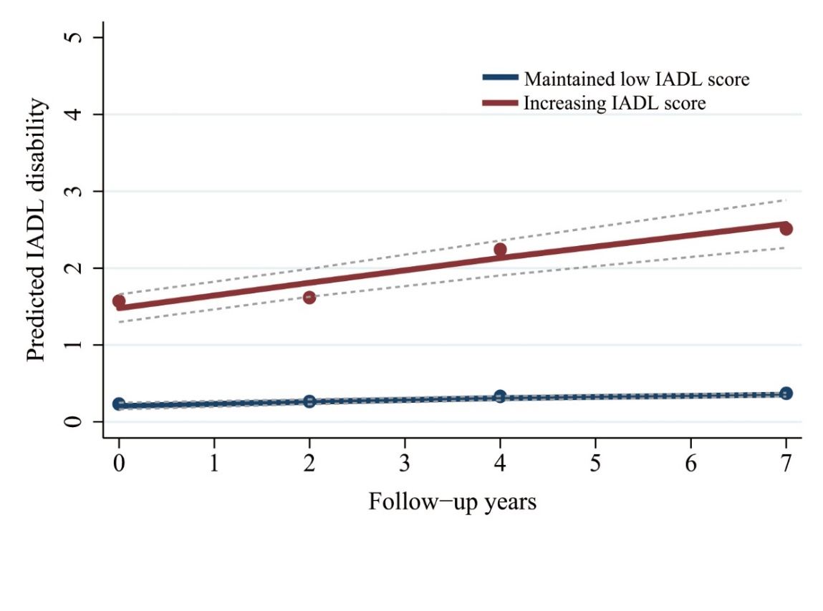

Figure S3. IADL trajectory groups during 2011 and 2018
Note: IADL, instrumental activity of daily living. “Maintained low IADL score” group represents those maintaining low degree of IADL disability between 2011 and 2018. “Increasing IADL score” group represents those with exacerbating IADL disability between 2011 and 2018.

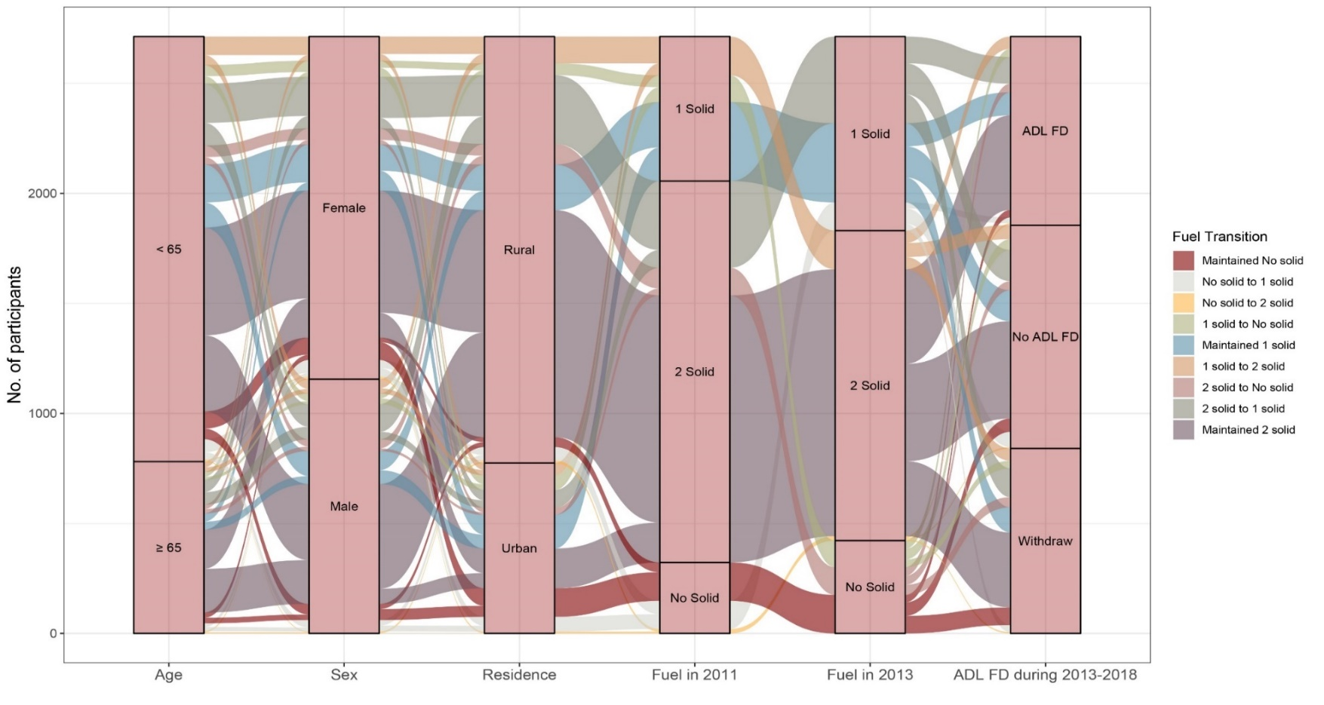

Figure S4. Sankey diagram of household fuel usage transition from 2011 to 2013 and subsequent new-onset ADL disability
Note: ADL, activity of daily living. FD, functional disability. 1 solid, either solid cooking fuel or solid heating fuel. 2 solid, both solid cooking fuel and solid heating fuel. No solid, both clean cooking fuel and clean heating fuel.
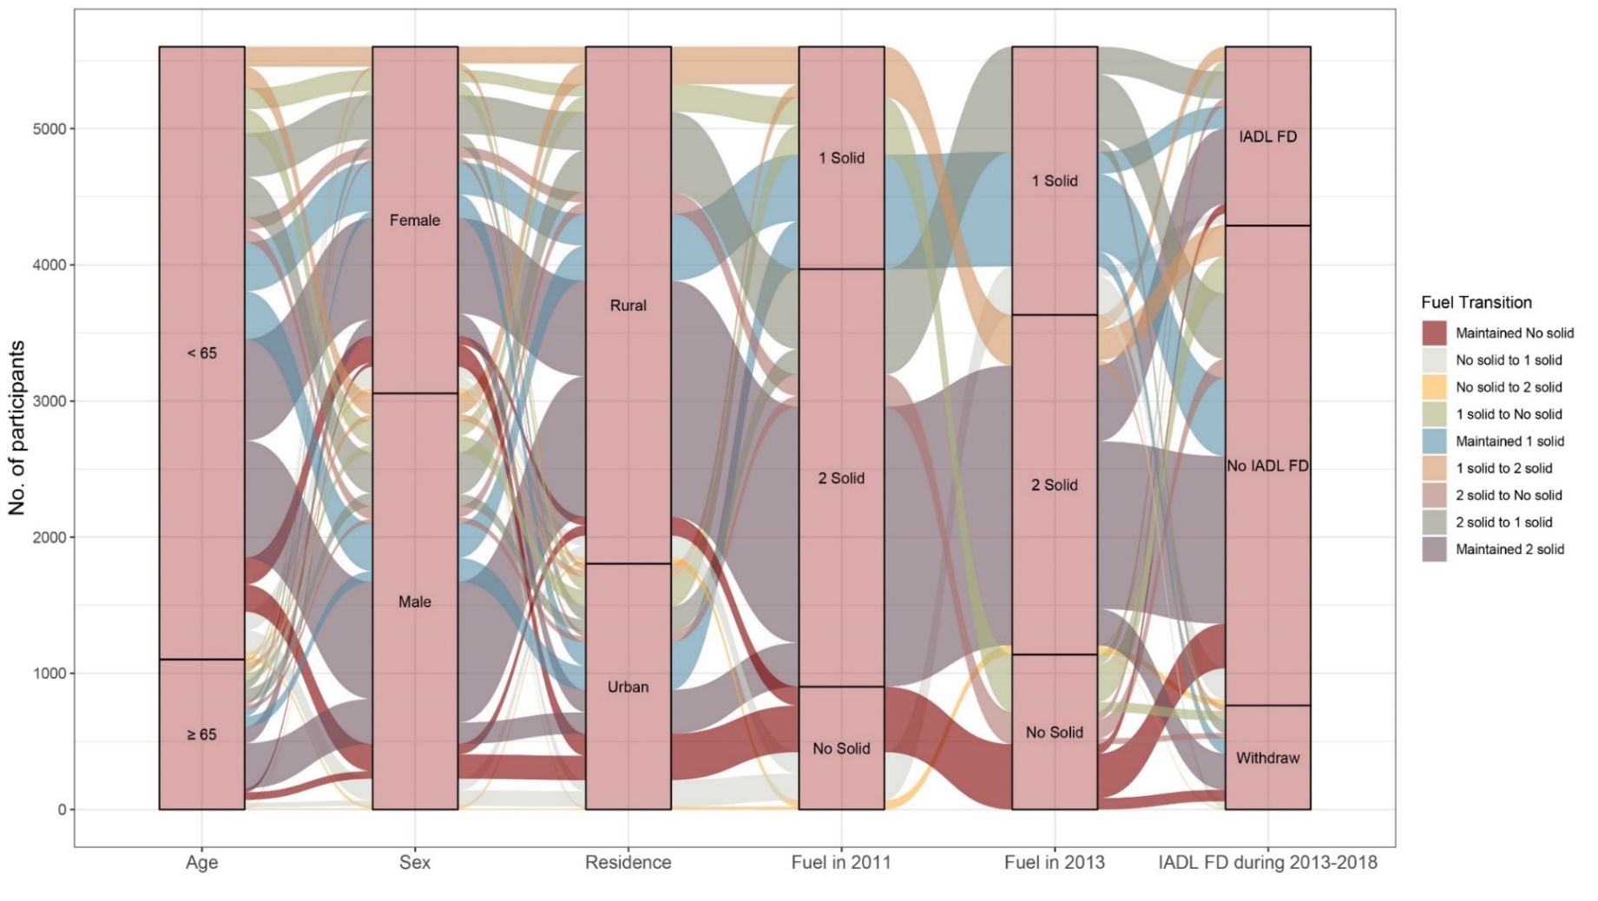

Figure S5. Sankey diagram of household fuel usage transition from 2011 to 2013 and subsequent new-onset IADL disability
Note: IADL, instrumental activity of daily living. FD, functional disability. 1 solid, either solid cooking fuel or solid heating fuel. 2 solid, both solid cooking fuel and solid heating fuel. No solid, both clean cooking fuel and clean heating fuel.

