Supplementary Information for
Atom-economic and Self-reported Thiol Activation through Visible Light Induced Photo-rearrangment for Efficient Click-ligation
Zhiwei Zhang,† Fang Zhang,† Long Deng, Huichao Guo, Tong Xia, Wenxuan Mao, Junji Zhang*
Key Laboratory for Advanced Materials and Joint International Research Laboratory of Precision Chemistry and Molecular Engineering, Feringa Nobel Prize Scientist Joint Research Center, Frontiers Science Center for Materiobiology and Dynamic Chemistry, Institute of Fine Chemicals, School of Chemistry and Molecular Engineering, East China University of Science and Technology, Shanghai 200237, China
Email addresses: zhangjunji@ecust.edu.cn
†These authors contributed equally to this work.

Contents
1. Materials and apparatus S3
2. Synthesis S3
3. Additional figures S9
4. Photochemical features S16
5. Computational details S18
6. NMR spectra S21
7. MS spectra S29
8. Reference S34

- Materials and apparatus
All reagents and chemicals were purchased from commercial suppliers and used without further purification unless otherwise indicated. Varian Cary 500 and Varian Cary Eclipse were employed to record absorption and emission spectra, respectively. Bruker AM-400 spectrometer was employed to record ¹H NMR spectra and Ascend-600 was employed to record ¹³C NMR spectra. All measurements were carried out in deuterated solvents. In all thiol Michael addition reactions, NEt₃ was chosen as the base. Evaporation of NEt₃ in vacuo from the resulting mixture enabled the product quantitatively with a trans/cis ratio. The chemical shift (δ) is recorded in parts per million (ppm) and relative to the residual solvent protons. The measured coupling constants were calculated in Hertz (Hz). To analyze the spectra, the software MESTRENOVA 11.0 was used. The resonances are quoted as follows: s = singlet, d = doublet, dd = doublet of doublets and m = multiplet. MS spectra were measured on a Micromass LCTTM (HREI-TOF) spectrometer or Matrix-Assisted Laser Desorption/Ionization Time of Flight Mass Spectrometry (ABI 4800 Plus). Visible light is provided by an LED flashlight plus a specific wavelength filter (> 530 nm) or an Hg/Xe lamp (Hamamatsu, LC8, Lightningcure, 200 W) plus a filter (475 nm, 520 nm, 560 nm, 730 nm).
- Synthesis
Supplementary Scheme 1. Synthesis route of the PBI-1a, 2a and semi-CDI-1, 2.
Supplementary Scheme 2. Thiol-Michael addition of semi-CDIs with acetylenedicarboxylic acid dimethylester (DMAD) and N-Boc-2-malemidoethylamine (NBM).
Synthesis of M2^{[1]}
In a 100 mL two-necked round-bottomed flask, perylene-3, 4, 9, 10-tetracarboxylic dianhydride (1.91 g, 4.86 mmol), and M1 (2.50 g, 14.60 mmol) in imidazole (12.00 g) were stirred 5 h at 160ºC. The reaction mixture was diluted with ethanol (70 mL) before complete cooling in order to dissolve the crystallizing imidazole. The reaction mixture was treated with added 2 M HCl solution (200 mL) and stirred overnight. The dark red precipitate was filtered and washed with water, and dried in vacuum at 60°C to give the crude product. The product was further purified by column chromatography on silica gel (eluent: CH₂Cl₂) to afford M2 (2.85 g, 84%) as red solid.

¹H NMR (400 MHz, CDCl₃) δ 8.61 (s, 4H), 8.50 (d, J = 8.1 Hz, 4H), 5.20-5.18 (m, 2H), 2.36-2.14 (m, 4H), 1.96-1.80 (m, 4H), 1.39-1.23 (m, 24H), 0.84-0.83 (m, 12H).

MALDI TOF MS (HR): Calc’d for C₄₆H₅₄N₂O₄ [M]⁺ 698.4084; Found 698.4016 (m/z).
Synthesis of PBI-Br^{[2]}
In a 150 mL closed round-bottom flask, a mixture of M2 (4.98 g, 7.12 mmol) and bromine (62.40 g, 0.39 mol) in 60 mL of dichloromethane was stirred at room temperature for 12 h. The excess of bromine was removed by air bubbling, the reaction mixture was diluted with dichloromethane, washed with Na₂S₂O₃ and H₂O, and then dried over anhydrous Mg₂SO₄. Upon removal of solvents in vacuo, the residual was purified with silica gel column chromatography (petroleum ether/CH₂Cl₂ = 2/1) to afford PBI-Br (2.76 g, 50%) as red solid.

¹H NMR (400 MHz, CDCl₃) δ 9.80 (d, J = 8.3 Hz, 1H), 8.93 (s, 1H), 8.74-8.60 (m, 5H), 5.24-5.12 (m, 2H), 2.30-2.19 (m, 4H), 1.87-1.84 (m, 4H), 1.34-1.27 (m, 24H), 0.85-0.83 (m, 12H).

¹³C NMR (151 MHz, CDCl₃) δ 164.39, 163.61, 163.29, 133.87, 133.51, 131.47, 128.08, 127.02, 123.72, 122.95, 120.93, 54.97, 54.79, 32.32, 32.25, 31.72, 26.63, 26.59, 22.57, 14.04.

HRMS-ESI: Calc’d for C₄₆H₅₃BrN₂O₄ [M+H]⁺ 777.3267; Found 777.3264 (m/z).
Synthesis of PBI-1a
A mixture of PBI-Br (0.20 g, 0.26 mmol), (2,5-dimethyl-3-thiophenyl) boronic acid (0.06 g, 0.38 mmol), and Pd(PPh₃)₄ (0.05 g, 0.04 mmol) was evacuated and backfilled with argon three times in a Schlenk tube. After the addition of degassed K₂CO₃ (aq. 2 mL), ethanol (1 ml) and toluene (5 mL), the tube was sealed under argon atmosphere and heated at reflux for 12 h. After being cooled to room temperature, the reaction mixture was diluted with dichloromethane, washed with water, and dried over anhydrous Mg₂SO₄. Upon removal of solvents in vacuo, the residual was purified with silica gel column chromatography (petroleum ether/CH₂Cl₂ = 2/1) in dark environment to afford PBI-1a (0.17 g, 82%) as red solid.

¹H NMR (400 MHz, CDCl₃) δ 8.64 (d, J = 7.0 Hz, 4H), 8.56-8.46 (m, 1H), 8.31 (d, J = 9.7 Hz, 1H), 8.12 (d, J = 8.3 Hz, 1H), 6.62 (s, 1H), 5.23-5.11 (m, 2H), 2.51 (s, 3H), 2.30-2.16 (m, 4H), 2.14 (s, 3H), 1.84-1.83 (m, 4H), 1.26-1.25 (m, 24H), 0.83-0.82 (m, 12H).

¹³C NMR (151 MHz, CDCl₃) δ 164.82, 163.73, 139.64, 136.20, 135.22, 134.75, 134.44, 133.10, 132.25, 131.41, 130.64, 127.86, 127.77, 125.27, 123.39, 122.64, 54.71, 54.66, 32.32, 31.76, 26.60, 22.56, 15.43, 14.05, 13.71.

MALDI TOF MS (HR): Calc’d for C₅₂H₆₀N₂O₄S [M-H]⁻ 807.4201; Found 807.4290 (m/z).
Synthesis of semi-CDI-1
PBI-1a (0.10 g, 0.13 mmol) was dissolved in 5 mL toluene with stirring under 530 nm light for 12 h. Upon removal of solvents in vacuo, the residual was purified with silica gel column chromatography (petroleum ether/CH₂Cl₂ = 2/1) to afford semi-CDI-1 (0.06 g, 60%) as orange-yellow solid.
¹H NMR (400 MHz, CDCl₃) δ 9.54 (s, 1H), 9.36 (s, 1H), 9.14 (d, J = 8.5 Hz, 2H), 8.99 (s, 2H), 6.95 (s, 1H), 5.32-5.31 (m, 2H), 3.12 (s, 3H), 2.62 (s, 1H), 2.54 (s, 3H), 2.36-2.35 (m, 4H), 1.98-1.96 (m, 4H), 1.34-1.33 (m, 24H), 0.84-0.82 (m, 12H).
¹³C NMR (151 MHz, CDCl₃) δ 165.21, 164.20, 136.07, 132.99, 132.67, 123.73, 123.60, 122.78, 122.72, 120.40, 54.96, 32.53, 31.87, 31.81, 29.70, 27.29, 26.83, 22.66, 22.61, 17.05, 14.08.

MALDI TOF MS (HR): Calc’d for C₅₂H₆₀N₂O₄S [M-H]⁻ 807.4201; Found 807.4315 (m/z).
Synthesis of PBI-2a
A mixture of PBI-Br (0.475 g, 0.611 mmol), (2-methylbenzo [b]thiophen-3-yl) boronic acid (0.18 g, 0.92 mmol), and Pd (PPh₃)₄ (0.05 g, 0.04 mmol) was evacuated and backfilled with argon three times in a Schlenk tube. After the addition of degassed K₂CO₃ (aq. 2 mL), ethanol (1 ml) and toluene (5 mL), the tube was sealed under argon atmosphere and heated at reflux for 12 h. After being cooled to room temperature, the reaction mixture was diluted with dichloromethane, washed with water, and dried over anhydrous Mg₂SO₄. Upon removal of solvents in vacuo, the residual was purified with silica gel column chromatography (petroleum ether/CH₂Cl₂ = 2/1) in dark environment to afford PBI-2a (0.38 g, 74%) as red solid.

¹H NMR (400 MHz, CDCl₃) δ 8.81-8.65 (m, 4H), 8.54 (d, J = 12.9 Hz, 1H), 8.02-7.91 (m, 3H), 7.39-7.29 (m, 2H), 7.23 (d, J = 7.4 Hz, 1H), 5.20-5.15 (m, 2H), 2.34 (s, 3H), 2.21-2.19 (m, 4H), 1.83-1.80 (m, 4H), 1.28-1.27 (m, 24H), 0.85-0.83 (m, 12H).

¹³C NMR (151 MHz, CDCl₃) δ 163.74, 163.43, 162.65, 162.33, 138.45, 135.41, 132.98, 130.56, 129.81, 127.01, 126.18, 123.94, 123.85, 122.46, 121.82, 121.54, 120.82, 53.77, 53.62, 31.28, 30.72, 30.68, 25.59, 25.55, 21.53, 21.49, 13.54, 12.99.

MALDI TOF MS (HR): Calc’d for C₅₅H₆₀N₂O₄S [M]⁺ 844.4274; Found 844.4156 (m/z).
Synthesis of semi-CDI-2
PBI-2a (0.10 g, 0.12 mmol) was dissolved in 5 mL toluene with stirring under 530 nm light for 12 h. Upon removal of solvents in vacuo, the residual was purified with silica gel column chromatography (petroleum ether/CH₂Cl₂ = 2/1) to afford semi-CDI-2 (0.07 g, 70%) as orange-yellow solid.

¹H NMR (400 MHz, CDCl₃) δ 9.75 (d, J = 11.9 Hz, 1H), 9.37 (dd, J = 8.5, 5.7 Hz, 2H), 9.10 (d, J = 7.8 Hz, 2H), 8.86 (s, 1H), 7.60 (s, 1H), 7.53-7.45 (m, 2H), 7.39-7.36 (m, 1H), 5.35-5.13 (m, 2H), 3.08 (s, 1H), 2.99 (s, 3H), 2.36-2.34 (m, 4H), 1.92-1.90 (m, 4H), 1.25-1.23 (m, 24H), 0.82-0.80 (m, 12H).

¹³C NMR (151 MHz, CDCl₃) δ 164.20, 163.17, 138.24, 132.32, 131.91, 131.60, 130.07, 129.16, 128.89, 128.46, 127.42, 125.41, 123.91, 122.90, 122.01, 53.95, 31.44, 30.76, 28.67, 25.74, 25.70, 21.56, 21.53, 16.32, 13.03.

MALDI TOF MS (HR): Calc’d for C₅₅H₆₀N₂O₄S [M+H]⁺ 845.4347; Found 845.4339 (m/z).
Thiol-Michael addition of semi-CDI-1, 2 with N-Boc-2-malemidoethylamine or DMAD (General)
A mixture of semi-CDI-1 or semi-CDI-2 (1.00 equiv), NBM or DMAD (1.20 equiv), toluene (5 mL), and TEA (0.10 equiv) in a round-bottom flask was stirred at room temperature for 2 h. Upon removal of solvents in vacuo, the residual was purified with silica gel column chromatography (petroleum ether/EA = 20/1) to afford semi-CDI-3 (80%, trans-: cis-isomer = 3:2), semi-CDI-4 (75%, trans-: cis-isomer = 3:2), semi-CDI-5 (68%), and semi-CDI-6 (73%) as yellow solid.
semi-CDI-3-trans
¹H NMR (600 MHz, CDCl₃) δ 9.72 (d, J = 18.8 Hz, 1H), 9.35 (dd, J = 8.4, 5.6 Hz, 2H), 9.14-9.01 (m, 2H), 8.87 (d, J = 24.8 Hz, 1H), 7.64-7.57 (m, 2H), 7.55-7.46 (m, 2H), 6.48 (s, 1H), 5.34-5.22 (m, 2H), 3.68 (s, 3H), 3.47 (s, 3H), 3.00 (s, 3H), 2.30-2.28 (m, 4H), 1.98-1.81 (m, 4H), 1.39-1.20 (m, 24H), 0.87-0.77 (m, 12H).

HRMS-ESI: Calc’d for C₆₁H₆₆N₂O₈S [M+H]⁺ 987.4618; Found 987.4602 (m/z).
semi-CDI-3-cis
¹H NMR (600 MHz, CDCl₃) δ 9.72 (d, J = 22.8 Hz, 1H), 9.38-9.37 (m, 2H), 9.20-8.97 (m, 2H), 8.74 (d, J = 14.7 Hz, 1H), 7.88 (dd, J = 7.9, 1.4 Hz, 1H), 7.72-7.71 (m, 2H), 7.59 (dd, J = 7.3, 1.6 Hz, 1H), 5.69 (s, 1H), 5.34-5.22 (m, 2H), 3.57 (d, J = 6.7 Hz, 6H), 2.94 (s, 3H), 2.37-2.17 (m, 4H), 1.90-1.87 (m, 4H), 1.29-1.22 (m, 24H), 0.82-0.80 (m, 12H).

MALDI TOF MS (HR): Calc’d for C₆₁H₆₆N₂O₈S [M-H]⁻ 985.4467; Found 985.3864 (m/z).
semi-CDI-4-trans
¹H NMR (600 MHz, CDCl₃) δ 9.69-9.60 (m, 1H), 9.47 (d, J = 21.3 Hz, 1H), 9.25 (d, J = 8.3 Hz, 2H), 9.08-8.97 (m, 2H), 7.35 (s, 1H), 6.56 (s, 1H), 5.32-5.30 (m, 2H), 3.92 (s, 3H), 3.52 (s, 3H), 3.22 (s, 3H), 2.49-2.41 (m, 3H), 2.39-2.31 (m, 4H), 1.93-1.92 (m, 4H), 1.39-1.22 (m, 24H), 0.87-0.80 (m, 12H).

MALDI TOF MS (HR): Calc’d for C₅₈H₆₆N₂O₈S [M-H]⁻ 949.4467; Found Mass (M⁻) 949.4140 (m/z).
semi-CDI-4-cis
¹H NMR (600 MHz, CDCl₃) δ 9.68 (d, J = 20.3 Hz, 1H), 9.40-9.30 (m, 3H), 9.12-9.02 (m, 2H), 7.60 (s, 1H), 6.06 (s, 1H), 5.30 (m, 2H), 3.76 (s, 3H), 3.68 (s, 3H), 3.18 (s, 3H), 2.64 (d, J = 1.4 Hz, 3H), 2.38-2.28 (m, 4H), 1.93-1.91 (m, 4H), 1.34-1.23 (m, 24H), 0.83-0.81 (m, 12H).

MALDI TOF MS (HR): Calc’d for C₅₈H₆₆N₂O₈S [M-H]⁻ 949.4467; Found 949.4140 (m/z).
semi-CDI-5
¹H NMR (600 MHz, CDCl₃) δ 9.52 (dd, J = 32.6, 13.1 Hz, 1H), 9.42-9.26 (m, 1H), 9.13-9.12 (m, 2H), 9.01-8.90 (m, 2H), 7.15 (s, 1H), 5.34-5.27 (m, 2H), 4.72-4.45 (m, 1H), 4.20 (dd, J = 9.5, 4.3 Hz, 1H), 3.54-3.53 (m, 2H), 3.26 (m, 2H), 3.10 (s, 3H), 3.07 (s, 1H), 2.69 (d, J = 26.3 Hz, 3H), 2.39-2.29 (m, 4H), 2.03-1.91 (m, 4H), 1.50-1.38 (m, 9H), 1.34-1.22 (m, 24H), 0.90-0.81 (m, 12H).

HRMS-ESI: Calc’d for C₆₃H₇₆N₄O₈S [M+Na]⁺ 1071.5282; Found 1071.5157 (m/z).
semi-CDI-6
¹H NMR (600 MHz, C₂D₂Cl₄, 120ºC) δ 9.76 (d, J = 2.6 Hz, 1H), 9.38-9.37 (m, 2H), 9.12-9.10 (m, 2H), 8.84 (dd, J = 10.7, 2.8 Hz, 1H), 8.01-7.89 (m, 1H), 7.75-7.64 (m, 2H), 7.48 (s, 1H), 5.38-5.23 (m, 2H), 4.50 (d, J = 24.1 Hz, 1H), 4.17-4.00 (m, 1H), 3.52-3.50 (m, 2H), 3.27-3.17 (m, 2H), 3.05-2.98 (m, 3H), 2.96 (d, J = 9.2 Hz, 1H), 2.41-2.25 (m, 4H), 2.08-1.95 (m, 4H), 1.46-1.42 (m, 9H), 1.40-1.30 (m, 24H), 0.91-0.89 (m, 12H).

HRMS-ESI: Calc’d for C₆₆H₇₆N₄O₈S [M-H]⁻ 1083.5306; Found 1083.5332 (m/z).

- Additional figures
¹H NMR monitoring of photoreaction of PBI-1a, 2a
NMR monitoring of PBI-1a
Supplementary Fig. 1 ¹H NMR monitoring of photoreaction of PBI-1a (400 MHz, CDCl₃). I-spectrum of PBI-1a before irradiation; II-spectrum of PBI-1a after irradiation with visible light (530 nm) for 18 h; III-spectrum after irradiation with visible light (530 nm) for 24 h. The photoreaction conversion ratio (79 %) of PBI-1a to semi-CDI-1 was determined by integrating the newly formed singlet peak at 2.62 ppm in III.

NMR monitoring of PBI-2
Supplementary Fig. 2 ¹H NMR monitoring of photoreaction of PBI-2a (400 MHz, CDCl₃). I-spectrum of PBI-2a before irradiation; II-spectrum of PBI-2a after irradiation with visible light (530 nm) for 18 h; III-spectrum after irradiation with visible light (530 nm) for 24 h; IV-spectrum after irradiation with visible light (530 nm) for 26 h; V-spectrum of isolated photoproduct semi-CDI-2. The photoreaction conversion ratio (72 %) of PBI-2a to semi-CDI-2 was determined by integrating the newly formed singlet peak at 3.08 ppm in IV.

Supplementary Fig. 3 ¹H NMR spectra of semi-CDI-2 (I) and semi-CDI-2 after addition of one drop of D₂O (II) in CDCl₃.

Supplementary Fig. 4 a) The chemical structures of PBI-2a and photorearrangement product semi-CDI-2. b) Structural characterization of semi-CDI-2 by NOESY spectrum in CDCl₃.

Supplementary Fig. 5 Proposed mechanism of the photorearrangement of PBI-2a upon irradiation.

Supplementary Fig. 6 Absorption of (a) PBI-1a (0.8 × 10⁻⁵ M) and (b) PBI-2a (0.6 × 10⁻⁵ M) before irradiation (black dash line) and subsequent detailed spectra changes upon sequential irradiation with 530 nm light (solid lines). Inset: the enlarged partial spectra ((a):390 nm-510 nm; (b): 300-520 nm).

Supplementary Fig. 7 Absorption spectra changes of (a) PBI-1a (0.8 × 10⁻⁵ M) and (b) PBI-2a (0.6 × 10⁻⁵ M) after prolonged irradiation with 560 nm in toluene.

Supplementary Fig. 8 LUMOs and the partially enlarged view of the a) PBI-1a; b) PBI-2a.
Supplementary Fig. 9 ¹H NMR spectra of the light-induced rearrangement of PBI-1a resulting in the stable and reactive semi-CDI-1 (I) and subsequent Michael addition with DMAD (I) to form the ligation product semi-CDI-4-trans (II)/-cis (III) are shown. The trans-/cis-isomer ratio was obtained from the spectrum of the eventual reaction mixture (IV).

Supplementary Fig. 10 ¹H NMR spectra of the light-induced rearrangement of PBI-1a resulting in the stable and reactive semi-CDI-1 (I) and subsequent Michael addition with NBM (II) to form the ligation product semi-CDI-5 (III) in CDCl₃.
Supplementary Fig. 11 ¹H NMR spectra of the light-induced rearrangement of PBI-2a resulting in the stable and reactive semi-CDI-2 (I) and subsequent Michael addition with NBM (II) in CDCl₃ to form the ligation product semi-CDI-6 (III) in C₂D₂Cl₄.

- Photochemical features
Determination of relative fluorescence quantum yields^{[3]}
Quantum yields are measured by the relative method, $Q_{X}$, is calculated according to the following eq. (1):
$Q_{X}=Q_{R}∙\frac{A_{R}}{A_{X}}∙\frac{E_{X}}{E_{R}}∙\frac{I_{R}}{I_{X}}∙\frac{n_{X}^{2}}{n_{R}^{2}}$(1)
where $Q_{R}$ is the quantum yield of the standard, A is the absorbance of the solution, E is the corrected emission intensity, I is the relative intensity of the exciting light and n is the average refractive index of the solution. Subscripts R and X refer to the reference and target compound, respectively. The relative intensity of the excitation light at different wavelengths is taken to be unity, which simplifies to eq. (2):
$Q_{X}=Q_{R}∙\frac{A_{R}}{A_{X}}∙\frac{E_{X}}{E_{R}}∙\frac{n_{X}^{2}}{n_{R}^{2}}$ (2)
The fluorescence quantum yield of PBI-1a, 2a and semi-CDI-1, 2 was determined by comparison with the reference PBI^{[4]} (with a fluorescence quantum yield of 0.99) (Fig. S12 (left)). Four to five samples were prepared each for PBI-1a, 2a (semi-CDI-1, 2) and reference PBI, with a different absorbance at an excitation wavelength of 487 nm (0.01-0.1). Then, the excitation wavelength was fixed at 487 nm, and the fluorescence of the target samples was measured. Fluorescence quantum yields were determined by eq. (2).
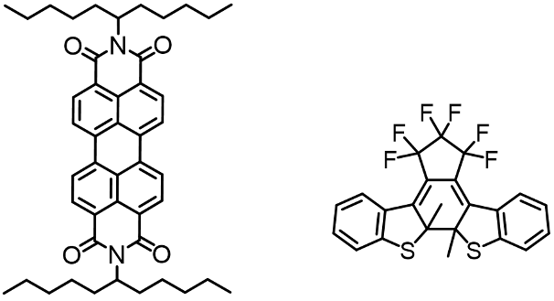
Supplementary Fig. 12 Structure of reference PBI (left) and closed-ring isomer of DAE (right).

Determination of overall photoreaction quantum yields^{[5]}
The photoreaction quantum yields ($φ$) of the PBI-1a, 2a is defined as eq. (3):
$φ=\frac{\frac{dn_{m}}{dt}}{n_{p}（1-{10}^{-A'}）}$ (3)
where n_{m} is the number of molecules of the photogenerated semi-CDI-1, 2; n_{p} is the irradiation photon number per second at irradiation wavelength; A' is the absorbance of the PBI-1a, 2a at irradiation wavelength. Based on Lambert-Beer’s law, the absorbance of photogenerated semi-CDI-1, 2, A is expressed as eq. (4):
$A=ε×\frac{n_{m}}{N_{A}}×\frac{1000}{υ}×l$ (4)
where ε is the absorption coefficient of the semi-CDI-1, 2 (L mol⁻¹ cm⁻¹ ), N_{A} Avogadro’s number, v solution volume (cm³ ), l cell length (cm). From eqs. (3) and (4), $φ$is expressed as follows:
$φ=\frac{N_{A}υ\frac{dA}{dt}}{1000εln_{p}（1-{10}^{-A'}）}$ (5)
In the early stage of the photoreaction the conversion ratio from the PBI-1a, 2a to the semi-CDI-1, 2 is low and A' is assumed to be constant.
$\int_{A\left(0\right)}^{A\left(t\right)}{dA}=\frac{1000εln_{p}（1-{10}^{-A^{'}}）φ}{N_{A}υ}\int_{0}^{t}{dt}$ (6)
$\frac{A\left(t\right)-A(0)}{t}=\frac{1000εln_{p}(1-{10}^{-A'})φ}{N_{A}υ}$ (7)
Take $\frac{A\left(t\right)-A(0)}{t}$as k, eq. (4) is expressed as follows:
$k=\frac{1000εln_{p}(1-{10}^{-A'})φ}{N_{A}υ}$ (8)
The excitation wavelength was fixed at 520 nm and according to eq. (8), the overall photoreaction quantum yields of PBI-1a, 2a were determined by comparison with the reference closed-ring isomer of DAE (λ_{max} =515 nm, ε =1.00 L mol⁻¹ cm⁻¹) (Fig. S12 (right)).
- Computational details
Gaussian 09 software package was used for the calculation.^{[6]} The ground-state geometries were fully optimized in toluene solution by using DFT calculations at the PBE0 level^{[7]} in conjunction with the polarizable continuum model (CPCM)^{[8]} using toluene as the solvent at the 6-311g* basis set.^{[9]} At the optimized geometries, time-dependent DFT (TDDFT) calculations were carried out using the 6-311g* basis set. All calculations were carried out using the Gaussian09 program package. Long alkyl chains of all compounds were replaced by methyl groups to simplify the system here.

Supplementary Table 1. TDDFT/PCM vertical excitation wavelength (nm) of the first singlet excited states of detected compounds with the orbitals involved in the major excitation (H = HOMO and L = LUMO) and oscillator strengths (f) in toluene.
Compounds | Excited state | Oscillator strength | MO composition | Vertical excitation wavelength (nm)
PBI-1a | S₁ | 0.3535 | H→L (0.9338)  H-1→L (0.0619) | 580
PBI-1b | S₁ | 0.2960 | H→L (0.9301)  H→L+1 (0.0623) | 612
Semi-CDI-1 | S₁ | 0.5331 | H→L (0.8654)  H-1→L (0.1175) | 464
PBI-2a | S₁ | 0.2675 | H→L (0.9330)  H-1→L (0.0603) | 589
PBI-2b | S₁ | 0.3387 | H→L (0.9704) | 596
Semi-CDI-2 | S₁ | 0.1966 | H→L (0.3752)  H-1→L (0.6127) | 465

Supplementary Table 2. Orbital energies in eV for PBI-2a, 2b and semi-CDI-2 in toluene..
Compounds | HOMO | LUMO | ΔE
PBI-2a | -6.20 | -3.53 | 2.67
PBI-2b | -5.85 | -3.17 | 2.67
semi-CDI-2 | -6.47 | -3.31 | 3.16

Supplementary Table 3. Spatial plots (isovalue = 0.02) of HOMO and LUMO of the PBI-2a, PBI-2b and semi-CDI-2 in toluene.
Compounds | HOMO | LUMO
PBI-2a | 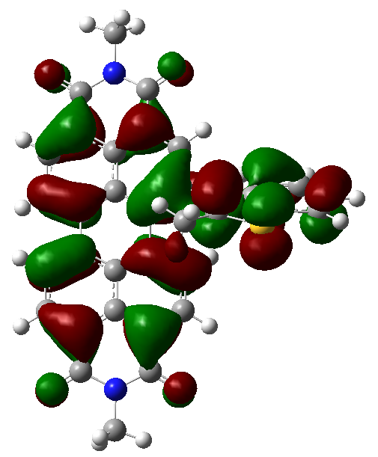 | 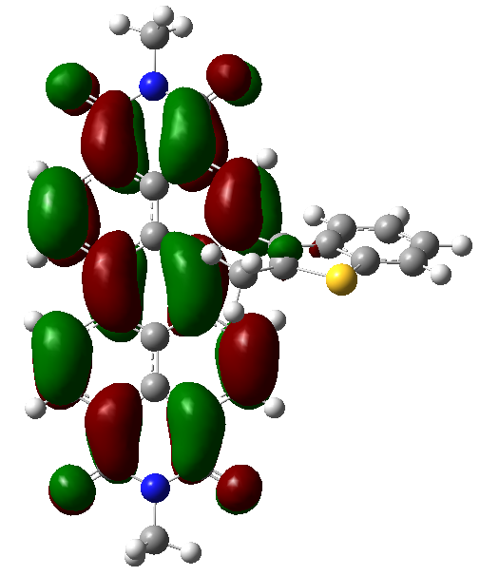
PBI-2b | 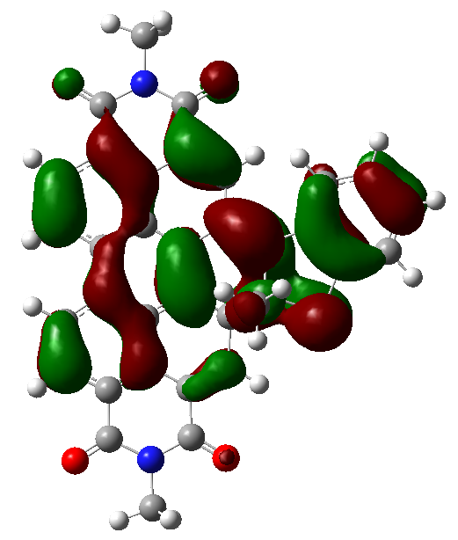 | 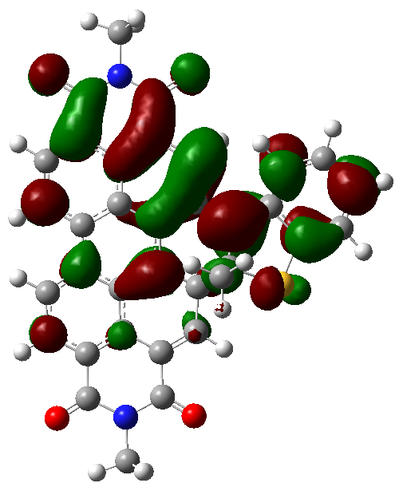
semi-CDI-2 | 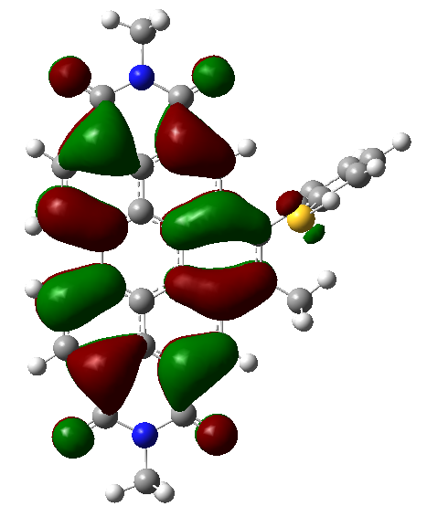 | 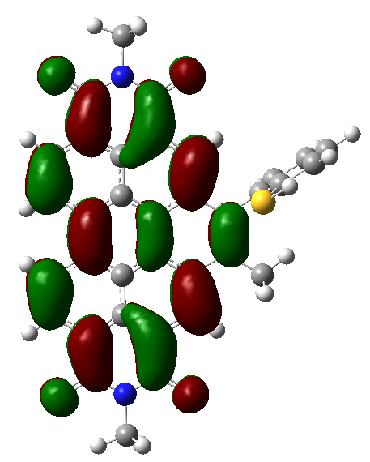

- NMR spectra
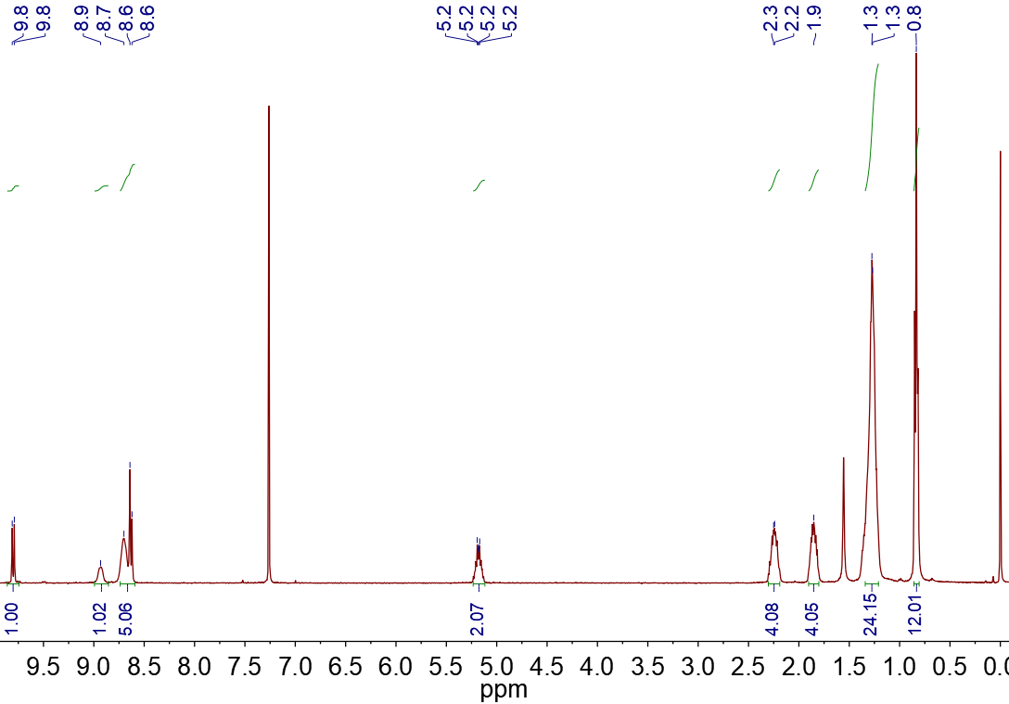 Supplementary Fig. 13 ¹H NMR of compound PBI-Br (400 MHz) in CDCl₃.

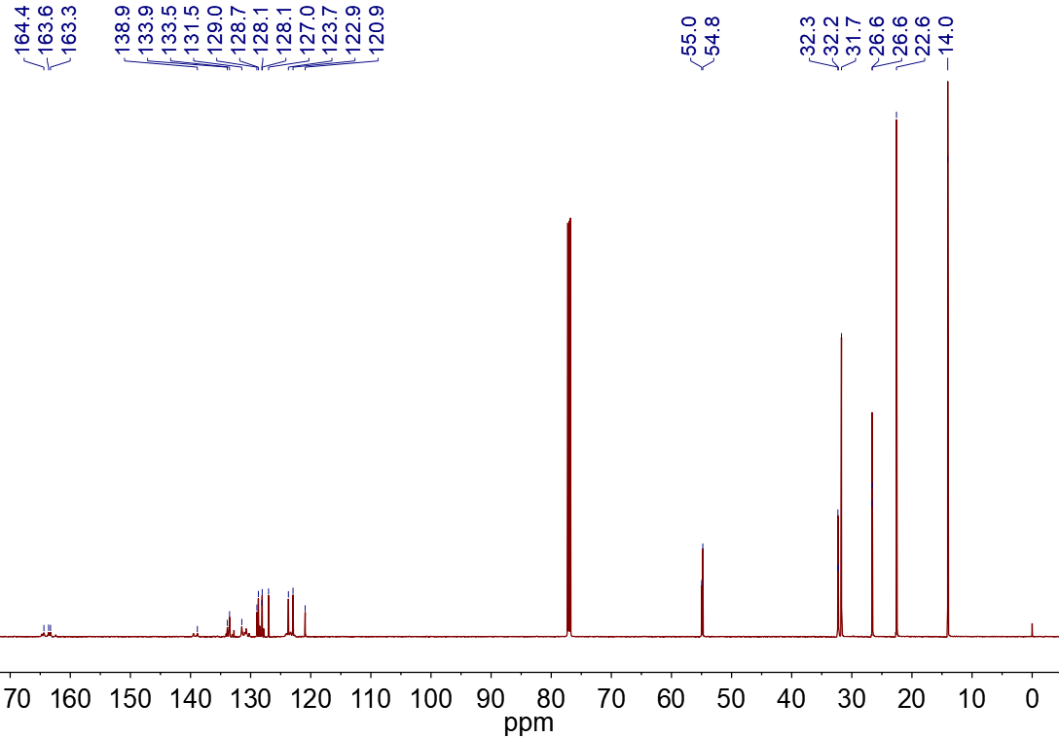 Supplementary Fig. 14 ¹³C NMR of compound PBI-Br (151 MHz) in CDCl₃.

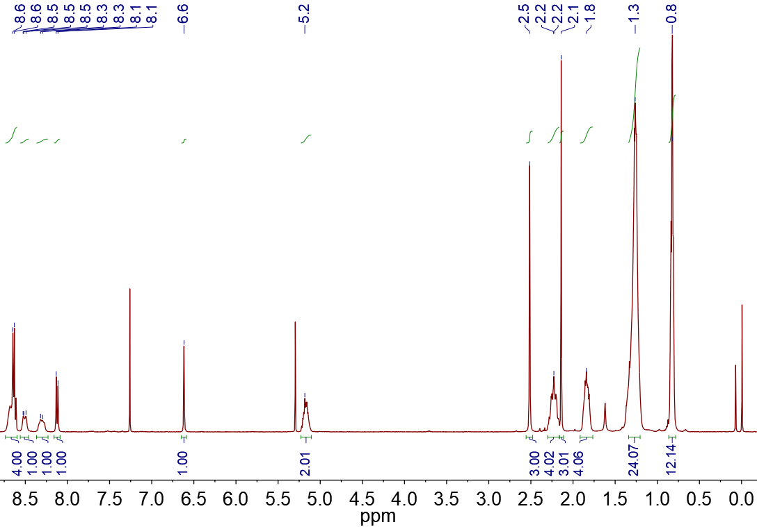 Supplementary Fig. 15 ¹H NMR of compound PBI-1a (400 MHz) in CDCl₃.

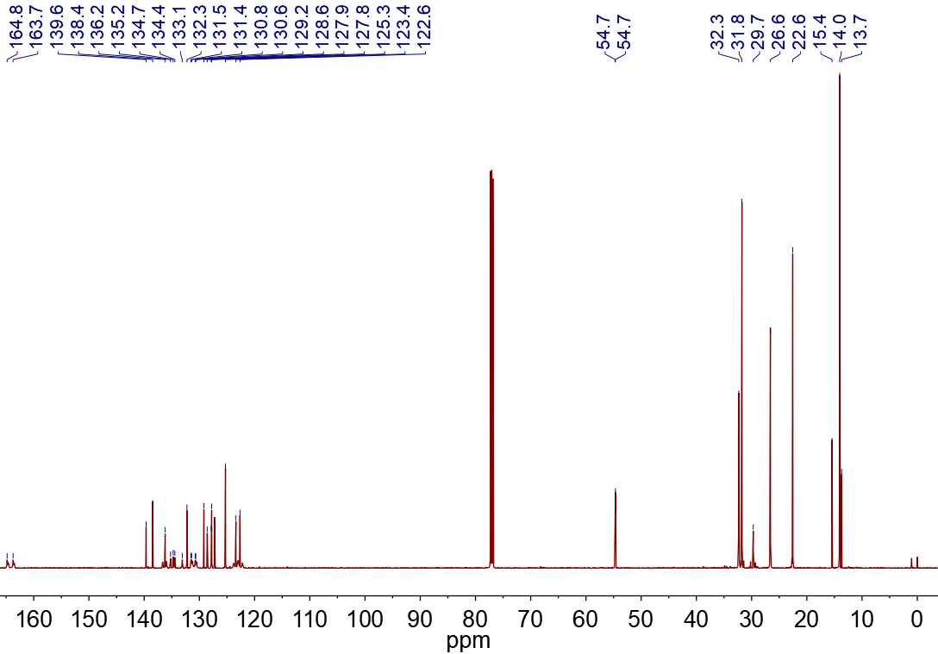 Supplementary Fig. 16 ¹³C NMR of compound PBI-1a (151 MHz) in CDCl₃.
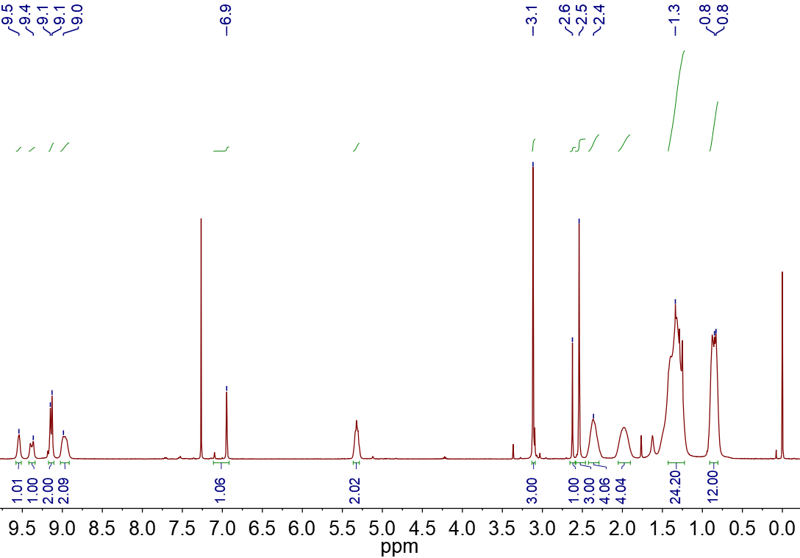 Supplementary Fig. 17 ¹H NMR of compound semi-CDI-1 (400 MHz) in CDCl₃.

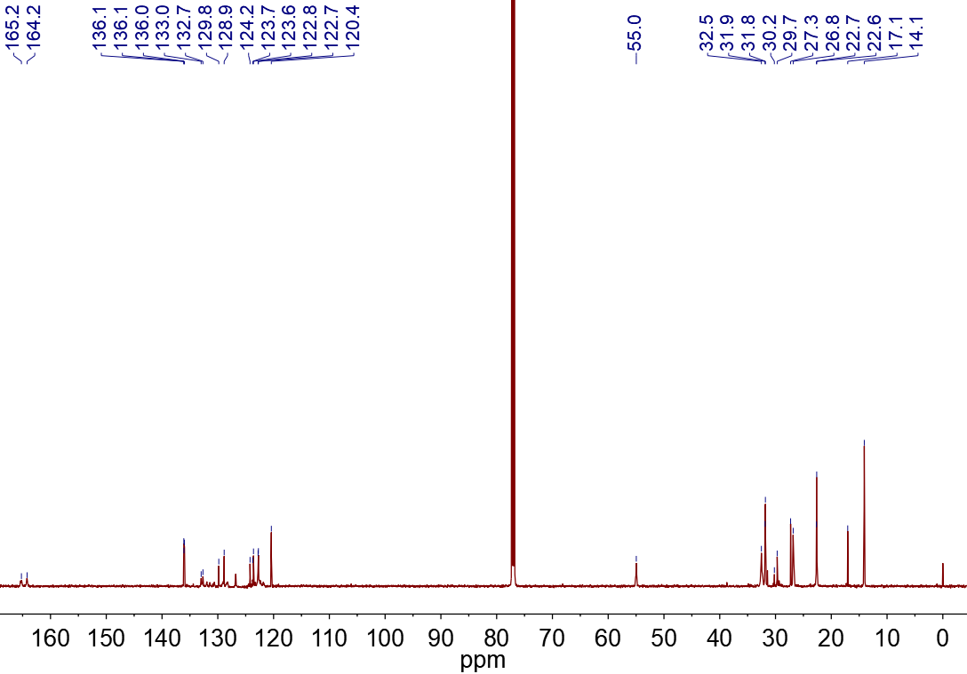 Supplementary Fig. 18 ¹³C NMR of compound semi-CDI-1 (151 MHz) in CDCl₃.
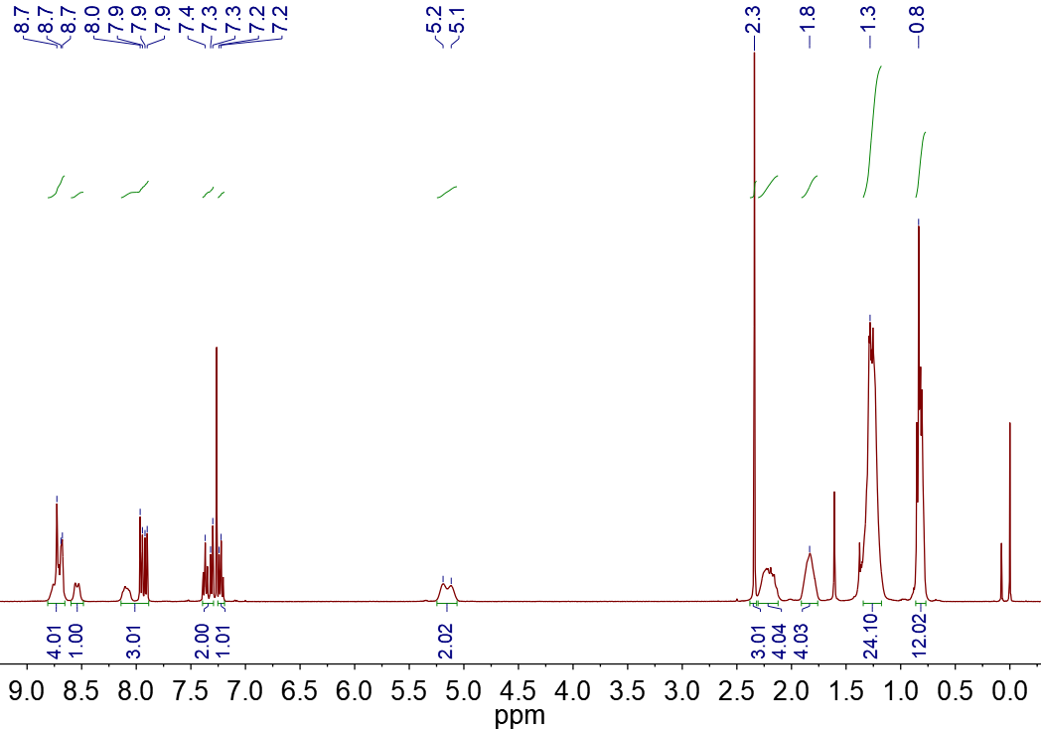 Supplementary Fig. 19 ¹H NMR of compound PBI-2a (400 MHz) in CDCl₃.

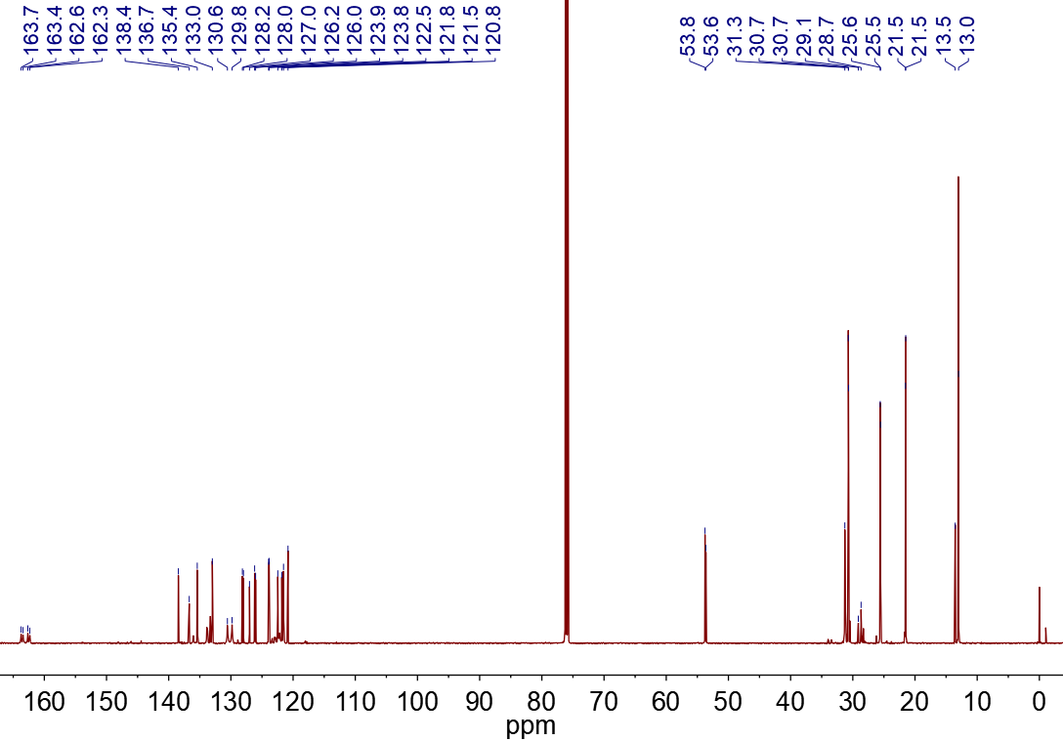 Supplementary Fig. 20 ¹³C NMR of compound PBI-2a (151 MHz) in CDCl₃. 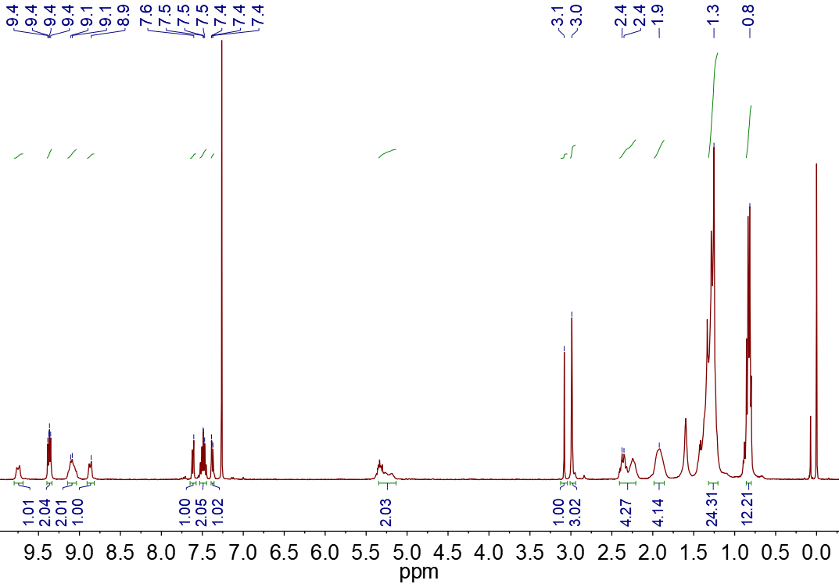 Supplementary Fig. 21 ¹H NMR of compound semi-CDI-2 (400 MHz) in CDCl₃.

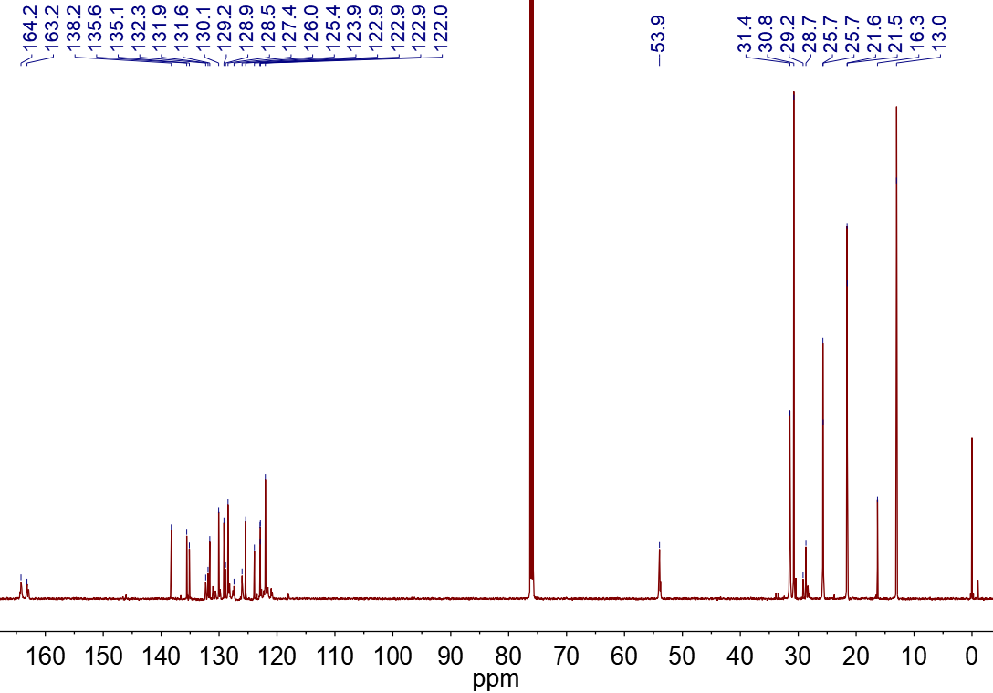 Supplementary Fig. 22 ¹³C NMR of compound semi-CDI-2 (151 MHz) in CDCl₃.
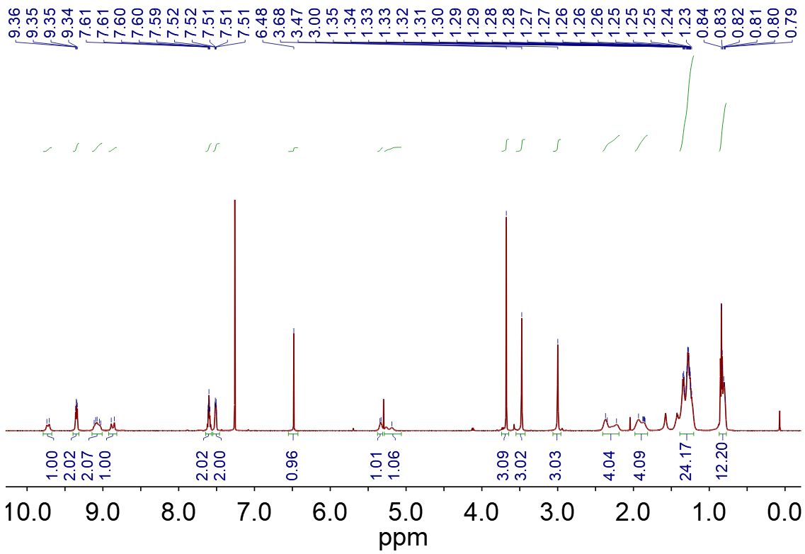
Supplementary Fig. 23 ¹H NMR of compound semi-CDI-3-trans (600 MHz) in CDCl₃.

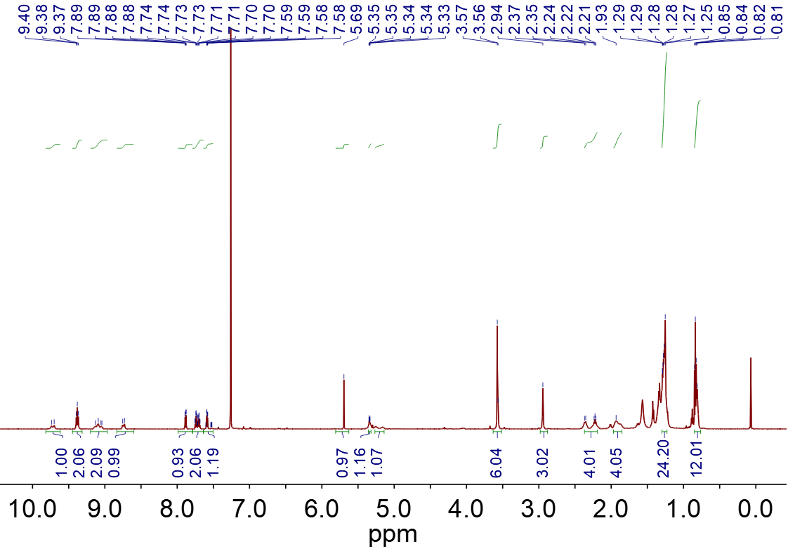
Supplementary Fig. 24 ¹H NMR of compound semi-CDI-3-cis (600 MHz) in CDCl₃.

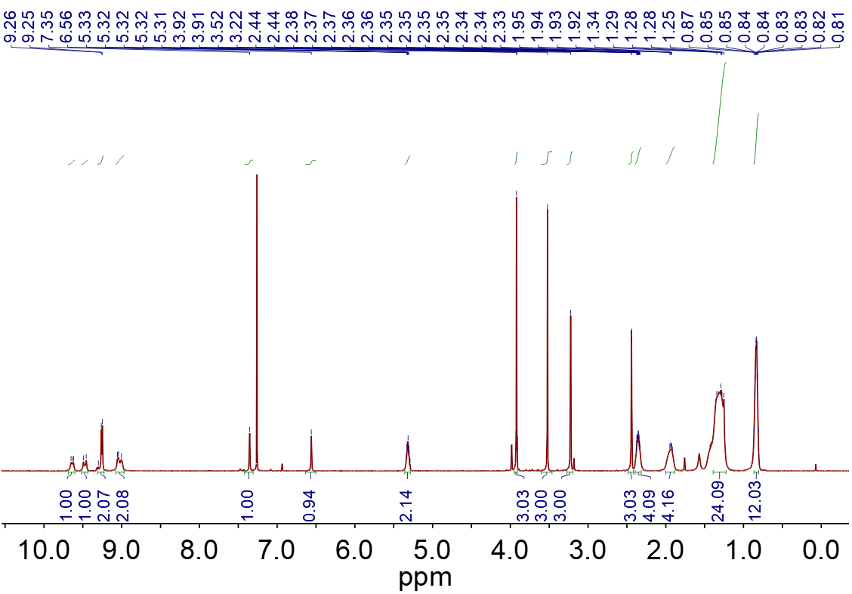 Supplementary Fig. 25 ¹H NMR of compound semi-CDI-4-trans (600 MHz) in CDCl₃.

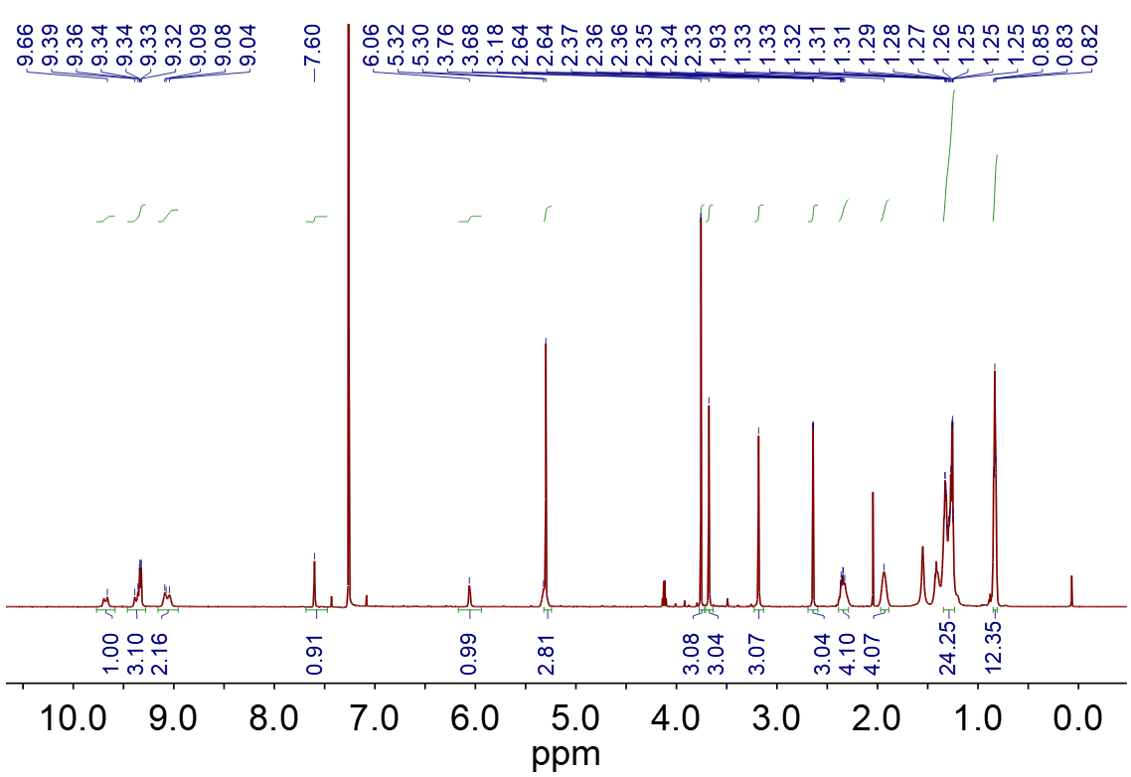 Supplementary Fig. 26 ¹H NMR of compound semi-CDI-4-cis (600 MHz) in CDCl₃.
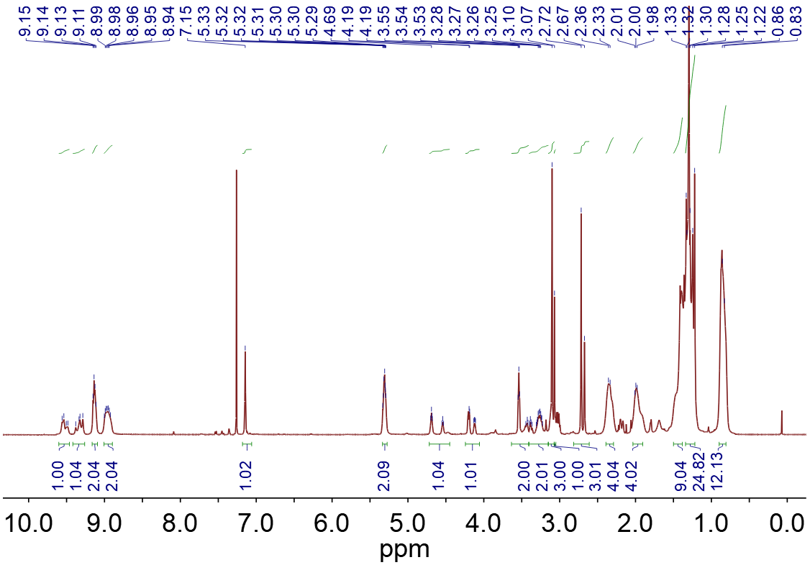 Supplementary Fig. 27 ¹H NMR of compound semi-CDI-5 (600 MHz) in CDCl₃.

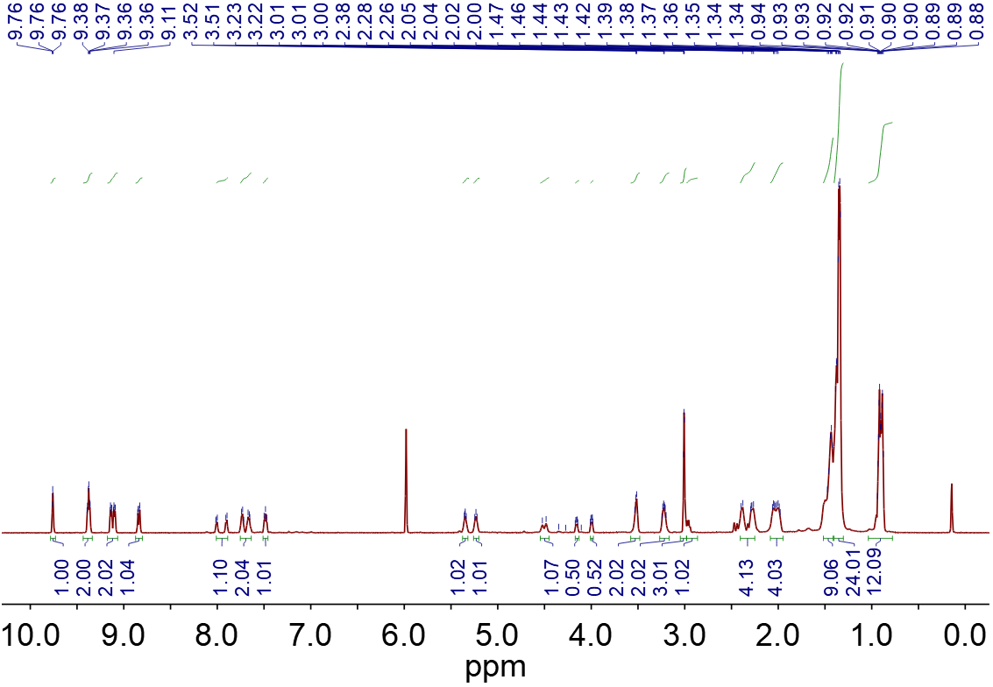
Supplementary Fig. 28 ¹H NMR of compound semi-CDI-6 (600 MHz, 120 ℃) in C₂D₂Cl₄.

- MS spectra

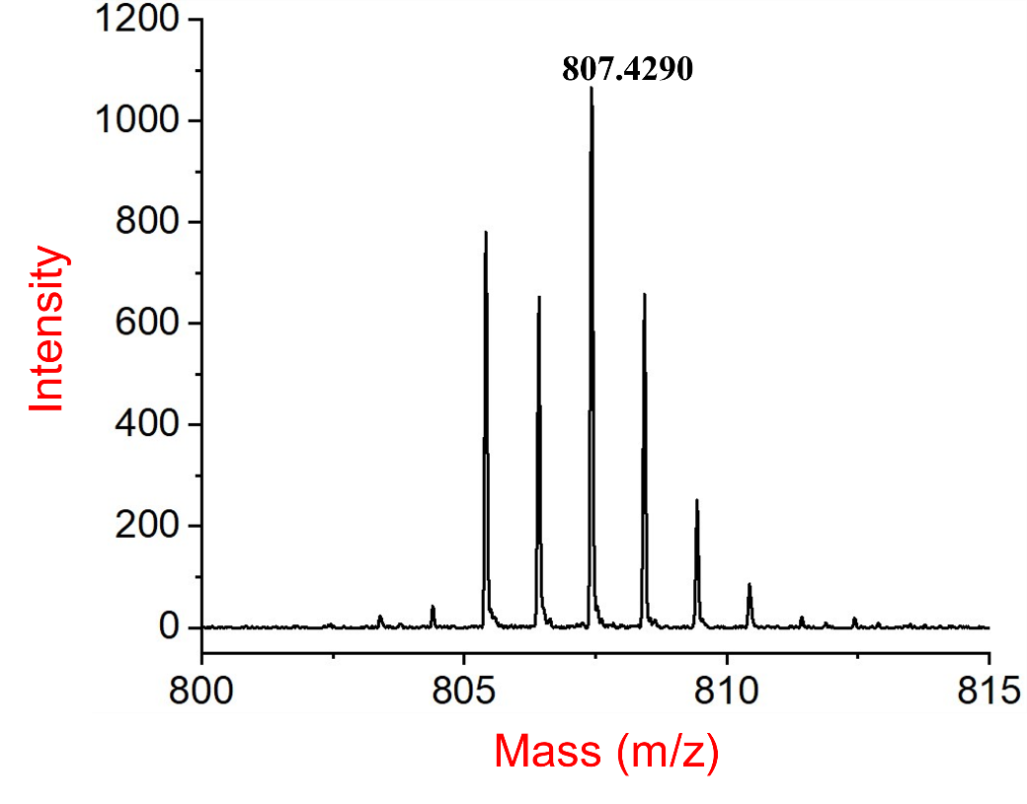
Supplementary Fig. 29 HRMS (MALDI-TOF) spectrum of compound PBI-1a.

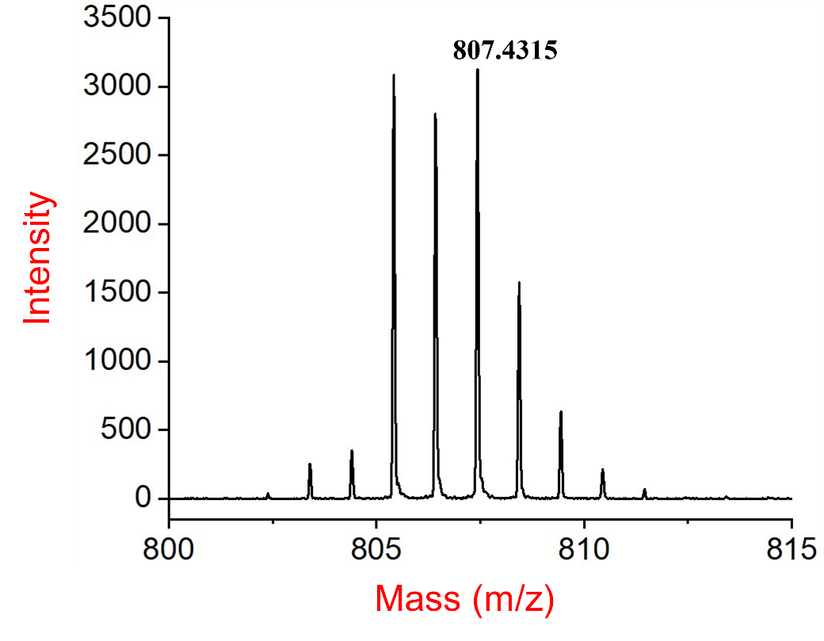
Supplementary Fig. 30 HRMS (MALDI-TOF) spectrum of compound semi-CDI-1.
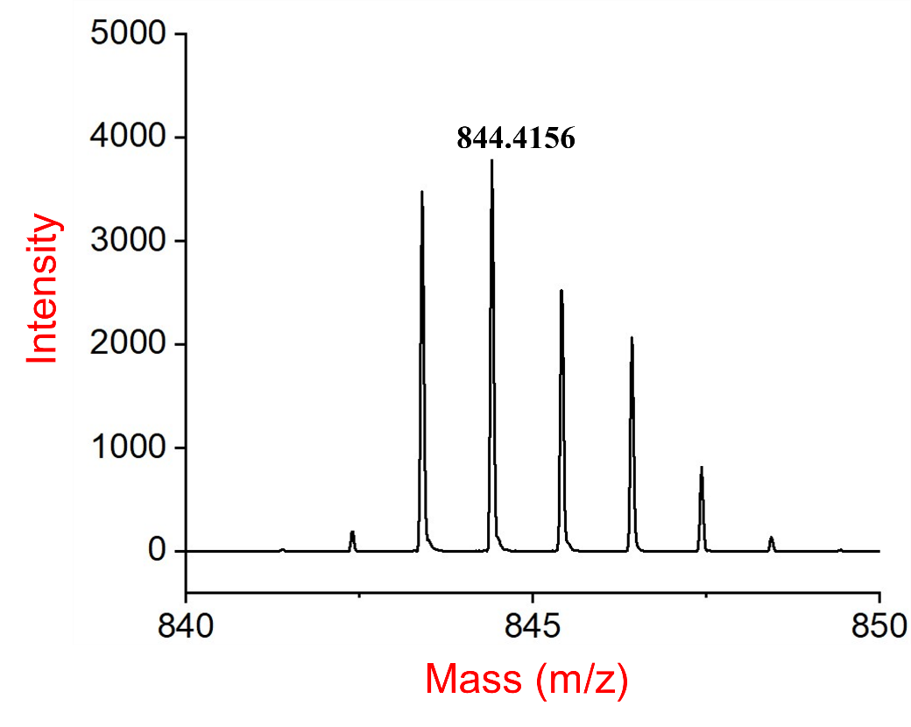
Supplementary Fig. 31 HRMS (MALDI-TOF) spectrum of compound PBI-2a.

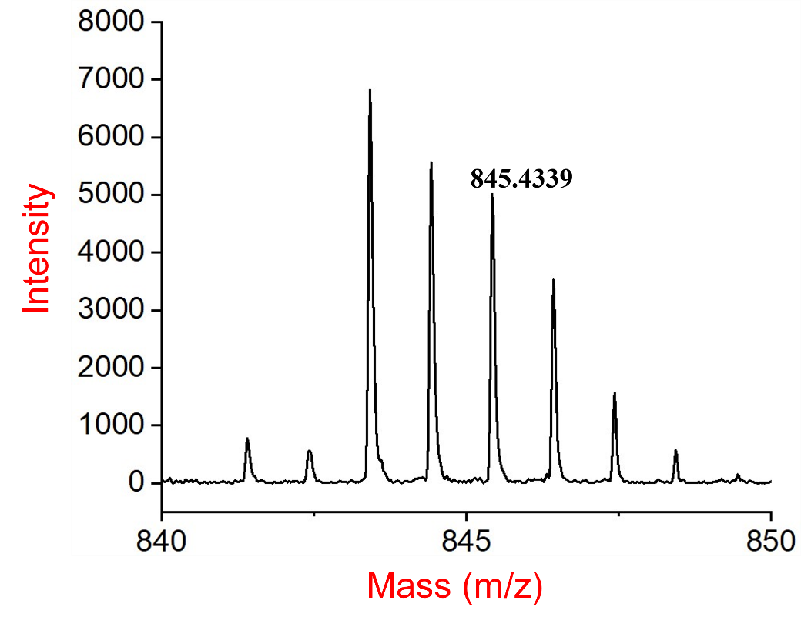
Supplementary Fig. 32 HRMS (MALDI-TOF) spectrum of compound semi-CDI-2.
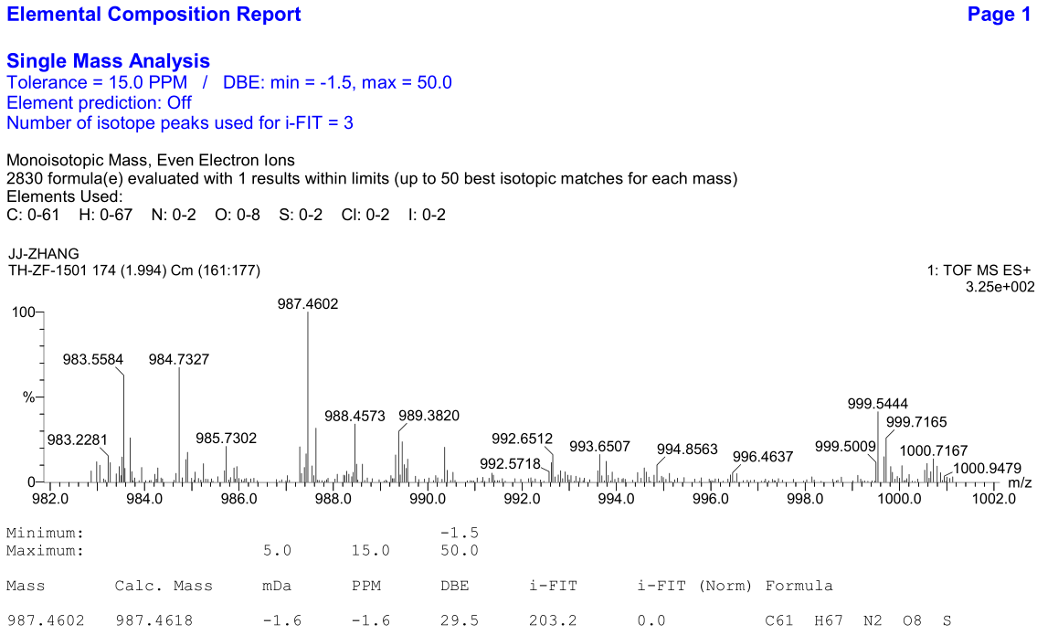
Supplementary Fig. 33 HRMS (ESI) spectrum of compound semi-CDI-3-trans.

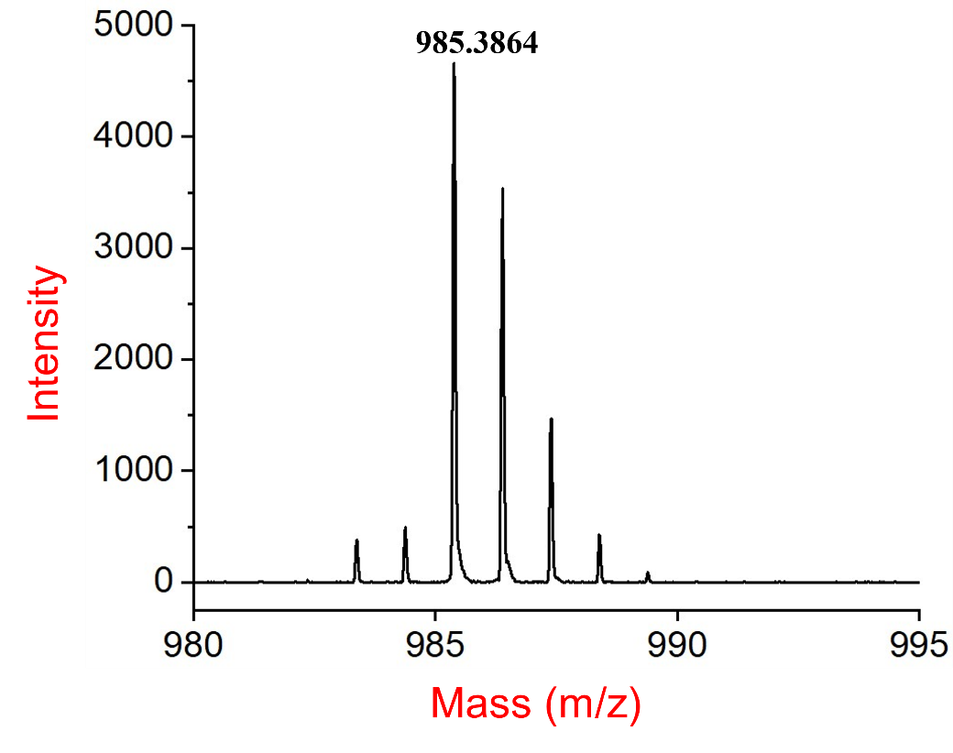
Supplementary Fig. 34 HRMS (MALDI-TOF) spectrum of compound semi-CDI-3-cis.
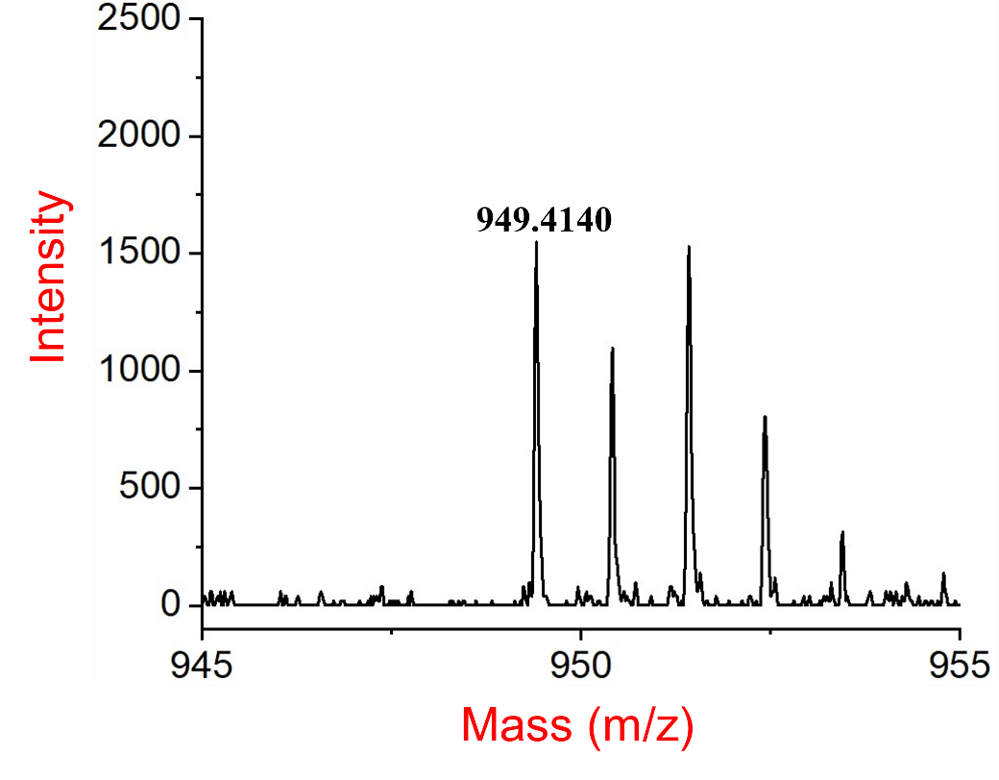
Supplementary Fig. 35 HRMS (MALDI-TOF) spectrum of compound semi-CDI-4-trans.

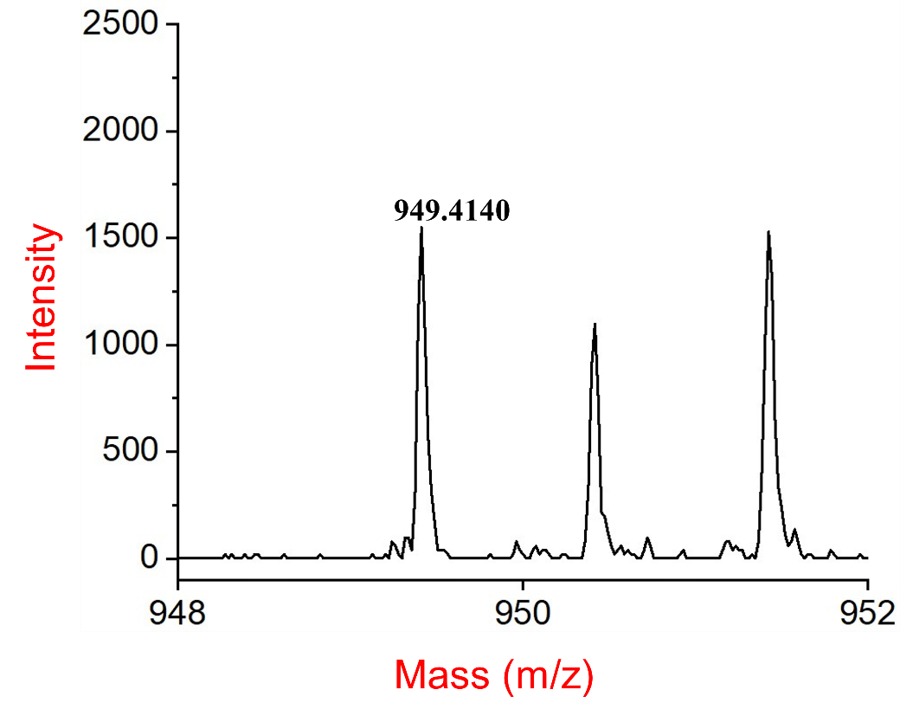
Supplementary Fig. 36 HRMS (MALDI-TOF) spectrum of compound semi-CDI-4-cis.
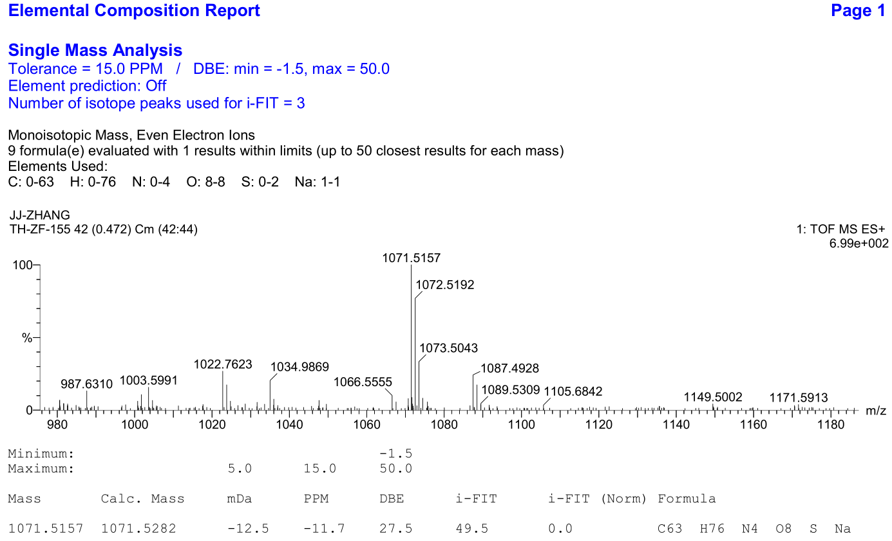
Supplementary Fig. 37 HRMS (ESI) spectrum of compound semi-CDI-5.

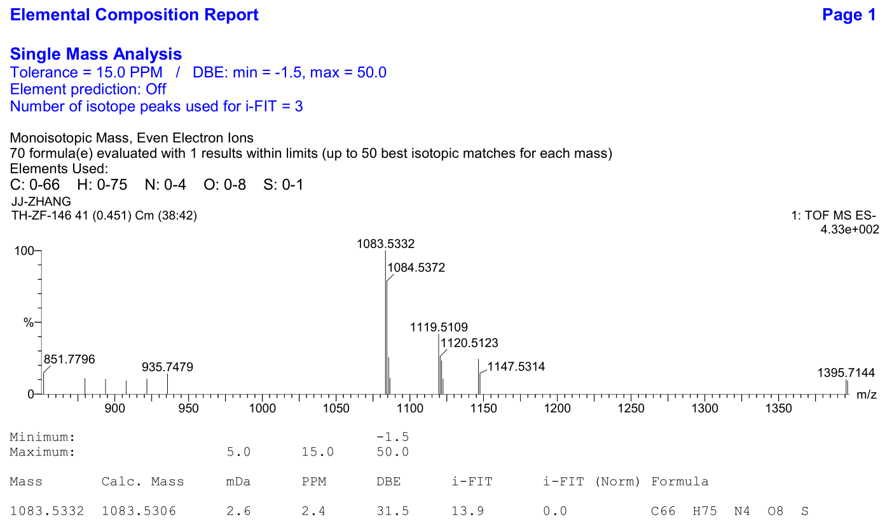
Supplementary Fig. 38 HRMS (ESI) spectrum of compound semi-CDI-6.

- Reference
- Yano, Y. et al. Step-growth annulative π-extension polymerization for synthesis of cove-type graphene nanoribbons. J. Am. Chem. Soc. 142, 1686-1691 (2020).
- Khokhlov, K., Schuster, N. J., Ng, F. & Nuckolls, C. Functionalized helical building blocks for nanoelectronics. Org. Lett. 20, 1991-1994 (2018).
- Williams, A. T. R., Winfifield, S. A. & Miller, J. N. Relative fluorescence quantum yields using a computer-controlled luminescence spectrometer. Analyst. 108, 1067-1071 (1983).
- Fukaminato, T. et al. Molecular design strategy toward diarylethenes that photoswitch with visible light. J. Am. Chem. Soc. 136, 17145-17154 (2014).
- Sumi, T., Takagi, Y., Yagi, A., Morimoto, M. & Irie, M. Photoirradiation wavelength dependence of cycloreversion quantum yields of diarylethenes. Chem. Commun. 50, 3928-3930 (2014).
- Hehre, W. J., Ditchfield, R. & Pople, J. A. Self-consistent molecular orbital methods. XII. Further extensions of gaussian-type basis sets for use in molecular orbital studies of organic molecules. J. Chem. Phys. 56, 2257-2261 (1972).
- Perdew, J. P., Burke, K. & Ernzerhof, M. Generalized gradient approximation made simple Phys. Rev. Lett. 77, 3865 (1996).
- Cossi, M.; Rega, N.; Scalmani, G.; Barone, V. Energies, structures, and electronic properties of molecules in solution with the C-PCM solvation model. J. Comput. Chem. 24, 669-681 (2003).
- Perdew, J. P.; Burke, K.; Ernzerhof, M. Generalized gradient approximation made simple. Phys. Rev. Lett. 78, 1396 (1997).

