Supporting information
Observation of a robust and highly active catalyst for water electrolysis under the current density of${1000 mA cm}^{-2}$
Yudi Zhang^{1,2}, Kathryn E. Arpino³, Qun Yang³, Naoki Kikugawa³, Dmitry Sokolov³, Clifford W. Hicks³, Jian Liu^{1,2}, Claudia Felser³, Guowei Li^{1,2}
- CAS Key Laboratory of Magnetic Materials and Devices, and Zhejiang Province Key Laboratory of Magnetic Materials and Application Technology, Ningbo Institute of Materials Technology and Engineering, Chinese Academy of Sciences, Ningbo 315201, China
- University of Chinese Academy of Sciences, 19 A Yuquan Rd, Shijingshan District, Beijing 100049, China
- Max Planck Institute for Chemical Physics of Solids, Nöthnitzer Strasse 40, 01187, Dresden, Germany
- Center for Advanced Solidification Technology, School of Materials Science and Engineering, Shanghai University, Shanghai 200444, China
Email: liguowei@nimte.ac.cn, claudia.felser@cpfs.mpg.de, liujian@shu.edu.cn
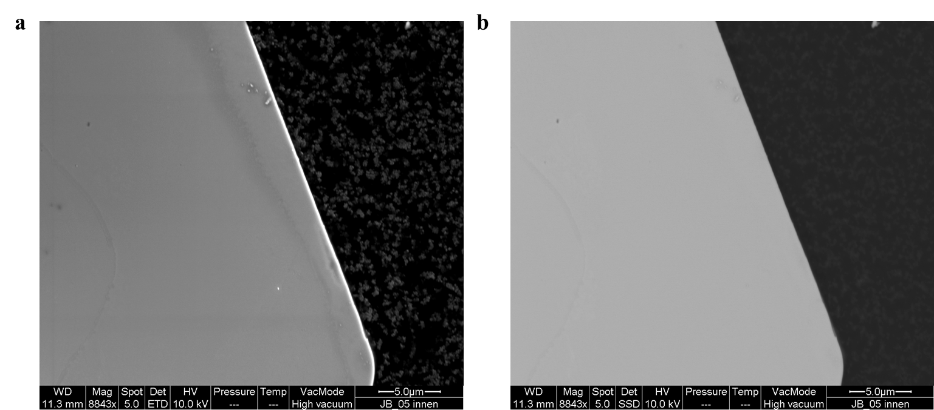
Fig S1. SEM images of the fresh SRO single-crystal recorded with secondary electrons and b. backscattering electrons.

Fig. S2. Raman spectrum of the fresh SRO crystal.

Fig S3. XPS survey spectrum of the fresh SRO before catalysis.

Fig S4. XPS spectrum of the fresh SRO crystal taken at the Ru 3d.

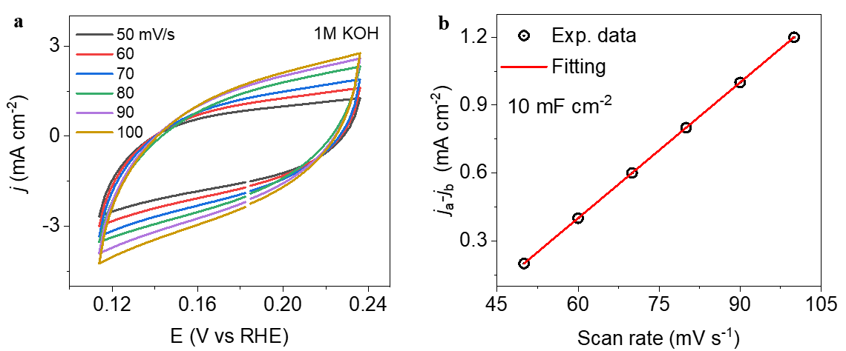
Fig S5. a. CV curves of the activated SRO catalysts at different scan rates. b. double layer capacitance can be obtained by plotting the scan rate with current density at a given potential.

Fig S6. FRA spectrum of the activated SRO catalyst in 1M KOH electrolyte.

Fig S7. FRA spectrum of the activated SRO catalyst in 0.5 M H₂SO₄ electrolyte.

Fig. S8. Comparison of the LSV curves before and after stability test in 1 M KOH electrolyte.

Fig. S9. SEM image of the SRO crystal surface before catalysis.

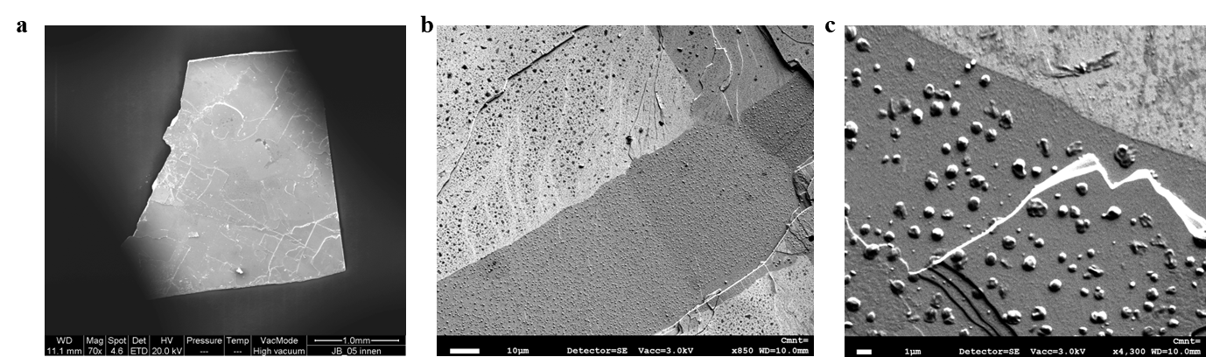
Fig 10. SEM images of (001) SRO crystal surface after activation. One can see the increased roughness of the surface and the formation of numerous island-like particles.

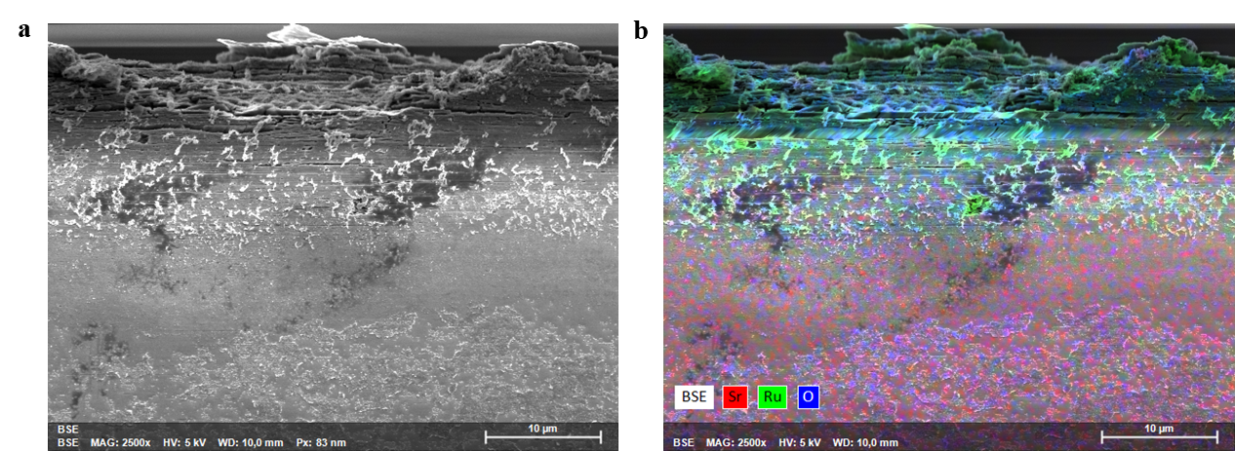
Fig. S11 a. SEM image of the activated SRO crystal after catalysis reaction. The arrow means along the c direction. b. Elemental mapping indicates the Ru element accumulation and the Sr element depletion at the top surface.

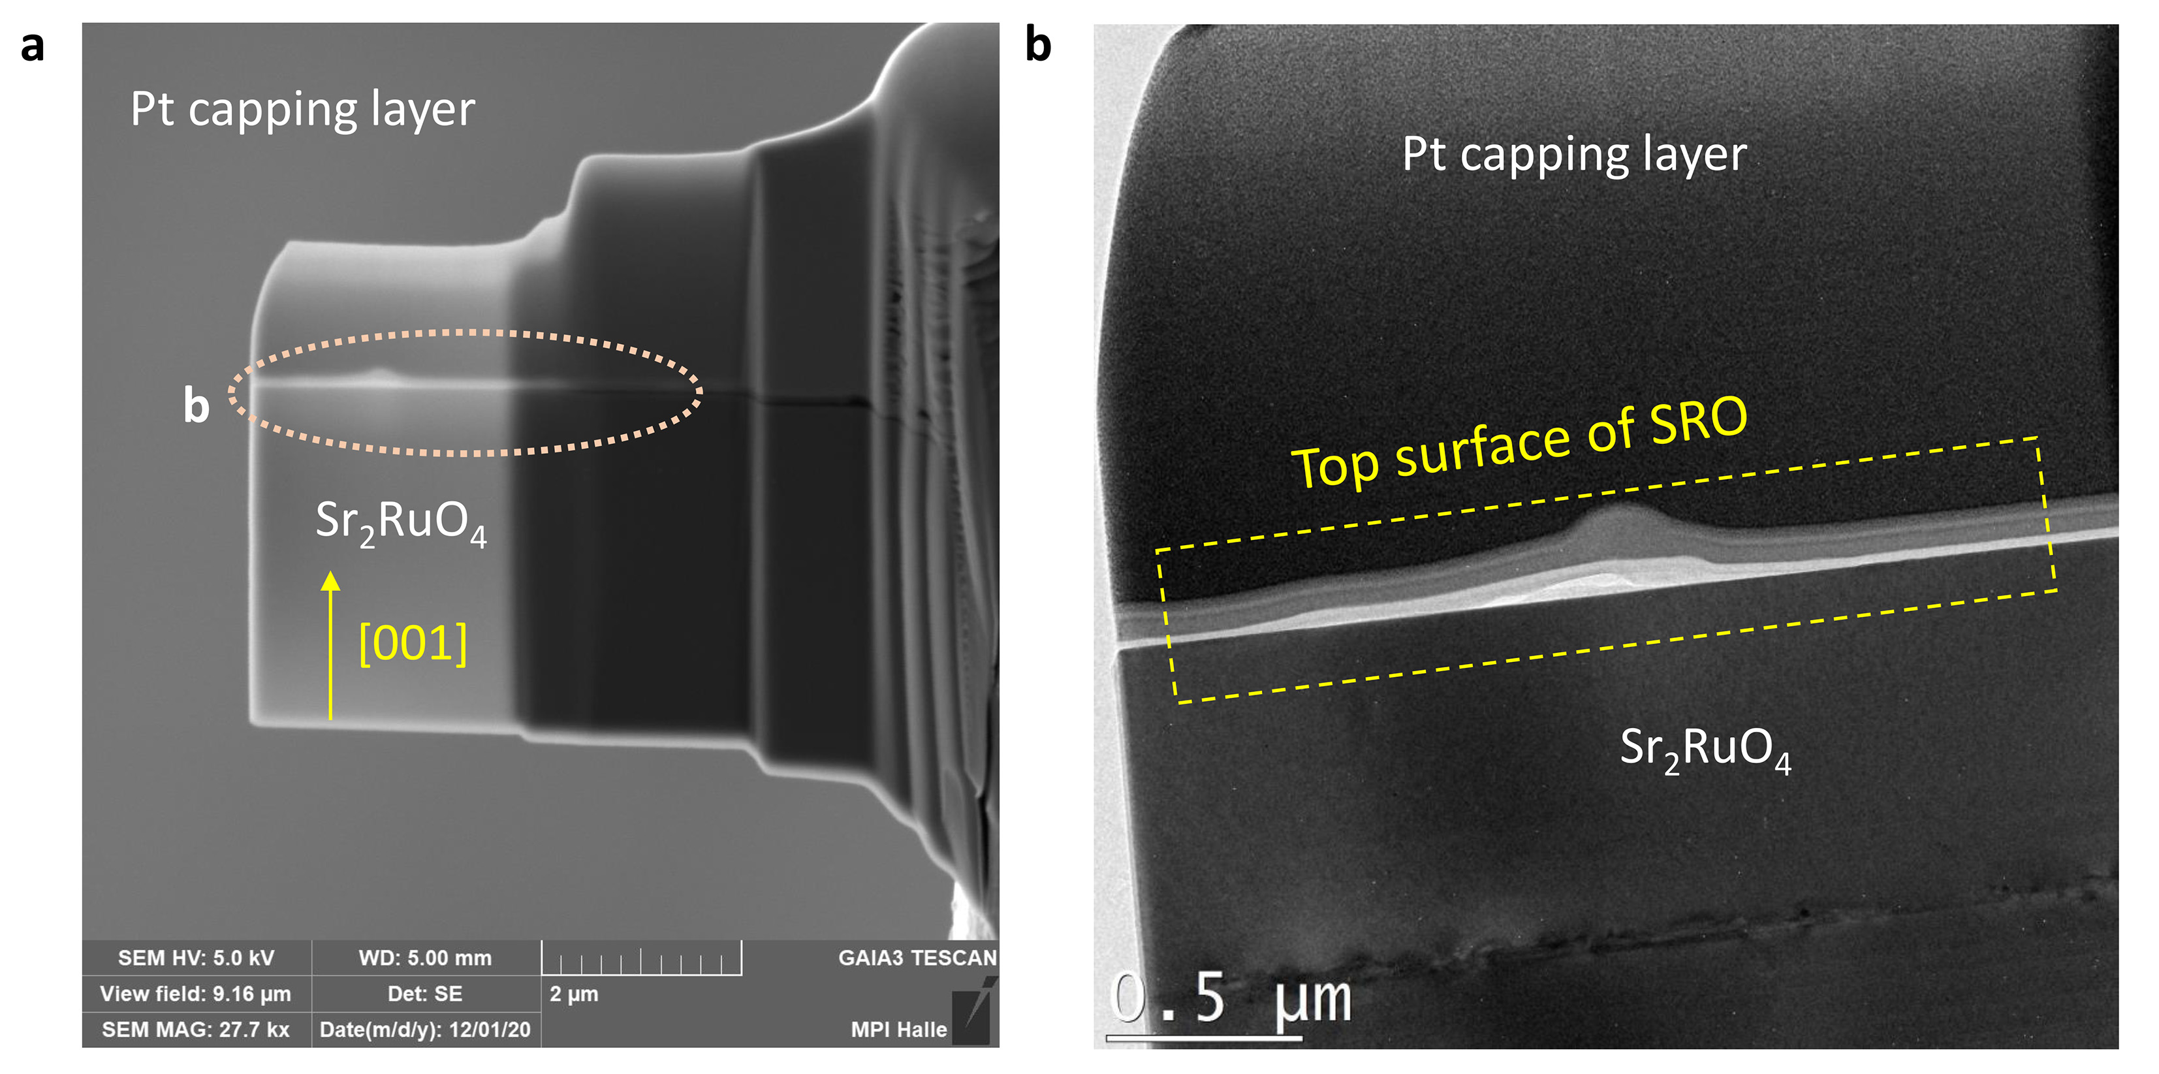
Fig. S12 TEM laminar of the SRO crystal after activation.

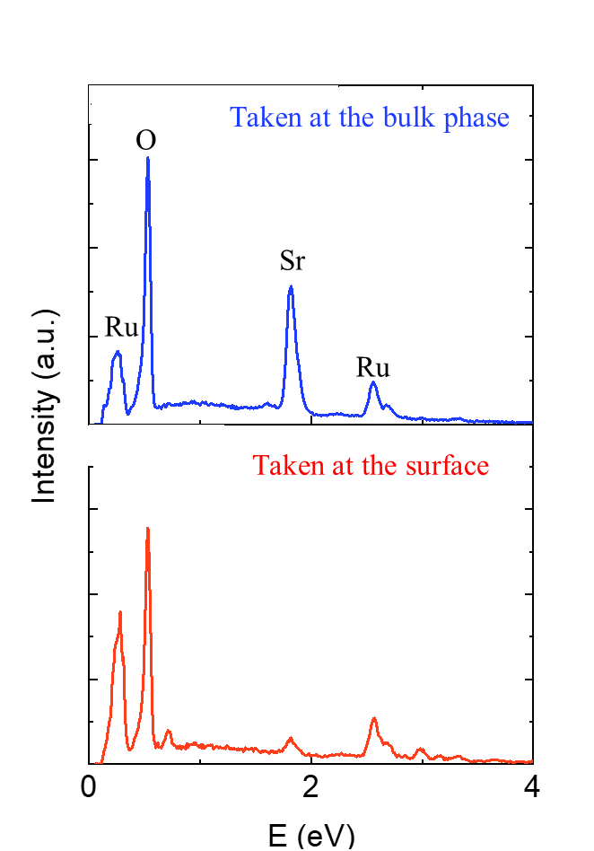
Fig. S13 EDS spectra taken from the surface and the internal bulk (recorded on the SEM of Fig. S11)

Fig.14. XPS spectrum of Sr 3d peak after HER test. The component corresponds to the lattice Sr decreased significantly in comparison with the fresh crystal.

Fig. 15. Magnetic properties of the activated SRO crystal after catalysis. The main phase exhibits paramagnetic properties.

Fig. S16. ZFC-FC curves of the activated SRO single crystals. There is no magnetic transition up to 350 K.

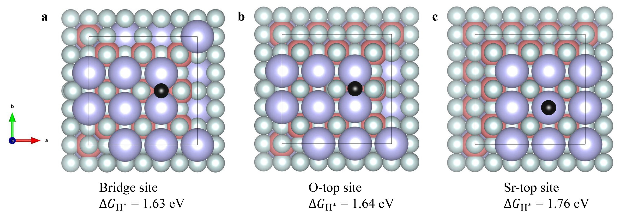
Fig. S17. The geometry of hydrogen adsorption at the pristine SRO (001) surfaces, a. bridge b. O-top site, and c. Sr-top site. Grey, pink, purple, and black balls represent O, Ru, Sr, and H atoms, respectively.

 | Top hollow | Top O | Top Sr
E_{slab+H} (eV) | -1265.36235323 | -1265.36026350 | -1265.23538619
E_{slab} (eV) | -1263.38745927 | -1263.38745927 | -1263.38745927
E_{a} (eV) | 1.40510604 | 1.40719577 | 1.53207308
Table S1. Calculated energy of adsorbing hydrogen on the surface of SRO.

 | Site 1 | Site 2
E_{b} (eV) | -0.35983708 | -0.56798121
Gibbs (eV) | -0.12983708 | -0.56798121
Charge transfer (eV) | 0.2941403 | 0.1981467
Table S2. Calculated energy of adsorbing hydrogen on Ru₆ cluster.

