Additional file 1

Supplementary Methods
RNA-Seq analysis
RNA-Seq analyses of LNCaP and LNCaP/MDVR cells were conducted by BioTools (New Taipei City, Taiwan) and the complete protocol was provided by BioTools. Briefly, an mRNA and complementary (c)DNA library was prepared using KAPA mRNA HyperPrep Kits (Roche) and sequenced using the NovaSeqTM 6000 sequencing system (Illumina) in 300~400-bp paired-end reads. In the data modulation step, the quality of raw reads was checked using FastQC and MultiQC, and then raw-paired end reads were trimmed with Trimommatic v0.38 (leading:3; trailing:3; sliding window:4:15; Minlen:30) followed by DIAMOND to detect contamination [1-3]. Clean reads were mapped to the reference genome (Homo sapiens GRCh38) using HISAT2 v2.1.0 [4]. FeatureCount v1.6.0 [5]. was used to map the count readings to an individual gene. Read counts were normalized to relative log expression using the DESeq2 v1.22.1 package in R [6]. Parameters and codes from each R package followed the default, except for those mentioned above. Differentially expressed genes (DEGs) were determined using DESeq2. The threshold of significance was set to log(fold change) of >2, and p was adjusted to <0.05, based on Benjamini and Hochberg’s approach [7]. Gene Ontology (GO) and Kyoto Encyclopedia of Genes and Genomes (KEGG) pathway enrichment analyses of DEGs were performed using clusterProfiler v3.10.1 [8]. Gene set enrichment analysis (GSEA) was performed with 1000 permutations to identify the activated enriched pathways from MSigDB [9].

Clinical outcomes and dataset analyses
The Cancer Genome Atlas (TCGA) PCa dataset contains 414 primary PCa samples from patients treated with radical prostatectomy under National Cancer Institute, National Institutes of Health Review Board approval, which consisted of level 3 normalized microarray gene mRNA expression data (UNC_AgilentG4502A_07). Expression data (and the resulting z-scores) were log2-normalized. For the GSEA, GSEA software was downloaded from the Broad Institute [10], and gene signature responses to hypoxia (Q1, Hallmark, Elvidge [11], Leonard [12], Winter [13], and Manalo [14], RB1 loss-of-function [15], p53 mutations [16], PCa progression (KEGG, Tomlins [17], and Ouyang [18]), cell migration (Wu [19]), metastasis (Cromer [20] and Sung [21]), EMT (GO and Chakrabarti [22]), small cell lung cancer (SCLC) progression (KEGG), and NEPC differentiation (Li [23] and Beltran [24]) were used to determine associations with mean expression levels of ZBTB46, HIF1A, FOXA2, and MCTP1. Cutoff values used to identify “ZBTB46-high,” “FOXA2-high,” “HIF1A-high,” or “MCTP1-high” patients were predetermined by half the number of patients from both the GSEA analyses. The normalized enrichment score (NES) and false discovery rate (FDR) were calculated using GSEA. To evaluate MCTP1 expression levels with PCa progression and survival, PSA levels were measured using mRNA expression data from the Taylor PCa dataset (GSE21036) [25], which included 28 normal prostate samples and 98 primary and 13 metastatic PCa samples. A log-rank test was used for the survival curve analysis of 111 PCa patients (98 primary and 13 metastatic samples), and the hazard ratios of MCTP1 high (n=56)/MCTP1 low (n=55) were determined for each group. The study was approved by the Memorial-Sloan Kettering Cancer Center (MSKCC) Institutional Review Board. Correlations among the mRNA levels of MCTP1, ZBTB46, and HIF1A were validated using the TCGA and GSE21036 PCa datasets.

Supplementary Figures
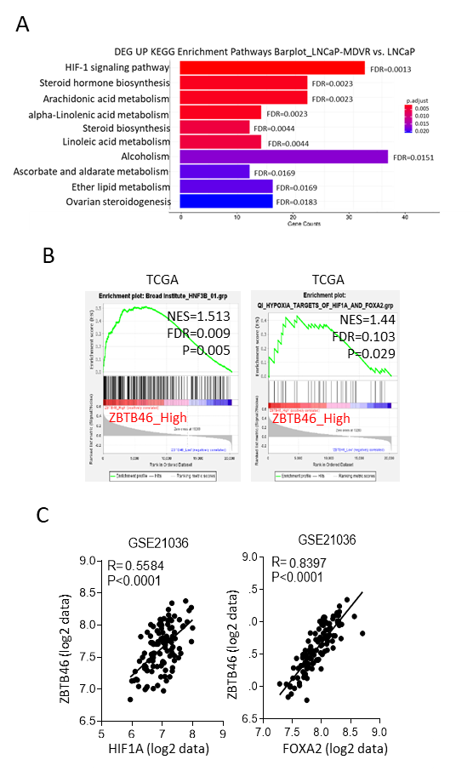

Fig. 1. ADT-induced ZBTB46 is associated with a hypoxic pathway through HIF1A/FOXA2 upregulation. A Relative differentially expressed genes (DEGs) among upregulated KEGG enrichment pathways determined by RNA-Sequencing (Seq) analysis with MDV3100-resistant cells (LNCaP-MDVR) vs. parental LNCaP cells. HIF1 signaling pathway was robustly upregulated in cells with ADT-resistance based on a significant false discovery rate (FDR) and p adjusted value by the RNA-Seq analysis. B Gene set enrichment analysis (GSEA) of TCGA prostate cancer (PCa) dataset showing that higher ZBTB46 expression in PCa samples was positively correlated with the upregulated FOXA2-targeted or HIF1A/FOXA2-targeted gene signature. NES, normalized enrichment score; FDR, false discovery rate. C Pearson correlation coefficient analysis of mean mRNA expression of ZBTB46 relative HIF1A and FOXA2 in patients from the GSE21036 PCa dataset. The significance of the positive correlation among the mean mRNA expression of ZBTB46, FOXA2, and HIF1A was determined by two-tailed Pearson correlation XY analyses in GraphPad Prism. R, correlation coefficient, P, p (two-tailed) value.

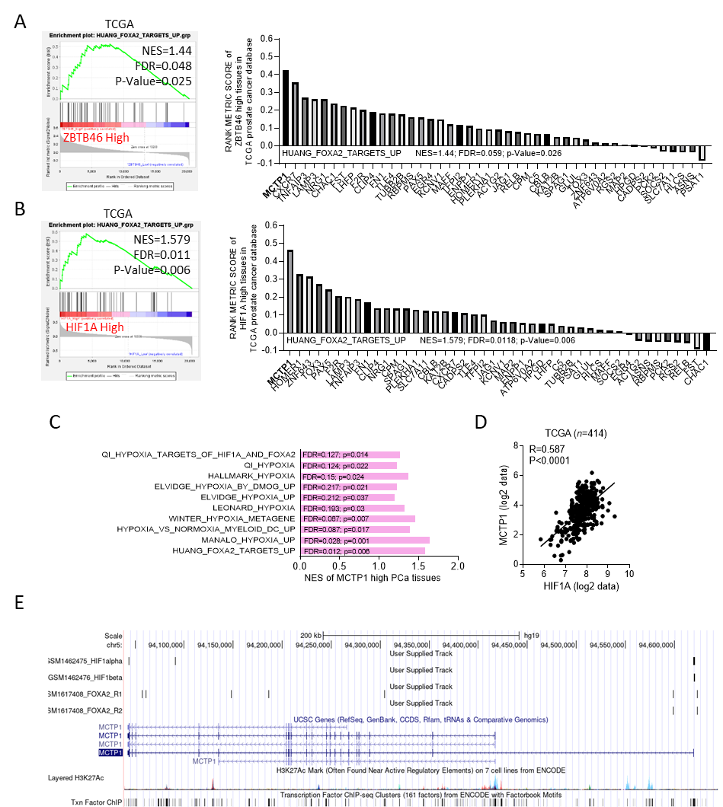

Fig. 2. Upregulation of MCTP1 is possibly linked to hypoxia-associated HIF1A/FOXA2 signaling. A and B GSEA of TCGA PCa dataset showing that higher ZBTB46 and HIF1A expression levels in prostate tissues were positively correlated with the upregulated FOXA2-targeted gene signature. MCTP1 was a candidate gene at the top of both lists of upregulated FOXA2 target genes and was upregulated in tissues that highly expressed ZBTB46 and HIF1A. NES, normalized enrichment score; FDR, false discovery rate. C GSEAs of TCGA PCa dataset showing that higher MCTP1 expression of PCa samples was positively associated with multiple hypoxia-responsive gene signatures. D Pearson correlation coefficient analysis of mean mRNA expression of MCTP1 relative to HIF1A levels in PCa patients from the GSE21036 dataset. Significance was determined by two-tailed Pearson correlation XY analyses in GraphPad Prism. R, correlation coefficient, P, p (two-tailed) value. E ChIP-Seq analysis of the detected DNA-binding sites for HIF1A/B and FOXA2 of the MCTP1 gene. The ChIP-Seq data were from Gene Expression Omnibus (GEO) (GSM1462475, GSM1462476, GSM1617408, and GSM1617409) and analyzed it by Genome Browser (Genomics Institute, UCSC, CA, USA).

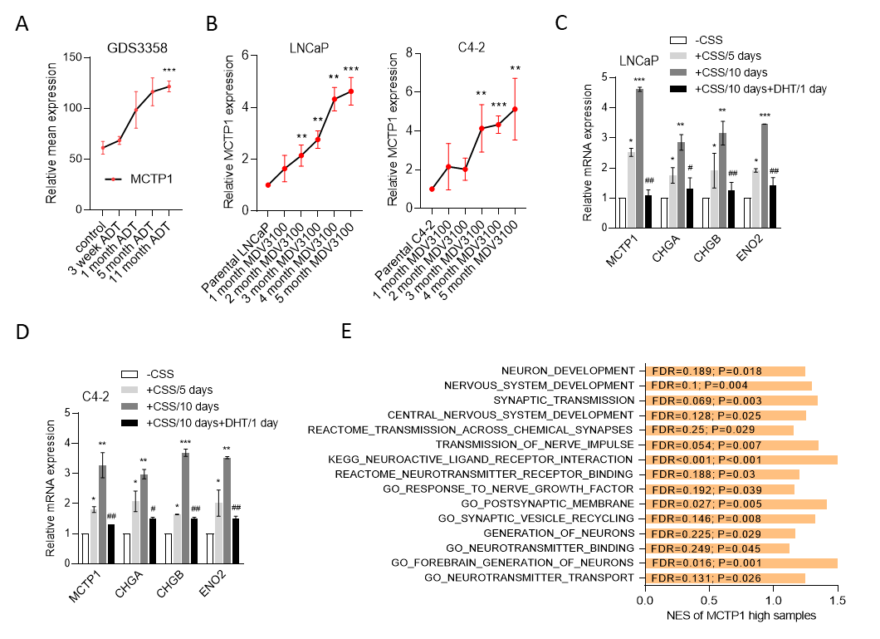

Fig. 3. Hypoxia-induced MCTP1 may be linked to ADT-associated NED of PCa. A Mean expression of MCTP1 in LNCaP cells from the GDS3358 database during 11 months of androgen withdrawal. * vs. the control, by a one-way ANOVA. B MCTP1 mRNA levels in LNCaP and C4-2 cells during 5 months of 20 μM MDV3100 treatment compared to parental LNCaP and C4-2 cells, by an RT-qPCR analysis. * vs. parental LNCaP or C4-2, by a one-way ANOVA. C and D Relative mRNA levels of MCTP1 and NE markers in LNCaP (C) and C4-2 (D) cells following treatment with CSS-containing medium for 5 and 10 days and further treated with 10 nM DHT for 1 day. * vs. -CSS; # vs. +CSS/10 days, by a two-way ANOVA. Quantification of mRNA is presented as the mean ± SEM from three biological replicates. * p<0.05, ** p<0.01, *** p<0.001. E GSEA of TCGA PCa dataset showing that higher MCTP1 expression of PCa samples was positively associated with various neurodevelopment-responsive gene signatures. NES, normalized enrichment score; FDR, false discovery rate.

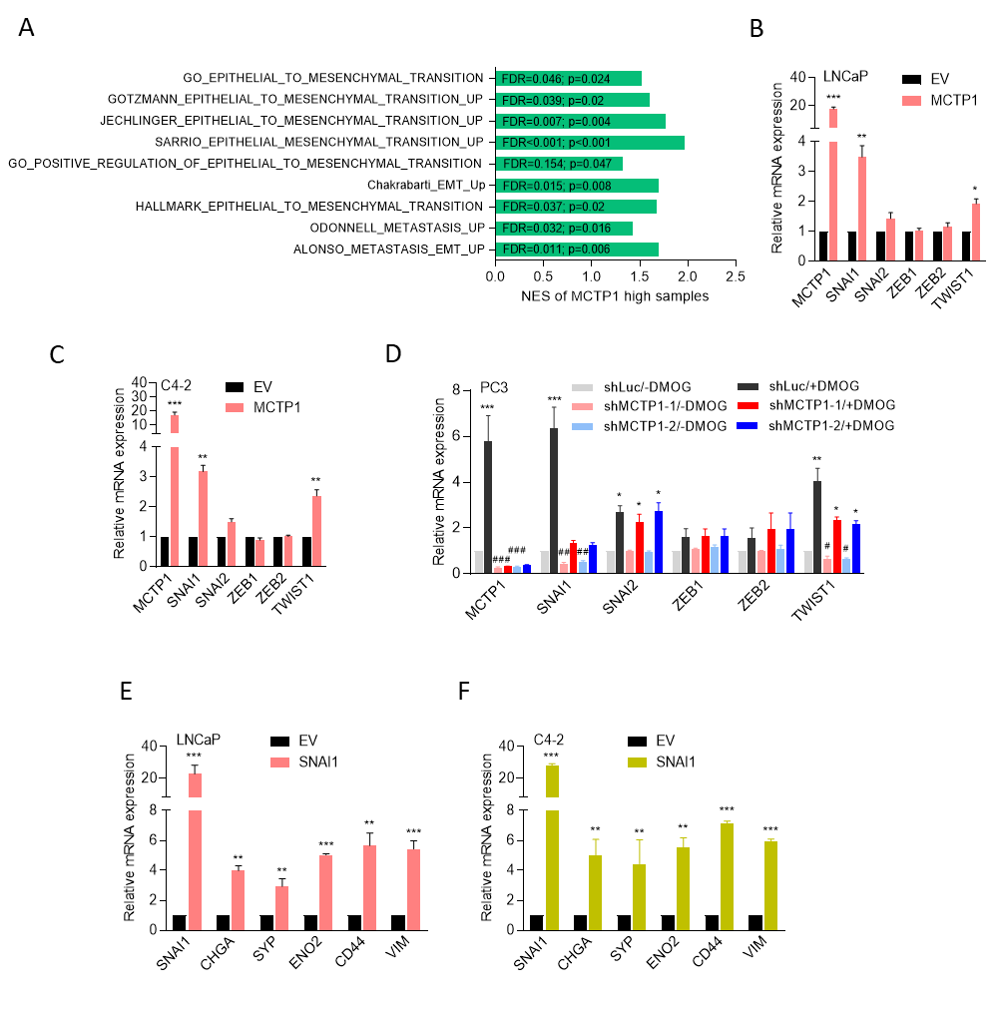
Fig. 4. SNAI1-associated EMT and NED of PCa may occur through upregulation of MCTP1-driven calcium/AKT signaling. A GSEA of TCGA PCa database showing that enrichment of MCTP1 expression was associated with upregulated expression of the EMT and metastasis-responsive gene signatures. NES, normalized enrichment score; FDR, false discovery rate. B and C Relative mRNA levels of MCTP1 and EMT-associated transcription factors in LNCaP (B) and C4-2 (C) cells following stable transfection with an empty vector (EV) or an MCTP1 cDNA vector. * vs. the EV, by a one-way ANOVA. D Relative mRNA levels of MCTP1 and EMT-associated transcription factors in PC3 cells stably transfected with a non-target control (Luc) or MCTP1 shRNA vector following treatment with 10 μM DMOG for 24 h. n=3 per group. * vs. -DMOG; # vs. shLuc, by a two-way ANOVA. (E and F) Relative mRNA levels of SNAI1, NE (CHGA, SYP, and ENO2), and EMT (CD44 and VIM) markers in LNCaP (E) and C4-2 (F) cells expressing an EV or MCTP1 cDNA. * vs. the EV, by a two-way ANOVA. Quantification of mRNA is presented as the mean ± SEM from three biological replicates. * p<0.05, ** p<0.01, *** p<0.001.

Supplementary tables
Table 1. Primer sequences of the DYK Flag-tagged FOXA2 protein and MCTP1-GFP reporter constructs.
Wild-type and mutants of Flag-tagged FOXA2 protein constructs
DYK-FOXA2_FL F | ATCCTTGTAATCAGAGGAGTTCATAATGGGCCG
DYK-FOXA2_FL R | GACGACGATAAGTAAGAAGACGACGGCTTCAGG
DYK-FOXA2_361 F | GATTACAAGGATGACGACGATAAGTAAGAAGACGACGGC
DYK-FOXA2_361 R | CTCAGGCGGCAGGCCCGG
DYK-FOXA2_252 F | GATTACAAGGATGACGACGATAAGTAAGAAGACGACGGC
DYK-FOXA2_252 R | CTGGCGGCGCAGGTAGCA
DYK-FOXA2_113 F | GATTACAAGGATGACGACGATAAGTAAGAAGACGACGGC
DYK-FOXA2_113 R | GAGCGGGCTCAGGCTGGG
Wild-type and mutants of MCTP1 gene-GFP reporter constructs
WT_MCTP1-GFP F | GTGTGACCTTCACCCAATTTC
WT_MCTP1-GFP R | TCCACACTGAGCGATGAAC
MCTP1_HRE1M F | CTTATTCAGATGTCAATTGTTTATGTGCA
MCTP1_HRE1M R | ACATCTGAATAAGATAAGTTG
MCTP1_HRE2M F | GTTTCTCCATTCAATTGGCTCTTTT
MCTP1_HRE2M R | AATGGAGAAACTCTGGGCTG
MCTP1_FRE1M F | CCTTAGCTGACAATTGGTTTCACTACATCT
MCTP1_FRE1M R | TCAGCTAAGGGAGTGGGTCC
MCTP1_FRE2M F | TAGAAATTCCAATTGTTGTCTCGCATCA
MCTP1_FRE2M R | GAATTTCTAATATGCAAAAGT
MCTP1_FRE3M F | AAAGGTAACACAATTGAAACAAAACAA
MCTP1_FRE3M R | TGTTACCTTTATAACAAATATT
MCTP1_FRE4M F | AACAAAACACAATTGAAAACTTAGGTTG
MCTP1_FRE4M R | TGTTTTGTTTTTGTTACCTTT
MCTP1_ZREM F | GGGGCGGGGGCCAATTGCTTCAGCTTT
MCTP1_ZREM R | GCCCCCGCCCCGTTGCGCT

Table 2. Immunoblot antibodies. The source and dilution of each antibody used for immunoblotting in this study are listed.
Primary  antibody | Clonality | Source  (catalog no.) | Dilution | Secondary  antibody | Source | Dilution
ZBTB46 | Polycloncal | GeneTex (GTX121617) | 1:1000 | Rabbit | Jackson | 1:10000
HIF1A | Polycloncal | Affinity (AF1009) | 1:1000 | Rabbit | Jackson | 1:10000
FOXA2 | Monoclonal | Santa Cruz (sc-374376) | 1:500 | Mouse | Jackson | 1:10000
ENO2 | Monoclonal | Santa Cruz (sc-21738) | 1:500 | Mouse | Jackson | 1:10000
CHGA | Monoclonal | Cell signaling (85798) | 1:1000 | Rabbit | Jackson | 1:10000
NKX3-1 | Monoclonal | Cell signaling (83700) | 1:1000 | Rabbit | Jackson | 1:10000
DYK | Monoclonal | Genescript (A00187S) | 1:1000 | Mouse | Jackson | 1:10000
SNAI1 | Monoclonal | Santa Cruz (sc-271977) | 1:500 | Mouse | Jackson | 1:10000
SNAI2 | Monoclonal | Cell Signaling (9585) | 1:1000 | Rabbit | Jackson | 1:10000
TWIST1 | Monoclonal | Abcam (ab175430) | 1:1000 | Mouse | Jackson | 1:10000
CTNNB1 | Polycloncal | Proteintech (51067-2-AP) | 1:1000 | Rabbit | Jackson | 1:10000
GAPDH | Monoclonal | Santa Cruz (sc-47724) | 1:1000 | Mouse | Jackson | 1:10000
Table 3. Primer sequences for the RT-qPCR. Sequences of the primers used in the RT-qPCR assays in this study are listed 5’-3’. F, forward; R, reverse.
Gene | Primer sequence
ZBTB46 F | AGCAGGTGGAAGATGACAGC
ZBTB46 R | TGCTGGCTTCGGTGAC
HIF1A F | TATGAGCCAGAAGAACTTTTAGGCCG
HIF1A R | CACCTCTTTTGGCAAGCATCCTG
FOXA2 F | TGCACTCGGCTTCCAGTATG
FOXA2 R | GTTGCTCACGGAGGAGTAGC
HSE6 F | CTGAACTGAGTCAGGCTCCTG
HSE6 R | TCCAGACACTCCGGGCAATTTG
SOX9 F | AGGAAGCTCGCGGACCAGTAC
SOX9 R | GGTGGTCCTTCTTGTGCTGCAC
KDM3A F | GCCAACATTGGAGACCACTTCTG
KDM3A R | CTCGAACACCTTTGACAGCTCG
NKX3-1 F | CAGAGACCGAGCCAGAAACG
NKX3-1 R | CTGAGTGTGGGAGAAGGCAG
KLK3 F | TTTCCAATGACGTCTGTGCG
KLK3 R | CCAGAATCACCCGAGCAGG
MCTP1 F | GAAGATGACAAAGATGACAAGGACAGTG
MCTP1 R | TCAGCGGAATGCAGTACAGG
CHGA F | ACTGAAGGAGCTCCAAGACC
CHGA R | TCTGCCTCCTTGGAATCCTC
CHGB F | GCCACGTGCCTATTTCATGT
CHGB R | GCTCCTTCCTCACCGTAGTT
ENO2 F | CTTGGAGCTGGTGAAGGAAG
ENO2 R | GTCAAATGGGTCCTCAATGG
SYP F | TGCAATGGGTCTTCGCCATC
SYP R | CGGTCTTGTTGGCACAATCC
MYCN F | AGTTTGACTCGCTACAGCCC
MYCN R | TCAAGCAGCATCTCCGTGAC
SNAI1 F | GTTTACCTTCCAGCAGCCCT
SNAI1 R | TCCCAGATGAGCATTGGCAG
SANI2 F | GTTTTCCAGACCCTGGTTGCTTC
SNAI2 R | GAGCCCTCAGATTTGACCTGTC
ZEB1 F | GGCATACACCTACTCAACTACGG
ZEB1 R | TGGGCGGTGTAGAATCAGAGTC
ZEB2 F | AATGCACAGAGTGTGGCAAGGC
ZEB2 R | CTGCTGATGTGCGAACTGTAGG
TWIST1 F | GCCAGGTACATCGACTTCCTC
TWIST1 R | TCCATCCTCCAGACCGAGAAG
CTNNB1 F | CACAAGCAGAGTGCTGAAGGTG
CTNNB1 R | AGATTCCTGAGAGTCCAAAGACAGTTC

Table 4. Antibodies for immunoprecipitation. The source and dilution of each antibody used for immunoprecipitation in this study are listed.
Primary  antibody | Species | Clonality | Source  (catalog no.) | Dilution
ZBTB46 | Mouse | Monoclonal | Santa Cruz (sc-390260) | 1:1000
FOXA2 | Rabbit | Polycloncal | AVIVA (ARP39508_T100) | 1:1000
DYK | Mouse | Monoclonal | Genescript (A00187S) | 1:2000

Table 5. Antibodies for immunohistochemical staining. The source and dilution of each antibody used for immunohistochemical staining in this study are listed.
Primary  antibody | Species | Clonality | Source  (catalog no.) | Dilution
ZBTB46 | Mouse | Monoclonal | Santa Cruz (sc-390260) | 1:100
FOXA2 | Rabbit | Polycloncal | Abcam (ab108422) | 1:100
HIF1A | Rabbit | Polycloncal | Affinity (AF1009) | 1:50
MCTP1 | Rabbit | Polycloncal | AVIVA (ARP44441_P050) | 1:50
CTNNB1 | Rabbit | Polycloncal | Proteintech (51067-2-AP) | 1:50
SNAI1 | Rabbit | Polycloncal | IREAL (IR50-154) | 1:100
ENO2 | Mouse | Monoclonal | Santa Cruz (sc-21738) | 1:50
CHGA | Mouse | Monoclonal | Santa Cruz (sc-393941) | 1:50
PCNA | Mouse | Monoclonal | Cell Signaling (2586) | 1:1000

Table 6. Chromatin immunoprecipitation (ChIP) antibodies and primer sequences. The source and dilution of each antibody and the sequences (5’-3’) of each primer used for ChIP in this study are listed.
ChIP antibodies
Primary antibody | Species |  | Clonality | Source | Dilution
ZBTB46 | Mouse |  | Monoclonal | Santa Cruz (sc-390260) | 1:500
HIF1A | Rabbit |  | Polycloncal | Affinity (AF1009) | 1:1000
FOXA2 | Mouse |  | Monoclonal | Santa Cruz (sc-374376) | 1:1000
Acety-H3 | Rabbit |  | Polycloncal | Millipore (06-599B) | 1:1000
IgG | Rabbit |  | Polycloncal | Millipore (PP64B) | 1:1000
ChIP primers
Site |  | Sequence
MCTP1_HRE1 F |  | GTGTGACCTTCACCCAATTTC
MCTP1_HRE1 R |  | ACAGGATAGGACTGCATAGAAC
MCTP1_HRE2 F |  | TACATTTGCCCCACCGCTAAC
MCTP1_HRE2 R |  | AGAGCAACGTGAATGGAGAAAC
MCTP1_FRE1 F |  | GAGGAAACATGGACTCTCACTCTGG
MCTP1_FRE1 R |  | GACTGGGCATATTCAAGGACAGAAC
MCTP1_FRE2 F |  | GAAAGTCAGTTTAATTGGGTGTCCTGC
MCTP1_FRE2 R |  | CTTATTGTGAGGGTGAGGGTTGG
MCTP1_FRE3 F |  | CATCCCCAGAGCCTATCACAG
MCTP1_FRE3 R |  | CAGTATGCTTTGGAGGTGTTACCAAC
MCTP1_FRE4 F |  | CAAATAAAGAAAAGGGAGGGGTGGATG
MCTP1_FRE4 R |  | AAGCGAGCTGGAGTGGAAACTATG
MCTP1_ZRE F |  | AGAAAAGGGAGGGGTGGATG
MCTP1_ZRE R |  | TCCACACTGAGCGATGAAC
Reference
1. Ewels P, Magnusson M, Lundin S, Kaller M: MultiQC: summarize analysis results for multiple tools and samples in a single report. Bioinformatics 2016, 32:3047-3048.
2. Bolger AM, Lohse M, Usadel B: Trimmomatic: a flexible trimmer for Illumina sequence data. Bioinformatics 2014, 30:2114-2120.
3. Buchfink B, Xie C, Huson DH: Fast and sensitive protein alignment using DIAMOND. Nat Methods 2015, 12:59-60.
4. Kim D, Langmead B, Salzberg SL: HISAT: a fast spliced aligner with low memory requirements. Nat Methods 2015, 12:357-360.
5. Liao Y, Smyth GK, Shi W: featureCounts: an efficient general purpose program for assigning sequence reads to genomic features. Bioinformatics 2014, 30:923-930.
6. Love MI, Huber W, Anders S: Moderated estimation of fold change and dispersion for RNA-seq data with DESeq2. Genome Biol 2014, 15:550.
7. Wang L, Feng Z, Wang X, Wang X, Zhang X: DEGseq: an R package for identifying differentially expressed genes from RNA-seq data. Bioinformatics 2010, 26:136-138.
8. Yu G, Wang LG, Han Y, He QY: clusterProfiler: an R package for comparing biological themes among gene clusters. Omics 2012, 16:284-287.
9. Liberzon A, Birger C, Thorvaldsdóttir H, Ghandi M, Mesirov JP, Tamayo P: The Molecular Signatures Database (MSigDB) hallmark gene set collection. Cell Syst 2015, 1:417-425.
10. Subramanian A, Tamayo P, Mootha VK, Mukherjee S, Ebert BL, Gillette MA, Paulovich A, Pomeroy SL, Golub TR, Lander ES, Mesirov JP: Gene set enrichment analysis: a knowledge-based approach for interpreting genome-wide expression profiles. Proc Natl Acad Sci U S A 2005, 102:15545-15550.
11. Elvidge GP, Glenny L, Appelhoff RJ, Ratcliffe PJ, Ragoussis J, Gleadle JM: Concordant regulation of gene expression by hypoxia and 2-oxoglutarate-dependent dioxygenase inhibition: the role of HIF-1alpha, HIF-2alpha, and other pathways. J Biol Chem 2006, 281:15215-15226.
12. Leonard MO, Cottell DC, Godson C, Brady HR, Taylor CT: The role of HIF-1 alpha in transcriptional regulation of the proximal tubular epithelial cell response to hypoxia. J Biol Chem 2003, 278:40296-40304.
13. Winter SC, Buffa FM, Silva P, Miller C, Valentine HR, Turley H, Shah KA, Cox GJ, Corbridge RJ, Homer JJ, et al: Relation of a hypoxia metagene derived from head and neck cancer to prognosis of multiple cancers. Cancer Res 2007, 67:3441-3449.
14. Manalo DJ, Rowan A, Lavoie T, Natarajan L, Kelly BD, Ye SQ, Garcia JG, Semenza GL: Transcriptional regulation of vascular endothelial cell responses to hypoxia by HIF-1. Blood 2005, 105:659-669.
15. Chicas A, Wang X, Zhang C, McCurrach M, Zhao Z, Mert O, Dickins RA, Narita M, Zhang M, Lowe SW: Dissecting the unique role of the retinoblastoma tumor suppressor during cellular senescence. Cancer Cell 2010, 17:376-387.
16. Elkon R, Rashi-Elkeles S, Lerenthal Y, Linhart C, Tenne T, Amariglio N, Rechavi G, Shamir R, Shiloh Y: Dissection of a DNA-damage-induced transcriptional network using a combination of microarrays, RNA interference and computational promoter analysis. Genome Biol 2005, 6:R43.
17. Tomlins SA, Mehra R, Rhodes DR, Cao X, Wang L, Dhanasekaran SM, Kalyana-Sundaram S, Wei JT, Rubin MA, Pienta KJ, et al: Integrative molecular concept modeling of prostate cancer progression. Nat Genet 2007, 39:41-51.
18. Ouyang X, Jessen WJ, Al-Ahmadie H, Serio AM, Lin Y, Shih WJ, Reuter VE, Scardino PT, Shen MM, Aronow BJ, et al: Activator protein-1 transcription factors are associated with progression and recurrence of prostate cancer. Cancer Res 2008, 68:2132-2144.
19. Wu Y, Siadaty MS, Berens ME, Hampton GM, Theodorescu D: Overlapping gene expression profiles of cell migration and tumor invasion in human bladder cancer identify metallothionein 1E and nicotinamide N-methyltransferase as novel regulators of cell migration. Oncogene 2008, 27:6679-6689.
20. Cromer A, Carles A, Millon R, Ganguli G, Chalmel F, Lemaire F, Young J, Dembélé D, Thibault C, Muller D, et al: Identification of genes associated with tumorigenesis and metastatic potential of hypopharyngeal cancer by microarray analysis. Oncogene 2004, 23:2484-2498.
21. Sung SY, Hsieh CL, Law A, Zhau HE, Pathak S, Multani AS, Lim S, Coleman IM, Wu LC, Figg WD, et al: Coevolution of prostate cancer and bone stroma in three-dimensional coculture: implications for cancer growth and metastasis. Cancer Res 2008, 68:9996-10003.
22. Chakrabarti R, Hwang J, Andres Blanco M, Wei Y, Lukacisin M, Romano RA, Smalley K, Liu S, Yang Q, Ibrahim T, et al: Elf5 inhibits the epithelial-mesenchymal transition in mammary gland development and breast cancer metastasis by transcriptionally repressing Snail2. Nat Cell Biol 2012, 14:1212-1222.
23. Li Y, He Y, Butler W, Xu L, Chang Y, Lei K, Zhang H, Zhou Y, Gao AC, Zhang Q, et al: Targeting cellular heterogeneity with CXCR2 blockade for the treatment of therapy-resistant prostate cancer. Sci Transl Med 2019, 11.
24. Beltran H, Rickman DS, Park K, Chae SS, Sboner A, MacDonald TY, Wang Y, Sheikh KL, Terry S, Tagawa ST, et al: Molecular characterization of neuroendocrine prostate cancer and identification of new drug targets. Cancer Discov 2011, 1:487-495.
25. Taylor BS, Schultz N, Hieronymus H, Gopalan A, Xiao Y, Carver BS, Arora VK, Kaushik P, Cerami E, Reva B, et al: Integrative genomic profiling of human prostate cancer. Cancer Cell 2010, 18:11-22.

