Supplementary Material

Supplemental Table 1: Compounds in the volcano plot that differ between TGM-1M and PCOS

Compound | Category | Fold change | Adjusted p-value
L-Asparagine | Amino Acid | 9.06 | <0.0001
L-Cystine | Amino Acid | 8.91 | <0.01
L-Phenylalanine | Amino Acid | 4.18 | <0.0001
L-Methionine | Amino Acid | 2.49 | <0.0001
L-Glutamate | Amino Acid | 2.42 | <0.0001
L-Serine | Amino Acid | 0.41 | <0.0001
L-Proline | Amino Acid | 0.27 | <0.0001
Linoleate | PUFA | 71.36 | <0.0001
Arachidonic Acid | PUFA | 0.03 | <0.0001
Docosapentaenoic Acid (DPA) | LC-PUFA | 0.06 | <0.0001
Docosahexaenoic acid (DHA) | LC-PUFA | 0.04 | <0.0001
Eicosapentaenoic acid (EPA) | LC-PUFA | 0.03 | <0.0001
Dihomo-y-linolenic acid (DGLA) | LC-PUFA | 0.02 | <0.0001
Cholic acid | Bile Acid | 0.14 | <0.001
Taurolithocholate (TLC) | Bile Acid | 0.12 | <0.0001
Tauroursodeoxycholic acid (TUDCA) | Bile Acid | 0.12 | <0.0001
Taurocholate (TCA) | Bile Acid | 0.06 | <0.0001
Glycochenodeoxycholate (GCDCA) | Bile Acid | 0.04 | <0.0001
Taurochenodeoxycholate (TCDCA) | Bile Acid | 0.04 | <0.0001
Glycocholate (GCA) | Bile Acid | 0.04 | <0.0001
Taurodeoxycholate | Bile Acid | 0.03 | <0.0001
Acyl-C8 | Acyl Carnitine | 12.63 | <0.001
Acyl-C14 | Acyl Carnitine | 4.45 | <0.01
Numbers >1 indicate that these compounds are higher among transgender males on testosterone for 1 month and numbers <1 indicate that these compounds are higher among individuals with PCOS. Compounds with fold change >2 or <0.5 are shown here. PUFA: polyunsaturated fatty acids; LC-PUFA: long-chain polyunsaturated fatty acids.

Supplemental Table 2. Exploratory correlations between targeted metabolite panel and HOMA-IR or serum total testosterone.
 | HOMA-IR |  | Total Testosterone
Metabolite | PCOS | TGM 1 Month | PCOS | TGM 1 Month
L-Carnitine | 0.58, 0.088 | 0.60, 0.073 | 0.64, 0.052 | -0.84, 0.004*
Acyl-C2 (acetyl-carnitine) |  |  | 0.61, 0.064
Acyl-C3 (propionyl-carnitine) | 0.69, 0.035* |  |  | -0.66, 0.044*
Acyl-C4 (butanoyl-l-carnitine) | 0.59, 0.081
Acyl-C5 (isovalerylcarnitine) | 0.58, 0.088 |  |  | -0.62, 0.060
Acyl-C8 (L-octanoylcarnitine) |  |  | 0.63, 0.055
Glycochenodeoxycholate |  |  |  | 0.72, 0.023*
L-Alanine |  |  | 0.87, 0.002*
L-Arginine |  |  | 0.58, 0.082
L-Asparagine |  | 0.58, 0.088 | 0.73, 0.021*
L-Cystine |  |  | 0.67, 0.041*
L-Histidine |  | 0.58, 0.088 | 0.70, 0.029* | -0.72, 0.023*
L-Lysine |  | 0.73, 0.020* |  | -0.75, 0.017*
L-Glutamate | 0.58, 0.088
L-Phenylalanine | 0.66, 0.044* |  | 0.66, 0.042*
L-Tyrosine | 0.59, 0.081 |  | 0.60, 0.071 | -0.61, 0.067
L-Valine | 0.59, 0.067 |  | 0.71, 0.027*
L-Isoleucine |  |  | 0.61, 0.067 | -0.64, 0.054
L-Leucine |  |  | 0.80, 0.007* | 0.62, 0.060
Glycine |  |  |  | 0.75, 0.017*
Linoleate |  | -0.82, 0.006*
Eicosapentaenoic acid (EPA) | -0.56, 0.096 | -0.60, 0.073
Dihomo-g-linolenic acid (DGLA) |  | -0.60, 0.073
Arachidonic acid | -0.58, 0.088 | -0.83, 0.005*
Docosahexaenoic acid (DHA) |  | -0.72, 0.023*
Docosapentaenoic acid (DPA) | -0.66, 0.044* | -0.69, 0.035*
Correlations are presented as (r-value, p-value). All correlations with a raw p-value of less than 0.1 are listed above; those with statistical significance (raw, not FDR-adjusted p<0.05) with an asterisk.*
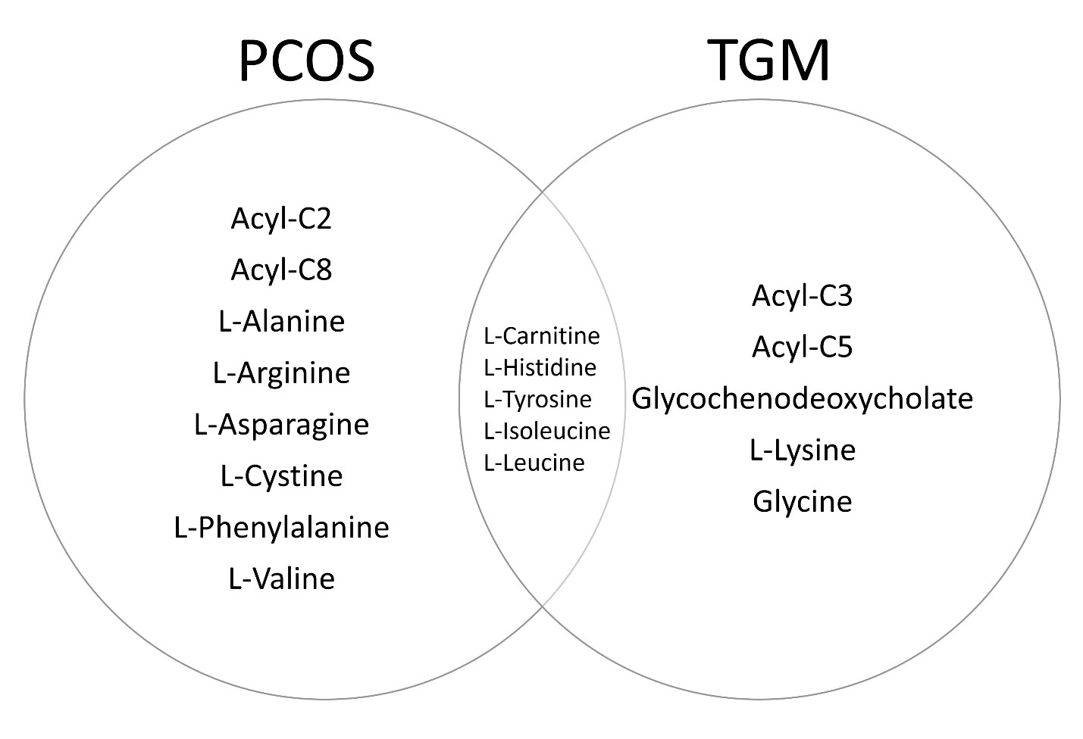

Supplemental Figure 1. Metabolites that correlate with serum total testosterone. This venn diagram graphically shows the metabolites in Supplemental Table 2 that correlate with total testosterone among individuals with PCOS and TGM or in both groups. Note that the metabolites shown in the figure include those with positive or negative correlations and include metabolites that did not reach statistical significance. Statistical significance is depicted in Supplemental Table 2.

