Table 1․
Wheelchair constructions

Frame construction | Advantages | Disadvantages
1. Folding frame  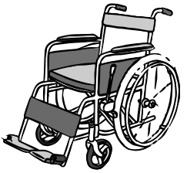 | Compact folds for storage or transportation in a car, taxi, bus. | Cross straps and equipment may corrode or break.
 | The wheelchair is flexible, allowing it to absorb vibrations when traveling on rough or uneven surfaces. | The chair bends during compression, which can make it difficult for the chair to move. Causes loss of motor energy and human fatigue.
2. Hard frame  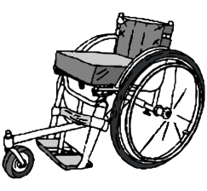 | It is easier to move due to the lack of flexibility of the frame. The frame is strong. | The frame is not folded for transport, or the back is usually folded down. It has detachable rear wheels.
 | It is easier to work in different inclination positions. | Tricycles are often rigid due to the difficulty of developing a folding system.
 | The rear wheelbase can be easily adjusted.
 | Due to the small parts, the production is easier.
 | It is easier to change the details to support the spine.
3. Four wheels  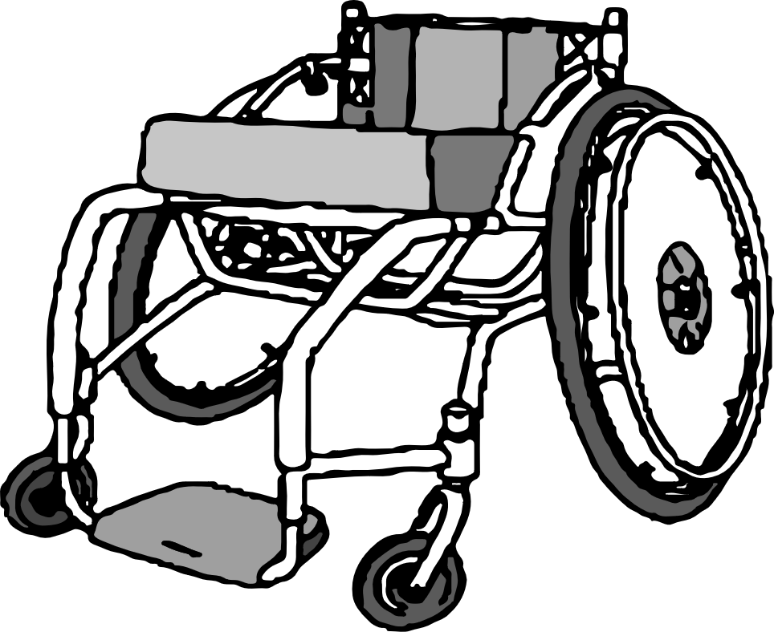 | A wheel system shorter than three is advisable for good detail. | Small front wheels or footrests are often required, which can increase rolling resistance in soft terrain.
 | Often the stability is lateral, but it depends on the base length of the wheel.
4. Three wheels  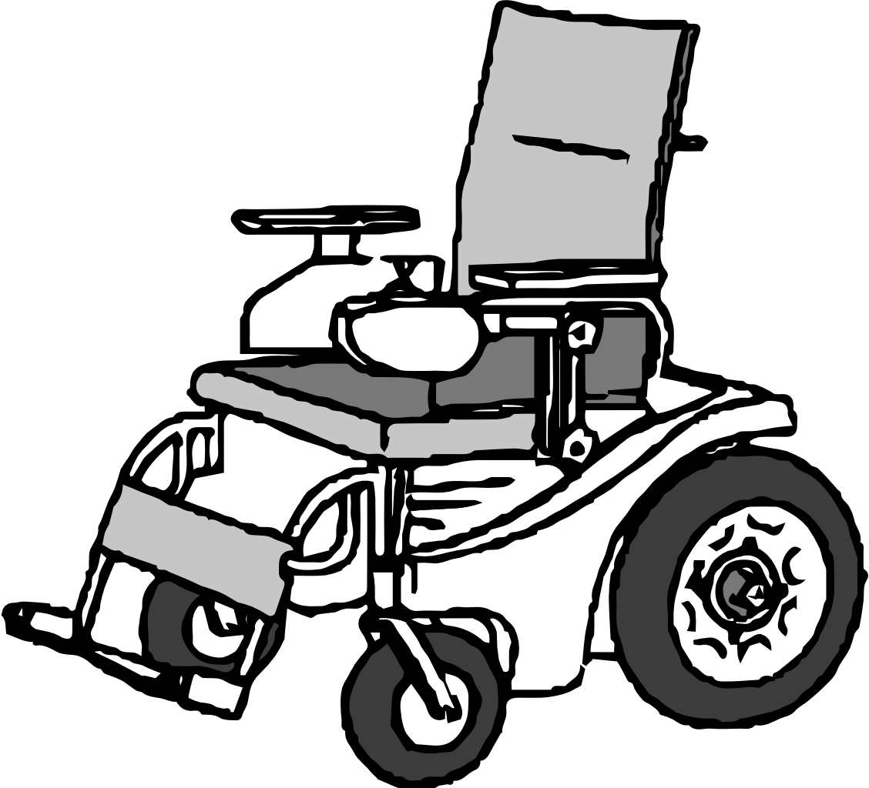 | The long tricycle, attached to a large wheel, facilitates its movement on uneven or bumpy terrain. | Wheelchairs are more difficult to maneuver inside.
 | Long tricycle  is stable when moving in the front direction. | Lateral stability is very sensitive to the length of the moving system.
5. Trike  The Trick wheelchair moves with the help of handles, which activate the bicycle chain, due to which the wheelchair moves. The triple system usually includes a storage compartment for carrying items. The wheelchair is attached to the frame of the bicycle. It can be detached if necessary. 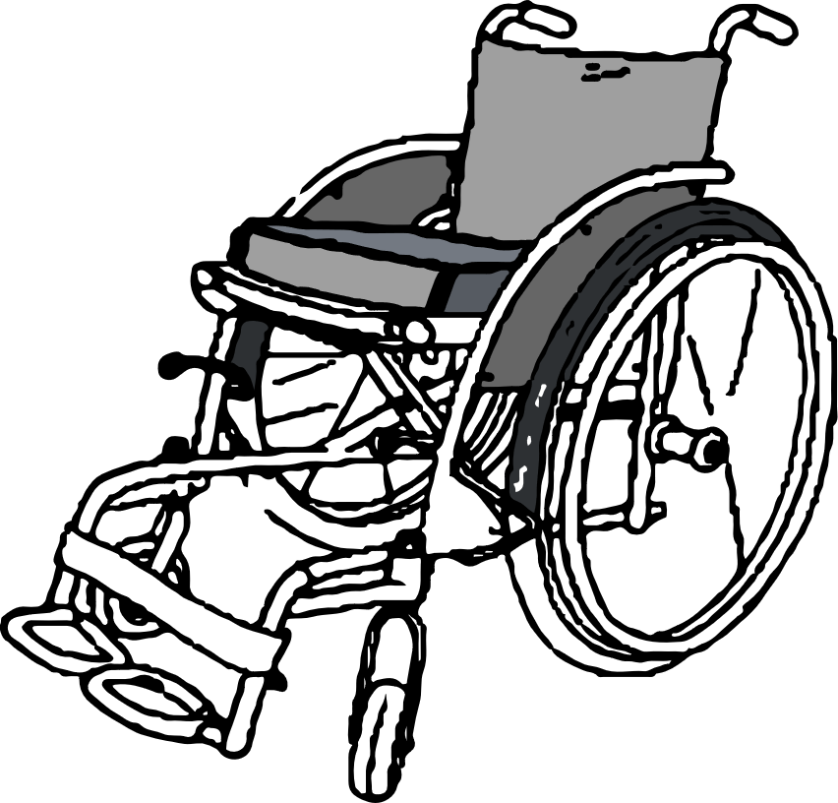 | The larger front wheel overcomes rough terrain, mud, gravel and sand. | Not used in small areas.
 | Can help with cargo transportation? Can use up to 100% locally available bicycle parts, making them fully repairable with local resources. | Expensive, difficult to produce and replace parts.
 |  | The chain motor requires maintenance.
6. Motor wheelchair  Wheelchair with engines and transmission. The movement is usually carried out by means of a control panel attached to a wheelchair. Requires powerful batteries.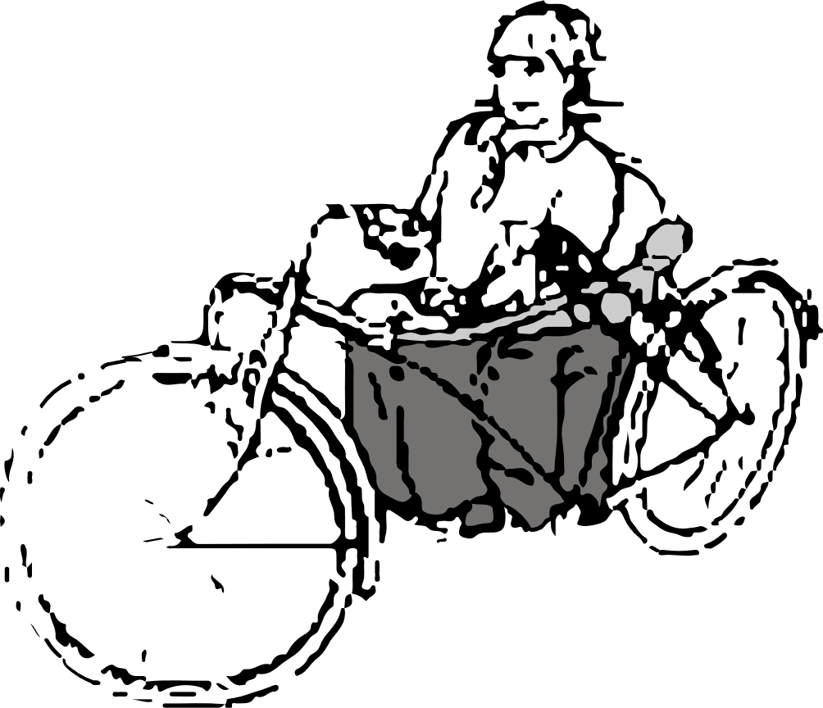 | Provides mobility for people with limited mobility of hands, fingers, self-propelled wheelchairs, who have to travel long distances on difficult terrain, which significantly slows down their movement or causes unnecessary fatigue in self-propelled wheelchairs. | It is difficult to move.
 |  | It is difficult to find money-making parts.

