Lymphatic dysfunction sustains memory impairment despite Aβ reduction by reactive astrocytes in an Alzheimer’s disease model

Eun Ji Lee^{1,2†}, Yoori Choi^{1,3†*}, Eun-Joo Park^{4,5}, Dong Soo Lee^{1,2,3}

¹Department of Nuclear Medicine, College of Medicine, Seoul National University, Seoul, Republic of Korea; ²Department of Molecular Medicine and Biopharmaceutical Sciences, Graduate School of Convergence Science and Technology, Seoul National University, Seoul, Republic of Korea; ³Department of Nuclear Medicine, Seoul National University Hospital, Seoul, Republic of Korea; ⁴Biomedical Research Institute, Seoul National University Hospital, Seoul, Republic of Korea. ⁵Department of Radiology, Seoul National University Hospital, Seoul, Republic of Korea.

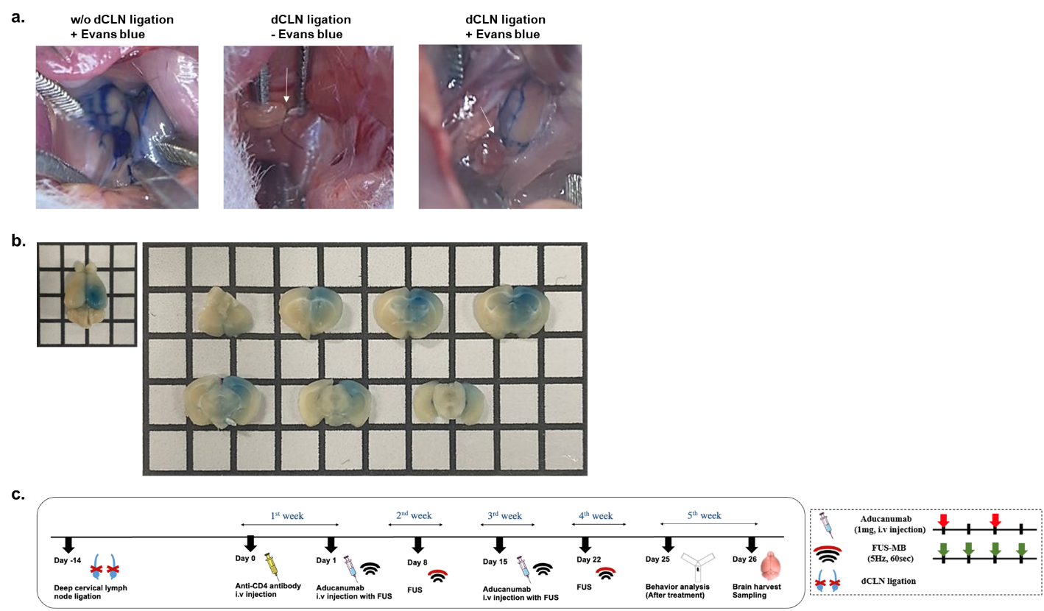
Supplementary Figure 1. Validation of the dCLN-ligated model and FUS setup
(a) Evans blue was injected into the cisterna magna of mice to confirm dCLN ligation. The lymphatic channels entering the dCLN from the cerebral direction (white arrow) were tied. It was confirmed that Evans blue did not escape with dCLN in ligated mouse 30 min after injection. (b) Evans blue was intravenously injected to confirm BBB opening by FUS in the right hippocampus. After 24 h, coronal sections at 1-mm intervals confirmed that Evans blue was injected centered on the hippocampus. (c) The timeline of the experimental plan is described. After modeling, drug injections were performed for a month.

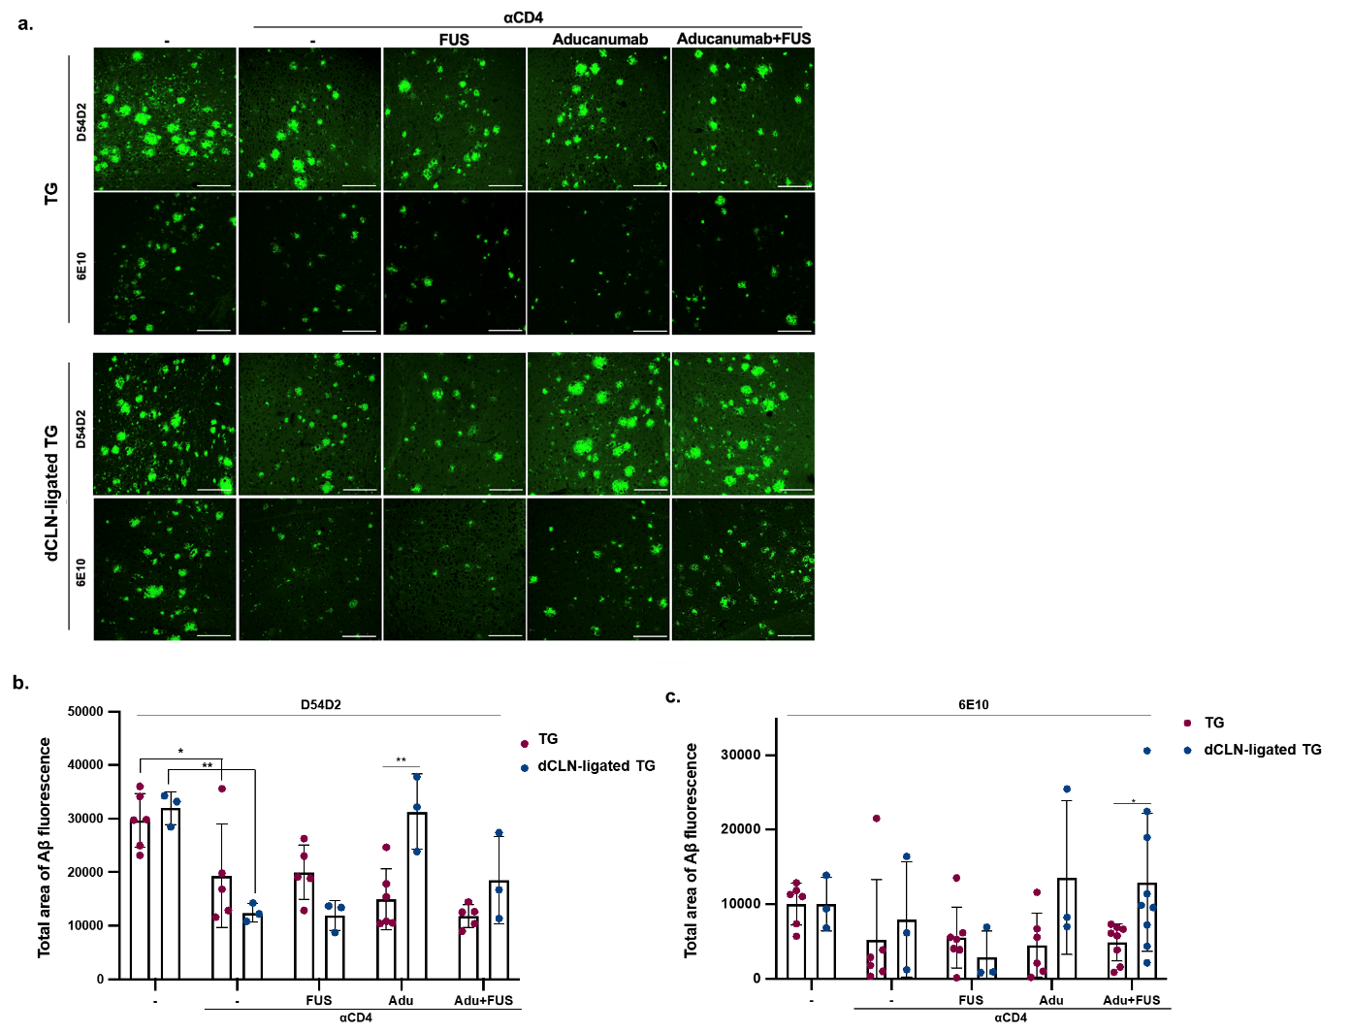
Supplementary Figure 2. Inactivation of CD4 T cells modulated Aβ pathology in the entorhinal cortex.
(a) Immunofluorescence images of the entorhinal cortex from AD and dCLN-ligated AD models under different conditions are shown. Coronal brain sections were stained with D54D2 and 6E10 antibodies showing Aβ accumulation. (b, c) The total area of D54D2- and 6E10-positive signals in each stained image was quantified. The decreased amount of Aβ by anti-CD4 antibody treatment was shown with the use of D54D2 antibody. Aβ pathology was exacerbated when aducanumab was administered to dCLN-ligated AD models. Scale bar = 50 µm. (*p<0.05, **p<0.01, ***p<0.001; one-way ANOVA)

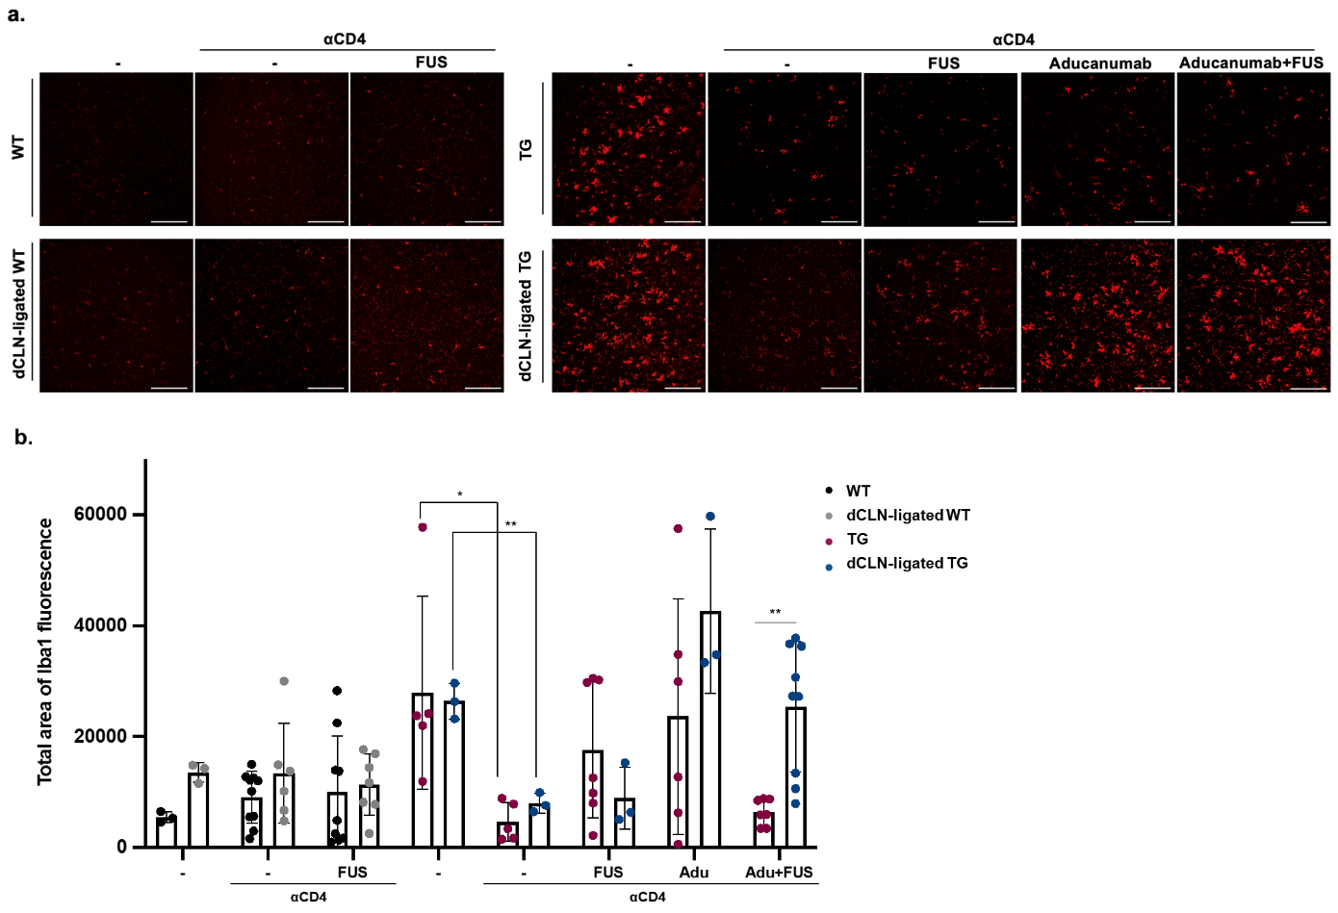
Supplementary Figure 3. The response of microglia to treatments was changed in the entorhinal cortex after dCLN ligation.
(a) Immunofluorescence images of the entorhinal cortex of coronal brain sections stained with an Iba1 antibody showing microglia activation are shown. (b) The total area of Iba1-positive signals in each stained image was quantified. The activation level of microglia was decreased by the anti-CD4 antibody, except in the aducanumab-injected dCLN-ligated group. Scale bar = 50 µm. (*p<0.05, ***p<0.001; one-way ANOVA)

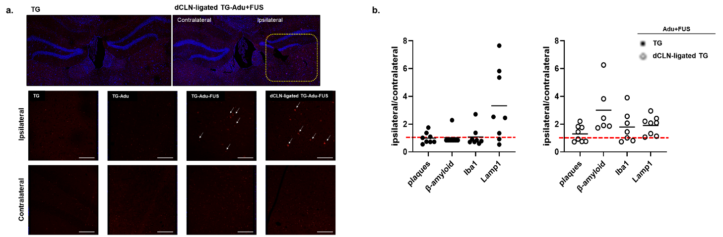
Supplementary Figure 4. Aβ antibody entering the ipsilateral hemisphere by FUS had a pathological effect.
(a) Aducanumab injected via FUS was identified. The red signals indicate infiltrated aducanumab (white arrow). Only in the FUS-co-administered group was it confirmed that the drug inflow increased intensively on the ipsilateral side. (b) Ipsilateral and contralateral ratios obtained from AD and dCLN-ligated AD groups treated with aducanumab and FUS are shown. The red horizontal line indicates the reference point. After dCLN ligation, significantly more soluble Aβ was identified in the ipsilateral region, and reactive microglia showed the same tendency. Scale bar = 50 µm. (*p<0.05; one-way ANOVA)

