Supplementary material.
Table 1. Antibiotic susceptibility pattern of methicillin resistant Staphylococcus aureus (MRSA) strains
Strain # | LZD | VAN | TGC | ERY | CLI | FA | SUL | OXA | CFE | PCN | FOX | CIP | IMP | SXT | NA | AMP | NOR | DO | TEC | G | AMK
MR1 | S | S | S | R | R | R | R | R | R | R | R | R | - | - | - | - | - | - | - | S | S
MR2 | S | S | S | R | R | R | R | R | R | R | R | R | - | - | - | - | - | - | - | S | S
MR3 | S | S | S | R | R | R | R | R | R | R | R | R | - | - | - | - | - | - | - | S | S
MR4 | S | S | S | R | R | R | R | R | R | R | R | R | - | - | - | - | - | - | - | S | S
MR5 | S | S | S | R | R | R | R | R | R | R | R | R | - | - | - | - | - | - | - | S | S
MR6 | S | S | S | R | R | R | R | R | R | R | R | R | - | - | - | - | - | - | - | S | S
MR7 | S | S | R | R | R | R | R | R | R | R | R | R | - | - | - | - | - | - | - | S | S
MR8 | S | S | S | R | R | R | R | R | R | R | R | R | - | - | - | - | - | - | - | S | S
MR9 | S | S | S | R | R | R | R | R | R | R | R | R | - | - | - | - | - | - | - | S | S
MR10 | S | S | S | R | R | R | R | R | R | R | R | R | - | - | - | - | - | - | - | S | S
MR11 | S | S | R | R | R | S | R | R | R | R | R | R | - | - | - | - | - | - | - | S | S
MR12 | S | S | S | R | R | R | R | R | R | R | R | R | - | - | - | - | - | - | - | S | S
MR13 | S | S | S | R | R | R | R | R | S | R | R | R | - | - | - | - | - | - | - | S | S
MR14 | S | S | S | R | R | R | R | R | R | R | R | R | - | - | - | - | - | - | - | S | S
MR15 | S | S | S | R | R | R | R | R | R | R | R | R | - | - | - | - | - | - | - | S | S
MR16 | S | S | S | R | S | - | - | - | - | - | R | R | S | R | R | R | - | - | R | S | S
MR17 | S | S | S | R | R | - | - | - | - | - | R | R | S | R | R | R | - | - | R | S | S
MR18 | S | R | S | R | S | - | - | - | - | - | R | R | S | R | R | R | - | - | R | S | S
MR19 | S | S | S | R | S | - | - | - | - | - | R | R | S | R | R | R | - | - | R | S | S
MR20 | S | S | S | R | S | - | - | - | - | - | R | R | S | R | - | R | - | - | R | S | S
MR21 | S | S | S | R | S | - | - | - | - | - | R | R | S | R | R | R | - | - | R | S | S
MR22 | S | S | S | R | S | - | - | - | - | - | R | R | S | R | - | R | - | - | R | S | S
MR23 | S | S | S | R | S | - | - | - | - | - | R | R | R | R | S | R | - | - | R | S | S
MR24 | S | S | S | R | S | - | - | - | - | - | R | R | S | R | R | R | - | - | R | S | S
MR25 | S | S | S | R | S | - | - | - | - | - | R | R | S | R | R | R | - | - | R | S | S
MR26 | S | S | R | S | R | R | R | R | R | R | R | R | S | R | R | R | S | S | R | S | S
MR27 | S | S | R | R | R | R | R | R | R | R | R | R | S | R | R | R | R | R | R | S | S
MR28 | S | S | R | R | R | R | R | R | R | R | R | S | S | R | R | R | R | R | R | R | R
MR29 | S | S | R | R | R | R | R | R | R | R | R | R | S | R | R | R | R | R | R | R | R
MR30 | R | S | R | R | R | R | R | R | R | R | R | R | S | R | R | R | R | R | R | R | S
MR31 | S | S | S | R | R | R | R | R | R | R | R | R | - | - | S | R | R | S | R | S | S
MR32 | S | S | S | R | R | R | R | R | R | R | R | R | - | - | S | R | S | R | S | S | S
Abbreviations: LZD= Linezolid, VAN=Vancomycin, TGC= Tigecycline, ERY= Erythromycin, CLI= Clindamycin, FA= Fusidic Acid, SUL= Sulzone, OXA= Oxacillin, CFE= Cefixime, PCN= Penicillin, FOX= Cefoxitin, CIP= Ciprofloxacin, IPM= Imipenem, SXT= Trimethoprim-Sulphamethoxazole, NA= Nalidixic Acid, AMP= Ampicillin, NOR= Norfloxacin, D30= Doxycycline, TEC= Teicoplanin, G= Gentamycin, AMK= Amikacin, R= Resistant, S= Sensitive

Table 2. Host range and efficiency of plating (EOP) of TSP phage against clinical isolates of MRSA strains, S. aureus, S. epidermidis and other gram negative organisms.
Species | Strains |  |  | Spot test ª | EOP
Methicillin Resistant S. aureus | MR1 |  |  | - | -
Methicillin Resistant S. aureus | MR2 |  |  | ++ | 0.005
Methicillin Resistant S. aureus | MR3 |  |  | +++ | 0.0003
Methicillin Resistant S. aureus | MR4 |  |  | - | -
Methicillin Resistant S. aureus | MR5 |  |  | +++ | 5 × 10⁴
Methicillin Resistant S. aureus | MR6 |  |  | +++ | 0.016
Methicillin Resistant S. aureus | MR7 |  |  | - | -
Methicillin Resistant S. aureus | MR8 |  |  | +++ | 0.6
Methicillin Resistant S. aureus | MR9 |  |  | +++ | -
Methicillin Resistant S. aureus | MR10 |  |  | +++ | 1
Methicillin Resistant S. aureus | MR11 |  |  | - | -
Methicillin Resistant S. aureus | MR12 |  |  | + | -
Methicillin Resistant S. aureus | MR13 |  |  | - | -
Methicillin Resistant S. aureus | MR14 |  |  | +++ | 0.065
Methicillin Resistant S. aureus | MR15 |  |  | +++ | 0.005
Methicillin Resistant S. aureus | MR16 |  |  | +++ | 0.005
Methicillin Resistant S. aureus | MR17 |  |  | +++ | 0.26
Methicillin Resistant S. aureus | MR18 |  |  | +++ | 0.002
Methicillin Resistant S. aureus | MR19 |  |  | +++ | 53
Methicillin Resistant S. aureus | MR20 |  |  | ++ | 0.007
Methicillin Resistant S. aureus | MR21 |  |  | ++ | -
Methicillin Resistant S. aureus | MR22 |  |  | - | -
Methicillin Resistant S. aureus | MR23 |  |  | +++ | -
Methicillin Resistant S. aureus | MR24 |  |  | +++ | -
Methicillin Resistant S. aureus | MR25 |  |  | +++ | 0.32
Methicillin Resistant S. aureus | MR26 |  |  | +++ | 32
Methicillin Resistant S. aureus | MR27 |  |  | + | 0.002
Methicillin Resistant S. aureus | MR28 |  |  | ++ | 0.004
Methicillin Resistant S. aureus | MR29 |  |  | +++ | 0.5
Methicillin Resistant S. aureus | MR30 |  |  | - | -
Methicillin Resistant S. aureus | MR31 |  |  | +++ | -
Methicillin Resistant S. aureus | MR32 |  |  | + | -
Methicillin Sensitive S. aureus | MSSA1 |  |  | - | -
Methicillin Sensitive S. aureus | MSSA2 |  |  | - | -
Methicillin Sensitive S. aureus | MSSA5 |  |  | + | -
Methicillin Sensitive S. aureus | MSSA6 |  |  | + | -
Methicillin Sensitive S. aureus | MSSA7 |  |  | ++ | 0.08
Methicillin Sensitive S. aureus | MSSA8 |  |  | - | -
Methicillin Sensitive S. aureus | MSSA9 |  |  | - | -
Methicillin Sensitive S. aureus | MSSA10 |  |  | - | -
Staphylococcus epidermidis | SE1 |  |  | - | -
Staphylococcus epidermidis | SE2 |  |  | - | -
Staphylococcus epidermidis | SE3 |  |  | - | -
Staphylococcus epidermidis | SE4 |  |  | - | -
Staphylococcus epidermidis | SE5 |  |  | - | -
Gram Negative organisms | E. coli |  |  | - | -
Gram Negative organisms | Klebsiella pneumoniae |  |  | - | -
Gram Negative organisms | Serratia marsecence |  |  | - | -
Gram Negative organisms | Pseudomonas aeruginosa |  |  | - | -
Gram Negative organisms | Acinetobacter baumannii |  |  | - | -
Gram Negative organisms | Enterobacter cloacae | - | -
ª Spot test results (-) No lytic activity, (+) Small lytic activity, (++) moderate lytic activity, (+++) Strong lytic activity

Table 3. Open reading frame (ORF) analysis of TSP phage
ORFs | CDS position | Strand | Length  (aa) | Start codon | Function | Best match BLASTp | Identities | Accession No. | Molecular weight  (KDa)
ORF1 | 278...679 | + | 133 | ATG | Hypothetical protein | Staphylococcus phage S13 | 119/133  (89%) | BAL42329.1 | 15.2
ORF2 | 693…875 | + | 60 | ATG | Hypothetical protein 44AHJD_20 | Staphylococcus virus 44AHJD | 60/60  (100%) | NP_817315.1 | 6.9
ORF3 | 882…2093 | + | 403 | ATG | Capsid and scaffold protein | Staphylococcus phage vB_SauP-436A1 | 402/403  (99%) | QEA03132.1 | 46.1
ORF4 | 2108…3091 | + | 327 | ATG | Phage collar protein | Staphylococcus phage SCH1 | 327/327  (100%) | YP_009787916.1 | 37.9
ORF5 | 3084…3839 | + | 251 | ATG | Phage lower collar protein | Staphylococcus phage Pabna | 249/251  (99%) | YP_009816552.1 | 29.1
ORF6 | 3852…5789 | + | 645 | ATG | Putative minor structure protein  Putative major teichoic acid biosynthesis protein C | Staphylococcus phage S13  Staphylococcus phage SLPW | 626/645  (97%)  620/645  (96%) | BAL42324.1  YP_009278568.1 | 74.5
ORF7 | 5796…6548 | + | 250 | ATG | Putative endolysin | Staphylococcus phage S13' | 244/253  (96%) | BAL42323.1 | 28.6
ORF8 | 6611…8056 | + | 481 | ATG | Phage tail fibers protein | Staphylococcus phage SCH1 | 464/481  (96%) | YP_009787912.1 | 54.7
ORF9 | 8101…9876 | + | 591 | ATG | Major tail protein | Staphylococcus phage Pabna | 589/591  (99%) | YP_009816548.1 | 60
ORF10 | 9878…10300 | + | 140 | ATG | Putative holin | Staphylococcus phage GRCS | 140/140  (100%) | YP_009004302.1 | 16.2
ORF11 | 10275…11714 | + | 479 | ATG | CHAP domain-containing protein | Staphylococcus phage Pabna | 476/479  (99%) | YP_009816546.1 | 52.1
ORF12 | 11828…14113 | - | 761 | ATG | DNA polymerase | Staphylococcus phage SCH1 | 753/761  (99%) | YP_009787907.1 | 90.2
ORF13 | 14129…15376 | - | 415 | ATG | DNA packaging protein | Staphylococcus phage SCH1 | 414/415  (99%) | YP_009787906.1 | 50.3
ORF14 | 15424…15906 | - | 160 | ATG | Hypothetical protein | Staphylococcus phage SCH1 | 160/160  (100%) | YP_009787905.1 | 19.4
ORF15 | 16072…16485 | - | 137 | ATG | Hypothetical protein | Staphylococcus phage SCH1 | 110/137  (80%) | YP_009787904.1 | 16.4
ORF16 | 16488…16667 | - | 59 | ATG | Hypothetical protein | Staphylococcus phage SLPW | 59/59  (100%) | YP_009278557.1 | 7.2
ORF17 | 16718…17086 | - | 122 | ATG | Single-stranded DNA binding protein | Staphylococcus phage Pabna | 121/122  (99%) | YP_009816539.1 | 14.3
ORF18 | 17110..17346 | - | 78 | ATG | Hypothetical protein  phiAGO13_02 | Staphylococcus phage vB_SauP_phiAGO1.3 | 75/78  (96%) | YP_009797772.1 | 9.2
ORF19 | 17364..17666 | - | 100 | ATG | Hypothetical protein | Staphylococcus phage SCH1 | 95/100  (95%) | YP_009787900.1 | 11.6
ORF20 | 17659.. 17841 | - | 60 | ATG | Hypothetical protein | Staphylococcus phage S24-1 | 40/60  (67%) | YP_004957416.1 | 6.9
aa = amino acids

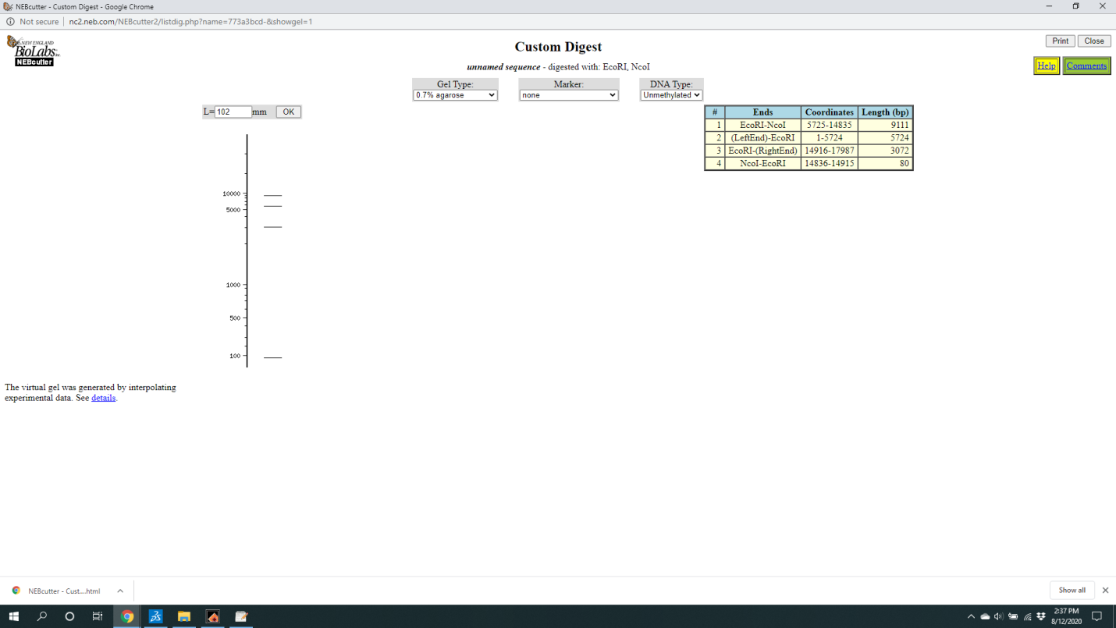

Fig S1: Restriction digestion pattern of TSP phage DNA proposed by Neb cutter. Double digested with NcoI and EcoRI indicates 3 fragments of 9.1, 5.7 and 3 kb if the DNA is linear.

