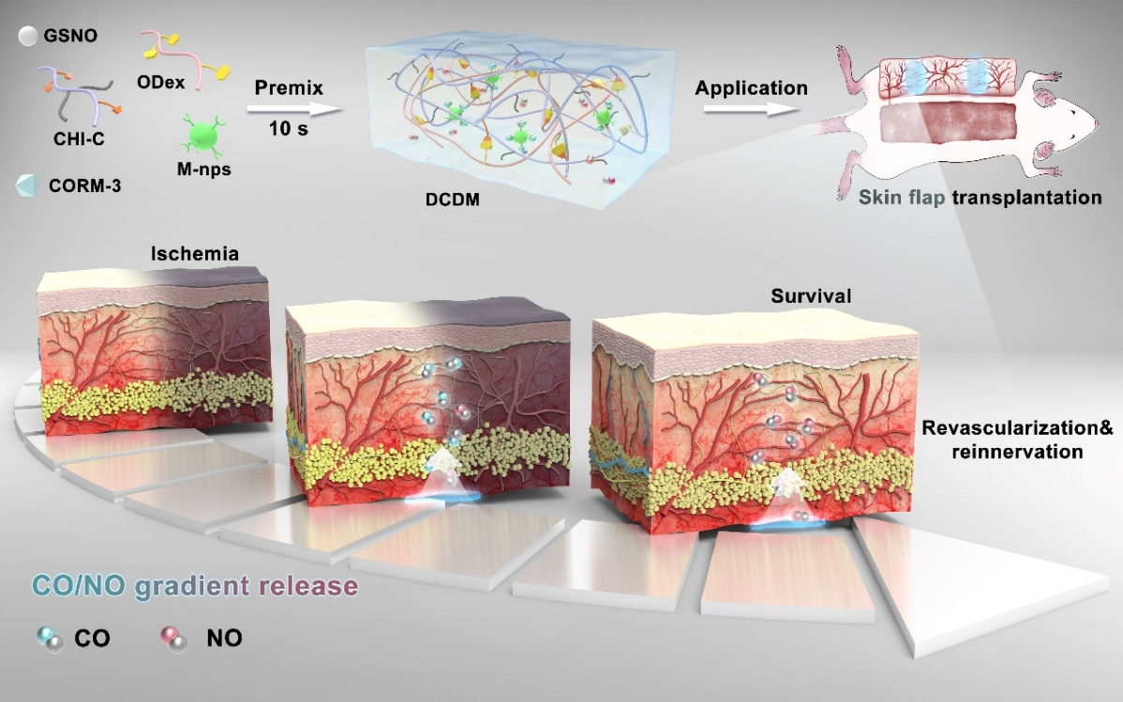
Scheme 1. Schematic representation for the design strategy and applications of bio-multifunctional DCDM hydrogel for revascularization of skin graft.

