Experimental Section
Materials.
Chitosan (degree of deacetylation≈95%, 100–200 mps), dextran (Mw: ~70 kDa), 3, 4-dihydroxy hydrocinnamic acid, 1-ethyl-3-(3-dimethylaminopropyl)-carbodiimide hydrochloride (EDC), lead-oxide (ZnO) were purchased from Aladdin. Sodium periodate (NaIO₄) was purchased from Acros. 4-(Methylamino) Pyridine was purchased from TCI. Fibrin glue was purchased from Shanghai yuanye Bio-Technology Co., Ltd. Gelatin type A (from porcine skin, 300 Bloom), Live/Dead Cell Double Staining Kit, CORM-3 and GSNO was purchased from Sigma. CCK-8 was purchased from Beyotime. CD31, IL-6, TNF-a, IL-1b and all other antibodies are purchased from abcam. IR@dye 680-NHS ester and IR@dye 800-NHS ester was purchased from LI-COR.
Preparation of nps and M-nps
Gelatin nps were prepared by using a typical two-step desolvation method. Briefly, the gelatin (1.25 g) was first dissolved in deionized water (25 mL) at 50 ℃. After complete dissolution, acetone (25 mL, 4 ℃) was added to precipitate the high molecular weight gelatin in the solution. The supernatant was discarded and then deionized water (25 mL) was added to redissolve the precipitated gelatin at 50 °C. The pH of the gelatin solution was then adjusted to 2.5 using hydrochloric acid solution, and then added dropwise acetone (80 mL) to gelatin solution (≈ 4 mL min⁻¹) under vigorous agitation. Then glutaraldehyde (740 μL, 25 wt%) was added to the nps suspension. After cross-linking for 16 h, 100 mL of 0.1 M glycine solution was added to terminate the reaction. After centrifuge thoroughly, nps was lyophilized for further use.
M-nps was synthesized through the classical solution saturation lyophilization method. A 100 mg/mL 4-(Methylamino) Pyridine aqueous solution was prepared, and the nps were dispersed in it under ultrasonic environment, after 1 h ultrasonic treatment, the solution was shaken overnight on a shaker. After taking out the next day, the solution was first freeze-dried, then fully washed, and subjected to a second freeze-drying to obtain M-nps for use.
Synthesis of CHI-C and ODex
CHI-C and ODex were synthesized as our previous synthesis scheme. In brief, CHI-C was synthesized by the EDC activation reaction between the amino group of chitosan and the carboxyl group of hydrocinnamic acid. Firstly, chitosan was dissolved in HCl (aq, ph=4.5). An appropriate amount of hydrocinnamic acid and EDC were added to the above solution, and vigorously stirred at room temperature for 7 h while retaining the pH of 5. After the reaction was completed, the resulting solution was dialyzed in acidified DDW and DDW to remove excess reagents, and CHI-C was obtained by lyophilization. ODex was synthesized by reacting dextran (DEX) with sodium periodate. In short, DEX (4 g) was dissolved in DDW (320 mL) and sodium periodate (4.2 g in 80 mL DDW) solution was added to the above solution. After stirring reaction for 24 h, the resulted solution was dialyzed in DDW (molecular weight cut-off: 12000) and ODex was obtained by lyophilization.
Formation of CHI-C/ODex-M-nps hydrogel (CCOD-M-nps) and DCDM
CHI-C and ODex were separately dissolved in PBS, and mixed to form CCOD. A certain mass percentage of M-nps was added to ODex solution, and this solution was mixed with the CHI-C solution to obtain CCOD-M-nps. The preparation method of DCDM was similar to that of CCOD-M-nps. In order to achieve the gradient sustained release of CO and NO, first, CHI-C and ODex were separately dissolved in PBS. A certain mass of M-nps was dispersed into ODex solution under sonication the process, then different concentrations of GSNO were added to this solution, this is solution A. Different concentrations of CORM-3 were added to CHI-C solution, this is solution B. Solution A and solution B were extruded through a screw needle to obtain DCDM (A to B volume ratio is 1:1). The preparation process of DCDM was shown in Figure 2a.
FT-IR spectra of the samples
All samples were lyophilized, mixed with KBr and ground into a fine powder. The powder was tested with a BLUCK spectrophotometer within 500~4000 cm⁻¹.
Injectability, Self-healing, morphology and rheological properties of the hydrogels
The prepolymer DCDM was added into a single-channel, then was extruded. (Diameter: 29 G). The cylindrical hydrogel which dyed into different colors was cut into two pieces. Then it was pieced together under certain pressure. After 3 minutes, the self-healing ability of the hydrogel was observed.
The microstructure of nps, M-nps, CCOD, DCDM and bacteria was lyophilized and a layer of 2 nm thick Au was sputtered on the surface of the sample to increase its conductivity. The microstructure was observed by JEOL FESEM 6700F electron microscope, and the energy of primary electron was 3 kV.
Similar to the previous test scheme, the cylindrical hydrogel was prepared with 30 mm diameter and 4 mm height. In all the experiments, the parallel plate geometry diameter was 25 mm, temperature: 25 °C, frequency: 0.1 Hz, and oscillatory stress: 1 Pa were kept constant. The self-healing property of the hydrogel was tested by the rheological test in continuous step strain measurements (a fixed frequency of 10 rad s⁻¹. Each strain interval was kept as 150 s.).
Swelling and degradation of the hydrogels in vitro
A certain quality of hydrogel was placed in a 9 cm petri dish with PBS, and the hydrogel was removed from the petri dish and weighed after the excess surface water was removed. The swelling rate (SR) is determined by the following formula:
SR (%) = (W_{t} - W₀)/W₀×100%
Degradation rate (DR) is determined by the following formula:
DR (%) = (W₀- W_{t})/W₀×100%
W_{t} is the weight of the hydrogel taken out of the petri dish at different time points, and W₀ is the initial weight of the wet hydrogel. The experiment was repeated for three times.
Adhesive strength, hemostatic and antibacterial ability of the hydrogels
Fresh pig skin was used to test the adhesion between hydrogel and host tissue. The skin tissue was fully washed and simply cut into 20 mm × 40 mm rectangle. A certain volume of hydrogel solution was applied to the surface of pig skin and the other skin was buttoned up. The adhesion area was 20 mm × 10 mm and tested with a tensile machine. All these tests were carried out three times.
Hepatic hemorrhage sprague-dawley rat (male, weight 240-280 g) were used to observe the hemostatic properties of the hydrogels. the rats were anesthetized with 4% w/v chloral hydrate and fixed on a surgical board, the board was tilted about 30°. The rat liver was exposed through an abdominal incision, and the tissue fluid near the liver was wiped with gauze. A pre-weighed filter paper was placed under the liver, then a 2 mm wound of the liver was cut with a scalpel, and prepolymer solution was immediately injected into the bleeding site with a syringe. After 10 minutes, the weight of the blood-sucking filter paper in each group was compared with the weight of the blood-sucking filter paper in the control group (no treatment after liver cut).
We used a punch to make 1 cm circular holes on agar plates coated with S. aureus and E. coli. The sterile DCDM were added into the holes and incubated at 37 ℃ for 24 h, and the inhibition rings were observed on agar.
Gradient release of dyes in vivo, CO and NO Release Study in vitro
In order to attain a reasonable prediction for drug release, we synthesized a simulated gel. The IR@dye 680-NHS ester and IR@dye 800-NHS ester were used to simulate CORM and GSNO. The gel preparation process was the same as that for DCDM, except that CORM and GSNO were replaced with IR@dye 680-NHS ester and IR@dye 800-NHS ester. Nude Mice were conducted under general anesthesia via isoflurane (3%–4% isoflurane for induction, 1%–2% isoflurane for maintenance). The hairs on the back of the mice were carefully shaved and 100 µL dye solution or simulated gel were injected into their backs subcutaneously (The volume ratio of the two dyes was 1:1, the concentration of each dye was 10 mM), followed by a continuously whole mouse body fluorescence intensity analysis in a small animal in vivo imaging device (LI-COR Odyssey Mouse POD) for 14 days.
CO and NO colorimetric assay kits were used to determine CO and NO concentrations in solution. Briefly, all reagents used and the test environment were pre-saturated with high purity nitrogen. DCDM block (1 mL, CORM 200 μM, GSNO 400 μM) was immersed in 3 mL PBS, then 50 μL aliquots of sample solution removed at various time points and the soaking solution replaced to simulate tissue fluid flow. Samples were added to the colorimetric kit, the absorbance of characteristic peaks measured using a UV-Vis spectrophotometer, and retardation curves calculated based on the corresponding kit standard curve.
In Vitro Cell Experiments
Cytotoxicity test
DCDM cytotoxicity was evaluated using human umbilical vein endothelial cells (HUVECs). Briefly, log-phase HUVECs were seeded in 96-well plates (1 × 10⁴ cells well⁻¹) and cultured in 100 µL growth medium at 37 °C for 24 h. The prepared DCDM (200 µL) was soaked in PBS and incubated at 37 °C. Leach liquor was collected at 1, 12, 24, 48, 72 and 128 h to incubate the cells, and 100 µL DMEM media containing 1/10 volume of CCK-8 reagent added to each well. HUVECs were then incubated for a further 2 h at 37 °C. Finally, absorbance of each group was read at 450nm using a microplate reader, where absorbance values were directly proportional to cell viability.
Cell migration capacity test
An in vitro scratch-wound healing assay was used to evaluate the effect of treatments on HUVEC migratory ability. Lines were drawn on the back of 6-well plates using a marker pen, and transverse lines drawn uniformly at distances of 1 cm between the lines, with three lines in each well. HUVECs were seeded in the 6-well plates (5 × 10⁵ well⁻¹) and cultured in growth medium (DMEM containing 10%FBS) until reaching confluence. Cells were divided into groups as follows: blank, CORM PBS solution (200 μM), GSNO PBS solution (400 μM), mixed CORM + GSNO PBS solution (CORM, 200 μM; GSNO, 400 μM), CCOD-M-nps, and DCDM (CORM 200 μM, GSNO 400 μM). When cells reached 100% confluency, they were evenly scratched with a small pipette head, perpendicular to the horizontal line made using the marker pen and three lines in each well. The intersections of the lines were used as landmarks for observing and photographing. After washing three times in PBS, serum-free medium containing different drugs was subsequently added to each well and cells incubated at 37 °C. Cells were photographed with an inverted fluorescence microscope at 0, 12, 24, and 48 h.
In vivo experiments
Animal experiments were approved by Jilin University Animal Care and Use Committee. (Approval No. 20200677).
Degradation of the DCDM in vivo.
To evaluate the in vivo degradation of DCDM, three Sprague Dawley (SD) rats were anaesthetized and shaved, then a random rectangular skin flap (1.5 × 2 cm) made on the back of each animal. Subsequently, a 500 μL freshly prepared DCDM (CORM 200 μM, GSNO 400 μM) was implanted subcutaneously into the flap pocket. On completion, a photographic record was made. Flap pocket was opened on days 7, 14, and 28 and the remaining hydrogel in each rat was photographed.
CO and NO Release Study in vivo
36 adult male SD rats (weight, 280–300 g) were randomly divided into normal group, CORM+GSNO group and DCDM group. Briefly, PBS (500 μL), CORM+GSNO PBS solution (500 µL per choke zone, CORM 200 µM, GSNO 400 µM) and newly synthesized DCDM (500 µL, CORM 200 µM, GSNO 400 µM) were injected subcutaneously in the caudal choke area of rats from each of the three groups. Blood sample were collected from the femoral artery at the designated time points after injection (1 h, 12 h, 72 h, and 168 h) and carefully stored for the detection of CO and NO. After blood collection, rats were sacrificed and tissue samples of the caudal choke area (1×3 cm) were collected. The NO concentration of serum and tissue were analyzed using NO assay kit (Nitric Oxide Assay Kit, Colorimetric). The final absorbance values were read at 540 nm in a microplate reader. Concentration of NO was calculated by the OD value. Another part of the above blood was used for the measurement of carboxyhemoglobin saturation (HbCO %), and the OD values of each group at different time points were measured at 530 nm, 583 nm and 569 nm using a microplate reader. The HbCO % was calculated according to the corresponding formula.
Flap model
Ischemia-reperfusion dorsal skin flap model of rats
A rat ischemia-reperfusion dorsal skin flap model was designed to evaluate the effects of DCDM on revascularization after transplantation. To produce the flap model, 48 adult male SD rats (weight 280–300 g) were randomized into four groups (12 rats per group), as follows: blank, mixed solution-injected, CCOD-M-nps, and DCDM. All rats were anaesthetized by isoflurane inhalation, and their backs shaved and disinfected using iodine solution.
A rectangular 11 × 3 cm single pedicled island flap was then made on one side of the back of each rat. Flaps were only connected to the body by the deep circumflex iliac artery (Figure S9). Once the flap was raised, CCOD-M-nps or DCDM (500 µL per choke zone, containing CORM 200 μM, GSNO 400 μM) was applied onto the inner surfaces of the two choke zones. After the hydrogel was cured (approximately 30 s), the only perforator was occluded using a microvascular clip. Clips were released to determine reperfusion performance 5 h later. After all operations described above, flaps were sutured in situ using 4-0 nylon. For the mixed solution-injected group, mixed CORM + GSNO PBS solution (200 μM + 400 μM, 500µL) was subcutaneously injected into each choke zone as soon as the flap was closed.
Flaps in the four groups were observed and photographed on the 7th day post-surgery. Furthermore, flap surface temperatures and thermal images were obtained using an FLIR T650sc camera (FLIR Systems, Inc., Wilsonville Ore.). Rats were then humanely sacrificed, and skin tissue samples from each choke zone harvested for subsequent hematoxylin and eosin, immunohistochemistry (CD-31, IL-6, IL-1β), and immunofluorescence (VEGF, TNF-α) staining, as well as gene sequencing.
CTMr tests were conducted to assess the nociceptive sensation of flaps three months post-surgery, using the method described in detail by Petruska et al. Briefly, a pair of forceps was used to pinch three parallel spots in the proximal, middle and distal parts of the skin flap. A pinch of normal dorsum skin with forceps elicited distinct wrinkles and, based on this phenomenon, average reflex intensity scores were calculated for each skin flap by taking the average of scores for the three spots. The Chi-square test was used to determine the statistical significance difference of differences in reflex intensity among groups; P < 0.05 was considered significant. All rats were then humanely sacrificed, and skin tissue samples harvested from each choke zone for later immunofluorescence staining to detect NF200, α-SMA, and TH.
Infrared thermal imaging, postmortem arteriography and laser speckle imaging
Prior research indicated that both CORM and GSNO have vasorelaxant effects. We hypothesized that combined administration of CORM and GSNO would be more beneficial than each individual drug, with DCDM resulting in longer lasting effects than mixed drugs in PBS solution. To test this hypothesis, 30 adult male SD rats (weight, 280–300 g) were randomly divided into five groups (N = 6), including CORM PBS solution (200 μM, 500 µL per choke zone), GSNO PBS solution (400 μM, 500 µL per choke zone), mixed CORM + GSNO PBS solution (CORM 200 μM, 0.5 mL; GSNO 400 μM, 500 µL per choke zone), CCOD-M-nps (500 µL per choke zone), and DCDM (CORM 200 μM, GSNO 400 μM, 500 µL per choke zone) groups. All rats were anesthetized by continuous inhalation of isoflurane and their dorsal hair carefully removed using an electric shaver. Drugs were then injected subcutaneously into the two choke zones of rat right dorsal flap regions. Temperatures and thermographic images of rat dorsal areas were acquired before drug administration and on days 1, 3, 7, and 14 after the injection using an FLIR infrared camera.
To further investigate vasodilatation function, 24 rats were randomized into control, CORM + GSNO PBS solution, CCOD-M-nps, and DCDM groups, which underwent the same injection procedures described above. On days 1 and 7 after drug administration, rats were euthanized and perfused with lead-oxide gel through the aorta. Then, rat bodies were transferred to a 4 °C refrigerator and stored for 24 h. Flaps were harvested the following day and examined using a Siemens X-ray machine (Siemens, Erlangen, Germany) to reveal their vascular networks.
To visualize the effects of DCDM, flap blood flow was continuously monitored using a laser speckle imaging system (RWD RFLSI Ⅲ). Rat back flaps were lifted up and only connected to the body by the deep circumflex iliac artery. CCOD-M-nps, CORM + GSNO, and DCDM were applied to the inner surface of choke zones, as previously described. A laser speckle imaging system was used to assess blood flow and record images before, and after 10 and 30 min, drug administration.
mRNA transcriptome sequencing (RNA‐seq) and bioinformatics analysis
RNA integrity was assessed using an RNA Nano 6000 Assay Kit for the Bioanalyzer 2100 system (Agilent Technologies, CA, USA). Total RNA was used as input material for RNA sample preparation. Briefly, mRNA was purified from total RNA using poly-T oligo-attached magnetic beads. Fragmentation was carried out using divalent cations under elevated temperature in First Strand Synthesis Reaction Buffer (5×). First strand cDNA was synthesized using random hexamer primers and M-MuLV Reverse Transcriptase, then RNaseH used to degrade the RNA. Second strand cDNA synthesis was subsequently performed using DNA Polymerase I and dNTPs. Remaining overhangs were converted into blunt ends using exonuclease/polymerase activities. After adenylation of the 3' termini of DNA fragments, adaptors with hairpin loop structures were ligated to prepare for hybridization. To preferentially select cDNA fragments of 370–420 bp in length, library fragments were purified using the AMPure XP system (Beckman Coulter, Beverly, USA). Then, PCR was performed with Phusion High-Fidelity DNA polymerase, Universal PCR primers, and Index (X) Primer. Finally, PCR products were purified using the AMPure XP system, and library quality assessed on the Agilent Bioanalyzer 2100 system. Clustering of index-coded samples was performed using a cBot Cluster Generation System with a TruSeq PE Cluster Kit v3-cBot-HS (Illumina), according to the manufacturer’s instructions. After cluster generation, prepared libraries were sequenced on an Illumina Novaseq platform to generate 150 bp paired-end reads. The data obtained were subjected to quality control, reads mapped to the reference genome, novel transcripts predicted, gene expression levels quantified, differential expression analysis quantified, as well as GO and KEGG enrichment analysis, Gene Set Enrichment Analysis, single nucleotide polymorphism analysis, alternative splicing analysis, and protein-protein interaction analysis of differentially expressed genes, including weighted correlation network analysis. Arteriovenous Anastomosis
Rats were anesthetized with inhaled isofluorane via mask during the procedure. The anterior neck area of the rats was shaved and sterilized with 75% medical alcohol. A median incision was made in each rat’s neck, and the common carotid artery and external jugular vein were then separated and isolated. The external jugular vein was cut off and the distal end of the vein was ligated. The cardiac end of the external jugular vein was anastomosed to the common carotid artery in an end-to-side fashion using 12–0 nylon sutures. DCDM was applied to the anastomoses using a 1 ml syringe. The wound was then closed carefully with 4-0 silk sutures. Ultrasound Doppler (GE LOGIQ E9) in the operation area were carried out on the 4h, 7th and 28th days after the operation. The venous outflow tracts were harvested 28 days later. Sections of the tissues were made perpendicular to the veins. These sections were then subject to hematoxylin and eosin (HE) staining, Masson staining, immunohistochemical staining of IL-6 and TNF-α and immunofluorescence staining (α-SMA, MMP-9, and Ki67). All the antibodies were purchased from Abcam.
Measurement of endothelial function of jugular vein
Rats external jugular vein were isolated, and dissected free from adherent tissue. Each vein was cut into 3-mm vein rings and subsequently equilibrated in oxygenated Krebs-buffer (118.3mM NaCl, 4.7mM KCl, 1.2mM MgSO₄, 1.2mM KH₂PO₄, 2.5mM CaCl₂, 25mM NaHCO₃, 0.026 mM EDTA, 11 mM glucose) under a tension of 0.8g in organ chambers for 1h. Endothelial function of carotid vein was assessed using DMT wire myograph systems (DMT 620M, Denmark). Vein rings were precontracted using U-46619. When tension development to this precontraction was stable, DCDM time gradient response curve was completed to assess vascular smooth muscle relaxation. After the above operations are completed, the vein rings were made into sections and stained as described earlier. The antibodies used were all from Abcam.
Statistical Analyses
All the experimental data were statistically analyzed as a mean ± standard deviation (SD). The data were analyzed by one-way ANOVA followed by Tukey’s test (Origin software) where *p < 0.1 meant a significant difference. (*p < 0.1, **p < 0.05, ***p < 0.001).
Live subjects
All rats or mice subject to surgery were anesthetized with isoflurane and administered 5 mg/kg ketoprofen before surgery for analgesia. All animal experiments were conducted according to the protocols approved by the Animal Care and Ethics Committee of The First Hospital of Jilin University in China. (Approval No. 20200677)

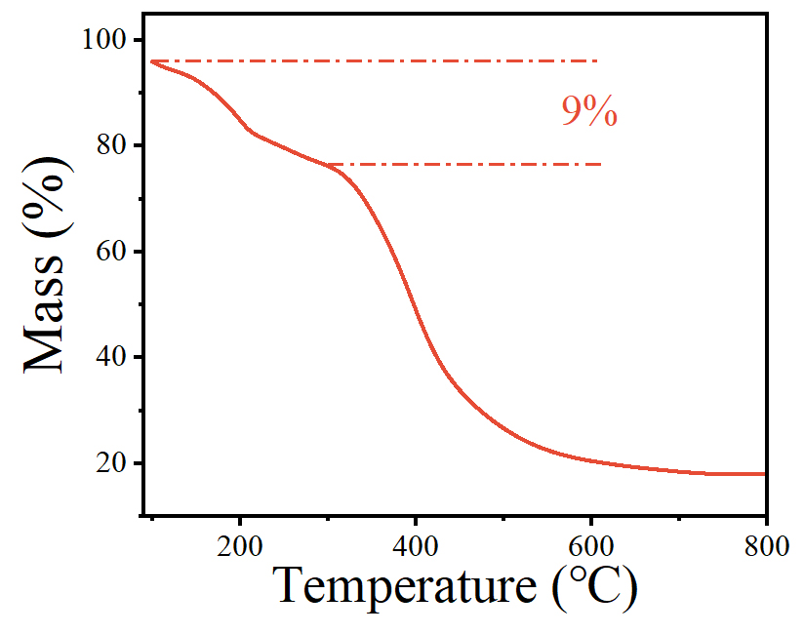

Figure S1. Thermogravimetric analysis (TGA) thermograms of M-nps.

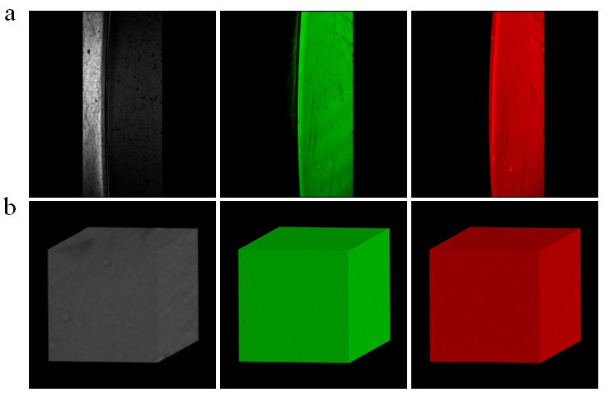
Figure S2. We used red IR@dye 800-NHS ester to label nps, and the green IR@dye 680-NHS ester was directly doped into the gel. The 2D(a) and 3D(b) scanning resulted show that nps could be uniformly dispersed into the gel structure without aggregation.
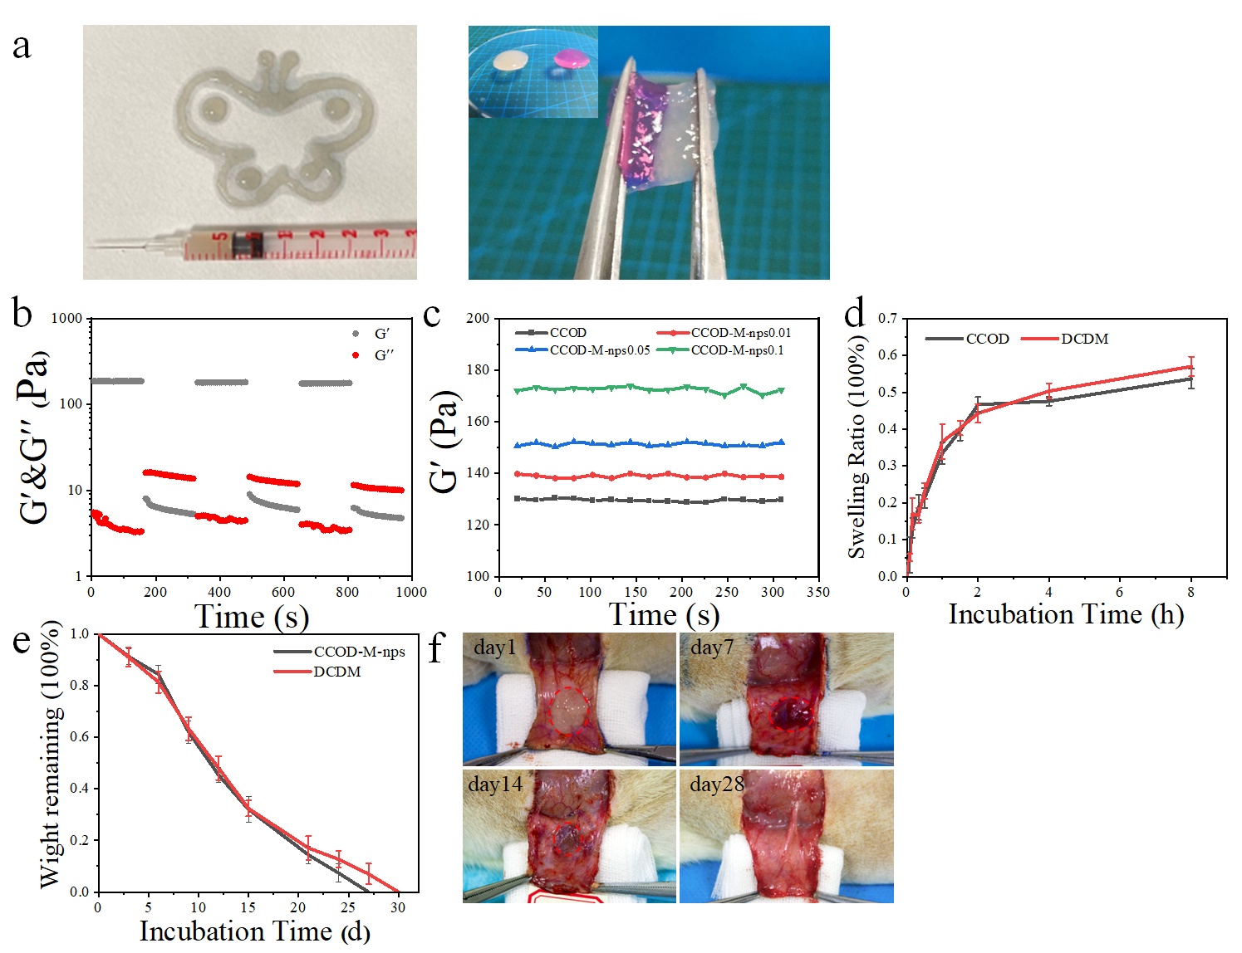
Figure S3. Characterization of the hydrogels. a) The injection and self-healing process of DCDM. The DCDM could pass through the needle (29 G), and the incised hydrogels were observed to be completely self-healing without obvious cracks. b) G′ and G′′ values of the DCDM in continuous step strain measurements (a fixed frequency of 10 rad s⁻¹. Each strain interval was kept as 150 s.) With the change of shear stress, gel storage modulus and loss modulus change alternately, which proves that gel has the advantage of shear self-healing. c) the storage modulus of CCOD-M-nps. As the concentration of nps increased, the interaction sites between nps and gel monomer increased, and the molecular skeleton became closer, leading to a slight increase in storage modulus. d) The CCOD-M-nps and DCDM swelling curve. With the addition of nps, the gel swelling rate has no obvious change. e) and f) In vitro explanation and in vivo degradation. The degradation cycle of DCDM was about 28 days, which could meet the needs of intraoperative repair.
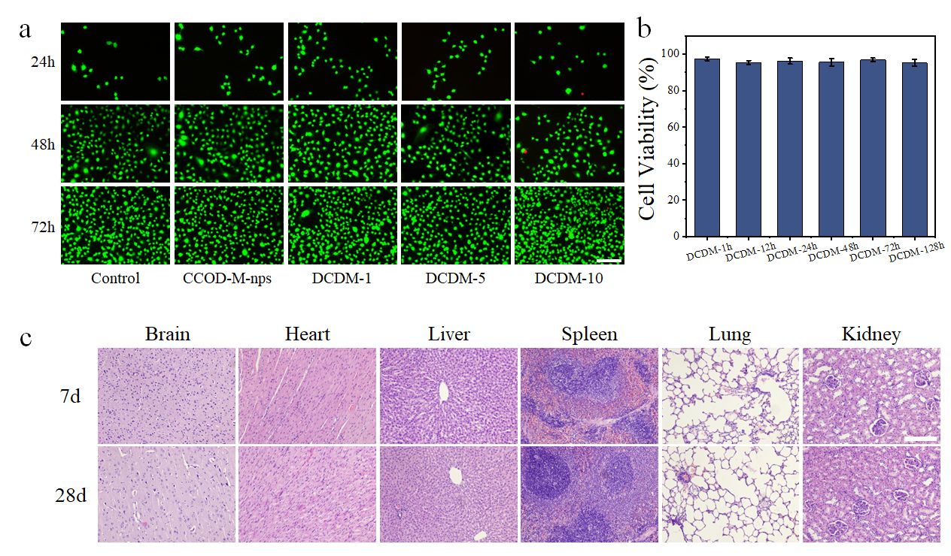
Figure S4. Bio-compatibility of CCOD-M-nps and DCDM. a) Live/Dead staining of Umbilical vein endothelial cells（HUVECs）. Scale bar: 200 µm. b) Cytotoxicity analysis of the CCOD-M-nps and DCDM at different time. c) HE staining of rats organs. Scale bar:100 µm.

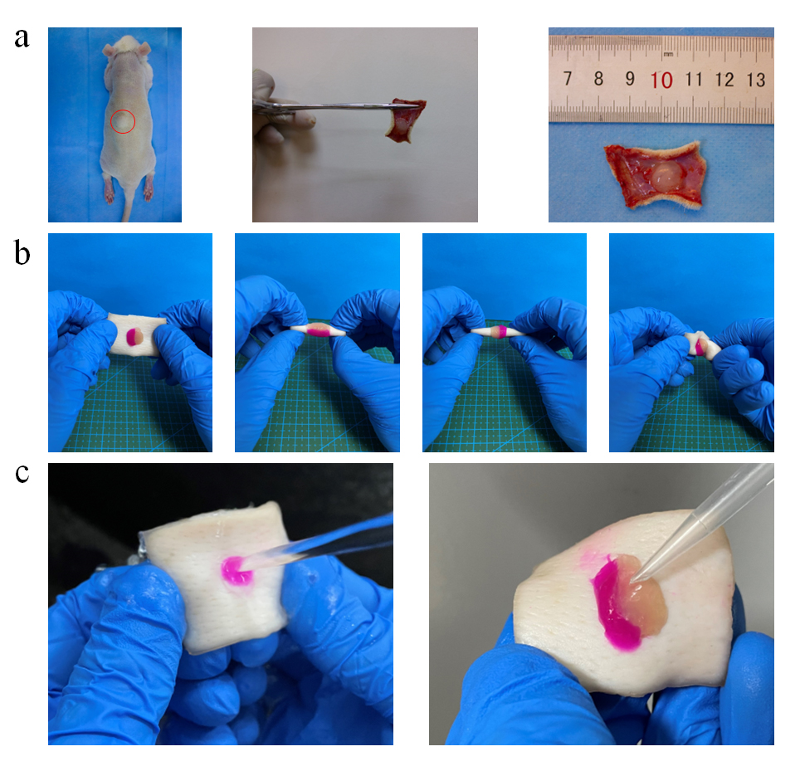
Figure S5. DCDM adhesion demonstration. a) The DCDM was injectable and could stick to the subcutaneous layer. b), c) The hydrogel showed no detachment after distorting, water-scouring and blow-drying.
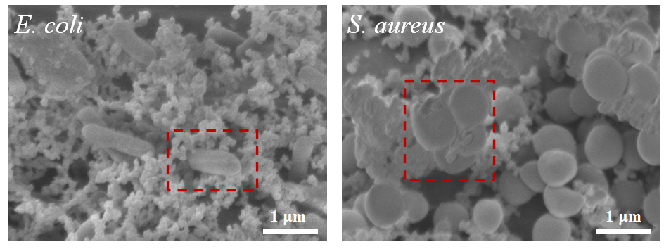
Figure S6. SEM of E. coli and S. aureus on the surface of DCDM. The picture in the red frame was the morphology of dead bacteria. Scale bar: 1 μm.
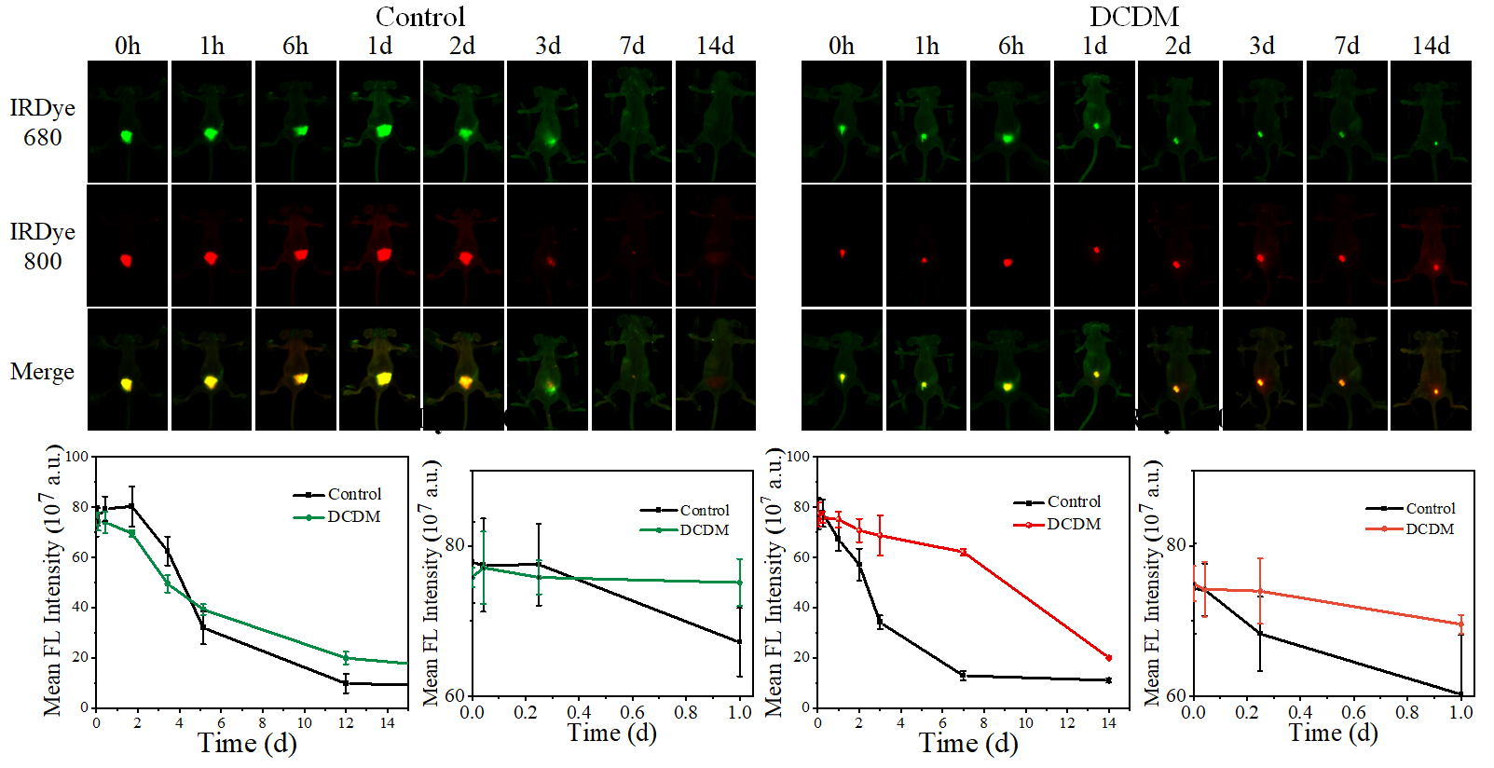
Figure S7. Fluorescent dyes mimic the release of drug molecules. The IR@dye 680-NHS ester and IR@dye 800-NHS ester were used to simulate the two molecules, the results showed that as time went on, compared with the control group, the sustained-release period of IRDye@ 680 in the DCDM did not significantly change, while the sustained-release period of IRDye@ 800 loaded with the internal nps was significantly prolonged.
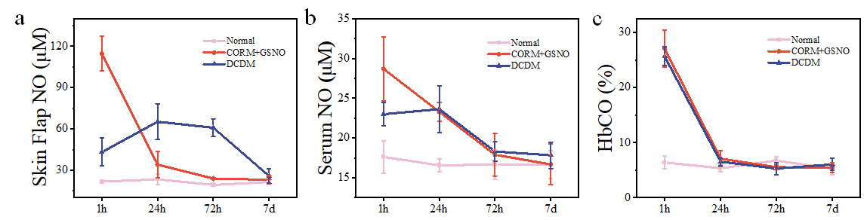
Figure S8. In vivo release of sustained release system in rats. a)Determination of the skin flap NO concentration by colorimetry. b) Serum NO levels. c) Arterial blood carboxyhemoglobin saturation under different treatments.
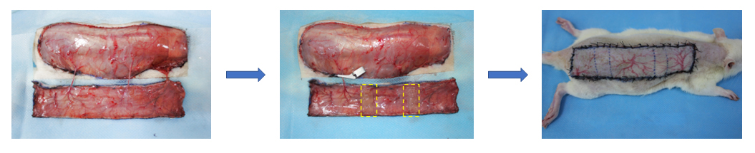

Figure S9. Surgery flow chart of single pedicle ischemia flap model.

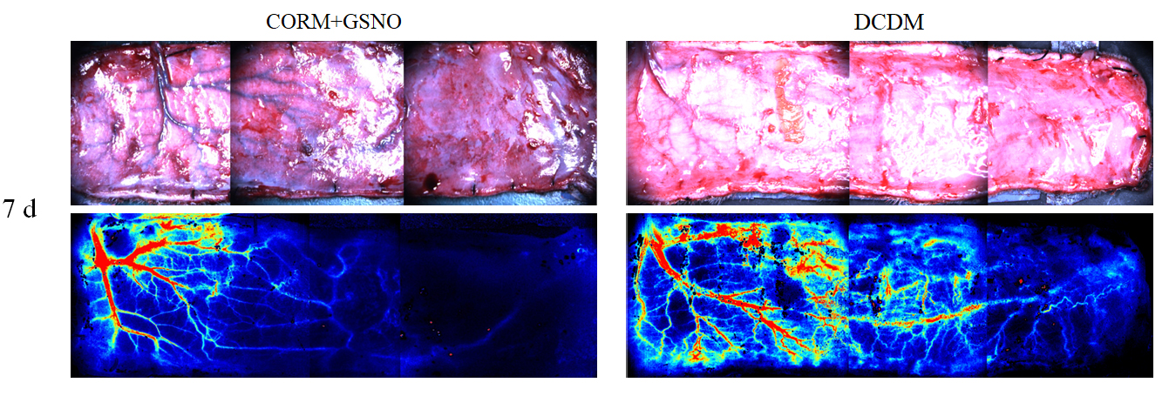
Figure S10. Macroscopic photographs of inner surfaces of flaps and laser speckle images of flaps blood flow 7 days post-operative.
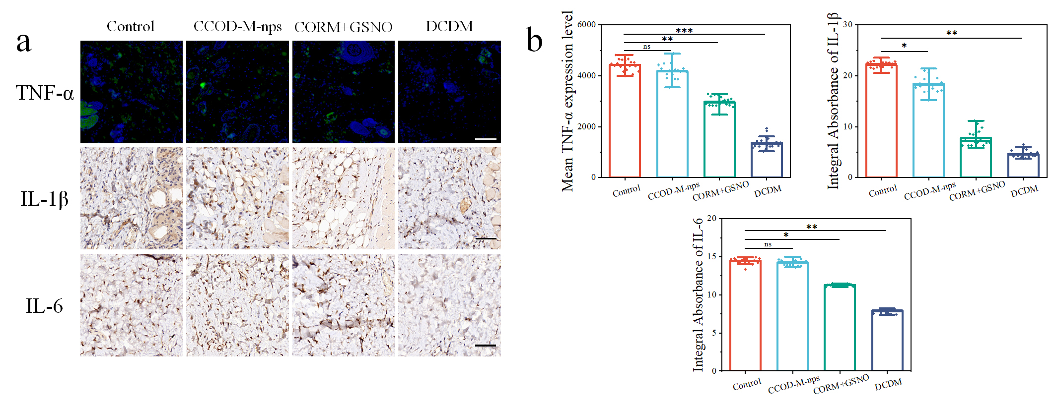
Figure S11. Representative immunohistochemical staining of TNF-α, IL-6 and IL-1β of the flaps 7 days post-surgery.Scale bar: 50 μm.
Video S1: Laser speckle Video of flap choke zones after administration

