Supplementary materials for
Preclinical evaluation of new α-radionuclide therapy targeting LAT1:
2-[²¹¹At]astato-α-methyl-phenylalanine in tumor-bearing model

Yasuhiro Ohshima^{1,†}, Hiroyuki Suzuki², Hirofumi Hanaoka³, Ichiro Sasaki¹, Shigeki Watanabe¹, Hiromitsu Haba⁴, Yasushi Arano², Yoshito Tsushima³, Noriko S. Ishioka¹

Affiliations
¹Department of Radiation-Applied Biology Research, Quantum Beam Science Research Directorate, National Institute for Quantum and Radiological Science and Technology, Takasaki, Japan.
²Graduate School of Pharmaceutical Science, Chiba University, Chiba, Japan
³Gunma University Graduate School of Medicine, Maebashi, Japan
⁴Nishina Center for Accelerator-Based Science, RIKEN, Wako, Japan

†Corresponding author:
Yasuhiro Ohshima, PhD.
Quantum Beam Science Directorate, National Institute for Quantum and Radiological Science and Technology, 1233 Watanuki, Takasaki, Gunma, 370-1292, Japan
Tel: +81 27 346 9461
Fax: +81 27 346 9688
E-mail: ohshima.yasuhiro@qst.go.jp

Detailed Materials and Methods

Production of ²¹¹At
²¹¹At was produced via the ²⁰⁹Bi(α,2n)²¹¹At reaction [1]. ²⁰⁹Bi foil (size: 10 mm × 10 mm × 0.25 mm thickness, purity: 99.999%, Goodfellow Corporation (Coraopolis, PA, USA)) was irradiated with α-particles (28.1 MeV, current: 3.5 µA) for 3 h using an azimuthally varying-field (AVF) cyclotron AVF930 (Sumitomo Heavy Industry) at the Takasaki Advanced Radiation Research Institute, QST. ²¹¹At was recovered by the dry distillation method reported previously [1]. Briefly, an irradiated target was heated on a quartz boat at 650°C for 30 min under streaming of He gas to distill ²¹¹At, and the evacuated ²¹¹At was trapped into a polyetheretherketone (PEEK) tube cooled by liquid nitrogen. ²¹¹At was also produced at the RIKEN RI Beam Factory in a similar manner [2]. A metallic ²⁰⁹Bi target (chemical purity: >99.999%, thickness: 25.5 mg/cm²) prepared by a vacuum evaporation on an aluminum plate (thickness: 1 mm) was irradiated with α-particles (29.1-MeV, current: 6.1 µA) delivered from the RIKEN AVF cyclotron. The α-particles first passed through a Be vacuum window (thickness: 18.1 μm), He cooling gas (length: 65 mm; pressure: 1.08 bar), and finally hit the ²⁰⁹Bi target at 15 degrees. Thus, the effective thickness of the ²⁰⁹Bi target was 98.0 mg/cm². The α-particle energy was calculated to be 28.2 MeV on the center of the target with the SRIM program. After the 8.15-h irradiation, ²¹¹At was extracted from the target by heating at 850ºC for 15 min under streaming of O₂ gas (10 mL/min) and trapped into a perfluoroalkoxy (PFA) tube (i.d.= 1 mm, length = 100 cm) which was cooled with ethanol (-96°C) in a cooling apparatus (EYELA UT-2000). Trapped ²¹¹At was harvested with CHCl₃ and dried with N₂ gas. Radioactivity and radionuclidic purity of ²¹¹At were evaluated with a 687-keV γ-ray using a high-purity germanium (HP-Ge) detector coupled to a multichannel analyzer (Seiko EG&G MCA 7700).

Cell culture
SKOV3 was routinely maintained in Dulbecco's modified Eagle's medium (Wako Pure Chemical Industries, Osaka, Japan) containing 10% heat-inactivated fetal bovine serum (Serum Source International, Charlotte, NC, USA), penicillin (100 units/mL), streptomycin (100 μg/mL), and L-glutamine (2 mM) at 37°C in 5% CO2, 95% air.

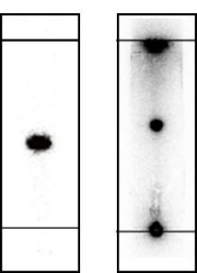

Fig. S1 TLC radiochromatograms after the first-step reaction preparing Prot-[²¹¹At]-2-AAMP (left) and after the following deprotection reaction (right). The Rf value of Prot-[²¹¹At]-2-AAMP was 0.47 on TLC developed with a mixture of hexane and ethyl acetate (4/1, v/v) (left), and that of [²¹¹At]-2-AAMP was 0.57 on TLC developed with a mixture of 1-butanol, acetic acid and water (4/1/1, v/v/v) (right).

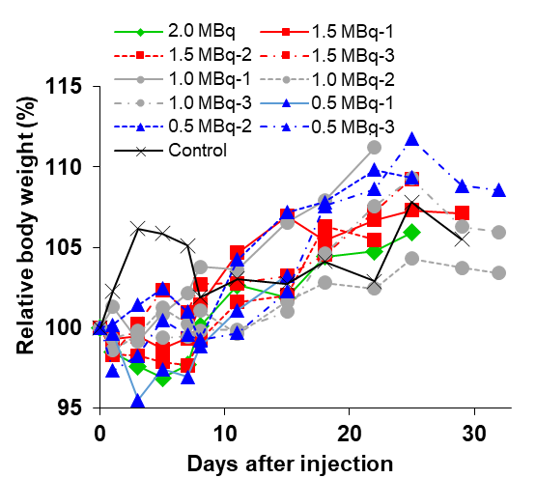

Fig. S2 Body weight change after intravenously injection of [²¹¹At]-2-AAMP (0.5, 1, 1.5 and 2 MBq/head) to the mice once at Day 0.

Reference
- Vaidyanathan G, Zalutsky MR. 1-(m-[211At]astatobenzyl)guanidine: synthesis via astato demetalation and preliminary in vitro and in vivo evaluation. Bioconjug Chem. 1992;3:499-503.
- Fujiki K, Kanayama Y, Yano S, Sato N, Yokokita T, Ahmadi P, et al. ²¹¹At-labeled immunoconjugate via a one-pot three-component double click strategy: practical access to α-emission cancer radiotherapeutics. Chem Sci. 2019;10:1936-1944.

