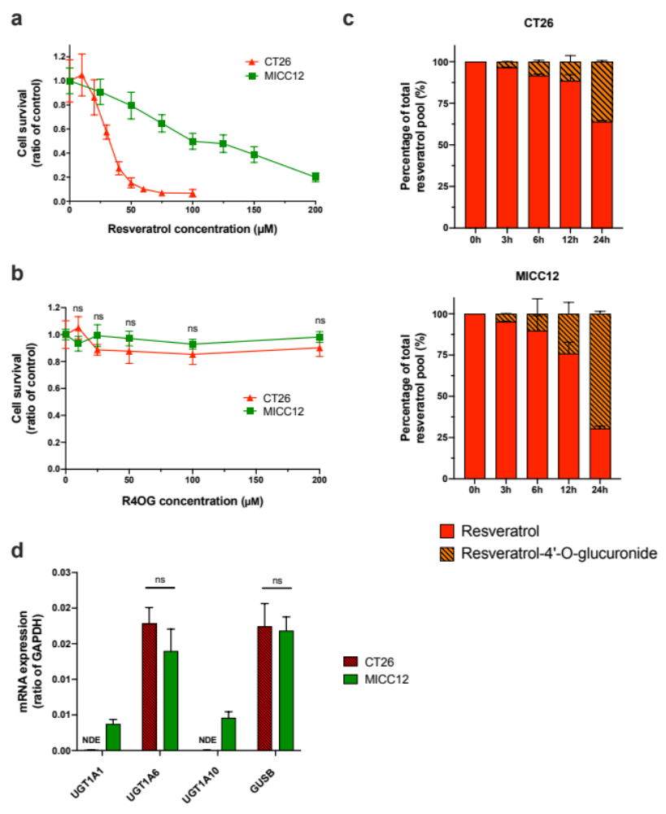

Supplemental Fig 1 Mice tumor and non-tumor colorectal cell lines resveratrol sensitivity is related to metabolization capacity and expression of UGT1A enzymes genes. Dose-response experiments were carried out by treatment of mice colorectal cancer cell line CT26 (red triangles) with increasing doses of resveratrol (a) and resveratrol-4’-O-glucuronide (b). Transformed MICC12 mice intestinal cell line (green squares) was used as healthy non-tumor cells. Resveratrol (red) and its glucuronide derivate resveratrol-4’-O-glucuronide (dashed orange) were quantified in cell culture media after 0, 3, 6, 12 and 24 h incubation with the different cell lines (c). Expression of UGT1A1, UGT1A6, UGT1A10 and GUSB genes were assessed in the different cell lines (CT26: dashed red, MICC12: green) by RT-qPCR, using GAPDH gene as a reference for normalization (d). Results are expressed with mean +/- SD. ** : p<0.01 ; ns : non-significant ; NDE: Non-detectable expression

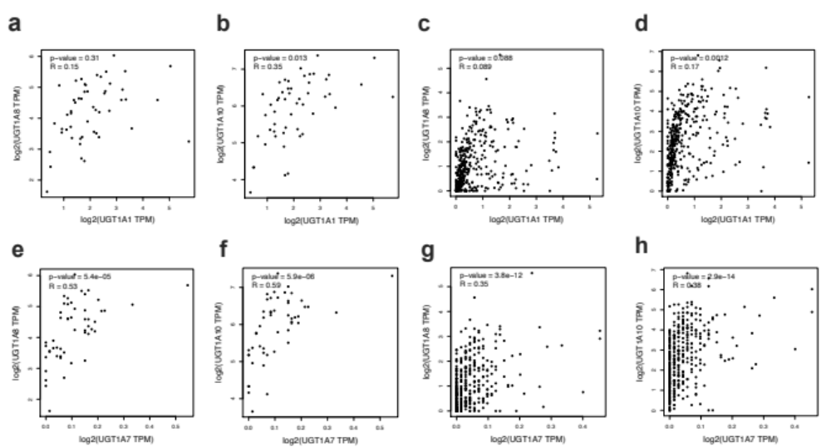

Supplemental Fig 2 Pearson correlation analysis between UGT1A1 and UGT1A8 (a) or UGT1A10 (b) expressions in healthy colorectal tissues. Pearson correlation analysis between UGT1A1 and UGT1A8 (c) or UGT1A10 (d) expressions in colorectal cancers. Pearson correlation analysis between UGT1A7 and UGT1A8 (e) or UGT1A10 (f) expressions in healthy colorectal tissues. Pearson correlation analysis between UGT1A7 and UGT1A8 (g) or UGT1A10 (h) expressions in colorectal cancers

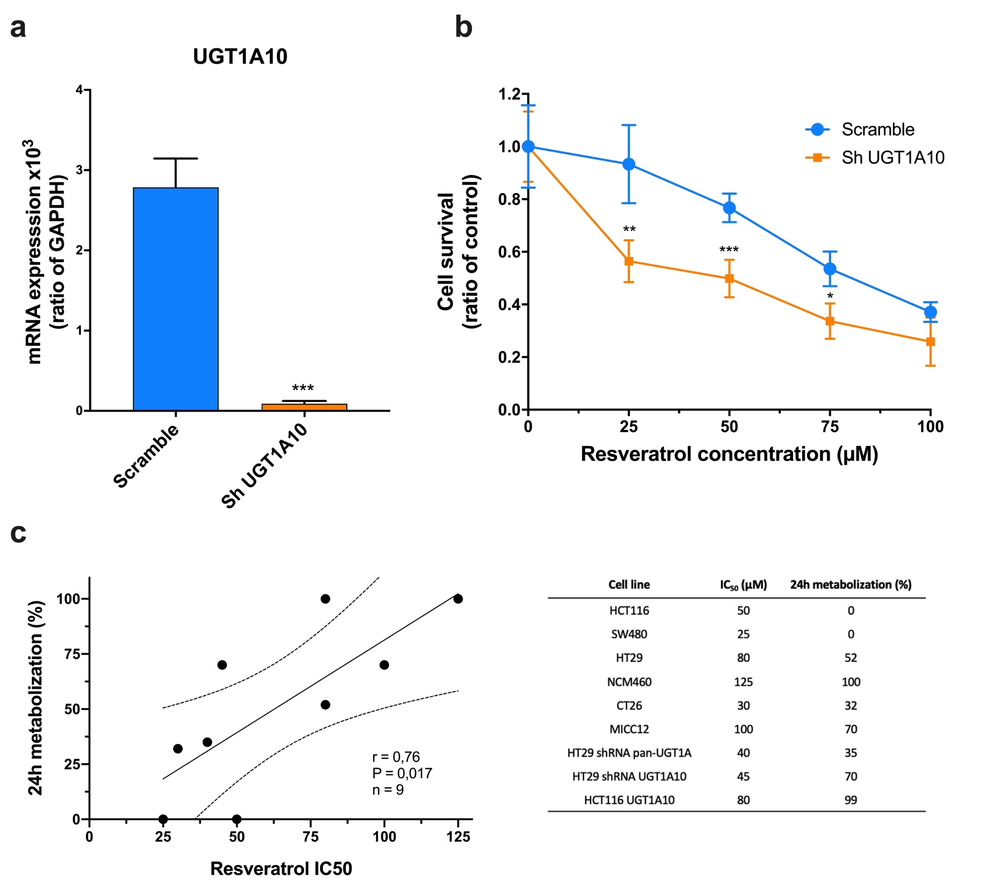

Supplemental Fig 3 Expression of UGT1A10 gene was assessed in sh scramble (blue) and sh UGT1A10 (orange) transduced NCM460 cells by RT-qPCR, using GAPDH gene as a reference for normalization (a). Dose-response experiments were carried out for resveratrol by treatment sh scramble (blue dots) and sh UGT1A10 (orange squares) transduced NCM460 cells (b). Scatter plot of Pearson’s coefficient analysis between cell lines resveratrol IC₅₀ and their percentage of resveratrol metabolization at 24 h (c, corresponding numerical values are presented in the associated table). Results are expressed with mean +/- SD. * : p<0.05 ;** ; p<0.01 ; *** : p<0.001

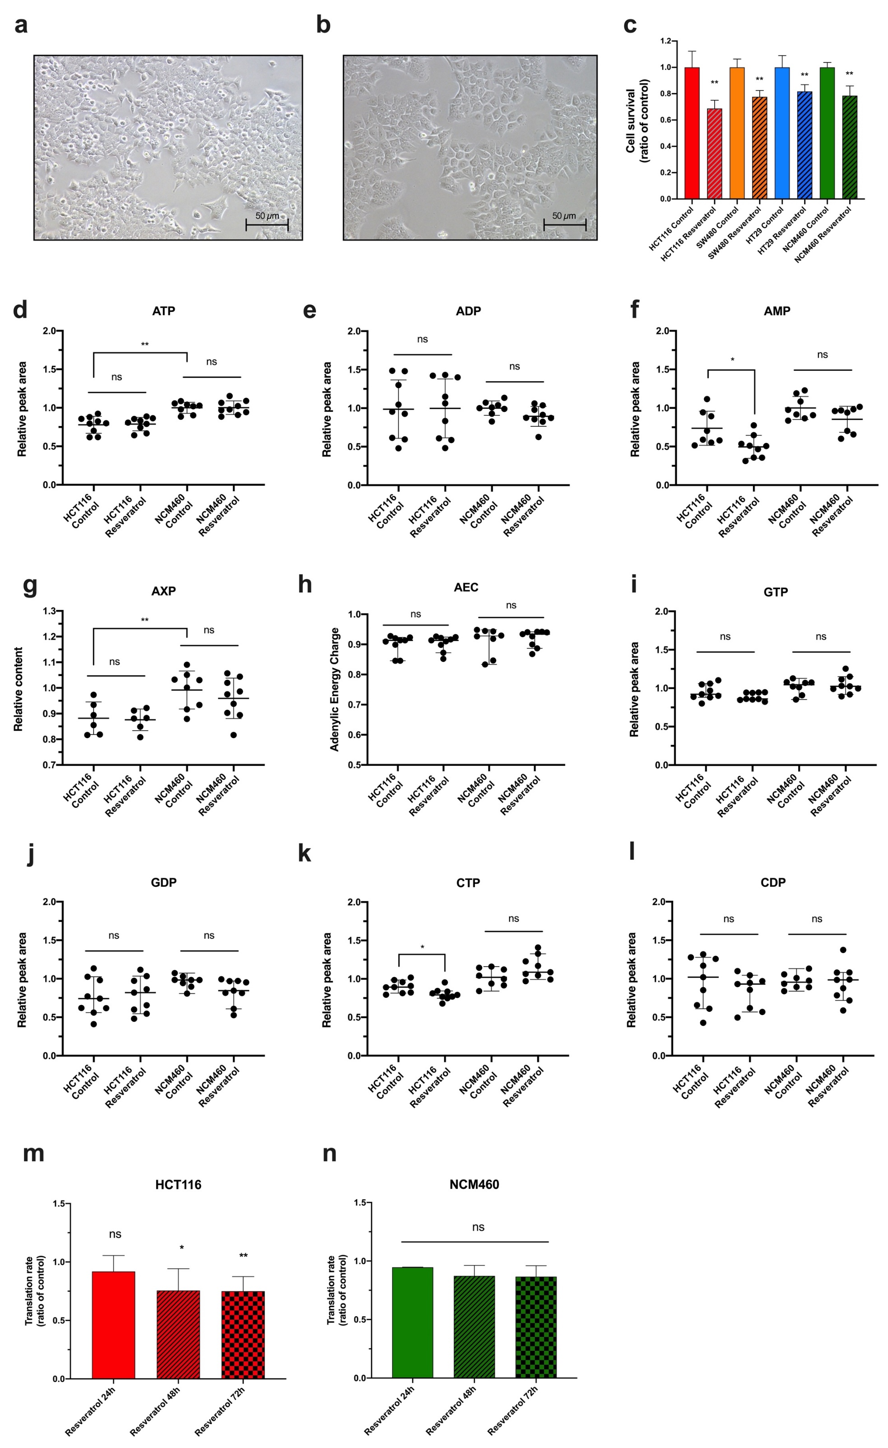Supplemental Fig 4 Optical microscopic observations of HCT116 cells treated (b) or not (a) with 50 µM resveratrol for 24 h. Survival experiments for HCT116 (red and dashed red), SW480 (orange and dashed orange), HT29 (blue and dashed blue) and NCM460 (green and dashed green) cells after 24 h of 50 µM resveratrol treatment (c). Relative peak area (untreated NCM460 value was used as the reference) for ATP (d), ADP (e), AMP (f), GTP (i), GDP (j), CTP (k), CDP (l) nucleotides levels and relative AXP content (g) in HCT116 and NCM460 cells after 24 h 50 µM resveratrol exposure. Adenylic charge of HCT116 and NCM460 cells after 24 h 50 µM resveratrol exposure (h). Histograms showing translation rates of HCT116 (m) and NCM460 (n) cells after 24h (simple), 48h (dashed) and 72h (checkerboard) 50µM resveratrol exposure was assessed by total-protein puromycine incorporation revealed by western-blot. Results are expressed with mean +/- SD. * : p<0.05 ; ** : p<0.01 ; *** : p<0.001 ; ns : non-significant

